##### 

**Department of Mechanical, Industrial, and Mechatronics Engineering**

Please select your current program below:

* **~~Mechanical Engineering~~**
* **~~Industrial Engineering~~**
* **~~Mechatronics Engineering~~**

| Course Number | MEC 322 |
| --- | --- |
| Course Title | Manufacturing Fundamentals |
| Semester/Year | Winter/2025 |
| Instructor | Dr. Krishnan Venkatakrishnan |
| Section Number | 08 |

| **Project Report No. 1** | |
| --- | --- |

| Report Title | Group Project Report |
| --- | --- |
| Group | 2 |
| Submission Date | Apr 4, 2025 |
| Due Date | Apr 4, 2025 |

| Student Name | Student ID (xxxx1234) | Signature* |
| --- | --- | --- |
| Farooq Nomani | 8258 | F.N |
| Karnveer Multani | 32960 | K.M |
| Shane Itwarie | 1921 | S.I. |
| Muneeb Hasan | 36538 | M.H |
| Abdallah Akkila | 40505 | A.A |
| Osman Asif | 35477 | O.A |
| Britney Khuu | 38417 | B.K |

(Note: Remove the first 4 digits from your student ID)

*\*By signing above you attest that you have contributed to this submission and confirm that all work you have contributed to this submission is your own work. Any suspicion of copying or plagiarism in this work will result in an investigation of Academic Misconduct and may result in a “0” on the work, an “F” in the course, or possibly more severe penalties, as well as a Disciplinary Notice on your academic record under the Student Code of Academic Conduct, which can be found online at:* [*http://www.ryerson.ca/senate/policies/pol60.pdf*](http://www.ryerson.ca/senate/policies/pol60.pdf)*.*

# Abstract

The goal of this project was to design a functional prototype capable of picking up metal, styrofoam, and plastic balls and then deposit them into designated holes in small boxes within a one-minute time frame in order to score as many points as possible. The design process prioritized meeting all constraints of the project, such as using a four-bar linkage system, and making sure the prototype can extend to the distance required. The final design consisted of a parallel four bar linkage with an extended straight rear acting as a lever, a three fingered claw, a rotating base, and a string attached to the claw. In our initial trial run, our prototype was semi-successful, leading us to make some changes. Our claw was successful in picking up all 3 types of balls and our linkage was successful in reaching each box, however, our claw failed to deposit the balls inside the boxes. This led to us extending the bottom part of the claw and angling it upward in order to scoop up the balls efficiently, and we added a part to the claw that extends to the handle which can push the balls into the holes.

# Table of contents

**Abstract** **2**

**Table of contents** **2**

**1. Introduction** **2**

**2. CAD drawing** **2**

**3. References** **2**

**4. Appendices** **2**

# 

# Introduction

This report will briefly touch upon the important parts of the group’s design development process and share the specifications and drawings for each individual part of the final design’s prototype model. The group had to go through the whole process of brainstorming various designs, applying concepts and principles to decide on the best decision, and analyzing any problems in the final design. In addition, coming up with a mechanism to reach the goal of this project required taking mechanical systems and other aspects into account.

Since the arm of the final design is a parallel four-bar linkage system, the convenience of use and how it affected other parts of the design were important considerations. In addition, the group decided that using a gear system for the base was a good decision as it would allow the base to rotate around the vertical axis. As for the claw that would end up holding the balls in the final test run, it proved to be quite difficult when deciding what kind of design would be optimal and efficient. In the end, the group decided on a simple claw that consists of: a stationary bottom platform and a clamp on top that is controlled by pulling a string.

The next few parts of this report will include all of the final design’s parts and their respective specifications that were taken into consideration to accommodate each other and the project’s goal.

# CAD drawing

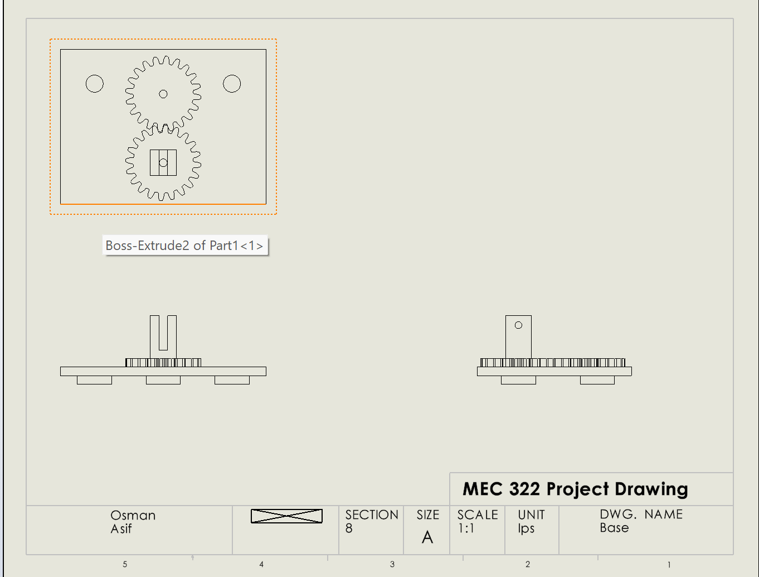

**Figure 1** This is an assembly drawing of the base

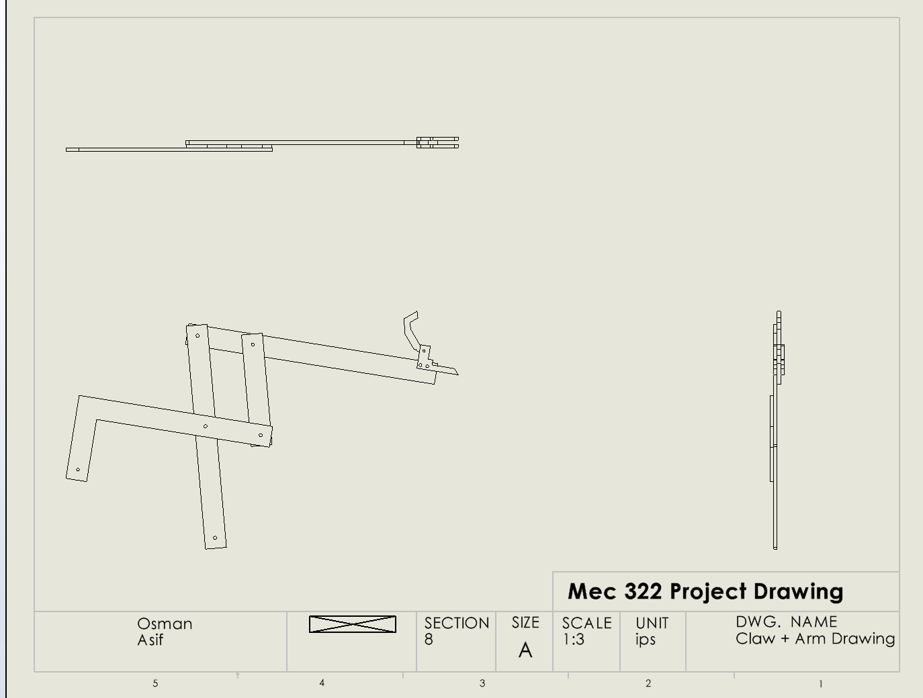

**Figure 2** This is an assembly drawing of the arm

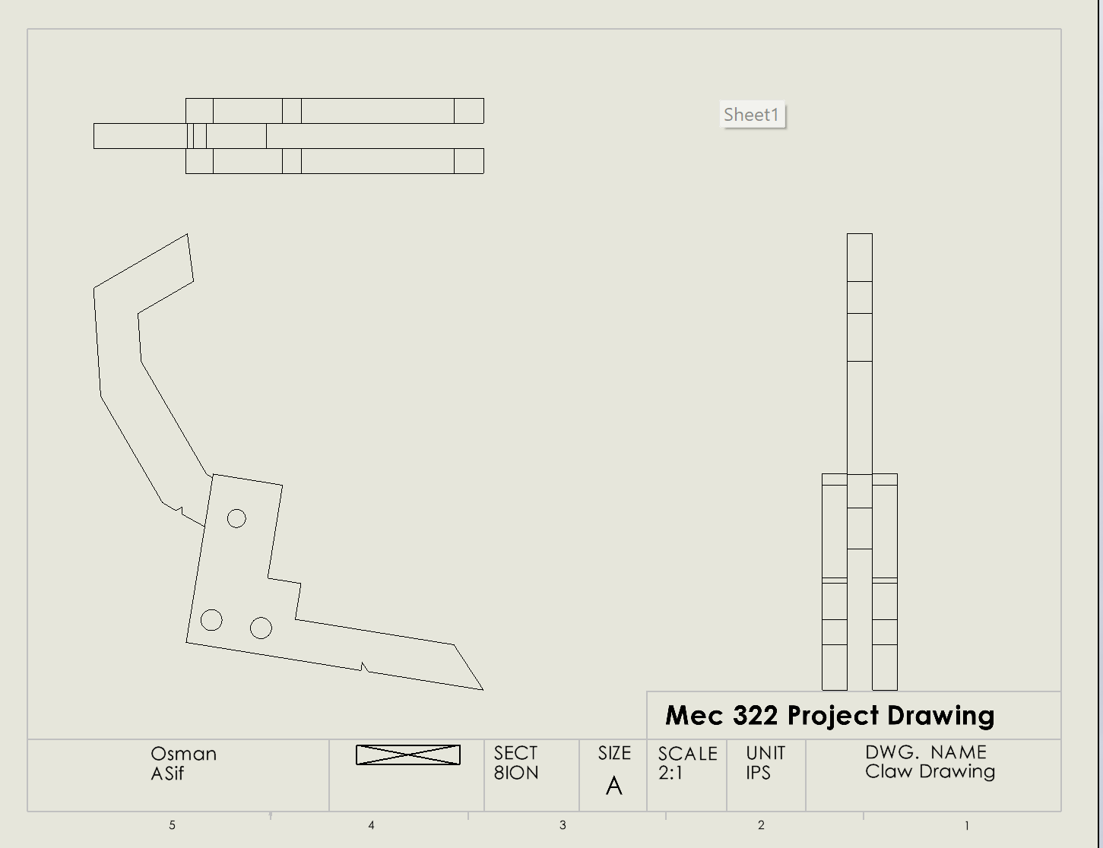

**Figure 3** This is an assembly drawing of the claw

# References

[1] *MEC322 Project Outline* 2025, Toronto Metropolitan University, Toronto, Ontario.

# Appendices