Hardware Battery Emulator for Safe BMS Testing

Stabilizing the cell/host boards and adding a profile-based GUI for reliable battery and load emulation

January 2026



Hardware Battery Emulator for Safe BMS Testing
Stabilizing the cell/host boards and adding a profile-based GUI for reliable battery and load emulation

Author: Osman Tosun

January 2026

This report was prepared by Osman Tosun as an independent contractor for Fontys University of Applied Sciences. It presents a preliminary engineering concept for discussion and internal use only. The views and assumptions expressed are those of the author and do not constitute a formal specification, guarantee, or official statement of Fontys University of Applied Sciences.

Hardware Battery Emulator for Safe BMS Testing

Stabilizing the cell/host boards and adding a profile-based GUI for reliable battery and load emulation

Technical concept document prepared for Fontys University of Applied Sciences
as part of the early-stage design of a Hardware Battery Emulator for Safe BMS Testing

by

Osman Tosun

Classification: Public



Table of Contents
Chapter 1 5
Introduction 5
1.1 Project results 5
1.2 Block Diagram 6
Chapter 2 7
2.1 Software setup 7
2.1.1 Physical setup 8
2.2 Command protocol 9
Chapter 3 10
3.1 Loading Screen 11
3.2 Channel Selection 11
3.3 Option Selection 12
3.4 Custom Settings 13
3.5 Battery Profiles 14
3.6 Help 15
Chapter 4 16
4.1 Conclusion 16
4.1 Recommendations/What the next student should do next 16
Chapter 5 18

Chapter 1

Introduction

Battery management system (BMS) testing can be quite hazardous. Modern batteries store a lot of energy, and, if they catch fire, can be difficult to extinguish. On the other hand, an insufficiently tested BMS represents a hazard to users and the environment. The solution is to emulate the battery and the load so that testing can be completed under a wide range of conditions without taking excessive risks. In the past other people and groups have worked on this project. The goal is to continue development where the previous groups left off.

1.1 Project results

For this project, a hardware-based battery emulator has already been developed. The software that came with it is barebone, and the hardware has some issues. This mean that there are a few main goals to successfully finish this project. This being:
- Testing previous hardware: The hardware that has been obtained from a previous group, who worked on it before, must be tested and validated to ensure that the system has full functionality for the use case.
- Creating a stable prototype and fix the known issues obtained from the previous group
When possible, integrate emulating static load for specific battery types: many kinds of batteries are being used in the modern world. It is important to BatteryNL that the most used battery types (and maybe even future types) can all be emulated on the hardware used.

1.2 Block Diagram

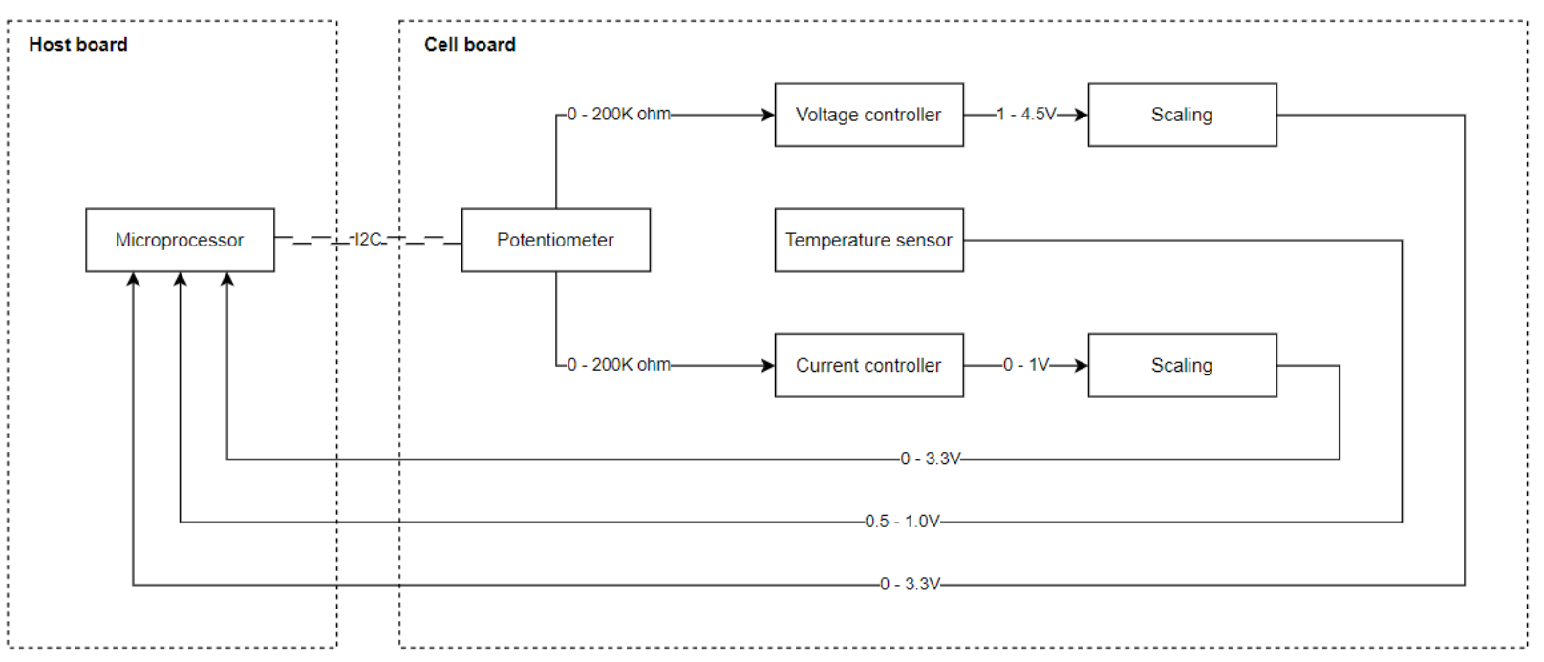
Figure 1.2.1 Block Diagram of BMS emulation system

- Potentiometer: this is a dual potentiometer which is controlled by the host board via I2C protocol. The potentiometer changes resistance what will result in different voltage and current at the output.
- Voltage controller: based on the resistance on the set pin of the controller a voltage is regulated at its output.
- Current controller: based on the voltage divider driven by the potentiometer the current is regulated using an opamp mosfet buffer.
- Temperature sensor: to maintain the temperature on the board a sensor is added to measure this and send back to the host board.
- Scaling: to check if the output behaves as desired the output will be scaled to 0 – 3.3V and send back to the host board

Chapter 2

Firmware design

To update the software side of the project, the GUI had to be redesigned to make the system more user-friendly and easier to operate. Previously, the setup required two separate cables: one for UART communication with a computer and another for power. This was inconvenient and impractical for such a small device.
By integrating a Nextion display, the external UART-based user interface could be removed. The simulator can now be controlled directly through the built-in touchscreen, reducing the setup to a single compact, self-contained interface and significantly improving usability

2.1 Software setup

To operate the BMS simulation device, the system is powered from a single external supply. The Nextion touchscreen is mounted on the device and connected to the controller through a UART interface (TX/RX + GND). This replaces the previous PC-based UART control and removes the need for an additional communication cable.
After powering on, the firmware initializes the required peripherals (UART for the Nextion display, I²C/SPI if used, GPIO outputs, and any DAC/digital potentiometer channels used for voltage/current emulation). The device then loads default safety values and a standard battery profile so the simulator starts in a predictable state. The GUI displays the main control page where the user can select a battery profile, adjust parameters, and start/stop the simulation directly from the device.

2.1.1 Physical setup

Here is the physical setup of the BMS simulation device. The system is divided into three main parts, labelled for clarity:

A: Cell Board – A modular board that emulates a single battery cell by generating the required cell voltage/current and providing measurement feedback.
B: Host Board – The central controller that manages all connected cell boards, sends their setpoints, and collects and processes measurement data.
C: Display (GUI) – The user interface used to select battery profiles and settings, and to transmit these commands to the system in real time.

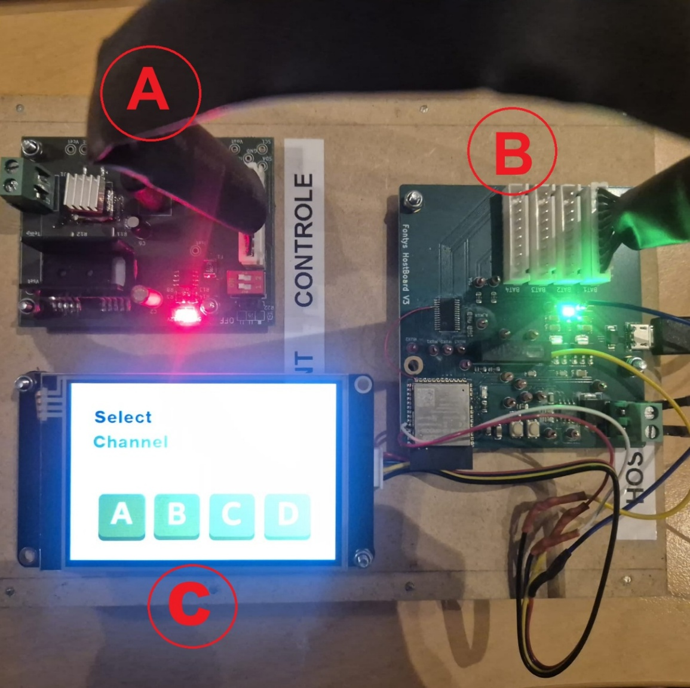
Figure 2.1.1 Physical setup of real system.

2.2 Command protocol

Communication between the GUI and the firmware is done via UART (TX/RX). The firmware receives plain-text commands in a fixed format:
va[voltage1]ca[current1]vb[voltage2]cb[current2]vc[voltage3]cc[current3]vd[voltage4]cd[current4]
Each voltage/current pair corresponds to one simulated cell (channel):
- va / ca → Cell A (voltage wiper step / current wiper step)
- vb / cb → Cell B
- vc / cc → Cell C
- vd / cd → Cell D
Before applying the settings, the firmware validates the received values. The typical limits used are:
- Voltage step: 0 … 255
- Current step: 60 … 255
Because the wiper values are inverted in the hardware mapping, lower numbers represent higher output. For example, maximum output for Cell A is sent as:
va0ca60
This sets Cell A to approximately 5 V and 2 A.
Minimum output (effectively off) is sent as:
va255ca255
This reduces the output of Cell A to zero.

Chapter 3

User Tutorial
The display is made with a Nextion NX4832K035. It is from the enhanced series of the Nextion display line. The idea is that the display is green, the same green as BatteryNL, so it would fit the theme. The display will show options to choose a channel and set the voltage by selecting a preset value or entering your own custom value. This chapter will tell you more about it.

3.1 Loading Screen
The first screen you will get welcomed with is the loading screen. A loading screen matters because it reduces user confusion: when the device powers on and doesn’t respond instantly, people assume it’s frozen or broken.

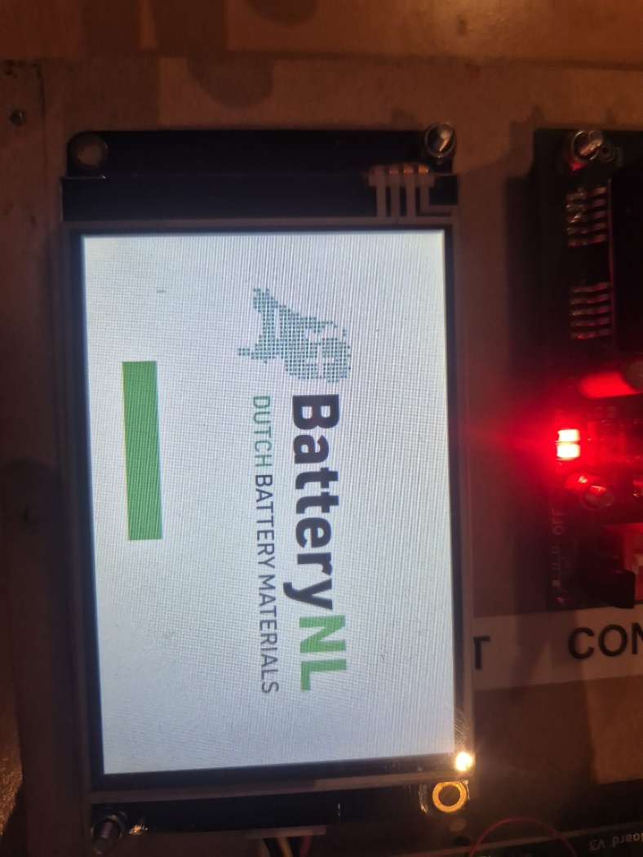
Figure 3.1 Loading Screen Gui page

3.2 Channel Selection
The Channel Selection page lets you choose which BMS channel you want to simulate. After the loading screen, this is the first page you’ll see, which is why we treat it as the “home screen”. In section A of Figure 3.2, you can select channel A, B, C, or D. The question mark (section B in Figure 3.2) opens the help menu, which is explained further in Chapter 3.6.
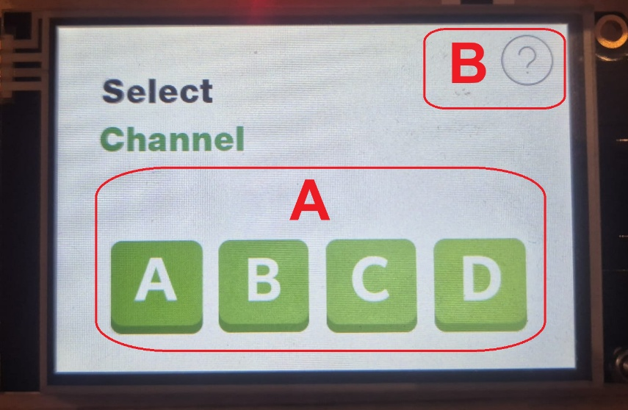
Figure 3.2 Channel Selection page

3.3 Option Selection
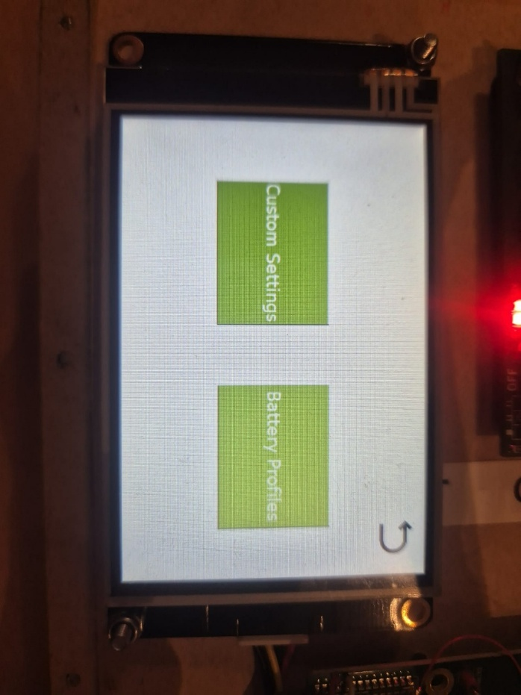
After selecting the channel that your BMS simulation PCB (host cell) is connected to, you can either enter your own custom battery values (left button) or choose a preset battery profile (right button).

Figure 3.3 “Custom” or “preset profiles” option

3.4 Custom Settings

After selecting “Custom Settings” on the option selection page (Chapter 3.3), you can set the values that are sent to the host cell of the chosen channel. Figure 3.4 is split into five sections (A to E), which are explained below.

In section A, you can set the voltage and current for the BMS simulation host cell. Use the sliders to choose the desired values.

In section B, press Apply to send the selected voltage and current to the host cell.

In section C, you can see the read-back values from the system: voltage, current, and temperature. If the temperature rises above 40°C, a flashing warning icon will appear to alert the user.

In section D, the Stop button sets the host cell output to 0 V and 0 A.

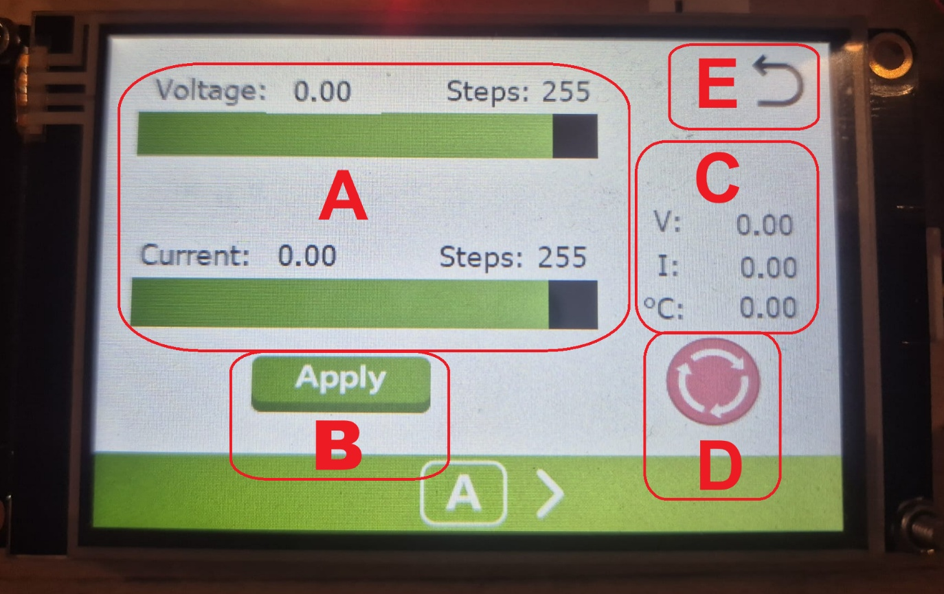
In section E, you can return to the option selection page (Figure 3.3).

Figure 3.4 Custum settings page

3.5 Battery Profiles

After selecting “Battery Profiles” on the option selection page (Chapter 3.3), you can choose a pre-programmed battery profile for the selected channel. Figure 3.5 is divided into four sections (A to D), which are explained below.
In section A, you can select a battery type and its preset voltage/current values. The available profiles are Li-ion, LiFePO, and Lead-acid, since these are the most common options. If you want to change or add profiles, you can edit them in the attached Nextion file.
In section B, the system shows the read-back values: voltage, current, and temperature. If the temperature goes above 40°C, a warning icon will appear to alert the user.
In section C, the Stop button sets the host cell output to 0 V and 0 A.
In section D, you can return to the option selection page (Figure 3.3).

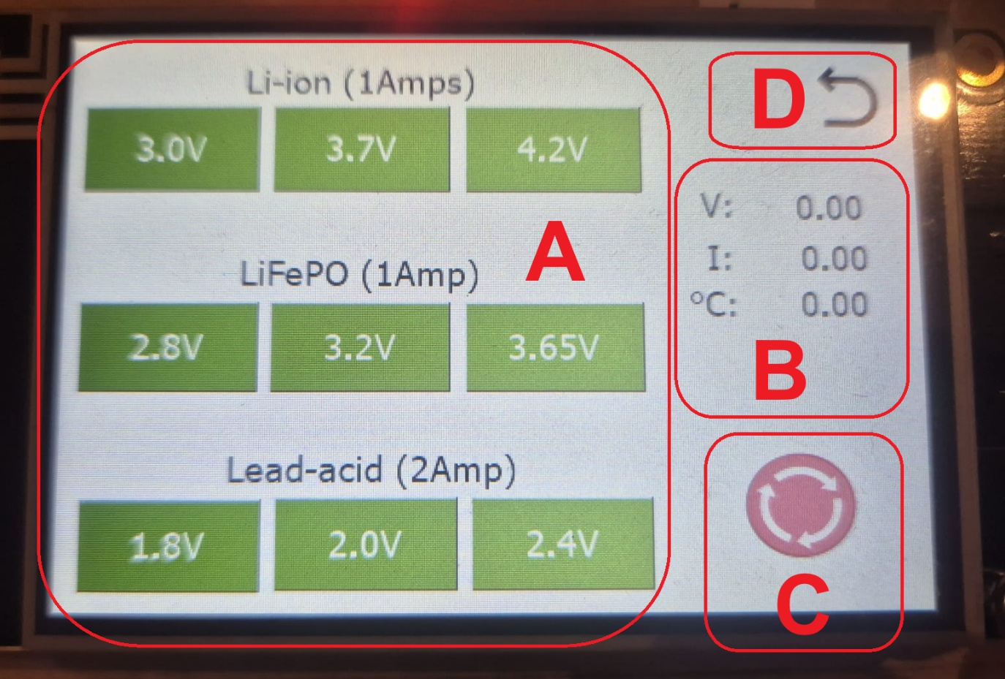
Figure 3.5 Battery profiles page

3.6 Help
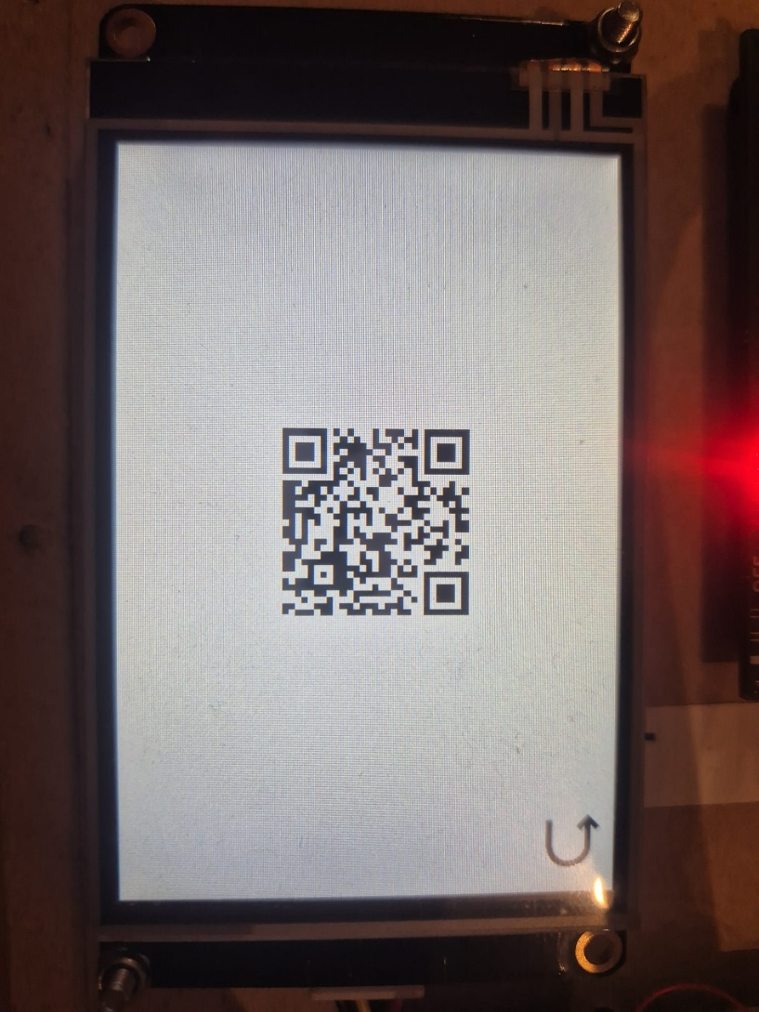
In Figure 3.2, you can select a channel or tap the question mark. This will take you to Figure 3.6, where a QR code is shown. Scanning the QR code opens a GitHub page that contains this document and the source files. This makes it easier for users to understand the project and prevents misunderstandings.

Figure 3.6 QR code page to help the user.

Chapter 4

Conclusion & Recommendations

4.1 Conclusion

After testing the GUI and validating it with the teachers, it can be concluded that the GUI works seamlessly with the host board and cell boards to simulate a BMS. The new Nextion-based interface makes the device easier to use because the user can control and monitor key values directly on the device, without needing a separate UART connection to a computer. This reduces the setup from two cables to a single power connection, improving usability and making the system more practical for quick testing.
Overall, the software functions as intended: the GUI reliably sends the selected settings to the host, the host updates the cell boards, and the display shows the expected feedback to the user. The final result is a more user-friendly BMS simulation device that is faster to set up, clearer to operate, and suitable for demonstrations and basic validation tests.

4.1 Recommendations/What the next student should do next

Recommendations for the GUI and hardware integration
The GUI communicates with the ESP32 via the RX/TX UART pins, but it is currently connected using external wires. For a cleaner and more reliable setup, redesign the PCB so the RX/TX lines are routed directly to the display connector.

Recommendations from the previous group
- Connect the BOOT button to ESP32 GPIO0.
- Replace the USB Micro-B connector with USB-C to align with current EU standards.
- Remove the USB power line completely (do not power the system through USB).
- Connect the multiplexer ENABLE pin permanently to 3.3 V or control it from the MCU (currently this is done with a jumper).
Recommendations from the current group
- Update the host board power design to support a lower supply voltage and reduce LDO dropout losses to improve efficiency.
- Add pin headers/connectors for cooling fans (preferably on the cell boards, but could also be added on the main board).
- Simplify the design by removing the −12 V supply (only if it is not required for any functionality).
- If possible, remove the multiplexer to simplify the design—an ESP32 typically has enough GPIO pins to handle the required signals directly.

Chapter 5

Appendices

GitHub: https://github.com/Osmantsn/BMS-Battery-Emulator

Repository contents (folders/files)

• BatterySystemHardware2025-2025: Original hardware package from the previous group (electrical schematics and related hardware documentation).

• NewBMS_nextion_v2: Updated Arduino/ESP32 firmware used for the current version of the BMS Battery Emulator.

• Nextion: Nextion HMI project for the GUI, including the images used in the interface.

• README.md: Short repository overview and usage notes.

