  - Knowledge Discovery In Databases

  - COURSE: First Partial
  - INSTITUTION: UNIVERSIDAD TECNOLOGICA EL RETOÑO
  - STUDENT ID: 4496
STUDENT NAME: OSMAR HERNANDEZ FRAUSTO
  - KEY TOOLS:
- Python
- Pandas
- SciKit-Learn
TEACHER: JORGE EDUARDO HERRERA SERRANO
DATE: October 6th, 2026

ABSTRACT:
Machine Learning is an excellent way to predict numeric values using linear regression. This means that we can use it to efficiently predict and prevent real time scenarios. This document redacts the basics to use the SciKit-Learn library from python to predict the burnout in students’ academic life.

Content Table
Introduction 1
Deveolopment & Methodology 1
Analytical & Coneptual Questions 3
Conclusions 6

Introduction
Burnout in students is one of the main concerns for therapists and academic advisers since it is one of the leading causes for suicide, substance abuse and others situations that may affect students’ life style. This is way being able to predict the conditions that may lead to burnout and try to prevent those conditions that may lead to a higher burnout. Knowing this, Machine Learning can help to predict the level of burnout a student may experience if exposed to those conditions, this way teachers and school can adapt in order to even and reduce the burnout in students.

Deveolopment & Methodology
import pandas as pd
from sklearn.metrics import mean_absolute_error as MAE
from sklearn.model_selection import train_test_split as TTS
from sklearn.tree import DecisionTreeRegressor

# Function to check the mae of the predictions' validation
## Notes to self that should be fix but right now I dont care:
### - This is a bad practice in python al global values in a function should be passed in the parameters
### - Not to split nor create the regresor in every iteration since the state is always 1 is inefficient
def Get_Mae(max_leafs):

#split all the data into values to train and values to validate chosen at random
train_X,val_X,train_y,val_y=TTS(X,y,random_state=1)

#Create the model with a max number of leafs(ramifications) and a seed
Utr_Burnout_Model=DecisionTreeRegressor(max_leaf_nodes=max_leafs,random_state=1)

#train the model with my Data
Utr_Burnout_Model.fit(train_X,train_y)

#The model uses lineal regresion to predict the y values (If used the same val values results should be acurate)
val_predictions=Utr_Burnout_Model.predict(val_X)

print("The BurnOut Predictions are:")
print(val_predictions)

#Get the diference between teh spected values and the real values
mae=MAE(val_y,val_predictions)

return (mae)

#Get the whole table from the csv
Burnout_Data=pd.read_csv("group_data.csv")

#What value is gonna be my goal or I will try to predict
y=Burnout_Data.Academic_Burnout_Index

#Uncomment to see all columns names
#print(Burnout_Data.columns)

print(y)

#Get names AND values from the csv except 1st and last column
X=Burnout_Data.iloc[:, 1:-1]

print(X)

#USER action
is_mae_acceptable=False
leafs_array=[5,10,20,40,80,100,200,500]

while(not is_mae_acceptable):

for number in leafs_array:
mae=Get_Mae(number);
print("max_leaf_nodes: %d mae: %d" %(number,mae))

print("Is mae acceptable? y/n")
answer=input()
if answer=="y" or answer=="Y":
is_mae_acceptable=True
else:
leafs_array=[]
print("Insert the new 5 values you want to check next")
for i in range(5):
print("Value %i" %(i))
value=int(input())
leafs_array.append(value)

Analytical & Coneptual Questions
As the model is train we can see some difference between what we expected and what the models says respect the students’ burnout.
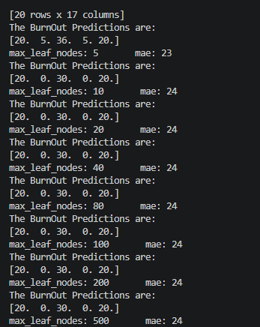
This is called the mae (mean absolute error) and It basically tells us how much our results can variate. It is up to us to decide “is this deviation acceptable?”. In the previous image we can see our mae is around 24 but we can see that if we reduce the lead modules we use, which basically means how many ramifications we want in our tree model, we can reduce that number. We can se that 5 is the lesser number with 23 mae, it is closer to our expected results, so we use it as our reference point. It is the lesser now but it could be more than we need, overfitting.

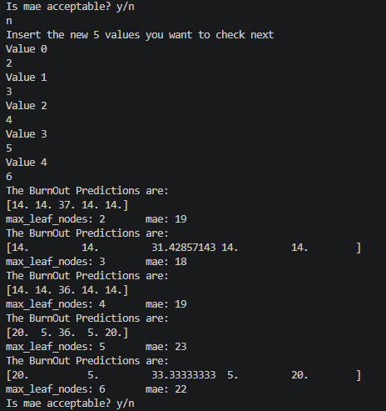
As we suspected 5 is overfitting as lesser numbers give us more precise results but as we can see 2 (The minimum leaf models number) is actually underfitting because it gave us a higher error rate this would mean that 3 leaf modes are our perfect point but there is something we are not taking into account. This is just one tree model and is pretty linear. But we can do something, we can run a lot of DessionTreeRegresors and and get the mean of those DTR, that is called a RandomForestRegressor.
import pandas as pd
from sklearn.metrics import mean_absolute_error as MAE
from sklearn.model_selection import train_test_split as TTS
from sklearn.ensemble import RandomForestRegressor

def Get_Mae(max_leafs):

train_X,val_X,train_y,val_y=TTS(X,y,random_state=1)

Utr_Burnout_Model=RandomForestRegressor(max_leaf_nodes=max_leafs,random_state=1)

By changing that part of the code, we can start using an RFR and get a different mae.
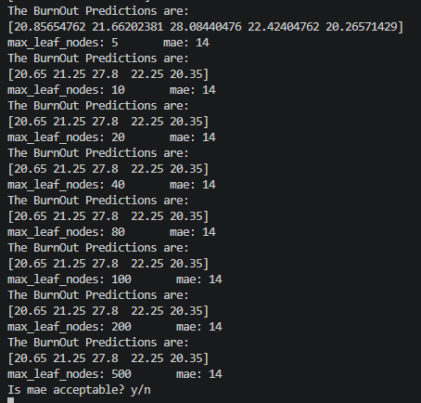
As we can see without having to manually search for the max leaf node our results are more precise going down to 14.
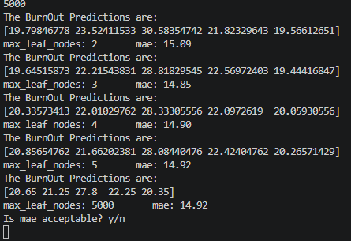
If we do the same we did with the DTR and enable floats we will se that 3 is still our balance point but with this model our results will only have a 14,85 deviation.
Now in my opinion this is a hug deviation for predicting burnout in students if it fails up, we could not be pushing them enough to their max capacities but in the other hand if it fails down, we could be forcing a lot of students into burnout. So, we could change the model again in order to find the one that gives us the best results, or as our data is limited as only 19 rows, we could extend our sample space to train these models again now with more data available.

Conclusions
This project taught me how to use machine learning to predict values using certain conditions. Using panda and scikit-learn I learned how to train a model in order to get the results I want and how to validate the results I got. I now understand a little how modern AI models may operate behind using many machine learning models. I learned concepts like overfitting and underfitting and how they can affect my results even if they look like they won’t, also this waked up a desire for try and use machine learning in some of my personal life aspects.

