|  |  |  |  |  |  |  |  |
| --- | --- | --- | --- | --- | --- | --- | --- |
| Submission Coversheet (All Programmes) | | | |  |  |  |  |
|  |  |  |  |  |  |  |  |
| **Student ID Number**  *(Do not include student name as anonymous marking is implemented)* | KOK17441521 | | | | | | |
| **Programme Title** | Computing Technologies BSc Extended | | | | | | |
| **Module Title** | Foundations in Programming | | | | | | |
| **Module Code** *(listed on Moodle and in LTAFP)* | QAC020B021S | | | | | | |
| **Module Convenor** | Asim Majeed | | | | | | |
| **Coursework Title** | Assignment 2 – Library Management System | | | | | | |
| **Academic Declaration:**  *Students are reminded that the electronic copy of their essay may be checked, at any point during their degree, with Turnitin or other plagiarism detection software for plagiarised material.* | | | | | | | |
| **Word Count** | Total: 2280  Q2:973 | | | **Date Submitted** | | 23/4/18 | |
|  |  | | |  | |  | |
| Please save your file as:  student id_module code_module_title_assessment name  for example: COR15416549_QAB020N592S_Managing Organisations)_Essay 1 Teamwork | | | | | | | |

**Question 1.**

**Library Management System**

It seems fair to say that most of libraries are facing impact of advancing technology and computerization of human and paper powered systems is a necessity.

The aim of this work is to develop library management system using Visual Basic .NET programming language. System should:

* provide an option to lease or return a book depending upon availability
* keep the record of leased books,
* provide option to list the collection filtered by lease state.

INITIALISATION

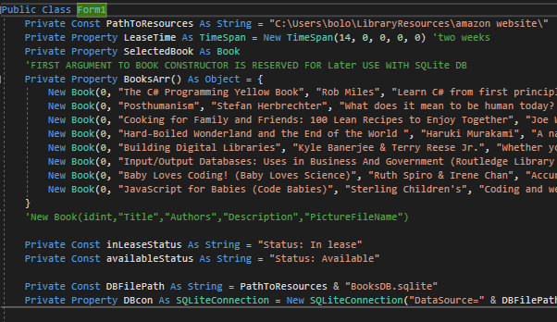

Figure 1a. Preparation of properties.

During Initialisation helper properties are declared, letting to abstract from hard-coded values in main logic code. Properties include:

* path pointing to location where pictures and SQLite Database are stored,
* default lease time for book,
* initial example Array of **Book** instances.

1.Book Class declaration. (Figure 1b)

All properties of a book are provided as constructor arguments, except **isLeased** **Boolean**, describing the lease state of the particular book, defaulting to false, and being changed only during Database reading operations or leasing/returning the book. IComparable interface has been implemented to allow sort books alphabetically. **LeaseBook(DateOfReturn)** and **ReturnBook()** methods provide safe interface for changing the value of its lease state.

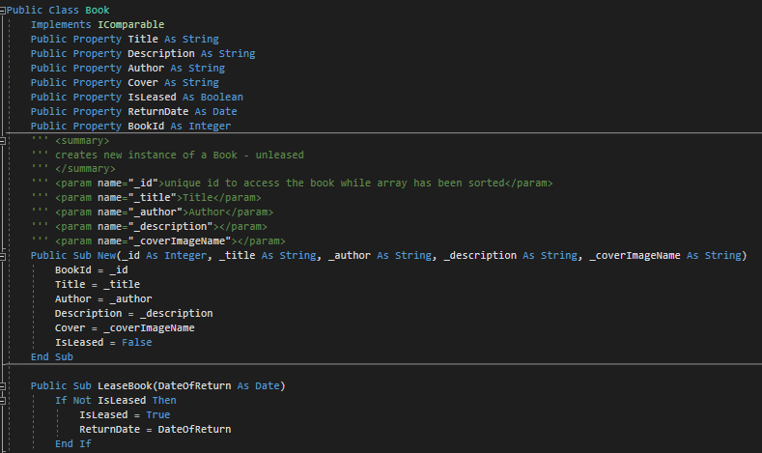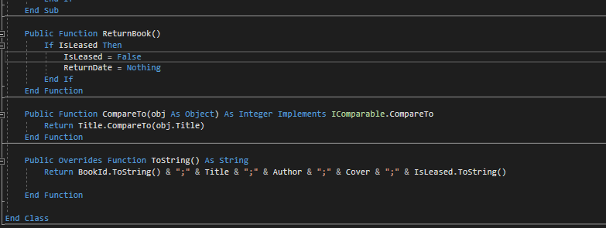

Figure 1b. Book Class declaration.

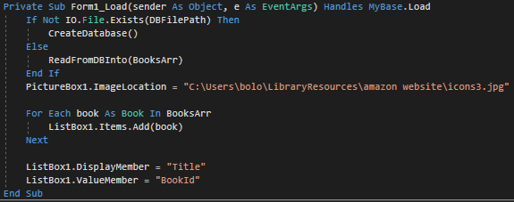

Figure 2. Load event – recovering stored data and populating ListBox .

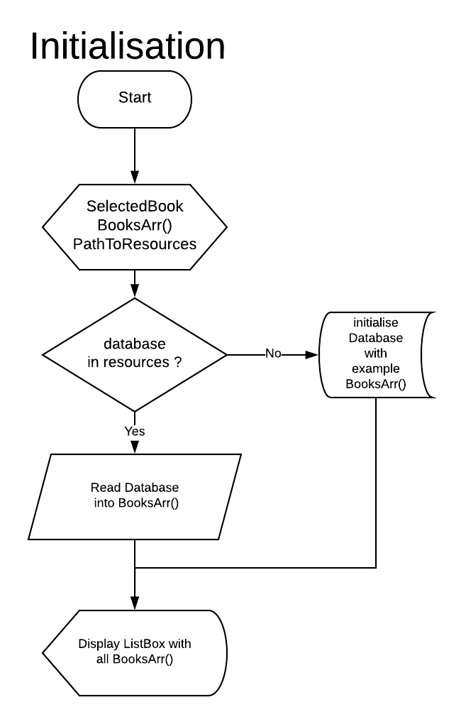

Figure 2b. Load event procedure - flowchart.

Initialisation (Figures 2 & 2b) checks for existing database or creates one from example data hard-coded in **BookArr()** declaration.

Functions **CreateDatabase()** and **ReadFromDBinto(array)** contain abstracted details of connecting with SQLite Database, which are beyond the requirements of this assignment, and were exercised only to develop better understanding of professional approach to library system management, and will be briefly addressed at the end. Default picture is being displayed, and Listbox filled with contents of BookArr() in foreach loop.ListBox1.DisplayMember is set to display titles of books.

Next, depending which action user has taken, following procedures are being executed:

BOOK SELECTION

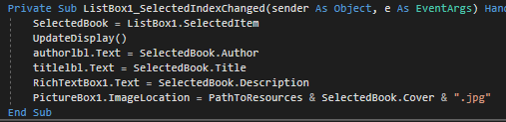

Figure 3.SelectedIndexChanged event handler.

Books can be selected in two ways, by clicking the desired title on the **ListBox** or pressing the *next/previous (“<<”,”>>”)* buttons. The latter performs operation on **ListBox.SelectedIndex** property which in turn results in an **SelectedIndexChanged** event invoking the selection procedure described in section 1. This approach allowes to reduce amount of cryptic code ,repetitive **if**-statements and organise code in atomized and transparent manner. Any other procedures use **SelectedBook** property referring to currently selected **Book** object stored in the **BooksArr** array.

1.Direct Book Selection

Direct book selection occurs when user clicks on the title displayed in the ListBox resulting in **SelectedIndexChanged** event, handled by function that stores the reference to the object in the **SelectedBook** property (Figure 3). Appropriate textboxes are filled with corresponding values of a selected book. **PictureBox1.ImageLocation** is set to string path to picture expressed as concatenation of base path, cover file name reference, and extension.

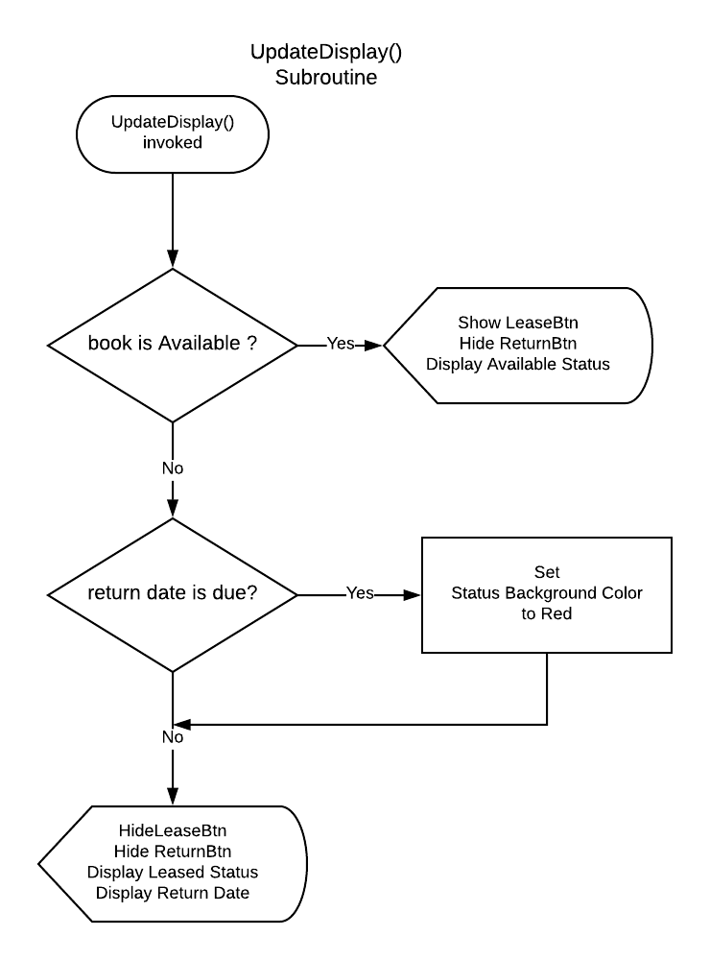

Figure 4a. UpdateDisplay Subroutine - flowchart.

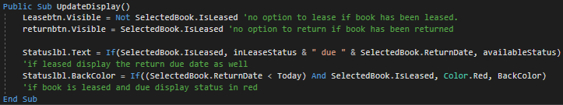

**UpdateDisplay** subroutine (Figures 4a & 4b.) factors out the code responsible for updating only the controls that change depending on book lease state. *Lease* button is displayed only when book is available to lease and vice versa, by simply assigning logical **NOT** of book’s **Boolean** lease state to visibility of *Lease* Button. Equally, the return button visibility is directly dependent on the same value. This way allows to achieve instant user feedback, expanded on in second part of assignment. The ternary expression has been used, assigning the value in declarative-like manner on the basis of Boolean value of condition - arithmetic comparison between the Date type and **Today** variable. **Today** is the automatic variable returning the current system time in the format of **Date** Type, used here to decide if the book has been kept above the permissible limit. Figures 4 and 5 present the GUI in these cases. The return date is displayed, along the status, and if return date is due, status is highlighted red.(Figure 6).

Figure 4b. Update Display subroutine – Source code.

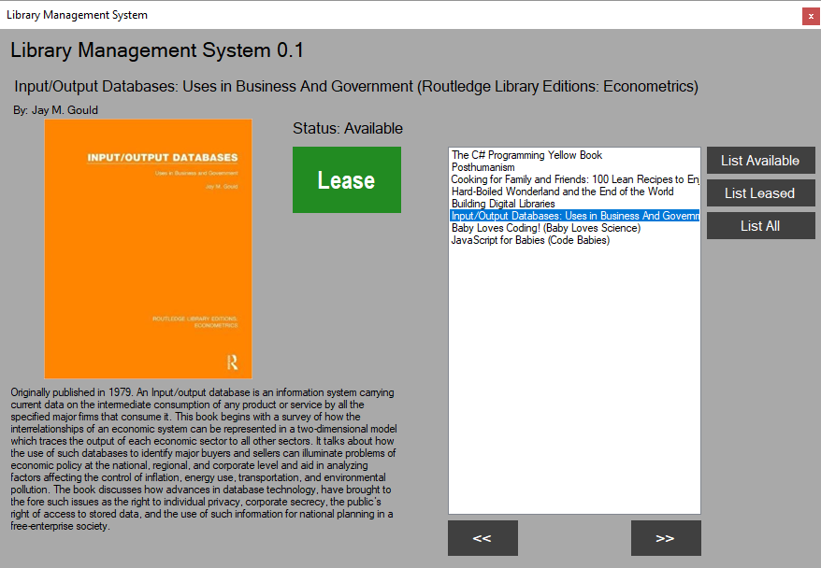

Figure 5.Example of interface. Book is Available To Lease.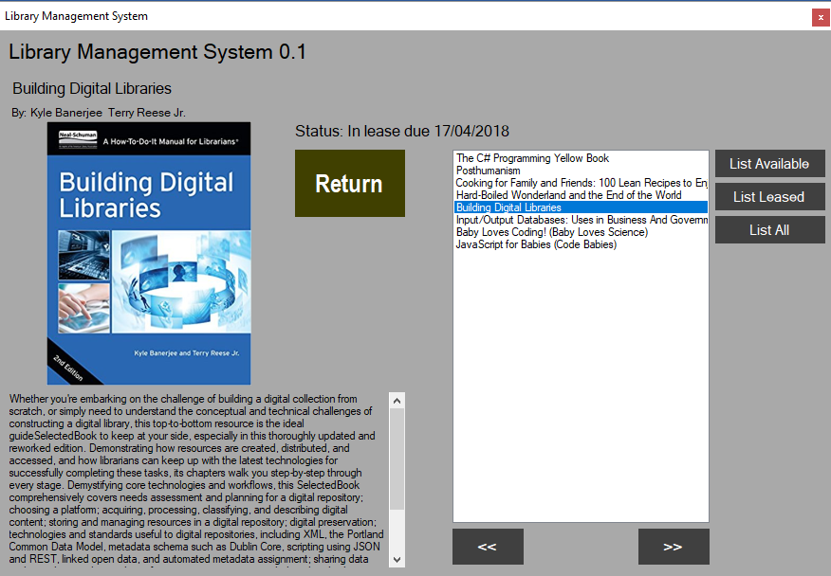

Figure 6. Example of interface- Book is Leased.

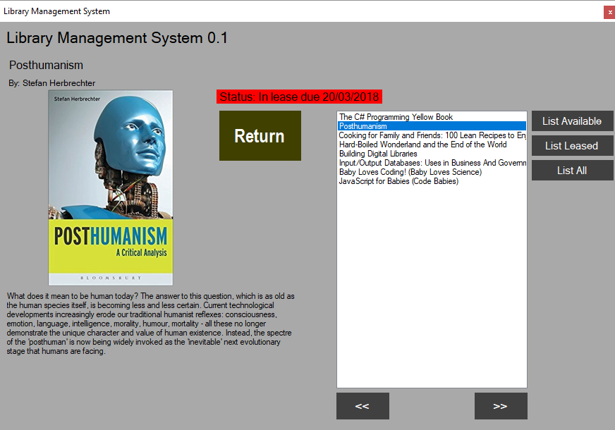

Figure 7. Example of interface - Book is due.

2.Selection by Next/Previous buttons.

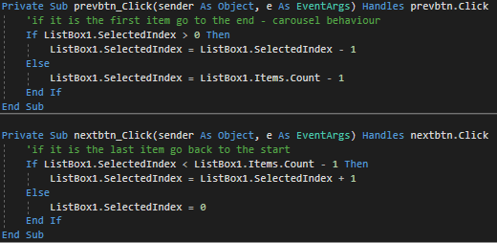

Figure 8a. Next/Previous Book button handlers.

Buttons simply change the **SelectedIndex** property of **ListBox** and provide cyclical behaviour of list. Clicking the Next button while on last book, user selects the first book in the list. Comparing the current index with zero, and index of last element we can determine moment when user reaches the start/end of the list. Flowchart on figure 8b describes simple logic of source code from Figure 8a.

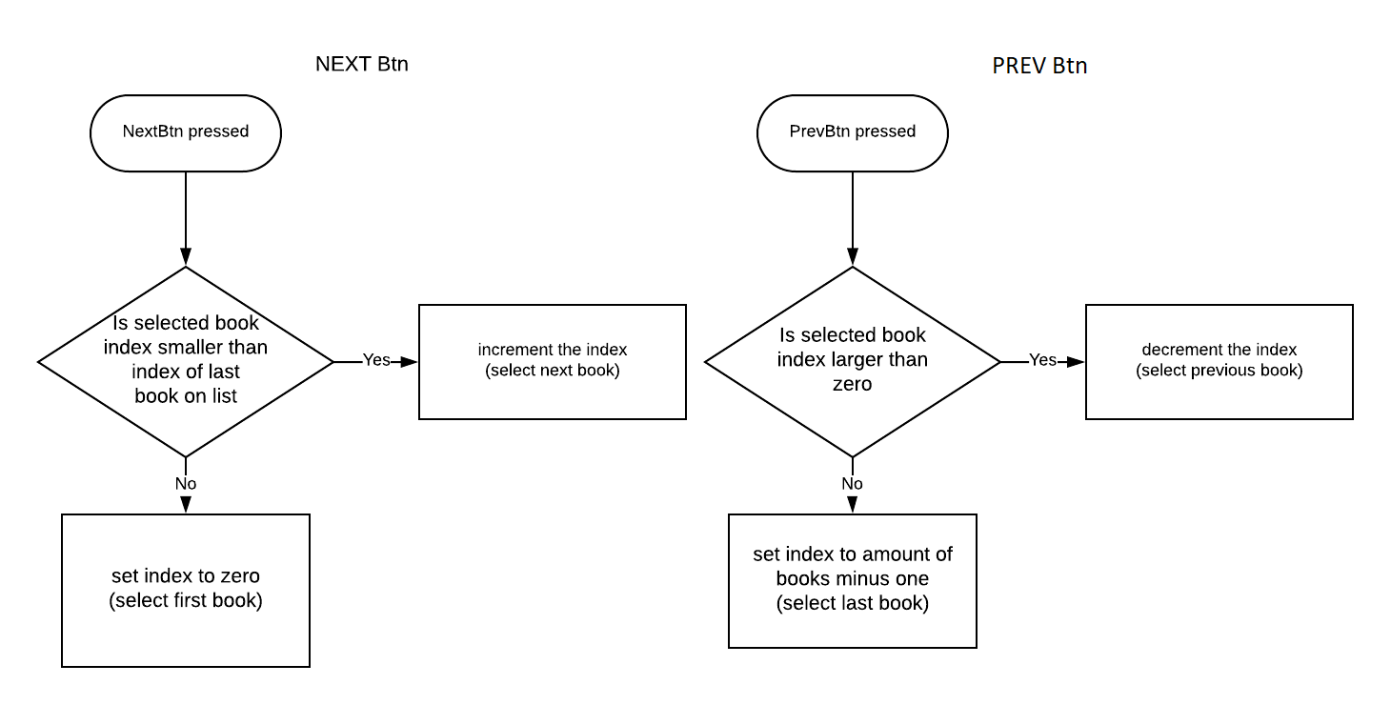

Figure 8b. Next/Previous Book button handlers

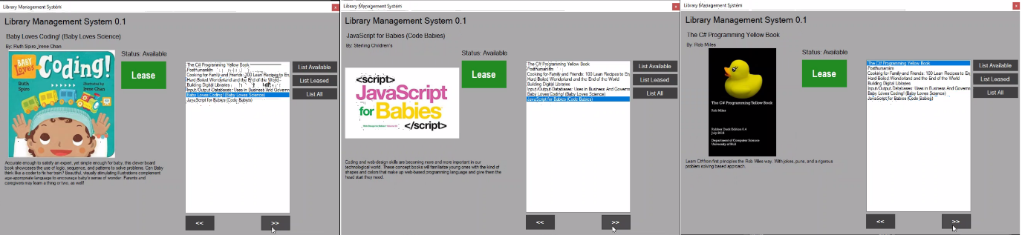

Figure 9a. Result of consecutive clicks on next book button.

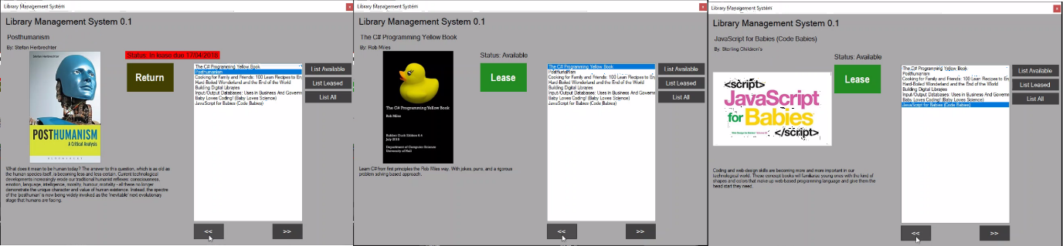

Figure 9b. Result of consecutive clicks on previous book button.

Figures 9a and 9b present the user interface while performing selection with this method. Notice the behaviour of **PictureBox** with **SizeMode** set to **Zoom**, where book covers maintain original aspect while user interface layout remains unchanged.

LEASING/RETURNING BOOK

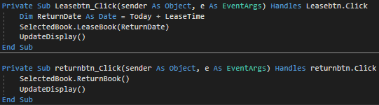

Figure 9. Lease/Return Buttons handlers

Complete Logic for ensuring the validity of book’s lease state is hidden away in **LeaseBook** method of **Book** object, declaration of which is displayed on figure 1b, and simply prevents book from being leased/returned twice in a row; However, since interface itself does not allow for this to happen its function will be useful only in case of **Book** class being reused in different projects. The flowchart for controlling visibility/accessibility of these options is already covered on Figure 4a.

The **Book** object stores the return due date in its **Book.ReturnDate** field to be accessible for database write/read functions, and for **UpdateDisplay** subroutine, where it is being accessed and displayed to the user. Display is updated to provide graphical response on user action. The *Lease* button disappears and the return button is displayed along with the return date.

FILTERED LISTING

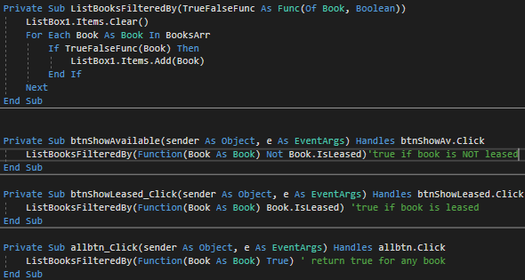

Figure 10. Listing subroutine and click event handlers.

*List All*, *List Available* and *List Leased* Buttons allow user to filter displayed books list by their lease state. It is achieved by looping through array of books and adding the object reference to list if condition provided is true. Looping logic is extracted into a subroutine, accepting delegate function as a parameter. The delegate function is declared to behave as a filter, accepting **Book** object and returning a **Boolean** that indicates whether the book object should be displayed in the **ListBox**. This approach opens future possibilities for querying the book collection against different conditions - specifying author, title or any other condition while abstracting from looping mechanism. Following figures present the graphical interface while choosing above options.

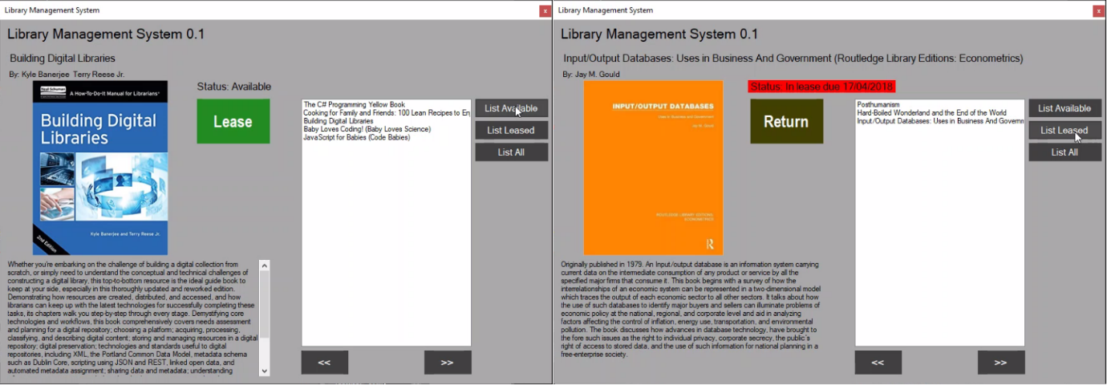

Figure 11. GUI - listing available books (left), and leased books (right).

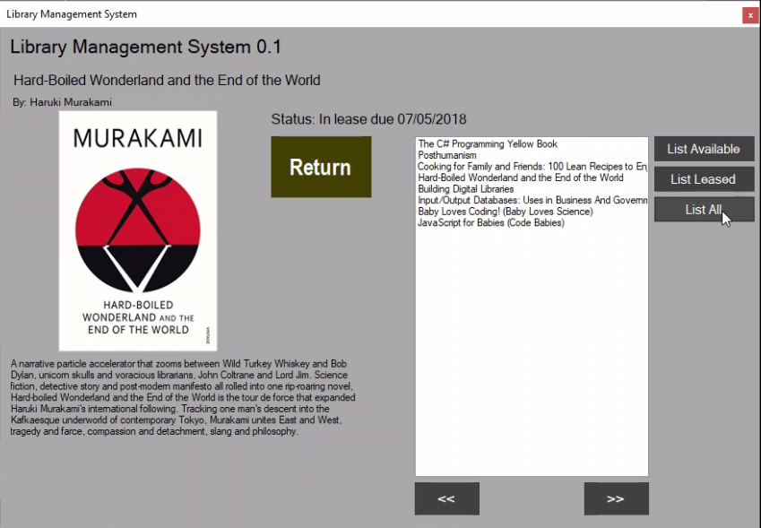

Figure 12.GUI - result of pressing List All button.

RESOURCES FOLDER AND SQLITE DATABASE

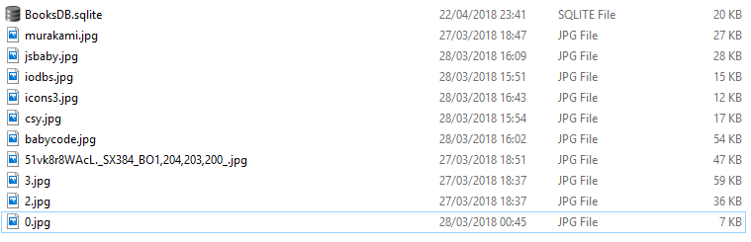

Figure 13. Files in PathToResources Folder.

Functions **CreateDatabase()** and **ReadFromDBinto(array),** mentioned in the Initialisation section of this work , and **SaveLeaseState()** function operate on SQLite database and provide convenient way to store and retrieve the data of book collection. As this functionality is not a requirement of an assignment they were separated and moved into functions; However, accessing SQL results requires accessing the results array by numerical indexes through diverse SQLiteResult.GetValue methods. The source-code for mentioned functions follows:

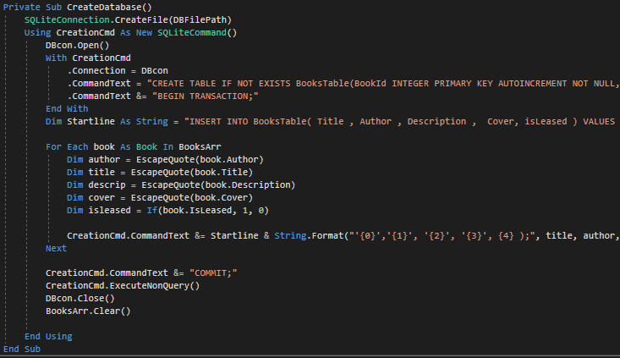

Figure 14. Creating Database file and a table from data in BookArr()

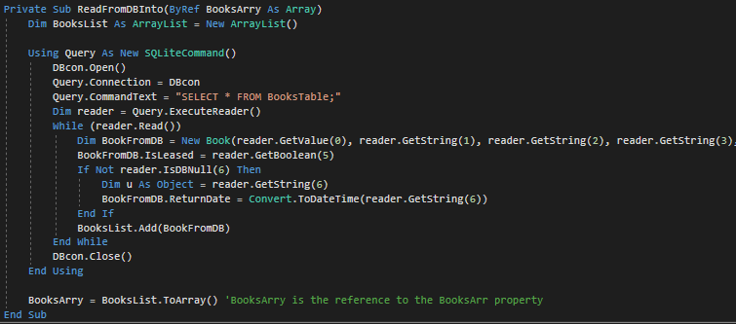

Figure 15. Reading data from database into Array

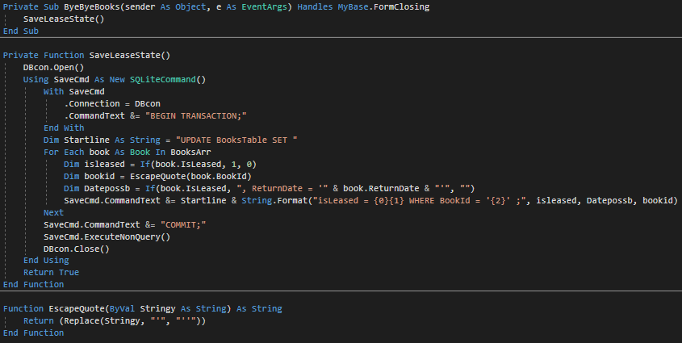

Figure 16.FormClosing event handler, function saving data to SQLite file, and function escaping SQLite single quotes.

**Question 2. Self-reflective commentary.**

The main struggle while programming an application regards the conflict between will to explore the possibilities of the language, expanding my knowledge about programming paradigms, and keeping the source code simple and proving the required knowledge. Even though having advantage of basic knowledge about classes, functional orientation and encapsulation, i attempted to store each property of a book in separate arrays to follow usage of arrays indicated in requirements. Data was contained in Arrays of Strings for Title, Description, Author, and picture Image Name, and array of Booleans for lease statuses. It proved soon to be tedious and prone to errors as indexes of separate arrays were not matching while operating on **ListBox** displayed values. Due to that displaying list of books filtered by lease status became very complex task, requiring checking the index of a title in array, then using it to retrieve remaining properties. Accessing data this way was cryptic, and affected code readability. Especially the state of lease status of the book was hard to maintain across separate arrays. Since my main goal was to abstract from hard-coded values and multiple if statements, I decided to research on creating data structures in VB or classes that would allow me to write less verbose, more elegant and clearer code, creating fields with separate Data Types (String, Int32, Boolean, Date), distinctive names, and addressing them in more human readable way. The usage of Array datatype was then reduced to role of containing references to Book objects, and significantly simplified the logic of filtering list of books. It let me refactor code around references to these objects, and addressing the selected index property only in ListBox1.selectedindexchanged event handler. Altogether, it made code requiring less additional comments, and easier to read. Conversely, it moved me away from practising low-level technical aspects of accessing arrays using indexes.

Researching on features of **ListBox** I discovered that **ListBox.items** member can be collection of any objects, and **ListBox** control offers possibility to represent object references stored in its collection through its **Listbox.DisplayMember** property (MSDN, 2018a). Discovering these facts let me to focus on creating my own data structure - Book that would be represented by its Title field using **DisplayMember** functionality, thus organising my code in more comprehensible way, around collection of Book objects, what opened future possibilities to develop the project into much more flexible system and made operations on behaviour of controls easier to implement. Following Assignment requirement I made options to Lease book/Return book unavailable accordingly setting the **button.Visible** property. This reduces the time that user spends on achieving the information about the lease state of the book, and constrains the decisions to only valid options. (Amant, 2000). In Other words, user do not need to click on the *Lease* button in order to learn that it is already leased, and vice Versa, if this is the case. This simplifies both the controls layout and flow control. The downside of the approach may become apparent in case when lease state would not be of Boolean nature, for instance when the book is in the stock, but cannot be leased for some specific reason, or case when we would like to store amount of times when the book lease has been extended.

User interface implementation required research around **PictureBox** form control, and many other style properties of controls explained in Microsoft Developers Network(2018b) documentation. Coming from web development background I put more attention to graphical user interface, and decided to make it appealing, simple and modern. For instance, using Zoom value on **PictureBox.SizeMode** allowed me to retain shape of the control, regardless of displayed picture size. For testing purposes, I used various book cover shapes of non-standard aspect ratio. Coding carousel behaviour on items list, when *“next book”* or *“previous book”* buttons are clicked, helps users to maintain uninterrupted experience.

Approaching to the final form of the application I had to constantly constrain myself, to not start implementing new features, and focus on main requirements of the assignment. Brown et al. (1998) and Prabhakar (2008) identified this problem, commonly referred as “Feature Creep” in software development literature. As my knowledge about programming exceeds requirements of current year, the passion to learn about programming stays in conflict with keeping the implementation easy to explain and keeping the extra features not shadowing the substantial requirements which marking criteria are based on. One of results of mentioned issue was implementing the SQL database connection to store book collection and its state between sessions. While helping me with understanding some of the core concepts, and use index based array access, It required me to decouple it and factor out of main logic in the final version making me spend time on implementation details of feature that is not attributing to the goal.

I am overall satisfied from progress I made during this assignment. The conflict between exploration of language features and maintaining the code complexity led to positive outcome, enforcing me to learn how to abstract from implementation details. Additionally, having encountered numerous methods and language features, for instance **IComparable** implementation on book objects, “**with**” and “**using**” expressions or delegate lambda functions, kept me enjoyed and motivated during programming. Still, there are certain aspects that could be implemented in a more professional manner, leaving room for further improvement of my programming skills. I didn’t succeed in achieving the effect of books disappearing from the list when clicked, as I was trying to avoid repeating refreshing the view and looping through array each time. I struggled with this concept until colleague explained to me his use of two **ListBoxes**. Such approach or making use of **ListBox.DataSource** property (MSDN, 2018c) could save a lot of unnecessary memory operations. It proves that my problem-solving skills and documentation research could improve, and often simplest and most elegant solution requires thinking out of the (List)Box.

REFERENCES:

* Amant, St. R. (2000) *Real-World Examples for HCI Instruction.* Available At: <https://pdfs.semanticscholar.org/b6a6/de7ed2f61753a80add12354d56aaa967bdb4.pdf>(Accessed:3/4/18)
* Brown, W. J. , Malveau R. C., McCormick III, H. W., Mowbray , T.J. (1998) *AntiPatterns: Refactoring Software, Architectures, and Projects in Crisis.* New York: John Wiley & Sons, Inc.
* MSDN Microsoft Developer Network(2018a) *ListControl.DisplayMember Property.* Available At: <https://msdn.microsoft.com/en-us/library/system.windows.forms.listcontrol.displaymember(v=vs.110).aspx> (Accessed:3/4/18)
* MSDN Microsoft Developer Network(2018b) *System.Windows.Forms Namespace.* Available At: <https://msdn.microsoft.com/en-us/library/system.windows.forms(v=vs.110).aspx> (Accessed:3/4/18)
* MSDN Microsoft Developer Network(2018c) *ListControl.DataSource Property* Available At: https://msdn.microsoft.com/en-us/library/system.windows.forms.listcontrol.datasource(v=vs.110).aspx (Accessed:3/4/18)
* Prabhakar, G. P. (2008) Scope creep in software development*. Journal of Social Management* 6(1) pp.45-59. Available At: https://www.researchgate.net/publication/281743773 (Accessed: 3/4/18)