ASSIGNMENT 4

Osmond Oke

2010-06-20

# Markdown Basics

## Favorite Foods.

* Chicken Wings
* Plantain
* Fried Rice

## Images

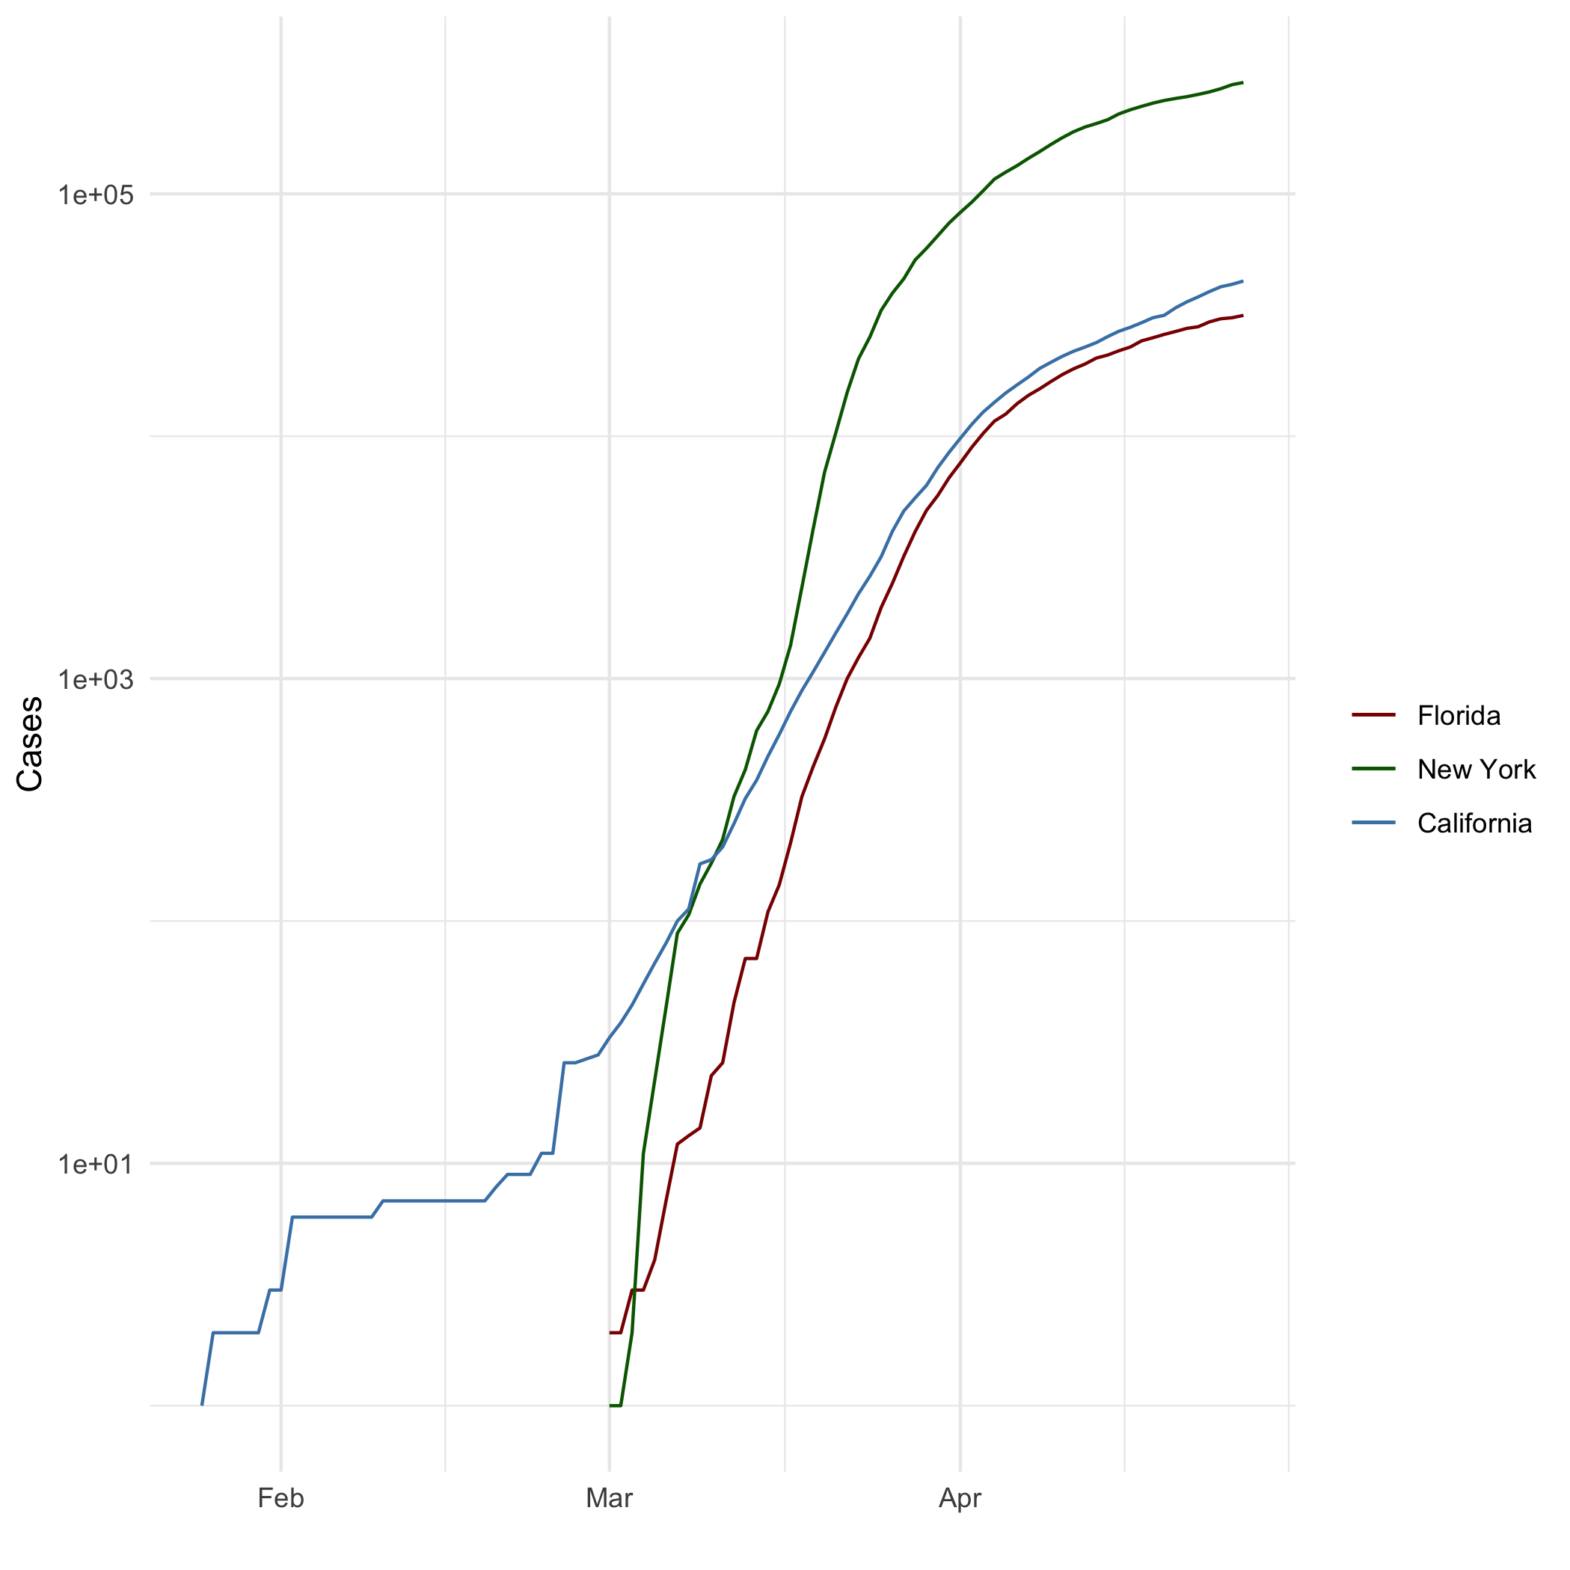

All Cases Log Plot

## Add a Quote

“To understand reporting is to understand R Markdown, but to understand R Markdown is not to understand Reporting”

## Add an Equation

$$\sum_{n=1}^{10}{n^{2}}$$

Lander (2014)

## Add a Footnote

[1]

## Add Citations

* R for Everyone
* Discovering Statistics Using R

# Inline Code

## NY Times COVID-19 Data

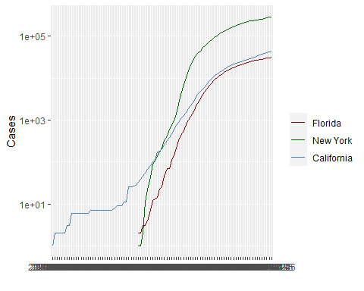

## R4DS Height vs Earnings

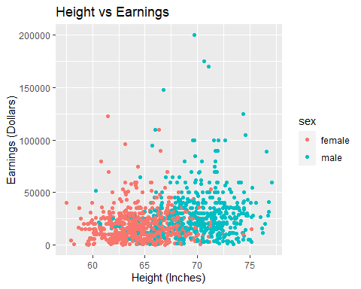

# Tables

## Knitr Table with Kable

One Ring to Rule Them All

|  |  |  |  |  |
| --- | --- | --- | --- | --- |
| name | race | in_fellowship | ring_bearer | age |
| Aragon | Men | TRUE | FALSE | 88 |
| Bilbo | Hobbit | FALSE | TRUE | 129 |
| Frodo | Hobbit | TRUE | TRUE | 51 |
| Galadriel | Elf | FALSE | FALSE | 7000 |
| Sam | Hobbit | TRUE | TRUE | 36 |
| Gandalf | Maia | TRUE | TRUE | 2019 |

## Pandoc Table

##   
##   
## +--------+--------+--------+---------------+-------------+------+  
## | &nbsp; | Name | Race | In Fellowship | Ring Bearer | Age |  
## +========+========+========+===============+=============+======+  
## | **1** | Aragon | Men | TRUE | FALSE | 88 |  
## +--------+--------+--------+---------------+-------------+------+  
## | **2** | Bilbo | Hobbit | FALSE | TRUE | 129 |  
## +--------+--------+--------+---------------+-------------+------+  
## | **3** | Frodo | Hobbit | TRUE | TRUE | 51 |  
## +--------+--------+--------+---------------+-------------+------+  
## | **5** | Sam | Hobbit | TRUE | TRUE | 36 |  
## +--------+--------+--------+---------------+-------------+------+  
## | **8** | Sauron | Maia | FALSE | TRUE | 7052 |  
## +--------+--------+--------+---------------+-------------+------+  
##   
## Table: One Ring to Rule them all

# References

Lander (2014) Field, Miles, and Field (2012)

Field, A., J. Miles, and Z. Field. 2012. *Discovering Statistics Using R*. SAGE Publications. <https://books.google.com/books?id=wd2K2zC3swIC>.

Lander, J. P. 2014. *R for Everyone: Advanced Analytics and Graphics*. Addison-Wesley Data and Analytics Series. Addison-Wesley. <https://books.google.com/books?id=3eBVAgAAQBAJ>.

1. This is a footnote by Osmond Oke