**OSMOSE Database – Technical Manual**







|  |  |
| --- | --- |
| Document Owners | Liudmila Dobriakova [RPLY] |
| Contributors |  |
| Dissemination | Public |
| Date | 30/08/2016 |
| Version | 1.0 |

Table of Contents

1 DB Introduction 3

1.1 Overview 3

1.2 DB Architecture 4

1.3 Licensing 5

# DB Introduction

To take care about backend it is always necessary to store and manipulate some amount of the data.

For this scope the database management system usually used, that is a software application which interacts with the rest of the system to capture the data.

At this moment the relational model of the database is the most poular and supported by all OS and application servers and represented by SQL language.

For the OSMOSE project to provide the backend the mySQL DB have been chosed as a free and open source SW, providing multi-threaded, multi-user database server.

## Overview

Detailed information about the mySQL DB server installation and configuration could be found in the official page on the URL: http:// <http://dev.mysql.com/>. Here we just provide some basic information about how this software have been used for the OSMOSE project.

The Virtual Machine provided by image contain already installed mySQL server with the Database populated with the tables with some data. Services provided by the project are publishing the data to the tables for the further quering and visualizing of this data by the Stargate user interface.

In case of necessity, the new installation of the mySQL server could be done following these commands for the unix OS:

$ sudo apt-get install mysql-server

For our server we used root/root credentials.

To start the server engine on the Ubuntu OS execute the following command from the terminal:

$ sudo /etc/init.d/mysql start

To access the DB and tables execute the following command:

$ sudo mysql -p osmose_service_svil

The mySQL prompt will appear and the query could be executed, for instance to get the list of the tables populated into the DB the following command could be executed:

> SHOW TABLES;

The advantadge of the MySQL server is what the clients can connect to it using several protocols and can be written in many languages. There are API for Java clint program that use JDBC connections, which have been used to populate the data for the OSMOSE platform.

There is also Graphical user interfaces available to simplify work for the database development, for instance MySQL Workbench.

Schema to populate the tables and some initial data could be found in the GitHub repository on the URL:

## DB Architecture

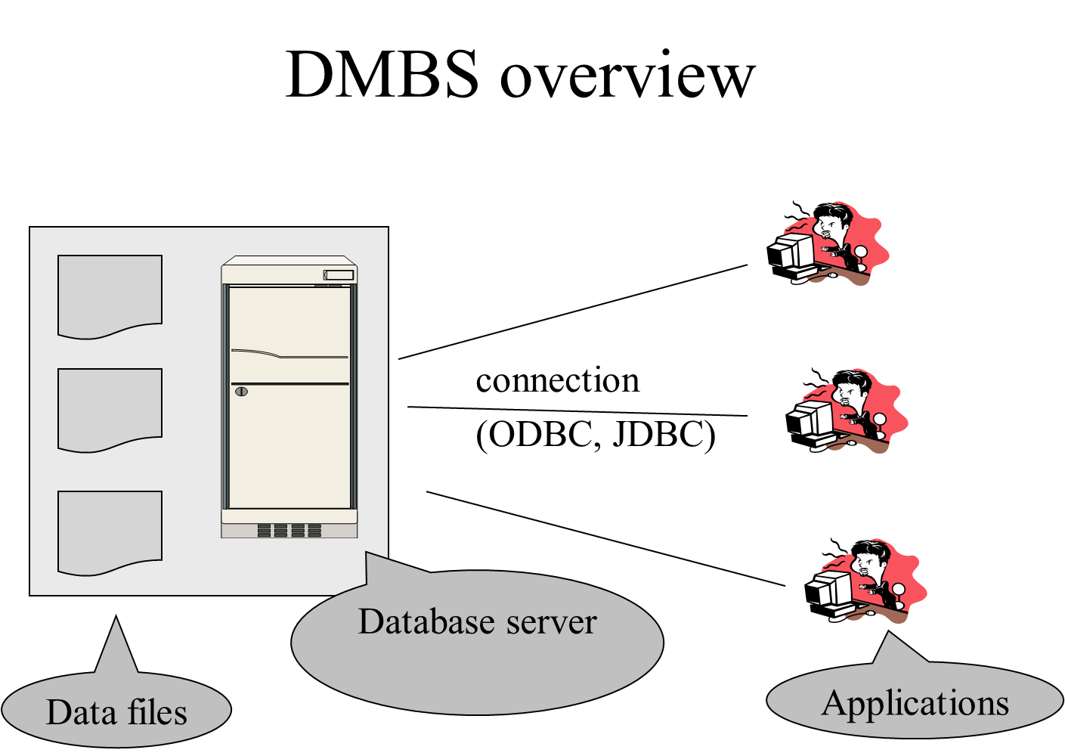

Figure 1 – the overview of the DBMS system

The DB structure is presented in the picture below:

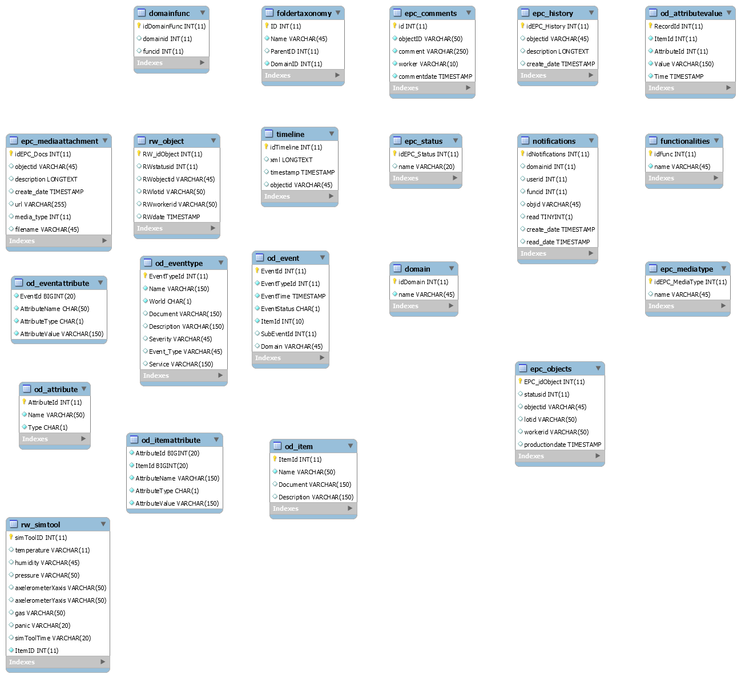

Figure 2 – the DB EPR diagram

## Licensing

The MySQL software is Dual Licensed. Users can choose to use the MySQL software as an Open Source product under the terms of the GNU General Public License (<http://www.fsf.org/licenses/>) or can purchase a standard commercial license from Oracle. See <http://www.mysql.com/company/legal/licensing/> for more information on our licensing policies.