**OSMOSE Database – User Manual**



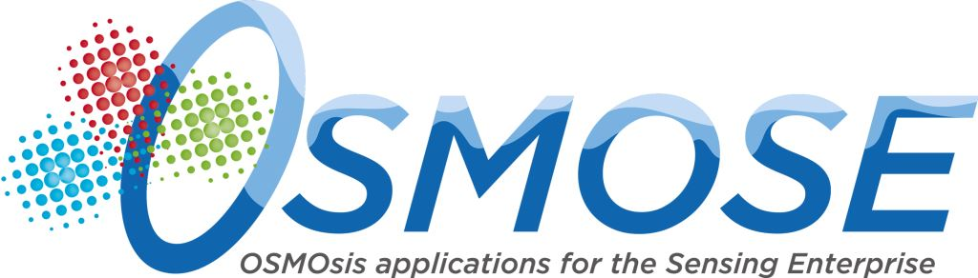



|  |  |
| --- | --- |
| Document Owners | Liudmila Dobriakova [RPLY] |
| Contributors |  |
| Dissemination | Public |
| Date | 30/08/2016 |
| Version | 1.0 |

Table of Contents

1.1 Introduction 3

1.2 Licensing 3

## Introduction

No user interaction should be performed with database. For this reason no user manual will be provided. All the transaction will be handled by backend services and User interfaces.

For the detailed information about the mySQL DB server please refer the official page on the URL: http:// <http://dev.mysql.com/>.

## Licensing

The MySQL software is Dual Licensed. Users can choose to use the MySQL software as an Open Source product under the terms of the GNU General Public License (<http://www.fsf.org/licenses/>) or can purchase a standard commercial license from Oracle. See <http://www.mysql.com/company/legal/licensing/> for more information on our licensing policies.