**Examination Report**

|  |  |
| --- | --- |
| Issue UID | {IssueUid} |
| Issue date | {IssueDate} |
| Pet owner | {PetOwner} |
| Pet name | {PetName} |
|  |  |
|  |  |

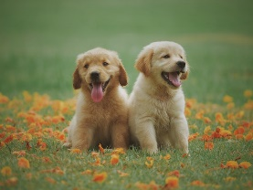 Animal Clinic

123 Veterinary Street, City, Country

|  |  |
| --- | --- |
| Weight (KG) | {PetWeight} |
| Temparature (°F) | {IssueDate} |
| Heart rate | {PetHeartRate} |
| Respiration rate | {PetRespirationRate} |

|  |  |
| --- | --- |
| Blood pressure (systolic) | {PetBpSys} |
| Blood pressure (diastolic) | {PetBpDia} |
| Capillary refill time | {PetCapilRefill} |
| Mucous membrane | {PetMucousMem} |

**Vitals**

|  |  |
| --- | --- |
| Historical | {PetExaminationHistorical} |
| Physical | {PetExaminationPhysical} |
| Clinical | {PetExaminationClinical} |
| Differential diagnosis | {PetExamincationDiffDiag} |
| Advice / Other comments | {PetExaminationAdvice} |
| Next visit | {PetExaminationNextVisit} |

**Examination**

**Prescription**

|  |  |  |  |
| --- | --- | --- | --- |
| **Item name** | **Quantity** | **Dosage** | **Precautions** |
| Consultation | 1 |  |  |