**DATABASE LAB MIDLAB TASK**

1. Describe salgrade

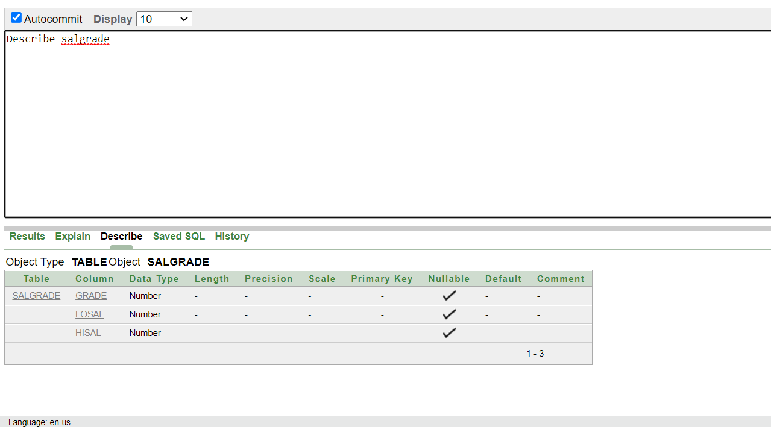

2. select deptno from dept

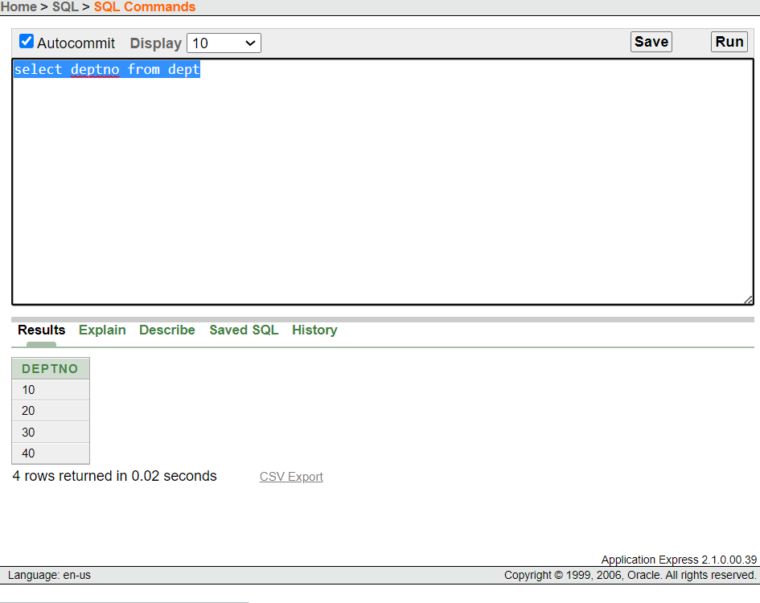

3. select ename,sal, sal+sal*0.05 as "5% INCREMENT" from emp;

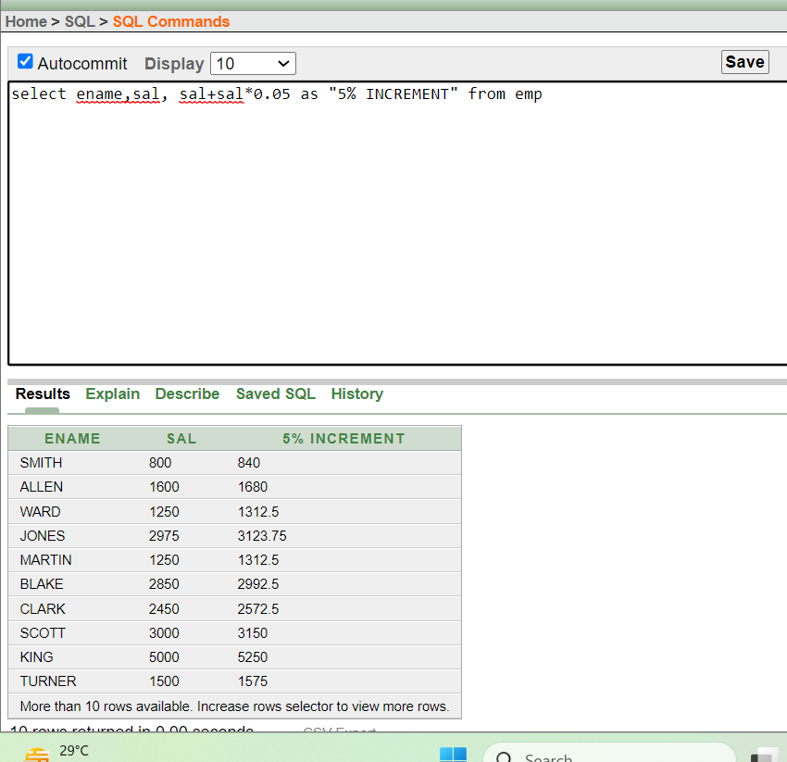

4. select sal+sal*0.05 as "NEW SALARY" from emp;

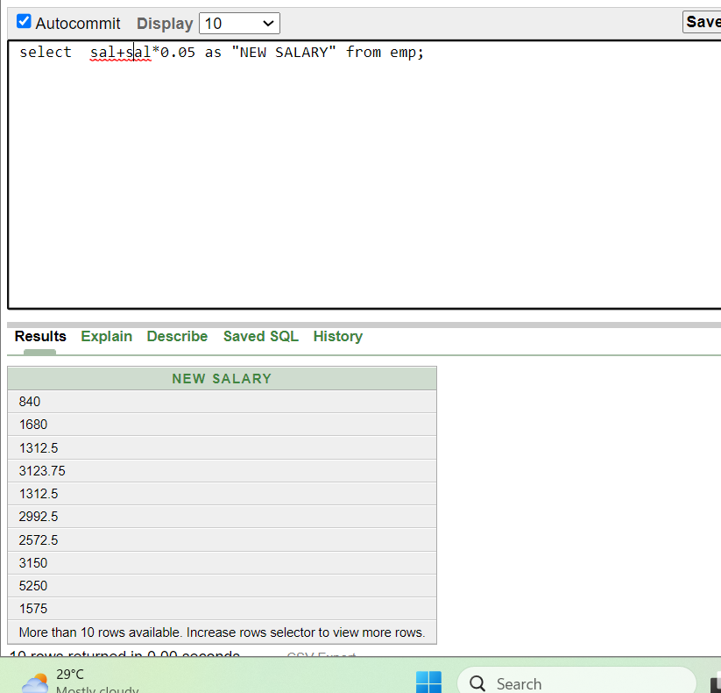

5. select * from emp where ename='BLAKE'

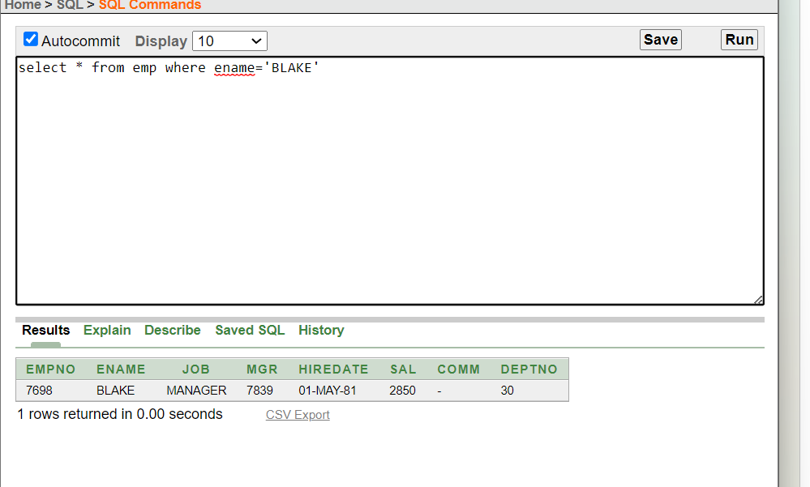

6. select ename||''||' is hired on '|| hiredate||' as a '||job as "EMPLOYEE DETAILS" from emp order by hiredate;

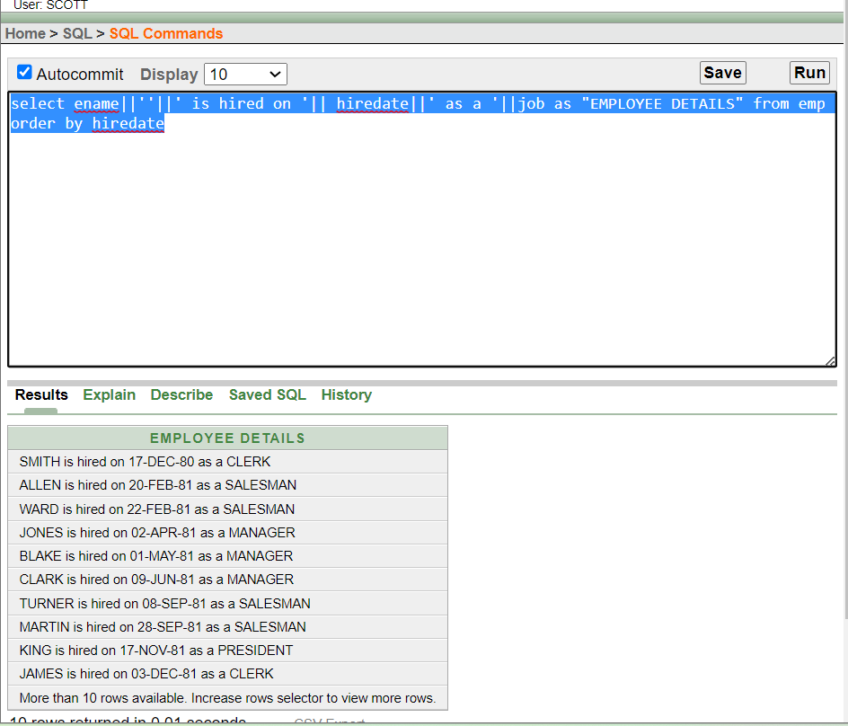

7.

1. describe emp
2. describe dept
3. describe salgrade

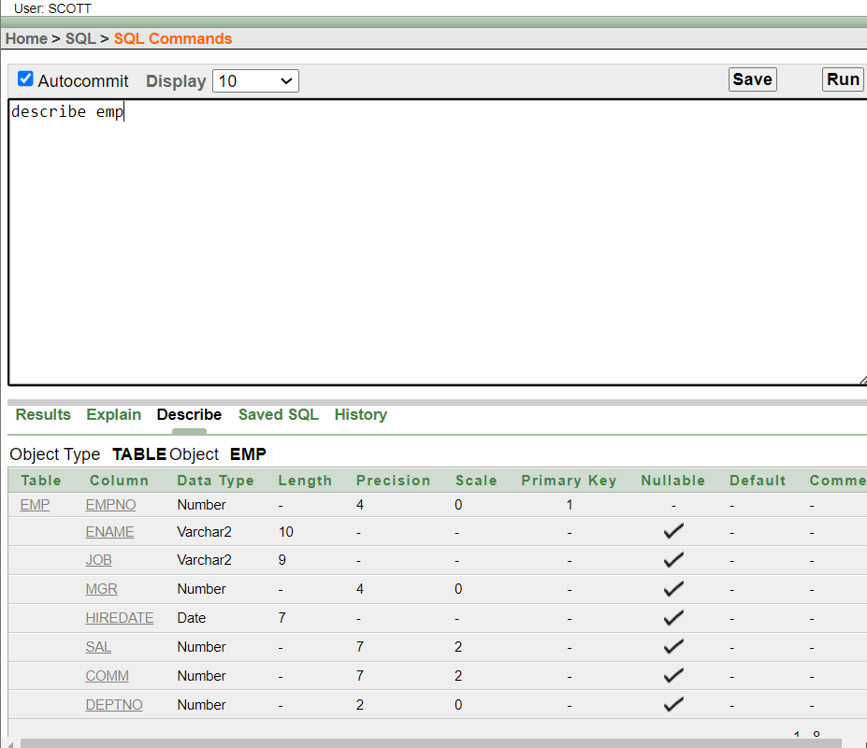

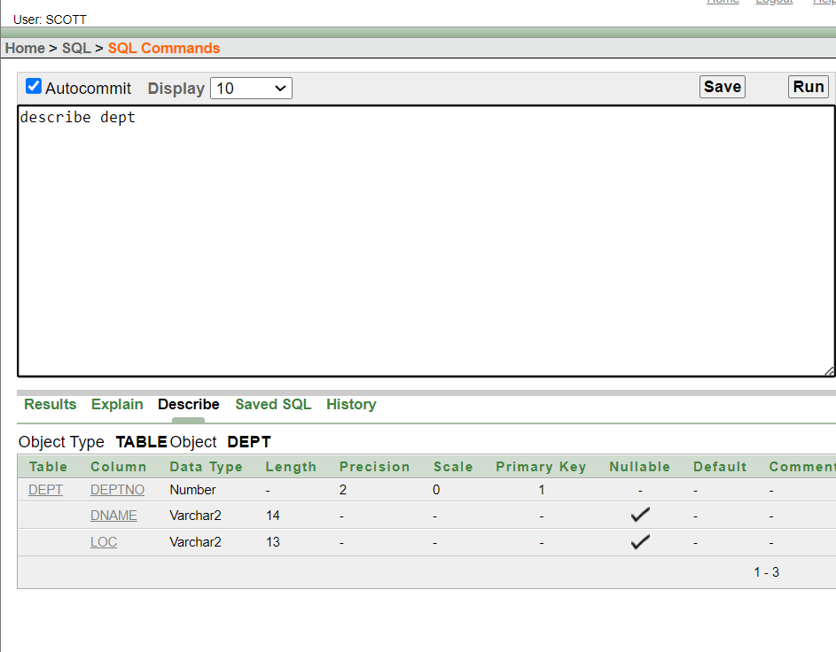

8. select distinct job from emp

