

Mastering Embedded System Online Diploma
- www.learn-in-depth.com

Project Number | First Term (Final Project 1 )
Project Name | Pressure Controller Project
Name | Osama Youssef Tawadrous
My Profile | https://www.learn-in-depth.com/online-diploma/osamayoussef996%40gmail.com

- Table Of Content :-
- Case study
- Requirement Diagram
- System Analysis
- Use Case Diagram
- Activity Diagram
- Sequence Diagram
- System Design
- Source and Header files with Block Diagrams
- Sections and symbols for object files
- Symbols for final executable file
- Readelf utility for final executable file
- The map file and symbols
- Simulation using Proteus

- Case study :

A ”client” expects you to deliver the software of the following system:
- Specification (from the client)
- A pressure controller informs the crew of a cabin with an alarm when the pressure exceeds 20 bars in the cabin.
- The alarm duration equals 60 seconds.
- Keep track of the measured values.

- Assumptions :
- The system setup and shutdown procedures
are not modeled.
- The system maintenance is not modeled.
- The pressure sensor never fails.
- The alarm never fails.
- The system never faces power cut.

- Requirement Diagram :

We will divide our case study to three main requirements
- High Pressure Detection Process .
- Inform The Crew at High Pressure Levels .
- Optional Storage of Pressure Readings .
Each main requirement has refinement requirements as
mentioned below .

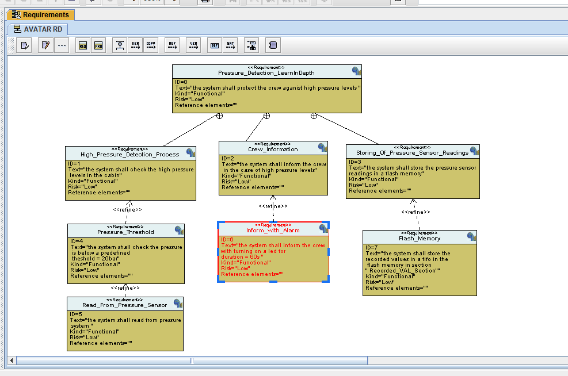

- System Analysis Diagram :

- Use Case Diagram :

In use case diagram , we discuss system boundary and main functions , so in our use case digram we will observe that our system boundary include the main function algorithm , Get pressure reading function and
display alarm function and exclude the pressure sensor
alarm actuator and flash memory for storing readings .

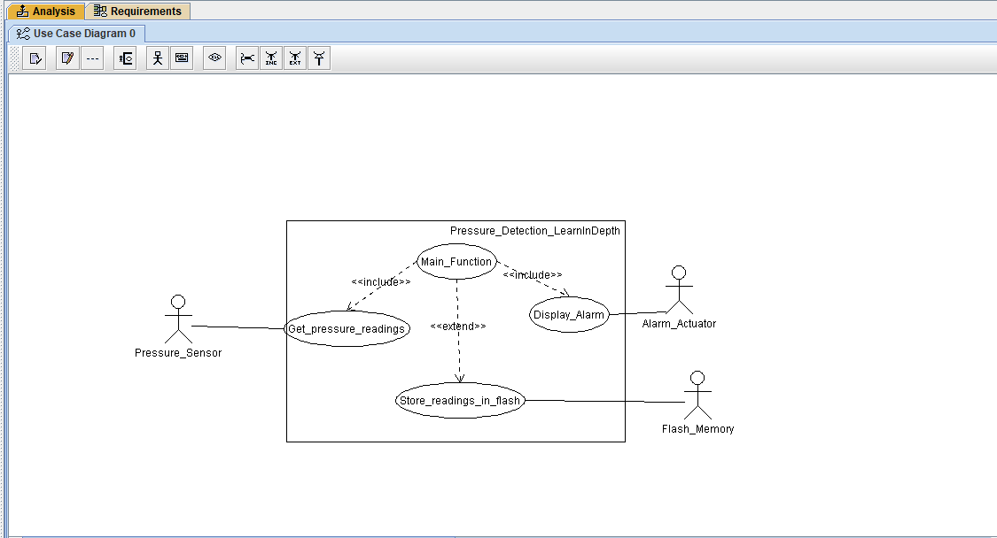

- Activity Diagram :

In Activity Diagram , we discuss relation between main
functions , as shown below , firstly we will read the
pressure value and then store it in flash memory , after
that we compare the value of pressure with threshold in
case study , if it exceeded this value we will turn on the
alarm for 60 seconds to inform the crew that the pressure
exceeded the threshold .

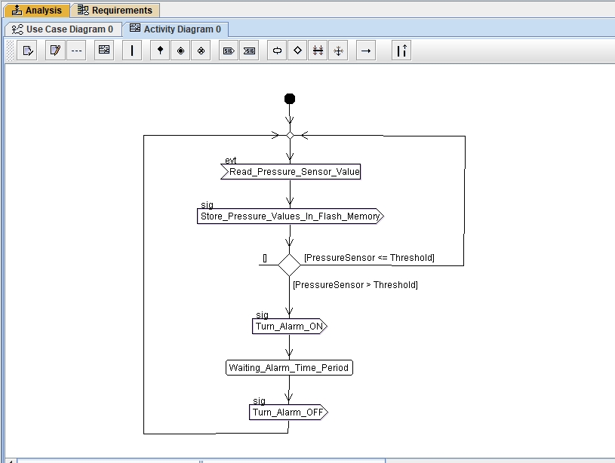

- Sequence Diagram :

In use Sequence Diagram, we discuss Communication
between main system entities and actors ,as we mentioned above in activity diagram , we will see interaction between Pressure sensor actor , main function algorithm , alarm actuator and flash memory

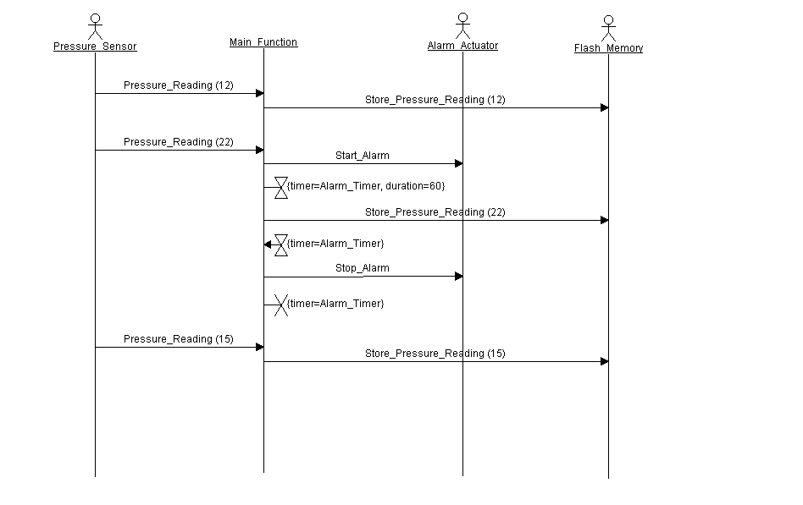

- System Design:

We will divide our case study to FOUR main modules
- Pressure Sensor Driver Module.
It is has one function , senses the pressure of the cabin and send it to the controller.
- Main_Function Module.
It has three function , the first function is receiving the reading from pressure sensor module , and the second function is checking the value of pressure and take the decision if alarm will turn on or not , the third function
is to send the reading to the alarm to display it .
- Alarm Monitor Module .
It has two function , the first function is receiving the reading from controller , the second function to send the action will be token to the alarm monitor driver.
- Alarm Monitor Driver Module. It has one function , take the action if turning on the alarm or not 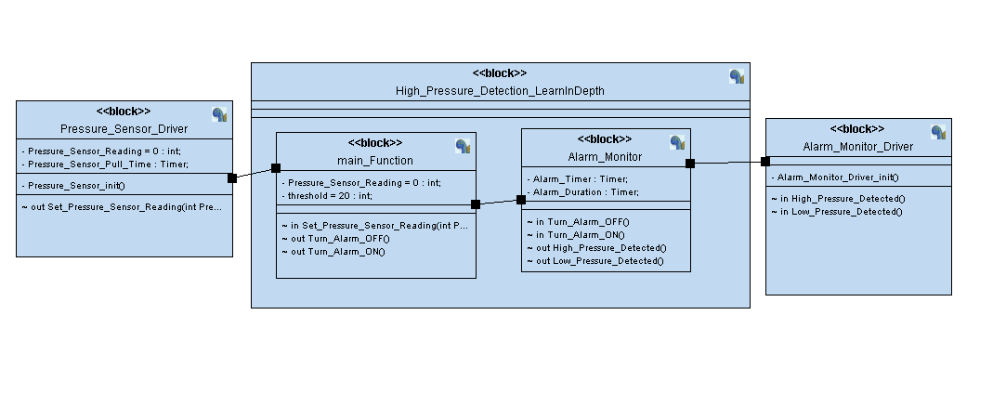

- Source files with Block Diagrams :
- Pressure Sensor Diagram :

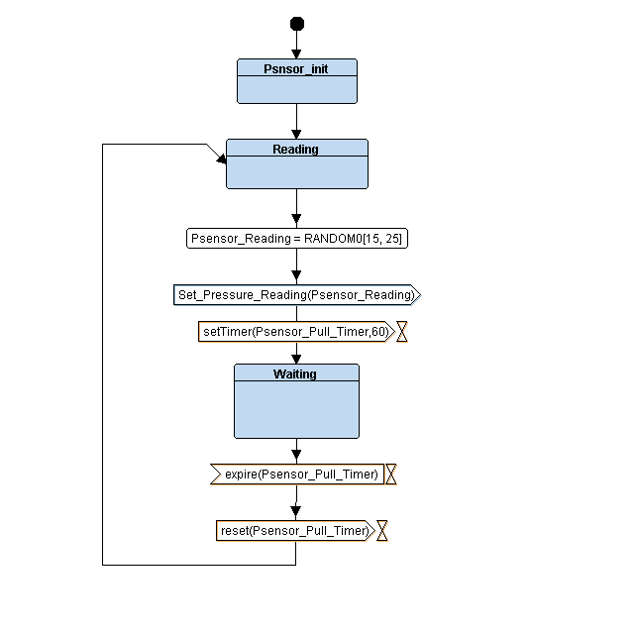

- Pressure Sensor Header File :

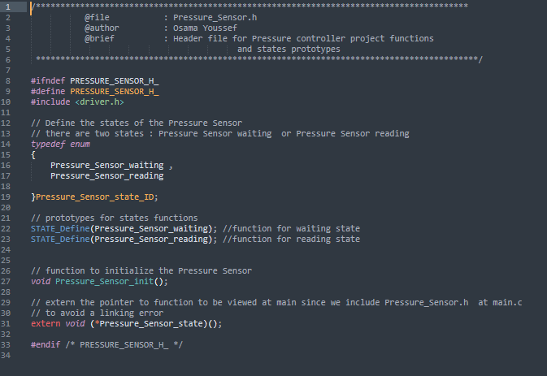
- Pressure Sensor Program File :

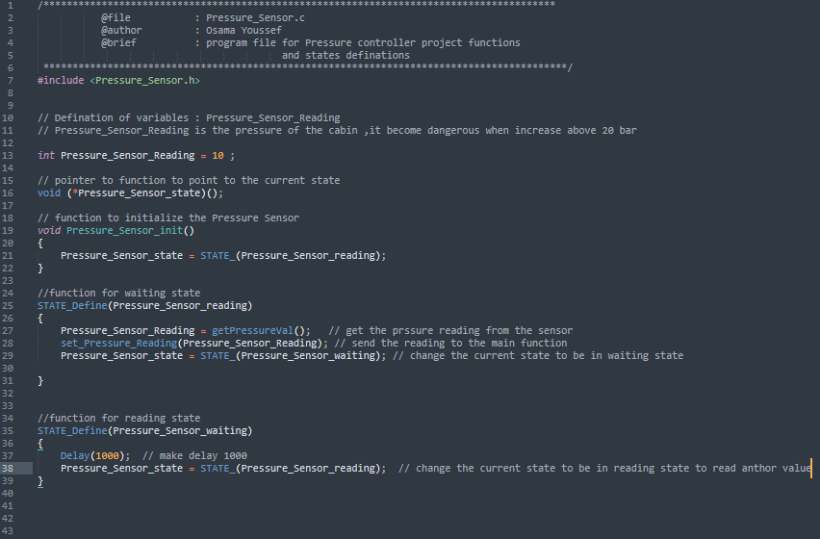

- Main Function Diagram :

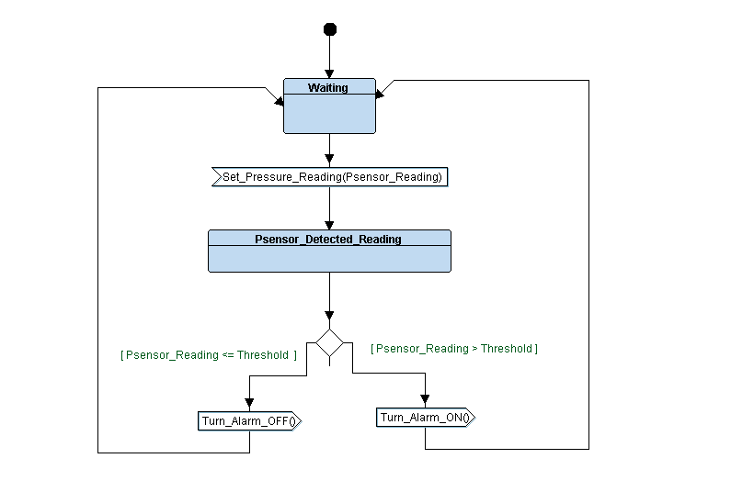

- Main Function Header File :

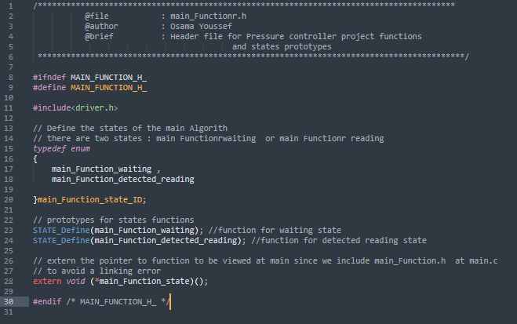

- Main Function Program File :

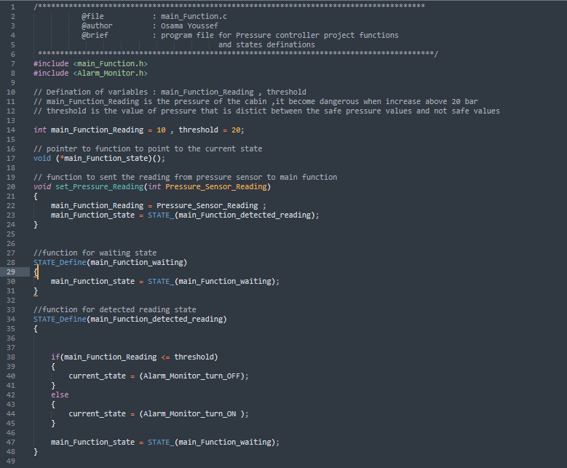

- Alarm Monitor Diagram :

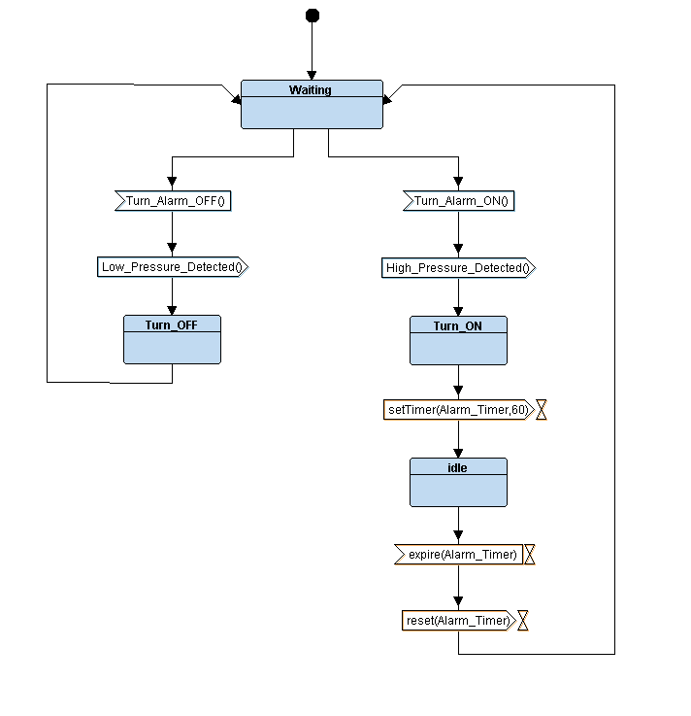

- Alarm Monitor Header File :

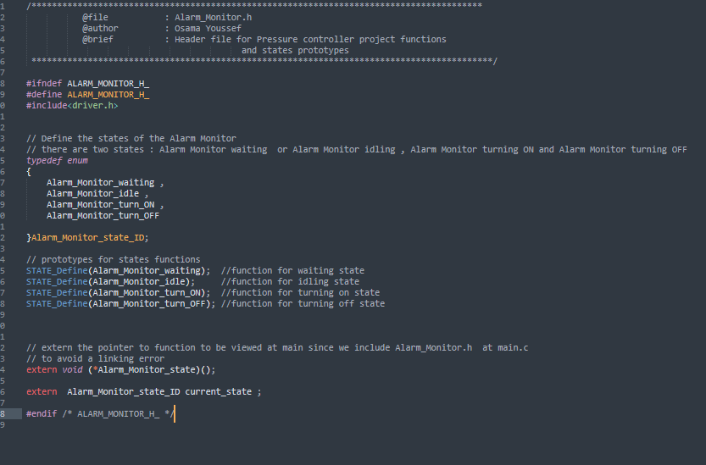

- Alarm Monitor Program File :
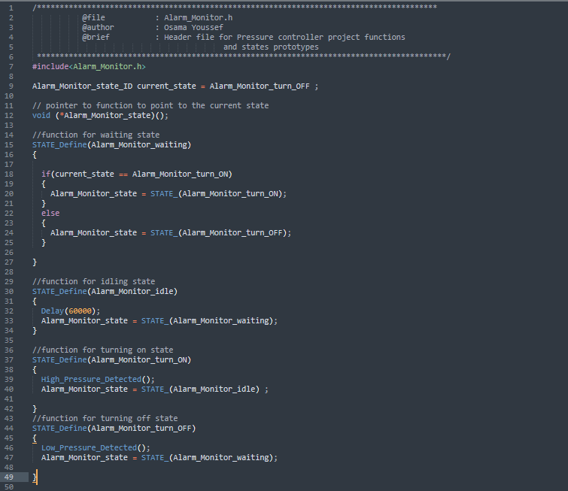

- Alarm Monitor Driver Diagram :
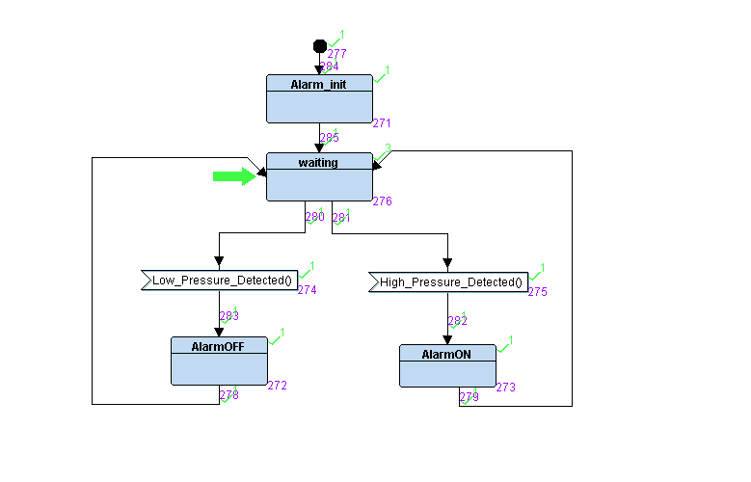
- Alarm Monitor Driver Header File :

- Alarm Monitor Driver Program File :

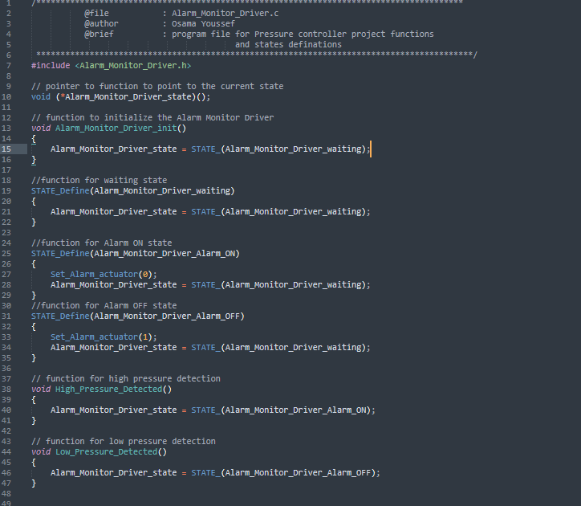

- Driver Header File :

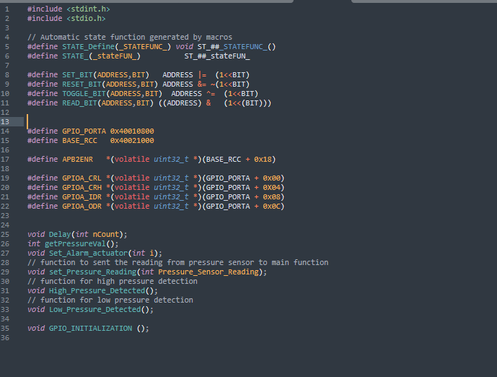

- Driver Program File :

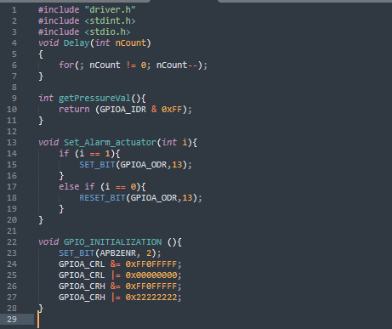

- Main Program File :

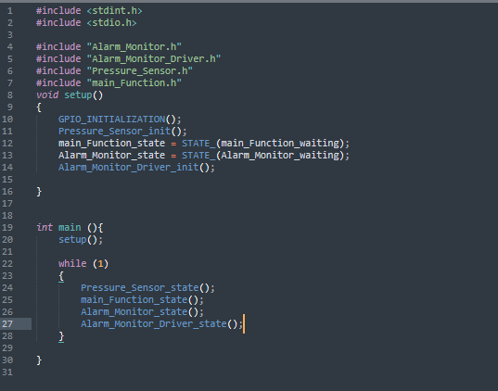
- Startup Program File :

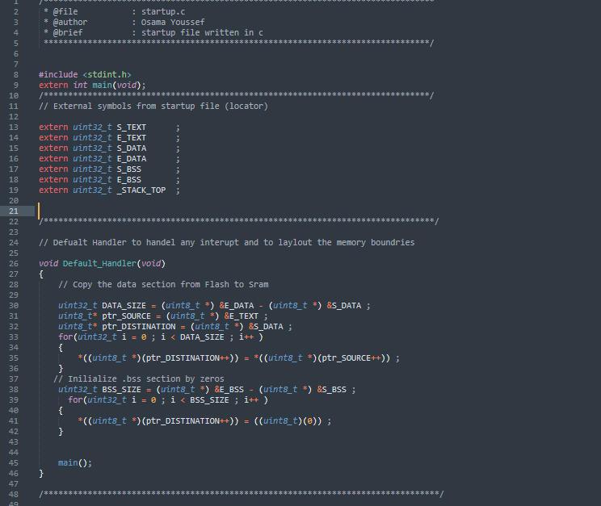

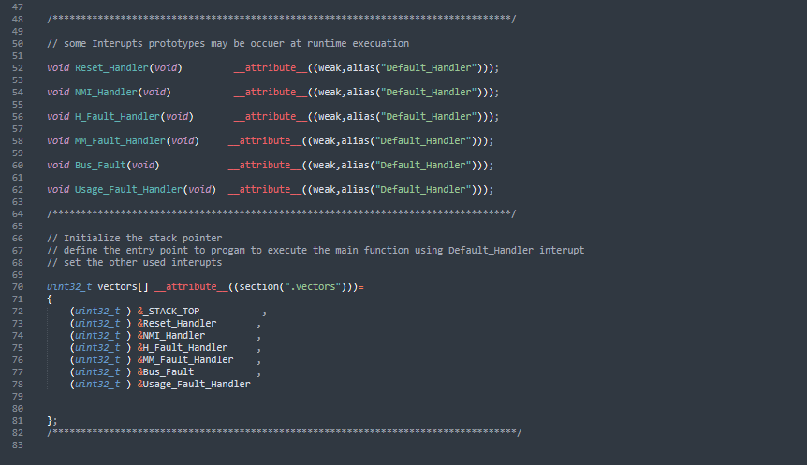

- Linker script.ld :

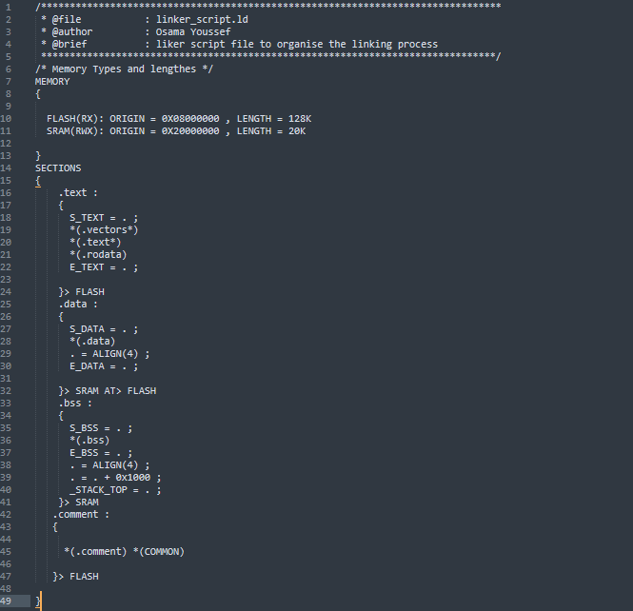

- Sections and symbols for object files :

- Pressure Sensor object file sections :

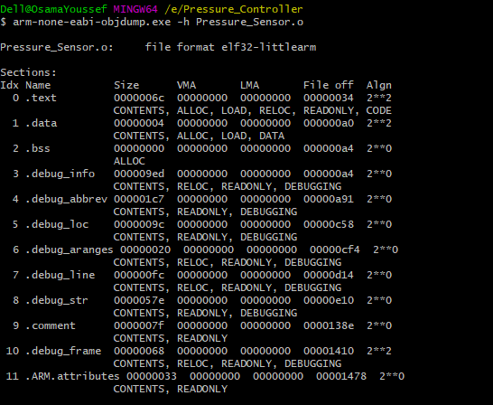

- Pressure Sensor object file symbols :

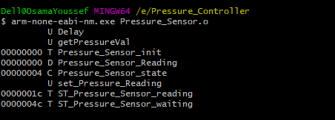

- Main Function object file sections :

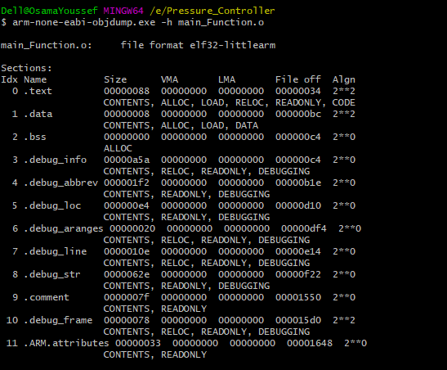

- Main Function object file symbols :

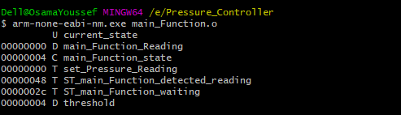

- Alarm Monitor object file sections :

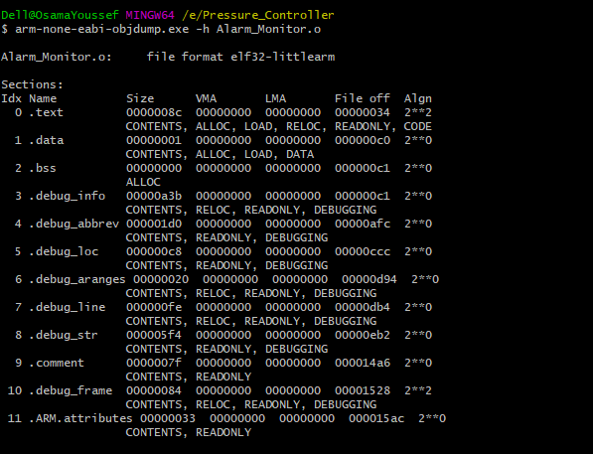

- Alarm Monitor object file symbols :

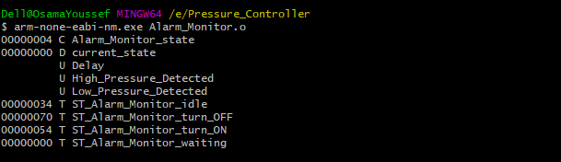

- Alarm Monitor Driver object file sections :

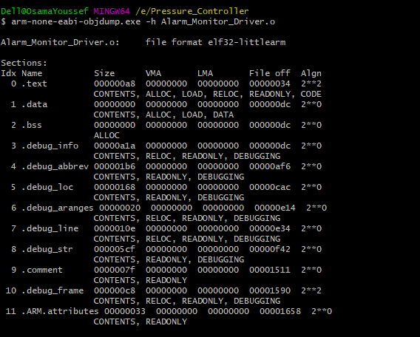

- Alarm Monitor Driver object file symbols :

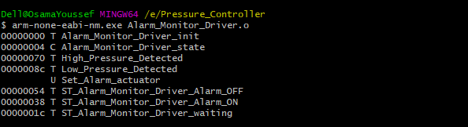

- Symbols for final executable file:

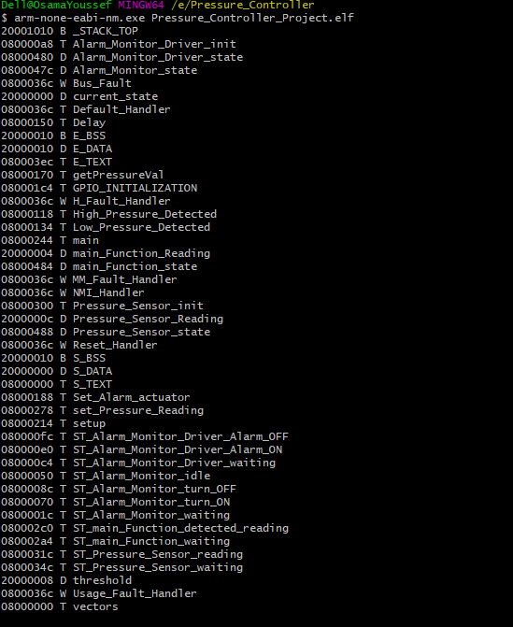

- Readelf utility for final executable file :

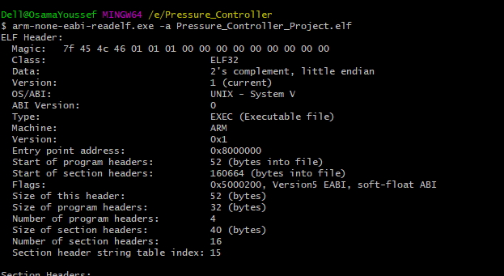

- The map file and symbols :

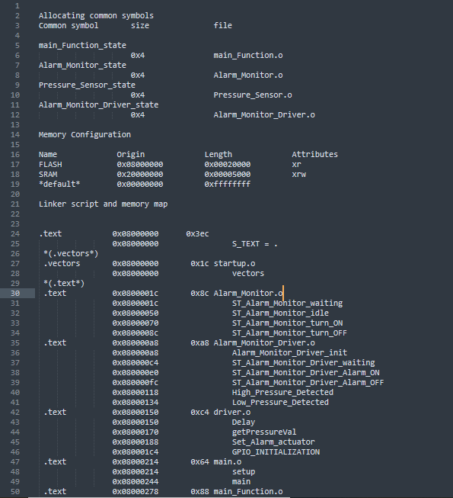

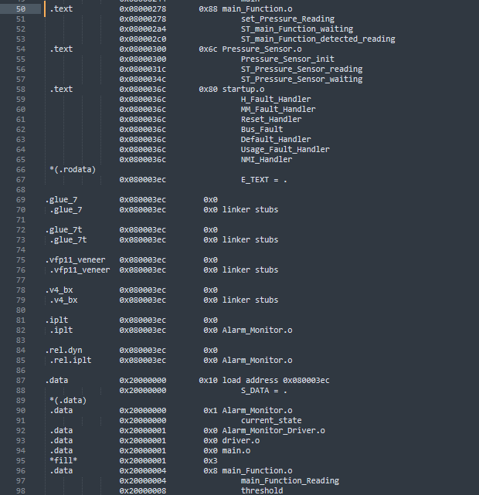

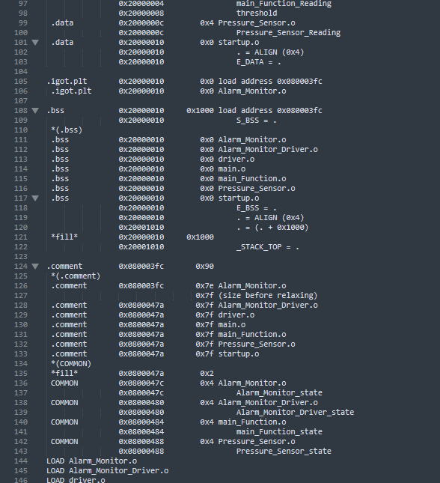

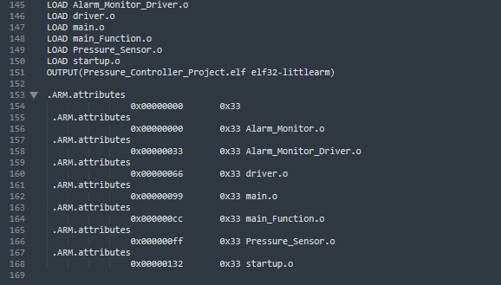

- Simulation using Proteus :

