Smart Campus Safety Detection System

Theme: Campus Safety Monitoring
BCS407 - Artificial Intelligence

Done by:
Ossama Alhussni 20220001208
Noureddin Albaba 20220001550
Mohammed Aasim 20220002173
Hamza Haleemah 20220001116

Abstract
Campus safety monitoring relies heavily on manual inspection, which is subject to human error and resource constraints. This project presents an AI-Based Smart Campus Safety Detection System that applies deep learning object detection to automatically identify three critical safety object classes: Emergency Exit Indicator Lights, Fire Alarms, and Wet Floor Signs. The system was developed and evaluated across three experiments to assess the independent and combined contributions of dataset quality and model architecture to detection performance. A YOLO11 model trained on an original dataset established a baseline, achieving a mean F1 score of 0.871 on the test set, with fire alarms representing the weakest class at an F1 of 0.720. Two improvement strategies were then applied: upgrading the dataset and targeted augmentation including horizontal flipping, rotation, and blur, increasing the dataset to 2973 images; and transitioning the architecture from YOLO11 to YOLO26. The upgraded YOLO26 model achieved the strongest overall performance with a mAP@0.5 of 0.948, a mean F1 of 0.934, and a fire alarm recall of 0.932, representing a substantial improvement over the baseline. Results demonstrate that both data quality improvements and architectural advancement contribute meaningfully to detection robustness, with their combination yielding the best outcome. The system is deployed via the Roboflow Inference API, enabling real-time inference without local GPU hardware, and is positioned as a supplementary tool to support existing campus safety protocols.
Keywords
Object Detection, Campus Safety Monitoring, YOLO, Data Augmentation, Computer Vision

Introduction
Campus safety is a critical concern for universities and educational institutions worldwide. Each year, preventable incidents including fires, slip-and-fall accidents, and delayed evacuations result in injuries that could be mitigated through more consistent monitoring of safety infrastructure. The ability to automatically detect safety-related objects such as emergency exit signs, fire alarms, and wet floor signs can significantly improve response times and reduce the risk of accidents. Traditional manual monitoring approaches are limited by human attention and resource constraints, making automated computer vision systems an attractive alternative. Recent advances in deep learning have made real-time object detection increasingly accessible and practical for deployment in institutional settings. Convolutional neural network-based architectures, particularly the YOLO family of models, have demonstrated strong performance in detecting diverse object categories under varied environmental conditions, including differences in lighting, viewing angle, and occlusion. These capabilities make them well suited for the dynamic and spatially complex environments characteristic of university campuses, where safety equipment must be reliably identified across a wide range of indoor settings. A baseline AI-Based Smart Campus Safety Detection System was developed in Project 1 using YOLO11 trained on an annotated dataset of three safety object classes: Emergency Exit Indicator Lights, Fire Alarms, and Wet Floor Signs. While the system demonstrated promising results, the evaluation revealed critical limitations that preclude direct real-world deployment. Most notably, fire alarm detection achieved an F1 score of only 0.720, driven by a recall of 0.643, indicating that more than one in three fire alarm instances went undetected in the test set. This level of false negative rate is unacceptable in a safety-critical application where a missed fire alarm could have serious consequences. This motivated two targeted improvement strategies: upgrading the dataset and evaluating a more advanced detection architecture.
This project builds directly on the Project 1 baseline by pursuing both improvement strategies in parallel and evaluating their individual and combined contributions. Three research questions guide this work: To what extent does improving dataset quality improve detection performance over the Project 1 baseline? Does transitioning from YOLO11 to the more recent YOLO26 architecture provide measurable performance gains when evaluated on the same upgraded dataset? Does the combination of an improved dataset and a more capable architecture produce a system that is sufficiently reliable for consideration in real-world campus safety deployment? The system was designed, trained, and evaluated to detect the same three safety object classes established in Project 1. Dataset preparation and model training were conducted using the Roboflow platform, and models were evaluated across standard detection metrics including precision, recall, F1 score, and mean average precision. The project follows a complete end-to-end machine learning pipeline, from dataset refinement and augmentation through model training, comparative evaluation, and inference demonstration. The remainder of this report is structured as follows: the Literature Review contextualises the project within existing research on object detection improvement techniques; the Baseline Model Analysis summarises Project 1 results and identifies the weaknesses that motivated this work; the Methodology details the dataset upgrades, model selection, and training procedure; the Results section presents quantitative evaluation outcomes across all three experiments; and the Discussion addresses comparative findings, limitations, ethical considerations, and directions for real-world deployment.

Literature Review
Object detection remains a foundational task in computer vision, requiring systems to both localize and classify objects within images through bounding box predictions and categorical labels. The field has undergone substantial transformation over the past two decades, transitioning from traditional handcrafted feature representations such as Histogram of Oriented Gradients paired with Support Vector Machines, to deep learning approaches that have substantially advanced detection accuracy and computational efficiency (Dalal & Triggs, 2005). The emergence of two-stage detectors, represented by Faster R-CNN, introduced the region proposal network mechanism, which sequentially identifies candidate object regions before applying classification. Though achieving higher accuracy metrics, these approaches incur substantial computational overhead and exhibit latency unsuitable for time-sensitive applications (Ren et al., 2017). In contrast, single-stage detectors skip the identifying object regions step and directly predicts bounding boxes and class probabilities in a unified forward pass, enabling real-time inference rates essential for deployment scenarios. Transformer-based detectors, such as DETR, have also emerged as a compelling alternative by replacing convolutional backbones with self-attention mechanisms to model global context across an image. While DETR eliminates the need for hand-designed components like anchor boxes and achieves competitive accuracy, it suffers from significantly slower training convergence and higher computational costs, limiting its suitability for real-time applications (Carion et al., 2020). This positions convolutional single-stage detectors, particularly the YOLO family, as the more practical choice for deployment scenarios where speed and efficiency are paramount. The YOLO detection model fundamentally reframed object detection as a single regression task, establishing a new standard for real-time performance. The base model can process images at 45 frames per second and process live video with 25 milliseconds of latency with good accuracy. YOLO is particularly effective for scenarios involving diverse objects across varied environmental conditions since it takes in contextual information about classes and their appearance while training (Redmon et al., 2016). These improvements have positioned YOLO as the popular choice for real-world deployment where inference speed and detection robustness are critical requirements. Computer based monitoring has demonstrated substantial benefits for occupational and environmental safety. A YOLOv8 model was used for detection systems for personal protective equipment monitoring on construction sites. The model demonstrated high precision rates across real-world deployment scenarios with significant variation in lighting and viewing angles while maintaining a low computational cost (Tong et al., 2025). This underscores the practical utility of the YOLO architecture in providing high-speed, high-accuracy object detection and classification within dynamic real-world environments. Subsequent iterations of the YOLO architecture have continued to advance the accuracy-efficiency frontier. YOLOv11, released by Ultralytics in 2024, introduced architectural refinements including an updated backbone and improved feature extraction modules, reducing parameter count while improving mean average precision across standard benchmarks compared to its predecessor (Ultralytics, 2024). Building on this progression, YOLO26 was released in January 2026 as the latest evolution of the series, engineered specifically for edge and low-power deployment. YOLO26 introduces several notable innovations: the removal of the Distribution Focal Loss module to simplify export and broaden hardware compatibility, a native end-to-end NMS-free inference design that eliminates post-processing latency, and the MuSGD optimizer, which is a hybrid of SGD and Muon inspired by advances in large language model training, which provides more stable convergence during training. These architectural decisions collectively enable YOLO26 to run up to 43% faster on CPUs compared to prior versions while maintaining competitive detection accuracy, making it one of the most practically deployable models in the YOLO family for resource-constrained environments (Ultralytics, 2025).
The Roboflow platform is crucial for facilitating reproducible computer vision research and development workflows, standardized annotation protocols, and data validation tools, that seamlessly integrate with YOLO training pipelines. The platform also provides rich and varied datasets to train the model and improve its performance. Furthermore, it maintains a transparent audit trail, which makes the model’s developmental history explainable and easy to review. Roboflow simplifies the reporting process and enables streamlined collaboration across distributed teams (Ultralytics, 2023). Within the broader context of campus and institutional safety, a recent study has demonstrated that deep learning-based approaches for anomaly detection and early warning systems can supplement human monitoring capabilities, achieve high accuracy in real-time threat detection, and accelerate emergency response times by up to 30% (Liu, 2025). However, practical implementation of such systems remains challenging due to the diversity of campus environments, the need for robust predictions, and the requirement for explainable decision-making in safety-critical contexts.

Related work
Targeted augmentation and preprocessing techniques have been shown to meaningfully improve object detection model generalisation, particularly in visually inconsistent environments. Shorten and Khoshgoftaar (2019) conducted a broad survey confirming that geometric transforms including horizontal flipping and rotation are among the most consistently effective augmentation strategies, as they expose the model to object orientations unlikely to be fully represented in a limited training set. This is directly relevant to campus safety objects such as exit signs and fire alarms, which are mounted at varying angles and captured from multiple viewpoints. The application of blur augmentation is supported by Hendrycks and Dietterich (2019), who demonstrated that models not exposed to blurred inputs during training experience significant accuracy degradation when evaluated on real-world corrupted imagery, with error rates increasing by up to 60% under blur conditions compared to clean inputs. Training with blur augmentation directly addresses this vulnerability by simulating low-quality camera feeds and motion artifacts common in fixed surveillance setups. Bochkovskiy et al. (2020) further validated the role of augmentation within the object detection pipeline specifically, showing that combining geometric and photometric augmentations during YOLO training contributed to achieving 43.5% mAP on the COCO benchmark. At the architectural level, Lin et al. (2017) introduced Feature Pyramid Networks, which construct multi-scale feature hierarchies within the detector backbone to improve detection of objects across a range of sizes, a design that has since been incorporated into the YOLO family and is directly relevant to detecting safety objects that vary substantially in apparent size depending on camera distance. With respect to preprocessing, Kornblith et al. (2019) demonstrated that consistent input normalisation and standardised resizing are critical preconditions for effective transfer learning, ensuring that pre-trained feature representations remain applicable to the target domain. Krizhevsky et al. (2012) established the foundational precedent for flipping as a training-time augmentation, showing it reduced classification error in deep networks by preventing the model from treating mirrored versions of the same object as distinct categories. Together, these techniques form a principled augmentation and preprocessing strategy that directly supports improved detection robustness in this project.

Baseline Model Analysis (model metrics in results section)
The baseline system was built using YOLO11, selected for its single-stage detection architecture, native support within the Roboflow training pipeline, and strong accuracy-efficiency trade-off relative to two-stage alternatives such as Faster R-CNN. The model was initialised from YOLO11 weights pretrained on the COCO dataset, applying transfer learning to accelerate convergence on the custom campus safety dataset. The dataset used for baseline training was sourced from Roboflow and consisted of pre-annotated images across three classes: Emergency Exit Indicator Light, Fire Alarm, and Wet Floor Sign. The dataset was split using an 81/10/9 ratio for training, validation, and test subsets respectively, with the held-out test set comprising 59 images. No augmentation was applied beyond Roboflow's default Auto-Orient and resizing to 640x640 pixels. The model was trained for the number of epochs determined by Roboflow's early stopping mechanism, using COCO-pretrained weights as initialisation, default batch size, and default learning rate scheduling.
Two weaknesses emerged from analysing the baseline model’s results that directly motivated the improvement strategies adopted in subsequent experiments. The first was insufficient dataset diversity, particularly for the fire alarm class. The high false negative rate suggests the model encountered fire alarm instances at test time that differed visually from those seen during training, whether in form factor, colour, mounting configuration, or lighting. A dataset with more examples covering a wider range of real-world variation was therefore identified as necessary. Additionally, the dataset contained duplicate and inconsistently named classes, most notably "Wet Floor Sign" and "Wet-Floor-Sign" appearing as separate classes, fragmenting the available annotations and introducing label noise. The second weakness was architectural ceiling. While YOLO11 performed adequately, the baseline experiment was conducted on the model available at project inception. The subsequent release of YOLO26, with its NMS-free end-to-end design, improved small-object detection via ProgLoss and STAL, and up to 43% faster CPU inference, presented a meaningful opportunity to assess whether architectural advancement could provide complementary gains beyond what data improvements alone would yield. These two identified weaknesses, data quality and model architecture defined the two improvement axes explored in the subsequent experiments.

Dataset
A custom dataset was constructed by collecting images from different datasets to ensure a fair distribution of samples for each object class. The images show the objects across multiple dimensions including lighting conditions, camera angles, distances, and environmental backgrounds. This diversity is essential to yield a model that performs object detection well in real-world conditions.
The dataset consists of three object classes with the following distribution:

Class | Images Collected | Notes
Emergency Exit Indicator Light | 557 | Green/white exit signs, push-bar doors
Fire Alarm | 685 | Red pull stations, ceiling-mounted alarms
Wet Floor Sign | 507 | Yellow caution signs, various angles
Total | 1749  (Our previous dataset consisted of 1320 images) | Minimum project requirement met

The dataset was acquired through the Roboflow platform, consisting of pre-annotated images specifically curated for this task. Before training, Roboflow's built-in dataset health check was used to automatically validate annotation quality. This process flags common issues such as null examples containing no labelled objects, images with missing or duplicate annotations, and class imbalances across the dataset, allowing problematic entries to be identified and excluded before training. The initial model training used YOLO11 with a dataset split of 81/10/9 for training, validation, and test subsets respectively. For the upgraded dataset used in subsequent YOLO26 training, this split was revised to a 70/18/12 ratio. This revised distribution allocates a larger proportion of data to validation compared to the previous split, providing a more robust basis for hyperparameter tuning and reducing the risk of overfitting during the extended training process. Once verified, the data was compiled and integrated directly into the training pipeline via the Roboflow platform. The dataset was exported in YOLOv8 format, which is compatible with both YOLO11 and YOLO26, and stores annotations as normalized bounding box coordinates in text files alongside the corresponding images to allow performance evaluation later.
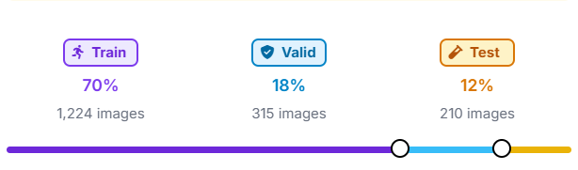
Methodology
The model selected for this project is YOLO11, developed by Ultralytics, with a subsequent upgrade to YOLO26 for improved deployment efficiency. The selection of YOLO11 as the initial model was made for the following reasons. First, it is a single-stage detector that processes the entire image in one forward pass, making it well-suited for real-time inference applications such as campus safety monitoring. Second, YOLO11 introduces architectural improvements over its predecessors including enhanced feature extraction for better multi-scale detection, which is important given the varying sizes of safety objects across different viewing distances. Third, the Roboflow platform provides native support for YOLO11 training, simplifying the end-to-end pipeline. Fourth, compared to Faster R-CNN, YOLO11 achieves comparable accuracy at significantly lower computational cost and fewer parameters, making deployment on standard hardware more feasible. The project subsequently transitioned to YOLO26, the latest model in the Ultralytics YOLO series, to leverage its native end-to-end NMS-free inference, improved small-object detection through ProgLoss and STAL, and CPU inference speeds up to 43% faster than prior versions, further strengthening the system's suitability for resource-constrained edge deployment (Ultralytics, 2025).

Feature | Faster R-CNN | YOLO11 | YOLO26
Detection Approach | Two stage | Single Stage | Single Stage
NMS Required | Yes | Yes | No
CPU Inference Speed (per image) | 200ms | 56ms | 39ms
mAP on COCO (val) | 37 | 39.5 (nano) | 40.9 (nano)
Parameters (nano) | 137M | 2.6M | 2.4M
Edge Deployment | Limited | Moderate | Optimised
Real-Time Capable | No | Yes | Yes
(Ren et al., 2017; Sapkota et al., 2024; Ultralytics, 2025)

The baseline experiment in project 1 was done using a YOLOv11 model. In this project, we added more images to the dataset and performed augmentation techniques: blur, rotation, and flip to further improve performance. The first experiment held both the architecture and dataset constant, reproducing the Project 1 baseline. The second experiment held the architecture constant at YOLO11 while upgrading the dataset, isolating the effect of data quality. The third experiment held the dataset constant at the upgraded version while switching the architecture to YOLO26, isolating the effect of architectural advancement. This controlled structure ensures that observed performance differences can be attributed to the specific variable changed in each experiment.
The complete training pipeline was executed on the Roboflow training platform, which provides cloud GPU training infrastructure. The pipeline for the YOLO26 model follows the same structure as the initial YOLO11 training pipeline, with the primary difference being the introduction of data augmentation at the dataset level. Flip, rotation, and blur augmentations were applied through Roboflow, expanding the dataset from 1749 to 2973 images, improving the model's ability to generalise across varied real-world conditions. The pipeline consisted of the following stages:
- Data preprocessing: Images were processed with Auto-Orient to ensure correct orientation and resized to 640×640 pixels using a stretch resize method to match the model's input requirements.
- Model initialisation: Training began from YOLO26 pretrained weights, pretrained on the COCO dataset, using transfer learning to leverage existing feature representations and accelerate convergence.
- Training configuration: The YOLO26 model was trained for 325 epochs. The YOLOv11 model was trained for 276. Early stopping terminated the training process to ensure the model did not overfit and retain its ability to generalise. The default batch size (16) and learning rate (0.01) as configured by the Roboflow cloud training platform were used, with learning rate scheduling applied automatically during training.
- Validation: After each epoch, the model was evaluated on the validation set to monitor mAP@0.5, precision, and recall, allowing selection of the best-performing checkpoint.
- Inference: The trained model was deployed via the Roboflow Inference API, enabling inference on local images without requiring local GPU hardware.
For inference, the Roboflow InferenceHTTPClient SDK was used to send images to the hosted model API and receive predictions. Bounding boxes and confidence scores were rendered on output images using the Python Imaging Library (PIL).
Results
Project 1 model (Yolov11) on the old dataset
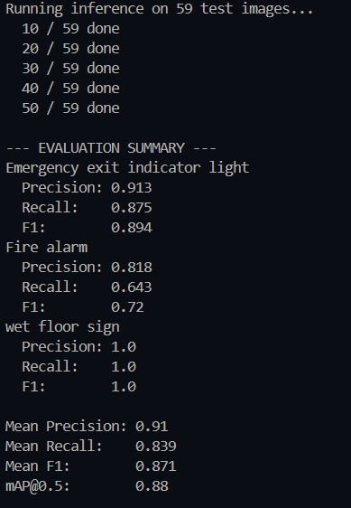
The trained YOLO11 model achieved strong performance across all evaluation metrics as measured on the held-out test set consisting of 59 images. The following table summarizes the overall results:
Metric | Score | Source
mAP@0.5 | 0.991 | Roboflow training dashboard
Mean Precision | 0.910 | Computed from confusion matrix (test set)
Mean Recall | 0.839 | Computed from confusion matrix (test set)
Mean F1 Score | 0.871 | Computed from per-class precision and recall

A per-class breakdown of precision, recall, and F1 score was computed from the confusion matrix generated on the test set:
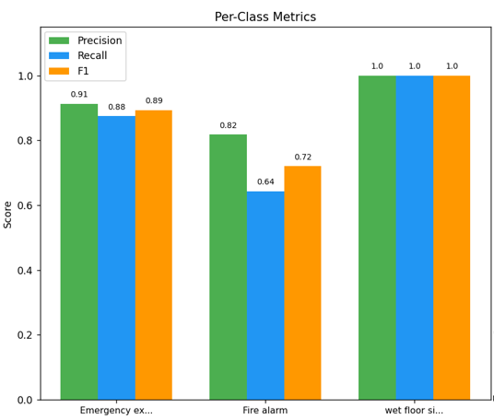
Class | Precision | Recall | F1 Score
Emergency Exit Indicator Light | 0.913 | 0.875 | 0.894
Fire Alarm | 0.818 | 0.643 | 0.720
Wet Floor Sign | 1.000 | 1.000 | 1.000
Mean | 0.910 | 0.839 | 0.871

Wet floor signs achieved perfect precision and recall, likely due to the high visual distinctiveness of yellow caution signs against typical backgrounds. Emergency exit signs performed well with an F1 of 0.894. Fire alarms showed the lowest performance with an F1 of 0.720. This was primarily driven by a lower recall of 0.643, which measures the model's ability to find all actual instances in the data; this suggests the model struggled with "false negatives," missing a notable proportion of fire alarms in the test set.
Confusion matrix
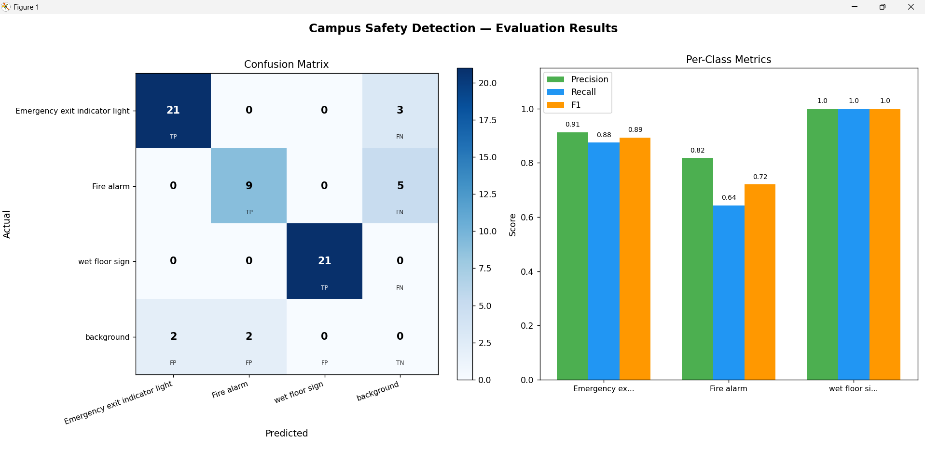

The confusion matrix revealed the following patterns:
- Emergency exit: 21 true positives, 3 false negatives (missed detections), and 2 false positives (background incorrectly classified as exit).
- Fire alarm: 9 true positives, 5 false negatives (missed), and 2 false positives. This class showed the highest number of missed detections, consistent with its lower recall score.
- Wet floor sign: 21 true positives, 0 false negatives, 0 false positives, perfect detection on the test set.
The false negatives for fire alarms are likely attributable to variation in fire alarm appearance across different manufacturers and mounting positions, as well as potentially fewer diverse training examples for this class compared to the other two.

Project 2 Yolo26
Trained on 325 epochs
Values measured on a test set of 210 images.
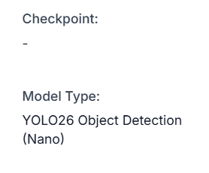
Training loss, precision, recall, mAP50, and mAP50-95 training graphs:
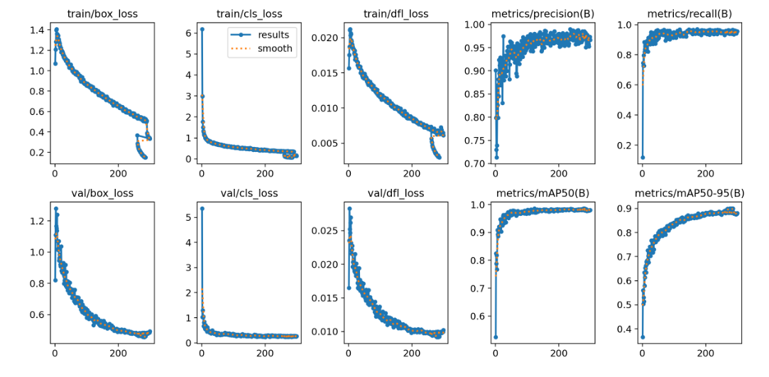
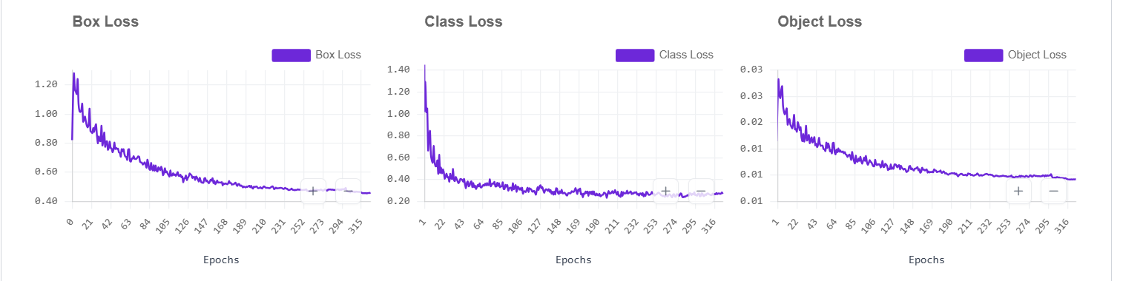
F1 confidence curve:
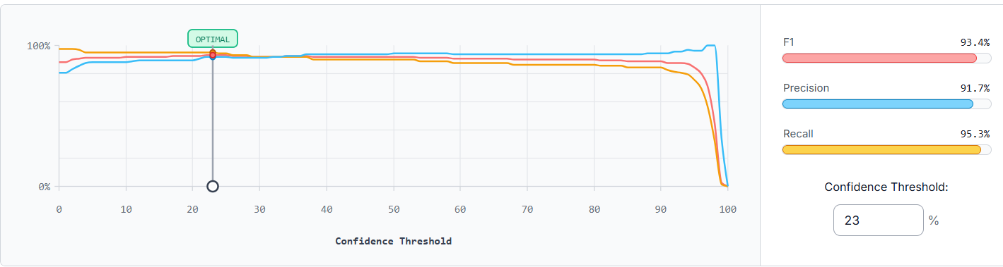
The F1 confidence curve for the YOLO26 model peaked at a confidence threshold of 23%, achieving an optimal F1 score of 93.4%, with a corresponding precision of 91.7% and recall of 95.3%. Notably, the curve remains exceptionally stable from a threshold of approximately 20% through to 90%, indicating that the model maintains consistently strong performance across a wide range of confidence values and is not sensitive to the exact threshold chosen for deployment. The sharp decline observed beyond the 90% threshold is expected behaviour, as requiring near-certain confidence causes the model to suppress valid detections, reducing recall drastically. For deployment, a threshold in the 23–50% range would be appropriate, with lower values prioritising recall, the more critical metric in a safety-monitoring context where missed detections carry greater consequence than false alarms.

Confusion matrix:
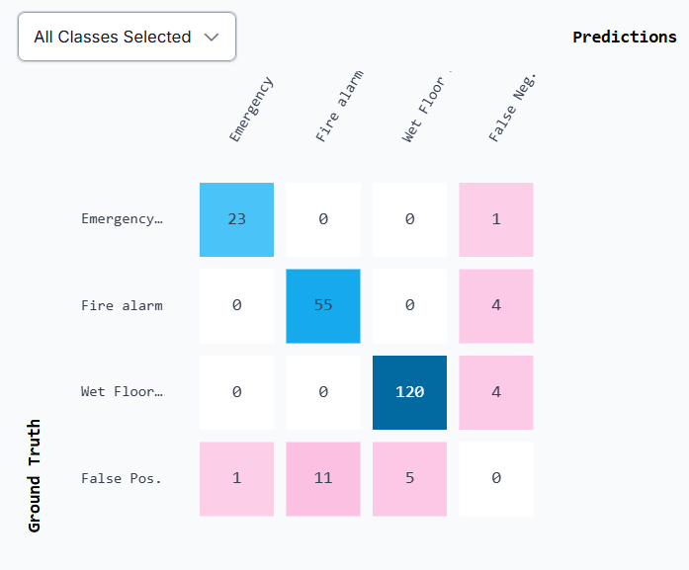
The confusion matrix revealed the following patterns:
• Emergency exit: 23 true positives, 1 false negative (missed detection), and 1 false positive (background incorrectly classified as an emergency exit). This indicates strong overall performance with very few missed detections.
• Fire alarm: 55 true positives, 4 false negatives, and 11 false positives. Although the model detected most fire alarms correctly, this class produced the highest number of false positives, suggesting that some background objects or visually similar features were incorrectly identified as fire alarms.
• Wet floor sign: 120 true positives, 4 false negatives, and 5 false positives. This class achieved the highest number of correct detections overall and demonstrated strong detection consistency, though a small number of missed detections and false alarms were still present.
Overall, the confusion matrix indicates that the model performs well across all three classes, with the wet floor sign class achieving the strongest detection performance. The fire alarm class appears to be the most challenging due to its higher false positive rate, which may be caused by variation in fire alarm designs, lighting conditions, or similarities with surrounding objects in the environment.
Evaluation metrics:
Metric | Score | Source
mAP@0.5 | 0.948 | Roboflow training dashboard
Mean Precision | 0.917 | Roboflow training dashboard
Mean Recall | 0.953 | Roboflow training dashboard
Mean F1 Score | 0.934 | Roboflow training dashboard
mAP@50-95 | 0.801 | Roboflow training dashboard

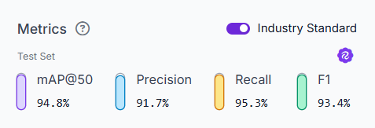
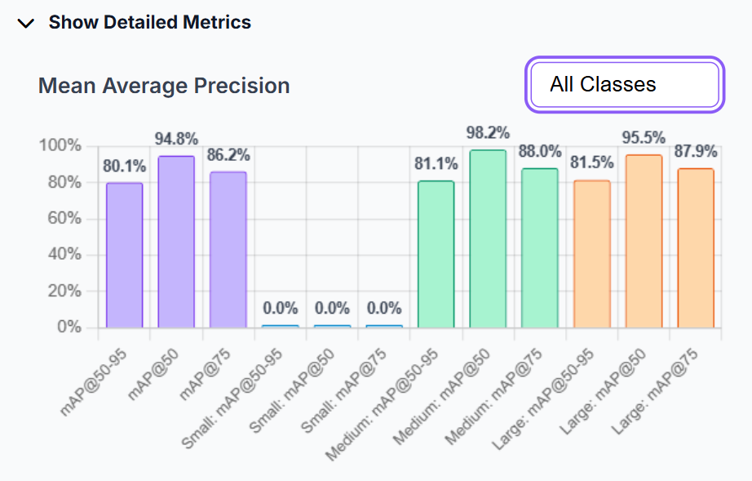
Per class evaluation (source: Roboflow):
Class | Precision | Recall | F1 Score
Emergency Exit Indicator Light | 0.958 | 0.958 | 0.958
Fire Alarm | 0.833 | 0.932 | 0.88
Wet Floor Sign | 0.96 | 0.968 | 0.964

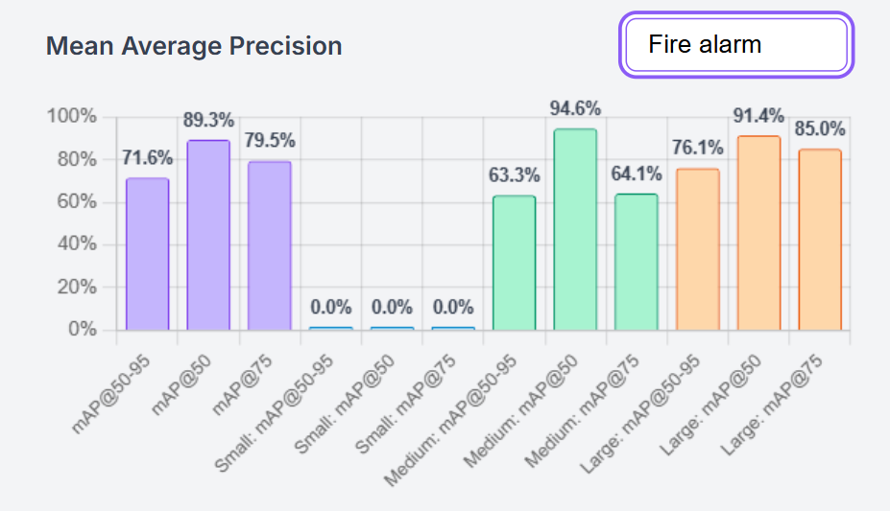
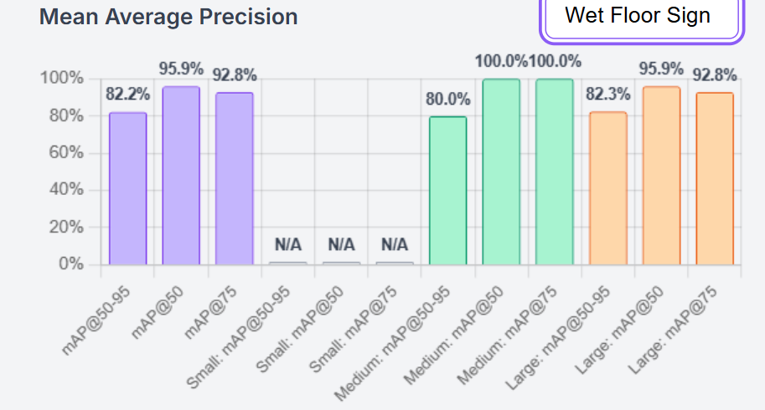
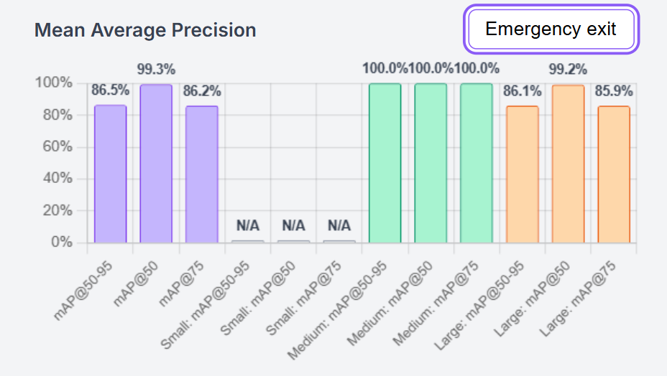

Project 2 Yolov11 (on upgraded dataset)
Trained on 276 Epochs
Values measured on a test set of 210 images.
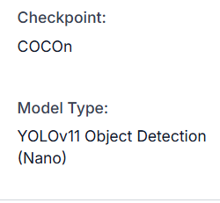
Training loss, precision, recall, mAP50, and mAP50-95 training graphs:
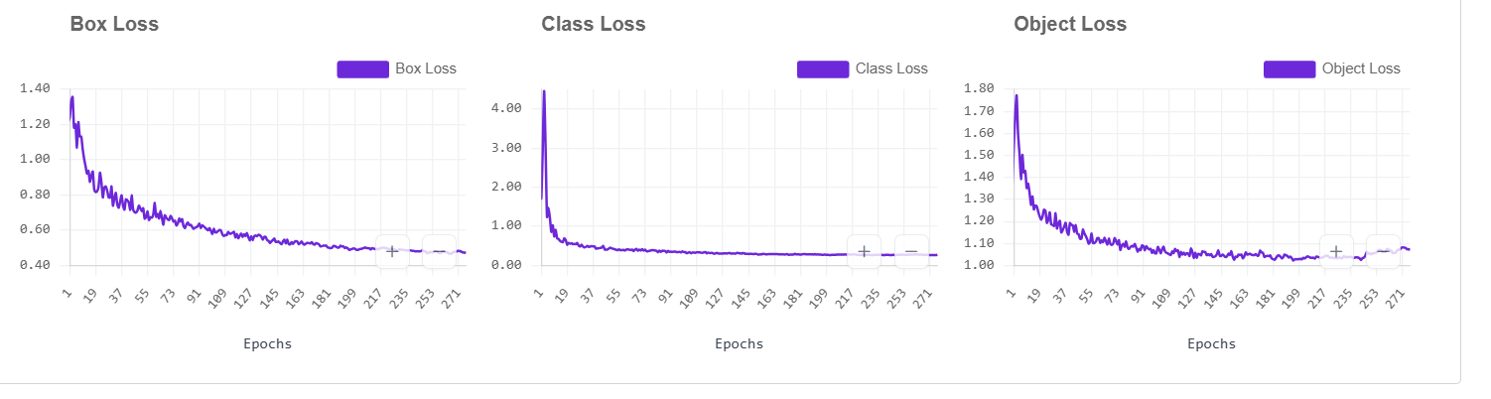
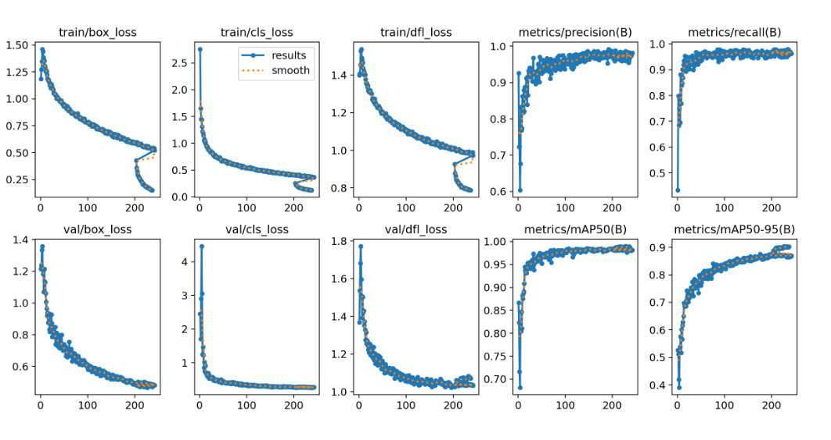
F1 confidence curve:
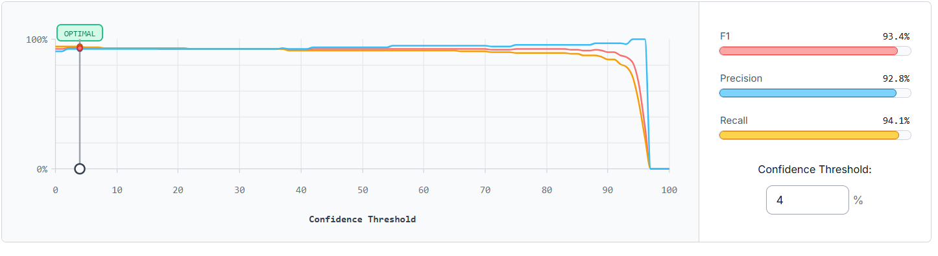
The F1 confidence curve for the YOLO11 model peaked at a confidence threshold of 4%, achieving an optimal F1 score of 93.4%, with a corresponding precision of 92.8% and recall of 94.1%. The curve demonstrates remarkable stability, remaining consistently high from near-zero threshold all the way through to approximately 90%, which indicates that the model produces well-calibrated, high-confidence predictions across virtually all valid detections. The very low optimal threshold of 4% suggests that the model assigns consistently high confidence scores to its correct detections. Even when accepting predictions with as little as 4% confidence, the model has already captured the best possible balance between precision and recall, indicating that very few low-confidence predictions exist that would need to be filtered out. As with the YOLO26 model, a sharp decline is observed beyond the 90% threshold, which is expected as overly restrictive confidence requirements suppress valid detections and collapse recall. For deployment, any threshold between 4% and 80% would yield near-optimal performance, giving operators considerable flexibility in tuning the sensitivity of the system.
Confusion matrix:
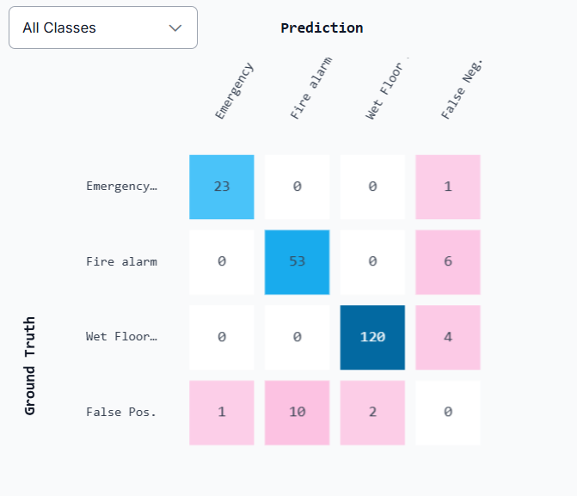
The confusion matrix revealed the following patterns:
• Emergency exit: 23 true positives, 1 false negative (missed detection), and 1 false positive (background incorrectly classified as an emergency exit). This class achieved strong detection performance with very few errors.
• Fire alarm: 53 true positives, 6 false negatives, and 10 false positives. This class produced the highest number of missed detections and false positives among all categories, indicating that fire alarms were the most difficult objects for the model to identify consistently. Variations in appearance, size, and environmental lighting conditions may have contributed to this reduced performance.
• Wet floor sign: 120 true positives, 4 false negatives, and 2 false positives. This class demonstrated the strongest overall performance, achieving a high number of correct detections while maintaining very few incorrect classifications.
Overall, the confusion matrix indicates that the model performs reliably across all three classes, with wet floor signs showing the highest detection accuracy and fire alarms remaining the most challenging class due to their comparatively higher false positive and false negative rates.
Evaluation metrics:
Metric | Score | Source
mAP@0.5 | 0.925 | Roboflow training dashboard
Mean Precision | 0.928 | Roboflow training dashboard
Mean Recall | 0.941 | Roboflow training dashboard
Mean F1 Score | 0.934 | Roboflow training dashboard
mAP@50-95 | 0.789 | Roboflow training dashboard

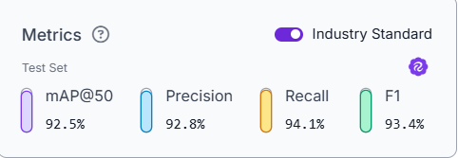
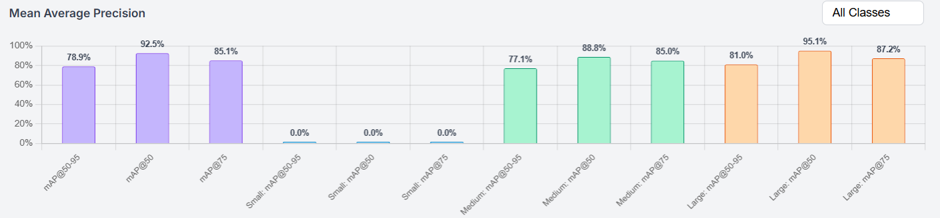

Per class evaluation (source: Roboflow) :
Class | Precision | Recall | F1 Score
Emergency Exit Indicator Light | 0.958 | 0.958 | 0.958
Fire Alarm | 0.841 | 0.898 | 0.869
Wet Floor Sign | 98.4 | 0.968 | 0.976

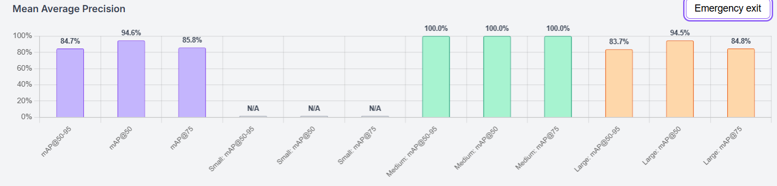
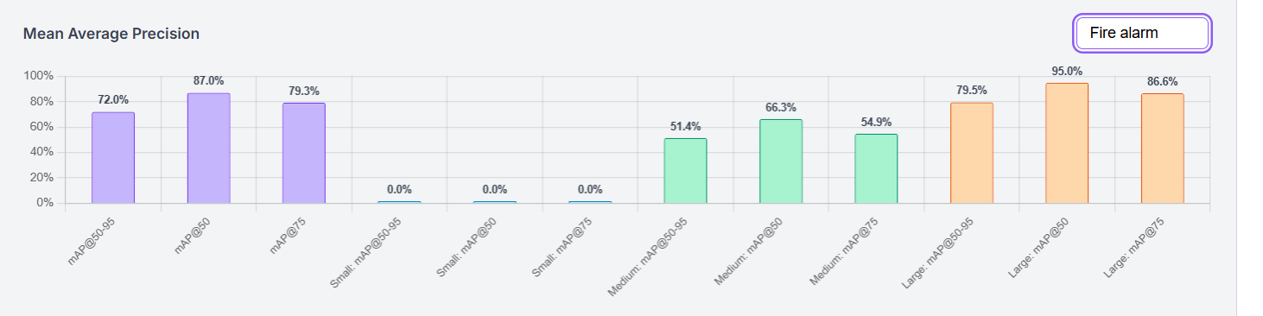
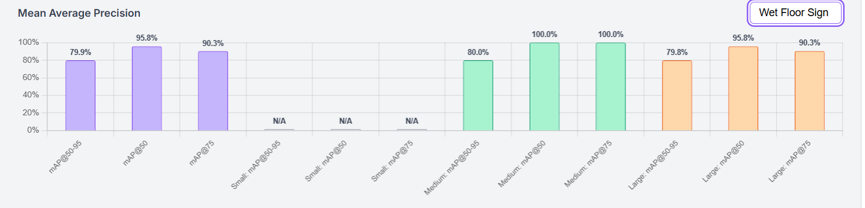

The configuration that led to the best results was to use the YOLO26 model on the upgraded dataset with data augmentation.

Cross-Experiment Performance Summary
Metric | YOLO11, Original Dataset | YOLO11, Upgraded Dataset | YOLO26, Upgraded Dataset
mAP@0.5 | 0.991* | 0.925 | 0.948
mAP@0.5:0.95 | - | 0.789 | 0.801
Mean Precision | 0.910 | 0.928 | 0.917
Mean Recall | 0.839 | 0.941 | 0.953
Mean F1 | 0.871 | 0.934 | 0.934
Exit Sign F1 | 0.894 | 0.958 | 0.958
Fire Alarm F1 | 0.720 | 0.869 | 0.880
Wet Floor F1 | 1.000 | 0.976 | 0.964
Test Set Size | 59 images | 210 images | 210 images
Epochs Trained | ~300 | 276 | 325
* Reported from validation set; all other figures from Roboflow dashboard on held-out test set.

Discussion
The three experiments conducted in this project allow for two distinct comparisons: the effect of the dataset upgrade on YOLO11 performance, and the effect of architectural advancement from YOLO11 to YOLO26 on the upgraded dataset. Together, these comparisons provide insight into both the data and model dimensions of detection performance for campus safety objects. The first experiment, YOLO11 trained on the original dataset, established a strong baseline with a mAP@0.5 of 0.991 on the validation set. However, per-class test set evaluation revealed meaningful limitations, particularly for fire alarms, which achieved an F1 score of only 0.720 driven by a recall of 0.643. This low recall indicates that the model frequently missed fire alarm instances, most likely due to limited diversity in the training examples for that class. Wet floor signs achieved perfect precision and recall on the original test set, though this likely reflects the limited size and low visual variety of that test partition rather than a robust generalisation capability.
Comparing the first and third experiments isolates the effect of the dataset upgrade while holding the architecture constant. Training YOLO11 on the upgraded dataset produced a substantial improvement in fire alarm recall from 0.643 to 0.898, and F1 from 0.720 to 0.869, confirming that the original dataset's limited diversity was the primary bottleneck for that class. Mean recall across all classes improved from 0.839 to 0.941, reflecting the broader benefit of a larger and more augmented dataset. The mAP@0.5 reported from the Roboflow dashboard for the upgraded YOLO11 model is 0.925, which appears lower than the original 0.991, however this comparison should be interpreted cautiously as the original figure was drawn from the validation set while the upgraded model metrics reflect evaluation on the larger test set. The underlying per-class improvements are the more meaningful indicator of genuine progress. Comparing the second and third experiments isolates the effect of architecture, with both models trained on the same upgraded dataset under equivalent conditions. YOLO26 outperformed YOLO11 across most metrics, achieving a higher mAP@0.5 of 0.948 versus 0.925, a higher mAP@0.5:0.95 of 0.801 versus 0.789, and a higher mean recall of 0.953 versus 0.941. The most notable per-class difference was in fire alarm recall, where YOLO26 achieved 0.932 compared to YOLO11's 0.898, suggesting that YOLO26's architectural refinements including its improved loss functions and end-to-end NMS-free design contributed to better sensitivity for the most visually challenging class. YOLO11 achieved a marginally higher wet floor sign F1 of 0.976 versus 0.964, though the difference is small and unlikely to be practically significant. Both models shared identical emergency exit performance at an F1 of 0.958, indicating that this class is sufficiently well-represented and visually distinctive for both architectures to learn it equally well. Across all three experiments, fire alarms consistently represented the most challenging detection class. This is attributable to the high variability in fire alarm appearance across manufacturers, mounting heights, and environmental contexts, compounded by the tendency for fire alarms to occupy a relatively small portion of the image frame. These findings are consistent with the broader literature reviewed in this project. The fire alarm recall improvement from 0.643 to 0.932 following dataset augmentation directly reflects the findings of Shorten and Khoshgoftaar (2019) and Bochkovskiy et al. (2020), who demonstrated that geometric and photometric augmentations produce meaningful generalisation gains, particularly for underrepresented or visually variable object categories. The additional gain delivered by YOLO26 over YOLO11 on the same dataset aligns with the architectural tuning literature, where Lin et al. (2017) and Tan and Le (2019) both demonstrated that targeted structural refinements produce complementary accuracy gains beyond what data improvements alone can achieve. The resilience of the system to blur conditions, supported by the blur augmentation applied during training, is consistent with the robustness improvements documented by Hendrycks and Dietterich (2019), whose work showed that exposure to corrupted inputs during training significantly reduces error rates under real-world image degradation. While the dataset upgrade and architectural improvements both contributed to meaningful gains for this class, further improvement would likely require targeted collection of more diverse fire alarm images across a wider range of building types and lighting conditions. The results collectively demonstrate that both data quality and model architecture are meaningful levers for improving detection performance, and that their combined effect, as seen in the YOLO26 results on the upgraded dataset, yields the strongest overall system.
Ethical Reflection
This project was developed with careful attention to ethical principles informed by established AI ethics frameworks, particularly those concerned with fairness, accountability, transparency, and privacy (Jobin et al., 2019). With respect to privacy, strict measures were taken throughout the dataset collection process to ensure that no identifiable personal data was captured. All images were reviewed to confirm the absence of recognizable faces and license plates. The system is designed to detect safety objects only, not individuals, significantly reducing the privacy risks associated with surveillance-oriented computer vision systems. These privacy considerations are further reinforced by the UAE's emerging legal and regulatory landscape.
The UAE Federal Decree-Law No. 45 of 2021 on the Protection of Personal Data establishes binding obligations around the lawful collection, processing, and storage of personal data, requiring that data use be proportionate and limited to its stated purpose (UAE Government, 2021). In alignment with the UAE AI Strategy 2031, which emphasizes the responsible and ethical deployment of artificial intelligence across sectors, any computer vision system deployed in institutional or public settings must demonstrate transparency in its decision-making and minimize unnecessary data retention (UAE Government, 2024). This project's design ensures capturing no biometric or personally identifiable information and focusing solely on object-level detection, making it consistent with both of these frameworks.
Regarding fairness and transparency, the model's most prominent limitation is its weaker performance on fire alarms and that should be clearly communicated to any stakeholders considering deployment. Deploying a system with known detection gaps without disclosure would be ethically irresponsible, missing a fire alarm in a real-world scenario could have serious consequences. Any real-world deployment should be accompanied by human oversight and should not be presented as a complete replacement for manual safety inspections. The system should be positioned as a supplementary monitoring tool that supports, rather than replaces, existing safety protocols. Accountability mechanisms, such as recording inference decisions and marking low-confidence detections for human review, should be implemented in any production deployment.

Real-World Implementation
The AI-Based Smart Campus Safety Detection System has meaningful potential for real-world deployment in university and institutional settings. The current system uses the Roboflow cloud inference API, which requires only an internet connection and a standard computer or camera-equipped device to capture and submit images. For a fully deployed system with continuous monitoring capabilities, dedicated hardware would be more appropriate. A Raspberry Pi or NVIDIA Jetson Nano device, costing approximately 100 to 300 US dollars, could run a locally hosted model at acceptable inference speeds for real-time monitoring. For higher throughput scenarios such as monitoring multiple camera feeds simultaneously, a dedicated GPU server would be required. A practical campus deployment could consist of a network of fixed cameras installed at key locations such as building entrances, corridors, and stairwells. Images would be periodically captured and analysed by the detection model. Because the system would rely on campus cameras, privacy safeguards such as restricted camera placement, secure image storage, limited data retention, and access control would be necessary to ensure responsible deployment. When a safety object is not detected in a location where it is expected to be present, for instance an emergency exit sign is missing or obstructed, an alert could be automatically sent to campus facilities management. This proactive approach would complement periodic manual safety inspections.
Addressing Previous Deployment Barriers
The Project 1 baseline identified two primary barriers to real-world deployment: insufficient fire alarm detection performance and inconsistent class labelling that undermined dataset integrity. Both have been meaningfully addressed in the improved models. Fire alarm F1 improved from 0.720 in the baseline to 0.880 under YOLO26 on the upgraded dataset, driven by the combination of augmented training data and architectural improvements. The architectural transition to YOLO26 directly addresses the deployment efficiency concern raised in Project 1: its NMS-free end-to-end design eliminates a post-processing stage, reducing inference latency, while its CPU inference speed improvements of up to 43% over YOLO11 make edge deployment on devices such as the Raspberry Pi or Jetson Nano more viable without GPU dependency. YOLO11 has been reported to achieve inference speeds of approximately 2.4 ms per image under optimised conditions (Sapkota et al., 2024), and YOLO26 advances this further, strengthening the case for real-time deployment on constrained hardware.
Remaining Challenges
Despite these improvements, several deployment challenges remain. Fire alarm detection, while substantially improved, still falls short of the reliability expected in a safety-critical context. An F1 of 0.880 and a false positive count of 11 in the confusion matrix indicate that the model still misclassifies background elements as fire alarms with some regularity, which in a live deployment would generate false alerts and risk eroding operator trust. Further targeted data collection across a wider range of fire alarm designs, mounting heights, and environmental lighting conditions remains necessary before this class meets production-grade standards. Additionally, the system continues to operate on individual images rather than continuous video streams. Integrating object tracking across frames would improve detection consistency, reduce transient false positives caused by motion blur or poor image quality, and enable temporal reasoning such as detecting when a safety object has been continuously absent for a defined period. The system has also not yet been evaluated across campus environments beyond those represented in the training dataset, and model performance in significantly different physical settings, such as outdoor areas, car parks, or older buildings with non-standard safety equipment, remains unknown. Fine-tuning on environment-specific data may be required for consistent cross-campus generalisation.
Misclassification and Human Oversight
Misclassification is an inherent risk in any computer vision system and must be explicitly accounted for in deployment planning. False positives could generate unnecessary alerts and erode trust in the system over time, while false negatives, where a genuine safety hazard goes undetected, carry more serious consequences in a safety-critical context. To mitigate these risks, all detections below a defined confidence threshold should be automatically flagged for human review rather than acted upon autonomously. The system should never serve as the sole mechanism for safety compliance verification, and facilities management staff should be trained to treat its outputs as decision-support rather than definitive findings.

Maintenance Plan
A structured maintenance plan would be essential to sustain system performance over time. The model should be evaluated against real-world detections on a quarterly basis, with performance metrics reviewed to identify any degradation in accuracy. As campus environments evolve through renovation, new signage, or changes in equipment, the training dataset should be updated accordingly and the model retrained to reflect these changes. Software dependencies, including the inference API, YOLO framework, and any hardware drivers, should be kept up to date to maintain compatibility and security. A version control system should be maintained so that any model update can be rolled back if it introduces performance regressions. Designating a responsible party, such as a campus IT or facilities team, to oversee these maintenance cycles would ensure the system remains reliable, accurate, and aligned with institutional safety requirements over its operational lifetime.
Conclusion
This project set out to address three core questions: whether deep learning object detection can reliably identify campus safety objects in real-world conditions, whether dataset improvements or architectural advancements contribute more to performance gains, and whether a practical, deployable system can be built on accessible infrastructure. The results across all three experiments confirm that YOLO-based object detection is well-suited for campus safety monitoring. Even the baseline YOLO11 model achieved a mean F1 of 0.871, demonstrating that the architecture can learn discriminative features for safety objects from a relatively small custom dataset. Emergency exit indicator lights proved the most consistently detectable class across all experiments, achieving an F1 of 0.958 in both upgraded models, while fire alarms remained the most challenging class in every configuration due to their visual variability across manufacturers and environments. Regarding the contribution of each improvement strategy, both dataset upgrades and architectural advancement produced measurable gains. Upgrading the dataset alone improved fire alarm F1 from 0.720 to 0.869 in YOLO11, confirming that data diversity was the primary limiting factor in the baseline. Transitioning to YOLO26 on the same upgraded dataset produced further gains, raising mAP@0.5 from 0.925 to 0.948 and fire alarm recall from 0.898 to 0.932, indicating that architectural refinements provide complementary benefits beyond what data improvements alone can achieve. Taken together, the combination of a well-curated dataset and a more capable architecture yielded the strongest system. On deployability, the Roboflow Inference API enabled real-time inference on standard hardware without GPU requirements, confirming that practical deployment within institutional settings is achievable at low cost. Several directions for future work emerge from these findings. First, fire alarm detection performance should be further improved through targeted collection of more diverse training examples spanning a wider range of alarm types, mounting configurations, and lighting conditions. Second, the system should be extended from single-image inference to continuous video stream processing with object tracking, which would improve detection consistency and reduce transient false positives. Third, the model should be evaluated across a broader range of campus environments beyond those represented in the current dataset to assess generalisation. Finally, integration with automated alert systems and facilities management platforms would move the system from a research prototype toward a fully operational safety monitoring tool, fulfilling its potential as a scalable supplement to manual campus safety inspection.

Appendix:
Results from a sample test run:
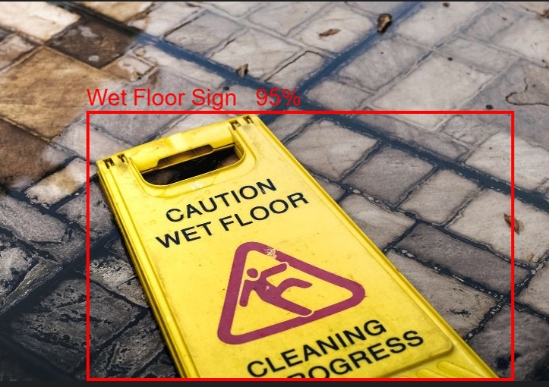
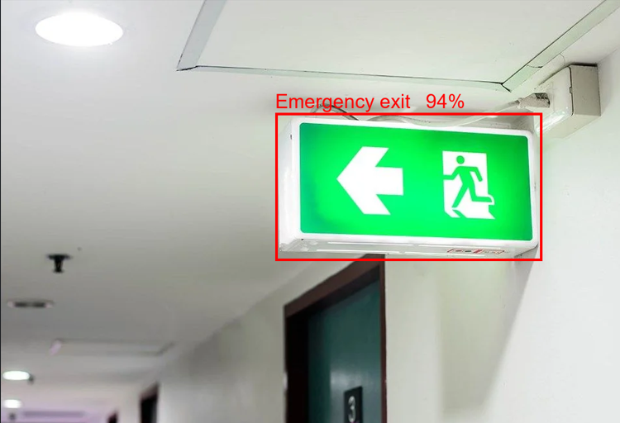
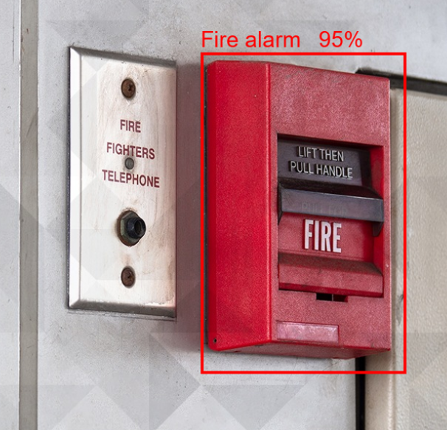
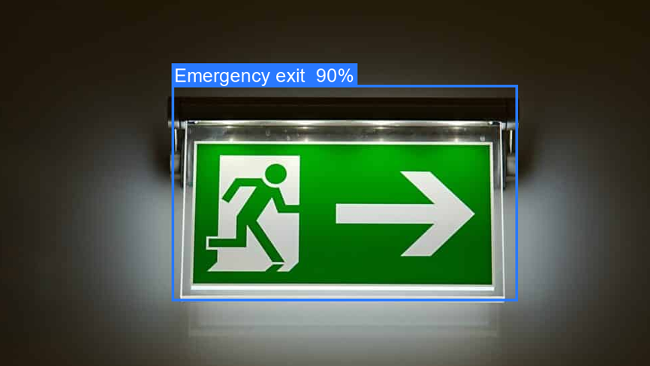

Data augmentation settings:
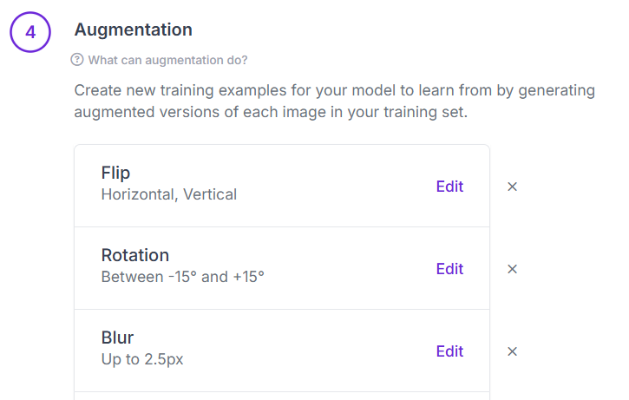
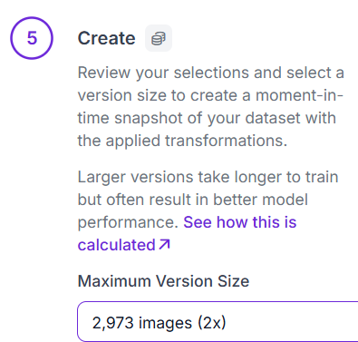
Parameter settings:
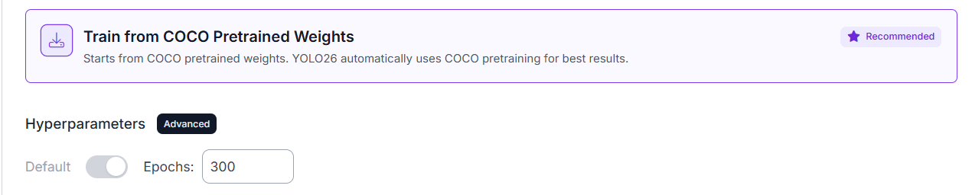
Dataset split:


Dataset quality check:
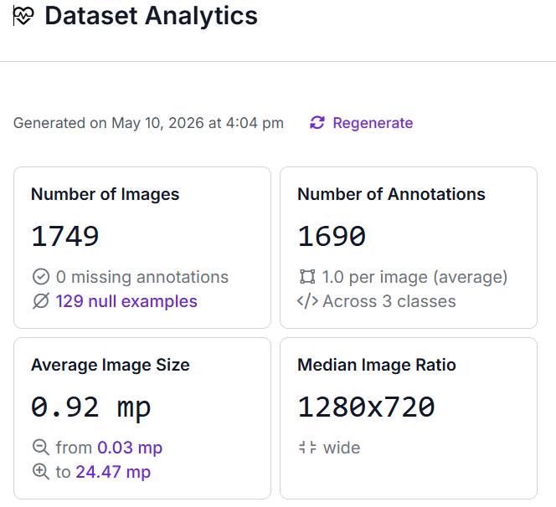

Code repository:
Includes the model, annotated and original dataset, and the code.
https://github.com/OssamaAlhussni/Object-detection/tree/main
Dataset link:
https://app.roboflow.com/ossamas-workspace-rckyc/project-2-trqfb/browse?queryText=&pageSize=50&startingIndex=0&browseQuery=true
Model Yolo26 link:
https://app.roboflow.com/ossamas-workspace-rckyc/project-2-trqfb/models/project-2-trqfb/5
Model Yolov11 link:
https://app.roboflow.com/ossamas-workspace-rckyc/project-2-trqfb/models/project-2-trqfb/6

References
- Dalal, N., & Triggs, B. (2005). Histograms of Oriented Gradients for Human Detection. https://lear.inrialpes.fr/people/triggs/pubs/Dalal-cvpr05.pdf
- Ren, S., He, K., Girshick, R., & Sun, J. (2017). Faster R-CNN: Towards Real-Time Object Detection with Region Proposal Networks. IEEE Transactions on Pattern Analysis and Machine Intelligence, 39(6), 1137–1149. https://doi.org/10.1109/tpami.2016.2577031
- Redmon, J., Divvala, S., Girshick, R., & Farhadi, A. (2016). You Only Look Once: Unified, Real-Time Object Detection. https://arxiv.org/pdf/1506.02640
- Tong, B., Li, G., Bu, X., Wang, Y., & Yu, X. (2025). A deep learning-based algorithm for the detection of personal protective equipment. PLOS One, 20(5), e0322115. https://doi.org/10.1371/journal.pone.0322115
- Ultralytics. (2023). Roboflow. Ultralytics.com. https://docs.ultralytics.com/integrations/roboflow/#upload-convert-and-label-data-for-yolo26-format
- Liu, L. (2025). Application of deep learning in behavior recognition and early warning system for campus safety management. PLOS One, 20(11), e0335040. https://doi.org/10.1371/journal.pone.0335040
- Jobin, A., Ienca, M. & Vayena, E. The global landscape of AI ethics guidelines. Nat Mach Intell 1, 389–399 (2019). https://doi.org/10.1038/s42256-019-0088-2
- Carion, N., Massa, F., Synnaeve, G., Usunier, N., Kirillov, A., & Zagoruyko, S. (2020). End-to-End Object Detection with Transformers. ArXiv:2005.12872 [Cs]. https://arxiv.org/abs/2005.12872
- Sapkota, R., Meng, Z., Churuvija, M., Du, X., Ma, Z., & Karkee, M. (2024). Comprehensive Performance Evaluation of YOLOv10, YOLOv9 and YOLOv8 on Detecting and Counting Fruitlet in Complex Orchard Environments. ArXiv.org. https://arxiv.org/abs/2407.12040
- Ultralytics. (2025). Ultralytics YOLO26. Ultralytics.com. https://docs.ultralytics.com/models/yolo26/#overview
- Ultralytics. (2024). YOLO11. Ultralytics.com. https://docs.ultralytics.com/models/yolo11/
- Hendrycks, D., & Dietterich, T. (2019). Benchmarking Neural Network Robustness to Common Corruptions and Perturbations. ArXiv:1903.12261 [Cs, Stat]. https://arxiv.org/abs/1903.12261
- Krizhevsky, A., Sutskever, I., & Hinton, G. E. (2012). ImageNet Classification with Deep Convolutional Neural Networks. Communications of the ACM, 60(6), 84–90.
- Bochkovskiy, A., Wang, C.-Y., & Liao, H.-Y. M. (2020). YOLOv4: Optimal Speed and Accuracy of Object Detection. ArXiv, 1. https://arxiv.org/abs/2004.10934
- Kornblith, S., Shlens, J., & Le, Q. V. (2019). Do Better ImageNet Models Transfer Better? ArXiv:1805.08974 [Cs, Stat]. https://arxiv.org/abs/1805.08974
- Shorten, C., & Khoshgoftaar, T. M. (2019). A survey on Image Data Augmentation for Deep Learning. Journal of Big Data, 6(1). https://doi.org/10.1186/s40537-019-0197-0
- Lin, T.-Y., Dollar, P., Girshick, R., He, K., Hariharan, B., & Belongie, S. (2017). Feature Pyramid Networks for Object Detection. Openaccess.thecvf.com. https://openaccess.thecvf.com/content_cvpr_2017/html/Lin_Feature_Pyramid_Networks_CVPR_2017_paper.html
- Tan, M., & Le, Q. V. (2019, May 28). EfficientNet: Rethinking Model Scaling for Convolutional Neural Networks. ArXiv.org. https://arxiv.org/abs/1905.11946
- UAE Government. (2021). Federal Decree by Law Concerning the Protection of Personal Data Federal Decree by Law No. (45) of 2021 Concerning the Protection of Personal Data. https://uaelegislation.gov.ae/en/legislations/1972/download
- UAE Government. (2024, November 7). UAE Strategy for Artificial Intelligence - The Official Portal of the UAE Government. U.ae. https://u.ae/en/about-the-uae/strategies-initiatives-and-awards/strategies-plans-and-visions/government-services-and-digital-transformation/uae-strategy-for-artificial-intelligence

