R_BASE

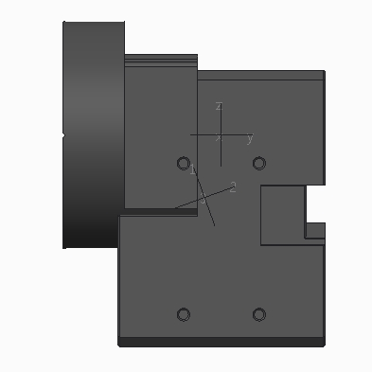

VOLUME = 9.1492975e+04 MM^3

SURFACE AREA = 2.4069864e+04 MM^2

AVERAGE DENSITY = 2.0418382e-06 KILOGRAM / MM^3

MASS = 1.8681385e-01 KILOGRAM

CENTER OF GRAVITY with respect to RA_BASE coordinate frame:

X Y Z 5.2172169e-04 -3.5433012e+00 -1.3214080e+01 MM

INERTIA with respect to RA_BASE coordinate frame: (KILOGRAM * MM^2)

INERTIA TENSOR:

Ixx Ixy Ixz 1.3035748e+02 3.1932021e-03 1.1810770e-03

Iyx Iyy Iyz 3.1932021e-03 1.0968963e+02 -6.6736731e-01

Izx Izy Izz 1.1810770e-03 -6.6736731e-01 6.0038088e+01

INERTIA at CENTER OF GRAVITY with respect to RA_BASE coordinate frame: (KILOGRAM * MM^2)

INERTIA TENSOR:

Ixx Ixy Ixz 9.5392110e+01 2.8478548e-03 0.0000000e+00

Iyx Iyy Iyz 2.8478548e-03 7.7069707e+01 8.0795311e+00

Izx Izy Izz 0.0000000e+00 8.0795311e+00 5.7692643e+01

RA1

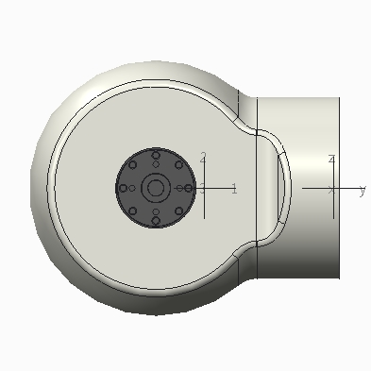

VOLUME = 1.5456454e+05 MM^3

SURFACE AREA = 6.6512132e+04 MM^2

AVERAGE DENSITY = 1.6243588e-06 KILOGRAM / MM^3

MASS = 2.5106828e-01 KILOGRAM

CENTER OF GRAVITY with respect to RA1 coordinate frame:

X Y Z 4.5422009e-01 -4.3392074e+01 -5.2043390e-04 MM

INERTIA with respect to RA1 coordinate frame: (KILOGRAM * MM^2)

INERTIA TENSOR:

Ixx Ixy Ixz 6.6587685e+02 5.4248447e+00 1.5731469e-03

Iyx Iyy Iyz 5.4248447e+00 1.0775305e+02 -1.5871079e-03

Izx Izy Izz 1.5731469e-03 -1.5871079e-03 6.5967298e+02

INERTIA at CENTER OF GRAVITY with respect to RA1 coordinate frame: (KILOGRAM * MM^2)

INERTIA TENSOR:

Ixx Ixy Ixz 1.9314739e+02 4.7640141e-01 1.5137964e-03

Iyx Iyy Iyz 4.7640141e-01 1.0770126e+02 4.0826933e-03

Izx Izy Izz 1.5137964e-03 4.0826933e-03 1.8689172e+02

RA2

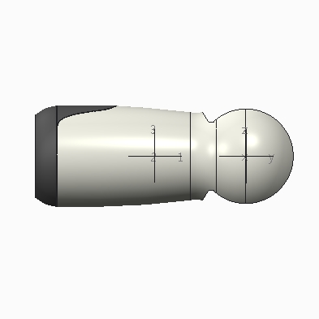

VOLUME = 1.8527422e+05 MM^3

SURFACE AREA = 1.0690806e+05 MM^2

AVERAGE DENSITY = 1.4203969e-06 KILOGRAM / MM^3

MASS = 2.6316293e-01 KILOGRAM

CENTER OF GRAVITY with respect to RA2 coordinate frame:

X Y Z -2.2708477e-02 -6.8183448e+01 -1.3860456e-02 MM

INERTIA with respect to RA2 coordinate frame: (KILOGRAM * MM^2)

INERTIA TENSOR:

Ixx Ixy Ixz 1.6726191e+03 -3.2327024e-01 1.3679928e-03

Iyx Iyy Iyz -3.2327024e-01 1.8873961e+02 -3.6610748e-01

Izx Izy Izz 1.3679928e-03 -3.6610748e-01 1.7167286e+03

INERTIA at CENTER OF GRAVITY with respect to RA2 coordinate frame: (KILOGRAM * MM^2)

INERTIA TENSOR:

Ixx Ixy Ixz 4.4917913e+02 8.4196051e-02 1.4508233e-03

Iyx Iyy Iyz 8.4196051e-02 1.8873943e+02 -1.1740439e-01

Izx Izy Izz 1.4508233e-03 -1.1740439e-01 4.9328859e+02

RA3

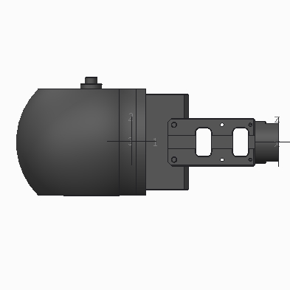

VOLUME = 1.2422211e+05 MM^3

SURFACE AREA = 4.6579987e+04 MM^2

AVERAGE DENSITY = 1.8148333e-06 KILOGRAM / MM^3

MASS = 2.2544242e-01 KILOGRAM

CENTER OF GRAVITY with respect to RA3 coordinate frame:

X Y Z 2.9928508e-04 -6.7483293e+01 5.0643015e-01 MM

INERTIA with respect to RA3 coordinate frame: (KILOGRAM * MM^2)

INERTIA TENSOR:

Ixx Ixy Ixz 1.2016130e+03 3.9290745e-03 0.0000000e+00

Iyx Iyy Iyz 3.9290745e-03 7.0953464e+01 8.4234000e+00

Izx Izy Izz 0.0000000e+00 8.4234000e+00 1.1977517e+03

INERTIA at CENTER OF GRAVITY with respect to RA3 coordinate frame: (KILOGRAM * MM^2)

INERTIA TENSOR:

Ixx Ixy Ixz 1.7489162e+02 -6.2412788e-04 0.0000000e+00

Iyx Iyy Iyz -6.2412788e-04 7.0895645e+01 7.1877594e-01

Izx Izy Izz 0.0000000e+00 7.1877594e-01 1.7108809e+02

RA4

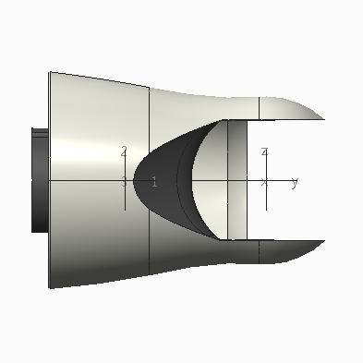

VOLUME = 1.5076389e+05 MM^3

SURFACE AREA = 8.1961536e+04 MM^2

AVERAGE DENSITY = 1.5007556e-06 KILOGRAM / MM^3

MASS = 2.2625975e-01 KILOGRAM

CENTER OF GRAVITY with respect to RA4 coordinate frame:

X Y Z -1.3358711e-01 -5.8087493e+01 -9.6098218e-02 MM

INERTIA with respect to RA4 coordinate frame: (KILOGRAM * MM^2)

INERTIA TENSOR:

Ixx Ixy Ixz 9.8840990e+02 3.8447745e-01 1.7678186e-02

Iyx Iyy Iyz 3.8447745e-01 1.4594795e+02 -1.1264272e+00

Izx Izy Izz 1.7678186e-02 -1.1264272e+00 9.5865455e+02

INERTIA at CENTER OF GRAVITY with respect to RA4 coordinate frame: (KILOGRAM * MM^2)

INERTIA TENSOR:

Ixx Ixy Ixz 2.2497191e+02 2.1401944e+00 2.0582792e-02

Iyx Iyy Iyz 2.1401944e+00 1.4594182e+02 1.3657842e-01

Izx Izy Izz 2.0582792e-02 1.3657842e-01 1.9521461e+02

RA5

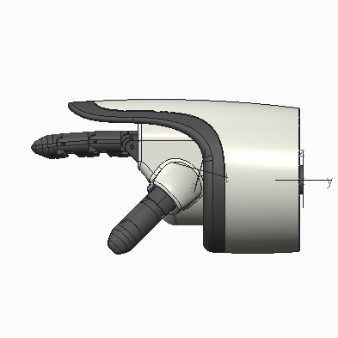

VOLUME = 2.0373895e+05 MM^3

SURFACE AREA = 1.3401935e+05 MM^2

AVERAGE DENSITY = 1.2765653e-06 KILOGRAM / MM^3

MASS = 2.6008606e-01 KILOGRAM

CENTER OF GRAVITY with respect to RA5 coordinate frame:

X Y Z 1.3880466e+00 -6.4104565e+01 6.1201242e+00 MM

INERTIA with respect to RA5 coordinate frame: (KILOGRAM * MM^2)

INERTIA TENSOR:

Ixx Ixy Ixz 1.5399065e+03 2.4466556e+01 1.4699118e+01

Iyx Iyy Iyz 2.4466556e+01 2.4889687e+02 1.6464826e+02

Izx Izy Izz 1.4699118e+01 1.6464826e+02 1.5208607e+03

INERTIA at CENTER OF GRAVITY with respect to RA5 coordinate frame: (KILOGRAM * MM^2)

INERTIA TENSOR:

Ixx Ixy Ixz 4.6136829e+02 1.3240668e+00 1.6908554e+01

Iyx Iyy Iyz 1.3240668e+00 2.3865400e+02 6.2609240e+01

Izx Izy Izz 1.6908554e+01 6.2609240e+01 4.5156319e+02

RF1

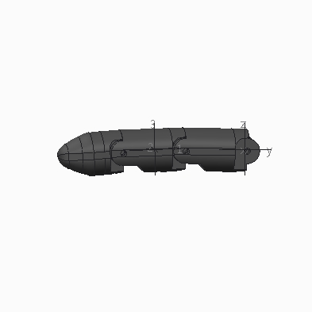

VOLUME = 8.1929027e+03 MM^3

SURFACE AREA = 5.7212425e+03 MM^2

AVERAGE DENSITY = 1.0000000e-06 KILOGRAM / MM^3

MASS = 8.1929027e-03 KILOGRAM

CENTER OF GRAVITY with respect to RF1 coordinate frame:

X Y Z 4.0198553e+00 -2.8601502e+01 1.2028061e-03 MM

INERTIA with respect to RF1 coordinate frame: (KILOGRAM * MM^2)

INERTIA TENSOR:

Ixx Ixy Ixz 9.0898557e+00 1.2310440e+00 1.9453643e-02

Iyx Iyy Iyz 1.2310440e+00 4.3736555e-01 -8.5085403e-02

Izx Izy Izz 1.9453643e-02 -8.5085403e-02 9.3314205e+00

INERTIA at CENTER OF GRAVITY with respect to RF1 coordinate frame: (KILOGRAM * MM^2)

INERTIA TENSOR:

Ixx Ixy Ixz 2.3876853e+00 2.8907407e-01 1.9493257e-02

Iyx Iyy Iyz 2.8907407e-01 3.0497448e-01 -8.5367256e-02

Izx Izy Izz 1.9493257e-02 -8.5367256e-02 2.4968591e+00

|  |  |  |  |
| --- | --- | --- | --- |
| R_BASE-RA1 | 0 | -24.5 | 0 |
| RA1-RA2 | 0 | -59.75 | 0 |
| RA2-RA3 | 0 | -95.25 | 0 |
| RA3-RA4 | 0 | -86 | 0 |
| RA4-RA5 | 0 | -87.45 | 0 |
| RA5-LF1 | 21.2078 | -107.735 | 21.3208 |