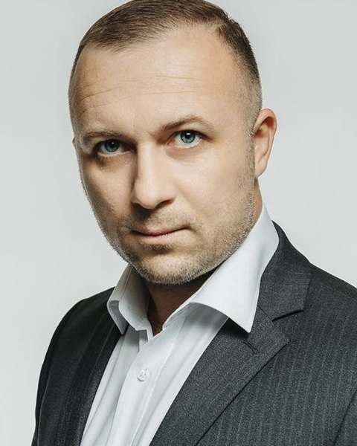
Ostap Dotsenko
Business Development & Marketing Leader
Business Development | B2B Marketing | E-commerce | Russia, China, Southeast Asia
Phone: +86 137 6171 6355; +7 985 874-49-58 (WhatsApp)
E-mail: norbanking@gmail.com | Telegram: @ostapdotcenko
LinkedIn: linkedin.com/in/ostapdotсenko (11,000+ followers)
Website: ostapdotcenko.ru | Location: Shanghai, Moscow (hybrid)

Target role
CBDO, CMO or Head of International Expansion: Russia — China — Southeast Asia.

Profile
13+ years in business development and marketing at the crossroads of Russia, China and Southeast Asia. Led B2B marketing at Megamarket (Russia’s #3 e-commerce, Sber ecosystem) and the O2O business at AliExpress Russia & CIS (Alibaba Group); since 2025, owner of a company in Shanghai. Teams of up to 40, a marketing budget of over RUB 1 bn a year, P&L at Megamarket, Alibaba and my own business. Federal programs, partnerships with banks, telecoms and government bodies. 20+ countries, 5 languages, including Chinese (B2+).

Key results
- +350% sellers year over year, 50,000 sellers on the platform (Megamarket).
- RUB 3 bn net profit — my programs’ impact, Q4 2023 (Megamarket).
- Federal program with the Ministry of Economic Development of Russia in 86 regions (Megamarket).
- From 0 to 2,000 companies in the “Made in Russia” program, 2024 (Megamarket).
- GMV $48M, +100% year over year; new buyers +185% (AliExpress Russia & CIS).
- Average campaign ROI 25x; 120+ media holding partners (Alibaba Group, 2020–2022).
- Turnkey corporate forum for Megamarket (Sber) in Shenzhen with 1,200+ attendees (own business).

Work experience

Owner & Founder — Shanghai Pinnacle Technology Co., Ltd.
2025 — present | Shanghai, China
GlobalTechTour — tech expeditions and benchmark tours across China and SEA; Aura Robotics — robotics and automation, sourcing robots directly from Chinese manufacturers. Owner’s P&L.
- Delivered a turnkey corporate forum for Megamarket (Sber) in Shenzhen with 1,200+ attendees: logistics, venue and business program.
- Organize delegation visits to the factories and R&D centers of BYD, Xiaomi, Baidu, Meituan, Poizon, Leju Robotics; Aura clients get direct access to the leadership and R&D of robot manufacturers.
- BelMol closed a dairy-automation deal in a 2-hour meeting at the Kepler factory; SolarTek toured Leju Robotics, Robotera, AgiBot and Kepler in 5 days.

Head of B2B Marketing — Megamarket (Sber ecosystem)
2023 — 2025 | Russia
Russia’s #3 e-commerce. Team of 16–40 (direct and through leads), marketing budget of over RUB 1 bn a year, P&L ownership for the business line.
- Built B2B seller-acquisition marketing: +350% sellers year over year, 50,000 sellers on the platform; my programs’ impact — RUB 3 bn net profit (Q4 2023).
- Launched a federal entrepreneur support program with the Ministry of Economic Development of Russia, run through “My Business” centers in 86 regions: acquisition strategy, materials and regional communications built from scratch.
- Ran the federal Megasreda marathon in 20 cities — from concept and logistics to content and PR; 1M+ views.
- Launched “Made in Russia”: brand program, onboarding and video campaign — from 0 to 2,000 companies.
- Inclusive marketplace for producers with disabilities: positioning, UX, PR campaign.

Independent Adviser — AdTech / MarTech / EduTech
2022 — 2023 | Uzbekistan, Kazakhstan, Southeast Asia
- Advised companies including MyDars and HiTarget (Indonesia): 20+ partners, product localization for SEA.

Head of O2O & New Business — Alibaba Group (AliExpress Russia & CIS)
2020 — 2022 | Russia and CIS
Team of up to 5, P&L ownership for the O2O business line.
- Built O2O partnerships with Alfa-Bank, Tinkoff, MTS Bank, MegaFon, Beeline, Rosneft and 120+ media holdings.
- GMV $48M (+100% year over year), new buyers +185%, average campaign ROI 25x.

Co-founder — O.F.D Creative Agency
2017 — 2020 (2017 — preparation and launch) | Shanghai, Hong Kong
Owner’s P&L.
- Joint Chinese-Russian team project: advertising solutions that promote businesses in the Chinese and Russian markets.
- Clients: FOREO, DECATHLON, Bank of China, WWE, CDEK.

Head of Commerce & BD — Data Centric Alliance
2015 — 2017 | Moscow, Shanghai
- Led media buying and business development in Asia; partners — Google HK, Yahoo HK, Tencent, Ctrip, Baidu.

BD Manager (China / SEA) — CityAds Media
2013 — 2015 | China, Southeast Asia
- Grew performance and affiliate marketing (CPA / CPC / CPL) in China and Southeast Asia; clients included Sasa (Hong Kong).

Key skills
- Business Development: market-entry strategy, partnerships and alliances, C-level negotiations, BD Asia & CIS, launching new business lines.
- Marketing: B2B Marketing, Demand Generation, Performance Marketing, Product Marketing, Sales Enablement, brand programs.
- Technology and data: e-commerce and marketplaces, AdTech / MarTech, Marketing Automation, CRM & Analytics, O2O.
- Communications: GR and government programs, federal events, PR; 50+ expos and forums in Russia and the CIS.

Languages
- Russian — native; English — C1; Chinese — B2+; Uzbek — B1; Korean — A2.

Education
- MIU — Civil Law.
- Lyceum under TashSIL — Korean Language Teacher.

Media and speaking
- RBC — interview “The key is to know your fundamentals and not be afraid”; RBC Industries.
- Sber Business — expert guide “Marketplaces: the complete guide to earning”.
- TASS — Ulyanovsk region and Megamarket develop a regional product showcase; “My Business” — Megasreda marathon, 1M+ views.
- Speaking: Russian Retail Show 2024 (speaker), Amber Forum 2024 (panel discussion), Manufacturers’ Summit, Irkutsk, 2024 (panel), Russian Retail Week 2025, SCO Forum 2025, federal Megasreda marathon.

Contact and links
- Phone: +86 137 6171 6355; +7 985 874-49-58 (WhatsApp). E-mail: norbanking@gmail.com
- Website: ostapdotcenko.ru (Russian, English, Chinese); blog: ostapdotcenko.ru/blog — new articles daily
- LinkedIn: linkedin.com/in/ostapdotсenko — 11,000+ followers
- Telegram: @ostapdotcenko; Instagram: @ostap.dotsenko; Facebook: Ostap Dotsenko
- Projects: globaltechtour.ru (and blog); aura-robotics.ru (and blog)
References available on request.

