**INFORMATION RETRIEVAL**



**ASSIGNMENT TOPIC:**

Vector Space Model

Faraz Sarwar 18k-1182

Sec:6E

Introduction:

The Assignment is based on information retrieval system . Vector Space Model is used to satisfy the system. User will Enter FREE TEXT QUERIES and get the relevant output IN GUI as well as Command Line interface .

The project shall be built using Tkinter, Python .

**GOOGLE COLAB LINK ::**

<https://colab.research.google.com/drive/1T4deHJMx122ybXYUXVTZlwhIbG3bAAYo#scrollTo=ubCrKhf30u5L>

**GITHUB :**

[**https://github.com/OsterFar/VECTOR_SPACE_MODEL_GUI**](https://github.com/OsterFar/VECTOR_SPACE_MODEL_GUI)

**GRAPHICAL USER INTERFACE : :**

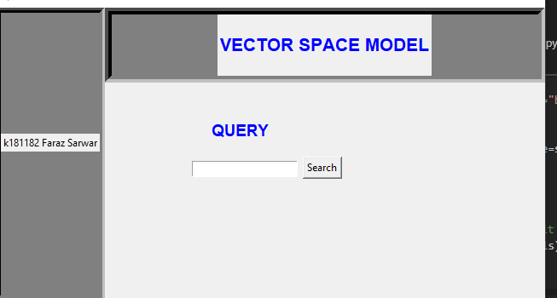

**QUERY:**

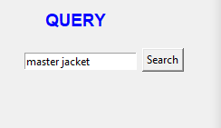

**RESULT:**

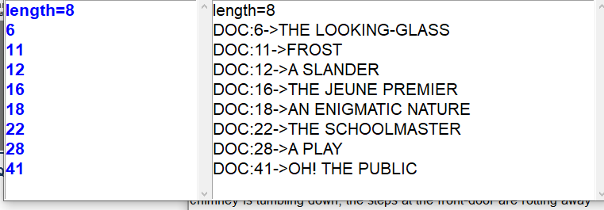

**Now , I click 11 so Doc11 content appear**

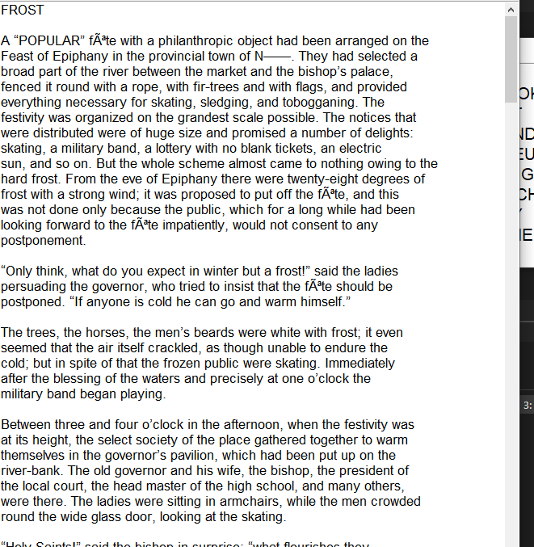

**==================================ThanKYou==============================**