
EE40FD: Electrical Machines and Drives
Induction Machine Modeling
Brian J. Osterman
University of Aberdeen, UK
Abstract
This report sets forth to show the derivation of an Induction Machine in general rotating reference frame. It also aims to show simulate such a machine using the libraries and functionality provided by the MATLAB software suite. In addition it will show how slip range, and rotational speed affects the machine torque.

Modeling

Derivation
For the derivation of the machine model in general rotating reference form it is important to start in with the general reference form, as the rotating reference is built upon that foundation. This is done by adjusting the equations found by the initial derivation to take into consideration the rotor position at any given angle θ_{g}.
Analysis of the general reference frame starts with the voltage equations for both the stator and rotor circuits. From basic analysis of the stator and rotor variables for a standard three phase induction machine, we find the voltage equations for these two circuits in the natural reference frame to be:
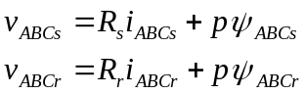 (1)
Where s and r represent the stator and rotor respectively, and ABC refers to matrices in the form:
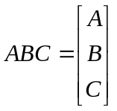 ie: 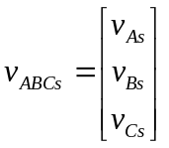 (2)
The matrix equations for flux linkage are also found to be:
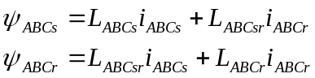 (3)
The matrices for self inductance of the two circuits shown in the equations above are defined as follows:
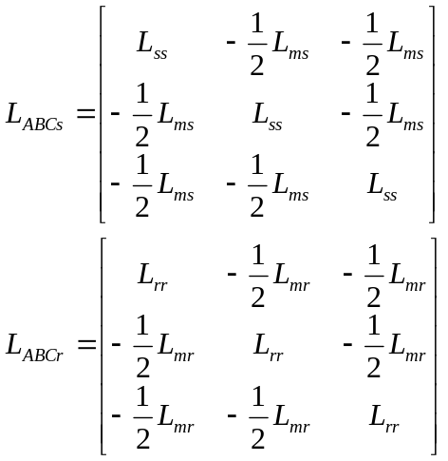 (4)
Matrix L_{ABCsr} represents the relationship between stator and rotor variables depending on rotor angle θ_{r}. Since the machine has symmetry it can be assumed that L_{ABCsr} = L_{ABCrs}.
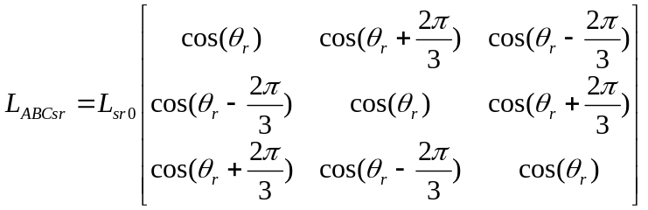 (5)
Where 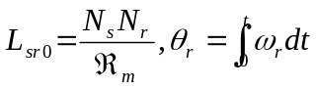 (6)
The elements in the above matrix are at maximum value when the windings overlap.
Since the above matrix varies with time and therefore is difficult to analyse the model can and should be converted for ease of use. This can be done by firstly refering all of the rotor variables directly to the stator as shown:
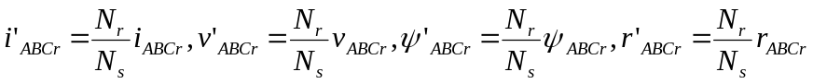 (7)
Substituting these new values into equations the new expression for voltage is obtained:
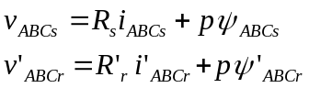 (8)
Flux linkage equations become:
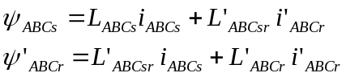 (9) where: 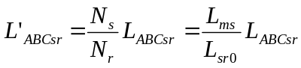 (10)
And the matrix L’_{ABCr} is given as:
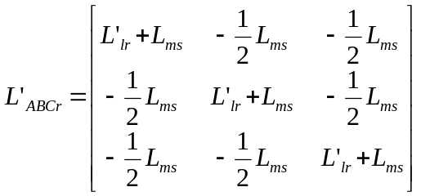 (11)
Where: 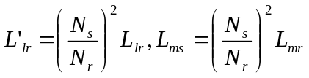 (12)
In general the transformation of stator variables follows the form:
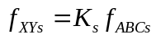 (13)
where 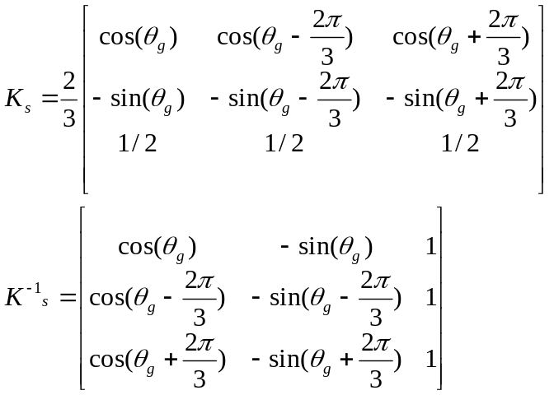 (14)
Similarly for the rotor variables:
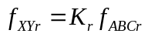 (15)
where 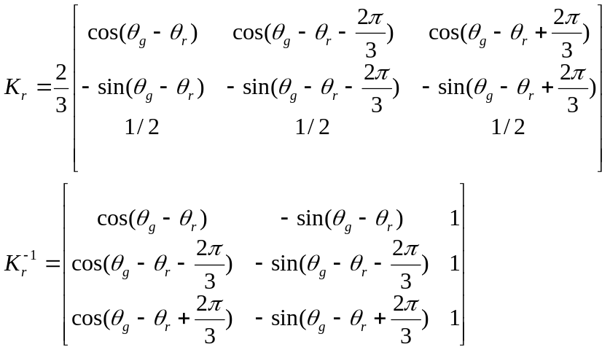 (16)
The angle of transformation for the rotor variables is 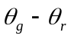because the rotor has its own position relative to the static frame.
Using the transformation formulas for the stator and rotor and then multiplying the voltage equations by the respective K matrix, the voltage equations can once again be rewritten:
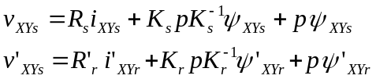 (17)
While the resistance matrices remain unaffected by the transformations.
Using the relations proven by the attached MATLAB code, it is shown that the voltage equations can again be rewritten to a simpler form:
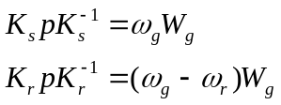 (18) where 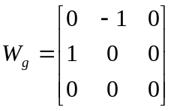 (19)
Thus the voltage equations become:
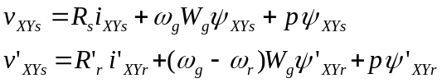(20) *Circuit voltage is proportional to the corresponding angular speed
Similarly the flux equations can be transformed as above and then subsequently simplified using relations again proved by the attached MATLAB calculations. First using the K transformations the flux equations are changed to:
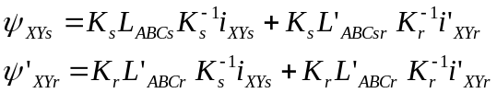 (21)
In MATLAB it is proven that we can simplify the above flux equations using the following relations:
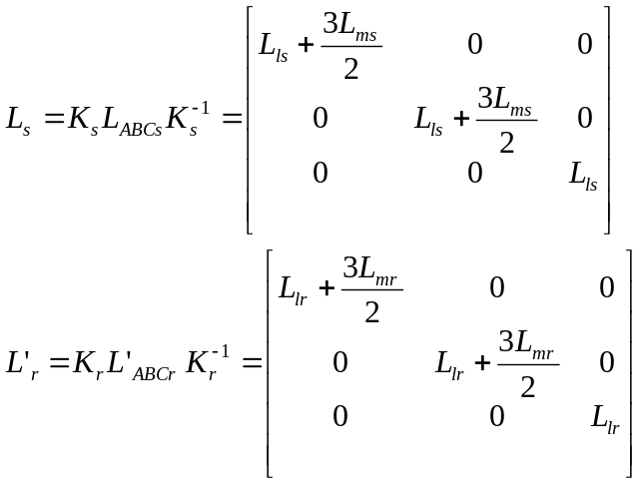 (22)
Now the inductance between the stator and the rotor (L’_{sr}) and vice-versa (L’_{rs}) can be obtained by the combination of (10) and (5) with the expressions for K_{s} and K⁻¹_{s}. I. The matrix is derived to be:
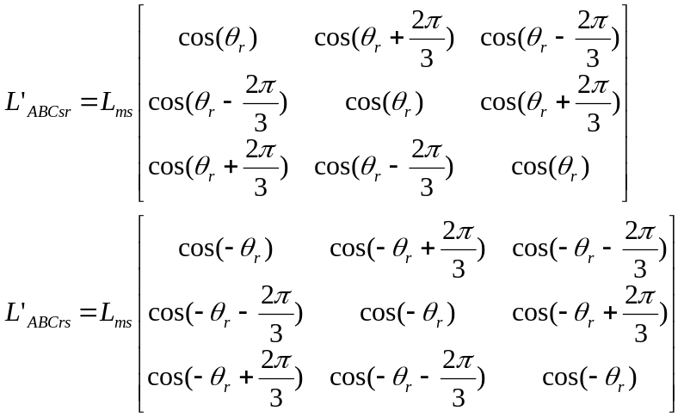 (23)
From this it can be shown that the mutual inductance matrix is defined and proven by:
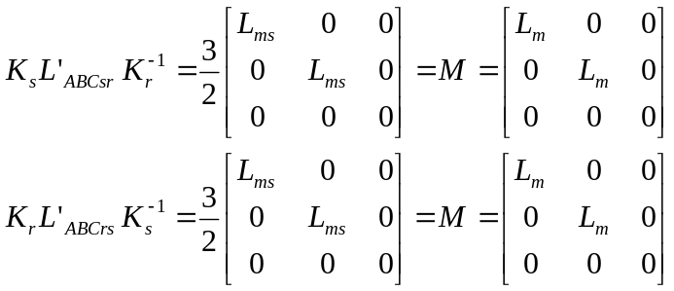 (24)
Where L_{m} is the magnetizing inductance. The relations above are again proved in the attached MATLAB code.
It can be seen that the from the two transformations above, that the mutual inductance matrix is converted to a matrix M where all the time-varying components are no longer present, being replaced by a matrix with constant coefficients. In addition, where the previous matrix had all non-zero elements, it is now represented by a diagonal matrix which implies that the stator and rotor components only interact on the same axis (ie: no interaction between the x-axis and y-axis variables).
Finally the flux equations can be further simplified:
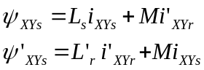 (25)
Using (25) the voltage equations are now represented as:
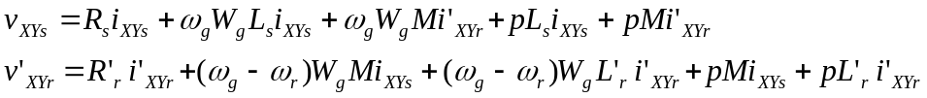 (26)
Now that the induction machine model in general rotating reference frame has been achieved, it can be further broken down for analysis by separating the X and Y components for the expanded form of voltage:
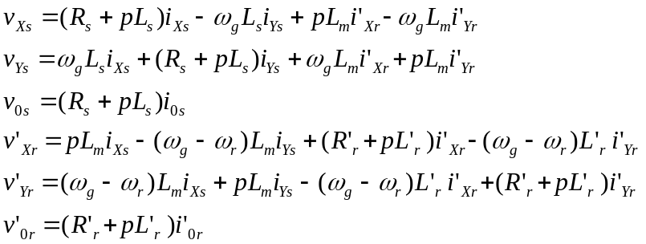 (27)
In matrix form it is represented as:
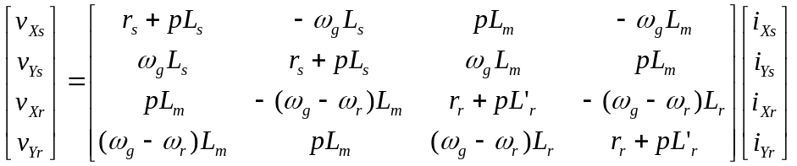 (28)
Prime notation is used because rotor parameter have been transferred to the stator side, however since data is typically given on the stator side, notation can be simplified without using the prime notation (‘).
The induction machine given by this assignment to derive is defined by the following parameters:
Stator operating frequency: 50Hz
Stator Voltage: 400V
Number of poles: 2
Stator Resistance: 0.12Ω
Stator Leakage Inductance: 0.0001H
Main Magnetizing Inductance: 0.01H
Rotor Resistance: 0.02Ω
Rotor Leakage Inductance: 0.0001H
Based on the general derivation above, the model for this machine is given to be:
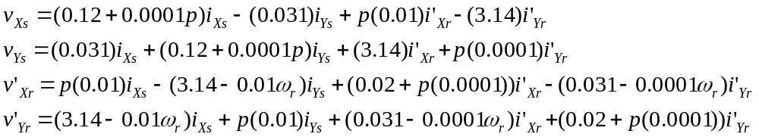 (29)

The MATLAB code used that proved the necessary matrix derivations is as follows:
%% Show Ks*pKs^-1 = w_g * Wg
syms theta_g;
Ks = (2/3)*([cos(theta_g), cos(theta_g - (2*pi/3)), cos(theta_g + (2*pi/3)); -sin(theta_g), -sin(theta_g - (2*pi/3)), -sin(theta_g + (2*pi/3)); 0.5, 0.5, 0.5 ]);
Ks_inv = [cos(theta_g), -sin(theta_g), 1; cos(theta_g - (2*pi/3)), -sin(theta_g - (2*pi/3)) 1; cos(theta_g + (2*pi/3)), -sin(theta_g + (2*pi/3)) 1];
pKs_inv = diff(Ks_inv)

fun1 = Ks*pKs_inv
KspKs_inv = simplify(fun1)

%% Show Kr*pKr^-1 = (w_g - w_r)*Wg
syms theta_r;
Kr = (2/3)*([cos(theta_g-theta_r),cos(theta_g-theta_r-(2*pi/3)),cos(theta_g-theta_r+(2*pi/3));-sin(theta_g-theta_r),-sin(theta_g-theta_r-(2*pi/3)),-sin(theta_g-theta_r+(2*pi/3));0.5 0.5 0.5]);
Kr_inv = [cos(theta_g-theta_r),-sin(theta_g-theta_r),1;cos(theta_g-theta_r-(2*pi/3)),-sin(theta_g-theta_r-(2*pi/3)),1;cos(theta_g-theta_r+(2*pi/3)),-sin(theta_g-theta_r+(2*pi/3)),1];
pKr_inv = diff(Kr_inv)

fun2 = Kr*pKr_inv
KrpKr_inv = simplify(fun2)

%% Show Ls = Ks*L_ABCs*Ks_inv
syms Lms Lls;
Lss = Lms + Lls;
L_abcs = [Lss,(-0.5)*Lms,(-0.5)*Lms;(-0.5)*Lms,Lss,(-0.5)*Lms;(-0.5)*Lms,(-0.5)*Lms,Lss];
Ls = Ks*L_abcs*Ks_inv
proof3 = simplify(Ls)

%% Show L'r = Kr*L'_ABCr*Kr_inv
syms Lmr Llr;
Lrr = Lmr + Llr;
L_abcr = [Lrr,(-0.5)*Lmr,(-0.5)*Lmr;(-0.5)*Lmr,Lrr,(-0.5)*Lmr;(-0.5)*Lmr,(-0.5)*Lmr,Lrr];
Lr = Kr*L_abcr*Kr_inv
proof4 = simplify(Lr)

%% Show Ks*L'_ABCsr*Kr_inv = M
L_abcsr = Lms.*[cos(theta_r),cos(theta_r+(2*pi/3)),cos(theta_r-(2*pi/3));cos(theta_r-(2*pi/3)),cos(theta_r),cos(theta_r+(2*pi/3));cos(theta_r+(2*pi/3)),cos(theta_r-(2*pi/3)),cos(theta_r)];
fun5 = Ks*L_abcsr*Kr_inv
proof5 = simplify(fun5)

%% Show Kr*L'_ABCrs*Ks_inv
L_abcrs = Lms.*[cos(-theta_r),cos(-theta_r+(2*pi/3)),cos(-theta_r-(2*pi/3));cos(-theta_r-(2*pi/3)),cos(-theta_r),cos(-theta_r+(2*pi/3));cos(-theta_r+(2*pi/3)),cos(-theta_r-(2*pi/3)),cos(-theta_r)];
fun6 = Kr*L_abcrs*Ks_inv;
proof6 = simplify(fun6)

MATLAB/SIMULINK Model
The machine model for simulation of the induction machine given above and derived at (29) is shown below. This model includes a step change to alternate between 2 different slip values (2% and 3%). This will be executed at 1 second of simulation time when testing. The variables are stored in a MATLAB file and pulled into the simulation from the workspace after running the code. This machine simulation takes the outcome of the system, in this case the current variables, and uses their values to calculate the torque of the machine. This gives us the torque of the machine starting at 2% slip, and at 1 second applying a step change of 3% slip to the system.

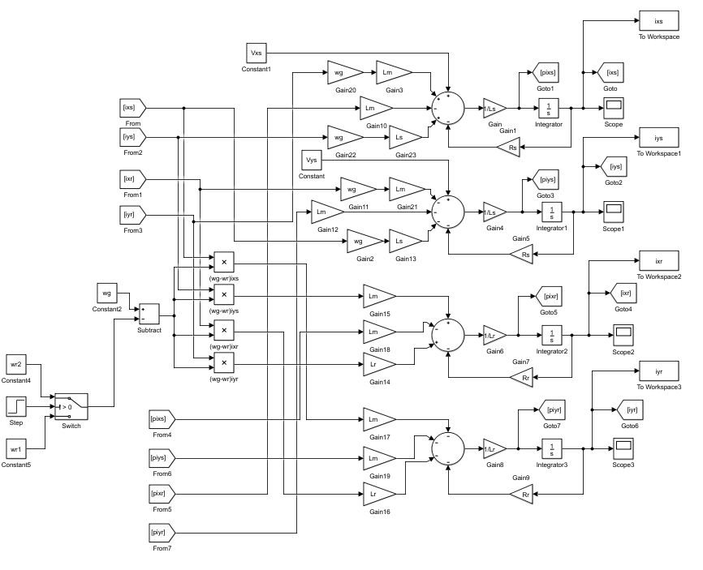

Results
Below are the graphical results from the simulation of the derived induction machine model shown above. The below graphs also include mapping of Torque during the simulation. They were obtained using data stored set in the MATLAB code:

fs = 50; %Hz
wg = 2*pi*fs;
Vxs = 400/(sqrt(3)); %V
Vys = 0;
P = 2; %poles
Rs = 0.12; %Stator Resistance
Rr = 0.02; %Rotor Resistance
Lls = 0.0001; %Stator Leakage Inductance
Llr = 0.0001; %Rotor Leakage Inductance
Lm = 0.01; %Magnetizing Inductance
we = wg;
wr1 = 0.98*we; % 2% slip
wr2 = 0.97*we; % 3% slip
Ls = Lls + Lm;
Lr = Llr + Lm;

load_system('InductionMachine_system')
set_param('InductionMachine_system','SimulationCommand','Start');
%% Calculate Torque
Te = -(3/2)*(P/2)*Lm*((iys*ixr) - (ixs*iyr))
plot(Te)

Slip vs Time
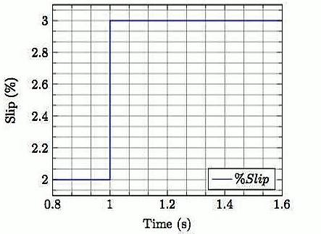

Current Ixs vs Time
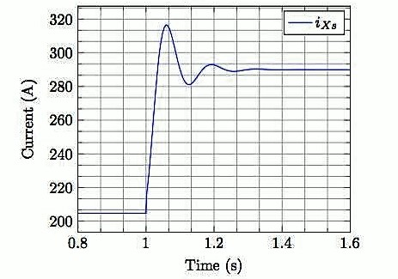

Current Iys vs Time
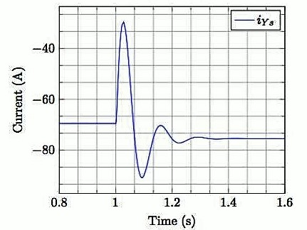

Current Ixr vs Time
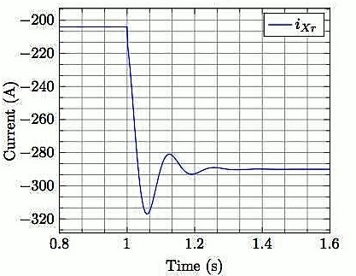

Current Iyr vs Time
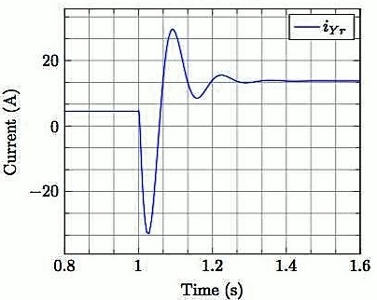

Torque vs Time
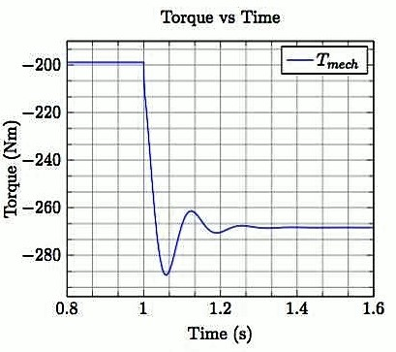

Discussion
While there are different general reference frames to pick from for simulation this assignment called for the use of the rotating reference frame. Two commonly used frames of reference for induction machines are the stationary reference frame, and the rotating reference frame. Rotating reference can be split into two subcatagories: rotor reference frame and the synchronously rotating reference frame. In the stationary reference frame, the d,q axis of the machine do not rotate. For the synchronously rotating reference frame, the system axis rotate at synchronous speed. Likewise for the rotor reference frame, the axis rotate at the rotor speed.
For the application used in this assignment it is more practical and in fact typically easier to use a rotating reference frame. As stated above in the derivation, the matrix L_{ABCsr} varies with time which is challenging to analyze. This assignment has a changing slip in the simulation, as such it makes even more sense to use a rotating reference frame in order to analyse and model the system.
From the general reference frame model of the system it can be shown that a change in stator speed (ω_{g}) will introduce different responses by the system. At low frequencies for stator speed it can be expected that the machine will have longer settling times. As the system frequency increases it is expected that the system will have shorter settling times. The downside to having high frequencies however is that typically there is more radical oscillations as it settles. This mean that there is less torque. Low frequency means higher torque. Depending on the necessary application of an induction machine it may be preferable to aim for one over the other.

Conclusion

By deriving the model for an induction machine, as well as building a digital model to use for simulation it provides greater comfort with Induction machines as a whole. By simulating users are able to see how the different components change the settling time and responses for the system. For derivation it can be shown that knowledge in tools such as MATLAB are advantageous as they simplify the amount of work needed by the user. It allows the user to incrementally multiply and simplify the matrices made from the derivation of the system. Otherwise there would be long chains of trigonometric relationships to be evaluated and simplified.

References
Ahmed, K. (2016). EE40FD Electrical Machines and Drives: Induction Machine Analysis. The University of Aberdeen, Part IV, 1-17.

