Table of Contents

1. Introduction 1

1.1 Purpose 1

1.2 Scope 1

1.3 Definitions, acronyms, and abbreviations 1

1.4 References 1

2. Overall descriptions 1

2.1 Product perspective 1

2.2 Product functions 2

2.3 User characteristics 4

2.4 Constraints 4

2.5 Assumptions and dependencies 4

3. Specific requirements 4

# 1. Introduction

This section gives a scope description and overview of everything included in this SRS document.

## 1.1 Purpose

## 1.2 Scope

The scope of this project is to create a Web application in order to provide an interface for the common user to view , having the option to buy, as a user, many types of clothing.

## 1.3 Definitions, acronyms, and abbreviations

## 1.4 References

# 2. Overall descriptions

## 2.1 Product perspective

There are two classes of users: new customer and registered customer .The new customer will face an interface which is a part of the Web application that will allow him to browse through the categories of clothes and has the option of creating an account.By creating an account, the new customer becomes a registered customer that can add products in the shopping cart and place orders.The application requires an internet connection as a method to order the products exposed on the site.

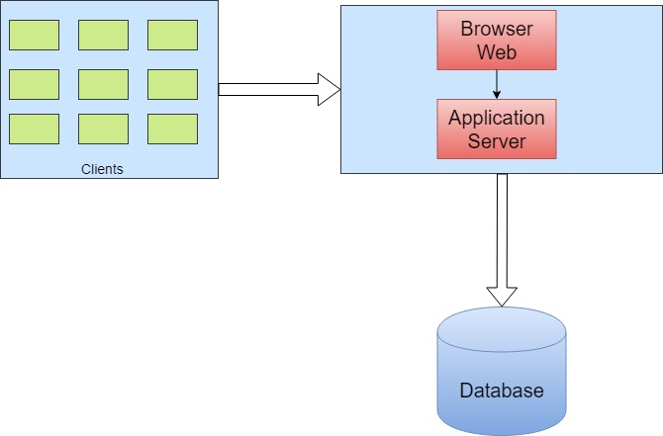

## 2.2 Product functions

## FirstUseCase.jpg

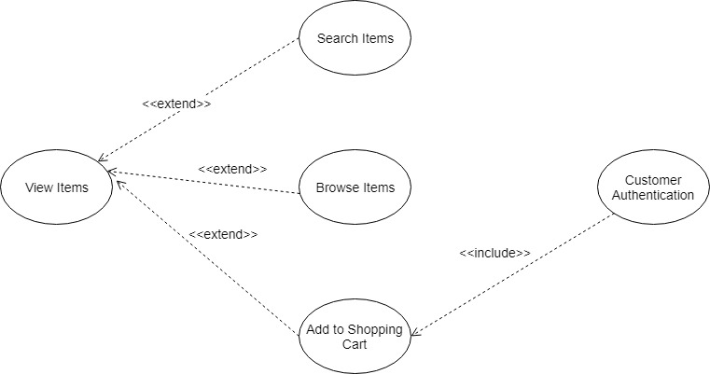

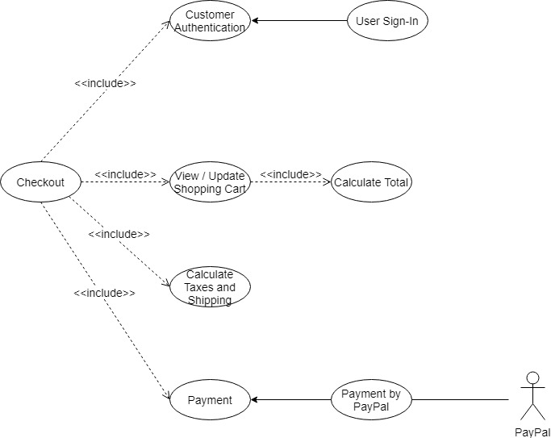

Using this application, the users will be able to view the items that are for sale using a Web Browser.The users can afford to filter some results: adults or children.Searching for a specific product is done by using the name in the search field.

After the users log in, they can add products in their shipping cart where they can see a total price for the current order, having the option of sending the order or canceling the order.Additional information about shipping and taxes is displayed near the value that they have to pay for the order.

## 2.3 User characteristics

There are two types of users that interact with the system: new and registered customers .Each of these types of users has different use of the system so each of them has their own functionalities as listed below.

The new customers can only view the items: search for items, browse for items.

The registered customers can also make a purchase: add items to the shopping cart and make a payment.

## 2.4 Constraints

## 2.5 Assumptions and dependencies

# 3. Specific requirements

This section contains all of the functional and quality requirements of the system. It gives a detailed description of the system and all its features.