# MATH 1061/1060 Calculus I Test 1 (Version A)

Friday, September 16, 2022

Name:

M Number:

# Part I: Multiple Choice Questions

* Do not open this booklet until you are given permission by your proctor.
* Make sure your two booklets match in Version (indicated by the color and indicated at the top of the cover page.)
* This booklet contains 12 multiple choice questions. Circle your answers here AND fill in the bubbles on the bubble sheet, found at the end of the Part II booklet.

# Part I: Multiple Choice Questions

There are 12 questions each worth 5 points. Circle your answer in this booklet **AND** fill in the bubbles on the bubble sheet. You can find the bubble sheet at the end of Part II.

1. In the picture below, what is the value of *y*?

*y*

4

*π/*6

* 1. 8
  2. 2

(C) 2*√*3

(D) 2*√*2

1

(E)

2

1. The expression ln

*x*3*ex y*2*√z*

can be written as

* 1. 3 ln(*x*) + *ex* 2 ln(*y*) + 1 ln(*z*)

*−*

2

1

* 1. 3 ln(*x*) *−* 2 ln(*y*) + 2 ln(*z*)

1

* 1. 3 ln(*x*) *−* 2 ln(*y*) *−* 2 ln(*z*)

1

* 1. 3 ln(*x*) + *x −* 2 ln(*y*) *−* 2 ln(*z*)

1

* 1. 3 ln(*x*) + *x −* 2 ln(*y*) + 2 ln(*z*)

1. The position of a particle in meters moving along a straight line after *t* seconds is given by the function *s*(*t*) = *t*2 *t* + 3. What is the average velocity of the particle during the time interval between *t* = 0 and *t* = 2 seconds?

*−*

* 1. 0 meters per second
  2. -3 meters per second
  3. 3 meters per second
  4. 1 meter per second
  5. -1 meter per second

1. Evaluate

lim

*x→*2*−*

*x*2 4*x* + 3

*.*

*−*

*x −* 2

If the limit is infinite, specify *∞* or *−∞*. If it otherwise does not exist, select DNE.

1. 0
2. *∞*
3. *−∞*
4. 4
5. DNE
6. Suppose *f* (*x*) is a function satisfying 2*x* 1 *f* (*x*) *x*2 for all *x*. For which values of *a* can the Squeeze Theorem be used to calculate lim *f* (*x*)?

*— ≤ ≤*

*x→a*

* 1. *a* = 0 only
  2. none of these 1
  3. *a* =

2

only

1

* 1. *a* = 0 and *a* =

2

* 1. *a* = 1 only

1. Calculate

only

lim

*x→∞*

*√x* + *x*2 + 4*x*8 3 + 4*x*4 *.*

If the limit is infinite, specify *∞* or *−∞*. If it otherwise does not exist, select DNE.

* 1. 4

1

2

* 1. *∞*
  2. *−∞*
  3. DNE

1. Calculate

lim

*x→*4

*√x*2 + 9 5

*.*

*−*

*x −* 4

If the limit is infinite, specify *∞* or *−∞*. If it otherwise does not exist, select DNE.

1. 8

4

5

1. DNE
2. *−∞*
3. *∞*
4. For what value of *c* is the function

(

*f* (*x*) =

continuous at *x* = 1?

* 1. -4
  2. 1
  3. -3
  4. 0
  5. It is not possible to find such a *c*.

*x*2 *−* 4 if *x ≤* 1 1 *− x* + *c* if *x >* 1

1. Suppose lim

*x→*2+

*f* (*x*) = 2, lim

*x→*2*−*

*f* (*x*) = 2, and *f* (2) = 3. Which of the following statements can we

conclude to be true?

1. lim *f* (*x*) = 2.

*x→*2

1. *f* (*x*) has a jump discontinuity at *x* = 2.
2. *f* (*x*) is differentiable at *x* = 2.
3. I only
4. II only
5. III only
6. I and III
7. I and II
8. Suppose that the the tangent line to *y* = *f* (*x*) at *x* = 1 passes through the points (1*,* 1) and (0*, −*1). Find *f* (1) and *f′*(1).

(A) *f* (1) = 1 and *f′*(1) = 1

(B) *f* (1) = 1 and *f′*(1) = *−*2

(C) *f* (1) = 1 and *f′*(1) = 2

(D) *f* (1) = 2 and *f′*(1) = 1

(E) *f* (1) = *−*2 and *f′*(1) = 1

1. Evaluate

lim

*x*2 *− x −* 6

*x→*3 *x*

2

*.*

*—* 2*x −* 3

If the limit is infinite, specify *∞* or *−∞*. If it otherwise does not exist, select DNE.

5

(A)

4

3

(B)

2

1. DNE
2. *∞*
3. *−∞*
4. Use the graph of *y* = *f* (*x*) to consider the statements.

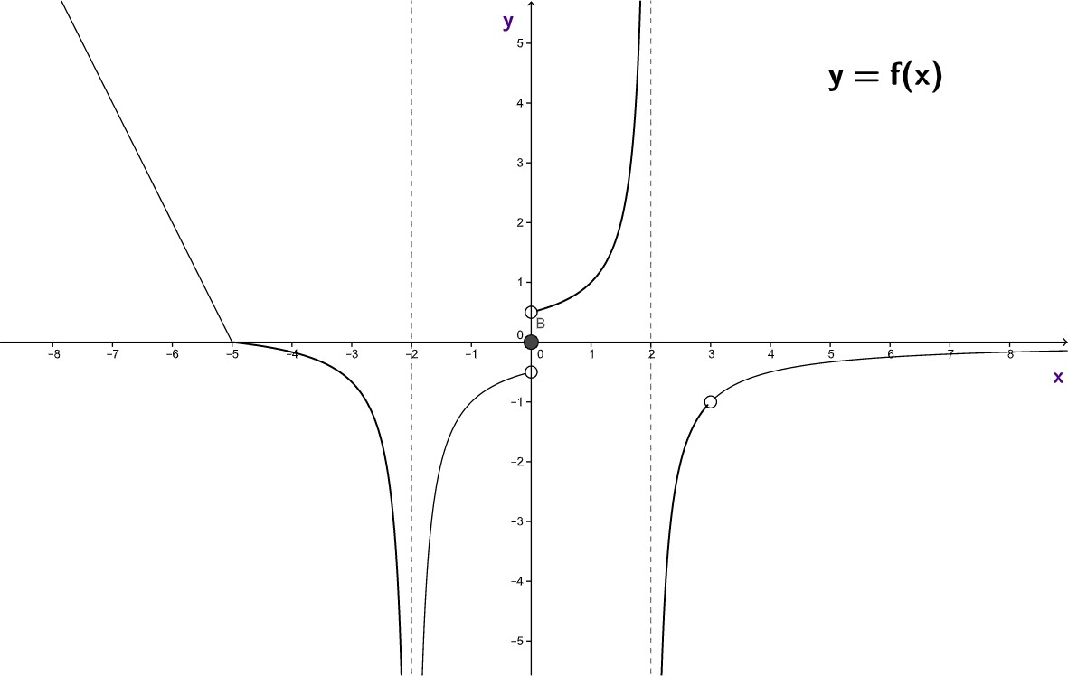

1. *f* (*x*) is continuous on (*−*6*, −*3).
2. *f* (*x*) is differentiable on (*−*6*, −*3).
3. *f* (*x*) is differentiable on (*−*1*,* 1). Which of these statements is/are true?
4. I only
5. II only
6. I and IIIu
7. I and II
8. II and III