Wireshark PCAP Analysis Report
DNS Query & TLS Connection Analysis
Generated from captured network traffic

1. Analysis: microsoft.com
This section summarizes the DNS resolution and connection details observed for the domain microsoft.com in the PCAP file "WK1-PM4.c - Wireshark PCAP Analysis v1.pcap".

1.1 Wireshark Screenshot
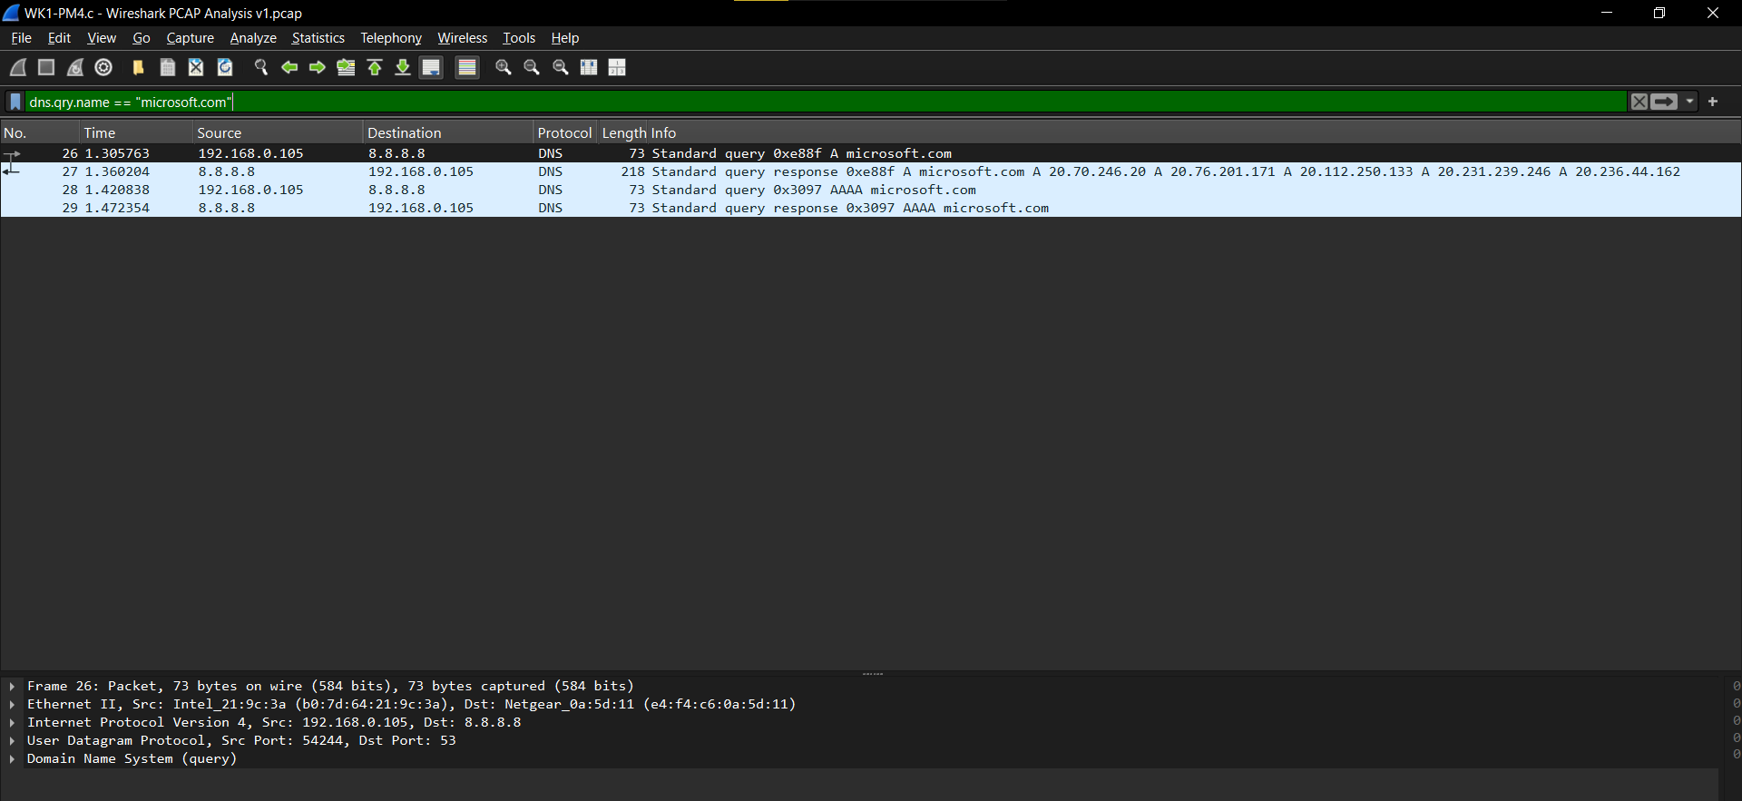
Figure 1: Wireshark capture – DNS queries for microsoft.com

1.2 Key Findings
Laptop IP Address | 192.168.0.105
DNS Server IP Address | 8.8.8.8 (Google Public DNS)
Queried Domain | microsoft.com
DNS Query Type | A (IPv4) and AAAA (IPv6)
Resolved Website IPs | 20.70.246.20, 20.76.201.171,  20.112.250.133, 20.231.239.246,  20.236.44.162
Server Name (SNI) | microsoft.com
Server Port | 443 (HTTPS)
TLS Version | TLSv1.3

1.3 Packet Details
Observed DNS transactions (filter: dns.qry.name == "microsoft.com"):
No. | Time | Source | Destination | Info
26 | 1.305763 | 192.168.0.105 | 8.8.8.8 | Standard query 0xe88f A microsoft.com
27 | 1.360204 | 8.8.8.8 | 192.168.0.105 | Standard query response 0xe88f A microsoft.com (multiple A records)
28 | 1.420838 | 192.168.0.105 | 8.8.8.8 | Standard query 0x3097 AAAA microsoft.com
29 | 1.472354 | 8.8.8.8 | 192.168.0.105 | Standard query response 0x3097 AAAA microsoft.com

1.4 Summary
The client at 192.168.0.105 sent DNS queries to Google’s public resolver (8.8.8.8) for both A and AAAA records of microsoft.com. The A-record response returned five IPv4 addresses belonging to Microsoft’s infrastructure. The subsequent HTTPS connection used port 443 and negotiated TLSv1.3.

2. Analysis: networkwalks.com
This section summarizes the DNS resolution and related traffic observed for the domain networkwalks.com.

2.1 Wireshark Screenshot
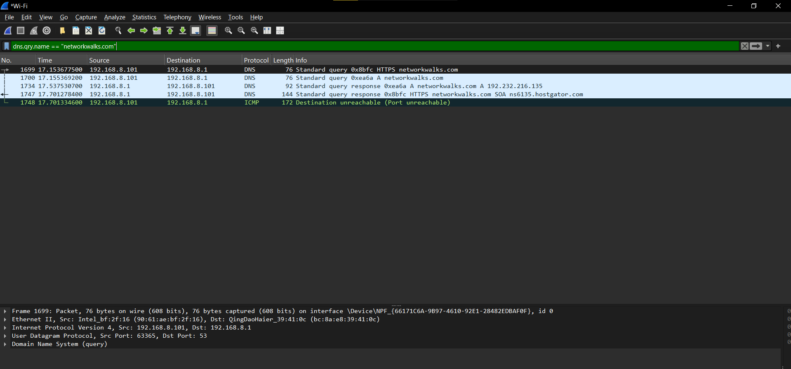
Figure 2: Wireshark capture – DNS queries for networkwalks.com

2.2 Key Findings
Laptop IP Address | 192.168.8.101
DNS Server / Gateway IP | 192.168.8.1
Queried Domain | networkwalks.com
DNS Query Type | HTTPS and A (IPv4)
Resolved Website IP | 192.232.216.135
Server Name (SNI) | networkwalks.com
Server Port | 443 (HTTPS)
TLS Version | TLSv1.3
Additional Observation | ICMP Destination unreachable (Port unreachable)

2.3 Packet Details
Observed DNS transactions (filter: dns.qry.name == "networkwalks.com"):
No. | Time | Source | Destination | Info
1699 | 17.153677 | 192.168.8.101 | 192.168.8.1 | Standard query 0x8bfc HTTPS networkwalks.com
1700 | 17.155369 | 192.168.8.101 | 192.168.8.1 | Standard query 0xea6a A networkwalks.com
1734 | 17.537531 | 192.168.8.1 | 192.168.8.101 | Standard query response 0xea6a A networkwalks.com A 192.232.216.135
1747 | 17.701278 | 192.168.8.1 | 192.168.8.101 | Standard query response 0x8bfc HTTPS networkwalks.com SOA ns6135.hostgator.com
1748 | 17.701335 | 192.168.8.101 | 192.168.8.1 | ICMP Destination unreachable (Port unreachable)

2.4 Summary
The client at 192.168.8.101 queried its local DNS resolver / gateway (192.168.8.1) for both HTTPS and A records of networkwalks.com. The A-record response returned the single IPv4 address 192.232.216.135. An ICMP “Destination unreachable (Port unreachable)” message was also observed. The HTTPS connection used port 443 and negotiated TLSv1.3.

3. Side-by-Side Comparison
The table below highlights the differences and similarities between the two captures.
Parameter | microsoft.com | networkwalks.com
Laptop / Client IP | 192.168.0.105 | 192.168.8.101
DNS Server IP | 8.8.8.8 | 192.168.8.1
Resolved Website IP(s) | 20.70.246.20  20.76.201.171  20.112.250.133  20.231.239.246  20.236.44.162 | 192.232.216.135
Server Name | microsoft.com | networkwalks.com
Server Port | 443 | 443
TLS Version | TLSv1.3 | TLSv1.3

4. Conclusion
Both captures demonstrate standard DNS resolution followed by HTTPS connections secured with TLSv1.3 on port 443. The microsoft.com traffic used Google’s public DNS (8.8.8.8) and received multiple A records, which is typical for large cloud-hosted services employing load balancing / anycast. The networkwalks.com traffic used a local resolver (192.168.8.1) and resolved to a single IPv4 address, with an additional ICMP port-unreachable message observed.
All findings are consistent with normal web-browsing behavior and modern TLS best practices.
— End of Report —

