Development - Osvaldo

**Write about the project general scope**

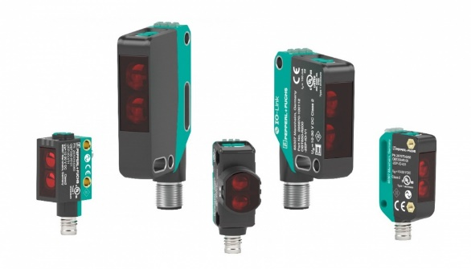The final objective of this project will be that some motion sensors that will be activated remotely, are going to send an alert signal to the cell phone when they are activated, this will be through an application that will send notifications, all this to be aware of the places or things that we can take care in that moment, below you can see an example of how the actuator in the RaspBerryPI works, basically when the sensor is activated it will send an alert in a matter of seconds.

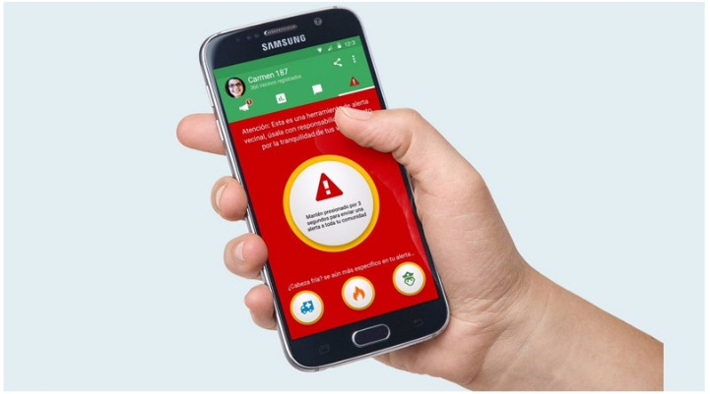

**ii. Propose new features for the app**

After this, a camera can be implemented which will be activated and can be adjusted to take a photo or record what happened, this will be saved and sent to the application where we can observe the cause; Another thing that can be implemented is to be able to connect several sensors in the same application to be able to monitor several places at the same time.