AR
CONVERSATIONAL
─────────────────────────────────────
AI Banking Assistant
Complete Feature Guide & User Manual
Version: Pilot 3 | Audience: Bank Staff, IT Administrators | 2025

1 | What is AR Conversational?
AR Conversational is an AI-powered banking assistant that understands natural-language questions from bank staff and retail/private banking clients, answering them by consulting your bank's real API catalog.

It is not a chatbot with scripted answers. It is an intelligent routing and composition engine that:
▶ Reads your question in plain language (English or Italian)
▶ Identifies which banking domain the question belongs to
▶ Routes the question to the correct specialist AI agent
▶ Consults your bank's actual API endpoints to find the answer
▶ Returns a structured, evidence-backed response

ℹ AR Conversational acts as a digital banking subject-matter expert — available 24/7, with knowledge of every API your bank has exposed.
2 | How It Works — Three-Layer Architecture
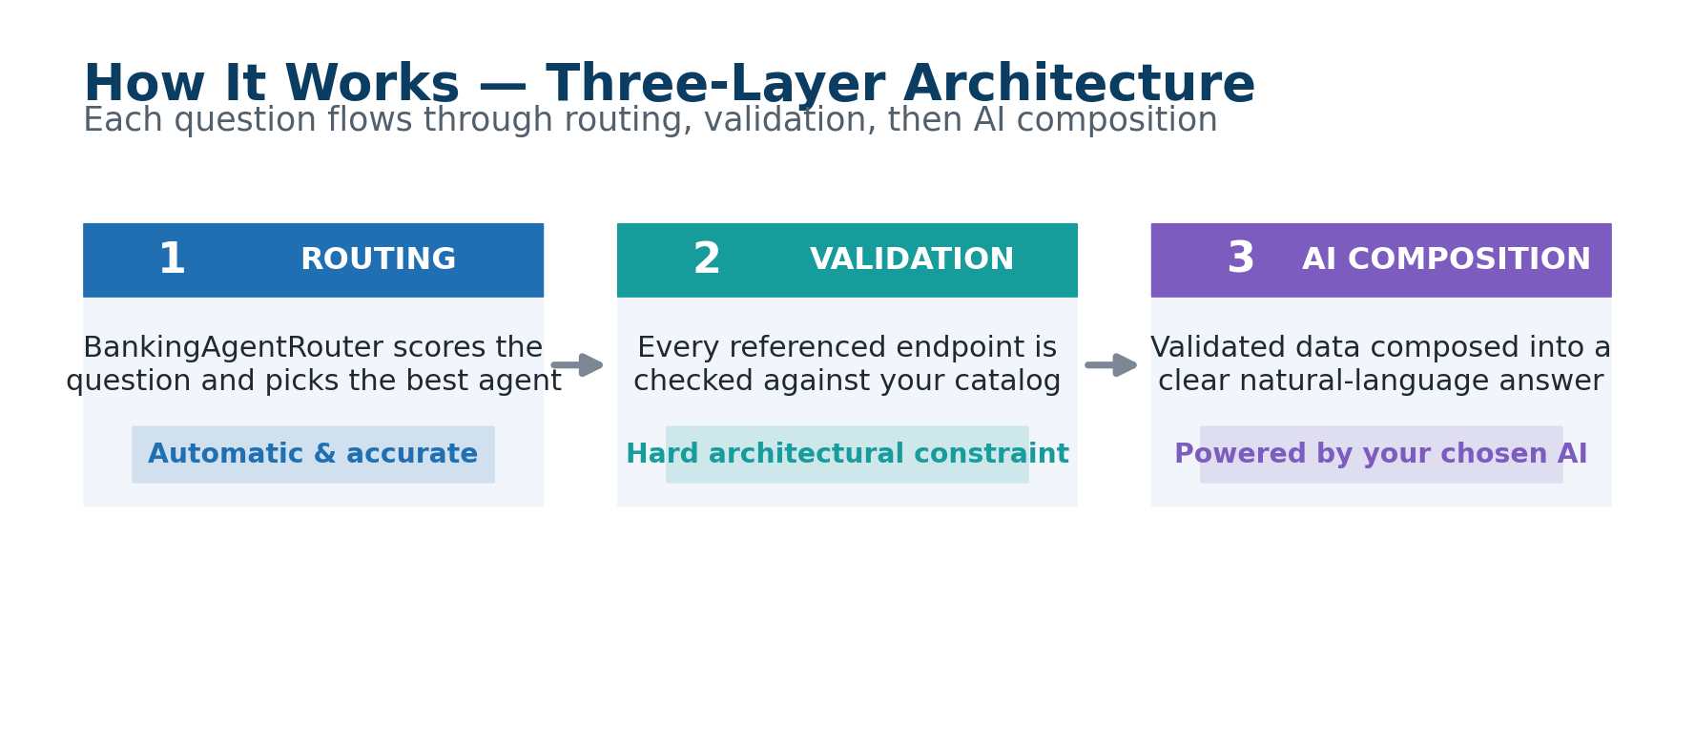
Layer | Description | Guarantee
Layer 1 — ROUTING | BankingAgentRouter scores your question against each agent's keyword library. Best-match agent is selected automatically. Manual override available. | Automatic & accurate
Layer 2 — VALIDATION | Every endpoint the AI references is checked against your imported API catalog. Cannot hallucinate or invent endpoints that don't exist. | Hard architectural constraint
Layer 3 — AI COMPOSITION | Validated endpoint data is sent to your AI provider (OpenAI, Claude, Gemini, Together.ai, Ollama…), which composes a clear natural-language answer. | Powered by your chosen AI

ℹ Anti-hallucination is enforced at architecture level, not as a prompt instruction — the system physically cannot reference an endpoint that is not in your catalog.
3 | Conversation Modes
AR Conversational operates in two distinct modes, tailored to the audience:
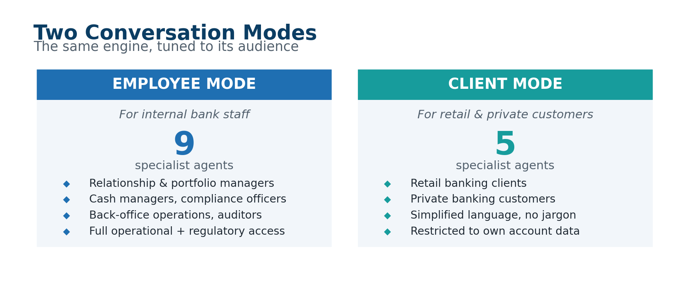

🏢 EMPLOYEE MODE  For internal bank staff  ◆ Relationship managers, portfolio advisors  ◆ Cash managers, compliance officers  ◆ Back-office operations, auditors  ◆ Full operational + regulatory access  ◆ 9 specialist agents available | 👤 CLIENT MODE  For retail & private banking customers  ◆ Retail banking clients  ◆ Private banking customers  ◆ Simplified language, no internal jargon  ◆ Restricted to own account information  ◆ 5 specialist agents available
4 | The 14 Specialist Agents
AR Conversational is powered by 14 specialist agents — 9 for employee use and 5 for client use. Each has deep expertise in a specific banking domain.
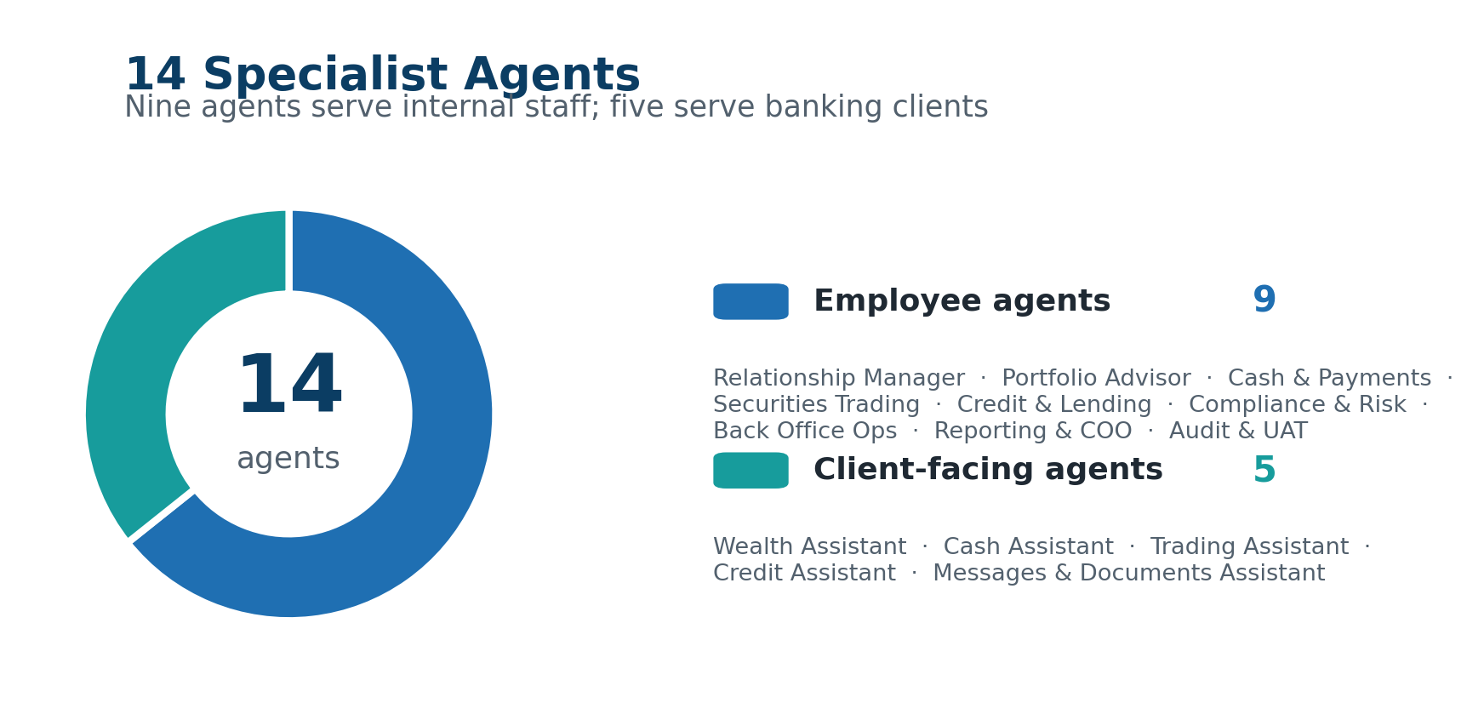

Employee Agents (9)
🤝 Relationship Manager
Client relationships, CRM, onboarding
◆ Client 360-degree views and profiles
◆ KYC status and onboarding pipelines
◆ Client segmentation (retail, private, corporate)
◆ Relationship history and touchpoints
◆ Mandate and advisory agreements
📊 Portfolio Advisor
Investment portfolios and wealth management
◆ Portfolio holdings and positions
◆ Asset allocation and rebalancing
◆ Performance attribution and returns
◆ Investment mandates and constraints
◆ Suitability assessments
💳 Cash and Payments Agent
Treasury, payments, transfers
◆ Account balances (available, booked, holds)
◆ SEPA credit transfers and direct debits
◆ SWIFT international wire transfers
◆ Standing orders and scheduled payments
◆ Intraday liquidity and cash positioning
📈 Securities Trading Agent
Capital markets and execution
◆ Order entry and management (equities, bonds, derivatives)
◆ Trade execution and fill status
◆ Market data and real-time quotes
◆ Trading history and blotter
◆ Settlement status and confirmations
🏦 Credit and Lending Agent
Loans, credit, mortgages
◆ Consumer and corporate loan details
◆ Credit limit utilization and headroom
◆ Mortgage terms and repayment schedules
◆ Collateral and guarantee structures
◆ Loan origination and approval workflows
🛡️ Compliance and Risk Agent
Regulatory compliance, AML, risk
◆ AML/KYC screening results
◆ Sanctions list checks
◆ Compliance alerts and exceptions
◆ Risk exposure and limit monitoring
◆ Regulatory reporting status
⚙️ Back Office Operations Agent
Post-trade, settlement, corporate actions
◆ Trade settlement and failed trades
◆ Reconciliation breaks
◆ Corporate actions (dividends, splits, rights)
◆ Nostro/vostro account management
◆ Custody and safekeeping positions
📋 Reporting and COO Agent
Management information, KPIs, regulatory metrics
◆ Operational dashboards and KPI reports
◆ Regulatory reporting (Basel, MiFID, EMIR)
◆ P&L attribution and revenue analysis
◆ SLA monitoring and incident metrics
◆ Capacity and volume statistics
🔍 Audit and UAT Agent
Audit trails, testing, system health
◆ Audit event logs and access history
◆ UAT test case management
◆ System health checks and API diagnostics
◆ Change management records
◆ Regulatory audit responses

Client-Facing Agents (5)
💼 Client Wealth Assistant
Personal investments and portfolio overview
◆ Portfolio total value and allocation breakdown
◆ Individual holding performance
◆ Year-to-date returns
◆ Upcoming maturities or events
🏧 Client Cash Assistant
Accounts, balances, transactions
◆ Available and booked account balance
◆ Recent transaction history
◆ Pending transactions and holds
◆ IBAN and account details
📉 Client Trading Assistant
Personal orders and trades
◆ Status of open orders
◆ Historical trade executions
◆ Dividends and corporate action entitlements
💰 Client Credit Assistant
Personal loans and credit products
◆ Loan balances and next repayment dates
◆ Credit card limits and usage
◆ Mortgage details and outstanding balance
◆ Repayment history
📄 Client Messages and Documents Assistant
Statements, documents, communications
◆ Account statements (PDF download links)
◆ Tax documents and certificates
◆ Bank notices and secure messages
◆ Document archive access
5 | Asking Questions
Ask questions the same way you would ask a colleague. No special syntax required. The system understands natural language in English and Italian.

🏢 Employee Mode — Examples  "What is the AML screening status for client ID 12345?"  "Show me the portfolio allocation for account CH93-0076."  "What SEPA payments are pending settlement today?"  "Has there been suspicious activity flagged in the last 30 days?"  "Qual è lo stato del mandato per il cliente Rossi?" | 👤 Client Mode — Examples  "What is my account balance?"  "Show me my last 10 transactions."  "When is my next loan repayment?"  "Can I get my last bank statement?"  "Come sta andando il mio portafoglio quest'anno?"
6 | Understanding the Answer
Every response includes three components:
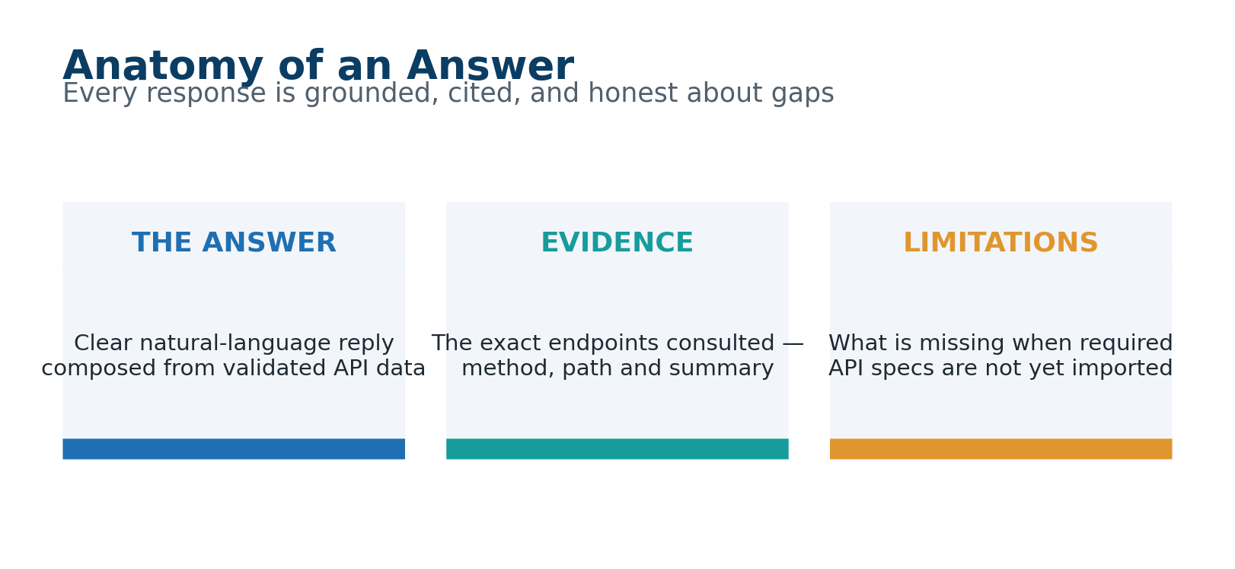

Component | Description
The Answer | A clear, natural-language response composed by the AI using validated banking API data as its reference.
Evidence | The specific API endpoints consulted — HTTP method, path, and summary. Confirms the answer is grounded in real API specifications.
Limitations | Shown when your bank has not imported the API specs needed to fully answer. Specifies what is missing and what to import.

ℹ The system will never provide an answer based on endpoints that do not exist in your imported catalog. You receive a clear limitation notice rather than an incorrect or fabricated answer.
7 | Business Coverage — 25 Banking Domains
# | Domain | Key Topics
1 | Customer & Onboarding | KYC, identity verification, client profiles
2 | Accounts | Current accounts, savings, IBAN, account opening
3 | Balances | Available balance, booked balance, holds, overdrafts
4 | Payments & Transfers | SEPA, SWIFT, instant payments, standing orders
5 | Cards | Debit cards, credit cards, limits, disputes
6 | Securities & Trading | Orders, executions, market data, settlement
7 | Portfolio & Holdings | Positions, allocation, NAV, performance
8 | Investment Advisory | Suitability, recommendations, mandates
9 | Credit & Lending | Loans, mortgages, credit lines, collateral
10 | Deposits & Treasury | Term deposits, FX deposits, rates
11 | Foreign Exchange | Spot, forward, hedging, FX rates
12 | Compliance & AML | Screening, sanctions, alerts, reports
13 | Risk Management | Exposure, limits, VaR, stress tests
14 | Fraud & Disputes | Chargebacks, fraud investigations, alerts
15 | Statements & Documents | PDF statements, tax docs, certificates
16 | Notifications & Messaging | Alerts, SMS, email, secure messages
17 | Authentication & Access | MFA, sessions, consents, tokens
18 | Beneficiaries & Payees | Payee management, verification, whitelists
19 | Standing Orders | Recurring payments, direct debits
20 | Reporting & Analytics | Dashboards, KPIs, regulatory metrics
21 | Back Office & Settlement | Reconciliation, corporate actions, nostro
22 | Wealth & Private Banking | Discretionary management, mandates
23 | Insurance & Bancassurance | Policies, claims, premiums
24 | Fees & Pricing | Tariffs, charges, fee schedules, bundles
25 | Audit & Operations | Audit trails, UAT, health checks
8 | AI Provider Configuration
AI Provider | Description & Best Use
OpenAI | GPT-4o and GPT-4o-mini — industry-leading general intelligence
Anthropic Claude | Claude 3.5 Haiku & Sonnet — strong reasoning and compliance
Google Gemini | Gemini 1.5 Flash & Pro — fast and cost-effective
Azure OpenAI | Microsoft Azure-hosted OpenAI — meets Azure compliance requirements
Together.ai | Open-source models (Llama 3.3, Qwen) — flexible and affordable
Ollama | Local/on-premise LLMs — 100% private, nothing leaves your network
Custom | Any OpenAI-compatible endpoint — bring your own banking AI model

ℹ For maximum data privacy, use Ollama — all AI processing runs on your own infrastructure. Nothing leaves your network. Recommended for environments with strict data sovereignty requirements.
9 | What AR Conversational Can Do Today
Feature | Details
✅ Natural language Q&A | English and Italian, any banking question
✅ Automatic agent routing | Best-fit selection from 14 specialist agents
✅ Manual specialist selection | Direct access to any agent from the UI
✅ Employee mode | Full operational + regulatory access for bank staff
✅ Client mode | Simplified, client-safe answers for retail/private customers
✅ Evidence-backed answers | Every answer cites real API endpoints from your catalog
✅ Limitations reporting | Clear notification when required APIs are not imported
✅ 25 banking domains | Auto-mapped from your API catalog keywords
✅ Anti-hallucination | Only real, imported endpoints are ever referenced
✅ 7 AI provider integrations | Choose the AI that fits your compliance needs
✅ Multi-language support | English and Italian out of the box
✅ API key encryption | AES-256-GCM for all provider credentials at rest
10 | What AR Conversational Will Be Able to Do
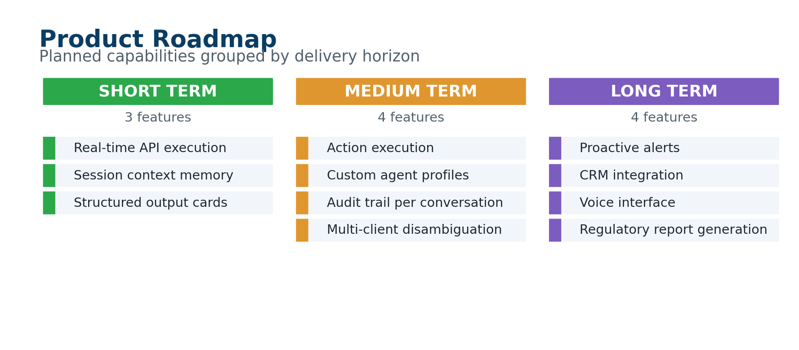
Timeline | Feature | Description
Short Term | Real-time API execution | Live banking data in answers, not just API references
Short Term | Session context memory | Multi-turn conversations remembering previous questions
Short Term | Structured output cards | Balance amounts, transaction tables, charts in the chat
Medium Term | Action execution | Initiate payments, book transfers from the conversation
Medium Term | Custom agent profiles | Define agents tuned to your specific API taxonomy
Medium Term | Audit trail per conversation | Full regulatory log of every interaction
Medium Term | Multi-client disambiguation | Handle multiple clients in one session with clear context
Long Term | Proactive alerts | AR surfaces unusual patterns without being asked
Long Term | CRM integration | Pre-fills context from the client open in your CRM
Long Term | Voice interface | Spoken questions and spoken answers for call centres
Long Term | Regulatory report generation | Compose full regulatory documents from natural language
11 | Security & Data Handling
Protection | Detail
API Key Encryption | AES-256-GCM. Keys never stored in plain text, never appear in logs or exports.
Network Isolation | Sidecar server binds to 127.0.0.1 only — not directly network-accessible.
No Data Leakage | Only question text and API metadata sent to your AI provider. No customer PII unless your own API responses include it.
Ollama Option | Full on-premise deployment — zero external network calls. Meets the strictest data sovereignty requirements.
Anti-Hallucination | Architectural constraint: the system cannot reference endpoints not in your catalog. Not a prompt-level guardrail.
Audit Logging | All sidecar calls logged. Questions, routing decisions, and AI responses available for audit.

AR Conversational — Turning your API catalog into a 24/7 banking expert.

