ARAPI
─────────────────────────────────────────
Banking API Test Automation Platform
Complete Feature Guide & User Manual
Platform: Phase 19 | Audience: QA Engineers, Developers, Test Managers | 2025

1 | What is ARAPI?
ARAPI is a no-code API test automation platform purpose-built for banking and fintech teams.
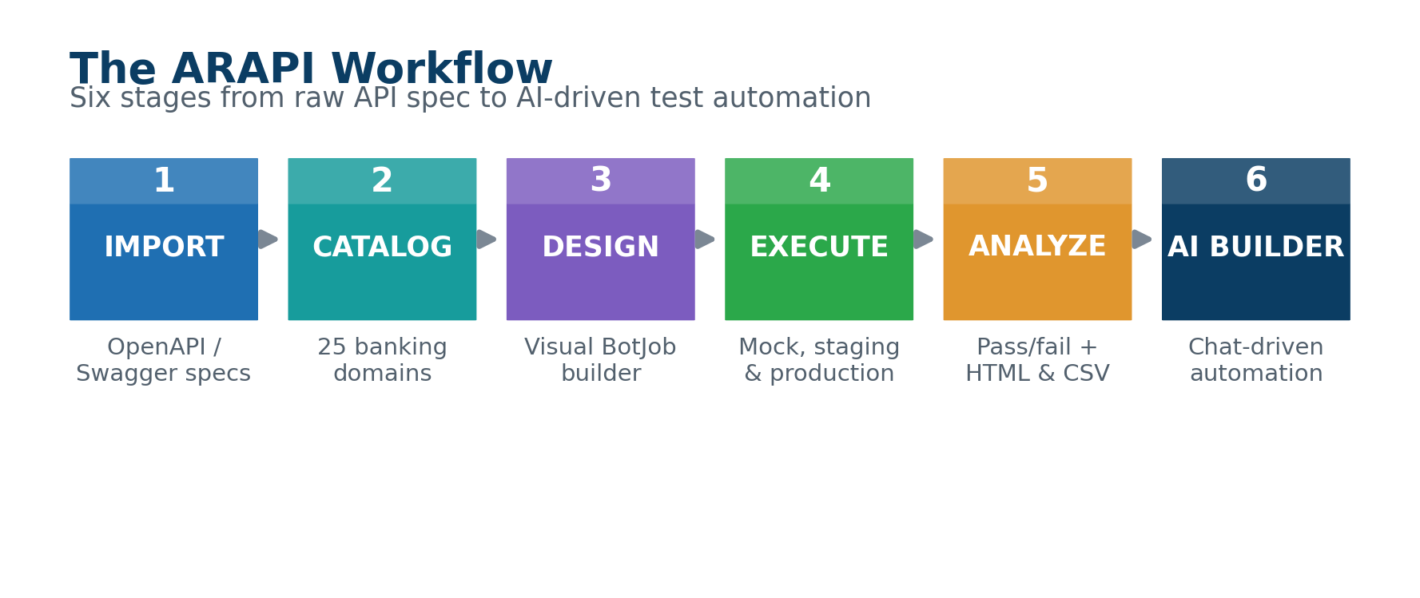

📥  Import  OpenAPI/Swagger specs — single files, folders, or entire directory trees with subfolders | 🗂️  Catalog  Browse all endpoints organized by 25 banking business domains | 🤖  Design  Build automated test workflows visually — no coding required | ▶️  Execute  Run against Mock Server, staging, or production environments | 📊  Analyze  Step-by-step pass/fail breakdowns with HTML and CSV exports | 🧠  AI Builder  Ask an AI assistant to search your catalog, create BotJobs, and run tests
ℹ ARAPI is vendor-neutral: it works with any OpenAPI 3.0 or Swagger 2.0 specification and supports seven AI providers.
2 | Core Concepts
Concept | Definition
API Catalog | Database of every endpoint imported from your OpenAPI/Swagger files. Source of truth for all testing — ARAPI cannot test an endpoint not in the catalog.
BotJob | A reusable, ordered test workflow made of Blocks and Commands. "Create client → extract ID → call account opening → assert 201 response."
Block | A logical group inside a BotJob (e.g. "Setup", "Create Client", "Verify", "Cleanup"). Organizes long workflows into readable sections.
Command | A single test step inside a Block. Typed (API_CALL, ASSERT, EXTRACT…), configured via the visual designer, with enable/disable toggle.
Environment | A named execution target: the built-in Mock Server, or your own staging/production environments with custom base URLs.
Variable | A named value flowing through a BotJob. Set at design time or extracted from API responses and referenced as ${varName} in requests.
3 | Importing API Specifications
Format | Extensions & Notes
OpenAPI 3.0 | .yaml / .yml / .json — Full support including $ref resolution
Swagger 2.0 | .yaml / .yml / .json — Automatically converted on import

Import Methods
Method 1 — Upload Files (Browser)
▶ Click Browse Files to select one or more OpenAPI/Swagger files
▶ Click Browse Folder to select an entire directory — ARAPI recursively scans all subfolders
▶ Files appear in a list with name and size; remove individual files with ×
▶ Click Import to process all selected files

ℹ Folder import preserves the subfolder structure. A file at specs/payments/sepa.yaml is stored as payments/sepa.yaml — the full directory tree is maintained.

Method 2 — Server Path (Admin/Desktop)
▶ Enter the absolute path to a folder on the server
▶ ARAPI scans recursively and imports all .yaml, .yml, and .json files
▶ Ignored: node_modules, dist, build, .git, vs, bin, obj

What Gets Imported
Data | Details
Endpoint | HTTP method + full path including parameters
Metadata | Summary, description, tags
Parameters | Name, location (query/path/header/body), required flag, type, example
Response schemas | Top-level JSON fields from response definitions

Error Handling
▶ Files that fail parsing are logged with the specific error reason
▶ Failed files do NOT stop the import of other files — the process always continues
▶ A summary shows successful specs, total endpoints, and failed file names with error details
4 | The API Catalog
Catalog Table Columns
Column | Description | Examples | Notes
Method | HTTP verb, color-coded | GET=Blue, POST=Green, PUT=Amber, DELETE=Red, PATCH=Purple
Path | Full endpoint path | /v1/accounts/{accountId}/balance
Summary | Human-readable description from OpenAPI spec
Mapping | Business category assignment | "mapped" or "unmapped"

Catalog Exports
Export | Description
Postman Collection v2.1 | Full catalog in Postman JSON. Import directly into Postman or Insomnia. File: arweb-postman-collection.json
Bash / curl Script | One curl command per endpoint. Pipe to bash to replay your entire catalog against any base URL. File: arweb-catalog.sh
5 | Business Categories — 25 Banking Domains
ARAPI automatically maps endpoints to 25 banking domains based on keyword matching against path, method, summary, and tags. Each category has 5 subcategories.
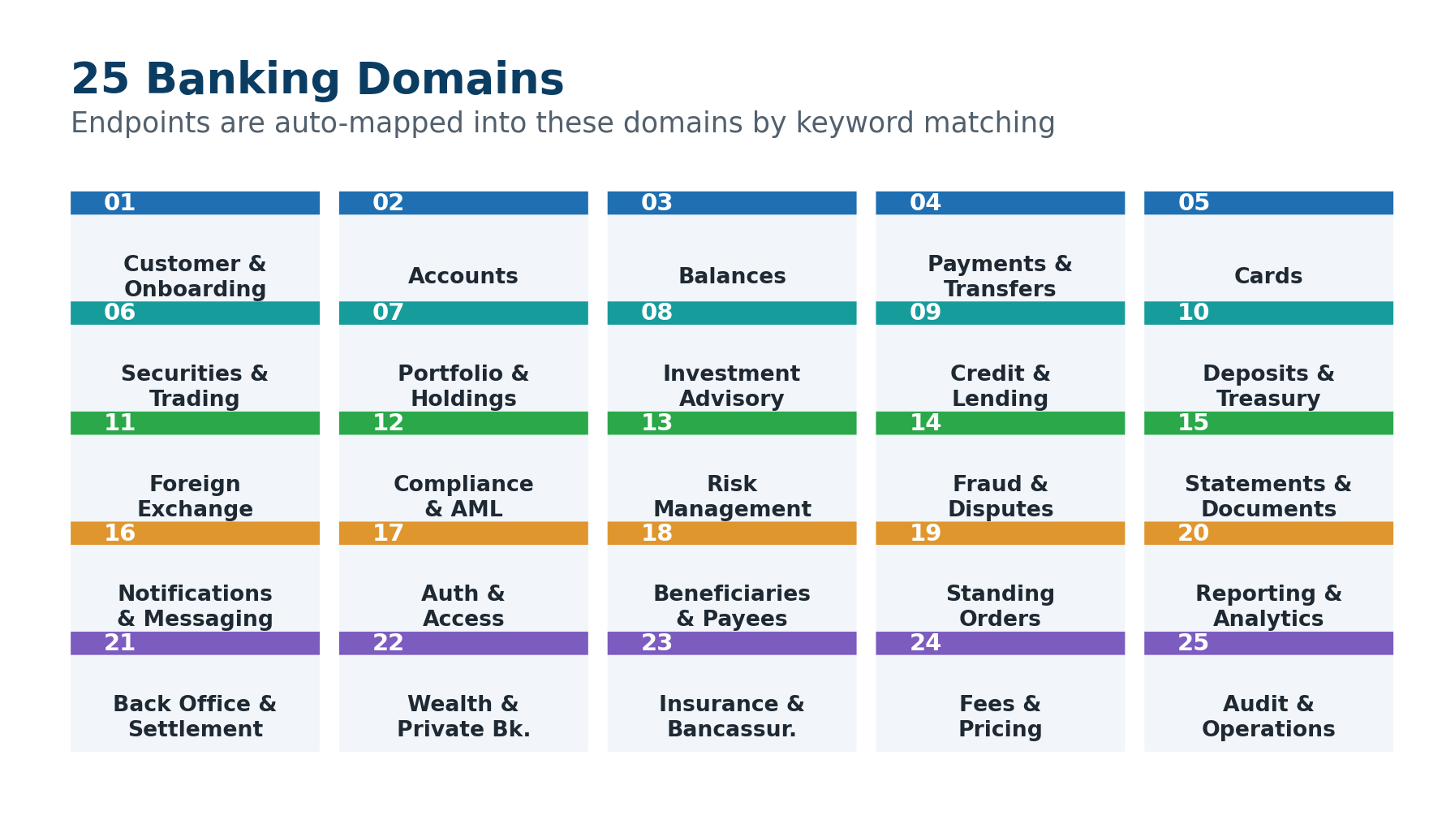

# | Category | Example Endpoint Paths
1 | Customer & Onboarding | /clients, /kyc, /onboarding, /identity
2 | Accounts | /accounts, /iban, /account-opening
3 | Balances | /balance, /available-balance, /holds
4 | Payments & Transfers | /payments, /sepa, /swift, /transfers
5 | Cards | /cards, /card-limits, /pin, /disputes
6 | Securities & Trading | /orders, /executions, /instruments, /blotter
7 | Portfolio & Holdings | /portfolio, /positions, /holdings, /nav
8 | Investment Advisory | /suitability, /recommendations, /mandates
9 | Credit & Lending | /loans, /mortgages, /credit-lines, /collateral
10 | Deposits & Treasury | /deposits, /term-deposits, /rates
11 | Foreign Exchange | /fx, /spot, /forward, /hedging
12 | Compliance & AML | /aml, /sanctions, /compliance, /screening
13 | Risk Management | /risk, /exposure, /limits, /var, /stress
14 | Fraud & Disputes | /fraud, /chargebacks, /investigations
15 | Statements & Documents | /statements, /documents, /reports
16 | Notifications & Messaging | /notifications, /alerts, /messages, /sms
17 | Authentication & Access | /auth, /mfa, /sessions, /consents
18 | Beneficiaries & Payees | /beneficiaries, /payees, /whitelist
19 | Standing Orders | /standing-orders, /recurring, /direct-debits
20 | Reporting & Analytics | /analytics, /kpi, /dashboards, /metrics
21 | Back Office & Settlement | /settlement, /reconciliation, /nostro
22 | Wealth & Private Banking | /wealth, /discretionary, /private-banking
23 | Insurance & Bancassurance | /insurance, /policies, /claims
24 | Fees & Pricing | /fees, /tariffs, /pricing, /bundles
25 | Audit & Operations | /audit, /events, /health, /uat
6 | Designing BotJobs — The Visual Designer
Creating a BotJob
▶ Go to Execute Tests → New BotJob, or ask the Bot Builder AI assistant to create one
▶ Give it a name (required) and description (optional)
▶ BotJob is created with one empty Main block
▶ Click Open Designer to build the workflow

Designer Layout — Three Panels
⬅ Command Palette  Grouped command types:  🔵 API — API_CALL  🟣 Variables — SET_VARIABLE, EXTRACT  🟢 Assertions — ASSERT_*  🟠 Control — WAIT, STOP_ON_FAILURE  🟡 Data — future commands  Drag & drop onto canvas | ⬛ Workflow Canvas  All blocks and commands in execution order:  ▶ Add Block — create logical sections  ▶ Reorder commands — drag handles  ▶ Enable/Disable — toggle without deleting  ▶ Delete — remove commands or entire blocks  ▶ Color-coded type badges per command | ⚙ Config Editor  Click any command to configure:  ▶ Fields vary by command type  ▶ Endpoint selector (searchable)  ▶ JSON body editor  ▶ Headers key-value editor  ▶ ${variable} tokens supported  ▶ Changes held until Save click
7 | Command Reference — All 8 Runnable Types
🔵 API_CALL
Makes an HTTP request to a catalog endpoint. Auto-stores response for downstream commands.
Endpoint | Select from your API catalog — searchable dropdown showing method + path
Body | JSON request body — supports ${variable} tokens
Headers | Additional request headers as key-value pairs — supports ${variable} tokens
Auto-captures | Response body → lastResponse | Status code → lastStatus
🟣 SET_VARIABLE
Sets or overwrites a workflow variable at runtime. Use to stage data or compute values for the next API call.
Variable Name | The variable to create or overwrite
Value | New value — supports ${variable} tokens and hardcoded values
🟢 ASSERT_STATUS_CODE
Validates the HTTP status code of the most recent API_CALL. Passes if lastStatus == expected.
Expected Code | Integer — e.g. 200, 201, 404, 422
🟢 ASSERT_FIELD_VALUE
Validates a specific field value in the last JSON response. Fails if path missing or value does not match.
JSON Path | Dot-notation path — e.g. data.account.status
Expected Value | String or number to compare against the field
🟢 ASSERT_JSON_PATH_EXISTS
Verifies a field exists in the last JSON response. Does not check its value — just presence. Use before EXTRACT.
JSON Path | Dot-notation path — e.g. data.clientId
🟣 EXTRACT_JSON_PATH
Extracts a value from the last JSON response and stores it as a workflow variable for use in subsequent commands.
JSON Path | Dot-notation path — e.g. data.clientId
Variable Name | The variable to store the extracted value in
🟠 WAIT
Pauses execution. Use when an async operation (payment propagation, async job) needs time before verification.
Duration (ms) | Pause length in milliseconds — maximum 10,000 ms (10 seconds)
🟠 STOP_ON_FAILURE
Halts execution if the previous command failed. All subsequent commands are skipped. Use to protect downstream steps that depend on authentication or resource creation.
No config | Place immediately after a critical assertion
8 | Variables & Token Resolution
Variables are declared at the BotJob level with optional initial values. Reference them as ${varName} in any API_CALL body, headers, or assertion values.

📌 Variable Flow Example  1. BotVariable: currency = "EUR"  2. API_CALL body uses ${currency}  → POST /payments/transfers  → body: { "currency": "${currency}" }  3. Response: { "accountId": "ACC-12345" }  4. EXTRACT data.accountId → ${accountId}  5. Next API_CALL: /accounts/${accountId}/balance  → Resolved: /accounts/ACC-12345/balance | 🔐 Secret Variables  Mark any variable as Secret to redact its value from:  ◆ Execution step results  ◆ HTML and CSV reports  ◆ Server logs  ✅ Use for:  ◆ Passwords  ◆ API / Bearer tokens  ◆ Sensitive test data  ◆ PINs and OTPs
9 | Environments
🔒 MOCK SERVER  Built-in — always available  ◆ ID: "mock" | Port: 8855  ◆ Cannot be deleted or edited  ◆ Auto-seeded from your catalog  ◆ Zero risk — no real APIs called  ◆ Request log with match tracking | 🌐 CUSTOM ENVIRONMENTS  Unlimited — staging, UAT, production
Field | Details
Name | Required — e.g. "Staging", "UAT", "Production"
Base URL | Required — e.g. https://staging.mybank.com
Description | Optional free text notes
Headers | Default headers for all requests (e.g. Authorization)
Default | Pre-selected environment when running BotJobs

10 | Executing Tests
Running a BotJob
▶ Find the BotJob in Execute Tests list → click Run
▶ Select target environment (defaults to your default environment)
▶ Click Execute

Execution Process
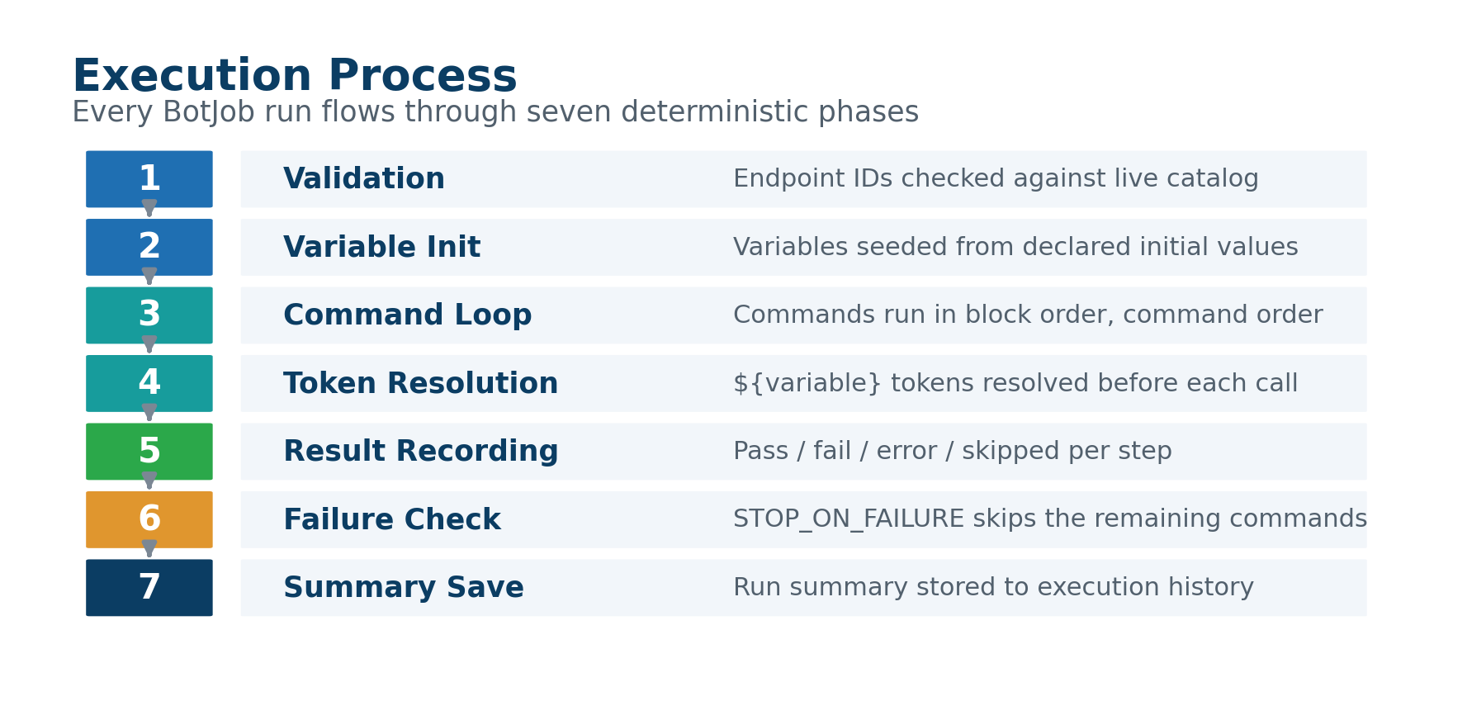
Step | Phase | Description
Step 1 | Validation | All API_CALL endpoint IDs checked against current catalog
Step 2 | Variable Init | Variables initialized from declared initial values
Step 3 | Command Loop | Commands execute in block order, command order
Step 4 | Token Resolution | ${variable} tokens resolved just before each command
Step 5 | Result Recording | Pass/fail/error/skipped recorded per step
Step 6 | Failure Check | STOP_ON_FAILURE skips remaining commands on trigger
Step 7 | Summary Save | Run summary saved to execution history

Status Reference
RUN STATUS | STEP STATUS
✅ passed — all commands passed  ❌ failed — one or more failed  ⚠️ error — unexpected runtime error  ⏳ running — execution in progress | ✅ passed — executed, all assertions matched  ❌ failed — assertion mismatch or wrong status  ⚠️ error — network error or missing variable  ⏭️ skipped — STOP_ON_FAILURE was triggered earlier
11 | Execution Results & Reports
Viewing Results — Execute Tests → History
View | Contents
Run card | Status badge, environment name, N passed / M failed / T total, duration, timestamp
Step detail | Status, command type, duration (ms), request JSON, response JSON, assertion results
Filtering | BotJob selector shows only runs for a specific workflow

Report Exports
📄 HTML Report  ◆ Formatted, browser-readable summary  ◆ Pass/fail per step with color coding  ◆ Printable to PDF from browser  ◆ File: run-{runId}.html | 📊 CSV Export  ◆ Tabular: stepId, commandType, status, durationMs, errorMessage  ◆ Import into Excel, Google Sheets, Jira  ◆ Perfect for BI tools and dashboards  ◆ File: run-{runId}.csv
Catalog Exports — Always Available
Export | File & Use
Postman Collection | arweb-postman-collection.json — import into Postman or Insomnia
Bash/curl Script | arweb-catalog.sh — replay all endpoints via command line against any base URL
12 | Mock Server
Purpose
The built-in Mock Server lets you run BotJobs safely without touching real APIs. Auto-seeded with your catalog endpoints, it returns generated responses and logs every request.

Request Log Columns
Column | Content | Notes
# | Sequential request number | Chronological ordering
Time | Timestamp | When the request was received
Method | HTTP verb | GET, POST, PUT, DELETE, PATCH
Path | Requested path | Full URL path called
Status | HTTP status returned | 200, 201, 404, etc.
Matched | Catalog match flag | True = known endpoint, False = unknown path

Stats Dashboard
Stat | Description
Total Requests | Count since server was started
Match Rate | Percentage of requests that matched a catalog endpoint
Most Hit | The endpoint called most frequently
13 | Bot Builder — AI Test Assistant
Bot Builder is ARAPI's built-in AI assistant that takes real actions: search your catalog, create BotJobs, and run tests — all from a conversation.

5 Actions the Bot Builder Can Take
Action | What It Does | Example Prompt
🔍 Search Catalog | Natural language search across all imported endpoints | "Find endpoints related to KYC and onboarding"
📋 List BotJobs | Show all existing BotJobs with names, IDs, descriptions | "What test workflows do I have?"
➕ Create BotJob | Create a named BotJob in the database, return ID + Designer link | "Create a BotJob for the payment transfer flow"
🌐 List Environments | Show all configured test environments | "What environments do I have?"
▶️ Execute BotJob | Run a BotJob and return pass/fail results | "Run 'Client Onboarding' against the Mock Server"

🧠 With Anthropic Claude  Full agentic loop (tool use API):  ◆ Searches catalog autonomously  ◆ Acts on results in same turn  ◆ Multi-step reasoning  ◆ Creates BotJobs with full context | 💬 With Other Providers  OpenAI, Together.ai, Gemini, Ollama:  ◆ Text-completion mode  ◆ Answers questions about the platform  ◆ Catalog search and BotJob creation still work  ◆ May need more explicit instructions
14 | Settings — AI Provider Configuration
Provider | Key Format | Default Model | Best Use
OpenAI | sk-... | gpt-4o-mini | Industry-leading, general purpose
Anthropic | sk-ant-... | claude-3-5-haiku-20241022 | Best for Bot Builder tool use
Google Gemini | Google API key | gemini-1.5-flash | Fast and cost-effective
Azure OpenAI | Azure key | gpt-4o-mini | Azure compliance — requires base URL
Ollama | No key needed | llama3.2 | 100% local — requires base URL
Together.ai | tgp_v1_... | Llama-3.3-70B-Turbo | Open-source models, affordable
Custom | Any key | gpt-4o-mini | Any OpenAI-compatible endpoint

Default Provider Toggle
▶ Enable DEFAULT on exactly one provider — this is used by all AI features
▶ Green DEFAULT = provider set + API key present → active
▶ Red NO KEY = set as default but no key saved → AI features unavailable
▶ Grey SET DEFAULT = not currently the default
▶ Enabling a new default automatically disables the previous one (atomic, exclusive)

Test Connection
▶ Click Test on any provider card to verify: key valid, API reachable, latency in ms
▶ Test sends a minimal prompt ("Say exactly: OK") and shows the response

ℹ API keys are encrypted at rest using AES-256-GCM. They never appear in logs, exports, or HTTP responses. Shown as ••••••••• in the UI after saving.
15 | What ARAPI Can Do Today
 | Feature | Details
✅ | Import OpenAPI 3.0 + Swagger 2.0 | JSON and YAML, single files or full folder trees
✅ | Folder/subfolder import | Preserves directory structure, browser + server path
✅ | Auto-category mapping | 25 banking domains via keyword matching
✅ | Catalog search | Instant filter across method, path, summary
✅ | Postman + bash export | Full catalog in Postman v2.1 or curl script
✅ | Visual BotJob designer | Drag-and-drop, 3-panel, no coding
✅ | 8 runnable command types | API_CALL, SET_VARIABLE, ASSERT_*, EXTRACT, WAIT, STOP
✅ | Variable system | ${token} resolution, secret masking, runtime extraction
✅ | Built-in Mock Server | Port 8855, auto-seeded, request log
✅ | Custom environments | Unlimited, named, with default headers
✅ | Execution history | All runs stored with step-level detail
✅ | HTML + CSV reports | Download per run, browser-printable to PDF
✅ | Bot Builder AI | Catalog search, BotJob create/list/execute from chat
✅ | Anti-hallucination | BotJob validation against live catalog before execution
✅ | 7 AI providers | OpenAI, Anthropic, Gemini, Azure, Together.ai, Ollama, Custom
✅ | Encrypted key storage | AES-256-GCM for all provider credentials
16 | What ARAPI Will Be Able to Do
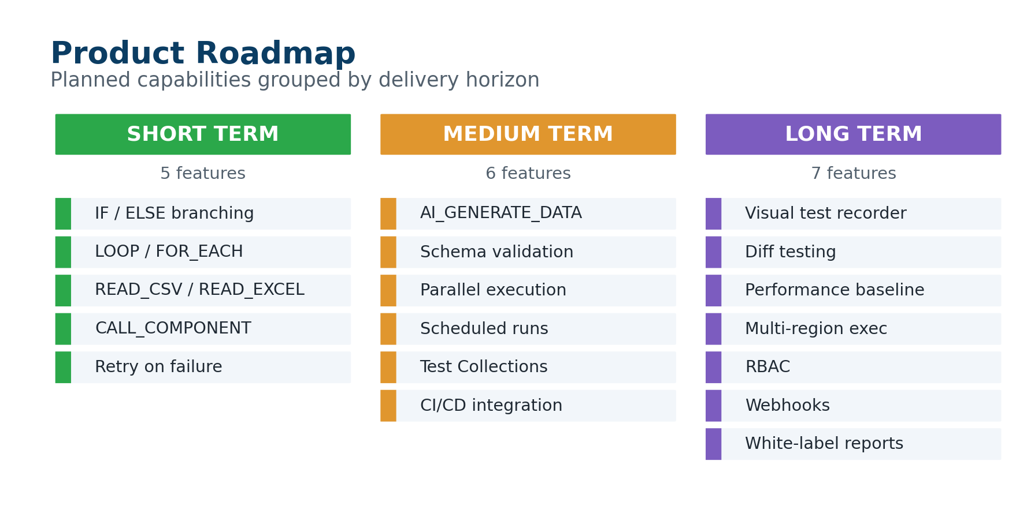
Timeline | Feature | Description
Short Term | IF/ELSE branching | Conditional command execution based on response values or variables
Short Term | LOOP / FOR_EACH | Iterate over a list — test 10 client IDs in one BotJob
Short Term | READ_CSV / READ_EXCEL | Data-driven testing: one row = one test run
Short Term | CALL_COMPONENT | Reusable sub-workflows — define Login once, use everywhere
Short Term | Retry on failure | Auto-retry flaky steps with configurable backoff
Medium Term | AI_GENERATE_DATA | AI generates realistic IBANs, amounts, names for test payloads
Medium Term | Schema validation command | Assert response matches a specific JSON schema
Medium Term | Parallel execution | Run multiple BotJobs simultaneously, aggregate results
Medium Term | Scheduled runs | Cron-based automation — regression suites nightly or hourly
Medium Term | Test Collections | Group BotJobs into suites: regression, smoke, integration
Medium Term | CI/CD integration | REST API + CLI to trigger runs from Jenkins, GitHub Actions, GitLab CI
Long Term | Visual test recorder | Record API calls from browser session, auto-generate BotJob
Long Term | Diff testing | Compare responses between environments (staging vs production)
Long Term | Performance baseline | Track response times over time, alert on regressions
Long Term | Multi-region execution | Run BotJobs from geographically distributed nodes
Long Term | RBAC | Role-based access for catalog, BotJobs, results
Long Term | Webhooks | Post results to Slack, Teams, or any webhook on completion
Long Term | White-label reports | Custom HTML report templates with your bank's branding
17 | Security & Architecture
Protection | Detail
Key Encryption | AES-256-GCM. Master key from filesystem (0600 permissions) or ARWEB_MASTER_KEY env var.
Network Isolation | Sidecar server binds to 127.0.0.1 only. Not directly network-accessible. Fronted by nginx proxy.
Anti-Hallucination | Architectural constraint: every BotJob API_CALL endpoint ID validated against live catalog before execution.
No Secrets in Exports | Secret variables are redacted. API keys never appear in HTML/CSV reports, logs, or HTTP responses.
WAL-mode SQLite | SQLite with Write-Ahead Logging for concurrent reads. Single-connection, all writes serialized.
Docker Isolation | API container runs as non-root node user. Web and API containers communicate on internal Docker network only.

Network Architecture
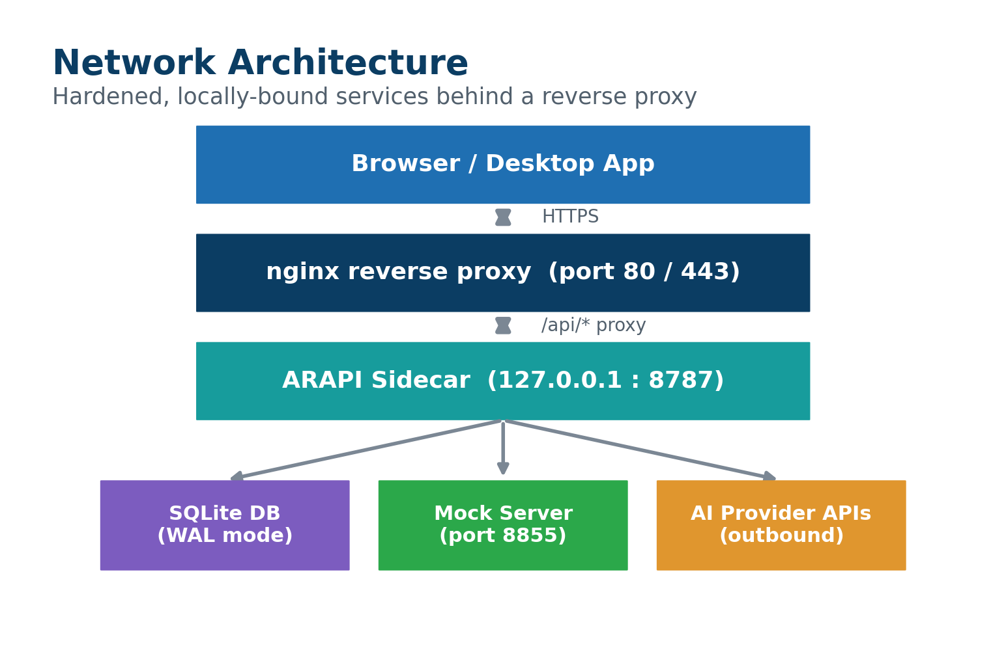
 | Browser / Desktop App
 | ↕ HTTPS
 | nginx reverse proxy (port 80 / 443)
 | ↕ /api/* proxy
 | ARAPI Sidecar (127.0.0.1:8787)
 | ├── SQLite database (WAL mode)
 | ├── Mock Server (port 8855)
 | └── AI provider APIs (outbound)
18 |  | REST API Quick Reference
Endpoint |  | Description / Body | Group
GET /catalog/endpoints |  | List all endpoints with category mapping | Catalog
POST /import/upload |  | Upload files from browser (JSON array of file contents) | Catalog
POST /import |  | Import from server filesystem path | Catalog
GET /catalog/export/postman |  | Download Postman Collection JSON | Catalog
GET /catalog/export/bash |  | Download bash/curl script | Catalog
GET /taxonomy |  | List 25 categories and subcategories | Taxonomy
GET /environments |  | List all environments | Environments
POST /environments |  | Create new environment | Environments
PUT /environments/{id} |  | Update environment | Environments
DELETE /environments/{id} |  | Delete environment | Environments
GET /botjobs |  | List all BotJobs | BotJobs
POST /botjobs |  | Create new BotJob | BotJobs
GET /botjobs/{id} |  | Get full BotJob (blocks + commands + variables) | BotJobs
PUT /botjobs/{id} |  | Save/update complete BotJob | BotJobs
DELETE /botjobs/{id} |  | Delete BotJob and all its data | BotJobs
POST /botjobs/{id}/execute |  | Execute BotJob ({ "environmentId": "mock" }) | BotJobs
GET /executions |  | List runs (filter: ?botJobId=) | Results
GET /executions/{id}/steps |  | Get step results for a run | Results
GET /executions/{id}/report.html |  | Download HTML report | Results
GET /executions/{id}/report.csv |  | Download CSV report | Results
GET /mock/status |  | Mock Server status { running, port } | Mock Server
POST /mock/start |  | Start Mock Server (seeds from catalog) | Mock Server
POST /mock/stop |  | Stop Mock Server | Mock Server
GET /mock/log |  | Get request log entries | Mock Server
POST /mock/log/clear |  | Clear request log | Mock Server
GET /settings/ai-providers |  | List providers (keys redacted) | Settings
POST /settings/ai-providers |  | Create/update provider | Settings
POST /settings/ai-providers/set-default |  | Set default provider (atomic) | Settings
POST /settings/ai-providers/test |  | Test provider { "provider": "together" } | Settings
POST /app-assistant/chat |  | Chat { "messages": [{role, content}] } | Bot Builder
GET /agents |  | List all AR Conversational agents | AR Conversational
POST /agents/ask |  | Ask question { question, mode, agentId? } | AR Conversational

ARAPI — No-code API test automation for banking and fintech teams.

