CLIENT USER MANUAL

AR Conversational
  - Complete Client Guide
Ask. Route. Review. Hand off.
Version 1.0.0 | Windows Desktop
Reviewed 26 August 2026

Document control
Field | Value
Product | AR Conversational Windows desktop application
Guide version | 1.0.0
Audience | Bank employees, client-demo operators, implementation teams, support, and administrators
Scope | AR Conversational; ARAPI authoring and execution are referenced only at the handoff boundary
Evidence basis | Version 1.0.0 source review, successful frontend build, running Tauri desktop application, and reproduced screenshots
Review date | 26 August 2026

Client-safe scope: Screens use local demonstration data and contain no API keys. Never enter production secrets, personal data, real account identifiers, or confidential documents into a demo or support session.

How to use this guide
- Read Sections 2-4 before operating a new installation or client demonstration.
- Use Section 6 for the visual walkthrough; every figure comes from the running AR Conversational desktop app.
- Use Sections 7-9 to understand modes, automatic routing, explicit agent selection, evidence, and answer limitations.
- Use Section 10 when conversational instructions cross into ARAPI catalog, BotJob, or execution work.
- Use Appendix A to locate every visible control and Appendix E for client acceptance.

Contents
1. About AR Conversational
2. Read this before using the current release
3. Installation and first launch
4. End-to-end quick start
5. Interface fundamentals
6. Screen-by-screen guide
7. Employee and client modes
8. Banking agents and routing
9. Questions, answers, limitations, and evidence
10. ARAPI delegation and cross-application workflow
11. Read-only API Catalog
12. AI provider settings
13. Security and operational practices
14. Troubleshooting
15. Feature status matrix
Appendix A. Complete control index
Appendix B. Agent reference
Appendix C. Local API reference
Appendix D. Glossary
Appendix E. Client acceptance checklist
Navigation: In Word, hold Ctrl while clicking an entry. In most PDF viewers, click normally. Each major section includes a Back to contents link.

1. About AR Conversational
Back to contents
AR Conversational is a Windows desktop banking-assistant interface for employee and client-demonstration conversations. It routes questions to named banking agents, relates answers to the API catalog shared with ARAPI, and delegates catalog/test/BotJob instructions to the ARAPI assistant workflow.
The React interface communicates with a localhost C# backend on port 8787. AR Conversational and ARAPI share catalog and settings data. The conversational app intentionally keeps endpoint import, workflow editing, generated scripts, and execution review in the separate ARAPI application.

Core concepts
Conversation mode: Employee or Client context used for automatic routing candidates, examples, input wording, and supported answer presentation.
Banking agent: A named routing profile with a mode, purpose, and banking keywords.
Auto-route: The default selection that chooses among agents for the current mode by keyword score.
Explicit agent: A manually selected agent that overrides automatic mode filtering for the next questions.
Evidence: Up to three method/path records selected from the shared catalog for a normal banking question.
Delegation: Handoff of catalog/test/BotJob wording to the ARAPI assistant route.
Synthetic answer: A local demonstration response produced from built-in mock records, never live core-banking data.

Application boundary
Use AR Conversational for | Use ARAPI for
Employee/client banking questions | OpenAPI/Swagger import and catalog ownership
Automatic or explicit banking-agent routing | BotJob creation and detailed workflow editing
Viewing catalog evidence and limitations | Bash/curl generation and controlled command-line execution
Read-only endpoint search | Test execution history, reports, environments, and mock controls
Shared AI-provider settings | Reviewing or approving delegated assistant actions

2. Read this before using the current release
Back to contents
Version basis: This manual describes the observed AR Conversational 1.0.0 desktop build reviewed on 26 August 2026. Catalog counts, provider state, and demo records will differ by workstation.

Current-build qualifications
- Balance/account answers in the reviewed build use local synthetic customer accounts with masked IBANs. They are not live or core-banking data and must not support a customer or financial decision.
- Visible conversation turns are held in the mounted page only. Navigating away, reloading, or restarting clears them; version 1.0.0 has no conversation-history workspace.
- Auto-route filters candidate agents by Employee/Client mode and scores keywords. A manually selected agent overrides that automatic mode filter.
- Endpoint evidence is a keyword-based catalog match, not API-contract validation, authorization proof, or runtime-success evidence.
- Normal /agents/ask and delegated /app-assistant/chat answers are deterministic in the reviewed C# path. They do not prove that the selected external provider generated the text.
- Provider Test reports a local configuration indicator in the reviewed build. Connected/OK and a zero-millisecond value are not an external-provider round-trip.
- Provider records and the selected default are shared with ARAPI. A change in either application affects the shared setting.
- Provider-list responses omit stored keys and the UI masks entry. The reviewed save path does not independently demonstrate an encryption transform, so protect the local database as credential-bearing.
- Delegated run wording can execute all saved BotJobs against the built-in Mock environment. Always inspect execution history in ARAPI and never interpret a local green result as a real banking-system change.
- Port 5174 is the development Vite UI port. The packaged Tauri desktop app loads bundled frontend files and does not require a public listener on that port.
Production safeguard: Treat AR Conversational as a local assistant and demonstration interface. Human review, customer authorization, source-system verification, and the organization's banking controls remain mandatory.

3. Installation and first launch
Back to contents

Install or unpack
- Use the AR Conversational installer supplied by your organization, or unpack the approved portable bundle into a user-writable directory.
- Keep the executable, packaged backend sidecar, and any supplied data directory together. Do not move individual binary files out of the distribution.
- Launch AR Conversational. A resizable desktop window opens; no application login is shown in version 1.0.0.

Verify first launch
- Confirm the top-right sidecar indicator becomes online.
- Open Home and confirm Shared backend is online on port 8787.
- Review Agent catalog coverage. A partial count means some agents currently have no keyword-matching catalog endpoints; it does not mean the installation failed.
- Open API Catalog and confirm expected imported endpoints are visible. If empty, import specifications in ARAPI.
- Open Settings and confirm local service information and the intended shared default provider record.

Shared local data
Both desktop applications use the same local database selected by their shell. A portable distribution may use data\arweb.db beside the executable when a data directory is supplied; other bundles use an application-data location. Back up the exact deployment path before upgrades or migrations.
Local-only services: The backend is intended for localhost access. Do not bind, proxy, or firewall-publish port 8787 to an untrusted network.

4. End-to-end quick start
Back to contents
- Start AR Conversational and wait for sidecar online.
- On first use, choose Start as Bank Employee or Start as e-Banking Client. Choose the perspective appropriate for the demonstration; this is not user authentication.
- Open Coverage and review the currently wired agents. Close Coverage when finished.
- Leave the agent selector on Auto-route for the first question, or choose a named agent when the responsibility is known.
- Enter one specific, non-sensitive question and choose Send (or press Enter). Do not include real customer or credential data.
- Read the complete answer and every limitation. Expand endpoints used when evidence is available, then validate the method/path in API Catalog or ARAPI.
- If the response is delegated to ARAPI, open ARAPI and review the catalog match, BotJob, mock execution, or other action before acceptance.
- Capture only approved, sanitized evidence. Remember that leaving the page clears visible conversation turns.

Safe first questions
Employee: Which catalog endpoints support account-balance servicing?
Client demo: Show my demonstration account balances.
Catalog handoff: Search the catalog for payment endpoints.

Never paste: Real names, IBANs, account numbers, authentication tokens, API keys, confidential messages, production payloads, or regulated customer documents.

5. Interface fundamentals
Back to contents

Global layout
Sidebar: Four destinations: Home, AR Conversational, API Catalog, and Settings.
Page title: The upper-left top bar repeats the current workspace name.
Employee / Client: The top-bar mode buttons change the in-memory conversation perspective. They do not authenticate a user or change the catalog.
sidecar indicator: Shows whether the React UI can reach the localhost backend. It refreshes approximately every five seconds.
No login required: A product-state notice, not a security guarantee. Windows access and data-file permissions form part of the boundary.

Sidebar destinations
Destination | Purpose
Home | Overview, shared-backend status, agent coverage, and shortcuts.
AR Conversational | Employee/client banking questions, agent routing, evidence, and ARAPI delegation.
API Catalog | Read-only search of the endpoint inventory shared with ARAPI.
Settings | Shared provider records, default selection, connection indicator, and local ports.

Common interaction states
- Blue filled button: selected mode or main page action.
- Outlined button: available secondary action, such as Mode, Coverage, Test, or Set default.
- Dimmed button: disabled until required text or configuration exists, or represents the current default.
- Green indicator: online, configured default, or Connected according to its label; read the release qualification for Provider Test.
- Orange limitation panel: mandatory warning about synthetic data, evidence quality, or another constraint.
- Chevron: expands or collapses provider details or endpoint evidence.

Keyboard and session behavior
Action | Behavior
Enter in the question field | Submits non-empty text when no request is already running.
Mouse/keyboard activate Send | Sends one local request and appends the result to this mounted page.
Navigate to another sidebar page | Unmounts the conversation workspace and clears its visible turns.
Reload/restart | Clears visible turns and starts a new UI session.
Mode change | Changes routing context for subsequent questions; it is not identity or authorization.

6. Screen-by-screen guide
Back to contents
The following 15 figures show every main AR Conversational screen and the important interactive states captured from the running desktop application. The values are demonstration data; the controls and safeguards are the focus.

6.1 Home overview
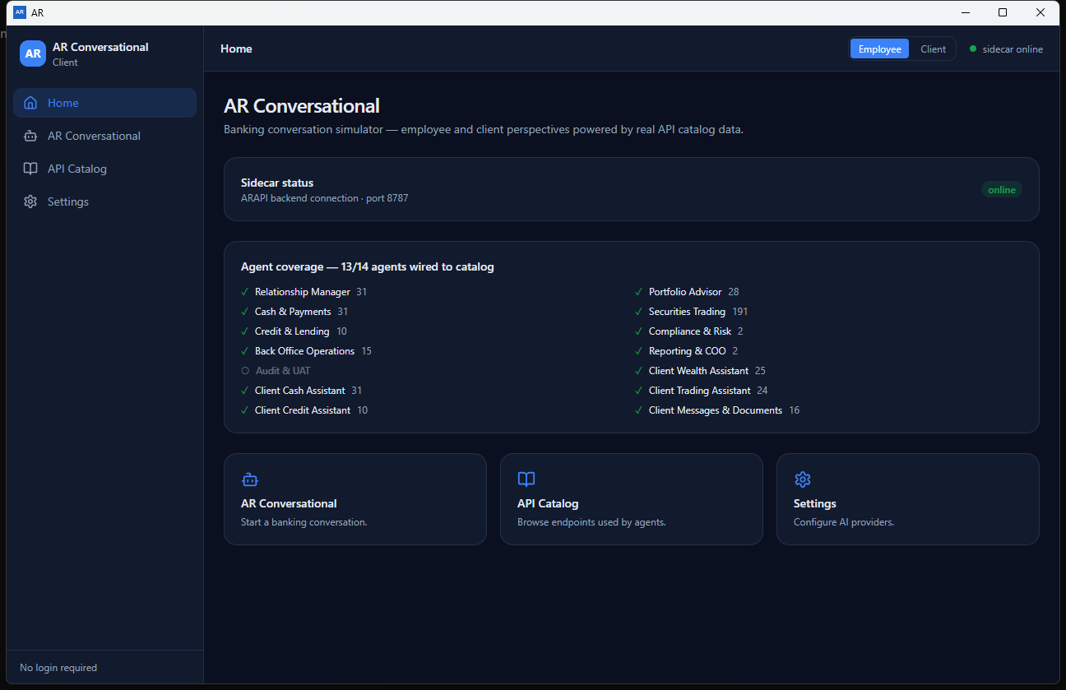
Figure 1. Home overview
Confirm the backend is online and review current catalog coverage before starting a client or employee conversation.
Coverage reading: 13/14 in this capture is dynamic keyword coverage, not a fixed product limit or a successful API-call count.

6.2 Employee conversation workspace
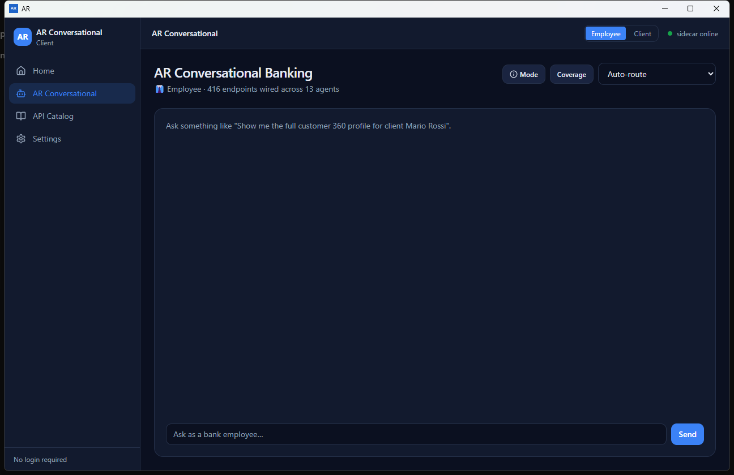
Figure 2. Employee conversation workspace
Employee mode changes automatic routing candidates, example language, and the way supported synthetic balance results are introduced.
Session scope: Questions and answers remain visible only while this conversation page stays mounted.

6.3 Conversation mode chooser
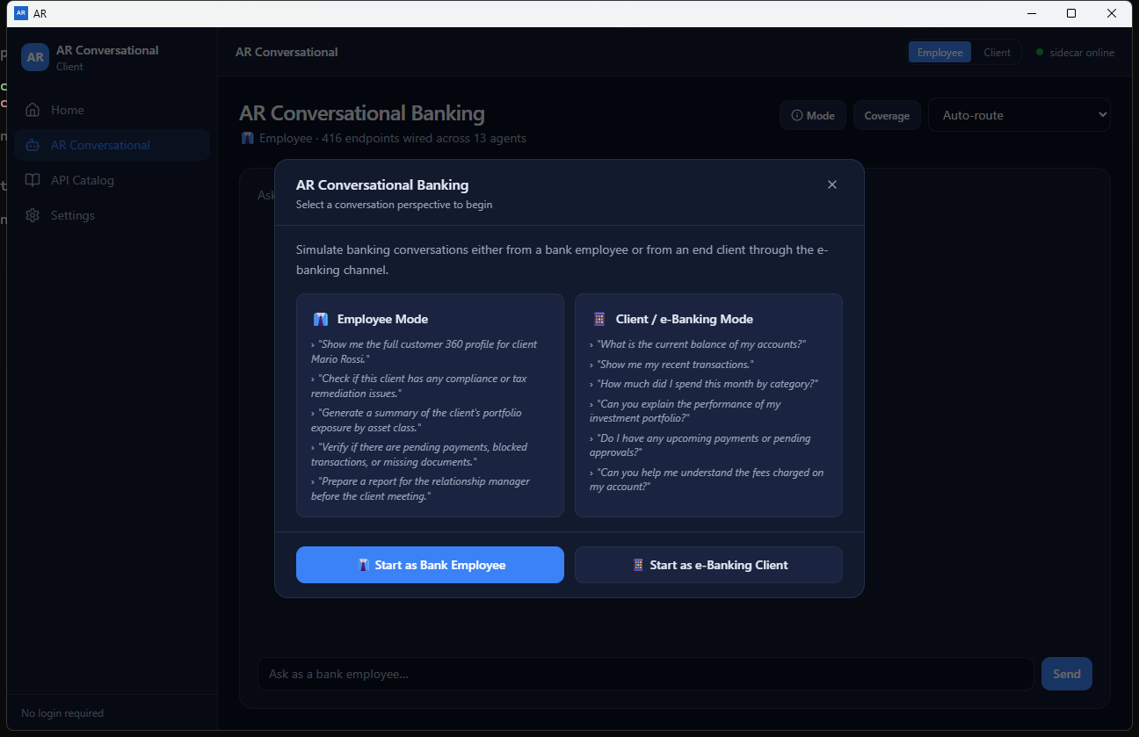
Figure 3. Conversation mode chooser
Choose the perspective that matches the simulation. Close keeps the current mode; the Mode button reopens this chooser later.
Mode is not identity: Start as e-Banking Client changes routing and wording. It does not authenticate a customer or authorize account access.

6.4 Agent catalog coverage
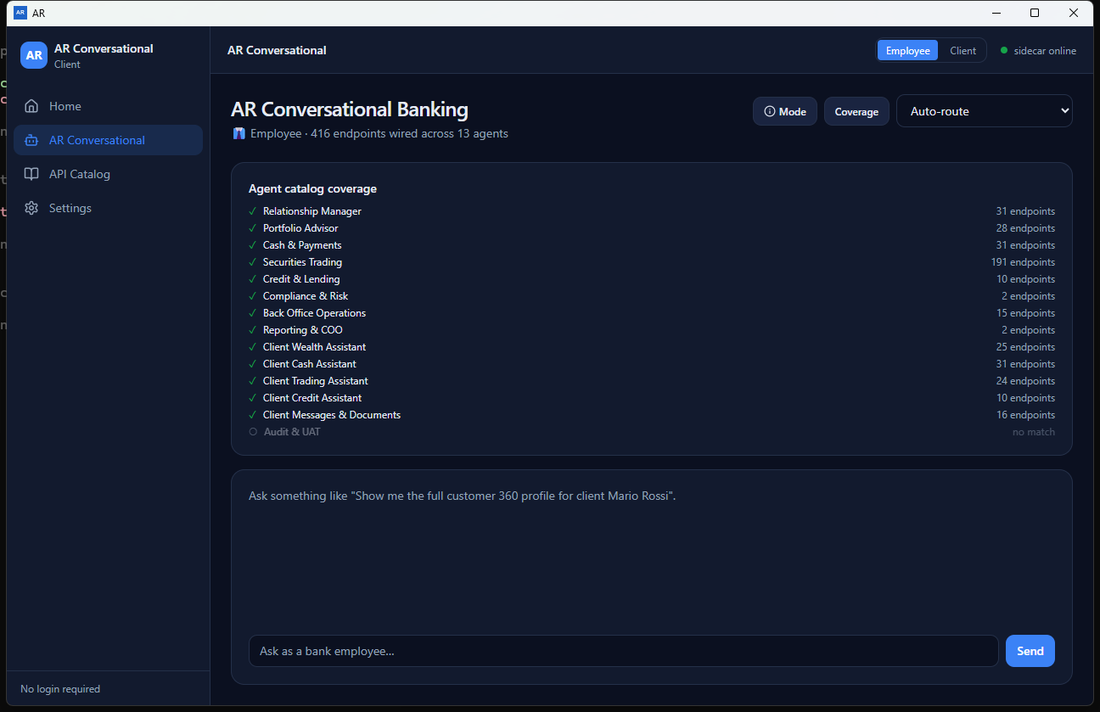
Figure 4. Agent catalog coverage
Coverage is a keyword-match inventory, not proof that every endpoint is suitable or callable for the question.
Match quality: A wired label/count indicates keyword overlap with catalog records. Validate each endpoint's real contract and ownership in ARAPI.

6.5 Explicit agent selection
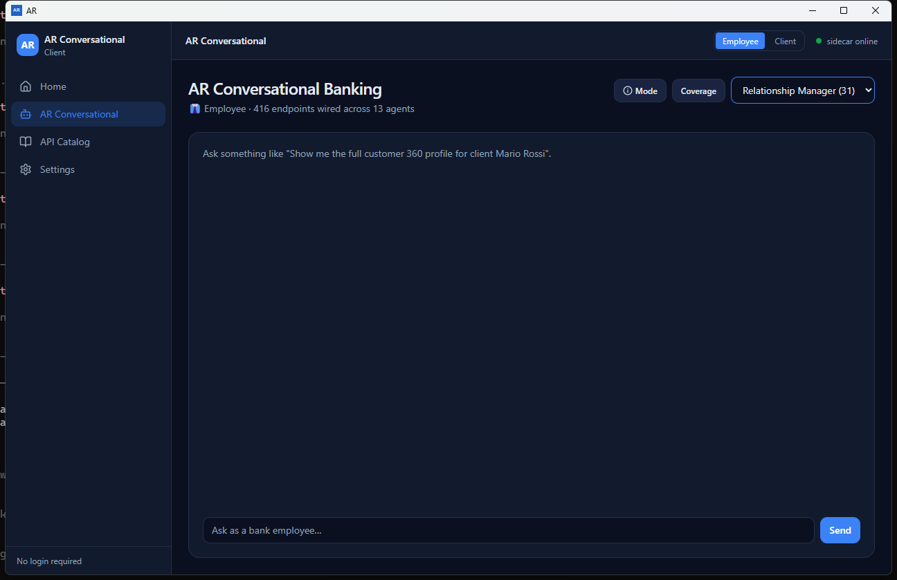
Figure 5. Explicit agent selection
An explicit selection takes precedence over automatic mode-and-keyword routing for the next question.
Override: Relationship Manager remains forced until Auto-route or another agent is selected, even if the active mode would normally choose another group.

6.6 Client e-Banking workspace
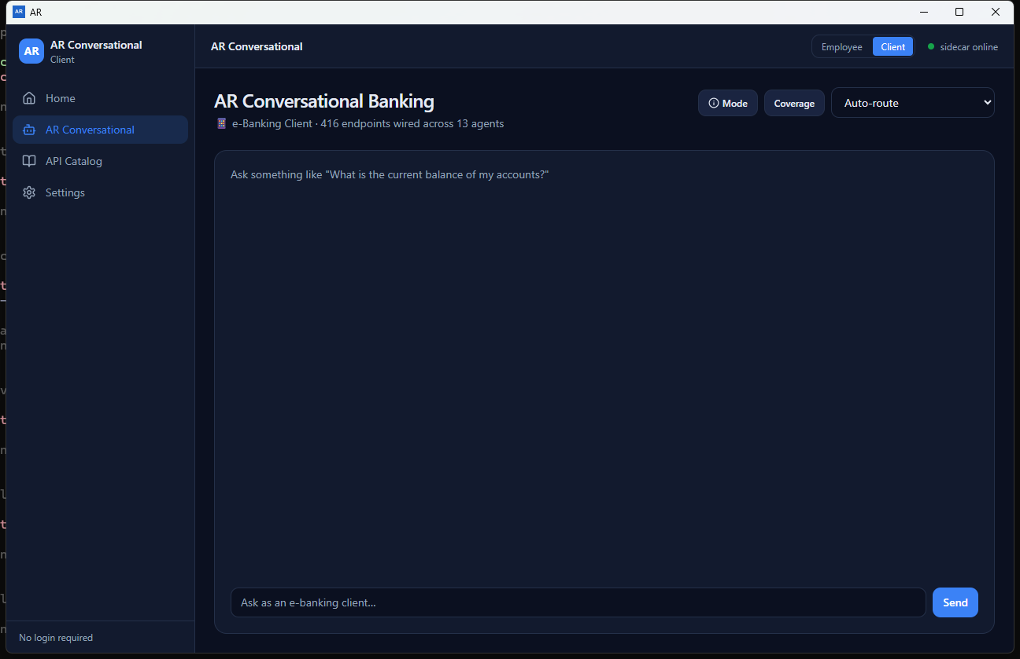
Figure 6. Client e-Banking workspace
Use Client mode for end-client wording and client-agent automatic routing. It does not authenticate or identify a real client.
Client-safe demonstration: Use synthetic questions only. The client mode is a presentation context, not a connected e-banking session.

6.7 Synthetic client balance answer
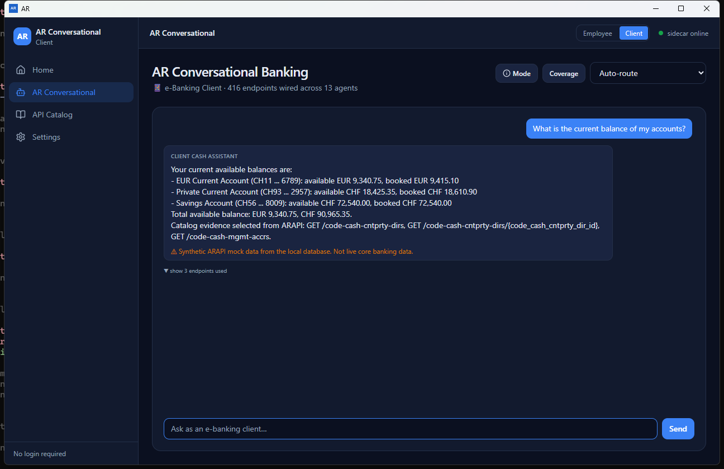
Figure 7. Synthetic client balance answer
The displayed balances are local synthetic ARAPI mock data, not live core-banking data and not suitable for financial decisions.
Synthetic balances: All shown account records are local demonstration data with masked identifiers. Never quote them as a customer position.

6.8 Expanded endpoint evidence
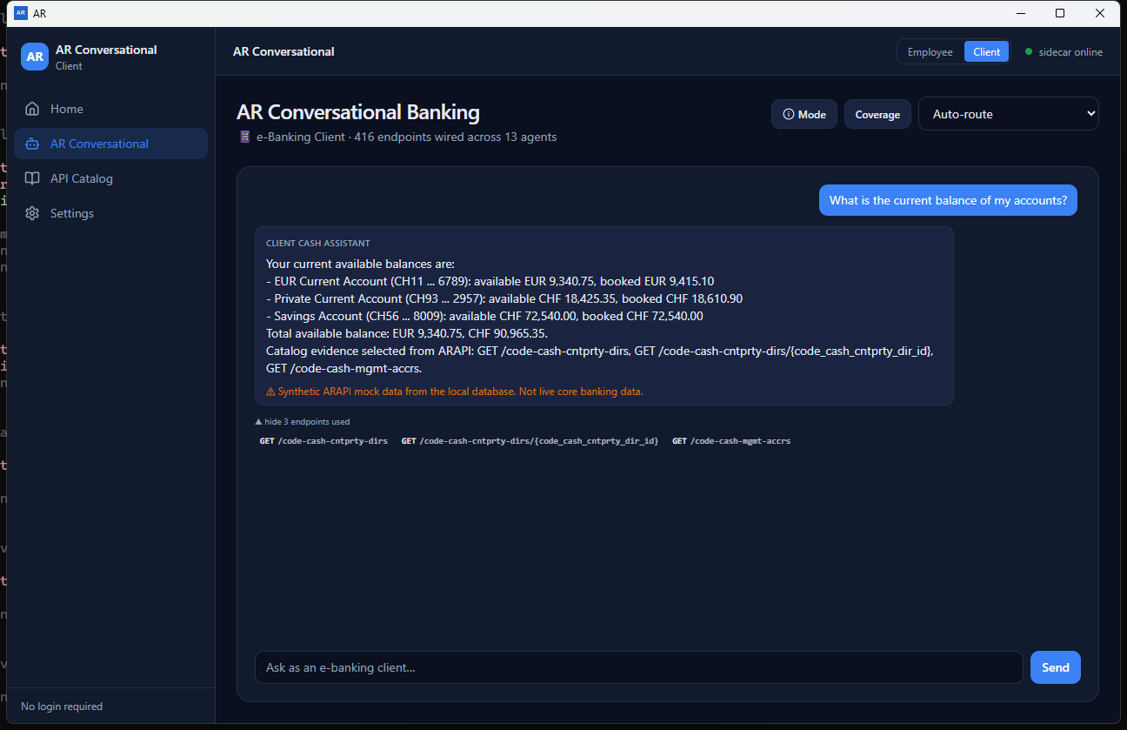
Figure 8. Expanded endpoint evidence
Evidence shows which catalog records were selected by keyword matching; review every method and path before relying on it.
Evidence boundary: Method/path pills are catalog matches. They do not show that authorization, request validation, network execution, or a source-system response occurred.

6.9 ARAPI catalog-search delegation
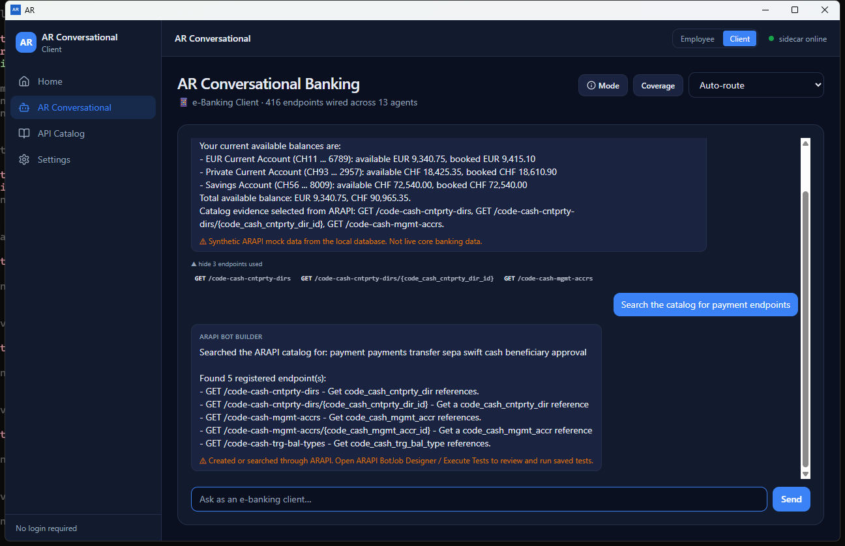
Figure 9. ARAPI catalog-search delegation
Catalog, BotJob, test-build, and related instructions are delegated to ARAPI. Review work in the separate ARAPI application.
Human handoff: Open ARAPI and review any matched endpoint, synthetic record, BotJob, or run. The conversational card is not final approval.

6.10 API Catalog overview
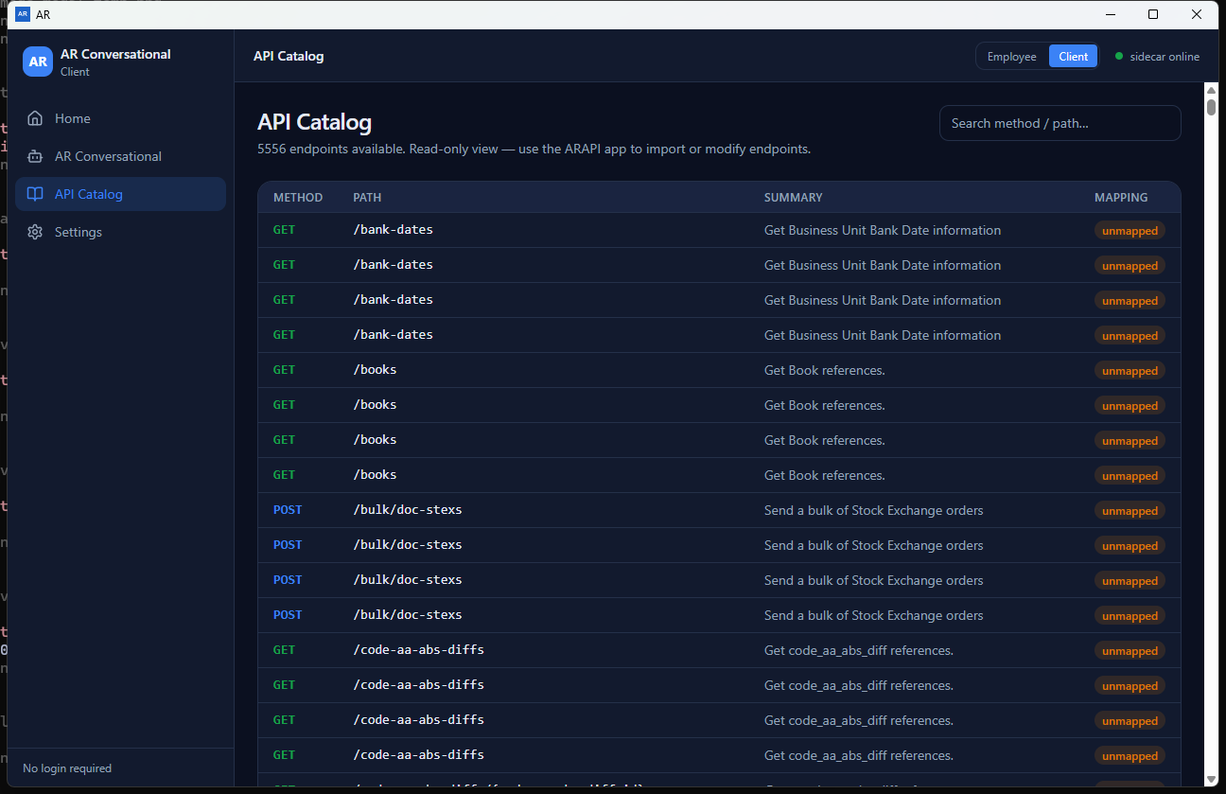
Figure 10. API Catalog overview
Endpoint counts and rows depend on the shared database. Import or modify specifications only in ARAPI.
Read-only: Import, edit, and mapping controls intentionally remain in ARAPI.

6.11 Filtered API Catalog
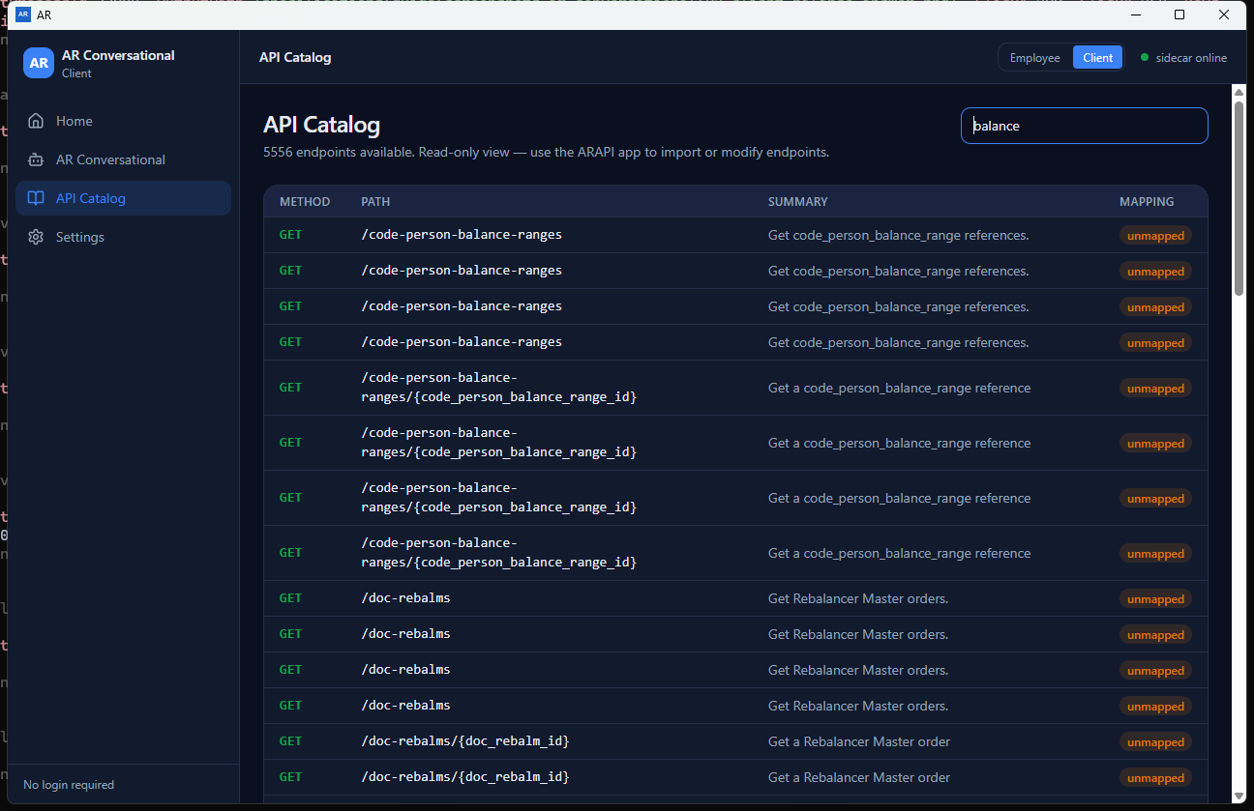
Figure 11. Filtered API Catalog
Search matches method, path, or summary text. Broad terms may return semantically weak matches that require human review.
Search semantics: Filtering uses method/path/summary text. A broad word such as balance may include technically or semantically unsuitable endpoints.

6.12 Settings provider list
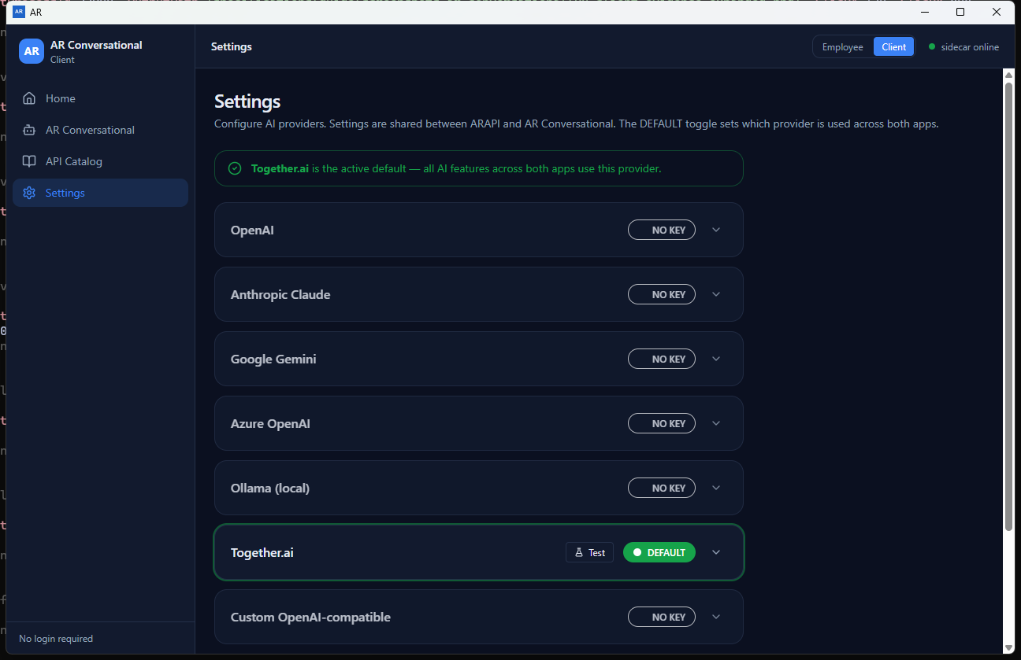
Figure 12. Settings provider list
Settings are shared with ARAPI. Changing the default or provider record affects both applications.
Shared setting: Changing provider records or default selection here changes the shared setting seen by ARAPI.

6.13 Provider configuration form
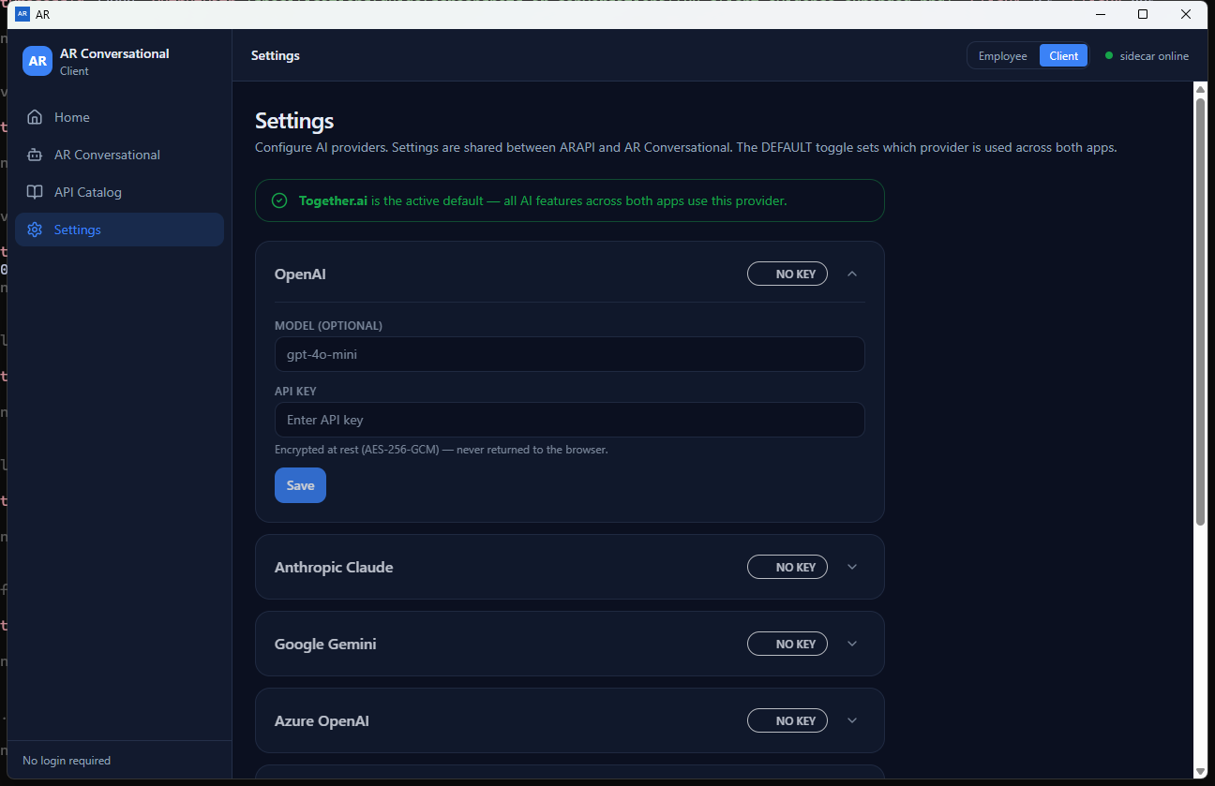
Figure 13. Provider configuration form
Leave a saved key field blank to preserve the existing key. Never place production credentials in screenshots or support tickets.
Credential handling: Blank after a saved key preserves it. Protect the local data store and never capture a typed production key.

6.14 Settings local services
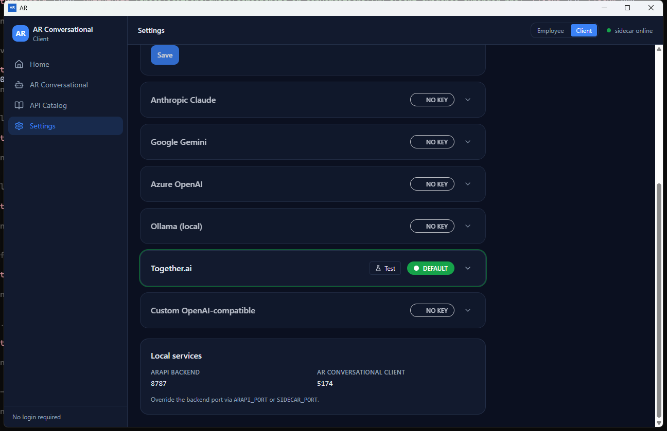
Figure 14. Settings local services
The backend is localhost-only. Port 5174 is the Vite development UI port; packaged desktop operation does not require exposing it.
Port scope: 8787 is the localhost backend; 5174 is development UI only. Neither should be advertised as a public client service.

6.15 Provider Test result
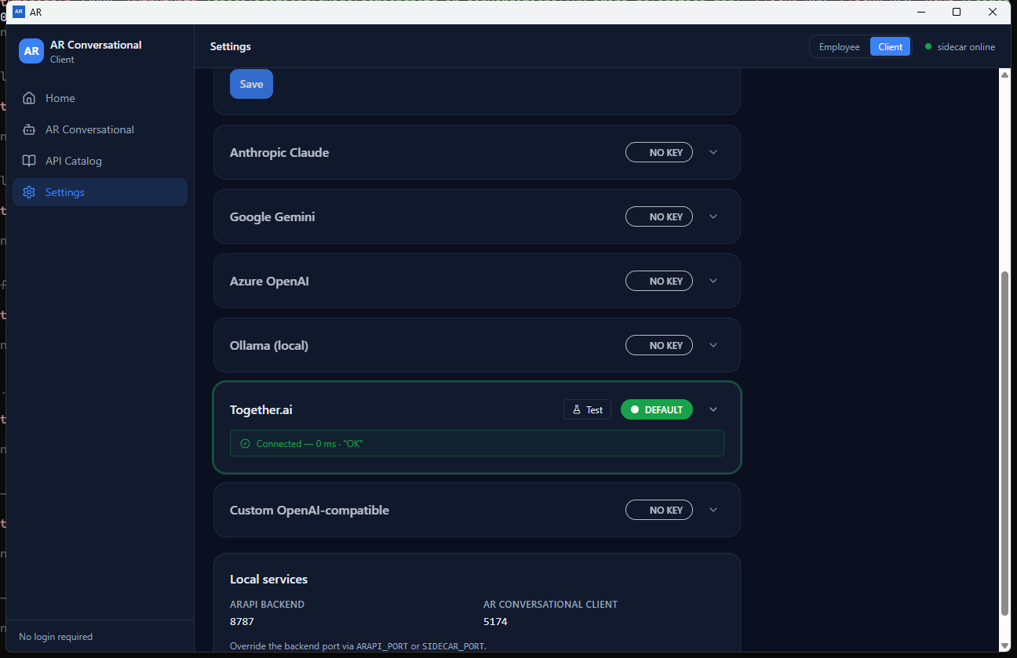
Figure 15. Provider Test result
In the reviewed C# build this is a local configuration indicator, not an external provider round-trip or proof that an LLM processed a request.
Connected qualification: In the reviewed build, this proves only that a local provider record exists. It does not prove external network, credentials, model entitlement, or LLM processing.

7. Employee and client modes
Back to contents
Mode controls the conversation perspective used by the interface and automatic agent routing. It is not login, customer identity, entitlement, consent, or upstream API authorization.
Behavior | Employee mode | Client mode
Automatic candidates | Nine employee agents | Five client agents
Example language | Servicing, operations, portfolio, controls | Balances, payments, trading, lending, messages
Input presentation | Bank-employee question context | e-Banking client-style question context
Synthetic balance wording | Employee-oriented explanation | Client-oriented account summary
Authentication effect | None | None
Catalog effect | None; shared inventory | None; shared inventory

Choose or change mode
- At first use, read the welcome comparison and select Start as Bank Employee or Start as e-Banking Client.
- Later, select the top-bar Employee/Client button for a direct change, or select Mode in the workspace to reopen the comparison.
- Ask a new question after the change. Previously displayed text is not reprocessed or relabeled.
- Return the agent selector to Auto-route if you want mode-filtered automatic routing; an explicit agent selection still takes precedence.

First-use modal behavior
The introduction is remembered locally after closing or choosing a mode. Use the Mode button to reopen it. Clearing browser/webview storage may cause it to appear again.
Client demonstrations: State explicitly that Client mode is synthetic and local before showing balances or messages. Do not let the visual context imply connection to a customer's bank session.

8. Banking agents and routing
Back to contents

How Auto-route works
- The backend takes the current Employee/Client mode and builds that mode's candidate list.
- It compares banking keywords from the question with each candidate's routing profile.
- The highest-scoring candidate handles the normal banking question; deterministic fallback behavior applies when scoring is weak.
- If a named agent is selected, that explicit ID is used instead of the mode-filtered automatic selection.
- The answer returns the agent name plus any evidence and limitations; inspect them before relying on the response.
Routing is classification: Agent choice does not grant data access, verify customer identity, validate an API contract, or invoke a live banking system.

Agent groups
Mode | Agent | Primary purpose
Employee | Relationship Manager | Customer-facing service, onboarding, accounts, balances, and payments.
Employee | Portfolio Advisor | Investment advisory and portfolio support.
Employee | Cash & Payments | Payments, transfers, and cash operations.
Employee | Securities Trading | Trading and execution workflows.
Employee | Credit & Lending | Loan and credit servicing.
Employee | Compliance & Risk | Compliance checks, risk, and controls.
Employee | Back Office Operations | Settlement, reconciliation, and operations support.
Employee | Reporting & COO | Reporting, analytics, and operational oversight.
Employee | Audit & UAT | Audit trail and test support.
Client | Client Wealth Assistant | Client-facing wealth and investment support.
Client | Client Cash Assistant | Client-facing cash, balance, and payment support.
Client | Client Trading Assistant | Client trading support.
Client | Client Credit Assistant | Client lending support.
Client | Client Messages & Documents | Client document and message handling.

Coverage panel
Coverage calls the local agent/capability inventory and displays current keyword-match counts against the shared catalog. Counts change after ARAPI imports or catalog changes. Zero means no current keyword match; it is not an agent permission state.

When to select an agent explicitly
- The organizational owner is known and the question is intentionally narrow.
- You are testing a specific agent's wording or evidence selection.
- Auto-route repeatedly chooses an adjacent responsibility for ambiguous wording.
- You are demonstrating how an agent behaves outside its normal mode. Label that as an override and not normal routing.
Reset after testing: Choose Auto-route when explicit-agent testing is finished, especially before changing from Employee to Client mode.

9. Questions, answers, limitations, and evidence
Back to contents

Write an effective question
- Ask one business question or instruction at a time.
- Use specific banking nouns and actions: account balance, payment status, portfolio holdings, loan repayment, compliance screening, settlement, or statement.
- State whether you want an explanation, a catalog search, or an ARAPI test/BotJob handoff.
- Use synthetic identifiers only; remove all production credentials and customer data.
- If evidence is important, ask for the relevant endpoint area and then validate it in API Catalog/ARAPI.

Request lifecycle
Stage | What happens | What the operator must verify
1. Submit | UI sends question, mode, and optional agent to localhost. | No sensitive text; intended mode/agent.
2. Classify | Normal banking question or delegated ARAPI intent is selected. | The returned agent/action matches the request.
3. Answer | Deterministic local answer or delegated action result is returned. | Read the complete content; do not infer external AI use.
4. Evidence | Up to three catalog records may be attached. | Method/path/summary and real contract suitability.
5. Limitations | Synthetic/no-match/other warnings may be shown. | Treat every limitation as mandatory acceptance context.
6. Handoff | ARAPI review may be required. | Open the separate app and inspect saved artifacts/history.

Synthetic balance response
Balance/account wording is the one normal-question area with a detailed local demonstration response in the reviewed backend. It reads built-in synthetic account rows, masks identifiers, totals the mock values, and appends a clear limitation. It does not query a core-banking system.
Financial-use prohibition: Do not communicate synthetic balances to a customer, reconcile them, make an investment/credit/payment decision from them, or retain them as evidence of a real position.

Evidence interpretation
Method/path: The endpoint record selected from the imported catalog.
Why it appeared: Keyword overlap between the expanded question and endpoint metadata.
What it proves: Only that a catalog record was selected for display.
What it does not prove: Schema correctness, data entitlement, authentication, network execution, response validity, or successful business effect.

Conversation retention
Version 1.0.0 does not persist visible turns as a searchable conversation history. If the organization needs an audit record, capture an approved sanitized summary and the corresponding ARAPI/source-system evidence before navigating away. Do not use screenshots as the only live-system proof.

10. ARAPI delegation and cross-application workflow
Back to contents
Prompts containing test creation/building, BotJob, catalog-search, catalog-for, or payment-endpoint intent are sent to the shared ARAPI assistant route rather than the normal banking-agent route.

Common delegated intents
Intent | Typical wording | Observed local result
Search/list | Search the catalog for payment endpoints | Returns matched endpoint records and a handoff warning.
Create/build | Create a BotJob for an account flow | May use an imported match or create a synthetic mock-only record and saved BotJob.
Run | Run the BotJobs | Can execute all saved BotJobs against the built-in Mock environment and return local summaries.

Required handoff procedure
- Read the conversational action/result card and identify whether it searched, created, or ran anything.
- Open the separate ARAPI application using the same local deployment/database.
- For search: validate method, path, summary, imported source, banking mapping, and ownership.
- For create: open BotJob Designer and review endpoint origin, every command, variable, body, header, ordering, enabled state, and environment.
- For run: open Execute Tests/History and identify every job that ran, the Mock target, status rows, and limitations.
- Delete or quarantine unwanted synthetic/demo artifacts only through approved ARAPI data-management procedures.
- Obtain human approval before generating Bash/curl or pointing any environment at a non-mock target.
No silent acceptance: A delegated card is an instruction result, not approval of an API contract, BotJob, test outcome, or production change.

Recommended division of responsibilities
Role | AR Conversational responsibility | ARAPI responsibility
Business user | Ask a sanitized question; read limitations. | Review business intent and expected effects.
API owner | Interpret catalog evidence cautiously. | Confirm real specification, method/path, schemas, and authorization.
QA/operator | Identify the requested handoff. | Review BotJob, environment, generated script, run, and target evidence.
Administrator | Protect workstation/local service. | Protect shared DB, credentials, backups, and deployment bundle.

11. Read-only API Catalog
Back to contents
API Catalog displays endpoints imported by ARAPI into the shared database. AR Conversational does not import, edit, delete, or map specifications.

Search
- Open API Catalog from the sidebar or Home shortcut.
- Enter a method, path fragment, or summary word in Search method / path.
- Review every returned row: HTTP method, path, summary, and mapping status.
- Clear or replace the search term to restore the broader inventory.
- Open ARAPI for source/import details, corrections, or workflow selection.

Interpret the rows
Field | Meaning | Review point
Method | GET, POST, PUT, DELETE, and other imported verbs. | Write methods may have side effects in a real target.
Path | Imported route template. | Confirm parameter names and base URL in the source contract.
Summary | Specification description used by search/routing. | May be incomplete or ambiguous.
Mapping | Banking taxonomy status from ARAPI. | Unmapped does not automatically mean unusable; requires owner review.

Catalog stewardship: When results are missing, stale, duplicated, or incorrectly described, correct the trusted specification/import in ARAPI. Do not try to compensate with confidential prompt text.

12. AI provider settings
Back to contents
Settings stores provider records shared by ARAPI and AR Conversational. The current deterministic conversation routes do not prove that the selected provider generated an answer; configure these records only for approved shared features and future integration needs.

Supported records
Provider | Default model shown | Base URL field
OpenAI | gpt-4o-mini | No
Anthropic Claude | claude-3-5-haiku-20241022 | No
Google Gemini | gemini-1.5-flash | No
Azure OpenAI | gpt-4o-mini | Yes - deployment endpoint
Ollama (local) | llama3.2 | Yes - usually http://localhost:11434
Together.ai | meta-llama/Llama-3-8b-chat-hf | No
Custom OpenAI-compatible | gpt-4o-mini | Yes - deployment endpoint

Configure or update
- Expand the intended provider card.
- Confirm or enter Model. For Azure, Ollama, or Custom, confirm Base URL according to the approved deployment.
- Enter a scoped, revocable API key only when required. The field masks typed characters.
- Select Save. After a key is stored, leaving the key field blank on a later save preserves it.
- Select SET DEFAULT on a configured provider when it should be the shared default. If exactly one keyed provider exists, the backend may promote it automatically.
- Select Test and interpret the result using the qualification below; perform any approved real provider/network validation separately.

Badges and controls
Control/state | Meaning
NO KEY | No stored key is reported for the provider; default selection is disabled.
SET DEFAULT | Available for a keyed, non-default provider; changes the shared default.
DEFAULT | The provider is the current shared default; choose another configured provider to change it.
Test | Returns the reviewed build's local provider-record indicator.
Connected / OK / 0 ms | Does not prove an external request, credential validity, model access, or provider-generated response.

Credential safeguards
- Use non-production or narrowly scoped keys wherever possible; rotate them according to policy.
- Do not put keys in screenshots, manuals, chat questions, logs, or support attachments.
- Provider-list API responses omit key values and the UI masks input, but the local database must still be classified and protected as credential-bearing.
- Restrict Windows account access and data-directory ACLs; back up and dispose of the database under credential-handling policy.
- Before claiming provider connectivity, perform an approved end-to-end check that actually contacts the provider and records sanitized evidence.
UI label qualification: Although the Settings page presents an encryption-at-rest statement, the reviewed C# save path does not independently demonstrate an encryption transform. Do not rely on that label as the only credential control.

13. Security and operational practices
Back to contents

Security boundary
AR Conversational has no internal login in version 1.0.0. The managed Windows account, endpoint controls, local file permissions, backend localhost binding, API credentials, source-system authorization, and organizational procedures form the operational boundary.

Required practices
- Install only an approved, signed distribution on an organization-managed Windows device.
- Keep backend port 8787 on localhost and block unapproved network exposure.
- Protect and back up the shared local database; it may contain catalog data, BotJobs, provider records, and credential-bearing fields.
- Use synthetic demonstration data. Do not enter production personal, banking, authentication, or confidential information into questions.
- Treat screenshots, reports, provider state, catalog details, and delegated ARAPI artifacts according to their data classification.
- Require human review and source-system evidence for any real API action or customer-facing statement.
- Separate development, mock, UAT, and production responsibilities; never infer target authorization from the selected conversation mode.
- Record application version, operator, sanitized question/purpose, agent/mode, ARAPI handoff, evidence location, and exceptions for controlled testing.

What not to enter
Prohibited input | Use instead
Real customer name, IBAN, account number | Synthetic names and clearly fake identifiers.
API key, OAuth token, password, session cookie | Approved secret store or runtime environment in ARAPI workflows.
Confidential payment/portfolio/credit content | Sanitized scenario that preserves only the test intent.
Production request/response body | Schema-only example with fabricated values.
Regulated documents or messages | Approved redacted sample designed for testing.

Operational evidence
For real-system acceptance, combine the sanitized conversational request with reviewed ARAPI artifacts and authoritative target evidence: approved request/response capture, service logs, audit record, database/state confirmation, or a business-owner reconciliation. A conversational answer or screenshot alone is insufficient.
No-login does not mean no security: Do not deploy the app on a shared/unmanaged account or assume Client mode identifies a customer. Apply workstation, file, credential, network, and source-system controls.

14. Troubleshooting
Back to contents
When escalating, include AR Conversational version, installation type, exact displayed message, current mode/agent, sanitized question, backend status, and reproduction steps. Remove credentials and customer data.

sidecar offline
Close and reopen the desktop app, confirm no process is already occupying port 8787, and contact the deployment administrator if status remains offline. Do not expose the port publicly.

Home shows no agent coverage
Wait for the backend to become online. If the list remains absent, verify GET /agents locally and restart the approved application bundle.

Agents show no match or zero endpoints
Open ARAPI, import a trusted OpenAPI/Swagger specification, and verify that relevant method/path/summary terms exist. Counts are keyword matches and update with the catalog.

The wrong agent answered
Return the selector to Auto-route and use a more specific question, or explicitly choose the intended agent. An explicit agent overrides the current mode's automatic candidate filter.

Send does nothing
Enter non-whitespace text and wait for the current request to finish. Send is disabled while busy; pressing Enter also submits.

A conversation disappeared
Visible turns are component memory only. Navigating away, reloading, or restarting clears them; there is no conversation-history workspace in 1.0.0.

A balance answer looks like real customer data
Stop and read the orange limitation. The reviewed build returns local synthetic accounts with masked IBANs. Never use it for customer service, valuation, or a financial decision.

Evidence appears unrelated
Evidence is selected by keyword matching and is limited to a few catalog records. Review method, path, summary, ownership, authorization, and the real contract in ARAPI before use.

An instruction was delegated to ARAPI
Prompts about creating/building tests, BotJobs, catalog searches, or payment endpoints use the ARAPI assistant route. Open ARAPI Designer/Execute Tests to review any result.

A delegated instruction says BotJobs were executed
The current delegated run intent can execute all saved BotJobs against the built-in Mock environment. Review ARAPI execution history and do not interpret local green rows as proof of a real downstream change.

Provider Test says Connected but AI behavior fails
The reviewed C# Test result is a local configuration indicator. Verify the record, model, base URL, entitlement, proxy/firewall, and an approved external provider check outside this indicator.

Catalog is empty or read-only
Use the separate ARAPI application's Import APIs workflow. AR Conversational intentionally provides no import, edit, or category-mapping controls.

Port 5174 cannot be reached
Port 5174 is the Vite development UI port. A packaged Tauri desktop app loads its bundled frontend and does not require a public web listener on 5174.

Safe diagnostic information
- AR Conversational version and installer/portable distribution type.
- Home sidecar status, backend port, and dynamic agent-coverage count.
- Current mode and selected agent name (or Auto-route).
- A fully sanitized reproduction question and the displayed limitation text.
- Endpoint methods/paths shown as evidence when those catalog details are approved for sharing.
- Provider name/model/base-URL hostname and badge state; never the key or Authorization data.
- Whether ARAPI shows the same catalog/provider data and whether a delegated artifact/run exists.

15. Feature status matrix
Back to contents
Capability | Status | Qualification
Employee and Client modes | Available | Presentation/routing context only; not authentication.
14 named banking agents | Available | Nine employee and five client routing profiles.
Auto-route | Available | Mode filter plus keyword score; explicit agent overrides.
Agent coverage | Available | Dynamic catalog keyword counts, not execution proof.
Normal banking answers | Available with qualification | Deterministic local response and catalog evidence.
Synthetic balance answer | Demo only | Local mock accounts; no core-banking connection.
Endpoint evidence | Available with qualification | Up to three keyword matches; validate contract in ARAPI.
Conversation history | Not persisted | Visible turns clear on navigation/reload/restart.
ARAPI search/list delegation | Available | Returns catalog matches for human review.
ARAPI BotJob creation delegation | Available with qualification | May create synthetic mock-only endpoint/job.
ARAPI run delegation | Available with qualification | Can run all saved jobs against built-in Mock.
API Catalog | Read-only | Search method/path/summary; import/edit remains in ARAPI.
Seven provider records | Available | Shared with ARAPI; protect the local data store.
Provider default selection | Available | Shared record state; not proof of LLM use.
Provider Test | Local indicator | Not an external provider round-trip in reviewed build.
Frontend development port 5174 | Development only | Not required as a public listener in packaged desktop.
Backend port 8787 | Available | Localhost-only shared C# backend.

Appendix A. Complete control index
Back to contents
This index covers all visible navigation, buttons, selectors, fields, disclosure controls, status controls, and important conditional actions in AR Conversational 1.0.0.
Area | Control | Available when | Result
Global | Home sidebar item | Always | Opens the overview and current shared-backend/agent status.
Global | AR Conversational sidebar item | Always | Opens the conversation workspace; remounting clears visible turns.
Global | API Catalog sidebar item | Always | Opens the read-only shared endpoint inventory.
Global | Settings sidebar item | Always | Opens shared provider and local-service settings.
Global | Employee / Client top-bar buttons | Always | Changes the current in-memory conversation perspective.
Global | sidecar status indicator | Always | Shows whether the UI can reach the localhost backend; refreshed every five seconds.
Home | AR Conversational shortcut card | Always | Opens the conversation workspace.
Home | API Catalog shortcut card | Always | Opens the read-only catalog.
Home | Settings shortcut card | Always | Opens provider settings.
Conversation | Mode | Always | Opens the Employee/Client comparison modal.
Mode chooser | Close (x) | Modal open | Closes the chooser without changing the current mode and records the introduction as seen.
Mode chooser | Start as Bank Employee | Modal open | Selects Employee mode and closes the chooser.
Mode chooser | Start as e-Banking Client | Modal open | Selects Client mode and closes the chooser.
Conversation | Coverage | Always | Shows or hides agent names and dynamic catalog-match counts.
Conversation | Agent selector / Auto-route | Agents loaded | Uses mode and keyword routing when blank, or forces the selected agent.
Conversation | Question input | Always | Accepts one question/instruction. Enter sends; empty text is ignored.
Conversation | Send | Non-empty question and not busy | Sends one request to the local backend and appends the result to the visible session.
Conversation | show/hide endpoints used | Answer includes evidence | Expands or collapses selected catalog method/path pills.
API Catalog | Search method / path | Catalog loaded | Filters by method, path, or summary; does not change the catalog.
Settings | Provider expand/collapse chevron | Always | Shows or hides Model, optional Base URL, API key, and Save.
Settings | NO KEY badge | Provider has no saved key | Disabled status; a key must be saved before selecting the provider as default.
Settings | SET DEFAULT | Provider has a key and is not default | Makes the provider the shared default across both apps.
Settings | DEFAULT badge | Provider is current default | Shows the provider selected for shared AI features; disabled until another provider is chosen.
Settings | Test | Provider has a key | Shows the current build's provider-test result.
Provider form | Model | Provider expanded | Stores the optional model value.
Provider form | Base URL | Azure, Ollama, or Custom provider expanded | Stores the provider/deployment endpoint.
Provider form | API key | Provider expanded | Accepts a new masked key; blank on a later save preserves the existing value.
Provider form | Save | Provider expanded | Persists the shared provider record and clears the typed key field.

Appendix B. Agent reference
Back to contents
Keywords summarize routing intent; the live score uses backend profiles and the wording in the current question. Coverage counts depend on the imported catalog.
Mode | Agent | Purpose | Example routing terms
Employee | Relationship Manager | Customer-facing service, onboarding, accounts, balances, and payments. | customer, onboarding, account, balance, payment
Employee | Portfolio Advisor | Investment advisory and portfolio support. | portfolio, holdings, allocation, investment, recommendation
Employee | Cash & Payments | Payments, transfers, and cash operations. | payment, transfer, SEPA, SWIFT, cash
Employee | Securities Trading | Trading and execution workflows. | trade, order, execution, security
Employee | Credit & Lending | Loan and credit servicing. | loan, credit, mortgage, repayment
Employee | Compliance & Risk | Compliance checks, risk, and controls. | compliance, AML, risk, screening
Employee | Back Office Operations | Settlement, reconciliation, and operations support. | settlement, reconciliation, operations
Employee | Reporting & COO | Reporting, analytics, and operational oversight. | report, analytics, audit
Employee | Audit & UAT | Audit trail and test support. | audit, UAT, log
Client | Client Wealth Assistant | Client-facing wealth and investment support. | wealth, portfolio, investment
Client | Client Cash Assistant | Client-facing cash, balance, and payment support. | payment, transfer, cash
Client | Client Trading Assistant | Client trading support. | trade, market, security
Client | Client Credit Assistant | Client lending support. | loan, credit, mortgage
Client | Client Messages & Documents | Client document and message handling. | document, message, statement

Appendix C. Local API reference
Back to contents
Administrator/developer reference: These are the localhost JSON routes used by the AR Conversational UI. Normal client use should stay in the desktop interface. Never publish the API publicly or send it secrets outside approved settings workflows.

Method | Route | Purpose
GET | /health | Backend liveness used for the online/offline indicator.
GET | /catalog/endpoints | Read the endpoint inventory shared with ARAPI.
GET | /agents | List 14 agents with dynamic catalog capability counts.
GET | /agents/capabilities | List agent names and endpoint-count summaries.
POST | /agents/ask | Route one banking question by mode/explicit agent and return answer, evidence, and limitations.
POST | /app-assistant/chat | Handle delegated ARAPI catalog/BotJob instructions.
GET | /settings/ai-providers | List provider records without returning key values.
POST | /settings/ai-providers | Create/update a shared provider record.
POST | /settings/ai-providers/set-default | Set the shared default provider by record ID.
POST | /settings/ai-providers/test | Return the current build's local provider-test result.

Appendix D. Glossary
Back to contents
Term | Meaning
Agent | A named routing profile with employee/client mode, description, and banking keywords.
Auto-route | Selection behavior that filters agents by mode and scores banking keywords in the question.
Capability count | Current count of catalog endpoints that keyword-match an agent; not a permission or runtime-success guarantee.
Conversation mode | Employee or Client UI context used for examples, placeholder text, automatic candidates, and supported answer wording.
Evidence | Up to three method/path catalog records selected for a normal banking question.
Limitation | A warning returned with an answer, such as synthetic data or no matching endpoint.
Synthetic data | Local demonstration records used by the reviewed C# backend; never live core-banking data.
Delegation | Routing of catalog/test/BotJob language from AR Conversational to the shared ARAPI assistant endpoint.
Shared database | The local data store used by both desktop apps for catalog, provider settings, BotJobs, and related records.
Default provider | The provider record marked as shared default; in this build the label alone does not prove an external LLM call occurred.

Appendix E. Client acceptance checklist
Back to contents

Application and security
- Version and distribution type are recorded; the approved bundle launches without a global Node.js dependency.
- sidecar online appears after a clean launch and port 8787 remains localhost-only.
- The exact shared local database path, backup/restore procedure, and ACL owner are documented.
- Operators understand that there is no internal login and Client mode is not authentication.

Conversation and catalog
- Employee and Client modes, Auto-route, and explicit agent selection behave as documented.
- All 14 agents are listed and coverage changes when the shared catalog changes.
- A synthetic balance demonstration displays masked identifiers and a visible no-live-data limitation.
- Evidence can be expanded and is understood as keyword matching, not execution proof.
- API Catalog search is read-only and the ARAPI import/correction owner is identified.
- Conversation turns are confirmed to clear on navigation/reload/restart.

ARAPI handoff
- A catalog-search instruction produces a reviewable ARAPI delegation card.
- Created/synthetic BotJobs are reviewed in ARAPI before save, script generation, or execution.
- Any delegated run is reconciled against ARAPI History and identified as built-in Mock unless separately proven.
- Human approval and target-side evidence are required for non-mock acceptance.

Providers and support
- Provider records/default selection are confirmed as shared with ARAPI.
- Keys are scoped, revocable, absent from screenshots, and the local database is protected as credential-bearing.
- Provider Test is accepted only as a local configuration indicator; any external validation is performed separately.
- Support procedures list sanitized evidence and explicitly prohibit credentials/customer data in tickets.
Sign-off: Record approver, date, application build, workstation/deployment, shared-data location, tested modes/agents, catalog source, evidence location, exceptions, and remediation owner.

Return to contents

