CLIENT USER MANUAL

ARAPI
  - Complete Client Guide
Import. Design. Execute. Export.
Version 1.0.0 | Windows Desktop
Reviewed 26 August 2026

Document control
Field | Value
Product | ARAPI Windows desktop application
Guide version | 1.0.0
Audience | Banking operations staff, QA analysts, implementation teams, and administrators
Scope | ARAPI only; AR Conversational is a separate application and is not documented here
Evidence basis | ARAPI 1.0.0 source, running desktop build, and the screenshots reproduced in this guide
Review date | 26 August 2026

Client-safe scope: The examples use mock or placeholder values. Never copy production API keys, access tokens, customer data, or confidential response bodies into documentation or support tickets.

How to use this guide
- Start with Sections 2-4 before operating a new installation.
- Use Section 6 as the visual, screen-by-screen walkthrough; every screenshot is from the running ARAPI desktop app.
- Use Section 7 when configuring Designer commands and Section 9 when generating or running Bash/curl files.
- Use Appendix A to look up every visible control and Appendix B only for approved local integration/diagnostic work.

Contents
1. About ARAPI
2. Read this before using the current release
3. Installation and first launch
4. End-to-end quick start
5. Interface fundamentals
6. Screen-by-screen guide
7. BotJob command reference
8. Variables and environments
9. Bash/curl script generation and execution
10. Execution results, history, and reports
11. Bot Builder and AI providers
12. Security and operational practices
13. Troubleshooting
14. Feature status matrix
Appendix A. Complete control index
Appendix B. Local API reference
Appendix C. Glossary
Appendix D. Client acceptance checklist
Navigation: In Word, hold Ctrl while clicking an entry. In most PDF viewers, click normally. Each major section includes a Back to contents link.

1. About ARAPI
Back to contents
ARAPI is a Windows desktop application for catalog-driven API testing. It imports real OpenAPI/Swagger specifications, presents their endpoints in a banking taxonomy, lets users assemble ordered BotJobs, and exports Bash/curl files for command-line execution.
The user interface is local and communicates with a localhost C# backend. No login is required inside the desktop app; workstation access, file permissions, network controls, and upstream API authentication remain the customer's responsibility.

Core concepts
Catalog: The imported, searchable list of real API methods and paths.
BotJob: A saved ordered workflow made of commands and variables.
Environment: A named target base URL plus optional default headers.
Run: A saved local execution/audit record with step rows.
Bash export: A generated .sh file containing enabled API_CALL commands as curl invocations.

Recommended operating sequence
- Import specifications and confirm the catalog.
- Create an approved environment or use the built-in mock context.
- Create/review the BotJob and Save it.
- Generate a Bash script into a controlled directory and review it.
- Set required variables, run the script, and retain target-side evidence.
- Use Execute Tests and Reports for the ARAPI-local audit and exports.

2. Read this before using the current release
Back to contents
Version basis: This manual describes the observed ARAPI 1.0.0 desktop build as reviewed on 26 August 2026. Screen counts and demo data will differ by workstation.

Current-build qualifications
- Test Cases is a reserved workspace: New test case is disabled in version 1.0.0.
- IF, ELSE, LOOP, FOR_EACH, READ_CSV, READ_EXCEL, AI_GENERATE_DATA, and CALL_COMPONENT are preview palette items. The Designer states that they are not executed and are recorded as skipped.
- BotJob-specific Bash generation includes enabled API_CALL commands only. Assertions, extraction, waits, and control/data commands are not emitted into the .sh file.
- Bot Builder may create a synthetic, mock-only endpoint/data record when no imported endpoint matches strongly enough. Review its evidence and never treat a synthetic record as an imported production contract.
- The observed desktop C# build uses the Execute Tests page as a local run/audit view. A green row is not independent proof that a real downstream banking system changed state; use the Bash execution path plus target-side logs/data for acceptance.
- Mock Start/Stop controls the in-app state/log in the observed build. Do not assume port 8855 is an externally callable HTTP listener unless the deployment administrator has enabled and verified one.
- The AI provider Test control is a local configuration indicator in the observed build. Confirm provider connectivity with a real Bot Builder request.
Production safeguard: Before pointing any environment at a non-mock system, obtain authorization, review the generated curl file, restrict credentials to least privilege, and agree on expected side effects and rollback.

3. Installation and first launch
Back to contents

Install or unpack
- Use the ARAPI installer supplied by your organization, or unpack the approved portable ARAPI bundle into a user-writable folder.
- Keep the executable, packaged backend, and any supplied data directory together. Do not move individual sidecar files out of the distribution.
- Launch ARAPI. The app opens a single resizable desktop window; no web login is required.

Verify first launch
- Confirm the top-right indicator becomes sidecar online.
- Open Home and confirm Engine status is online.
- Open Settings and confirm Sidecar port 8787 is displayed.
- If a portable distribution includes a data folder next to ARAPI.exe, preserve and back up that folder before upgrades. Other distributions use an application-data location selected by the desktop shell.
Local-only service: The backend is intended for localhost use. Do not publish port 8787 or 8855 on a public network interface.

4. End-to-end quick start
Back to contents
- Confirm sidecar online on Home.
- Open Import APIs. Use Upload Files for selected files/folders, or Folder (Desktop) for an existing local specification directory. Import .yaml, .yml, or .json files.
- Open API Catalog. Search for a known method/path and confirm the summary and mapping status.
- Open Environments. For a real approved target, create a named environment with its base URL and non-secret defaults. Keep credentials in variables where possible.
- Open BotJob Designer. Create/select a BotJob, add variables, add and configure commands, order them, and Save.
- Open Scripts (or select the BotJob in Execute Tests and choose Create Scripts). Select the environment and Browse to Documents\ARAPI\Scripts.
- Select Create Bash Script. Review the timestamped .sh file; set every required environment variable; run with Bash and curl.
- Use Execute Tests for the ARAPI-local run audit, then Reports for HTML/CSV or whole-catalog Postman/Bash downloads.
Best output directory: Use a dedicated user-writable directory such as %USERPROFILE%\Documents\ARAPI\Scripts. Do not save generated scripts inside the application installation folder.

5. Interface fundamentals
Back to contents

Global header
Page name: The left side of the top bar repeats the current workspace.
Employee / Client: Changes shared conversation-mode context where a mode-aware experience is used. It does not change catalog contents, environment definitions, or BotJob command order.
sidecar status: Green/online means the React interface can reach the local backend. Resolve offline before importing, saving, or running.

Sidebar
Destination | Purpose
Home | Overview, engine status, and shortcuts to every ARAPI area.
Import APIs | Load OpenAPI or Swagger documents from files or a folder.
API Catalog | Search the imported method/path inventory and mapping state.
Business Categories | Browse the 25-domain banking taxonomy.
Test Cases | Reserved reusable-test workspace; creation is disabled in this release.
Bot Builder | Use conversational actions to search, create BotJobs, and request runs.
BotJob Designer | Create, configure, enable/disable, and order commands.
Environments | Manage named base URLs and default headers.
Scripts | Generate a BotJob-specific Bash file containing ordered curl calls.
Execute Tests | Select a BotJob/environment and review the local run audit.
Mock Server | Control the in-app mock state and inspect its request/system log.
Reports | Download run reports and whole-catalog exports.
Settings | Configure AI provider records and view local-service ports.

Common visual states
- Blue primary button: the main action for the page.
- Dimmed button or palette item: required selection/data is missing, or the feature is reserved.
- Green badge: passed, active default, running, or online depending on context.
- Orange/red text: warning, failure, missing mapping, or validation error that requires review.
- Chevron: expand/collapse a provider, command, action card, or result row.
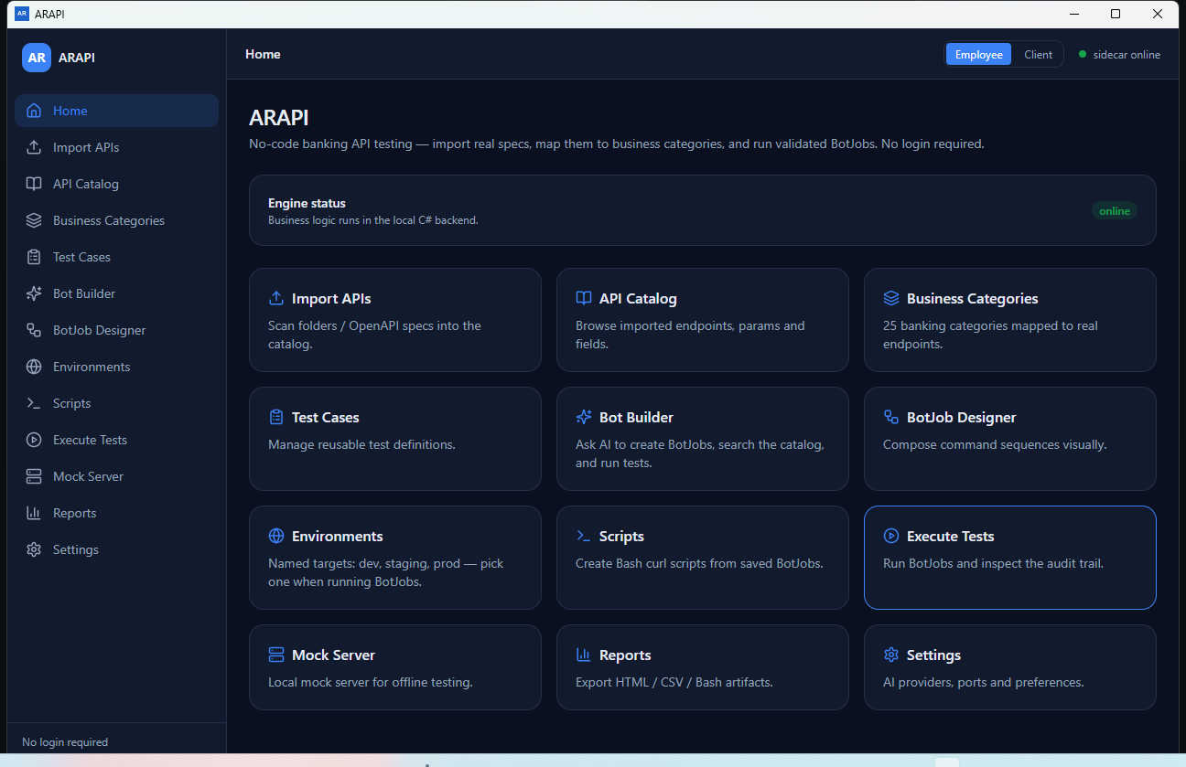
Figure 1. Home overview
Home provides engine health and shortcuts. Use any card or the matching sidebar item to open a workspace.

6. Screen-by-screen guide
Back to contents
The following pages show every main ARAPI screen and the important interaction states captured from the running desktop application. Values are demonstration data; workflows and controls are the focus.

6.2 Import APIs - Folder (Desktop)
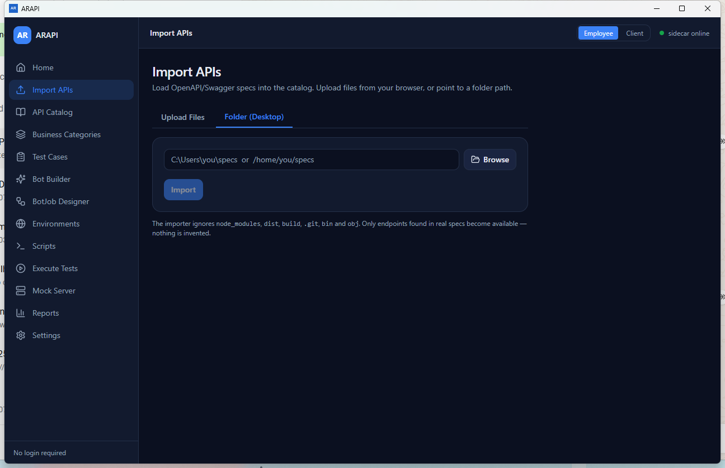
Figure 2. Import APIs - Folder (Desktop)
Choose Browse, select a specification folder, confirm the path, and select Import. Subfolders are scanned.
Importer scope: The recursive scan ignores node_modules, dist, build, .git, bin, and obj. Only endpoints present in parsed specifications enter the catalog.

6.3 Import APIs - Upload Files
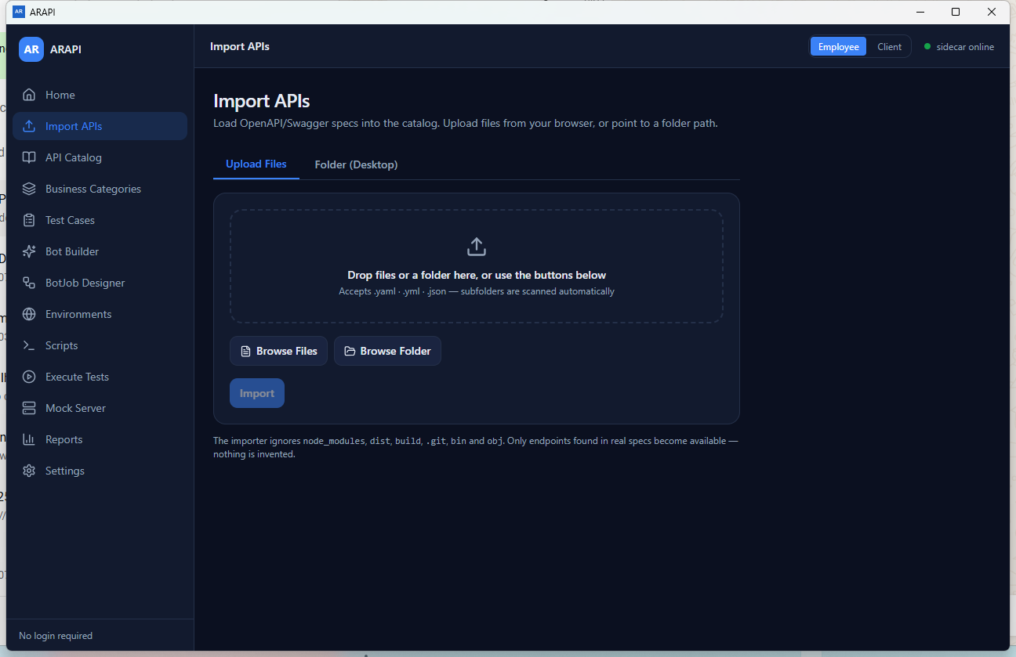
Figure 3. Import APIs - Upload Files
Drop YAML/JSON files or a folder, or use the browse buttons. Remove unwanted items before selecting Import.
Supported files: .yaml, .yml, and .json. Review the import summary and each reported failure before continuing.

6.4 API Catalog
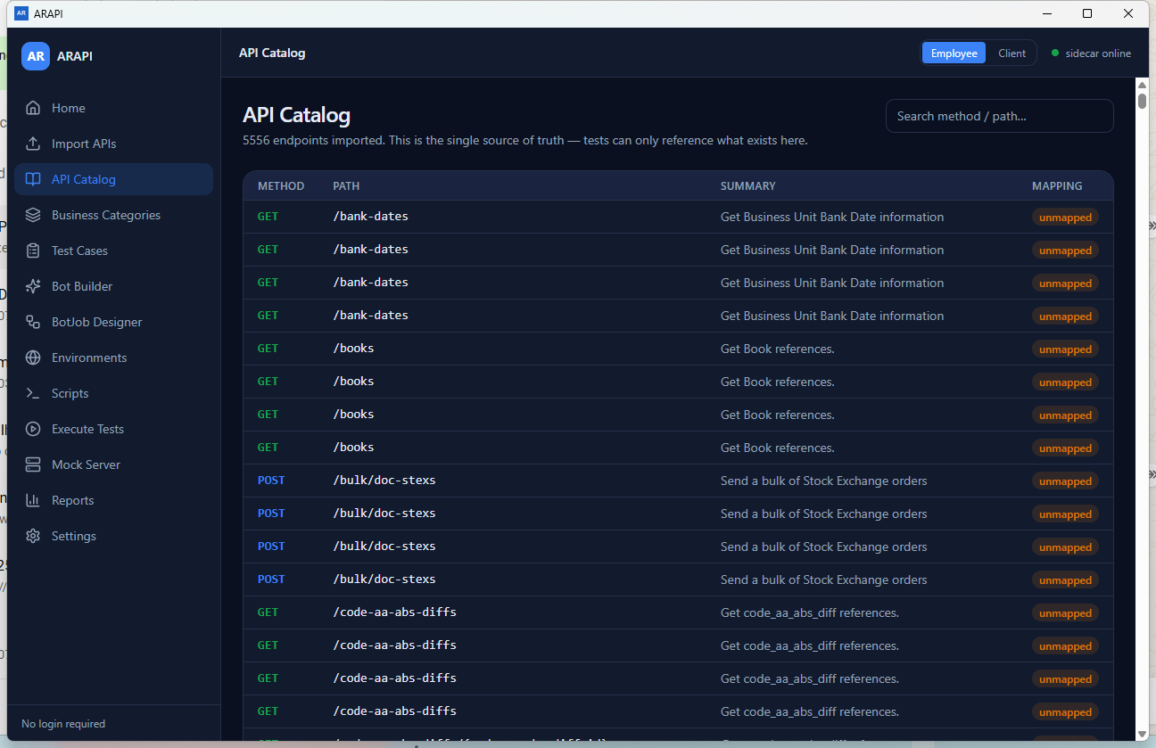
Figure 4. API Catalog
Search by HTTP method, path, or summary. Mapped/unmapped indicates whether taxonomy mapping exists.
Single source of selection: Designer API_CALL controls can select only endpoint IDs currently returned by the catalog.

6.5 Business Categories
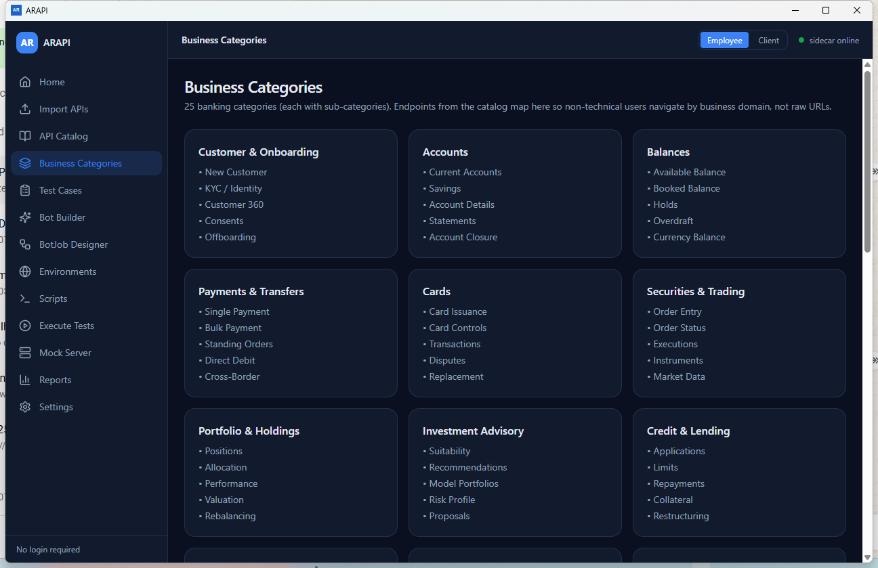
Figure 5. Business Categories
This is a read-only business view of the 25-domain taxonomy in the current UI.

6.6 Test Cases
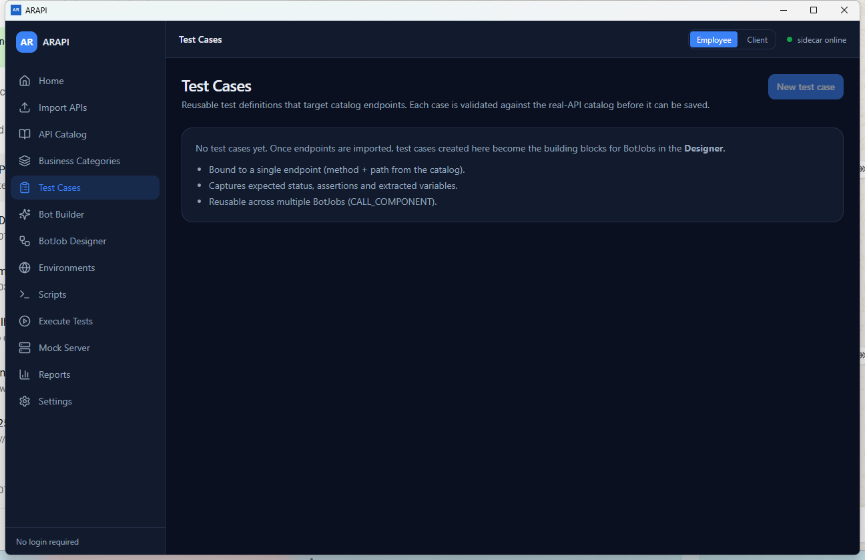
Figure 6. Test Cases
The page documents the intended reusable-test concept, but New test case is disabled in version 1.0.0.
Release status: New test case is disabled in 1.0.0. Use BotJob Designer for available workflow authoring.

6.7 Bot Builder - start
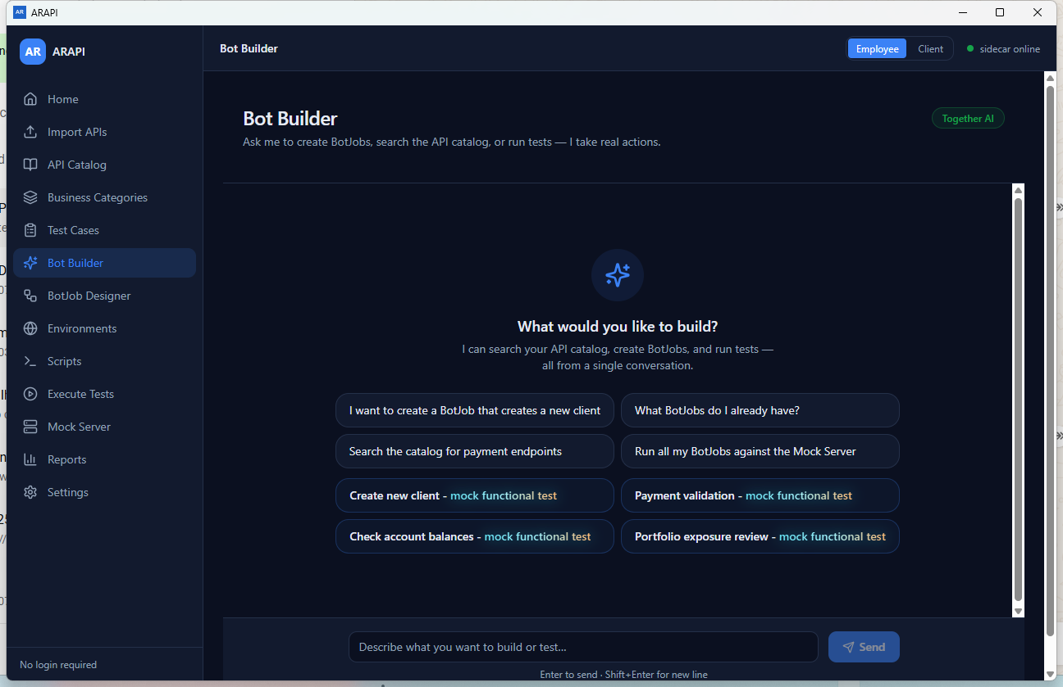
Figure 7. Bot Builder - start
Select a suggestion or write an instruction. Enter sends; Shift+Enter inserts a new line.

6.8 Bot Builder - catalog action
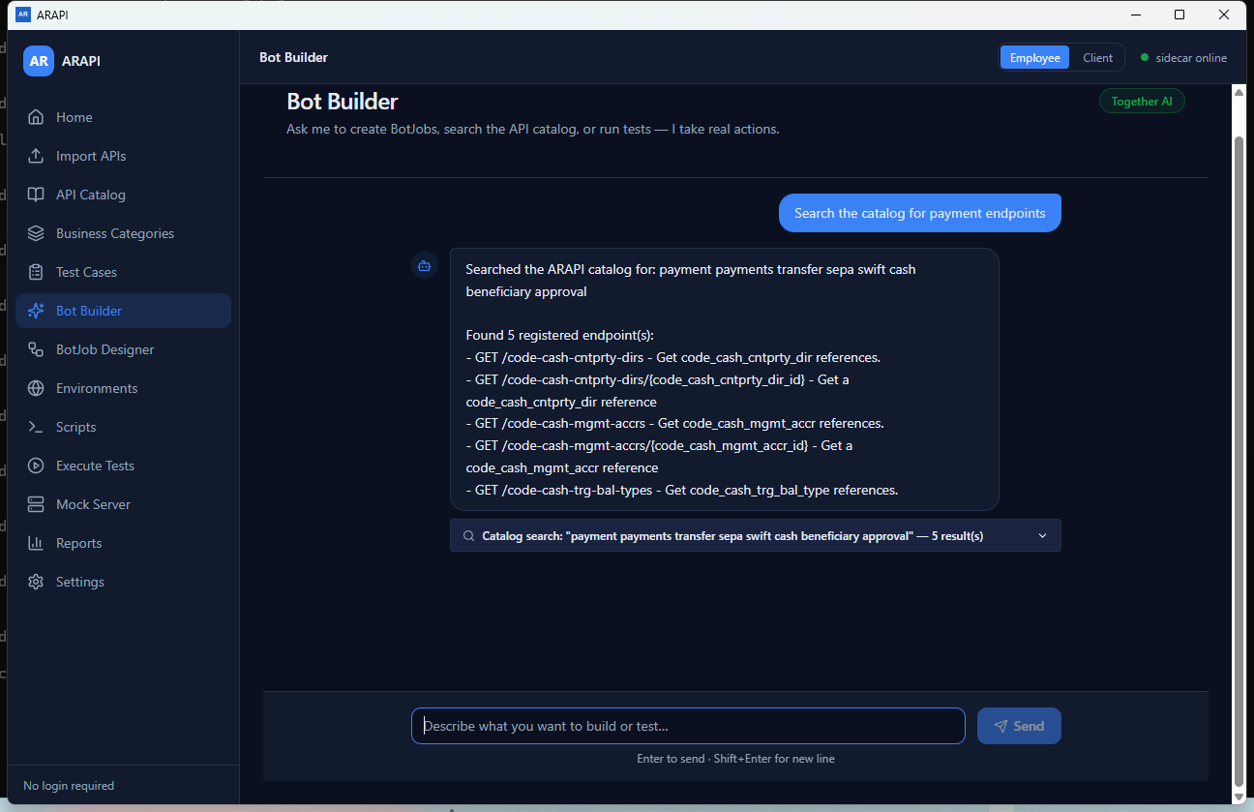
Figure 8. Bot Builder - catalog action
Review the returned endpoints and expand action cards. Never assume a conversational result is a production endpoint without catalog evidence.
Evidence rule: An action card is evidence of what ARAPI matched or created. Confirm whether the endpoint is imported or synthetic before relying on it.

6.9 BotJob Designer - no selection
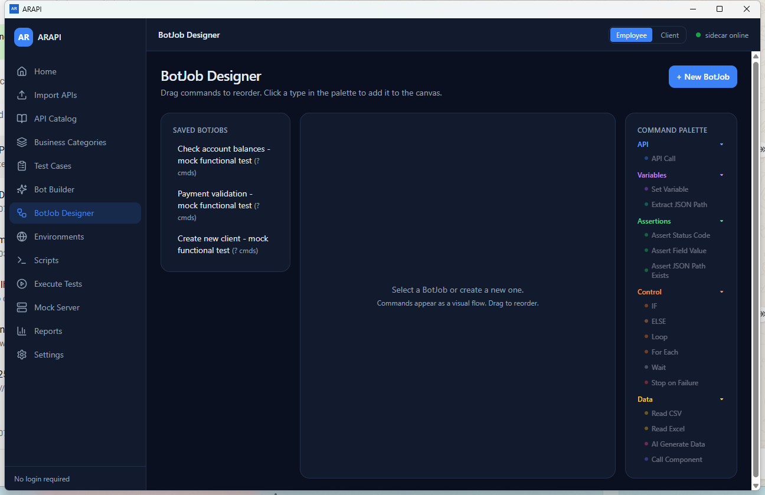
Figure 9. BotJob Designer - no selection
Select a saved BotJob or create one. Palette controls stay disabled until a job is selected.

6.10 BotJob Designer - selected job
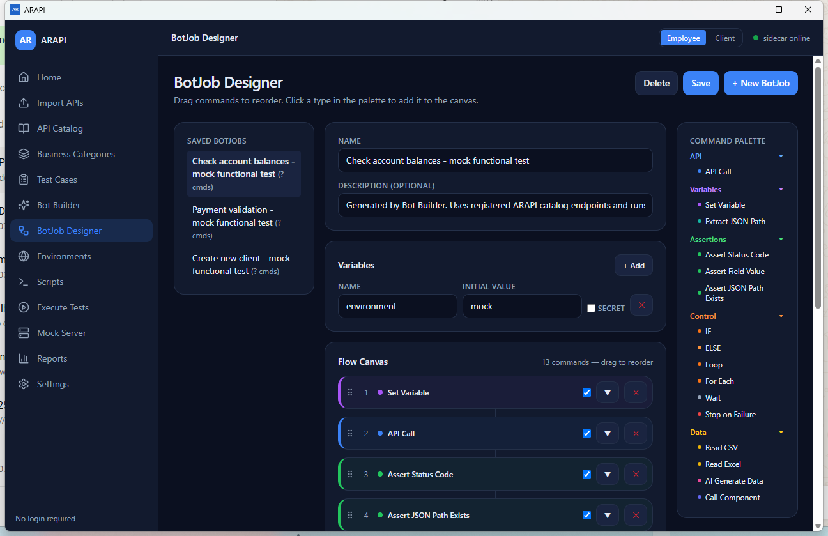
Figure 10. BotJob Designer - selected job
Edit metadata and variables, add palette commands, drag the grip to reorder, enable/disable commands, and Save.

6.11 BotJob Designer - API Call configuration
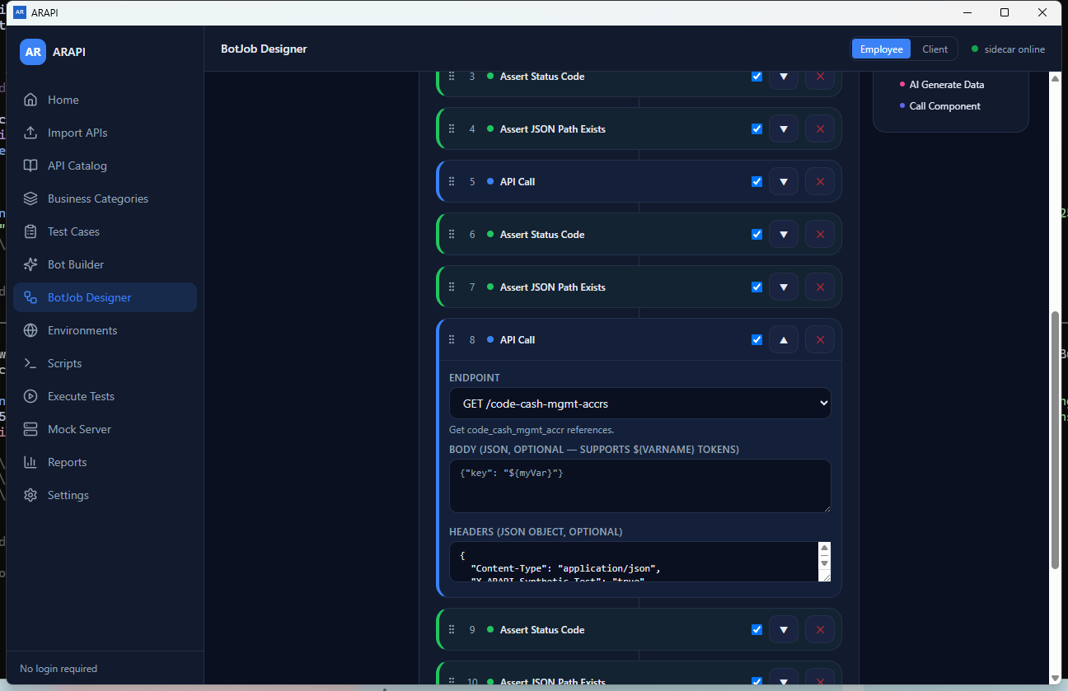
Figure 11. BotJob Designer - API Call configuration
Choose an imported endpoint, supply valid optional JSON, and reference variables with ${name}.
${token}
{"Authorization": "Bearer ${token}"}
{"customerId": "${customerId}"}

6.12 Environments
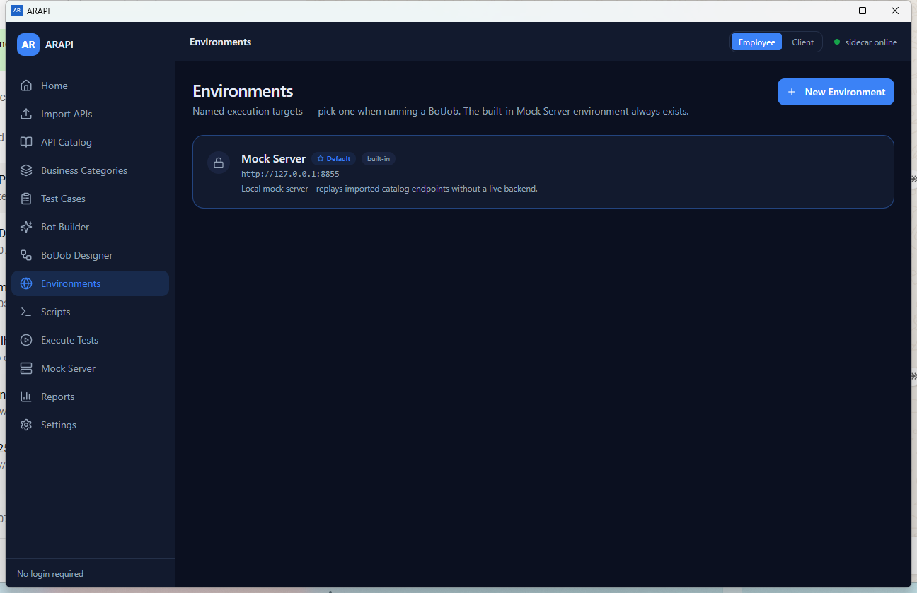
Figure 12. Environments
The built-in record cannot be edited or deleted. Create separate named targets for approved dev, test, or production systems.

6.13 Environment form
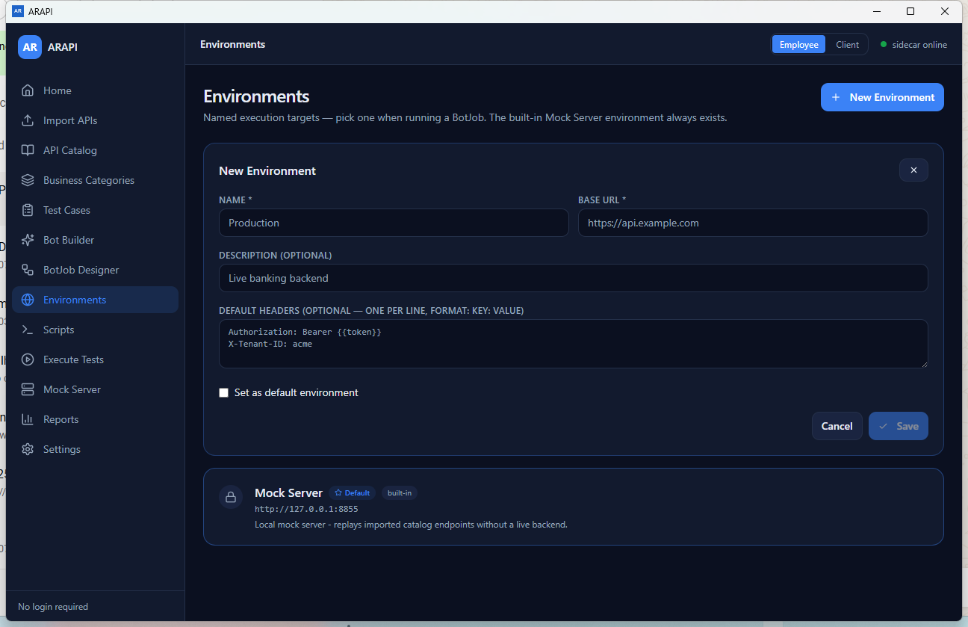
Figure 13. Environment form
Use one Key: Value header per line. Save is enabled only after Name and Base URL are present.
Authorization: Bearer ${token}
X-Tenant-ID: acme

6.14 Scripts - initial
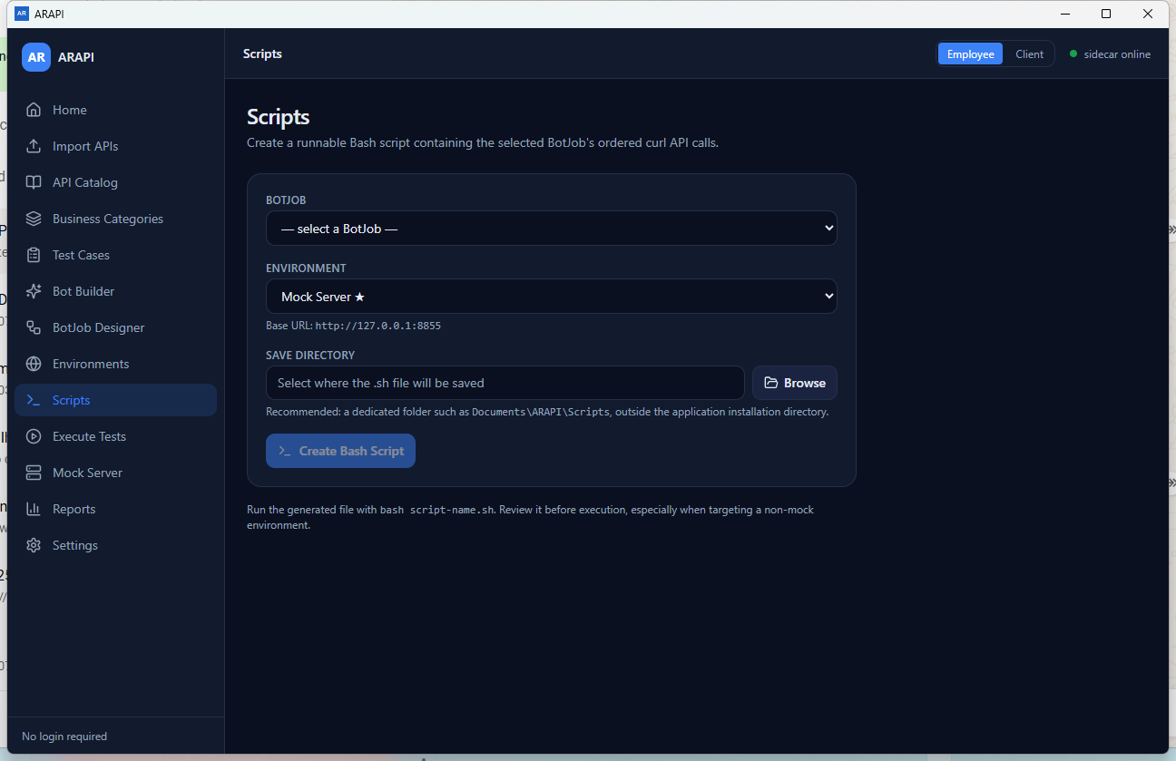
Figure 14. Scripts - initial
The action remains disabled until the required selections and desktop output directory are set.

6.15 Scripts - selected BotJob
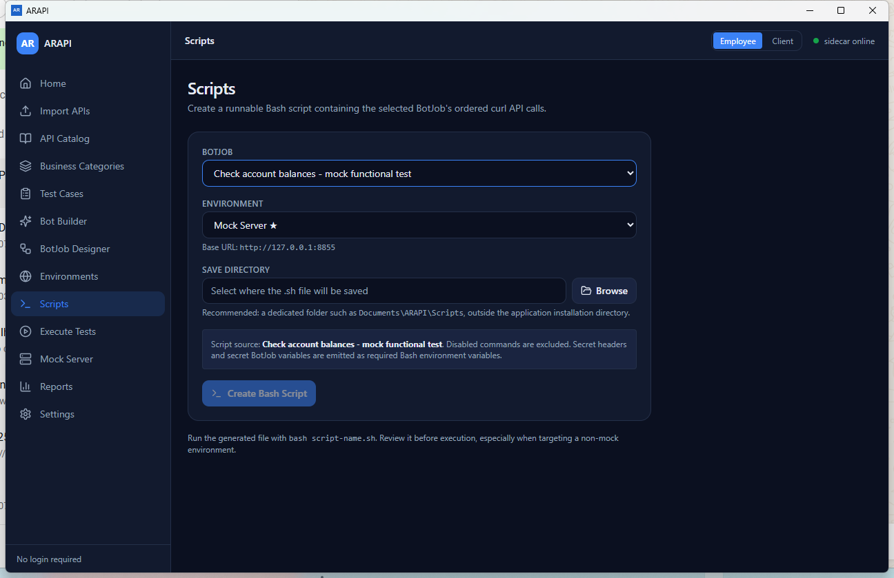
Figure 15. Scripts - selected BotJob
Choose Browse and use a dedicated directory such as Documents\ARAPI\Scripts. Then create the file.
Recommended directory: %USERPROFILE%\Documents\ARAPI\Scripts

6.16 Execute Tests - initial
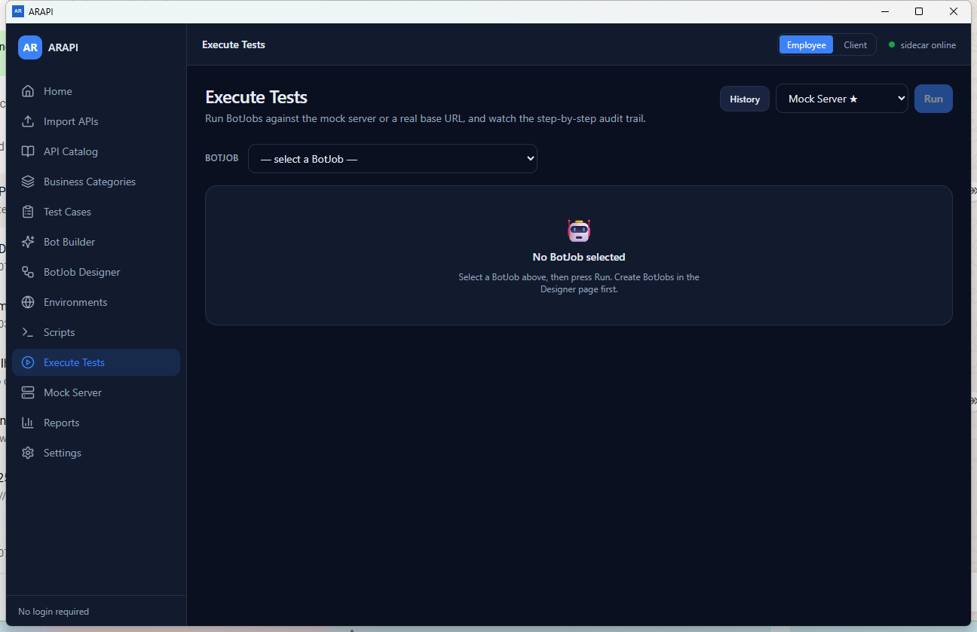
Figure 16. Execute Tests - initial
Select the execution environment and BotJob. Run and Create Scripts appear/enabled only when applicable.

6.17 Execute Tests - ready
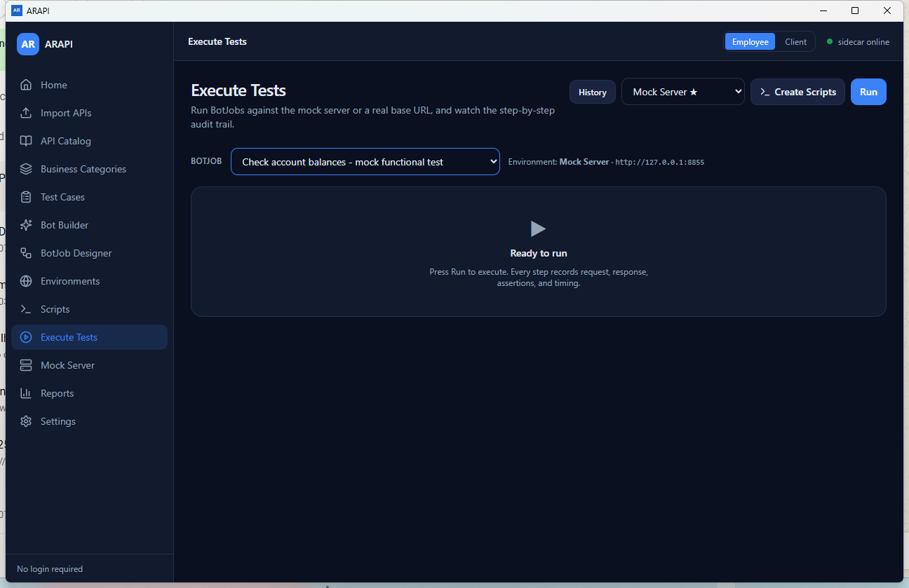
Figure 17. Execute Tests - ready
Create Scripts opens the Scripts page with the current BotJob and environment preselected; Run starts the local audit.

6.18 Execute Tests - result summary
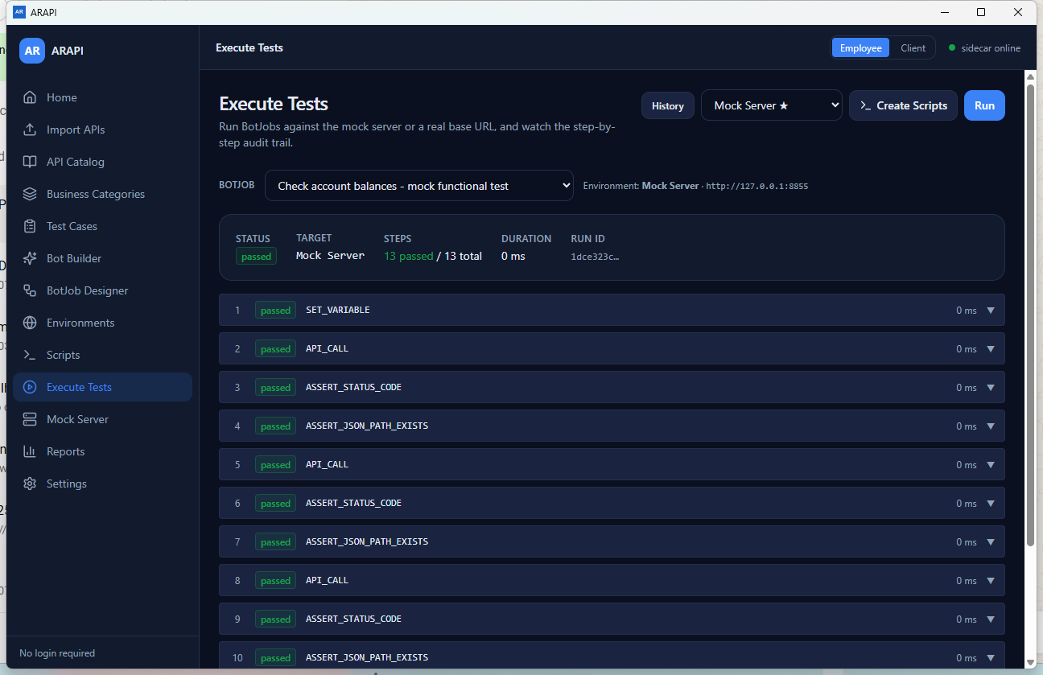
Figure 18. Execute Tests - result summary
Expand any row for details. Always correlate real-environment results with target-side evidence.
Evidence: Use target-side logs/data for live-system acceptance; a local ARAPI status alone is insufficient.

6.19 Execution step detail
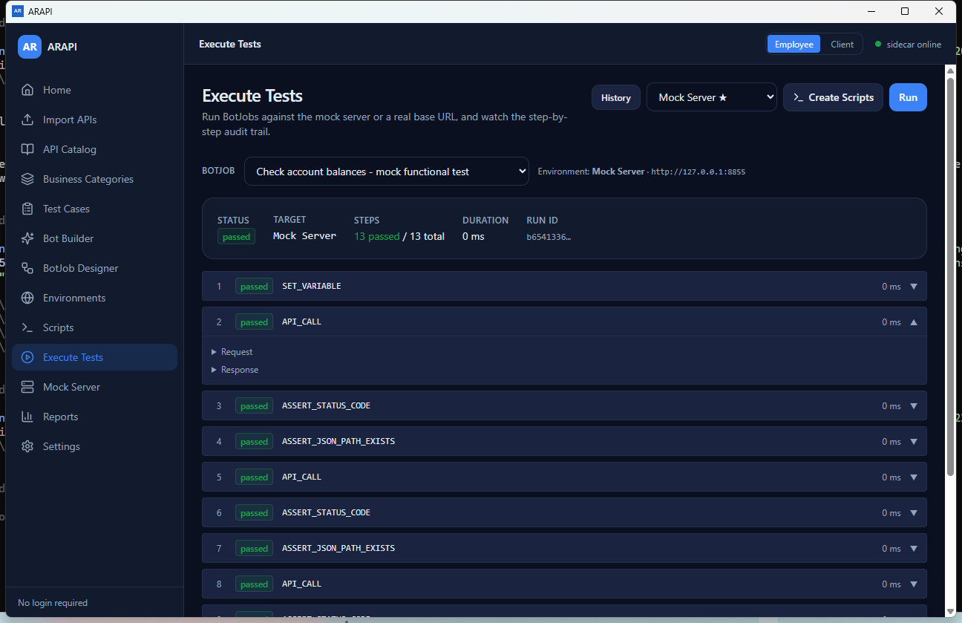
Figure 19. Execution step detail
Expand Request or Response when present. Do not copy sensitive payloads into tickets or client documents.

6.20 Execution History
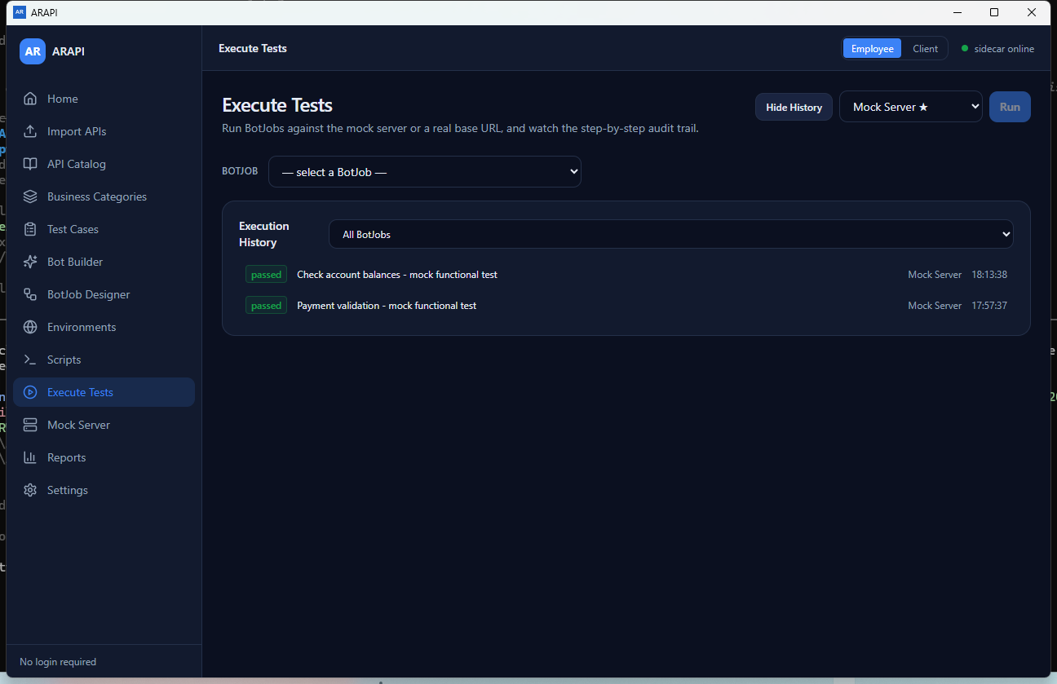
Figure 20. Execution History
Filter by BotJob and select a run to reload its summary and step results.

6.21 Mock Server - stopped
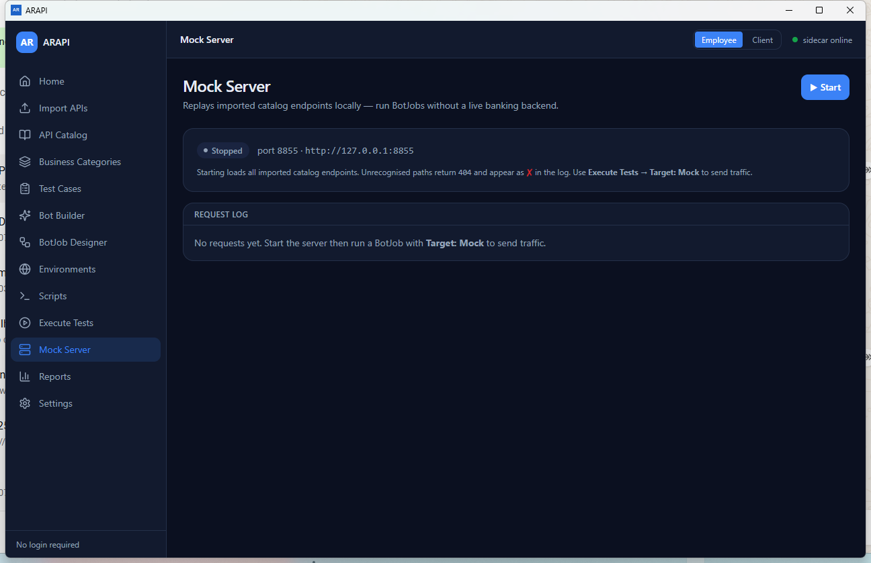
Figure 21. Mock Server - stopped
Start changes the ARAPI mock state and activates the dashboard log for the current build.

6.22 Mock Server - running
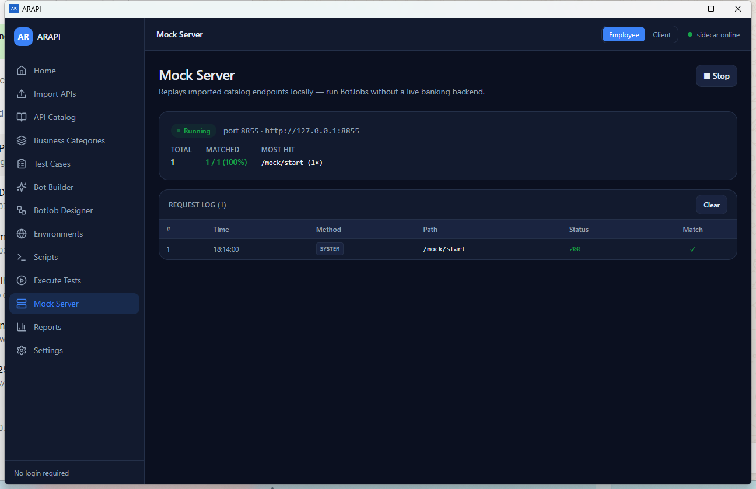
Figure 22. Mock Server - running
Stop changes state; Clear removes log rows. See the current-build note before treating port 8855 as an external listener.
Current build: The screenshot proves ARAPI state/log changes. It does not by itself prove that an external listener is bound to port 8855.

6.23 Reports and Exports
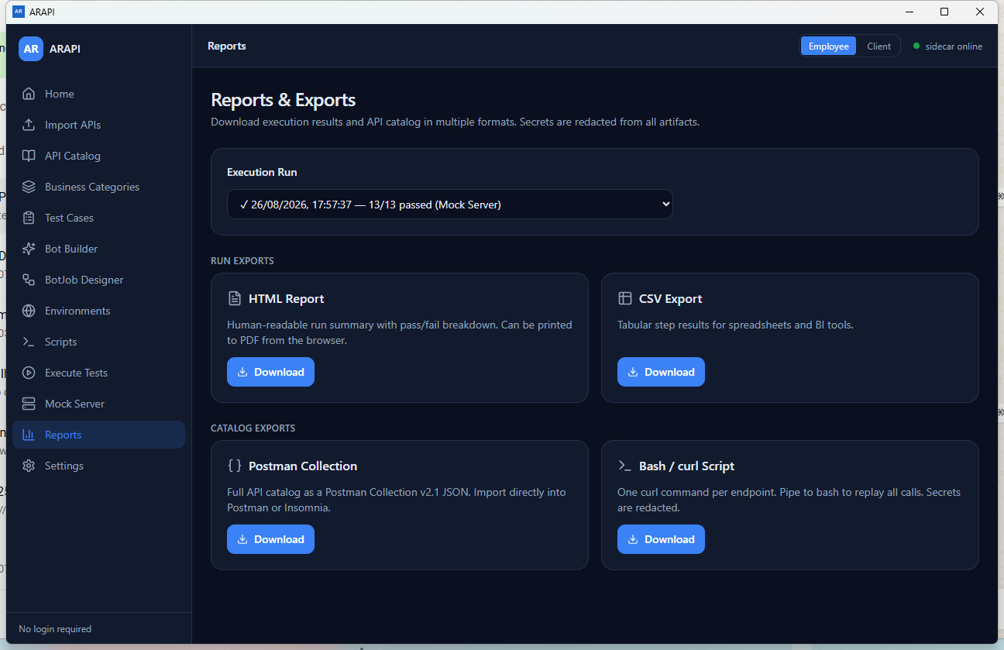
Figure 23. Reports and Exports
Run exports depend on a selected execution. Catalog exports are independent and cover the whole catalog.
Export distinction: Run HTML/CSV uses one selected run. Postman and Bash/curl export the whole catalog and default to a localhost base URL unless an integration caller supplies one.

6.24 Settings - provider list
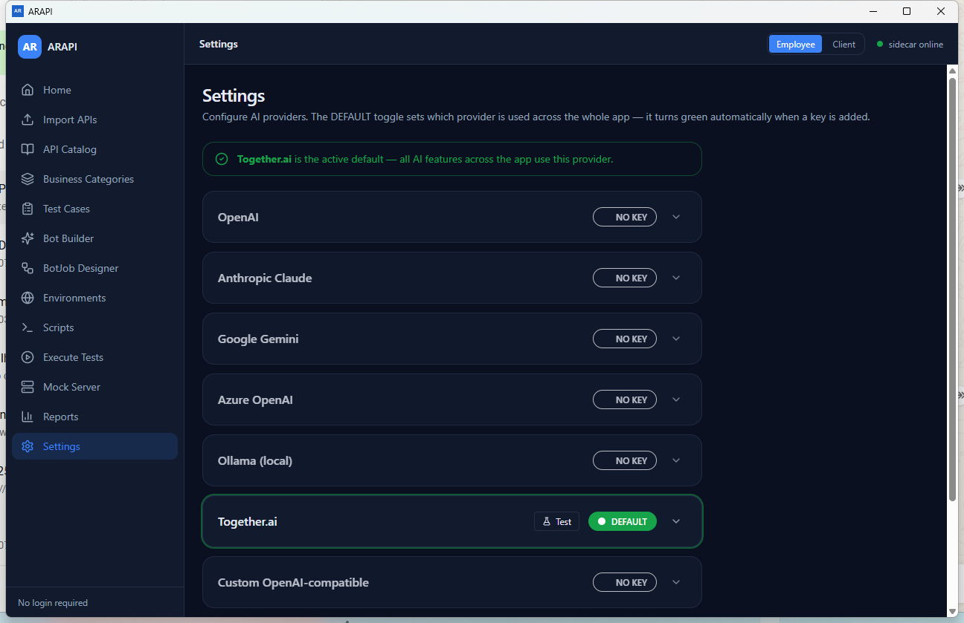
Figure 24. Settings - provider list
A green DEFAULT badge identifies the provider used by AI features. NO KEY providers cannot be selected as default.

6.25 Settings - provider form
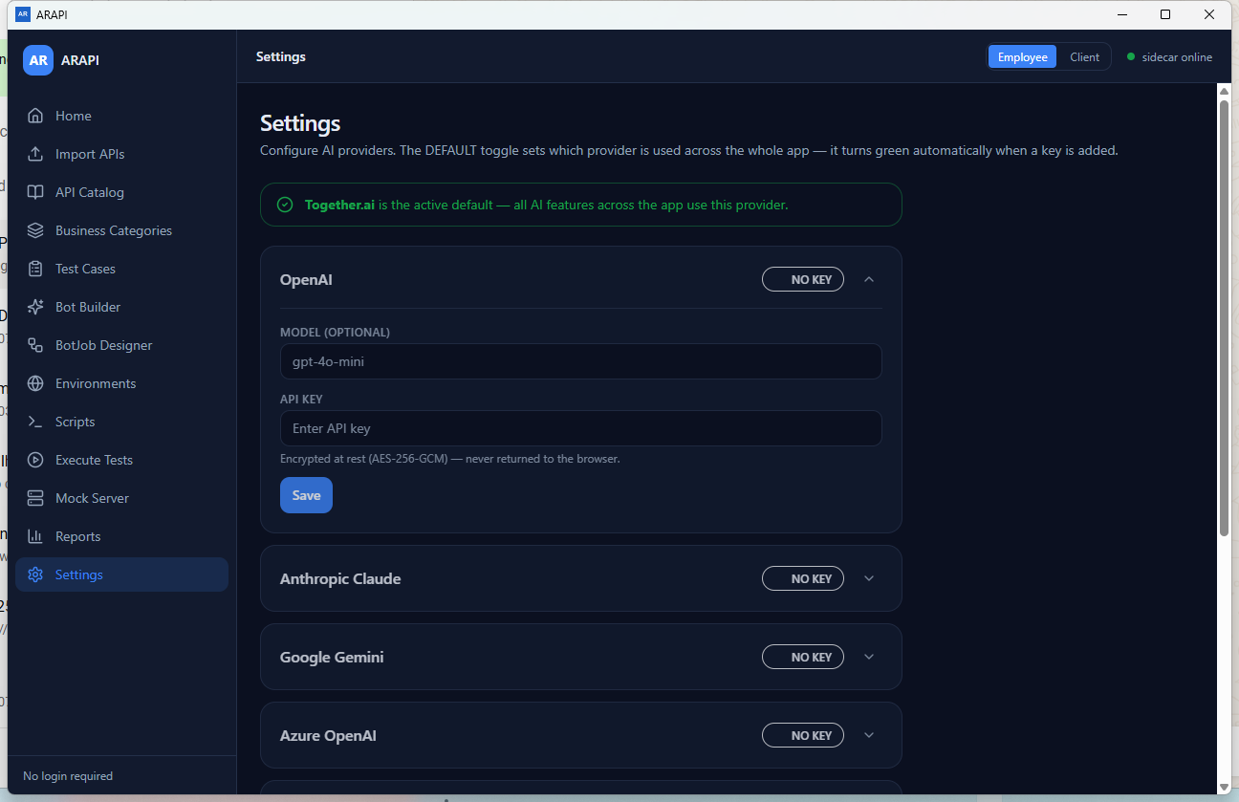
Figure 25. Settings - provider form
Enter the model and required provider values, save, then use Test as a configuration indicator.
Credential handling: The key field is masked and provider-list responses omit key values. Still protect the local ARAPI data store as sensitive and use non-production credentials where possible.

6.26 Settings - local services
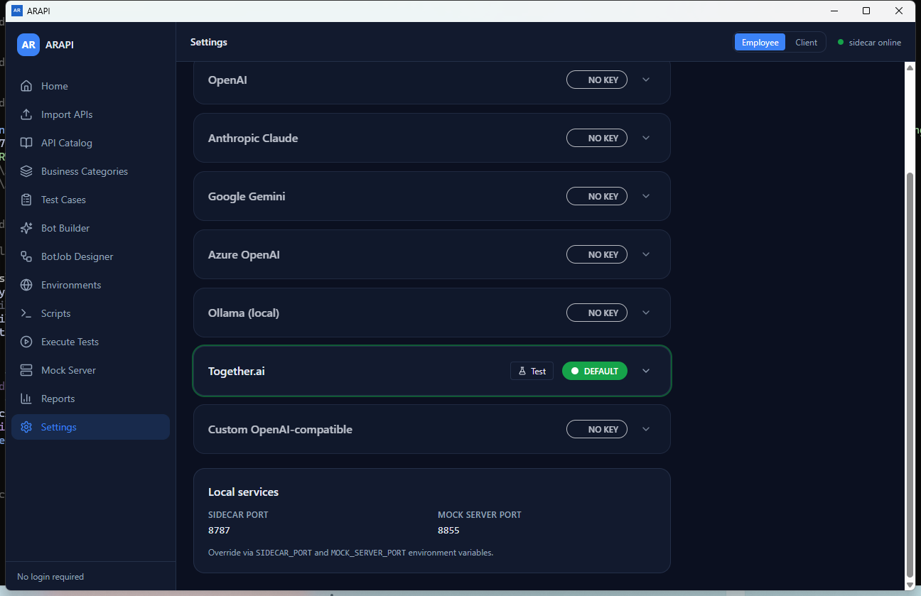
Figure 26. Settings - local services
These ports are localhost services. Environment-variable overrides are administrator/deployment settings.

7. BotJob command reference
Back to contents
Commands execute in canvas order when enabled. Click a palette item to add it, use the grip to reorder, the checkbox to enable/disable, the chevron to edit, and x to delete. Save after every material change.
Bash boundary: Only enabled API_CALL commands are exported to the BotJob-specific .sh file. The other command descriptions below apply to the Designer/runtime model and local run audit.

7.1 API commands

API Call (API_CALL)
Availability: Configurable

Purpose: Select one real endpoint from the imported catalog and prepare an HTTP request.
Configuration: Endpoint; optional JSON body; optional JSON header object. Body and header values accept ${variable} tokens.
Current release: Included by BotJob Bash export when enabled. In the run audit, request/response details are available when the runtime records them.

7.2 Variables commands

Set Variable (SET_VARIABLE)
Availability: Configurable

Purpose: Create or replace a runtime value for later commands.
Configuration: Variable name and value. The value may contain ${variable} tokens.
Current release: Not written as a separate Bash statement by the BotJob exporter; declared BotJob variables drive Bash defaults and guards.

Extract JSON Path (EXTRACT_JSON_PATH)
Availability: Configurable

Purpose: Read a value from the most recent JSON response and store it in a variable.
Configuration: JSON path such as $.data.token and destination variable name.
Current release: Available in the Designer/runtime model; not converted to Bash by the current exporter.

7.3 Assertions commands

Assert Status Code (ASSERT_STATUS_CODE)
Availability: Configurable

Purpose: Compare the last response status with an expected HTTP code.
Configuration: Expected integer from 100 through 599, commonly 200 or 201.
Current release: Appears in the local run audit; not converted to Bash by the current exporter.

Assert Field Value (ASSERT_FIELD_VALUE)
Availability: Configurable

Purpose: Compare a JSON-path value in the last response with an expected JSON value.
Configuration: JSON path and expected value. Valid JSON input is parsed; otherwise it is treated as text.
Current release: Appears in the local run audit; not converted to Bash by the current exporter.

Assert JSON Path Exists (ASSERT_JSON_PATH_EXISTS)
Availability: Configurable

Purpose: Confirm that the requested JSON path exists in the last response.
Configuration: JSON path such as $.data.id.
Current release: Appears in the local run audit; not converted to Bash by the current exporter.

7.4 Control commands

Wait (WAIT)
Availability: Configurable

Purpose: Pause the workflow for a bounded delay.
Configuration: Milliseconds from 0 through 10,000.
Current release: Recognized by the execution-engine model; not converted to Bash by the current exporter.

Stop on Failure (STOP_ON_FAILURE)
Availability: Verify in deployment

Purpose: Mark the workflow to stop after a failure.
Configuration: No visible fields.
Current release: The Bash exporter continues remaining curl calls, counts failures, and exits 1 at the end. Acceptance-test desktop stop behavior before relying on it.

IF (IF)
Availability: Preview

Purpose: Reserved conditional branch start.
Configuration: No configuration editor in this release.
Current release: Designer warns that this command is not executed and is recorded as skipped.

ELSE (ELSE)
Availability: Preview

Purpose: Reserved alternate branch.
Configuration: No configuration editor in this release.
Current release: Not executed; recorded as skipped.

Loop (LOOP)
Availability: Preview

Purpose: Reserved repeated execution block.
Configuration: No configuration editor in this release.
Current release: Not executed; recorded as skipped.

For Each (FOR_EACH)
Availability: Preview

Purpose: Reserved iteration over a collection.
Configuration: No configuration editor in this release.
Current release: Not executed; recorded as skipped.

7.5 Data commands

Read CSV (READ_CSV)
Availability: Preview

Purpose: Reserved CSV-driven data input.
Configuration: No configuration editor in this release.
Current release: Not executed; recorded as skipped.

Read Excel (READ_EXCEL)
Availability: Preview

Purpose: Reserved spreadsheet-driven data input.
Configuration: No configuration editor in this release.
Current release: Not executed; recorded as skipped.

AI Generate Data (AI_GENERATE_DATA)
Availability: Preview

Purpose: Reserved AI-assisted test-data creation.
Configuration: No configuration editor in this release.
Current release: Not executed; recorded as skipped.

Call Component (CALL_COMPONENT)
Availability: Preview

Purpose: Reserved call to a reusable component/test flow.
Configuration: No configuration editor in this release.
Current release: Not executed; recorded as skipped. The Test Cases page is also reserved in this release.

Command design rules
- Place API_CALL before assertions or extraction that depend on its response.
- Use catalog endpoint selection; do not paste an unregistered path into descriptive fields.
- Use ${name} consistently and declare variables with meaningful names.
- Keep secret initial values empty. Mark the variable secret so Bash requires an environment value.
- Disable rather than delete a command when temporarily excluding it for diagnosis.
- Do not rely on preview commands in client acceptance criteria.

8. Variables and environments
Back to contents

Variables
A BotJob variable has a name, optional initial value, and secret flag. Reference it in supported command text with ${name}.
Element | Guidance
Name | Use letters, digits, and underscores; prefer clear business names such as customerId or accessToken.
Initial value | Use only non-sensitive defaults. Leave secret values empty.
secret | For Bash export, requires the normalized shell variable from the environment.
Normalization | Bash names become uppercase; non-alphanumeric characters become underscores; a leading digit receives ARAPI_.
Unknown token | The exporter treats the normalized token as required and stops before curl if it is unset.

customer-id -> CUSTOMER_ID
2fa-token -> ARAPI_2FA_TOKEN
${accountId} -> ${ACCOUNTID} (normalized by the generated script)

Environments
An environment combines a base URL, optional description, and default headers. One environment can be marked default; the built-in Mock Server environment always exists and cannot be deleted.
- Name and Base URL are mandatory.
- Enter default headers one per line as Key: Value.
- Command headers override environment headers with the same name in Bash generation.
- Sensitive header names without a ${token} are replaced by required Bash environment variables rather than embedded in the generated file.
- Environment cards display saved headers in the current UI. Do not save literal production secrets as environment headers.
Safe pattern: Store Authorization: Bearer ${token}, declare token as a secret variable with no initial value, and supply TOKEN only to the Bash process or approved CI secret store.

9. Bash/curl script generation and execution
Back to contents

Generate from Scripts
- Select the saved BotJob.
- Select the environment and verify the displayed base URL.
- Select Browse and choose a dedicated folder such as Documents\ARAPI\Scripts.
- Select Create Bash Script. ARAPI writes a timestamped file such as check-account-balances-20260826-181500.sh.
- Read the complete file before running it, especially for POST, PUT, PATCH, or DELETE calls.

Generate from Execute Tests
After selecting a BotJob, the conditional Create Scripts button opens Scripts with the current BotJob and environment preselected. You still choose the save directory and select Create Bash Script.

What the exporter includes
- Enabled API_CALL commands in their saved order.
- The selected environment base URL and merged environment/command headers.
- JSON request bodies and ${variable} interpolation.
- Path parameters such as {accountId} converted to required shell variables.
- Required-variable guards for secret variables, sensitive headers, path parameters, and unknown tokens.
- A failure counter: each failed curl is reported, remaining calls continue, and the script exits 1 if any call failed.
Not included: Assertions, extraction, Set Variable steps, waits, stop markers, preview control flow, data-file commands, and component calls are not emitted into the BotJob-specific Bash file.

Generated Bash statement reference
Statement | Meaning
#!/usr/bin/env bash | Runs the file with Bash found in the environment.
# Generated by ARAPI... | Documents the source BotJob/environment; comments do not execute.
set -uo pipefail | Treats unset variables as errors and propagates pipeline failures. The exporter intentionally handles curl failures itself.
DEFAULT_BASE_URL='...' | Stores the selected environment URL as the default.
BASE_URL="${BASE_URL:-$DEFAULT_BASE_URL}" | Allows a runtime BASE_URL override without editing the file.
failures=0 | Initializes the curl failure counter.
: "${TOKEN:?Set TOKEN...}" | Stops immediately when a required value is unset or empty.
DEFAULT_NAME='value' | Stores a non-secret BotJob initial value.
NAME="${NAME:-$DEFAULT_NAME}" | Allows an environment override or uses the non-secret default.
echo '==> n/N METHOD /path' | Prints progress before each call.
if ! curl \ | Runs curl and enters the failure branch when curl returns non-zero.
--globoff | Prevents curl from treating braces/brackets in URLs as glob patterns.
--fail-with-body | Returns failure for HTTP 4xx/5xx while retaining the response body.
--silent --show-error | Suppresses progress meter but keeps error messages.
--request METHOD | Uses the catalog HTTP method.
--header 'Key: value' | Adds merged environment and command headers.
--data 'JSON' | Sends the optional body and causes application/json to be added when Content-Type was absent.
"${BASE_URL}"'/path' | Combines runtime/default base URL with the catalog path.
failures=$((failures + 1)) | Counts a failed curl while allowing the next API call.
if (( failures > 0 )); then ... exit 1 | Returns a non-zero process result when any API call failed.
echo 'All API calls completed successfully.' | Prints only when the failure counter is zero.

Run on Windows with Git Bash
cd /c/Users/YOUR_NAME/Documents/ARAPI/Scripts
export TOKEN='temporary-secret-value'
export ACCOUNT_ID='12345'
bash ./script-name.sh
echo $?

Run from Windows PowerShell when bash is on PATH
$env:TOKEN = 'temporary-secret-value'
$env:ACCOUNT_ID = '12345'
$env:BASE_URL = 'https://approved-test-api.example'
bash ./script-name.sh
$LASTEXITCODE
Remove-Item Env:TOKEN, Env:ACCOUNT_ID

Run from Windows Command Prompt
cd /d "%USERPROFILE%\Documents\ARAPI\Scripts"
set "TOKEN=temporary-secret-value"
set "ACCOUNT_ID=12345"
bash script-name.sh
echo %ERRORLEVEL%
set "TOKEN="
set "ACCOUNT_ID="

Run with Windows Subsystem for Linux
cd /mnt/c/Users/YOUR_NAME/Documents/ARAPI/Scripts
export TOKEN='temporary-secret-value'
bash ./script-name.sh
echo $?

Pre-run review checklist
- Correct BotJob name and timestamped file.
- Correct BASE_URL and approved environment.
- No unintended destructive methods or paths.
- Headers/bodies contain no embedded secret or real customer data.
- All required shell variables are set from an approved source.
- curl is available, TLS trust is configured, and network routing is approved.
- Expected side effects, monitoring, and rollback are agreed before execution.

10. Execution results, history, and reports
Back to contents

Run audit
Execute Tests stores a run summary and step rows. Summary fields are Status, Target, Steps, Duration, and Run ID. Step rows show command type, status, duration, and expandable details when recorded.
Status | Interpretation
passed | The local run record marks the step/run successful.
failed | An assertion or step reported a failure.
error | The step could not complete normally, for example a missing endpoint reference.
skipped | The command was disabled, stopped, preview-only, or otherwise not executed.
running | The run has not yet reached its final state.

Acceptance rule: For a real environment, require target-side logs, database/state evidence, or an approved response capture in addition to the ARAPI run status.

History
- Select History to show saved runs.
- Use All BotJobs to filter by workflow.
- Select a row to reload the summary and steps; the panel closes automatically.

Reports
Export | Scope | Use
HTML Report | Selected run | Readable summary; can be printed to PDF by the user's browser/viewer.
CSV Export | Selected run | Tabular step results for spreadsheet or BI review.
Postman Collection | Whole catalog | Postman Collection v2.1 JSON; review the default localhost base URL.
Bash / curl Script | Whole catalog | One simple curl per endpoint; unlike Scripts, it is not BotJob-specific.

Prefer Scripts for controlled execution: The Scripts page preserves a selected BotJob's enabled API_CALL order, environment headers, body data, variable guards, and final failure status. Reports Bash/curl is a broad catalog export.

11. Bot Builder and AI providers
Back to contents

Bot Builder
Bot Builder sends the visible conversation history to the local backend, which can search the catalog, list/create BotJobs, and request mock runs. Action cards expose catalog matches, created jobs, and run summaries.
- Use a suggestion or enter a precise business flow.
- Review catalog-search evidence before accepting a proposed workflow.
- If the result says a synthetic mock endpoint/data record was created, keep it out of production acceptance and exports intended to represent real contracts.
- Open Designer and review the created job, endpoint selections, body, headers, variables, and command order before Save or execution.
- Do not paste credentials, customer identifiers, account data, or confidential payloads into the conversation.

Supported provider records
Provider | Default model shown by ARAPI | Base URL field
OpenAI | gpt-4o-mini | Not shown
Anthropic Claude | claude-3-5-haiku-20241022 | Not shown
Google Gemini | gemini-1.5-flash | Not shown
Azure OpenAI | gpt-4o-mini | Required by deployment
Ollama (local) | llama3.2 | Shown; key not required for local Ollama
Together.ai | meta-llama/Llama-3-8b-chat-hf | Not shown
Custom OpenAI-compatible | gpt-4o-mini | Required by deployment

Configure a provider
- Expand the provider card.
- Enter or confirm the model and base URL where shown.
- Enter the API key and select Save. The field is masked; a blank key on later saves preserves the existing key.
- Select SET DEFAULT on a configured provider. If exactly one key exists, ARAPI may promote it automatically.
- Select Test, then make an actual Bot Builder request to verify end-to-end connectivity.
Local data sensitivity: Provider-list responses omit key values, but the workstation and ARAPI data directory must still be protected as credential-bearing assets. Use scoped, revocable, non-production keys for testing.

12. Security and operational practices
Back to contents

Before use
- Use an organization-managed Windows account and approved ARAPI distribution.
- Keep the local backend bound to localhost; do not expose service ports publicly.
- Back up the correct ARAPI data directory before upgrades or data-cleanup work.
- Import specifications only from trusted sources and review import failures.
- Create separate mock/dev/UAT/production environments and label them clearly.

Credentials and data
- Never store literal secrets in BotJob initial values, non-secret headers, descriptions, screenshots, or client documents.
- Use secret BotJob variables and short-lived environment variables or an approved CI secret store.
- Generated scripts and exported reports may contain paths, bodies, headers, response details, and business metadata; classify and retain them accordingly.
- Review scripts after generation and again before every non-mock run.
- Clear shell environment variables and delete temporary artifacts according to policy after use.

Change control
- Record ARAPI version, BotJob name, environment, script filename/hash, operator, start/end time, and target approval.
- Use a least-privilege API identity with a narrow expiration window.
- For write operations, document expected records and rollback/compensation before execution.
- Preserve HTML/CSV and target-side evidence in the approved audit location; do not rely on screenshots alone.
No-login does not mean no security: ARAPI's desktop UI has no internal login. Operating-system access, file ACLs, secret management, API authorization, and audit retention provide the security boundary.

13. Troubleshooting
Back to contents
Use the exact displayed error, affected BotJob/environment, ARAPI version, and reproduction steps when escalating. Remove secrets and customer data from attachments.

sidecar offline
Close and reopen ARAPI. Confirm no other process is occupying port 8787. If the status stays offline, contact the deployment administrator; the UI cannot work without the local backend.

Import is disabled
Choose at least one supported file on Upload Files, or select a valid directory on Folder (Desktop). Supported extensions are .yaml, .yml, and .json.

Import reports zero endpoints
Confirm the files contain OpenAPI/Swagger path operations, not only schemas/examples. Review the failure list and try one known-good specification.

Repeated catalog rows
Avoid importing the same specification tree repeatedly when duplicate rows are observed. Record the source folder and contact support before cleaning shared client data.

Palette commands are dimmed
Select or create a BotJob first.

Save does not enable
For environments, Name and Base URL are mandatory. Header lines must use Key: Value. For scripts, job, environment, and desktop output directory are mandatory.

API call references a missing endpoint
Open Designer, expand the API Call, select the current endpoint from the catalog, and Save. This can occur after catalog content is replaced.

Create Bash Script says there are no calls
Enable at least one API_CALL and ensure it references an endpoint still present in the catalog.

bash is not recognized
Install/use Git Bash, Windows Subsystem for Linux, or a CI agent with Bash and curl. Windows cmd.exe alone cannot interpret Bash syntax.

Script stops before the first curl
A required variable guard failed. Set the named environment variable, including path parameters and sensitive headers, then run again.

Script ends with exit code 1
One or more curl calls failed. Scroll to the first curl error, verify BASE_URL, network/TLS/authentication, and review the response body.

Run results are green but target evidence is absent
Treat ARAPI's local run summary as an audit record, not independent proof of a downstream state change. Use the generated Bash script and target-side logs/data for acceptance.

Port 8855 cannot be reached
The observed 1.0.0 C# desktop build maintains mock state/log in ARAPI. Do not assume an external listener is available unless your deployment administrator has enabled and verified one.

Reports has no run selector
Execute a BotJob first. Catalog Postman/Bash exports remain available without a run.

AI provider Test shows success but AI calls fail
The current desktop Test is a local configuration indicator. Verify endpoint, model, key entitlement, proxy/firewall, and an actual Bot Builder request.

Diagnostic information safe to collect
- ARAPI version and whether installer or portable distribution is used.
- Home engine status and Settings local-service port values.
- Specification filename/type and import counts (not confidential contents unless approved).
- BotJob name, command types/order, and whether the failing command is enabled.
- Environment name and sanitized base URL; never send tokens or full Authorization headers.
- Script filename, exit code, and sanitized curl error text.
- Run ID and report with sensitive request/response content removed.

14. Feature status matrix
Back to contents
Capability | Status | Qualification
Import YAML/JSON files/folders | Available | Recursive upload/desktop folder workflows.
Catalog search and mapping display | Available | Mapping is shown; no mapping editor button on the Catalog page.
25-domain banking taxonomy | Available | Read-only cards in current UI.
Test Case creation | Reserved | New test case is disabled.
Bot Builder catalog/search/create/run actions | Available with qualifications | May use synthetic mock endpoint/data when no strong catalog match.
Designer core commands | Configurable | API, variables, assertions, extract, wait; verify runtime acceptance per deployment.
Designer control/data preview commands | Preview | IF/ELSE/loops/read files/AI data/component are recorded skipped.
Environment CRUD | Available | Built-in Mock cannot be deleted.
BotJob-specific Bash/curl | Available | Enabled API_CALL commands only; desktop exact-directory picker.
Execute Tests audit/history | Available with qualification | Local run evidence; correlate real-system effects externally.
Mock dashboard | State/log available | External port listener must be deployment-verified.
HTML/CSV run reports | Available | Requires a saved run.
Postman/whole-catalog Bash | Available | Defaults to localhost base URL via UI download.
AI provider records/default selection | Available | Protect local data store as sensitive.
AI provider Test | Configuration indicator | Use a real Bot Builder request for end-to-end proof.

Appendix A. Complete control index
Back to contents
This index covers every visible button, selector, disclosure control, status control, and important conditional action in the ARAPI 1.0.0 UI.
Page | Control | Available when | Result
Global | Employee / Client | Always | Changes the shared conversation-mode context; it does not rewrite catalog or BotJobs.
Global | sidecar online/offline | Always | Displays local backend health. Resolve offline status before doing work.
Home | Shortcut cards | Always | Open the matching sidebar destination.
Import APIs | Upload Files tab | Always | Shows file/folder upload workflow.
Import APIs | Folder (Desktop) tab | Always | Shows local folder-path workflow.
Import APIs | Drop area | Upload tab | Adds dropped .yaml, .yml, and .json files; subfolders are scanned.
Import APIs | Browse Files | Upload tab | Opens a multi-file picker.
Import APIs | Browse Folder | Upload tab | Opens a folder picker and adds supported files below it.
Import APIs | Remove (x) | After adding a file | Removes one staged item before import.
Import APIs | Import | After files/path selected | Imports specifications and reports specification, endpoint, and failure counts.
Import APIs | Browse | Desktop folder tab | Selects one local folder.
API Catalog | Search method / path | Always | Filters by method, path, or summary.
Test Cases | New test case | Disabled in 1.0.0 | Reserved; does not create a record in this release.
Bot Builder | Suggestion buttons | Empty conversation | Sends the displayed prompt immediately.
Bot Builder | Catalog action card | After search action | Expands/collapses endpoint evidence.
Bot Builder | Open Designer | After BotJob creation action | Navigates to Designer; select the created job if it is not automatically highlighted.
Bot Builder | View Results | After execution action | Navigates to Execute Tests.
Bot Builder | Send | When prompt is non-empty | Sends the conversation; Enter also sends and Shift+Enter adds a line.
BotJob Designer | + New BotJob | Always | Prompts for a name and creates a saved BotJob shell.
BotJob Designer | Saved BotJob row | When jobs exist | Loads the selected job and commands.
BotJob Designer | Delete | Job selected | Deletes the BotJob after confirmation.
BotJob Designer | Save | Job selected | Persists metadata, variables, order, configuration, and enabled state.
BotJob Designer | + Add variable | Job selected | Adds a variable row.
BotJob Designer | secret checkbox | Variable exists | Causes Bash generation to require the value from the environment rather than embed an initial value.
BotJob Designer | Variable delete (x) | Variable exists | Removes the variable from the working definition.
BotJob Designer | Palette group heading | Always | Expands or collapses one command group.
BotJob Designer | Palette command | Job selected | Adds the command to the end of the canvas and opens its editor.
BotJob Designer | Drag grip | Command exists | Reorders the command in the workflow.
BotJob Designer | Enabled checkbox | Command exists | Includes/excludes the command from execution; disabled API calls are excluded from Bash export.
BotJob Designer | Expand/collapse | Command exists | Shows or hides command configuration.
BotJob Designer | Command delete (x) | Command exists | Removes that command from the working definition.
Environments | + New Environment | Always | Opens the environment form.
Environments | Star | Non-default custom environment | Sets the environment as default.
Environments | Edit | Custom environment | Opens the existing environment in the form.
Environments | Delete | Custom environment | Deletes after confirmation; built-in Mock cannot be deleted.
Environment form | Close / Cancel | Form open | Discards unsaved edits.
Environment form | Set as default | Form open | Makes the saved environment the default selection.
Environment form | Save | Name and Base URL present | Validates header lines and persists the environment.
Scripts | BotJob selector | Always | Selects the saved workflow used as the script source.
Scripts | Environment selector | Always | Selects base URL and default headers.
Scripts | Browse | Desktop app | Selects the exact output directory.
Scripts | Create Bash Script | Job, environment, and directory selected | Writes a timestamped .sh file containing enabled API_CALL curl commands.
Execute Tests | History / Hide History | Always | Shows or hides the saved-run list.
Execute Tests | Environment selector | Always | Chooses the run target and script handoff environment.
Execute Tests | BotJob selector | Always | Chooses the workflow; resets the displayed result.
Execute Tests | Create Scripts | BotJob selected | Opens Scripts with job and environment query selections.
Execute Tests | Run | BotJob selected | Creates a local run record and step audit.
Execute Tests | Step row | Result loaded | Expands errors, assertions, request, and response when recorded.
Execution History | All BotJobs filter | History open | Filters saved runs by BotJob.
Execution History | Run row | Runs exist | Loads that run and closes History.
Mock Server | Start / Stop | Always | Changes mock dashboard state.
Mock Server | Clear | Log contains rows | Clears the in-app request/system log.
Reports | Execution Run selector | Runs exist | Chooses the source run for HTML/CSV.
Reports | HTML Download | Run selected | Downloads a human-readable run report.
Reports | CSV Download | Run selected | Downloads step results for spreadsheet/BI use.
Reports | Postman Download | Always | Downloads the whole catalog as Postman Collection v2.1 JSON.
Reports | Bash/curl Download | Always | Downloads a simple whole-catalog Bash file; review its localhost base URL.
Settings | Provider expand/collapse | Always | Shows or hides editable model/base URL/API-key fields.
Settings | Save | Provider expanded | Persists the provider record; blank key preserves an existing key.
Settings | Test | Saved key exists | Shows the current build's provider configuration test result.
Settings | SET DEFAULT | Saved key exists and provider is not default | Makes the provider active for AI features.

Appendix B. Local API reference
Back to contents
Administrator/developer reference: These JSON routes are localhost-only implementation interfaces. Normal client operation should use the ARAPI UI and generated Bash files. Never publish this API publicly.

Method | Route | Purpose
GET | /health | Local backend liveness.
GET | /catalog/endpoints | List imported endpoints and mapping status.
POST | /import | Import a local folder from { folderPath }.
POST | /import/upload | Import uploaded OpenAPI/Swagger file content.
PUT | /catalog/endpoints/{endpointId}/category | Set or clear endpoint category mapping.
GET | /taxonomy | Return 25 banking categories and subcategories.
GET | /agents | List banking agents.
GET | /agents/capabilities | List agent capability counts.
POST | /agents/ask | Ask a banking agent.
POST | /app-assistant/chat | Send Bot Builder conversation messages.
GET | /settings/ai-providers | List provider settings without returning key values.
POST | /settings/ai-providers | Create or update a provider record.
POST | /settings/ai-providers/set-default | Set the default provider record.
POST | /settings/ai-providers/test | Return the current provider-test result.
GET | /environments | List environments.
POST | /environments | Create an environment.
PUT | /environments/{id} | Update an environment.
DELETE | /environments/{id} | Delete a non-built-in environment.
GET | /botjobs | List BotJobs.
POST | /botjobs | Create a BotJob shell.
GET | /botjobs/{id} | Get BotJob blocks, commands, and variables.
PUT | /botjobs/{id} | Save the complete BotJob definition.
DELETE | /botjobs/{id} | Delete a BotJob.
GET | /botjobs/{id}/export/bash | Generate BotJob-specific Bash; accepts environmentId query.
POST | /botjobs/{id}/execute | Create a run using { environmentId }.
GET | /executions | List runs; optional botJobId query filter.
GET | /executions/{runId}/steps | List step results for a run.
GET | /executions/{runId}/report.html | Download HTML run report.
GET | /executions/{runId}/report.csv | Download CSV run report.
GET | /catalog/export/postman | Download whole-catalog Postman JSON; optional baseUrl query.
GET | /catalog/export/bash | Download whole-catalog Bash; optional baseUrl query.
GET | /mock/status | Read mock dashboard state and port.
POST | /mock/start | Set mock state to running and add a system log row.
POST | /mock/stop | Set mock state to stopped and add a system log row.
GET | /mock/log | Read the mock log.
POST | /mock/log/clear | Clear the mock log.
GET | /separation/progress | Read packaged progress metadata when present.

Appendix C. Glossary
Back to contents
Term | Meaning
API Catalog | The imported endpoint inventory that constrains selectable API calls.
BotJob | A named ordered workflow containing commands and variables.
Command | One step in a BotJob, such as API_CALL or ASSERT_STATUS_CODE.
Environment | A named base URL plus optional default headers.
Mapping | Association between an endpoint and a banking business category.
Mock | A local/synthetic test context intended to avoid a production banking backend.
Run | One saved execution/audit record for a BotJob and environment.
Secret variable | A BotJob variable that Bash export requires from the process environment.
Synthetic endpoint | A mock-only catalog record that Bot Builder may create when no imported endpoint matches strongly enough.
Token | A ${name} placeholder resolved from BotJob/runtime variables.

Appendix D. Client acceptance checklist
Back to contents

Application
- ARAPI version and distribution type are recorded.
- sidecar online appears after a clean launch.
- Approved backup/restore location is documented and tested.
- Local ports are not exposed publicly.

Catalog and workflow
- A known-good specification imports with expected endpoint count.
- A sample catalog endpoint is searchable and correctly classified or marked unmapped.
- A BotJob can be created, configured, reordered, and saved.
- Preview commands are excluded from acceptance criteria.

Bash execution
- The Scripts page saves to Documents\ARAPI\Scripts or an approved equivalent.
- The generated file contains only intended enabled API_CALL commands.
- Secrets appear as required environment variables, not literal values.
- A mock/dev script returns the expected process exit code and target-side evidence.

Audit and AI
- Execution History reloads a saved run and Reports downloads HTML/CSV.
- Whole-catalog Postman/Bash files are reviewed for localhost base URL before use.
- AI provider configuration is verified with a real Bot Builder request.
- Operators understand synthetic endpoint labels and do not treat them as imported production APIs.
Sign-off: Client acceptance should record approver, date, environment, BotJob/script identifier, evidence location, exceptions, and remediation owner.

Return to contents

