AR Web Factory
Finding Avaloq Web Elements
Quick user guide — Page Scanner, Search by, Match rules, Hover Pick

Purpose
This short guide explains how to find web elements on an Avaloq page and add them to a bot job. Avaloq pages use custom HTML tags like <avq-text-button>, <avq-wp-tree-leaf>, <avq-icon-button> that the default scanner does not always catch. Use the Match rules field to reach them.

The two scanner inputs
Both fields are independent. The scanner runs both in one pass and merges the results — there is no overlap penalty.
Field | What it does | Typical values
Search by : | Finds elements by their HTML tag name. Works for standard tags. | button, input, a, label
Match rules : | Finds elements by tag prefix, tag suffix, or attribute. This is the one you need for Avaloq custom tags. | tagPrefix:avq, attr:data-test-id

How to search — step by step
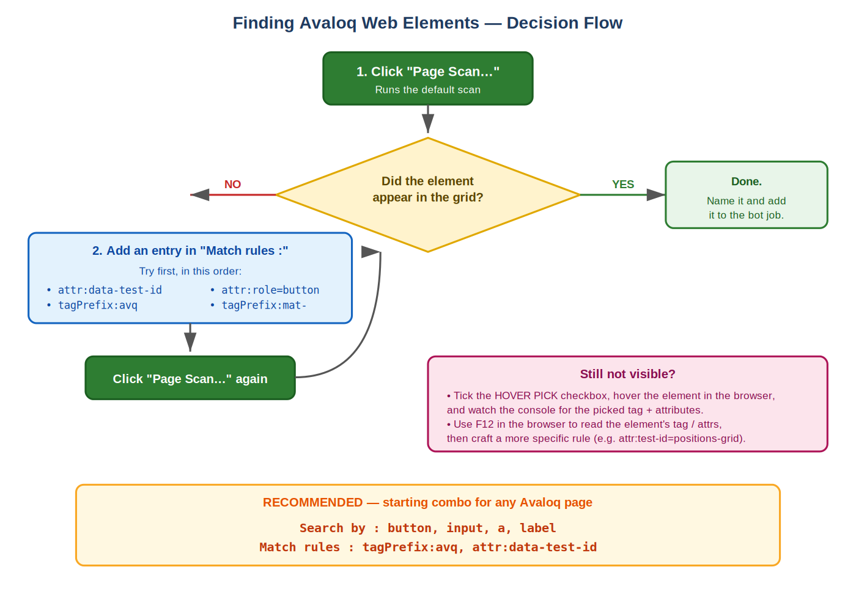

The four rule kinds (Match rules field)
Write one or more rules separated by commas. Each rule is kind:value. Matching is case-insensitive.
Rule | Matches | Example
tagPrefix:<p> | Tag name starts with <p> | tagPrefix:avq
tagSuffix:<s> | Tag name ends with <s> | tagSuffix:-button
attr:<name> | Element has attribute <name> (any value) | attr:data-test-id
attr:<name>=<value> | Attribute <name> equals <value> | attr:role=button
attrPrefix:<p> | Has any attribute whose name starts with <p> | attrPrefix:data-

The one rule you usually need first
Match rules : tagPrefix:avq, attr:data-test-id

Why: Avaloq sprays data-test-id on most interactive elements. Combined with tagPrefix:avq it covers almost every widget — checkboxes, buttons, menu items, tree nodes, tables. Use this combo first; narrow it down only if there is too much noise in the result grid.

The avq-text-button trap
Same tag, two very different behaviours:
- <avq-text-button> that wraps an <a> → classified as a link (clickable).
- <avq-text-button> with plain text inside (no anchor) → classified as a label, which the bot-job editor usually saves as an Output field for Excel export.
If you expected a click target and got an output field, the element had no <a> inside. This is a classification choice, not a bug — use Hover Pick on it to confirm.

HOVER PICK — when you don't know what to search for
Use this when the element is visible in the browser but you can't guess its tag or attributes.
- Tick the HOVER PICK checkbox (top-right of the scanner).
- Move the mouse over the element in the browser window.
- The scanner captures the element under the cursor and adds it to the grid with its tag, attributes, and coordinates already resolved.
Use Hover Pick as a discovery tool: once you see what tag and attributes the element has, you can build a clean Match rule for it and turn Hover Pick off again.

Common recipes
Goal | Match rules
Every Avaloq custom tag | tagPrefix:avq
Every element Avaloq tagged with data-test-id | attr:data-test-id
A specific grid / widget | attr:data-test-id=positions-grid
Just the text widgets (bold / italic / button …) | tagPrefix:avq-text
Workspace panels (tree leaves, action menus) | tagPrefix:avq-wp
Every role=button (ARIA pattern) | attr:role=button
Material components (<mat-...>) | tagPrefix:mat-
Full Avaloq starter combo (recommended) | tagPrefix:avq, attr:data-test-id

If you can't find the element
- Try attr:data-test-id on its own. It is the highest-yield single rule on Avaloq pages.
- Open the page in Chrome, press F12, right-click the element → Inspect. Read the tag name and attributes, then write a matching rule — for example attr:test-id=<the-value-you-saw>.
- If the element is inside a Shadow DOM or iframe it may still be unreachable. In that case, use HOVER PICK to capture it directly.
- Make sure the page is fully loaded before you click Page Scan…. Lazy-loaded content is not in the DOM until you interact with it.
For the full rule grammar and internals, see AVALOQ_SEARCH.md in the plugins folder.

