AR Web Scanner — User Guide Part 1: Desktop Application
Version: 4.2 | Audience: QA Engineers, Automation Authors
This guide covers the AR Web Scanner JavaFX desktop application — the authoring tool used to record and manage automation bot jobs.
Part 2 covers the Bot Job View and AR Web Factory in depth.
Screenshots are embedded from specifications/screenshots/.

Table of Contents
- Overview
- Installation
  - Root Folder Structure
  - ARWeb — Runtime Data Folder
  - ARWeb-Scanner — Application Folder
  - Launcher Script — exec_launcher-4.2.bat
  - Config-4.2 — Configuration Folder
- Prerequisites & First Launch
- Main Window
- Organizations
- Configuration Panel
- Bot Job List
- Creating a Bot Job
- Opening a Bot Job (Bot Job View)
- Scanner — Picking Web Elements
- Scanner Grid — Managing Scanned Elements
- Generating the Excel Data File
- How Bot Job Execution Works
  - The Big Picture
  - Structure of a Bot Job
  - The Execution Loop
  - Step-by-Step Execution Flow
  - How the Engine Finds Elements
  - Conditional Logic — IF, LOOP, GOTO
  - Launch vs Pre-Launch
- Launch — Running the Automation Engine
- Pre-Launch (Batch inside Scanner)
- Clone a Bot Job
- Export / Import a Bot Job
- Reports
- Backup & Restore
- OCR Element Recognition
- Troubleshooting

1. Overview
AR Web Scanner is a Windows desktop application that lets automation engineers:
- Record the web elements (buttons, inputs, links, labels) of a banking or web portal.
- Organize recorded elements into named Bot Jobs grouped inside Organizations.
- Drive a Chrome/Edge/Firefox browser via Selenium to verify elements work correctly before saving them.
- Generate an Excel data file required by the automation engine.
- Launch the AR Web Engine (a separate Java JAR) that replays the recorded actions in batch mode.
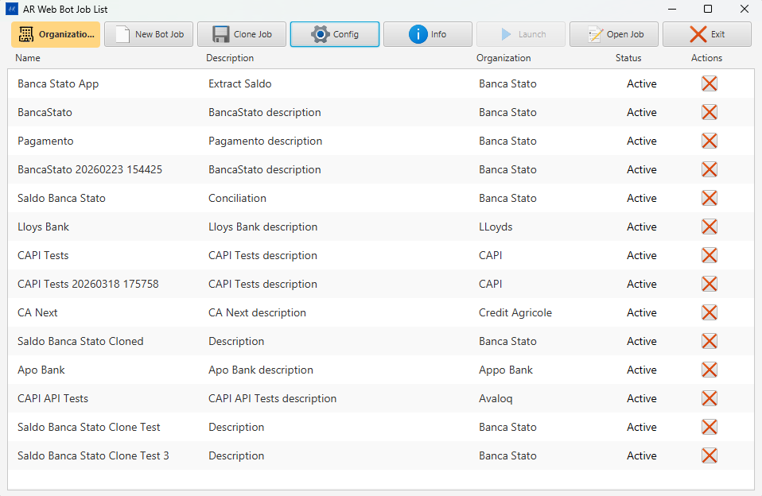
Main Window — AR Web Bot Job List

2. Installation
AR Web Scanner is distributed as a pre-packaged folder set. No installer wizard is needed — simply copy the provided folders to the target machine and run the launcher script.

Root Folder Structure
The installation is placed under a single root folder (e.g., C:\ARWeb\):
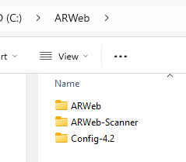
Installation root — three folders: ARWeb, ARWeb-Scanner, Config-4.2
Folder | Purpose
ARWeb\ | Runtime data folder — created and managed by the application at runtime
ARWeb-Scanner\ | Application folder — contains the JAR files, Java runtime, drivers, and launcher
Config-4.2\ | Configuration folder — contains ARWeb.config with all runtime settings

ARWeb (Runtime Data Folder)
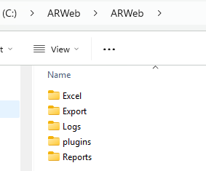
ARWeb runtime data folder — Excel, Export, Logs, plugins, Reports
Sub-folder | What gets written here
Excel\ | Excel data files (one .xlsx per bot job, used by the Engine)
Export\ | Exported bot job bundles (ZIP/JSON created by Export Job)
Logs\ | Engine log files (engine_debug_log_output.log, engine_debug_log_error.log, engine_debug_log_input.log)
plugins\ | Minified JavaScript plugins injected into the browser (hoverPick.min.js, actionExecutor.min.js, searchListAsync.min.js)
Reports\ | HTML and CSV test execution reports
This folder does not need to be populated manually. The application creates and writes all sub-folders at runtime.

ARWeb-Scanner (Application Folder)
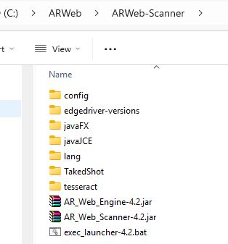
ARWeb-Scanner application folder — JARs, bat launcher, java runtime, drivers, and support folders
Item | Description
AR_Web_Scanner-4.2.jar | The Scanner application JAR (main executable)
AR_Web_Engine-4.2.jar | The Engine JAR — replays recorded bot job instructions
exec_launcher-4.2.bat | Windows batch launcher script (double-click to start)
config\ | Internal Scanner configuration defaults
edgedriver-versions\ | Bundled Edge WebDriver binaries for browser automation
javaFX\ | JavaFX runtime libraries (lib\ folder used by the launcher)
javaJCE\ | Java Cryptography Extension libraries
lang\ | Localisation resource files
TakedShot\ | Screenshot output folder for OCR test captures
tesseract\ | Bundled Tesseract OCR binaries used by the OCR feature

Launcher Script — exec_launcher-4.2.bat
Double-click exec_launcher-4.2.bat inside the ARWeb-Scanner\ folder to start the application.
@echo off
REM Set base directories (relative)
SET "BASE_DIR=%~dp0"
SET "JAVA_HOME=%BASE_DIR%java"
SET "FX_LIB=%BASE_DIR%javaFX\lib"
SET "ARWEB_CONFIG=C:\ARWeb\Config-4.2\ARWeb.config"
REM Add Java to PATH
SET "PATH=%JAVA_HOME%\bin;%PATH%"
REM Change to working directory
cd /d "%BASE_DIR%"
REM Run JavaFX app
java ^
-Dfile.encoding=UTF-8 ^
--module-path "%FX_LIB%" ^
--add-modules javafx.controls,javafx.web,javafx.fxml ^
-jar AR_Web_Scanner-4.2.jar -c "%ARWEB_CONFIG%"
pause
The only line you may need to edit after installation is ARWEB_CONFIG — it must point to the correct ARWeb.config file for your machine. By default it points to the Config-4.2\ folder inside the installation root.
The script uses %~dp0 so all other paths (Java, JavaFX, JARs) resolve relative to the script’s own folder — you can move the entire ARWeb\ tree to a different drive and it will still work, as long as ARWEB_CONFIG is updated.

Config-4.2 (Configuration Folder)
The Config-4.2\ folder contains ARWeb.config — the main settings file. It defines all runtime paths, database connection, browser selection, and per-site scanning priorities.
Key entries to verify after installation:
Key | Example value | Description
path_db | C:\ARWeb\ARWeb | Root for Excel, Logs, Reports, Export
path_engine | C:\ARWeb\ARWeb-Scanner\AR_Web_Engine-4.2.jar | Path to the Engine JAR
path_webdriver | C:\ARWeb\ARWeb-Scanner\edgedriver-versions\msedgedriver.exe | WebDriver binary
path_plugins | C:\ARWeb\ARWeb\plugins | Folder containing the minified JS plugins
path_license | C:\ARWeb\Config-4.2 | Folder containing the .lic license file
database | SQLite | Database engine (Access / PostgreSQL / SQLite)
browser | Edge | Browser for Selenium (Chrome / Edge / Firefox)

3. Prerequisites & First Launch
Requirement | Detail
Operating System | Windows 10 / 11 (64-bit)
Java | Bundled inside ARWeb-Scanner\java\ — no separate installation needed
Browser | Edge (bundled driver in edgedriver-versions\) or Chrome
Config file | ARWeb.config in Config-4.2\ — must be correct before first launch
License file | .lic file placed in the folder pointed to by path_license in the config

First Launch Steps
- Verify ARWEB_CONFIG in exec_launcher-4.2.bat points to your Config-4.2\ARWeb.config.
- Double-click exec_launcher-4.2.bat.
- On first run, database migrations execute automatically — a brief delay is normal.
- If the license file is missing or invalid, the Activation Software Required dialog appears.
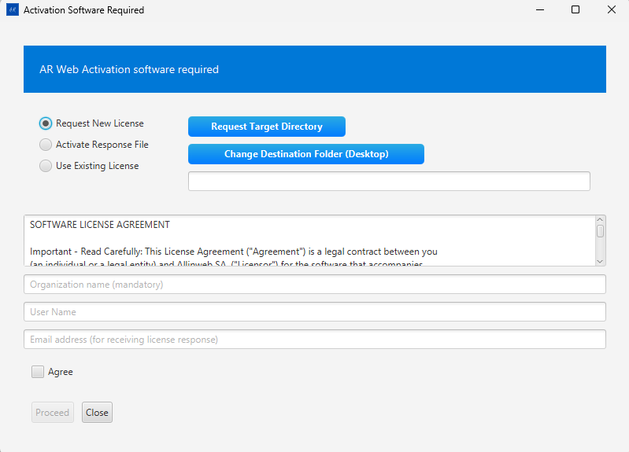
License Activation Dialog — request new license or activate from response file
Option | When to use
Request New License | First-time installation — generates a license request file to send to Allinweb
Activate Response File | You received a .lic response from Allinweb — browse to it here
Use Existing License | License file already exists in path_license — reloads it
- After successful license validation the main window opens.
Lock file: A .ARWebScanner.lock file is created in the working directory. If the application crashes and refuses to restart with a “lock file exists” error, delete .ARWebScanner.lock from the ARWeb-Scanner\ folder.

4. Main Window

AR Web Scanner — Main Window with Bot Job List
The main window has two areas:
- Top toolbar — action buttons (described below).
- Bot Job List — shows all saved bot jobs with columns: Name | Description | Organization | Status | Actions.

Toolbar Buttons
Button | Color / Style | What it does
Organizations | Gold background | Opens the Organizations & Environments manager
New Bot Job | Default | Creates a new bot job (requires at least one Organization)
Clone Job | Default | Clones the currently selected bot job
Config | Default | Opens the Configuration panel
Info | Default | Shows application version and environment info
Launch | Default | Runs the automation Engine for the selected bot job (Web App type only)
Open Job | Default | Opens the selected bot job in the Bot Job View
Exit | Default | Closes all browser sessions and exits the application
Note: The Launch button is disabled for Mobile bot jobs — those must be executed from AR Mobile.

Info Dialog
Click Info to open the About dialog showing the application version, build date, license expiration, and a License button for license management.
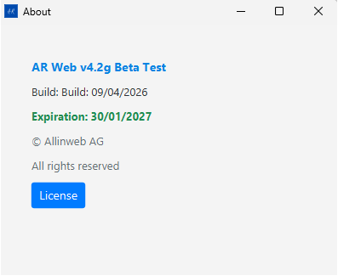
About dialog — AR Web version, build date, expiration, and License button

5. Organizations
Click Organizations to manage environments.
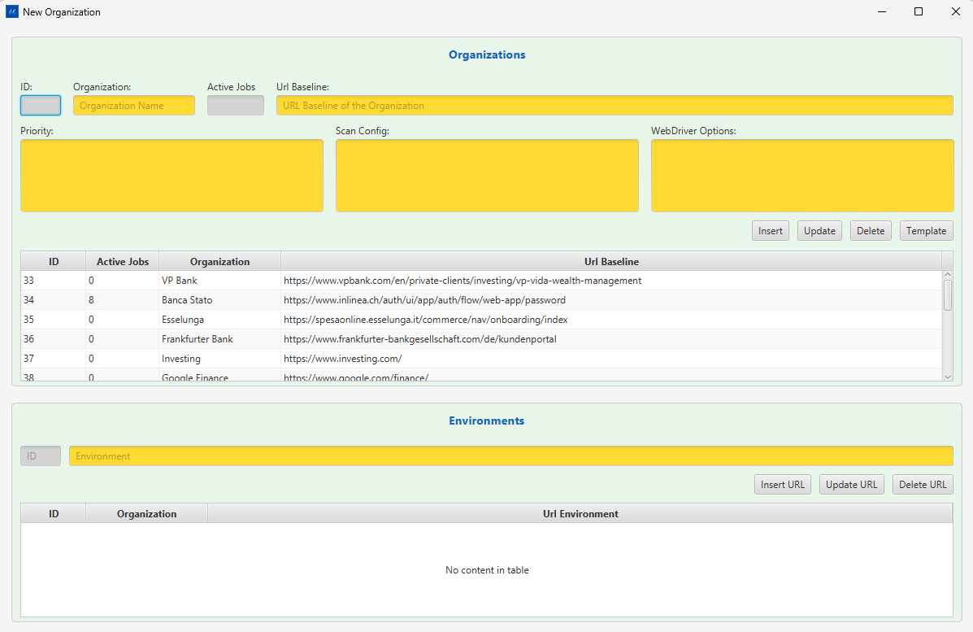
Organizations & Environments Dialog
- An Organization represents a banking portal or web application (e.g., “Avaloq”, “Temenos”).
- Each Organization has one or more Home URLs (environments like DEV, UAT, PROD).
- You must create at least one Organization before creating a Bot Job.

Add an Organization
- Click Organizations in the toolbar.
- Click + New in the dialog.
- Enter name and base URL.
- Click Save.

6. Configuration Panel
Click Config in the toolbar.
Open Config in the toolbar to access this panel.
The configuration panel stores all runtime paths and settings. Changes are written back to ARWeb.config.

Path Settings
Field | Purpose | Browse button
Path Excel | Folder where Excel data files are stored | Yes
Path License | Folder containing the .lic license file | Yes
Path Log | Folder for engine log files | Yes
Path Access DB | Folder for the MS Access .accdb database file | Yes
Path Report | Folder where test reports are written | Yes
Path Priority | File containing per-site element priority rules | Yes
Path Engine | Path to AR_Web_Engine.jar | Yes
Path WebDriver | Path to chromedriver.exe or msedgedriver.exe | Yes
Path Appium | Path to Appium server (mobile testing only) | Yes
Path Plugins | Folder containing minified JS plugin files | Yes
URL Plugins | Optional HTTP base URL for remote plugin loading | No

Database Settings
Control | Options
Database (ChoiceBox) | Access / PostgreSQL / SQLite
DB URL | JDBC connection string (PostgreSQL only)
DB User | PostgreSQL username
DB Password | PostgreSQL password

Browser
Control | Options
Browser (ChoiceBox) | Chrome / Edge / Firefox

Database Operations
Button | What it does
Reload DB | Re-runs pending database migrations and reloads data
Backup DB | Creates a timestamped backup of the current database
Restore DB | Restores the database from the date selected in the date picker
Delete All DB | Wipes all data (confirmation required)
Insert Sites | Seeds the database with site priority definitions from the priority file
Screenshot: see Config button in the main toolbar (shown above).

7. Bot Job List

Bot Job List — Name, Description, Organization, Status, Actions columns
The list is sorted by last-modified date. Each row shows:
Column | Description
Name | Internal name used for the Excel file (<Name>.xlsx)
Description | Human-readable description
Organization | The linked environment / home banking
Status | Active / Inactive
Actions | Per-row quick-action icons
Click a row to select it, then use the toolbar buttons to act on it.

8. Creating a Bot Job
- In the main window click New Bot Job.
  - If no Organizations exist you will see a prompt — add one first via Organizations.
- In the New Bot Job dialog:
  - Enter a unique Name (this becomes the Excel filename).
  - Enter an optional Description.
  - Select the Organization / Home Banking environment.
  - Choose the Type: Web App | Rest Api | Mobile.
- Click Save.
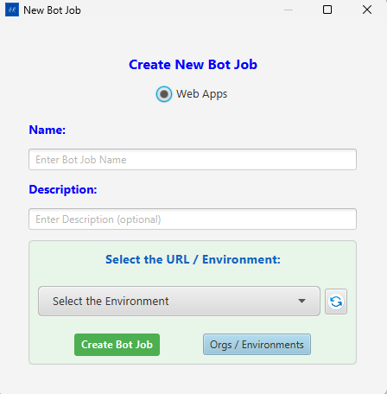
New Bot Job — Create dialog
The new job appears in the list.

9. Opening a Bot Job (Bot Job View)
Select a bot job in the list and click Open Job.
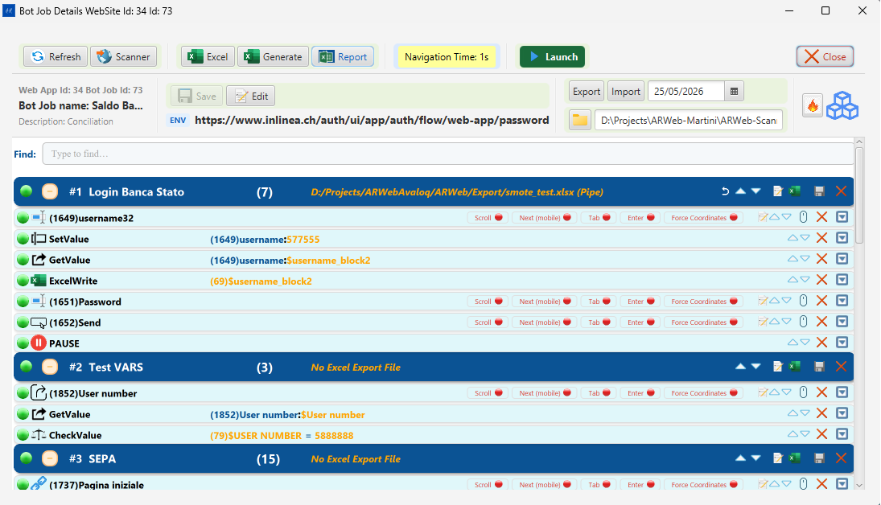
Bot Job View — Full window with toolbar and task instruction blocks
The Bot Job View is the main working area for a job. It contains:

Top Toolbar
Button | What it does
Refresh | Reloads the task instructions list from the database
Open Scanner | Opens the browser and activates the element picker plugin
Edit Bot Job | Toggles inline editing of the bot job name and description
Navigation Time: Ns | Cycles the post-navigation delay (0–10 seconds). Click repeatedly to increase; wraps back to 0. Color changes: green = 0s, orange = medium, red = high.
Launch | Runs the automation Engine (same as main window Launch)
Save Bot Job | Saves the current bot job name / description changes
Open Excel File | Opens the Excel data file in the default spreadsheet application
Generate Excel | Generates (or regenerates) the Excel file from current bot job data
Close Bot Job | Closes the view and returns to the main window
Open Report | Opens the test execution report in the browser
Create BAT | Creates a Windows .bat file to run the Engine from the command line
Export Job | Exports the entire bot job as a portable JSON/ZIP bundle
Import Job | Imports a previously exported bot job bundle
Component | Toggles the component box (shows linked component instructions)

Middle Area
- Tasks WebView — shows the recorded instruction list for the current bot job block.
- Component WebView — shows component-level shared instructions.

Current URL / Home URL
A dropdown at the top of the view shows the available Home URLs for this Organization. Changing it switches the target environment for the browser session.
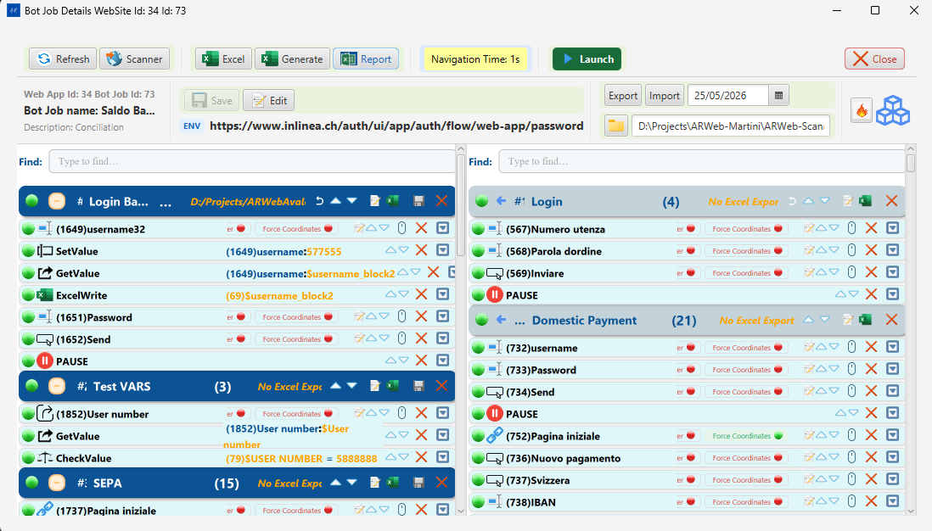
Bot Job View — Navigation Time button, ENV URL bar and Components panel

Working with Instructions — Context Menu
Every instruction row inside a block has a right-click context menu. Right-click any row to open it.
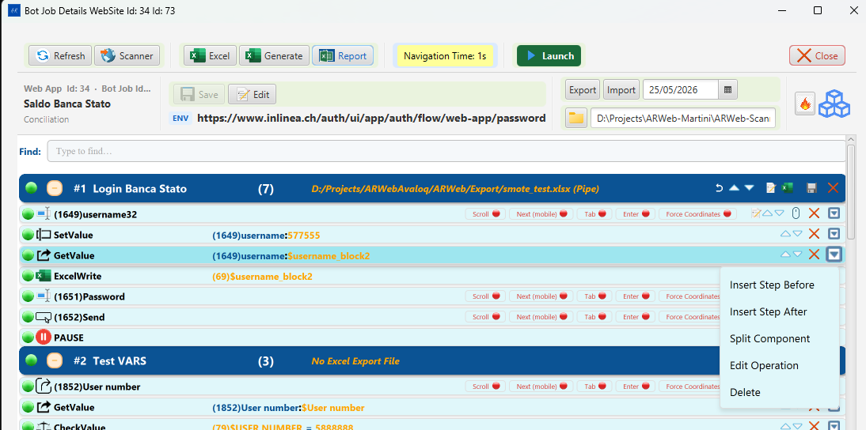
Instruction row right-click context menu — Insert Step Before, Insert Step After, Split Component, Edit Operation, Delete
Menu Item | What it does
Insert Step Before | Opens the Add/Update Operations dialog to insert a new instruction immediately above the selected row
Insert Step After | Opens the Add/Update Operations dialog to insert a new instruction immediately below the selected row
Split Component | Splits the current block into two blocks at the position of the selected instruction. The selected instruction and everything below it become a new block; everything above stays in the original block.
Edit Operation | Opens the Add/Update Operations dialog pre-filled with the current instruction — change the command, variable, or target web field
Delete | Removes the instruction from the block

Add/Update Operations Dialog
The Add/Update Operations dialog is opened from the context menu (Insert Step Before, Insert Step After, or Edit Operation). It is used to create new instructions or edit existing ones.
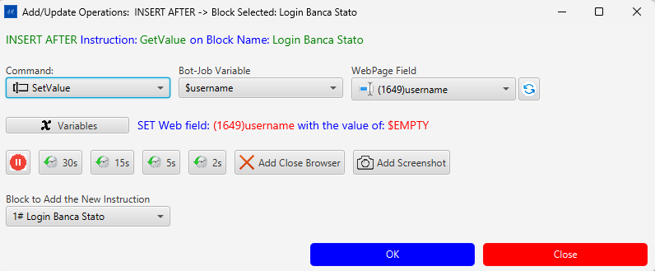
Add/Update Operations — Command dropdown, Bot-Job Variable, WebPage Field, pause buttons, block selector, OK/Close
The title bar and green label confirm the current action and position, for example: > Add/Update Operations: INSERT AFTER -> Block Selected: Login Banca Stato > INSERT AFTER Instruction: GetValue on Block Name: Login Banca Stato

Controls
Control | Description
Command | The automation action type (SetValue, GetValue, CheckValue, PAUSE, GOTO, etc.)
Bot-Job Variable | The variable that will supply or receive the value for this instruction
WebPage Field | The recorded web element this instruction acts on, shown as (ID)elementName
↺ (refresh) | Reloads the WebPage Field list from the database
Summary label | Live description of the full operation — e.g., SET Web field: (1649)username with the value of: $EMPTY
30s / 15s / 5s / 2s | Insert a pause of that duration before the instruction
Add Close Browser | Appends a close-browser step after this instruction
Add Screenshot | Appends a screenshot-capture step after this instruction
Block to Add | Dropdown to choose which block receives the new instruction
OK | Confirms and saves the instruction
Close | Cancels without saving

Command Types
The Command dropdown contains all available automation actions:
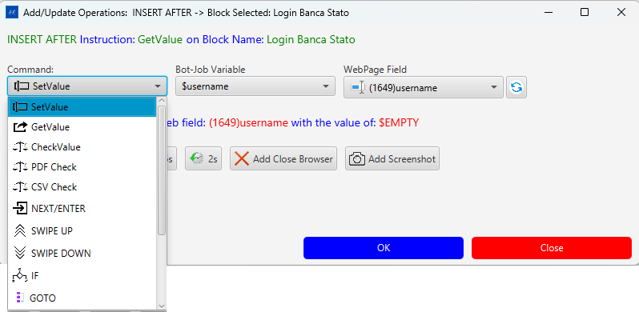
Command types — part 1: SetValue, GetValue, CheckValue, PDF Check, CSV Check, NEXT/ENTER, SWIPE UP, SWIPE DOWN, IF, GOTO
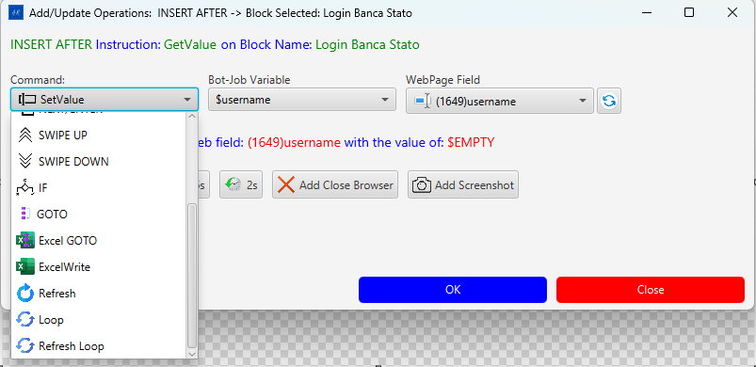
Command types — part 2: GOTO, Excel GOTO, ExcelWrite, Refresh, Loop, Refresh Loop
Command | What the Engine does
SetValue | Types the variable’s value into the target web field
GetValue | Reads the web field’s current text and stores it in the variable
CheckValue | Asserts the web field’s text matches the variable value; fails the step if not
PDF Check | Reads text from a PDF and checks it against the variable
CSV Check | Reads a value from a CSV file and checks it
NEXT/ENTER | Sends Enter / Tab to move focus or submit a form
SWIPE UP / SWIPE DOWN | Scrolls the page (used for touch/mobile flows)
IF | Conditional — runs the next step only if a condition is true
GOTO | Jumps execution to a named label or block
Excel GOTO | Jumps to a specific row in the Excel data file
ExcelWrite | Writes a static or computed value directly into the Excel output file
Refresh | Reloads the current browser page
Loop | Repeats the enclosing block N times
Refresh Loop | Reloads the page and repeats the block

Bot-Job Variables
Variables are named data holders that link instruction steps to Excel columns at runtime.
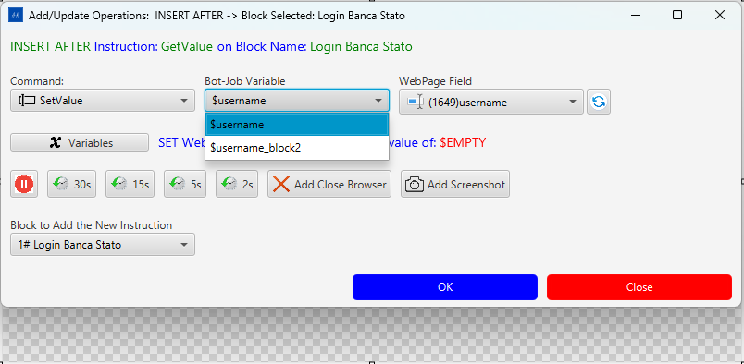
Bot-Job Variable dropdown showing $username and $username_block2
Click the Variables button to open the New Variables dialog:
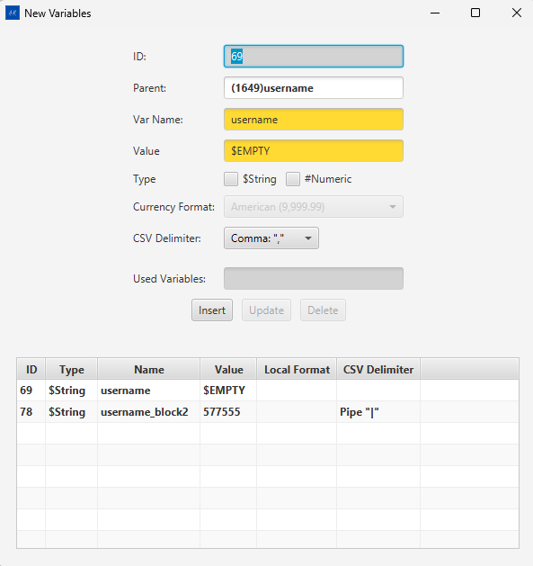
New Variables dialog — ID, Parent, Var Name, Value ($EMPTY),Type($String / #Numeric), Currency Format, CSV Delimiter, variable table
Field | Description
ID | Auto-assigned database ID
Parent | The web field instruction this variable is linked to (e.g., (1649)username)
Var Name | The variable’s identifier — used in instructions as $name (e.g., $username)
Value | Default value. $EMPTY means the value is read from the Excel column at runtime
Type | $String for text, #Numeric for numbers (enables Currency Format)
Currency Format | Number / decimal format for numeric values (e.g., American (9,999.99))
CSV Delimiter | Separator for multi-token variable values (Comma "," or Pipe "\|")
The variable table at the bottom shows all variables for the bot job. Use Insert / Update / Delete to manage them.

WebPage Fields
The WebPage Field dropdown lists every recorded element for this bot job, identified by (ID)elementName:
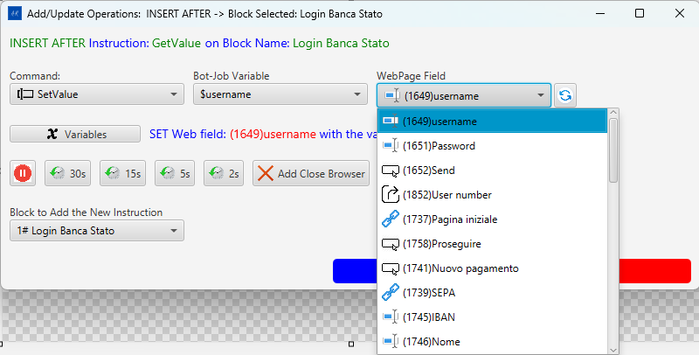
WebPage Field dropdown — (1649)username, (1651)Password, (1652)Send, (1852)User number, (1737)Pagina iniziale, and more
Each entry carries a type icon (input field, button, link, output) so you can confirm you are targeting the right element. The (ID) prefix is the element’s database ID — it matches the ID shown in the instruction row.

Variable Flow — How Data Moves Through a Bot Job
Variables are the bridge between the web page, the bot job instructions, and the Excel data file. Understanding this flow is essential for building working automations.

The Three-Way Link
Every variable connects three things:
Excel column ←→ Bot-Job Variable ←→ Web Field instruction
$username $username (1649)username
- The variable name (e.g., username) is the same as the Excel column header.
- The $ prefix (e.g., $username) is how the variable is referenced inside instructions.
- The WebPage Field (e.g., (1649)username) is the live DOM element the instruction acts on.

$EMPTY — Reading from Excel at Runtime
When a variable’s Value is set to $EMPTY, it means the Engine will read the actual value from the corresponding Excel column at the moment the instruction runs. This is the standard setup for data-driven tests: you fill the Excel sheet with test data, and the Engine feeds each row’s values into the web fields.
Excel row: username = "john.doe" → SetValue writes "john.doe" into (1649)username field
Excel row: username = "jane.doe" → SetValue writes "jane.doe" into (1649)username field

GetValue — Capturing Data FROM the Page
A GetValue instruction reads the current text of a web field and stores it into a variable. The Engine then writes that value into the matching Excel output column, so results can be reviewed after the run.
Web page field: (1852)User number = "12345"
↓ GetValue
Variable: $username_block2 = "12345"
↓
Excel output column "username_block2" = "12345"

SetValue — Writing Data TO the Page
A SetValue instruction reads the variable’s current value (from Excel) and types it into the web field.
Excel input column "username" = "john.doe"
↓
Variable: $username = "john.doe"
↓ SetValue
Web page field: (1649)username ← types "john.doe"

Variables Across Blocks
Variables are scoped to the bot job, not to a single block. A variable created in block #1 (e.g., $username_block2) can be read by a GetValue in block #1 and consumed by a SetValue in block #2 or block #3. This is how multi-step flows pass data between pages.
The variable name convention username_block2 is a human-readable hint: it signals the variable was introduced for use in block 2. There is no enforced naming rule — it is up to the automation author.

CSV Delimiter — Multi-Token Variables
When a variable value in the Excel file contains multiple tokens separated by a delimiter (e.g., Pipe "|" or Comma ","), the Engine iterates over each token across repeated executions of the same instruction. This is used for looped blocks where each iteration needs a different value.
Excel column "username" = "john.doe|jane.doe|bob.smith" (Pipe delimiter)
Loop iteration 1 → SetValue types "john.doe"
Loop iteration 2 → SetValue types "jane.doe"
Loop iteration 3 → SetValue types "bob.smith"

Summary Table
Command | Variable role | Excel column role
SetValue | Variable supplies the value to type | Input column — filled before the run
GetValue | Variable receives the value read | Output column — filled during the run
CheckValue | Variable supplies the expected value | Input column — the assertion target
ExcelWrite | Variable supplies a value to write directly | Output column — written without a web field

10. Scanner — Picking Web Elements
The scanner is the core recording mechanism.

Start Recording
- In the Bot Job View, click Open Scanner.
  - The Selenium-controlled browser opens and navigates to the bot job’s home URL.
  - The hoverPick.min.js plugin is injected into the page.
- In the browser, hover over any element — it will be highlighted.
- Click the element to pick it. The element’s XPath, tag name, text, and attributes are sent back to the Scanner grid.
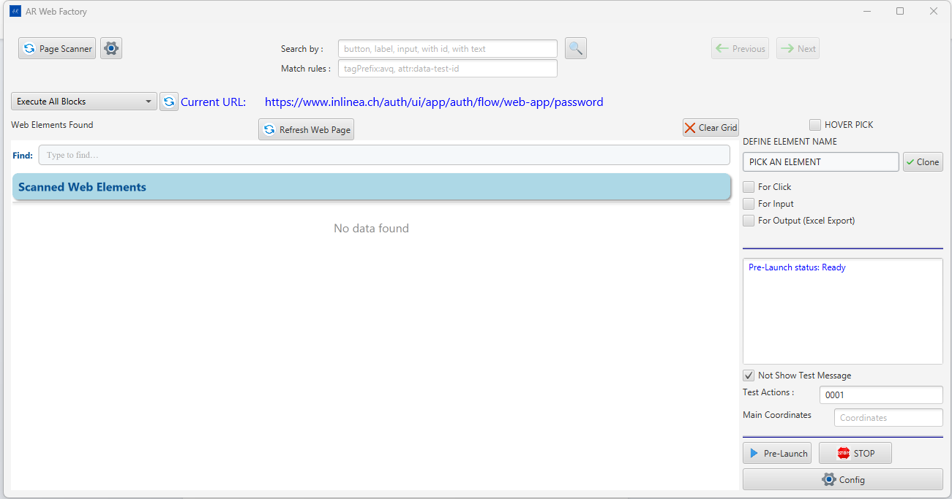
AR Web Factory — Scanner Grid with scanned elements from live page

Element Types Captured
Icon | Tag | Label shown
Input field icon | input, textarea | Input Text
Click icon | button | Button
Link icon | a, link | Link
Output icon | All others | Output (or raw tag name)

Page Scanner (Bulk Scan)
The Page Scan… button at the top-left of AR Web Factory injects the searchListAsync plugin into the live browser page and bulk-collects all interactive elements at once. Results populate the Scanner Grid grouped by element type.

AR Web Factory — Page Scan button, Search by and Match rules fields visible in the toolbar

Controlling What Gets Scanned
Two fields in the AR Web Factory toolbar let you narrow or extend the scan:
Search by (placeholder: button, label, input, with id, with text) — Comma-separated CSS tag names or special keywords that filter which elements are collected. Leave it blank and press Page Scan… to use the defaults (input, textarea, button, a, select, label). Press the 🔍 button to scan with a custom set.
Keyword | Selects
button, input, a, select, label, textarea | Elements by HTML tag
with id | Any element that has an id attribute
with name | Any element that has a name attribute
with text | Only elements that carry visible text
with test-id | Elements with a test-id attribute
Match rules (placeholder: tagPrefix:avq, attr:data-test-id) — Comma-separated keyword:value tokens that extend the scan to custom component libraries. Applied by both Page Scan… and 🔍.
Token | Example | Effect
tagPrefix:xxx | tagPrefix:avq | Includes <avq-*> custom components
tagSuffix:xxx | tagSuffix:-button | Includes tags ending with -button
attr:xxx | attr:data-test-id | Includes any element that has the named attribute
attrPrefix:xxx | attrPrefix:data- | Includes any element with an attribute starting with data-
See Part 2 § 9 for the full toolbar reference and a step-by-step explanation of how the scan script traverses iframes, Shadow DOM, and the main document.

11. Scanner Grid — Managing Scanned Elements
The Scanner Grid is the panel that receives and organizes picked elements. It appears embedded in the ARScannedElementScene window.

Scanner Grid (AR Web Factory) — Input Text / Button / Link blocks with element rows

Grid Toolbar
Control | What it does
Find input | Filters rows in real time across all fields (tag, name, text, XPath, attributes)
Insert All Elements | Sends all visible elements to the database (SEND_ALL_ELEMENTS_DTO). Disabled while sending.
Update All Elements | Updates all existing database records with current grid state (UPDATE_ALL_ELEMENTS_DTO).
Keep All | Marks every element as “keep” (ticks all Keep checkboxes)
Clear Keeps | Clears all Keep checkmarks
Delete Unchecked (N) | Opens a confirmation dialog then deletes every element NOT marked Keep. N = count to be deleted.
Clear Grid All | Empties the entire grid (frontend only). If Hover Pick checkbox is ticked it also tells the backend to truncate the cumulative elementDTO-HP.json file.
Hover Pick checkbox | When enabled, enables hover-pick accumulation mode. Clearing the grid also resets the backend HP file.
Rows per page | 5 / 10 / 20 / 50 — controls how many rows show per block per page

Element Blocks
Elements are grouped by HTML tag type. Each block has a header:
Control | What it does
−/+ collapse button | Collapses or expands the block
#N | Block order number
Type icon + label | Element type (Input Text / Button / Link / Output)
(N) count | How many elements in this block
Prev / Next | Pagination within the block (shown only when count > rows-per-page)
✕ (top-right) | Removes the entire block from the grid

Per-Row Controls
Each row represents one web element. Controls from left to right:
Control | What it does
Keep checkbox | Marks this element as “keep” — survives Delete Unchecked
Element name | Displays the element’s label. Display chain: clientNamed (user rename) → definedName → someText → tagName
Force badges (F/E/T/N/S) | Toggles the element-matching strategy in the Engine (see CompForce). Clicking cycles through modes.
Pick button (purple icon) | Sends the element back to the scanner tool for details preview (DETAILS_ELEMENT_DTO)
Edit button (pencil icon) | Enters inline rename mode — type a new name and press Enter or click Save
Save button (disk icon) | Saves the element to the database as an instruction (NEW_ELEMENT_DTO)
Test Input (keyboard icon) | Input / select / textarea only. Sends a test keystroke to the live element (TEST_INPUT_DTO)
Test Click (click icon) | Clicks the element in the live browser (TEST_CLICK_DTO)
✕ remove | Removes this single row from the grid (frontend only — does not delete from DB)

Scanner Grid — element rows showing Force badges, Pick, Edit, Save, Test Input, Test Click controls

Renaming an Element
- Click the Edit (pencil) icon on the row.
- An inline text input appears pre-filled with the current display name.
- Type the new name. Press Enter or click the Save icon.
- The renamed value is stored as clientNamed. If you clear the input or type back the original name, the override is removed and the original someText/definedName is shown again.

Delete Unchecked Workflow
Use this to quickly prune unwanted elements after a bulk scan:
- Tick the Keep checkbox on every row you want to keep.
- Click Delete Unchecked (N) — a confirmation modal shows how many will be deleted.
- Click Confirm to remove the unchecked rows from the grid.
This only affects the in-memory grid — it does NOT delete records from the database. Use Update All Elements after cleaning to sync the database.

Saving Elements to the Database
- Per row: Click the Save (disk) icon on a row → that single element is inserted/updated in the database as one instruction (NEW_ELEMENT_DTO).
- Bulk: Click Insert All Elements → all rows are sent together (SEND_ALL_ELEMENTS_DTO).
- Bulk update: Click Update All Elements → all rows update existing records.

12. Generating the Excel Data File
Before the Engine can run a bot job, an Excel file must exist at PATH_EXCEL\<BotJobName>.xlsx.
- In the Bot Job View, click Generate Excel.
  - The application reads all instructions for the current bot job and writes the Excel file.
- (Optional) Click Open Excel File to review or manually edit test data in the spreadsheet.
Use Open Excel File in the Bot Job View to open the generated file in your spreadsheet application.
Important: The Excel file must exist and be accessible before clicking Launch.

13. How Bot Job Execution Works
This section explains what happens when you press Launch or Pre-Launch — from loading the data all the way to the browser performing the actions on the live web page.

The Big Picture
AR Web Scanner is the authoring tool — you record what to do. AR Web Engine is the execution tool — it replays everything automatically, reading real data from Excel and driving a real browser.
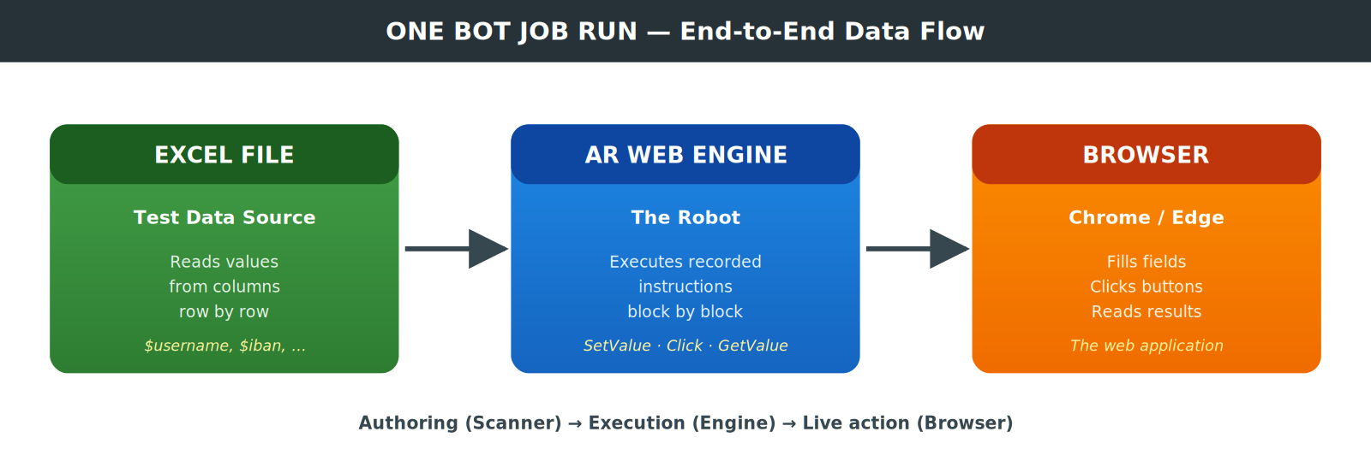

Structure of a Bot Job
Before understanding execution, you need to understand how a bot job is organized:
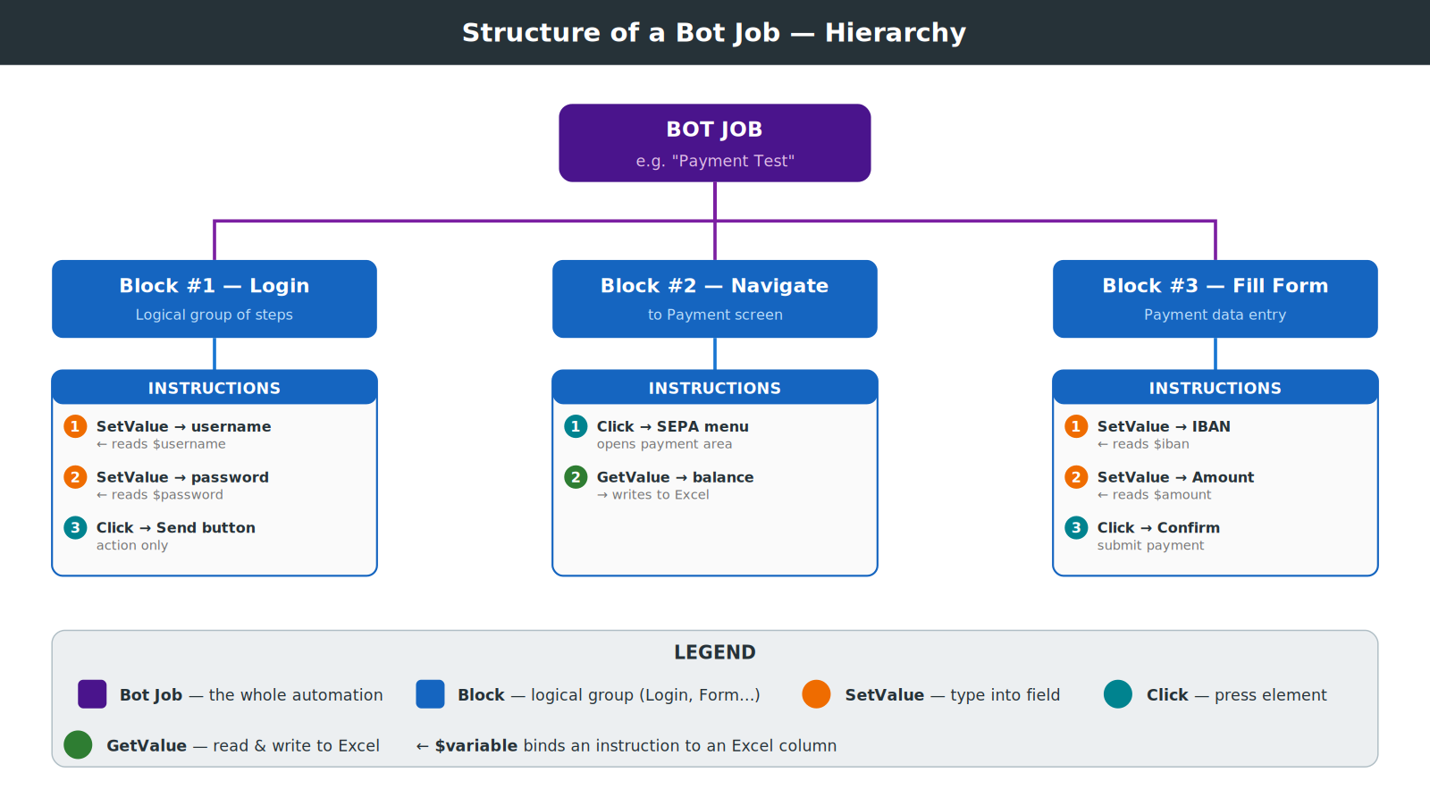
- Blocks are logical groups of steps (e.g., Login, Navigate, Fill Form).
- Instructions are the individual actions inside each block.
- Variables (like $username) link each instruction to an Excel column.

The Execution Loop
The Engine runs a three-level loop:
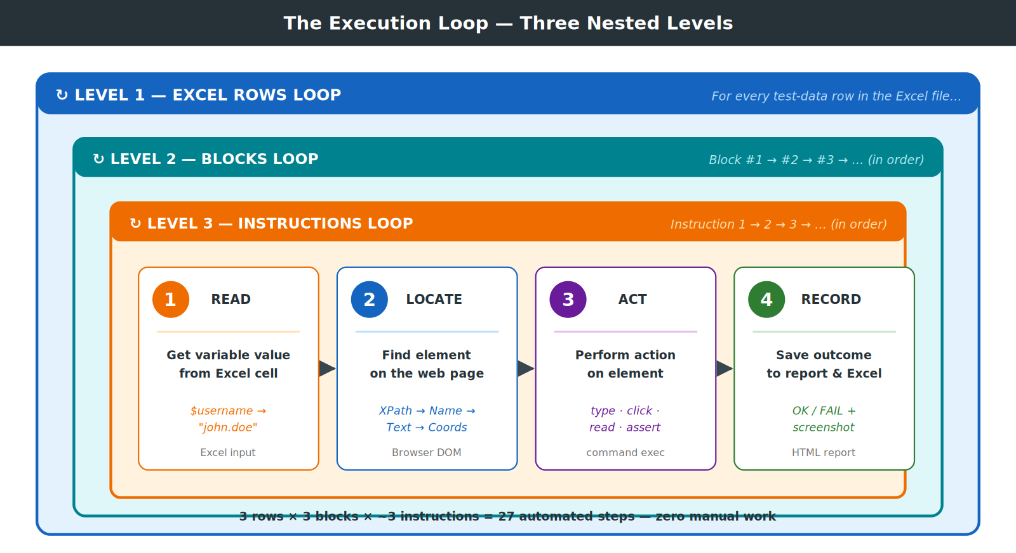
Example with 3 Excel rows: - Row 1 → run all blocks with test data “john.doe / Pass1234 / IBAN-001” - Row 2 → run all blocks again with “jane.doe / Pass5678 / IBAN-002” - Row 3 → run all blocks again with “bob.smith / Pass9012 / IBAN-003”
One Excel file, one bot job → three complete automated test runs with no manual intervention.

Step-by-Step Execution Flow
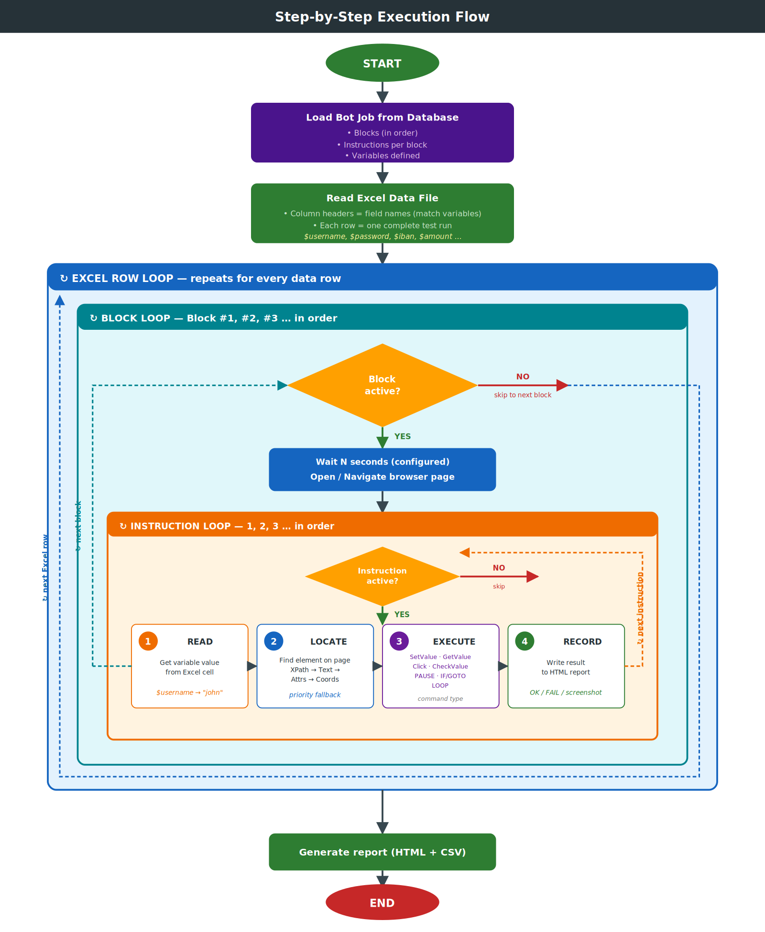

How the Engine Finds Elements on the Page
The Engine never blindly relies on a single strategy. It tries a priority fallback chain until it finds the element:
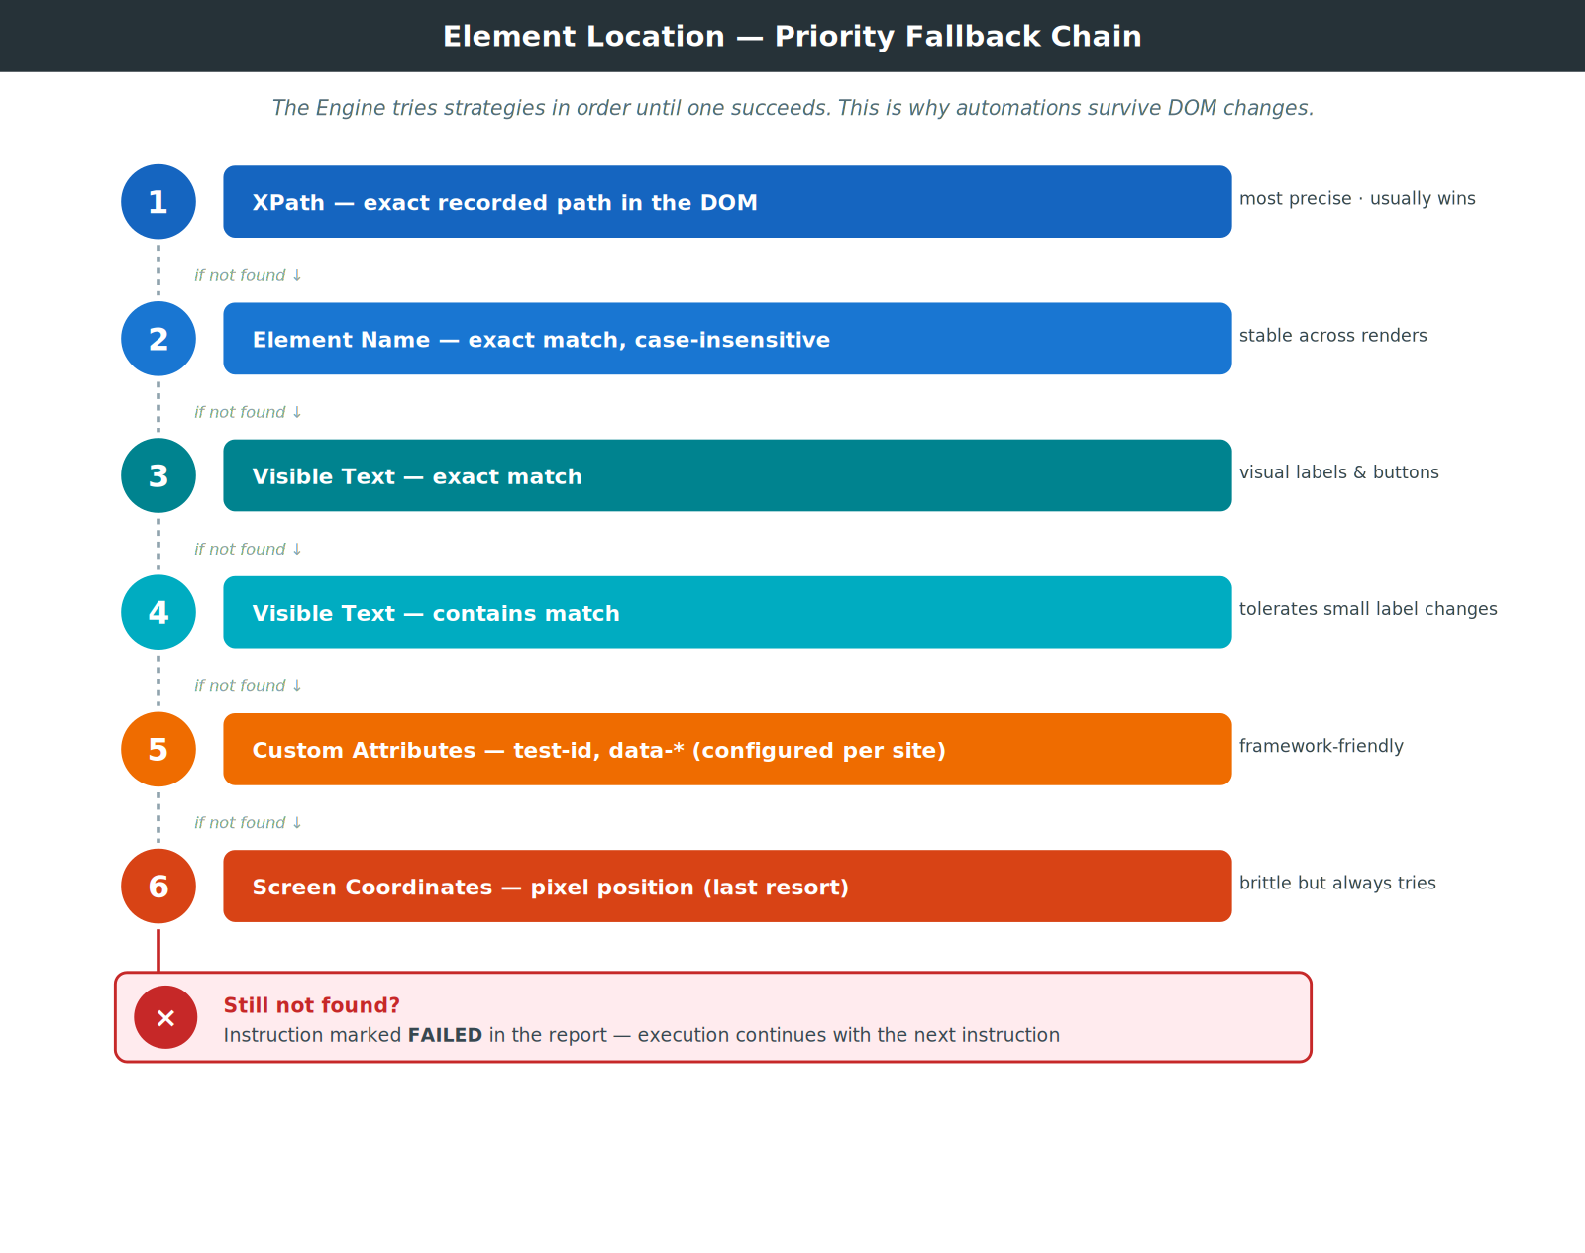
This fallback ladder means your automations keep working even when the application slightly changes its DOM structure.

Conditional Logic — IF, LOOP, GOTO
The Engine supports branching and looping inside the instruction sequence:
Command | What it does
IF / ENDIF | Skips a block of instructions if a condition is not met (e.g., skip payment step if balance is already correct)
LOOP | Repeats the instructions inside the loop N times (e.g., add 5 line items)
GOTO | Jumps execution to a different block (e.g., on error, jump to the “cleanup” block)
Excel GOTO | Reads the target block number from an Excel cell — the test data itself drives which path is taken
PAUSE | Waits N seconds (useful after page navigations that need extra time to load)

Launch vs Pre-Launch — Same Logic, Different Context
Both buttons execute exactly the same bot job logic. The difference is only WHERE the execution runs:
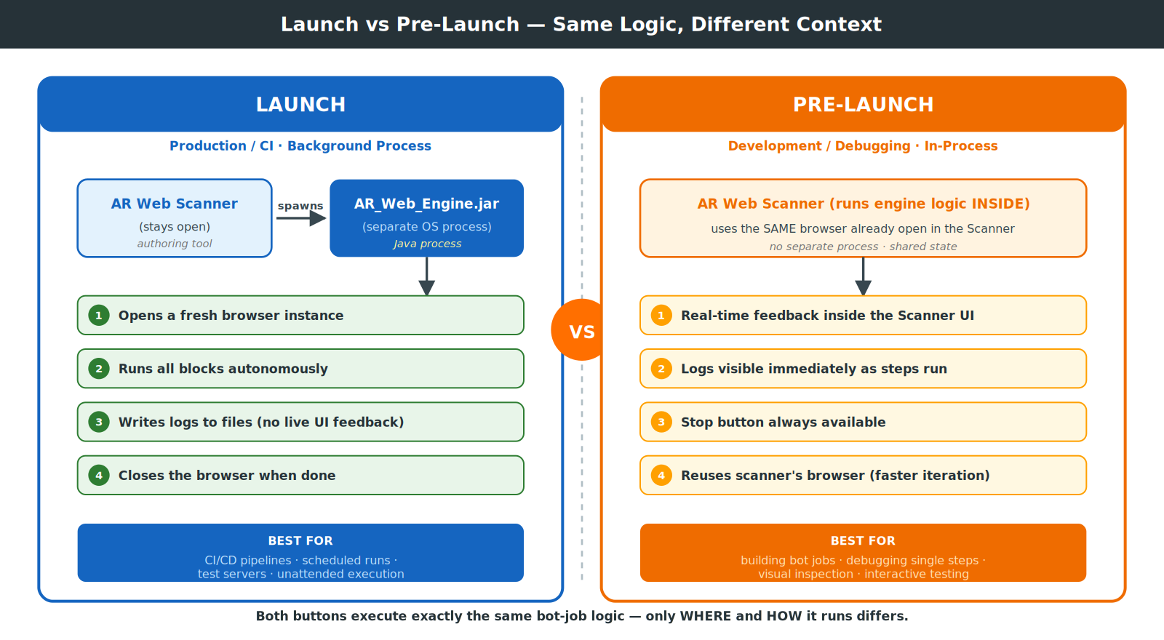
Tip: Use Pre-Launch while building and testing your bot job — you see every step happening in real time. Switch to Launch when deploying to a test server or CI pipeline.

14. Launch — Running the Automation Engine
Launch runs the AR_Web_Engine.jar in a separate process that replays the recorded bot job instructions against a live browser.

Pre-conditions
- Bot job type must be Web App or Rest Api (not Mobile).
- The Excel data file must exist (PATH_EXCEL\<BotJobName>.xlsx).
- Java 17+ must be on PATH.
- The WebDriver file must exist at PATH_WEBDRIVER.

How to Launch
- Select the bot job in the main list (or use the Launch button inside the Bot Job View).
- Click Launch.
- The Engine process starts in the background with output redirected to:
  - PATH_LOG\engine_debug_log_output.log
  - PATH_LOG\engine_debug_log_error.log
The Engine command executed is:
cmd.exe /c java.exe -jar "<PATH_ENGINE>" execute/j <orgId> <botJobId> 1 "<excelPath>" -c "<config>"

Bot Job View — Launch button in the toolbar starts the Engine process

15. Pre-Launch (Batch Inside Scanner)
Pre-Launch runs exactly the same automation actions as Launch — it drives the browser through the bot job instructions using the AR Web Engine — but executes the Engine inside the AR Web Scanner process instead of spawning a separate java.exe command.
Feature | Launch | Pre-Launch
What runs | AR Web Engine | AR Web Engine
Actions executed | All bot job instructions | All bot job instructions
Execution context | External cmd.exe /c java.exe process | Embedded within AR Web Scanner
Log location | engine_debug_log_*.log files | Scanner’s own console/log
Use case | Production / CI runs | In-Scanner debugging and development

AR Web Factory — Pre-Launch button and status indicator at bottom-right. Status shows “Pre-Launch status: Ready”
Use Pre-Launch when you want to see Scanner and Engine logs together during development. Use Launch for standard production test execution.

16. Clone a Bot Job
- Select a bot job in the main list.
- Click Clone Job.
- In the dialog, enter a new name and optionally change the description.
- Click Save.
The clone has all the same instructions as the original but is an independent job — changes to one do not affect the other.
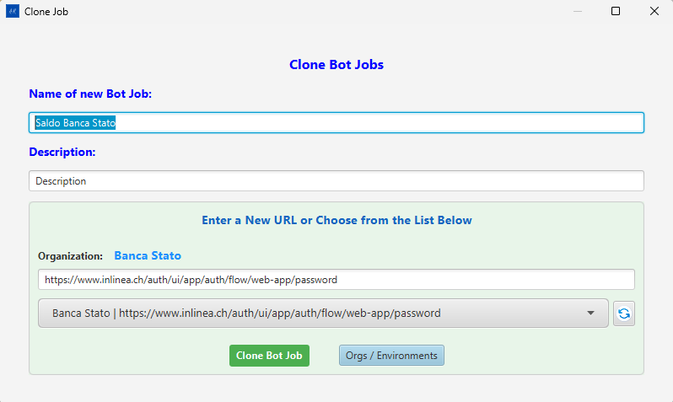
Clone Bot Jobs dialog — Name, Description, Organization URL selection

17. Export / Import a Bot Job

Export
- Open the bot job (click Open Job).
- In the Bot Job View, click Export Job.
- Choose a destination folder.
- The job is exported as a portable bundle (JSON or ZIP).

Import
- In the Bot Job View, click Import Job.
- Browse to the previously exported bundle file.
- The job is imported into the current database.

18. Reports
Click Open Report in the Bot Job View to open the last generated test report in your default browser.
Reports are stored at PATH_REPORT. Each run produces: - An HTML summary report. - A CSV data export.
Use Open Report in the Bot Job View toolbar to view the HTML report in your browser.

19. Backup & Restore
Access these from the Config panel.
Operation | Steps
Backup | Click Backup DB. A timestamped backup file is created at PATH_DB.
Restore | Select a date in the date picker, then click Restore DB. The backup file closest to that date is restored.
Delete All | Click Delete All DB and confirm. Wipes all instructions, bot jobs, and organizations.
Always back up before running Delete All or upgrading the database schema.

20. OCR Element Recognition
The AR Web Factory includes an OCR Configuration system that matches DOM elements to visually detected text in page screenshots. This supplements the standard XPath/attribute matching for pages where elements lack stable locators.

OCR Configuration Dialog
Click the gear icon (⚙) in the AR Web Factory toolbar to open OCR Configuration.
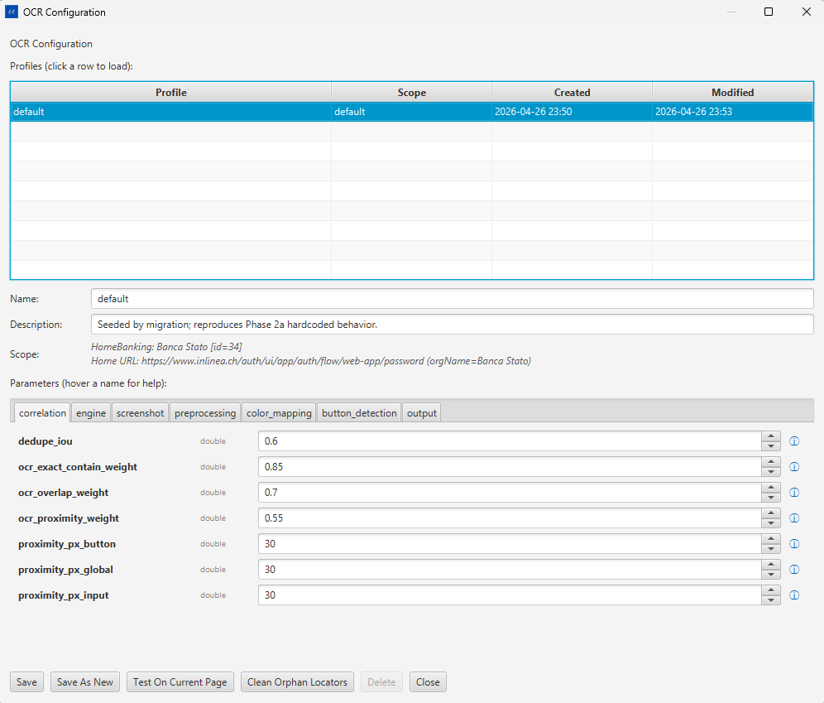
OCR Configuration — Profile table, parameter tabs (correlation, engine, screenshot, preprocessing, color_mapping, button_detection, output)
Section | Description
Profiles table | List of saved OCR profiles. Click a row to load it. Each profile is scoped to one Organization + Home URL.
Name / Description / Scope | Metadata for the selected profile
Parameter tabs | correlation, engine, screenshot, preprocessing, color_mapping, button_detection, output — each tab exposes tuning parameters with inline help (ⓘ hover)

Key Parameters (correlation tab)
Parameter | Type | Default | Description
dedupe_iou | double | 0.6 | Intersection-over-union threshold for deduplicating overlapping OCR detections
ocr_exact_contain_weight | double | 0.85 | Score weight when OCR text exactly contains DOM text
ocr_overlap_weight | double | 0.7 | Score weight for partial OCR/DOM text overlap
ocr_proximity_weight | double | 0.55 | Score weight for proximity-based matching
proximity_px_button | double | 30 | Pixel radius for button proximity matching
proximity_px_global | double | 30 | Global proximity radius

Profile Buttons
Button | Action
Save | Saves the current profile (overwrites)
Save As New | Creates a new profile with a new name
Test On Current Page | Runs OCR against the currently loaded page and opens the OCR Test Results dialog
Clean Orphan Locators | Removes stored OCR locators that no longer match any DOM element
Delete | Deletes the selected profile

OCR Test Results Dialog
After clicking Test On Current Page, the results dialog shows how well the OCR matches the DOM elements.
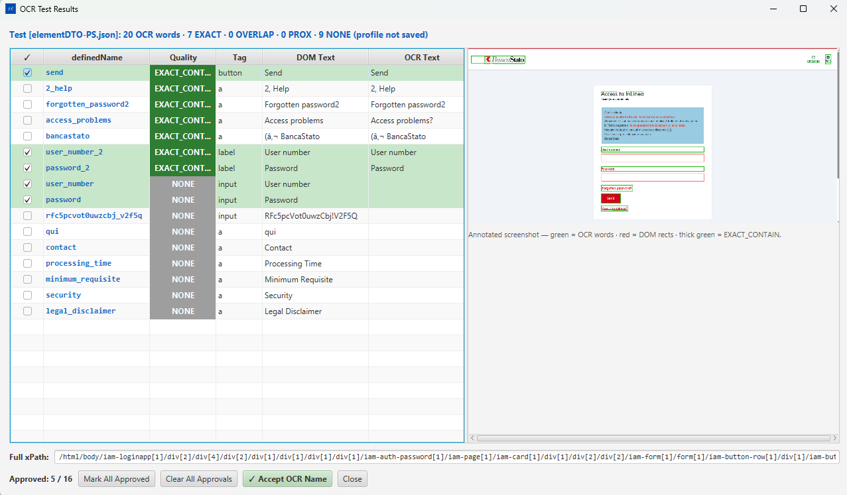
OCR Test Results — Quality column (EXACT_CONT / NONE), DOM Text vs OCR Text, annotated screenshot on right
Column | Description
✓ checkbox | Select elements to approve
definedName | Element’s stored name
Quality | Match quality badge: EXACT_CONT (green) = exact match, NONE (grey) = not matched
Tag | HTML element type (button, a, label, input)
DOM Text | Text extracted from the DOM
OCR Text | Text detected by OCR from the screenshot
The right panel shows the annotated screenshot with colored overlays: - Green = OCR-detected text regions - Red = DOM element bounding rectangles - Thick green = EXACT_CONTAIN matches

Bottom Controls
Control | Action
Full xPath | Shows the XPath of the selected element
Approved N / M | Count of approved vs total elements
Mark All Approved | Approves all elements in the list
Clear All Approvals | Removes all approval marks
✓ Accept OCR Name | Accepts the OCR-detected name for approved elements and stores them

21. Troubleshooting
Problem | Likely Cause | Solution
Application won’t start — “lock file exists” | Previous crash left .ARWebScanner.lock | Delete .ARWebScanner.lock from user.dir
Launch fails — “Excel file missing” | Excel not yet generated | Click Generate Excel in the Bot Job View
Launch fails — “WebDriver missing” | PATH_WEBDRIVER points to wrong path | Update in Config panel
Scanner picks nothing | PATH_PLUGINS not pointing to built plugin files | Check path_plugins in ARWeb.config and verify hoverPick.min.js exists there
Database errors on startup | Schema migration failure | Click Reload DB in Config; check PATH_LOG for migration errors
Browser not opening | Wrong browser selected or driver version mismatch | Match driver version to installed browser; select correct browser in Config

Continue in Part 2 for the complete Bot Job View reference and AR Web Factory guide.

