AR Web Scanner — User Guide Part 2: Bot Job View & AR Web Factory
Version: 4.2 | Audience: QA Engineers, Automation Authors
This guide covers the Bot Job View (task instruction editor) and the AR Web Factory window (Scanner Grid + element picker) in depth.
Part 1 covers the main window, organizations, configuration, launch, and backup. Screenshots are embedded from specifications/screenshots/.

Table of Contents
- Overview
- Bot Job View — Complete Reference
- Task Instruction Blocks
- Instruction Context Menu
- Add/Update Operations Dialog
- Instruction Types
- Component Panel
- AR Web Factory — Overview
- AR Web Factory — Toolbar Reference
- Scanner Grid — Element Blocks
- Scanner Grid — Per-Row Controls
- Define Element Name Panel
- Pre-Launch Panel
- OCR Configuration
- OCR Test Results
- WebSocket Message Quick Reference

1. Overview
After creating a Bot Job (covered in Part 1) the day-to-day work happens in two windows:
Window | Purpose
Bot Job View | Displays and edits the recorded task instruction blocks for a bot job
AR Web Factory | The Scanner Grid — picks, previews, and saves web elements from a live browser page
These two windows work together: you pick elements in AR Web Factory, save them, and they appear as instructions inside Bot Job View blocks.

2. Bot Job View — Complete Reference
Select a bot job in the main list and click Open Job.
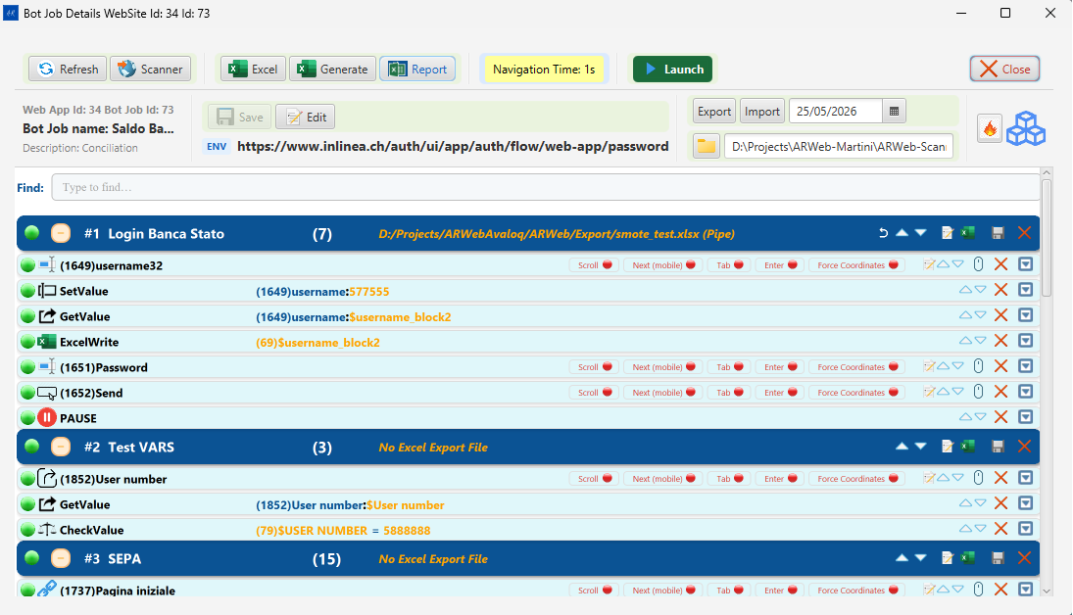
Bot Job View — full window with toolbar, ENV bar, and task instruction blocks

Title Bar
The window title shows: Bot Job Details WebSite Id: <orgId> Id: <botJobId>

Info Row (below toolbar)
Element | Description
Web App Id / Bot Job Id | Internal database IDs for the current org and job
Bot job name | Editable name field (toggle with Edit Bot Job)
Description | Editable description (shown when Edit is active)
Export / Import | Buttons for exporting the job as a portable bundle or importing one
Date | Last modified date of the bot job
ENV | The currently selected environment URL (dropdown)
Bot Job path | Display-only path showing the working directory for this run
Robot icon | Visual indicator for the bot job type

Toolbar Buttons
Button | Keyboard / Icon | What it does
Refresh | ↺ | Reloads the task instruction blocks from the database
Scanner | Browser icon | Opens the AR Web Factory window and launches the Selenium browser
Excel | Spreadsheet icon | Opens the Excel data file in the default application
Generate | Generate icon | Generates (or regenerates) the Excel file from current instructions
Report | Chart icon | Opens the last test execution HTML report in the browser
Navigation Time: Ns | Cycles 0→1→…→10→0 | Post-navigation wait. Green = 0 s, Orange = medium, Red = high
Launch | ▶ Play | Runs the Engine as an external java.exe process
Close | ✕ | Returns to the main Bot Job List window
The Navigation Time button changes color with the wait value: green (0 s), amber (1–4 s), red (5–10 s). Click it repeatedly to increase; it wraps back to 0 after 10 s.

ENV / URL Bar
The ENV bar shows the active home URL for the current bot job. Click the dropdown to switch between configured environments for the parent Organization.

3. Task Instruction Blocks
The central area of the Bot Job View lists the recorded automation steps organized into Blocks.

Bot Job View — task blocks #1 Login Banca Stato, #2 Test VARS, #3 SEPA

Block Header
Each block has a colored header row showing:
Element | Description
Play/Pause toggle (●/◐) | Enables or disables the block for the next run
# N | Block sequence number
Block name | Name of the block (e.g., “Login Banca Stato”)
(count) | Number of instructions in the block
Excel path | The associated Excel file path / “No Excel Export File” if not mapped
▲ ▼ | Move block up or down in execution order
📋 (copy) | Duplicate the block
🗑 (delete) | Remove the block and all its instructions
✕ | Collapse/expand the block

Instruction Row
Each instruction inside a block shows:
Column | Description
Type icon | Visual indicator of the action type (click, input, setvalue, pause, etc.)
ID | Instruction database ID in parentheses, e.g., (1649)
Description / Name | The element’s definedName or someText used for matching
Send | Badge indicating whether this instruction sends data to the Excel file
Test (invalid) | Validation state badge
Error | Error state badge
Force Coordinates | Blue badge; when lit the Engine uses screen coordinates as the primary locator

4. Instruction Context Menu
Right-click on any instruction row in the Bot Job View to open the context menu.
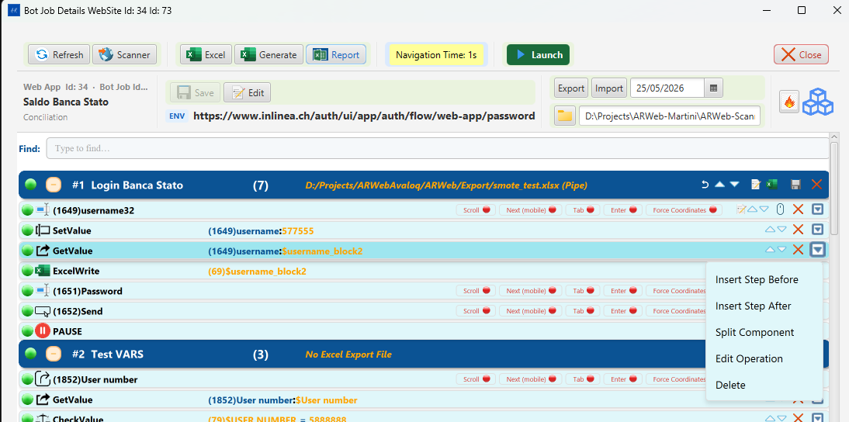
Instruction row context menu — Insert Step Before, Insert Step After, Split Component, Edit Operation, Delete
Menu Item | What it does
Insert Step Before | Opens the Add/Update Operations dialog to insert a new instruction immediately before the selected row
Insert Step After | Opens the Add/Update Operations dialog to insert a new instruction immediately after the selected row
Split Component | Splits the current block into two blocks at the position of the selected instruction. The selected instruction and everything below it move into a new block; everything above remains in the original block.
Edit Operation | Opens the Add/Update Operations dialog pre-filled with the selected instruction’s current values — allows you to change the command, variable, or web field
Delete | Removes the instruction from the block (confirmation required)

5. Add/Update Operations Dialog
The Add/Update Operations dialog is used both for inserting new instructions and for editing existing ones. It opens from the instruction context menu (Insert Step Before / After or Edit Operation).
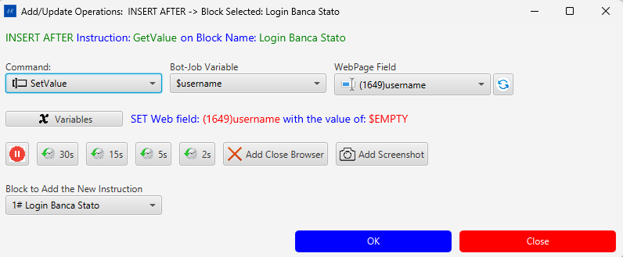
Add/Update Operations dialog — Command, Bot-Job Variable, WebPage Field, quick-pause buttons, block selector

Title Bar
The title bar shows the exact action and context, for example: > Add/Update Operations: INSERT AFTER -> Block Selected: Login Banca Stato
Below the title, a green label confirms the insertion point: > INSERT AFTER Instruction: GetValue on Block Name: Login Banca Stato

Main Controls
Control | Description
Command dropdown | The type of automation action to perform (see Command Types below)
Bot-Job Variable dropdown | The variable whose value will be used or stored by this instruction
WebPage Field dropdown | The recorded web element this instruction will act on
↺ (refresh) button | Reloads the WebPage Field list from the database
Summary label | Live preview of the operation, e.g., SET Web field: (1649)username with the value of: $EMPTY

Quick-Pause Buttons
Insert a wait instruction before the main action without opening a separate dialog:
Button | Inserts a pause of
30s | 30 seconds
15s | 15 seconds
5s | 5 seconds
2s | 2 seconds

Extra Options
Button | What it does
Add Close Browser | Appends a “close browser” instruction after this step
Add Screenshot | Appends a screenshot-capture instruction after this step

Block Selector
The Block to Add the New Instruction dropdown lets you choose which block the new instruction will be added to. Defaults to the block of the selected instruction.

Confirm / Cancel
Button | Action
OK | Saves the instruction and closes the dialog
Close | Cancels and discards changes

Command Types
The Command dropdown lists all available automation actions:
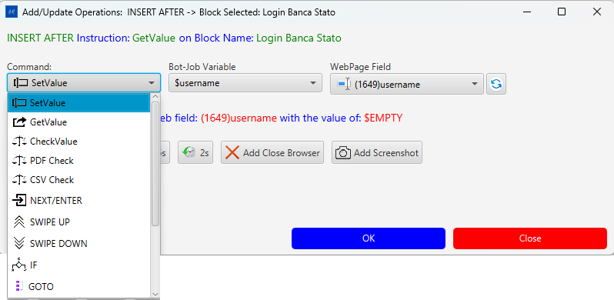
Command dropdown — part 1: SetValue, GetValue, CheckValue, PDF Check, CSV Check, NEXT/ENTER, SWIPE UP/DOWN, IF, GOTO
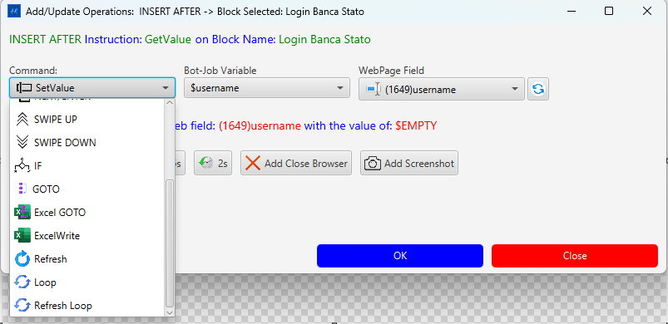
Command dropdown — part 2: GOTO, Excel GOTO, ExcelWrite, Refresh, Loop, Refresh Loop
Command | Description
SetValue | Types a variable value into a web field (input, select, textarea)
GetValue | Reads text from a web field and stores it in a variable
CheckValue | Asserts the web field’s text equals the variable value
PDF Check | Reads and checks text from a PDF document
CSV Check | Reads and checks a value from a CSV file
NEXT/ENTER | Sends Enter or Tab to advance focus (e.g., submit a form)
SWIPE UP | Scrolls the page upward (mobile/touch gesture)
SWIPE DOWN | Scrolls the page downward
IF | Conditional branch — executes the next instruction only if a condition is met
GOTO | Jumps to a named label or block
Excel GOTO | Jumps to a row in the Excel data file
ExcelWrite | Writes a value directly into the Excel output file
Refresh | Reloads the current browser page
Loop | Repeats the enclosing block a fixed number of times
Refresh Loop | Reloads the page and repeats the block

Bot-Job Variables
Variables are named placeholders that carry data between instructions and the Excel file.
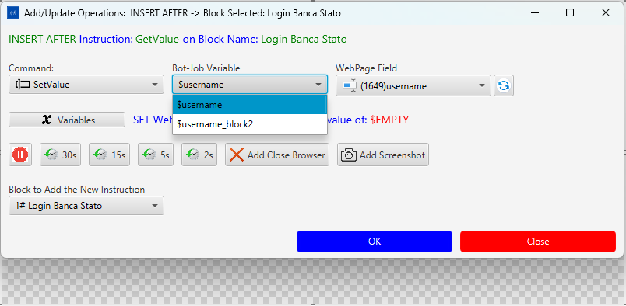
Bot-Job Variable dropdown — $username and $username_block2
Click the Variables button to open the New Variables dialog and manage the variable list for this bot job.
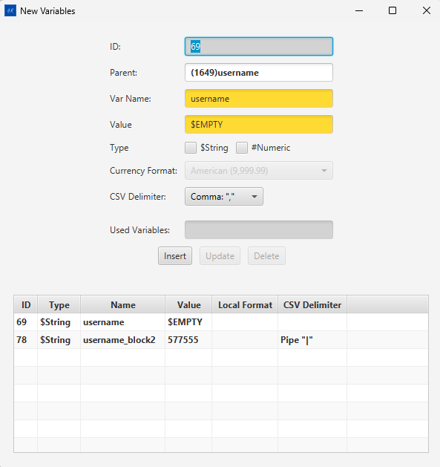
New Variables dialog — ID, Parent, Var Name, Value, Type ($String/#Numeric), CSV Delimiter, variable table
Field | Description
ID | Auto-assigned database ID
Parent | The web field instruction this variable is linked to (e.g., (1649)username)
Var Name | Variable identifier used in instructions (e.g., username) — referenced as $username
Value | Default value; $EMPTY means the value comes from the Excel column at runtime
Type | $String (text) or #Numeric (number with optional currency format)
Currency Format | Decimal / thousand separator format for numeric values (e.g., American (9,999.99))
CSV Delimiter | Delimiter used when the variable value contains multiple tokens (Comma "," / Pipe "\|" / etc.)
Used Variables | Read-only display of where this variable is referenced

Variable Table
The table at the bottom of the dialog lists all variables for the current bot job:
Column | Description
ID | Database ID
Type | $String or #Numeric
Name | Variable name
Value | Current default value
Local Format | Currency or number format (if numeric)
CSV Delimiter | Delimiter for multi-value variables
Use Insert / Update / Delete buttons to manage variables.

WebPage Fields
The WebPage Field dropdown lists all recorded web elements for the current bot job, identified by their database ID and defined name.
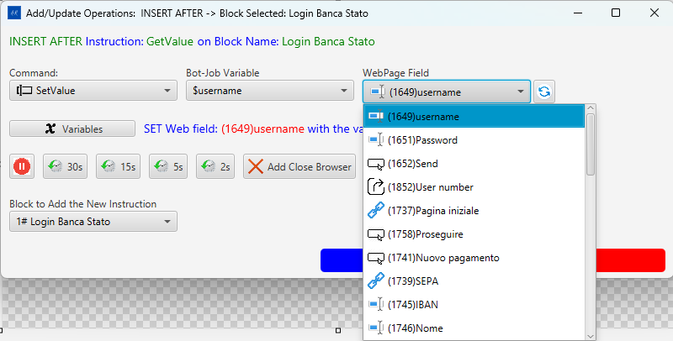
WebPage Field dropdown — all recorded elements for the bot job: username, Password, Send, User number, Pagina iniziale, etc.
Each entry shows: (ID)elementName — for example (1649)username, (1651)Password, (1652)Send.
The element type icon to the left of each entry indicates whether it is an input field, a button, a link, or an output element.

Variable Flow — How Data Moves Through a Bot Job
Variables are the bridge between the web page, the bot job instructions, and the Excel data file.

The Three-Way Link
Every variable connects three things:
Excel column ←→ Bot-Job Variable ←→ Web Field instruction
$username $username (1649)username
- The variable name (e.g., username) is the same as the Excel column header.
- The $ prefix (e.g., $username) is how the variable is referenced inside instructions.
- The WebPage Field (e.g., (1649)username) is the live DOM element the instruction acts on.

$EMPTY — Reading from Excel at Runtime
When a variable’s Value is $EMPTY, the Engine reads the actual value from the matching Excel column when the instruction runs. This is the standard setup for data-driven tests.
Excel row: username = "john.doe" → SetValue types "john.doe" into (1649)username
Excel row: username = "jane.doe" → SetValue types "jane.doe" into (1649)username

GetValue — Capturing Data FROM the Page
GetValue reads the current text of a web field, stores it in a variable, and the Engine writes it into the corresponding Excel output column.
Web field (1852)User number = "12345"
↓ GetValue
Variable $username_block2 = "12345"
↓
Excel output column "username_block2" = "12345"

SetValue — Writing Data TO the Page
SetValue reads the variable’s value (from Excel) and types it into the web field.
Excel input column "username" = "john.doe"
↓
Variable $username = "john.doe"
↓ SetValue
Web field (1649)username ← types "john.doe"

Variables Across Blocks
Variables are scoped to the whole bot job, not a single block. A variable set by GetValue in block #1 can be consumed by SetValue in block #2 or #3 — this is how multi-page flows pass data between steps.

CSV Delimiter — Multi-Token Variables
When an Excel cell contains multiple values separated by a delimiter (Pipe "|" or Comma ","), the Engine iterates over each token across repeated loop executions:
Excel: username = "john.doe|jane.doe|bob.smith" (Pipe delimiter)
Loop 1 → SetValue types "john.doe"
Loop 2 → SetValue types "jane.doe"
Loop 3 → SetValue types "bob.smith"

Command / Variable / Excel Summary
Command | Variable role | Excel column role
SetValue | Supplies the value to type into the field | Input — filled before the run
GetValue | Receives the value read from the field | Output — filled during the run
CheckValue | Supplies the expected assertion value | Input — the assertion target
ExcelWrite | Supplies a value to write directly | Output — written without a web field

6. Instruction Types
The following instruction types appear as colored icons in instruction rows:
Icon color / label | Engine action
Login | Navigates to the home URL and waits for the page to load
SetValue | Types text into an input field (value comes from Excel)
GetValue | Reads a value from the page and stores it in the Excel output column
ExcelWrite | Writes a static or computed value into the Excel sheet
CheckValue | Asserts a page value matches an expected Excel value
Click / Button | Clicks a button or link
Input Text | Focuses and types into a text input
PAUSE | Waits for a configurable number of seconds
Pagina iniziale | Navigates back to the home URL
The exact set of available instruction types is defined by ARConstantsEngine and the Engine command vocabulary.

7. Component Panel
Click the Component toggle button in the Bot Job View toolbar to open the Component panel alongside the task blocks.
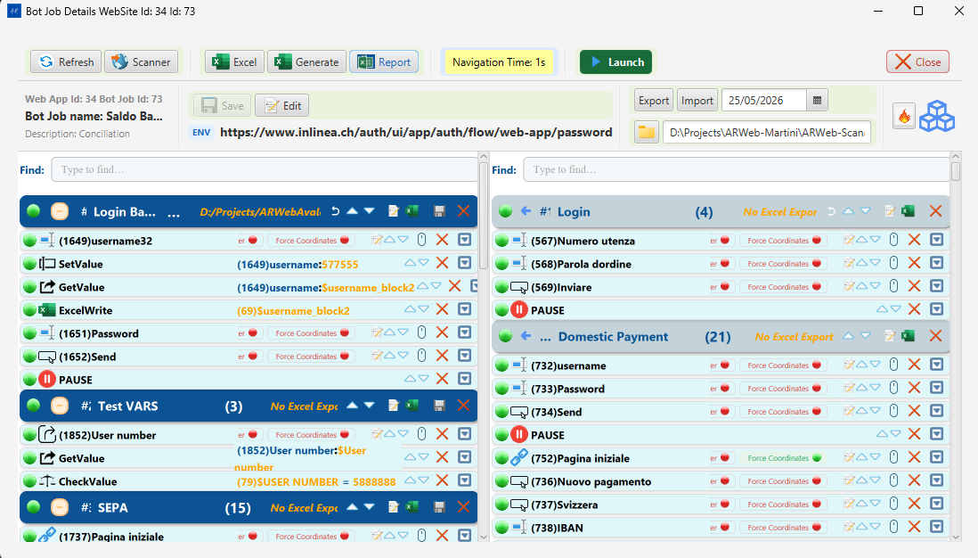
Bot Job View — Components panel open on the right side
The Component panel shows shared instruction components — reusable instruction blocks that can be linked into multiple bot jobs.
Panel element | Description
Component list | Tree of available components on the left
Component detail | Instructions inside the selected component on the right
Link / Unlink | Associate a component with the current bot job block
Components allow common sequences (e.g., a login flow) to be defined once and shared across multiple bot jobs without duplicating instructions.

8. AR Web Factory — Overview
Click Scanner in the Bot Job View toolbar to open the AR Web Factory window.
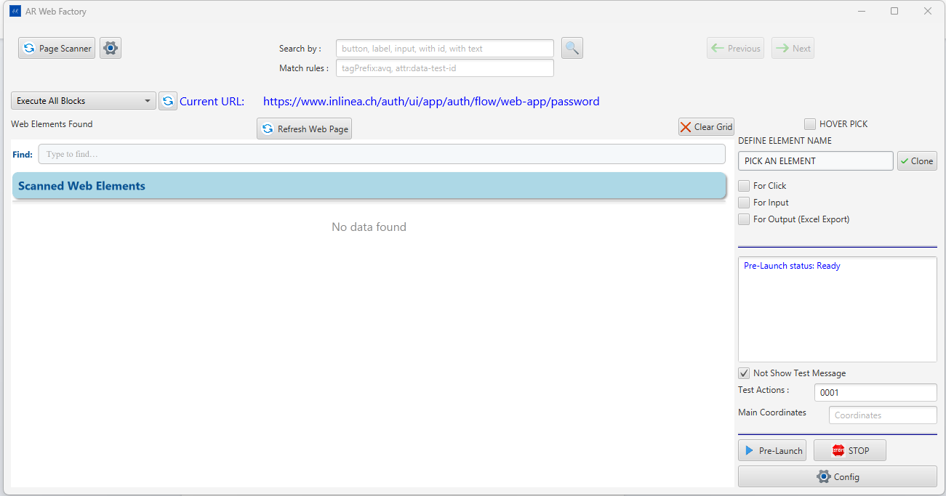
AR Web Factory — full window with toolbar, scanner grid, and Define Element Name panel
AR Web Factory is the recording and element management workspace. It has three areas:
Area | Location | Purpose
Toolbar | Top bar | Search, URL display, Execute All Blocks, page actions
Scanner Grid | Left/center | Element blocks with picked elements from the live page
Define Element Name panel | Right | Element type picker, clone option, Pre-Launch controls

9. AR Web Factory — Toolbar Reference

AR Web Factory — toolbar showing Page Scan button, Search by and Match rules fields, Execute All Blocks dropdown, Current URL, and right-side controls
Control | Description
Page Scan… button | Bulk-scans the live page using the default element types (input, textarea, button, a, select, label) plus any rules typed in Match rules — no need to fill in Search by
⚙ (gear) | Opens the OCR Configuration dialog
Search by field | CSS selectors or special keywords, comma-separated, that narrow down which elements are collected (see below)
🔍 button | Triggers the scan using the custom terms in Search by plus Match rules
Match rules field | Extended matching rules for custom component libraries (see below)
← Prev / Next → buttons | Navigate between previously scanned pages
Execute All Blocks dropdown | Select a block to execute; runs all instructions in that block via the live browser
Current URL | Read-only display of the URL currently loaded in the Selenium browser
Refresh Web Page | Reloads the current page in the Selenium browser
Clear Grid | Empties the scanner grid (prompts if Hover Pick is active)
Hover Pick checkbox (top-right) | When checked, enables hover-pick accumulation — each element picked by hovering is added to the grid

Search by — Syntax Reference
The Search by field (placeholder: button, label, input, with id, with text) controls which DOM elements the scan script collects from the page. Values are comma-separated.
Term | What it selects
button | All <button> elements
input | All <input> elements (any type)
a | All <a> (anchor/link) elements
select | All <select> (dropdown) elements
label | All <label> elements
textarea | All <textarea> elements
div, span | Container elements (only included in results if they have visible text)
with id | All elements that have an id attribute
with name | All elements that have a name attribute
with test-id | All elements that have a test-id attribute
with text | Only elements that carry visible text content
(empty) | Uses the default set: input, textarea, button, a, select, label
How to use: - The Page Scan… button always uses the default set plus any Match rules — leave Search by blank when you want to scan everything. - The 🔍 button uses exactly what is typed in Search by. Use it when you want a targeted scan (e.g., type with id to see only elements with IDs).

Match Rules — Syntax Reference
The Match rules field (placeholder: tagPrefix:avq, attr:data-test-id) extends the scan to include elements from custom component libraries that would otherwise be missed by plain CSS tag selectors. Values are comma-separated keyword:value tokens.
Rule prefix | Example | Effect
tagPrefix: | tagPrefix:avq | Includes all elements whose tag name starts with avq — e.g., <avq-button>, <avq-input>
tagSuffix: | tagSuffix:-button | Includes all elements whose tag name ends with -button
attr: | attr:data-test-id | Includes all elements that have the named attribute (data-test-id) regardless of tag
attrPrefix: | attrPrefix:data- | Includes elements with any attribute whose name starts with data-
Typical use cases: - Avaloq / AVQ applications: tagPrefix:avq captures the full component set (avq-input, avq-table-cell, etc.) - Test automation attributes: attr:data-test-id or attr:data-cy adds test-id–tagged elements on top of regular interactive elements - Angular Material: combine with tagPrefix:mat- to include Material Design custom elements
Both Page Scan… and 🔍 pass the Match rules to the scan engine alongside the search terms.

Page Scanning — How It Works Internally
When a scan is triggered the searchListAsync script is injected into the live browser page and:
- Traverses iframes (same-origin only) — elements inside <iframe> documents are collected and their XPaths are prefixed with the iframe’s XPath.
- Traverses Shadow DOM (open shadow roots only) — custom web components are discovered and their shadowHost selector is recorded.
- Traverses the main document — all elements matching the search terms are collected.
- Deduplicates by XPath — elements at identical coordinates with the same XPath are merged; the one with richer attributes (e.g., aria-label) is kept.
- Sorts the result list in element-type order: input → textarea → button → a → select → label → span → div.
- Post-processes labels: <div> elements that have visible text are reclassified as label; Angular mat-label associations are resolved; table cells normalize their someText.
- Returns the full list to Java as JSON; the Scanner Grid is populated with grouped element blocks.

10. Scanner Grid — Element Blocks
Elements are grouped into blocks by HTML element type. Each block has:
Control | Description
−/+ collapse toggle | Collapses or expands the block
#N | Block order number
Type icon + label | Element type: Input Text / Button / Link / Output
(N) | Count of elements in this block
Prev / Next | Pagination (shown when count > rows-per-page)
✕ | Removes the entire block from the grid

Grid Toolbar (above all blocks)
Button | WebSocket verb | Description
Insert All Elements | SEND_ALL_ELEMENTS_DTO | Inserts all grid elements into the database as instructions
Update All Elements | UPDATE_ALL_ELEMENTS_DTO | Updates existing database records for all grid elements
Keep All | — | Ticks all Keep checkboxes in the grid
Clear Keeps | — | Unticks all Keep checkboxes
Delete Unchecked (N) | — | Removes all rows that are NOT marked Keep; N = count to be removed
(unlabelled) | — | Rows-per-page selector (5 / 10 / 20 / 50)

11. Scanner Grid — Per-Row Controls
Each element row (from left to right):
Control | Description
Keep checkbox | Marks the element as “keep” — survives Delete Unchecked
Element name | Display label. Priority chain: clientNamed → definedName → someText → tag name
Force badges | Compact badge cycling through locator strategies: F = Force XPath, E = Force Exact text, T = Force contains-text, N = Normal (default), S = Shadow DOM
Pick (purple icon) | DETAILS_ELEMENT_DTO — sends the element back to the backend for a details preview
Edit (pencil) | Enters inline rename mode; type a new clientNamed value and press Enter
Save (disk) | NEW_ELEMENT_DTO — saves this single element to the database as an instruction
Test Input (keyboard) | TEST_INPUT_DTO — sends a keystroke to the live element (inputs only)
Test Click (cursor) | TEST_CLICK_DTO — clicks the element in the live browser
✕ | Removes this row from the grid (does not delete from database)

Renaming an Element
- Click the Edit (pencil) icon.
- The name field becomes an editable input.
- Type the new name → press Enter or click the Save disk icon.
- The value is stored as clientNamed and overrides definedName/someText in the display and in the saved instruction.

12. Define Element Name Panel
The right panel in AR Web Factory defines how a picked element is categorized before saving.
Control | Description
PICK AN ELEMENT section | Radio buttons / selection for the purpose of the pick
For Click | Marks the element as a clickable target
For Input | Marks the element as a text input field
For Output (Excel Export) | Marks the element as a read value that will be written to the Excel output column
✓ Clone checkbox | When checked, the next pick clones the currently selected instruction instead of creating a new one
After selecting the type, hover over the element in the Selenium browser and click to pick it. The element appears in the corresponding block in the grid.

13. Pre-Launch Panel
The Pre-Launch panel is at the bottom-right of AR Web Factory.

AR Web Factory — Pre-Launch status “Ready”, Pre-Launch button, STOP button, Config button
Control | Description
Pre-Launch status | Shows the current execution state: Ready / Running / Done / error message
Not Show Test Message checkbox | Suppresses intermediate test status dialogs during the run
Test Actions | Number of actions to execute (0 = all)
Main Coordinates | Override coordinates field (leave empty for automatic)
Pre-Launch ▶ button | Starts the automation run inside the Scanner process using the AR Web Engine
■ STOP | Stops an active Pre-Launch run
⚙ Config | Opens the Configuration panel
Pre-Launch vs Launch — both execute the same bot job instructions via the AR Web Engine. Pre-Launch runs the Engine embedded inside the Scanner process (useful during development to see logs in one place). Launch spawns a separate cmd.exe / java.exe process (used for production/CI runs).

14. OCR Configuration
Click the ⚙ gear button in the AR Web Factory toolbar.
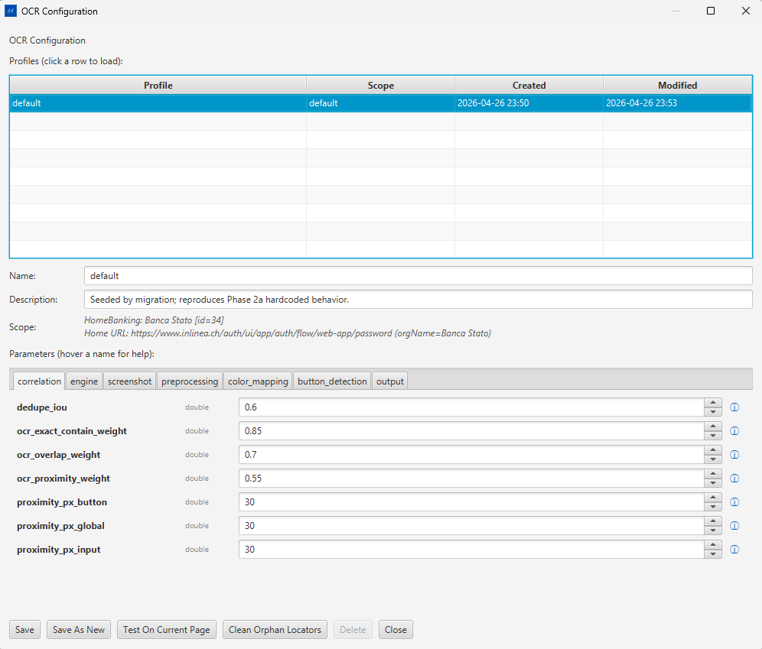
OCR Configuration dialog — profile table and parameter tabs

Profile Table
Column | Description
Profile | Profile name (e.g., “default”)
Scope | Org + Home URL this profile applies to
Created | Creation timestamp
Modified | Last save timestamp
Click a row to load the profile into the form below.

Profile Metadata
Field | Description
Name | Profile identifier
Description | Free-text note
Scope | Auto-filled from the active Organization and Home URL

Parameter Tabs
Tab | Purpose
correlation | Weights and thresholds for OCR-to-DOM text matching
engine | OCR engine selection and confidence threshold
screenshot | Screenshot capture area and scaling
preprocessing | Image pre-processing (binarization, contrast, deskew)
color_mapping | Color-based element type classification
button_detection | Button boundary detection parameters
output | Debug output and overlay rendering options
Hover over any parameter label to see its inline help tooltip (ⓘ).

Key Correlation Parameters
Parameter | Type | Default | Description
dedupe_iou | double | 0.6 | IoU threshold for deduplicating overlapping OCR detections
ocr_exact_contain_weight | double | 0.85 | Match score when OCR text exactly contains DOM text
ocr_overlap_weight | double | 0.7 | Score for partial text overlap
ocr_proximity_weight | double | 0.55 | Score based on spatial proximity
proximity_px_button | double | 30 | Pixel radius for button proximity matching
proximity_px_global | double | 30 | Global proximity radius

Profile Actions
Button | Action
Save | Overwrites the current profile with edited values
Save As New | Creates a new profile with a new name
Test On Current Page | Runs OCR against the active page; opens OCR Test Results
Clean Orphan Locators | Removes stored OCR locators with no matching DOM element
Delete | Deletes the selected profile
Close | Closes the dialog without saving

15. OCR Test Results
After clicking Test On Current Page in OCR Configuration.
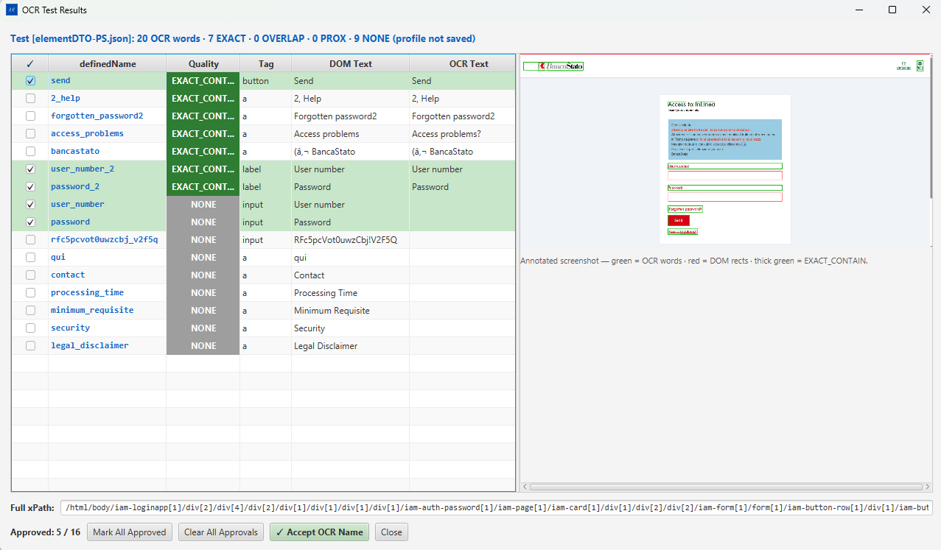
OCR Test Results — quality column, DOM Text vs OCR Text table, annotated screenshot panel

Results Table (left panel)
Column | Description
✓ checkbox | Select elements to approve
definedName | The stored element name
Quality | Match quality badge
Tag | HTML element type (button, a, label, input)
DOM Text | Text read directly from the DOM
OCR Text | Text detected by the OCR engine from the screenshot

Quality Badges
Badge | Color | Meaning
EXACT_CONT... | Green | OCR text exactly contains DOM text — high confidence match
NONE | Grey | No OCR match found for this element

Annotated Screenshot (right panel)
The screenshot taken at test time is shown with colored overlays:
Overlay | Color | Meaning
OCR word bounding boxes | Green | Text regions detected by OCR
DOM element rectangles | Red | DOM element bounding boxes
Exact-contain matches | Thick green | Elements with EXACT_CONTAIN quality
The Full xPath field at the bottom shows the XPath of the currently selected row.

Approval Controls
Control | Action
Approved: N / M | Running count of approved vs total
Mark All Approved | Sets all rows as approved
Clear All Approvals | Removes all approval marks
✓ Accept OCR Name | Stores the OCR-detected text as the clientNamed override for approved elements and persists them
Close | Closes the dialog

16. WebSocket Message Quick Reference
AR Web Factory communicates with the Java backend over a WebSocket connection. The following verbs are relevant to the Scanner Grid.

Outbound (Frontend → Backend)
Verb | Trigger | Description
SEND_ALL_ELEMENTS_DTO | Insert All Elements | Inserts all grid elements as instructions in the database
UPDATE_ALL_ELEMENTS_DTO | Update All Elements | Updates existing instruction records with current grid data
NEW_ELEMENT_DTO | Save (per row) | Inserts or updates a single element
DETAILS_ELEMENT_DTO | Pick button | Requests full detail preview for one element
TEST_INPUT_DTO | Test Input button | Sends a test keystroke to the live element
TEST_CLICK_DTO | Test Click button | Sends a click to the live element
CLEAR_HOVER_PICK_FILE | Clear Grid (HP mode) | Tells the backend to truncate the cumulative elementDTO-HP.json file

Inbound (Backend → Frontend)
Verb | Description
scannerGrid | Pushes a batch of scanned elements to populate the grid
mobileScannerGrid | Pushes elements from a mobile scan session
SEARCH_TOOL | Search/filter result payload for the Scanner search box
addPickOne | Adds a single hover-picked element to the grid
mobile-return-server | Response payload from a mobile companion session

For the main window, organizations, configuration panel, launch/pre-launch, clone, export/import, reports, backup/restore, and OCR — see Part 1.

