MultiTest.ai
Architecture & Implementation Manual
Enterprise API Test Platform

Version 2.0 — March 2026
Industry Context Layer • Plugin System • AI Integration • Test Library
Confidential — Your Company

1. Executive Summary
MultiTest.ai is an enterprise API test platform built with React and TypeScript. It provides automated test generation, execution, and reporting for any industry vertical. The platform features a modular Industry Context Layer, a Plugin System for extensible business rules, multi-provider AI integration, and a Schema Matching Engine for auto-generating tests from API specifications.
The architecture is industry-agnostic by design. The IndustryContext interface allows the platform to support additional verticals (insurance, telecom, healthcare, logistics) by swapping context modules and plugins without changes to the core engine.

2. System Architecture

2.1 Platform Architecture Overview
The following diagram shows the four-layer architecture of the MultiTest.ai platform, from the UI layer through the context and plugin layers down to the AI provider hub:
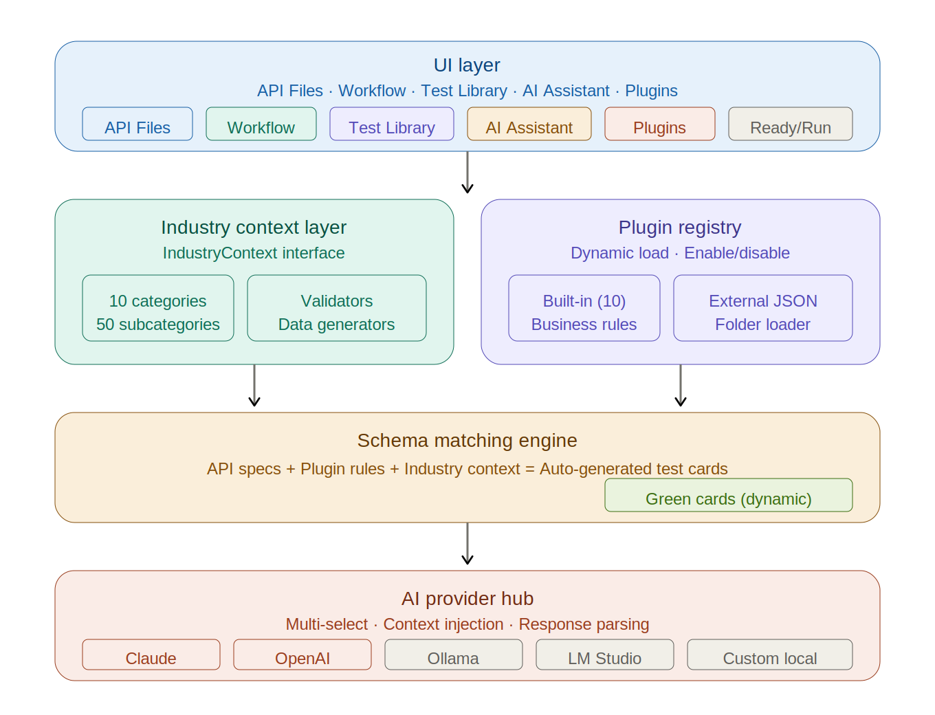
Figure 1 — MultiTest.ai Platform Architecture (4-layer model)

Architecture Summary
The platform is composed of four distinct layers, each with a clear responsibility:
- UI Layer — Eight tabs providing the user workflow: API Files (schema upload), Workflow (visual pipeline), Test Library (browsable catalog), AI Assistant (multi-provider AI), Plugins (management), Data Generator, Ready/Run (execution), and Report (results).
- Industry Context Layer — Contains the IndustryContext interface with 10 business categories and 50 subcategories, domain validators (IBAN, BIC, ISIN, amounts), and synthetic data generators. This layer can be swapped at runtime to support different industries.
- Plugin Registry — Manages 10 built-in plugins plus unlimited external plugins loaded from JSON files or folders. Each plugin contributes business rules, validators, data generators, and test cases. Plugins can be enabled/disabled without restart.
- AI Provider Hub — Multi-select provider architecture supporting cloud services (Anthropic Claude, OpenAI GPT) and local inference (Ollama, LM Studio, custom servers). Every request is enriched with the active industry context, loaded API specs, and business rules.

2.2 Layer Interaction
Layer | Components | Responsibility
UI Layer | 8 tabs: API Files, Workflow, Data Gen, Ready, Running, Report, Library, AI | User interaction, navigation, file upload, test execution control
Context Layer | IndustryContext interface, business categories, validators | 10 categories, 50 subcategories, validation rules, data generators
Plugin Engine | PluginRegistry, built-in + external plugins | Dynamic loading, enable/disable, rule evaluation, test case contribution
AI Hub | AIAssistantTab, 5+ providers | Multi-provider selection, context injection, response parsing

3. Schema Matching Engine

3.1 Data Flow
The Schema Matching Engine is the bridge between loaded API specifications and the active industry context. The following diagram illustrates the complete data flow from API schema input through matching and test generation:
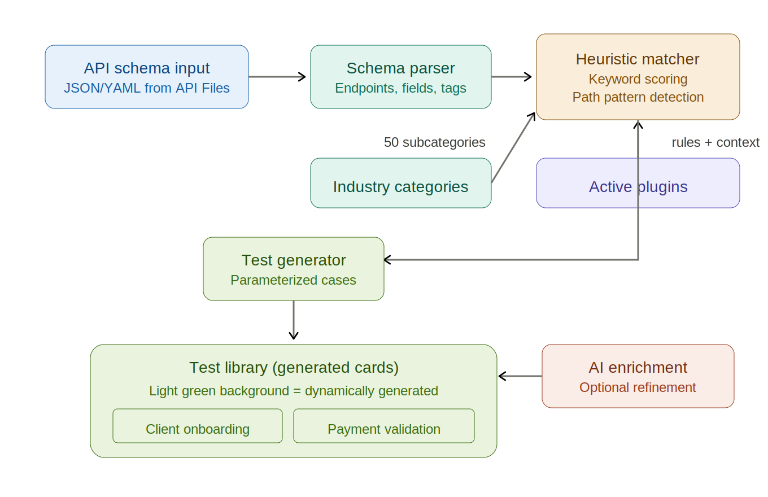
Figure 2 — Schema Matching Engine Data Flow

Flow Summary
The schema matching process follows six stages:
- API Schema Input — JSON or YAML OpenAPI specifications are loaded from the API Files tab.
- Schema Parser — Extracts endpoints, field names, data types, tags, and descriptions from each specification.
- Heuristic Matcher — Cross-references parsed data against the industry categories using weighted keyword scoring. Path segments score 3.0x, tags 2.0x, fields 1.5x, descriptions 1.0x.
- Active Plugins — Contribute additional business rules and context that feed into the matching engine for more precise categorization.
- Test Generator — When match scores exceed the threshold (default: 2.0), parameterized test cases are generated with business-oriented step descriptions.
- Test Library — Generated cards appear with a light green background to distinguish them from static plugin-provided tests. Optional AI enrichment can refine descriptions and add edge cases.

3.2 Heuristic Scoring
Signal | Weight | Example
Path segment match | 3.0 | /business-partners → Client Management
Tag/keyword match | 2.0 | tags: ['kyc'] → Compliance & KYC
Field name match | 1.5 | field: 'iban' → Payments & Transfers
Description match | 1.0 | 'transfer funds' → Internal Transfers
HTTP method bonus | 0.5 | POST on /payments → payment creation test

3.3 Auto-Generated Test Cards
Generated test cases include: auto-assigned category and subcategory, parameterized inputs from API schema fields, business-oriented step descriptions (not technical API calls), and source tracking with the 'api-generated' flag for visual distinction. These cards appear with a light green background in the Test Library.

4. Industry Context Layer

4.1 IndustryContext Interface
The IndustryContext interface is the abstraction point for multi-industry support:
- id — Unique identifier (e.g., 'api-services')
- categories — Array of BusinessCategory with subcategories
- rulesets — Business rules with evaluate() functions
- validators — IBAN, BIC, ISIN, amount, currency, date, client ID, risk class
- dataGenerators — Synthetic data for clients, accounts, payments, portfolios, instruments, loans

4.2 Default Categories (10 Categories, 50 Subcategories)
# | Category | Subcategories
1 | Client Management | Onboarding, Profile Update, Address Mgmt, Closure, Segmentation
2 | Account Lifecycle | Opening, Funding, Balance Ops, Limits, Closure
3 | Payments & Transfers | Internal Transfers, External Payments, Scheduled, Validation, Reconciliation
4 | Investment Portfolio | Creation, Asset Allocation, Rebalancing, Valuation, Reporting
5 | Trading Operations | Equity Orders, Bond Orders, Order Lifecycle, Settlement, Cancellation
6 | Compliance & KYC | KYC Updates, AML Checks, Document Verification, Risk Classification, Regulatory
7 | Corporate Actions | Dividend Distribution, Stock Split, Maturity, Coupon Payments, Adjustments
8 | Lending & Credit | Loan Creation, Credit Checks, Collateral, Repayment, Closure
9 | Reporting & Monitoring | Client Statements, Portfolio Reports, Activity, Audit Logs, Metrics
10 | Operational Maintenance | Data Maintenance, Batch Processing, System Monitoring, Error Recovery, Controls

5. Plugin System

5.1 Plugin Architecture
Each plugin (TestPlugin) contains metadata, rules with evaluate() functions, validators, data generators, test cases, and lifecycle hooks (onLoad, onEnable, onDisable). Plugins can be built-in (bundled) or external (loaded from JSON at runtime).

5.2 Built-in Plugins (10)
Plugin | Rules | Tests | Category
Client Management | 3 | 6 | client-management
Account Lifecycle | 2 | 5 | account-lifecycle
Payments & Transfers | 3 | 5 | payments-transfers
Investment Portfolio | 2 | 3 | investment-portfolio
Trading Operations | 2 | 3 | trading-operations
Compliance & KYC | 3 | 3 | compliance-kyc
Corporate Actions | 1 | 2 | corporate-actions
Lending & Credit | 2 | 2 | lending-credit
Reporting & Monitoring | 1 | 2 | reporting-monitoring
Operational Maintenance | 1 | 3 | operational-maintenance

5.3 Plugin Folder Loading
The platform supports loading plugins from a selected folder. The folder loader scans .json files, validates them against the plugin schema, and registers valid plugins. This enables a plugin marketplace model.

6. AI Assistant Integration

6.1 Multi-Provider Architecture
Provider | Type | Model | Default
Anthropic Claude | Cloud | claude-sonnet-4-20250514 | Enabled
OpenAI GPT | Cloud | gpt-4o | Disabled
Ollama | Local | qwen2.5:14b | Disabled
LM Studio | Local | local-model | Disabled
Custom Server | Local | custom | Disabled

6.2 Generation Modes
- Generate Test Cases — Business-oriented test cases using active context
- Analyze API Specs — Identifies coverage gaps and edge cases
- Explain Business Rules — Plain-language rule explanations
- Custom Prompt — Free-form with automatic context injection

7. Test Library
The Test Library is the central catalog for all test cases. It supports three sources: built-in plugin tests (default style), imported JSON tests, and auto-generated tests from the Schema Matching Engine (light green background). The dashboard provides search, category filtering, and subcategory navigation.

7.1 Visual Distinction
- Default style — Static test cases from built-in plugins
- Light green background — Dynamically generated from API schema matching
- Blue accent — AI-enriched test cases

8. SaaS Subscription Model
Feature | Starter | Professional | Enterprise
API specs | Up to 10 | Up to 100 | Unlimited
Built-in plugins | 3 | All 10 | All 10 + custom
External plugins | No | Up to 5 | Unlimited
AI providers | 1 (cloud) | 3 (cloud + local) | Unlimited
Test library | 100 tests | 1,000 tests | Unlimited
Schema matching | Basic | Full engine | Full + custom rules
Export formats | JSON only | JSON + reports | JSON + reports + CI/CD
Support | Community | Email + chat | Dedicated + SLA

9. Validation Checklist
- API schemas load correctly from the API Files tab
- Schema parser extracts endpoints, fields, tags, and descriptions
- Industry context provides 10 categories and 50 subcategories
- Plugin registry loads 10 built-in plugins on startup
- External plugins load from JSON files and folders
- Plugin enable/disable toggles work without restart
- Schema matching engine cross-references APIs with industry context
- Auto-generated test cards appear with light green background
- AI Assistant multi-select provider dropdown works
- AI context injection includes all relevant domain data
- Test Library search and filter functions correctly
- JSON import/export produces valid test case files
- No references to third-party vendor names in UI or code

10. File Structure
MultiTest/
App.tsx — Main application with 8-tab layout
AppShell.tsx — Theme wrapper and shell
banking/
BankingContext.ts — IndustryContext implementation
PluginSystem.ts — PluginRegistry singleton, JSON loader
TestLibraryStore.ts — Test case store with generated tracking
SchemaMatchingEngine.ts — Heuristic API-to-context matcher
index.ts — Barrel exports
plugins/ — Built-in plugins + external plugin examples
AIAssistantTab.tsx — Multi-provider AI interface
TestLibraryTab.tsx — Dashboard, categories, green cards, plugin manager
mt-*.scss — All style modules

11. Future Extensibility

11.1 Adding a New Industry Context
- Create a new file implementing IndustryContext
- Define categories, subcategories, validators, and data generators
- Create matching plugins for the new domain
- Call setActiveContext() to switch at runtime

11.2 White-Label Deployment
The platform is fully white-label ready. All branding uses configurable strings. The CSS class prefix (mt-) and theme variables can be customized per deployment. No third-party vendor names appear in the user interface or source code.

