MANSAK
Spot crowd problems before they happen
MANSAK is a multi-agent network from simulation, analysis and knowledge-driven planning. You give MANSAK an operational plan; it tests the plan with thousands of virtual pilgrims, improves it, and tests it again until the plan is as good as it can be.

TEAM Osama Abutaha · Ahmad Baabod
Effat University, Jeddah, Saudi Arabia
September 2026

1. Introduction
Every year, Hajj brings well over a million and a half pilgrims into a small set of holy sites within a few days. In Hajj 1446H (2025), the General Authority for Statistics counted 1,673,230 pilgrims from about 171 nationalities, of whom 1,506,576 came from outside the Kingdom, and 420,070 workers served them inside the holy sites [1], [2]. All of these pilgrims follow the same sequence of rituals — Tawaf at Masjid al-Haram, the stay in Mina, standing at Arafat, the night at Muzdalifah, the stoning at the Jamarat and the Farewell Tawaf — at fixed places and within fixed time windows.
Keeping such a crowd safe depends on the operational plan: when each group moves, which routes it uses, how many buses run between the sites, and where police, marshals and medical teams are placed. Research shows how quickly a crowd can become dangerous. A study of the 2006 crowd disaster at the Jamarat found that the crowd changed from smooth flow to stop-and-go waves and then to turbulent pushing shortly before the disaster, and that these warning signs can be detected in advance [3]. Simulation studies have also shown how high density and panic can turn a moving crowd into a dangerous one [4].
The Kingdom has invested heavily in digital services for pilgrims. Nusuk, the official platform supervised by the Ministry of Hajj and Umrah, is now the gateway through which pilgrims plan and book their journey [5], [6], [7], and the Pilgrim Experience Program under Saudi Vision 2030 works to improve services, digital solutions and infrastructure for pilgrims [8]. Yet an operational plan is still mostly tested on the day itself. Problems such as an overcrowded gate or a long bus queue are usually seen only when they appear on cameras — when the only option left is to react.
MANSAK changes this. It is a virtual Hajj — a digital twin [9] — in which AI-assisted virtual pilgrims live through the full Hajj under a proposed plan. Planners can see where and when problems would appear, fix the plan, and test it again before a single real pilgrim arrives.

1.1 Objectives
- Rehearse a complete Hajj operational plan in a virtual world before the season begins.
- Represent pilgrims as individuals with a profile, feelings, memory and a group, rather than as moving dots.
- Detect rising danger — crowding, heat, dehydration, exhaustion and separation from the group — early, and explain its cause.
- Turn every run into clear, evidence-based advice, and repeat the test until the plan stops improving.

2. Methodology
MANSAK takes an operational plan as its input and returns an improved plan as its output. Between the two, it runs a five-stage loop, shown in Figure 1.
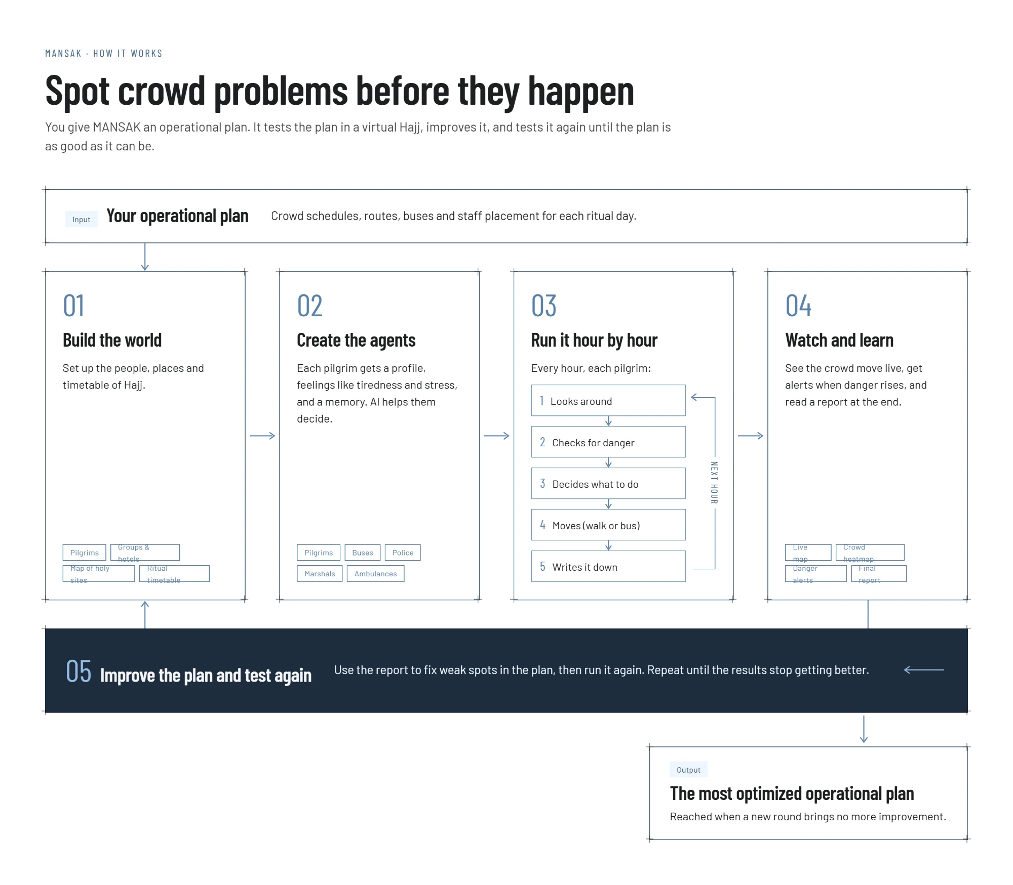
Figure 1. How MANSAK works: from the operational plan (input) to the most optimized operational plan (output).
Input — the operational plan. The plan describes the crowd schedules, routes, buses and staff placement for each ritual day. This is the plan that MANSAK tests and improves.

2.1 Step 1 — Build the world
MANSAK first builds a virtual version of Hajj from four parts:
- Pilgrims — a population with realistic age, nationality, language, health and mobility, including elderly pilgrims and pilgrims with chronic conditions.
- Groups and hotels — every pilgrim belongs to a Hajj group (Hamlah) of the same nationality, and each group has a hotel that acts as its base.
- Map of the holy sites — the arrival airport, Masjid al-Haram, Aziziyah, the Mina camps, Arafat, Muzdalifah, the Jamarat and the sacrifice area, placed on a real map. Each place has a capacity, so the system knows when it becomes overcrowded.
- Ritual timetable — the full Hajj sequence from Tawaf al-Qudoum to Tawaf al-Wadaa, each ritual with its own day and time window.

2.2 Step 2 — Create the agents
An agent is a virtual person or vehicle that makes its own choices. This approach, known as agent-based modelling, lets crowd behaviour emerge from many individual decisions instead of being scripted in advance [10], [11]. Research has shown that simple individual choices are enough to produce crowd-level effects, including crowd disasters [12]. MANSAK uses five types of agent (Table 1).
Table 1. The agents in MANSAK
Agent | Represents | How it behaves
Pilgrim | An individual pilgrim | Follows the ritual timetable with its group and reacts to crowding, heat, tiredness and danger.
Bus | Shared buses between the holy sites | Leaves only when enough riders have boarded, never exceeds its seats, and drives only along real roads on its own route.
Police | Security at checkpoints | Patrols its zone and switches to crowd-control mode when a hazard appears.
Marshal | Crowd guides | Patrols a zone and moves to the place where a hazard occurs.
Ambulance | Medical response | Goes to the pilgrim in the most danger, then returns to its base.

Each pilgrim is built in four layers:
- Profile — who the pilgrim is: age, nationality, language, health, mobility and group.
- Feelings — how the pilgrim is right now: stress, tiredness, hydration and panic, which change with heat, crowding and effort.
- Memory — what the pilgrim remembers: places visited, where its group is, and hazards it has seen.
- Decision-making — how the pilgrim chooses what to do next.
AI helps the pilgrims decide. At each decision, the pilgrim's situation is described in plain words to a large language model: where it is, how crowded each nearby place is, how far each destination is, any hazard, how it feels, and whether it is with its group. The AI chooses one action from a list of actions that are actually possible at that moment, and gives a one-sentence reason. This builds on recent research showing that AI-driven agents with memory can behave in believable, human-like ways [13].
Two safeguards keep this reliable. First, the AI can never choose an impossible action. Second, if the AI is unavailable or gives an unusable answer, a built-in safety rule makes the decision instead, so the simulation never stops. To stay fast and affordable, a pilgrim only asks the AI when something changes for it — a ritual window opens, a hazard appears, its danger level changes, or it loses its group.

2.3 Step 3 — Run it hour by hour
The virtual Hajj then moves forward in time. At every step, each pilgrim goes through the same five-part cycle:
- Looks around — sees its location, nearby crowds, the weather and any hazard.
- Checks for danger — calculates a danger score from 0 to 100 and names the reasons, such as an overcrowded place, severe dehydration, critical stress, exhaustion, separation from its group or a high-risk health profile.
- Decides what to do — continue to the next ritual, wait for the ritual window, rest, avoid the crowd, rejoin its group or, in real danger, leave for an emergency point.
- Moves — walks within an area, or queues for a bus to travel between areas.
- Writes it down — records what it saw, what it chose, why, and what happened next.
Then the next step begins. The length of a step can be adjusted: one-hour steps give fine detail on a busy day, while half-day steps rehearse the whole Hajj quickly. Planners can also test the plan under pressure by adding hazards — such as a blocked gate, dropped luggage, a crowd bottleneck or extreme heat — at any place and time.

2.4 Step 4 — Watch and learn
Planners watch the crowd move on a live map (Figure 2). Each pilgrim appears as an icon coloured by its status — stable, needs support, high risk or panicking — and a heatmap shows where pressure is building. A severity index sums up the condition of the whole crowd in one number from 0 to 100. A danger alert opens when a pilgrim enters a high-risk state and closes with a verdict: avoided, reduced, unchanged or worsened.
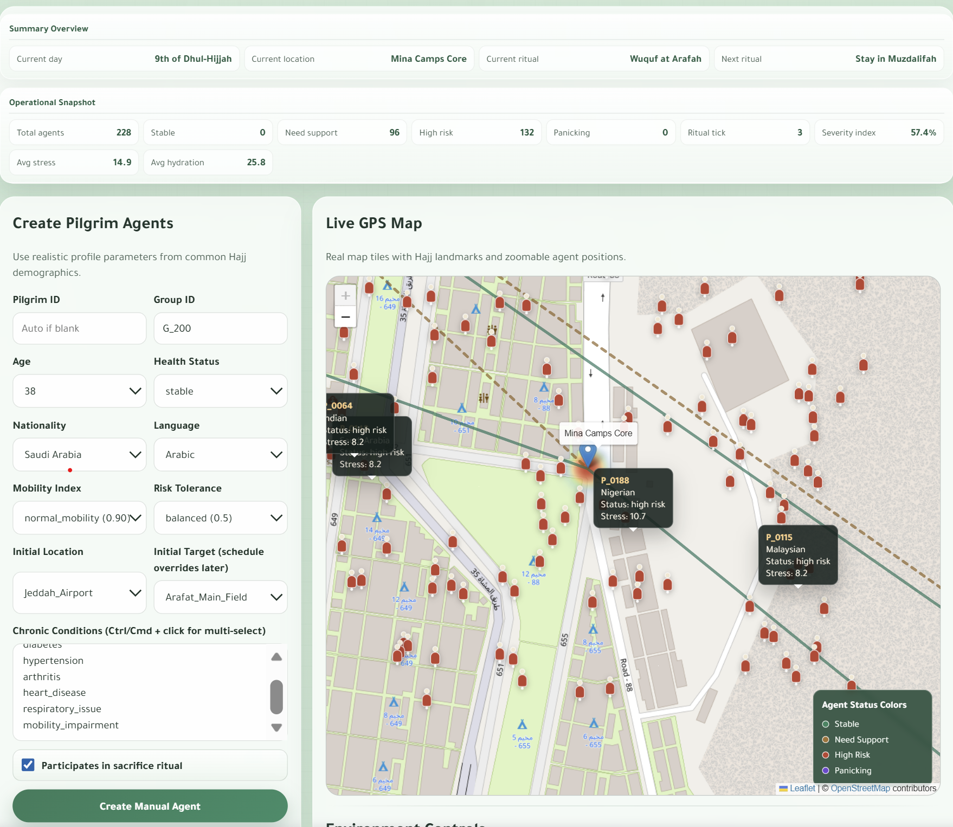
Figure 2. The MANSAK dashboard on the 9th of Dhul-Hijjah: crowd summary (top) and the live map of Mina with pilgrims coloured by status.
At the end of each run, MANSAK writes a final report in six parts: an overview, the decisions taken, every danger event (when, where, why and what happened next), how well the agents performed, suggested improvements with the evidence behind each one, and a final summary.

2.5 Step 5 — Improve the plan and test again
The report points to the weak spots in the plan — for example a route where pilgrims wait too long for buses, or a day when dehydration peaks. The planner changes the plan (adds buses, moves staff or changes when groups leave) and runs the virtual Hajj again with the same pilgrims, so that the two rounds can be compared fairly. This repeats until a new round brings no more improvement.
Output — the most optimized operational plan. The final plan is the one that performed best across all tested rounds, reached when a new round brings no further improvement.

3. Results
We tested the MANSAK prototype in four ways. All numbers in this section come from actual runs of the system.

3.1 A full Hajj rehearsal
Setup. 303 virtual pilgrims from ten nationalities, each in its Hajj group, lived through the full timetable from arrival to the Farewell Tawaf — 10.5 simulated days in 21 half-day steps — at 37 °C under the original plan.
- Danger builds in a predictable pattern (Figure 3). The severity index stayed at zero on arrival and on the 8th, rose to about 25 on the Day of Arafah as groups queued for buses from Mina, held at 40 through the night at Muzdalifah, and peaked at 69.4 on the 10th of Dhul-Hijjah — the day when stoning, sacrifice and Tawaf al-Ifadhah follow one another.
- The hidden danger was thirst and tiredness, not panic. Average hydration fell from 92 to 22 out of 100 by the 10th, while average stress stayed below 30 and no pilgrim panicked. At the peak, 297 of the 303 pilgrims (98%) were in the high-risk group — the kind of silent build-up that cameras cannot see.
- The first transport bottleneck appeared on the 9th, when 108 pilgrims were waiting at the same time for buses from Mina to Arafat.
- By the end of the run, 91.6% of all ritual steps had been completed.
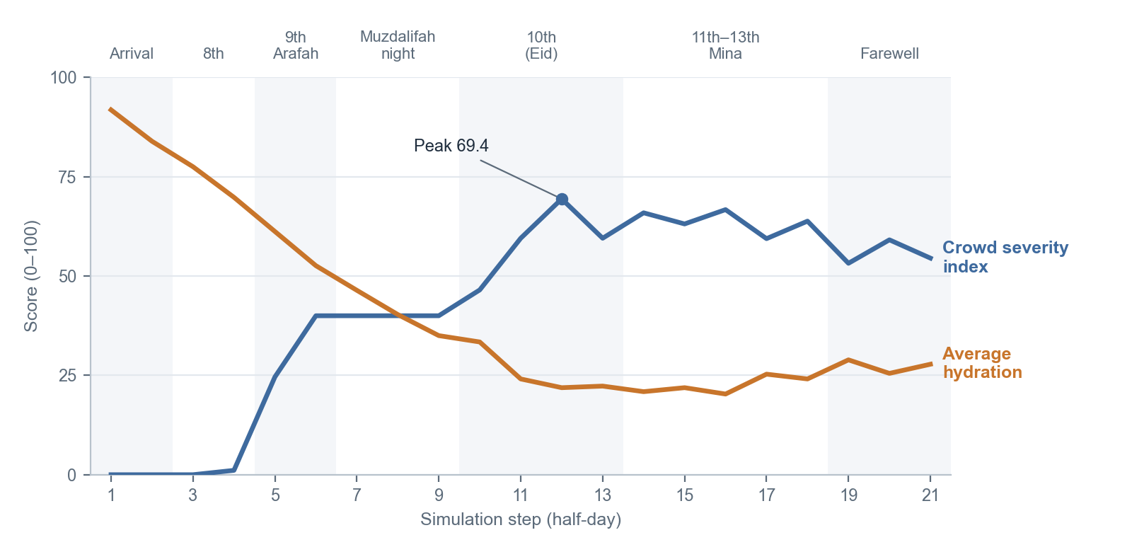
Figure 3. Crowd severity index and average pilgrim hydration across the full Hajj (303 pilgrims, original plan).

3.2 Improving the plan and testing again
Using the findings from the first run, we changed the plan and ran the same Hajj again with the same pilgrims. Table 2 compares five versions of the plan.
Table 2. Five versions of the operational plan tested on the same virtual Hajj
Plan | Buses | Longest bus queue (pilgrims) | Total bus waiting (pilgrim-steps) | Peak severity index | Ritual steps completed
A. Original plan (groups leave 90 minutes apart) | 9 | 108 | 294 | 69.4 | 91.6%
B. Extra buses on the two busiest routes | 13 | 113 | 179 | 69.5 | 91.5%
C. Double the buses on every route | 17 | 36 | 82 | 69.4 | 91.5%
D. All groups leave at the same time | 9 | 143 | 524 | 69.8 | 95.0%
E. Groups leave 3 hours apart | 9 | 103 | 188 | 66.5 | 89.4%

- Doubling the buses on every route (Plan C) cut total bus waiting by 72% and the longest queue by 67%.
- Adding buses only where the queues were longest (Plan B) cut total waiting by 39% but did not shorten the longest queue — the queue simply moved to another route. This shows why the whole plan must be tested together, not one part at a time.
- Group schedules involve trade-offs. Sending all groups at once (Plan D) let more pilgrims complete their rituals (95.0%) but nearly doubled bus waiting. Spacing groups three hours apart (Plan E) lowered the peak severity to 66.5 but reduced ritual completion to 89.4%. MANSAK makes these trade-offs visible before the season, so planners can choose on evidence.
- Buses alone did not lower the peak severity, because its main cause was dehydration on the 10th. The next round of improvement should therefore focus on water and rest points on that day rather than on more buses.

3.3 A larger crowd and the response to danger
In a longer run with 529 virtual pilgrims and one-hour steps (77 simulated hours and about 20,000 individual decisions), MANSAK:
- detected 365 danger events, all linked to dehydration in 37 °C heat; the most severe occurred where places were far above their capacity, such as the Masjid al-Haram perimeter and the Mina West Gate;
- saw the affected pilgrims take a protective action, usually resting, in the same hour the danger was detected;
- recorded that 97% of the danger events were reduced after the pilgrims acted; the remaining 3% were still open when the run ended.
During this run, the free allowance of the AI service ran out, so the built-in safety rules made the decisions. The simulation continued without interruption, confirming that MANSAK keeps working even when the AI is unavailable.

3.4 AI speed, cost and bus reliability
- With 12 pilgrims fully driven by a live AI model (Google Gemini), 100% of decisions came from the AI and each step took 1.86 seconds, because all pilgrims decide at the same time. Deciding one by one would have taken about 20 seconds per step.
- Asking the AI only when something changes cut the number of AI requests for a full Hajj by about a third — for example, from about 900 to about 610 requests for 43 pilgrims.
- Across a full run, no bus ever left its own route, and every bus that departed with fewer than five riders did so for one of two deliberate reasons: its riders had waited too long, or it was moving to where other pilgrims were waiting.

4. Innovation
MANSAK brings together several ideas that, to our knowledge, have not been combined for Hajj planning before. Table 3 compares it with the traditional approach.
Table 3. MANSAK compared with the traditional approach
 | Traditional approach | MANSAK
When problems are found | During the season, once they appear | Before the season, in a virtual rehearsal
What is tested | Separate parts, such as one gate or one road | The whole operational plan, across every ritual day
How people are modelled | Particles pushed by physical forces [14] | Individuals with a profile, feelings, memory, a group and a timetable
How decisions are made | Fixed rules | AI-assisted choices with a plain-language reason, with safety rules as backup
What planners receive | Counts and camera views | Danger alerts with causes, a full report and evidence-based suggestions
How the plan improves | Lessons learned after the season | A test–improve–retest loop until no further gain

- A plan-first digital twin. MANSAK tests the operational plan itself — schedules, routes, buses and staff — instead of only simulating crowd flow, and it closes the loop by improving and re-testing the plan.
- Thinking pilgrims instead of particles. Classic crowd models treat people as particles pushed by forces [14]. They are excellent for collisions but cannot feel tired, follow a five-day timetable or remember where their group is. MANSAK's pilgrims can.
- AI with guardrails. The AI can only choose actions that are physically possible, every choice comes with a reason in plain language, and safety rules take over whenever the AI fails. This makes the system explainable and trustworthy for decision-makers.
- Thinking only when needed. Pilgrims consult the AI only when their situation changes, and all pilgrims decide at the same time. This makes AI-driven crowds fast and affordable.
- Built for Hajj. The virtual world follows the real ritual timetable and time windows, links every pilgrim to a Hajj group and its hotel, and models the shared buses between the holy sites and the field staff.
- Early warning of silent danger. Danger is scored from named causes, so MANSAK can reveal slow build-ups such as dehydration long before they become visible — in line with research showing that the warning signs of crowd disasters can be detected in advance [3].
- Ready for national platforms. MANSAK is designed so that planning data of the kind already organised through Nusuk — groups, hotels and schedules — could feed it in the future, supporting the goals of the Pilgrim Experience Program [5], [8].

5. Conclusion
MANSAK turns Hajj planning from reacting to problems into preventing them. By letting AI-assisted virtual pilgrims live through the full Hajj under a proposed plan, it shows where and when crowding, long queues and silent dangers such as dehydration would appear, explains why, and helps planners fix the plan and test it again until it stops improving.
The prototype results show the value of this loop. MANSAK identified the transfer on the Day of Arafah and the 10th of Dhul-Hijjah as the most demanding points of the Hajj, cut bus waiting by 72% in a re-tested plan, revealed the trade-offs between group schedules and crowd pressure, and kept running even when the AI service was unavailable.
Limitations. MANSAK is still a prototype. It has been tested with hundreds of virtual pilgrims, not millions; its danger thresholds are based on published research and reasonable assumptions rather than live field measurements; and in the current version the planner applies the improvements between rounds.
Future work.
- Automatic plan search — let MANSAK propose and test plan changes by itself.
- Larger crowds — scale from hundreds to hundreds of thousands of virtual pilgrims.
- Group leaders and communication — pilgrims who guide their group and share warnings with each other.
- Real data — calibrate the model with official statistics and historical crowd counts, and connect it to planning data from national platforms.
With these steps, MANSAK can become a practical tool for making every Hajj season safer and smoother for the Guests of Al-Rahman.

6. References
[1] General Authority for Statistics (GASTAT). (2025, June 5). GASTAT: Total number of pilgrims performing Hajj 1446H (2025) reaches (1,673,230). https://www.stats.gov.sa/en/w/news/49
[2] General Authority for Statistics (GASTAT). (2025). Hajj statistics publication 2025. https://www.stats.gov.sa/documents/d/guest/hajj-statistics-publication-2025en-1-pdf
[3] Helbing, D., Johansson, A., & Al-Abideen, H. Z. (2007). Dynamics of crowd disasters: An empirical study. Physical Review E, 75(4), 046109. https://doi.org/10.1103/PhysRevE.75.046109
[4] Helbing, D., Farkas, I., & Vicsek, T. (2000). Simulating dynamical features of escape panic. Nature, 407(6803), 487–490. https://doi.org/10.1038/35035023
[5] Nusuk. (n.d.). Nusuk: The official platform supervised by the Ministry of Hajj and Umrah. Retrieved September 28, 2026, from https://www.nusuk.sa/
[6] Nusuk. (n.d.). Nusuk Hajj platform. Retrieved September 28, 2026, from https://hajj.nusuk.sa/
[7] Ministry of Hajj and Umrah, Kingdom of Saudi Arabia. (n.d.). Official portal of the Ministry of Hajj and Umrah. Retrieved September 28, 2026, from https://www.haj.gov.sa/
[8] Saudi Vision 2030. (n.d.). Pilgrim Experience Program. Retrieved September 28, 2026, from https://www.vision2030.gov.sa/en/explore/programs/pilgrim-experience-program
[9] Grieves, M., & Vickers, J. (2017). Digital twin: Mitigating unpredictable, undesirable emergent behavior in complex systems. In F.-J. Kahlen, S. Flumerfelt, & A. Alves (Eds.), Transdisciplinary perspectives on complex systems (pp. 85–113). Springer. https://doi.org/10.1007/978-3-319-38756-7_4
[10] Bonabeau, E. (2002). Agent-based modeling: Methods and techniques for simulating human systems. Proceedings of the National Academy of Sciences, 99(suppl. 3), 7280–7287. https://doi.org/10.1073/pnas.082080899
[11] Macal, C. M., & North, M. J. (2010). Tutorial on agent-based modelling and simulation. Journal of Simulation, 4(3), 151–162. https://doi.org/10.1057/jos.2010.3
[12] Moussaïd, M., Helbing, D., & Theraulaz, G. (2011). How simple rules determine pedestrian behavior and crowd disasters. Proceedings of the National Academy of Sciences, 108(17), 6884–6888. https://doi.org/10.1073/pnas.1016507108
[13] Park, J. S., O'Brien, J. C., Cai, C. J., Morris, M. R., Liang, P., & Bernstein, M. S. (2023). Generative agents: Interactive simulacra of human behavior. In Proceedings of the 36th Annual ACM Symposium on User Interface Software and Technology (UIST '23) (pp. 1–22). ACM. https://doi.org/10.1145/3586183.3606763
[14] Helbing, D., & Molnár, P. (1995). Social force model for pedestrian dynamics. Physical Review E, 51(5), 4282–4286. https://doi.org/10.1103/PhysRevE.51.4282

