 | Al Maaref University  Faculty of Sciences  Department of Computer Science  Fall 2025 - 2026

Practical Training (CSC 497) Report

Student ID : 101220726
Student Name : Zainab Ossayli

Speech Retrieval Project
Ektidar Program
Beirut, kafaa’t
Company Coordinator : Dr. Ali Jaber
University Advisor : Dr. Abdallah Abbas

Table of Contents

Company Information 3
Company Products and Services 3
Internship Information 4
Internship Abstract 4
Internship Plan and Responsibilities 4
Achievement Details 5
Achieved Development Areas 5
Hardware Environment 5
Software Platform 5
Learned Technologies 5
Used Tools 5
Product Benefits 5
Product Repository Link 6
Product Images Overview 6
Critical Analysis 9
Challenges Faced 9
Compatibility of University Courses 9
Personal Benefits 9
Professional Benefits 9
Comments on the Company 9
Work Opportunity 10
Personal Diary 11

Company Information
Company Name : Iktidar Program
Company Domain : N/A
Company Size : N/A
Company Sales Size (if available) : N/A
Company Website : N/A

Company Products and Services

Internship Information

Training Title : Speech Retrieval Project
Company Department : Computer
Internship Duration (hours) : 180 hours
Company Coordinator : DR. Ali Jaber
Company Coordinator (email) : ali.jaber@ul.edu.lb
University Advisor : DR. Abdullah Abbas
University Advisor (email) : [Email]@mu.edu.lb

Internship Abstract
This training focuses on building the database layer of the Speech Retrieval Project. The work includes designing the data structure and implementing the essential operations required to store, organize, and manage video-related information. The overall purpose of the project is to develop a system capable of supporting future speech processing and retrieval tasks by ensuring that all data is efficiently prepared and accessible.

Internship Plan and Responsibilities
- Planning the database structure
- Creating the database and tables
- Implementing core CRUD operations
- Modifying table schemas
- Creating project-specific tables (Videos, OverlapChunks, EmbedChunks)
- Populating tables from the dataset
- Implementing data retrieval functions

Achievement Details

Achieved Development Areas
- Database Development
- Backend Programming
- Data Processing & Retrieval
- System Architecture Design

Hardware Environment
- Local Development Environment: Python runtime on Windows OS
- Server/Database Environment: Local PostgreSQL/SQLite setup for testing and development

Software Platform
Windows Operating System

Learned Technologies
- Python: Used to implement all database functions and retrieval operations.
- SQL / SQLite / PostgreSQL: Learned how to create tables, manage data, and perform queries.
- Python Database Libraries (sqlite3 / psycopg2): Used to connect, execute commands, and interact with the database programmatically.
- Data Processing Techniques: Handling datasets, extracting information, and preparing structured data for storage.

Used Tools
- Visual Studio Code: Main code editor used to write, test, and organize Python files.
- Python Interpreter: Executed all backend scripts and database functions.
- SQLite / PostgreSQL: Tools used to create, store, and manage the project’s database.
- Git & GitHub: Version control tools for managing and backing up the project code.
- Command Line / Terminal: Used to run scripts, manage environments, and execute database commands.

Product Benefits
The resulting product of this training is a structured and functional database layer designed for the Speech Retrieval Project. It provides an organized way to store videos, original chunks, and embedded chunks, making future processing and retrieval fast and efficient. This database benefits the development team working on speech analysis, AI models, and information retrieval systems. It will be used as the core data foundation for the upcoming stages of the project and is not yet in public use, but it serves as an essential internal component for continued development.

Product Repository Link
The resulting product is not published online and is not hosted on any public repository. It is currently stored locally and used internally for the development of the Speech Retrieval Project.

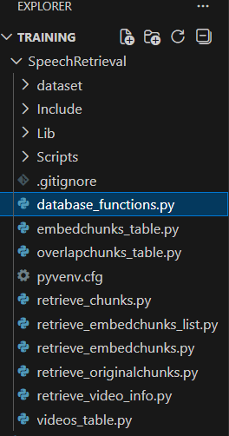
Product Images Overview

Project directory structure showing the main Python files used for database creation, table management, and data retrieval functions in the Speech Retrieval system.

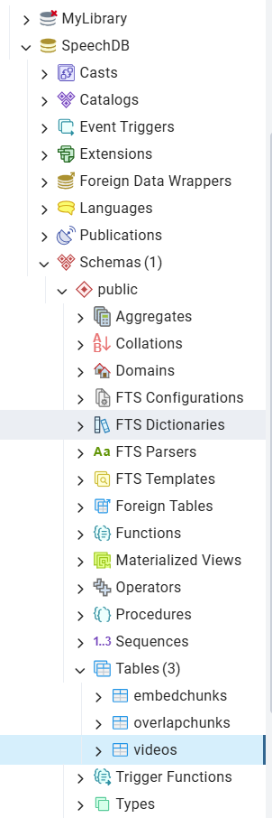

PostgreSQL database schema showing the main tables used in the Speech Retrieval project, including videos, overlapchunks, and embedchunks.

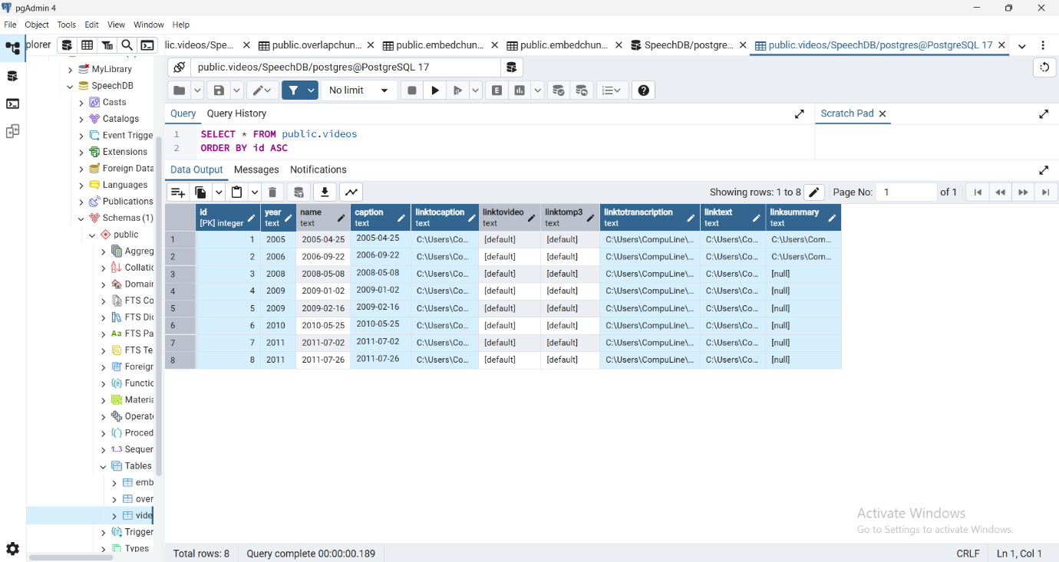
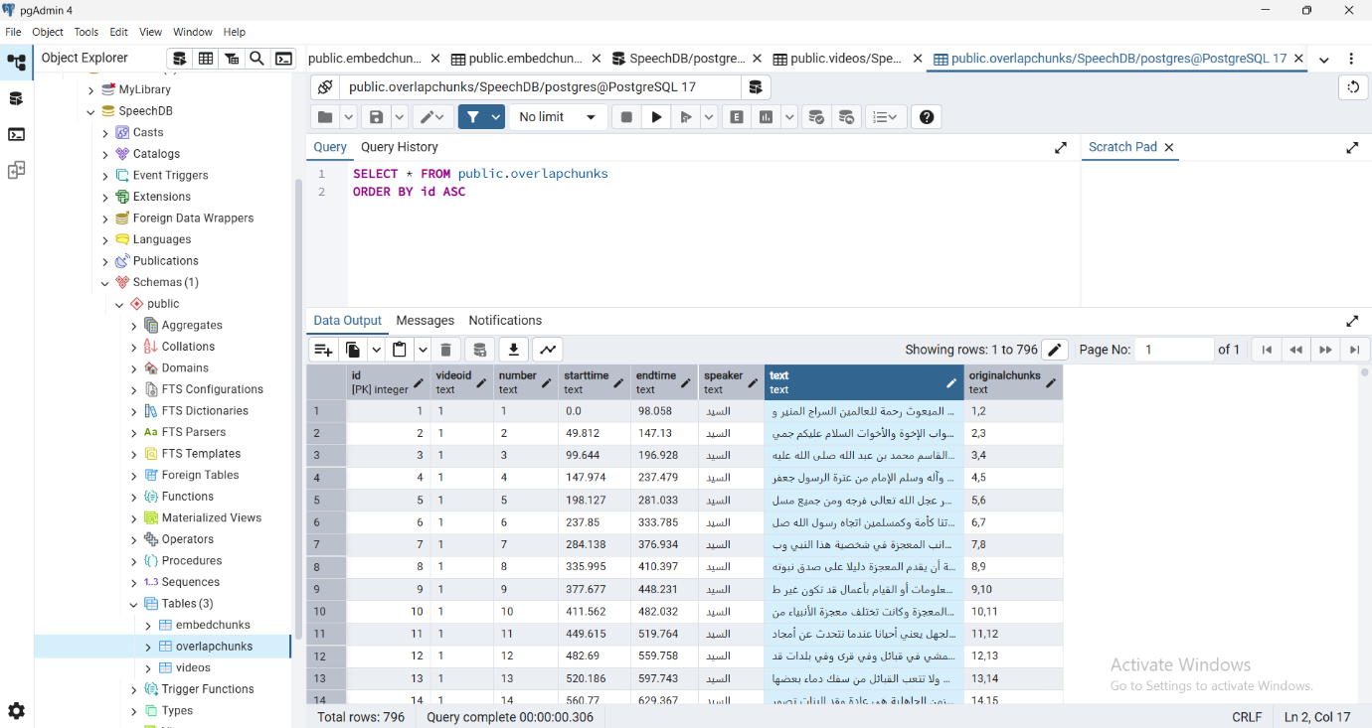
View of the videos table in PostgreSQL containing video metadata used for retrieval and processing.

Overlap chunks table displaying segmented speech text with timing and chunk mapping.

Embed chunks table displaying embedding vectors linked to overlap chunks for semantic retrieval.
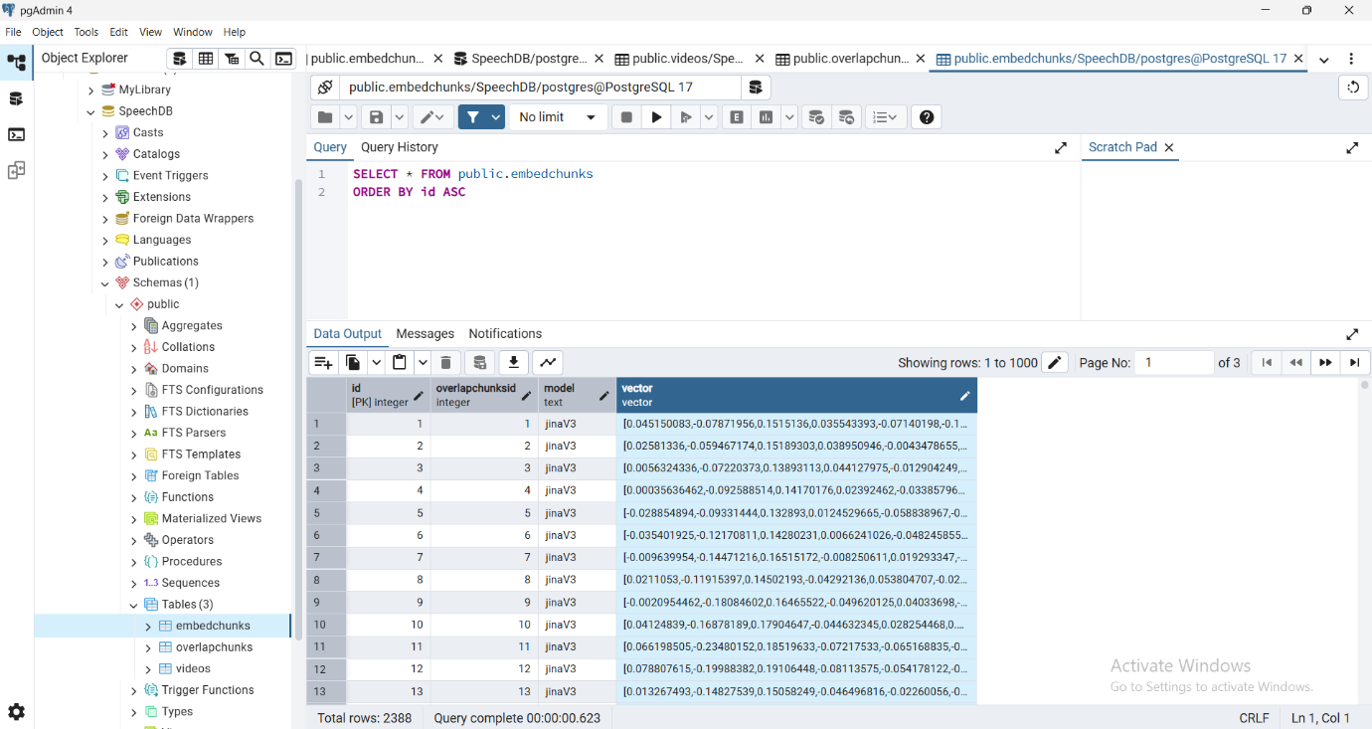

Critical Analysis

Challenges Faced
Some initial challenges were faced, mainly in understanding the database structure and writing correct SQL queries. Minor difficulties also appeared when integrating Python with PostgreSQL and debugging data retrieval. These challenges were gradually resolved with practice and did not significantly affect the training progress.

Compatibility of University Courses
The internship strongly reflected what was learned in the Artificial Intelligence course, especially in topics related to embeddings, data representation, and retrieval. In addition, database concepts studied in class were applied in practice through database design, data storage, and data retrieval using Python and PostgreSQL. This integration helped connect theoretical AI concepts with real backend implementation.

Personal Benefits
The internship helped improve my confidence in applying theoretical knowledge to real projects. It strengthened my problem-solving mindset, increased my independence in learning new concepts, and improved my ability to analyze and debug issues. Additionally, it enhanced my sense of responsibility and professional work habits.

Professional Benefits
The internship enhanced my technical skills in artificial intelligence concepts such as embeddings and data retrieval, as well as database management using Python and PostgreSQL. It also improved my ability to work on real-world backend tasks, understand project workflows, and follow structured development practices, which positively contributed to my professional growth.

Comments on the Company
The company provided a supportive and professional training environment with clear guidance and practical tasks related to artificial intelligence and database systems. The training content was relevant and allowed for hands-on experience, which helped enhance technical skills.
On the other hand, some tasks required a high level of self-learning, which could be challenging at times. However, this also contributed to improving independence and problem-solving skills.
Overall, the training was valuable and worth the time and effort, as it offered practical experience aligned with academic learning and real-world applications.

Work Opportunity
At the moment, there are no confirmed plans to continue working with the company after the internship. However, the experience was valuable and contributed positively to my academic and professional development.

Personal Diary
Week 1
Day 1 | Introduction to the Speech Retrieval Project and understanding the project objectives and overall workflow.
Day 2 | Studying the database description and architecture, including tables such as Videos, Chunks, OverlapChunks, and EmbedChunks.
Day 3 | Learning how to create a database and tables using PostgreSQL and understanding column types and relationships.
Day 4 | Implementing Python functions to create databases and tables dynamically.
Day 5 | Testing database creation and table structure and fixing initial schema issues.

Week 2
Day 1 | Implementing functions to insert rows into database tables using Python.
Day 2 | Working on functions to delete rows based on conditions and specific column values.
Day 3 | Implementing update functions to modify column values using row ID or name.
Day 4 | Adding and deleting columns dynamically in existing tables.
Day 5 | Testing all CRUD operations and validating data integrity.

Week 3
Day 1 | Understanding video data structure and how videos are linked to chunks.
Day 2 | Implementing functions to retrieve video information based on video name.
Day 3 | Implementing functions to retrieve all chunks related to a given video.
Day 4 | Testing retrieval functions and debugging SQL join issues.
Day 5 | Optimizing queries and improving data retrieval performance.

Week 4
Day 1 | Studying chunking concepts and the difference between chunks and overlap chunks.
Day 2 | Implementing functions to retrieve OriginalChunks of selected overlap chunks.
Day 3 | Handling lists of chunk numbers as input and processing them in SQL queries.
Day 4 | Debugging issues related to incorrect joins and empty query results.
Day 5 | Validating chunk retrieval accuracy.

Week 5
Day 1 | Introduction to embeddings and their role in information retrieval.
Day 2 | Storing embedding vectors in the EmbedChunks table.
Day 3 | Implementing functions to retrieve all embedded chunks of a video using a specific model.
Day 4 | Implementing functions to retrieve embeddings for a selected list of chunks.
Day 5 | Testing embedding retrieval and verifying vector correctness.

Week 6
Day 1 | Integrating database retrieval functions with embedding-based workflows.
Day 2 | Handling model selection and filtering embeddings by model name.
Day 3 | Improving query structure for embedding retrieval.
Day 4 | Testing full retrieval pipeline from video to embeddings.
Day 5 | Debugging data type and indexing issues.

Week 7
Day 1 | Reviewing the entire database architecture and retrieval logic.
Day 2 | Refactoring Python functions for reusability and clarity.
Day 3 | Running multiple test cases on different videos and chunk selections.
Day 4 | Fixing edge cases and improving error handling.
Day 5 | Documenting database functions and workflows.

Week 8
Day 1 | Final testing of all database and retrieval functions.
Day 2 | Validating consistency between videos, chunks, and embeddings.
Day 3 | Reviewing project milestones and completed tasks.
Day 4 | Preparing final documentation and summaries.
Day 5 | Final evaluation of the internship work and overall learning outcomes.

