**Serial GC**

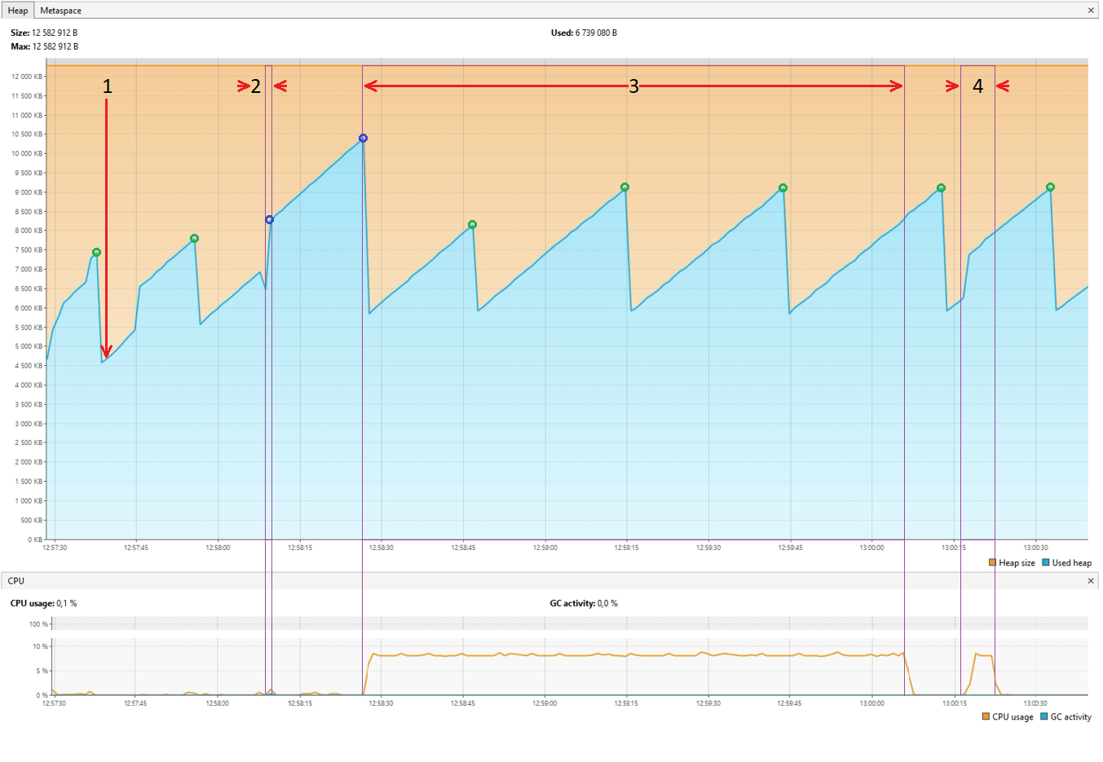

|  |  |
| --- | --- |
| 1 — вставка 250000 элементов массива  2 — сортировка слиянием  3 — сортировка пузырьком  4 — сортировка вставкой | Pause Young  Pause Full |

До момента 2 происходят малые сборки мусора, т.к. Old Generation еще не успел заполниться.

Сортировка слиянием заняла 1 миллисекунду, при этом за время работы произошло несколько малых и больших сборок мусора. Большая скорость обеспечивается за счет отсутствия множества перестановок элементов, но в процессе работы образуется много мусора - вспомогательных массивов. Учитывая только логику работы сортировки количество этих массивов должно быть равно

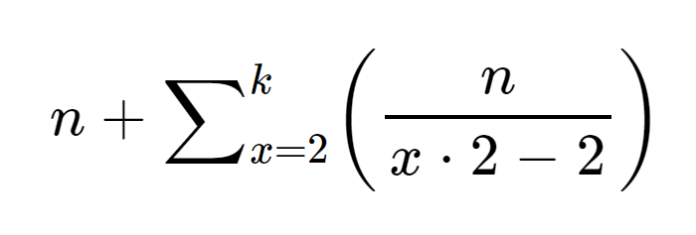

где *n* - количество элементов в массиве;

*k* - количество делений n пополам больших или равных 1 (с округлением *n* вверх);

Для нашего массива в 250000 элементов количество мусорных массивов должно составить 679949 плюс результирующий отсортированный массив на 250000 элементов, но в логике работы программы создается много больше дополнительных массивов, что видно по заполненности памяти элементами int[], которые не успели удалиться из нее после сортировки.

|  |  |
| --- | --- |
| До сортировки |  |
| После сортировки |  |

После завершения сортировки слиянием остался сильно заполненный Old Generation, что привело к Pause Full и major сборке мусора.

Сортировка пузырьком заняла 1 минуту 40 секунд, при этом происходили только малые сборки (3 раза), новых объектов создавалось очень мало, происходило много перестановок в одном массиве без сдвигов. В итоге мусор не создается, но скорость выполнения сортировки очень низкая.

|  |  |
| --- | --- |
| До сортировки |  |
| После сортировки |  |

Сортировка вставкой заняла 5 с половиной секунд, при этом во время работы сборок мусора не происходило, т.к. по логике работы программы мусора должно оставаться не много - в работе происходит перезапись двух переменных и не создается вспомогательных массивов.

|  |  |
| --- | --- |
| До сортировки |  |
| После сортировки |  |

|  |  |
| --- | --- |
| **1**  **2**  **2**  **2**  **2**  **2**  **2**  **2**  **2**  **2**  **2**  **2**  **2**  **2**  **3**  **3**  **3**  **3**  **3**  **3** | **[2024-03-01T12:57:23.101+0300][info][gc] Using Serial**  **[2024-03-01T12:57:24.168+0300][info][gc] GC(0) Pause Young (Allocation Failure) 3M->1M(11M) 3.482ms**  **[2024-03-01T12:57:28.209+0300][info][gc] GC(1) Pause Young (Allocation Failure) 5M->2M(11M) 3.072ms**  **[2024-03-01T12:57:28.281+0300][info][gc] GC(2) Pause Young (Allocation Failure) 5M->3M(11M) 2.526ms**  **[2024-03-01T12:57:28.323+0300][info][gc] GC(3) Pause Young (Allocation Failure) 6M->3M(11M) 1.291ms**  **[2024-03-01T12:57:28.437+0300][info][gc] GC(4) Pause Young (Allocation Failure) 6M->3M(11M) 1.149ms**  **[2024-03-01T12:57:28.617+0300][info][gc] GC(5) Pause Young (Allocation Failure) 6M->4M(11M) 3.581ms**  **[2024-03-01T12:57:37.667+0300][info][gc] GC(6) Pause Young (Allocation Failure) 7M->4M(11M) 2.153ms**  **[2024-03-01T12:57:55.675+0300][info][gc] GC(7) Pause Young (Allocation Failure) 7M->5M(11M) 1.377ms**  **[2024-03-01T12:58:08.667+0300][info][gc] GC(8) Pause Young (Allocation Failure) 8M->6M(11M) 1.042ms**  **[2024-03-01T12:58:08.679+0300][info][gc] GC(9) Pause Young (Allocation Failure) 9M->6M(11M) 0.443ms**  **[2024-03-01T12:58:08.702+0300][info][gc] GC(10) Pause Young (Allocation Failure) 9M->6M(11M) 0.574ms**  **[2024-03-01T12:58:08.707+0300][info][gc] GC(11) Pause Young (Allocation Failure) 9M->6M(11M) 0.480ms**  **[2024-03-01T12:58:08.711+0300][info][gc] GC(12) Pause Young (Allocation Failure) 9M->9M(11M) 0.031ms**  **[2024-03-01T12:58:08.726+0300][info][gc] GC(13) Pause Full (Allocation Failure) 9M->6M(11M) 15.045ms**  **[2024-03-01T12:58:08.730+0300][info][gc] GC(14) Pause Young (Allocation Failure) 9M->9M(11M) 0.031ms**  **[2024-03-01T12:58:08.742+0300][info][gc] GC(15) Pause Full (Allocation Failure) 9M->6M(11M) 11.953ms**  **[2024-03-01T12:58:08.746+0300][info][gc] GC(16) Pause Young (Allocation Failure) 9M->9M(11M) 0.029ms**  **[2024-03-01T12:58:08.757+0300][info][gc] GC(17) Pause Full (Allocation Failure) 9M->6M(11M) 10.955ms**  **[2024-03-01T12:58:08.761+0300][info][gc] GC(18) Pause Young (Allocation Failure) 10M->10M(11M) 0.028ms**  **[2024-03-01T12:58:08.773+0300][info][gc] GC(19) Pause Full (Allocation Failure) 10M->6M(11M) 12.667ms**  **[2024-03-01T12:58:08.777+0300][info][gc] GC(20) Pause Young (Allocation Failure) 9M->7M(11M) 0.349ms**  **[2024-03-01T12:58:26.898+0300][info][gc] GC(21) Pause Young (Allocation Failure) 10M->10M(11M) 0.069ms**  **[2024-03-01T12:58:26.909+0300][info][gc] GC(22) Pause Full (Allocation Failure) 10M->4M(11M) 11.798ms**  **[2024-03-01T12:58:46.715+0300][info][gc] GC(23) Pause Young (Allocation Failure) 8M->5M(11M) 0.393ms**  **[2024-03-01T12:59:14.740+0300][info][gc] GC(24) Pause Young (Allocation Failure) 8M->5M(11M) 0.463ms**  **[2024-03-01T12:59:44.710+0300][info][gc] GC(25) Pause Young (Allocation Failure) 9M->5M(11M) 0.360ms**  **[2024-03-01T13:00:12.783+0300][info][gc] GC(26) Pause Young (Allocation Failure) 8M->5M(11M) 0.410ms**  **[2024-03-01T13:00:32.798+0300][info][gc] GC(27) Pause Young (Allocation Failure) 8M->5M(11M) 0.458ms** |

**Parallel GC**

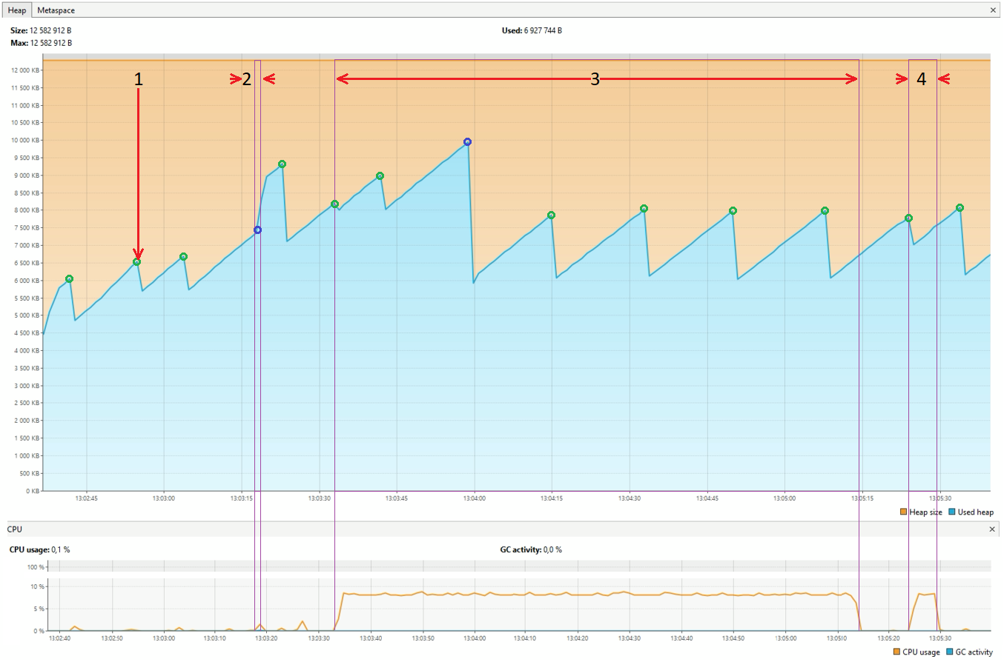

|  |  |
| --- | --- |
| 1 — вставка 250000 элементов массива  2 — сортировка слиянием  3 — сортировка пузырьком  4 — сортировка вставкой | Pause Young  Pause Full |

До момента 2 происходят малые сборки мусора, т.к. Old Generation еще не успел заполниться.

Сортировка слиянием заняла 2 миллисекунды, при этом за время работы произошло несколько малых и больших сборок мусора, что видно в логе.

|  |  |
| --- | --- |
| До сортировки |  |
| После сортировки |  |

После завершения сортировки слиянием произошло две малых сборки мусора.

Сортировка пузырьком заняла 1 минуту 40 секунд, при этом произошла одна большая и 5 малых сборок, что больше, чем при использовании Serial GC. Сборки происходят чаще, т.к. Parallel GC использует несколько потоков для сбора мусора.

|  |  |
| --- | --- |
| До сортировки |  |
| После сортировки |  |

Сортировка вставкой заняла 4 с половиной секунды, при этом при старте сортировки заканчивалась малая сборка, но в процессе самой работы сборок не происходило.

|  |  |
| --- | --- |
| До сортировки |  |
| После сортировки |  |

|  |  |
| --- | --- |
| **1**  **2**  **2**  **2**  **2**  **2**  **2**  **2**  **2**  **2**  **2**  **2**  **2**  **2**  **2**  **2**  **2**  **2**  **3**  **3**  **3**  **3**  **3**  **4** | **[2024-03-01T13:02:30.932+0300][info][gc] Using Parallel**  **[2024-03-01T13:02:31.978+0300][info][gc] GC(0) Pause Young (Allocation Failure) 3M->1M(11M) 2.356ms**  **[2024-03-01T13:02:33.609+0300][info][gc] GC(1) Pause Young (Allocation Failure) 4M->2M(11M) 2.670ms**  **[2024-03-01T13:02:33.661+0300][info][gc] GC(2) Pause Young (Allocation Failure) 5M->3M(11M) 1.487ms**  **[2024-03-01T13:02:33.705+0300][info][gc] GC(3) Pause Young (Allocation Failure) 6M->4M(11M) 2.616ms**  **[2024-03-01T13:02:33.728+0300][info][gc] GC(4) Pause Young (Allocation Failure) 7M->5M(11M) 2.614ms**  **[2024-03-01T13:02:36.599+0300][info][gc] GC(5) Pause Young (Allocation Failure) 8M->6M(10M) 2.824ms**  **[2024-03-01T13:02:36.736+0300][info][gc] GC(6) Pause Young (Allocation Failure) 8M->6M(11M) 2.606ms**  **[2024-03-01T13:02:36.748+0300][info][gc] GC(7) Pause Full (Ergonomics) 6M->4M(11M) 11.862ms**  **[2024-03-01T13:02:42.213+0300][info][gc] GC(8) Pause Young (Allocation Failure) 6M->4M(11M) 0.556ms**  **[2024-03-01T13:02:54.803+0300][info][gc] GC(9) Pause Young (Allocation Failure) 6M->4M(11M) 0.514ms**  **[2024-03-01T13:03:03.793+0300][info][gc] GC(10) Pause Young (Allocation Failure) 6M->5M(11M) 0.713ms**  **[2024-03-01T13:03:18.370+0300][info][gc] GC(11) Pause Young (Allocation Failure) 7M->5M(11M) 0.399ms**  **[2024-03-01T13:03:18.373+0300][info][gc] GC(12) Pause Young (Allocation Failure) 7M->6M(11M) 0.359ms**  **[2024-03-01T13:03:18.377+0300][info][gc] GC(13) Pause Young (Allocation Failure) 8M->6M(11M) 0.327ms**  **[2024-03-01T13:03:18.396+0300][info][gc] GC(14) Pause Full (Ergonomics) 6M->5M(11M) 19.037ms**  **[2024-03-01T13:03:18.415+0300][info][gc] GC(15) Pause Young (Allocation Failure) 7M->6M(11M) 0.335ms**  **[2024-03-01T13:03:18.424+0300][info][gc] GC(16) Pause Young (Allocation Failure) 8M->6M(11M) 0.253ms**  **[2024-03-01T13:03:18.426+0300][info][gc] GC(17) Pause Young (Allocation Failure) 8M->6M(11M) 0.183ms**  **[2024-03-01T13:03:18.429+0300][info][gc] GC(18) Pause Young (Allocation Failure) 8M->6M(11M) 0.135ms**  **[2024-03-01T13:03:18.431+0300][info][gc] GC(19) Pause Young (Allocation Failure) 7M->6M(11M) 0.170ms**  **[2024-03-01T13:03:18.434+0300][info][gc] GC(20) Pause Young (Allocation Failure) 8M->6M(11M) 0.168ms**  **[2024-03-01T13:03:18.437+0300][info][gc] GC(21) Pause Young (Allocation Failure) 8M->6M(11M) 0.202ms**  **[2024-03-01T13:03:18.446+0300][info][gc] GC(22) Pause Full (Ergonomics) 6M->6M(11M) 9.331ms**  **[2024-03-01T13:03:18.449+0300][info][gc] GC(23) Pause Young (Allocation Failure) 8M->6M(11M) 0.198ms**  **[2024-03-01T13:03:18.452+0300][info][gc] GC(24) Pause Young (Allocation Failure) 8M->6M(11M) 0.207ms**  **[2024-03-01T13:03:18.455+0300][info][gc] GC(25) Pause Young (Allocation Failure) 8M->6M(11M) 0.192ms**  **[2024-03-01T13:03:18.457+0300][info][gc] GC(26) Pause Young (Allocation Failure) 8M->6M(11M) 0.180ms**  **[2024-03-01T13:03:18.460+0300][info][gc] GC(27) Pause Young (Allocation Failure) 8M->7M(11M) 0.160ms**  **[2024-03-01T13:03:22.801+0300][info][gc] GC(28) Pause Young (Allocation Failure) 9M->6M(11M) 0.382ms**  **[2024-03-01T13:03:33.513+0300][info][gc] GC(29) Pause Young (Allocation Failure) 8M->6M(11M) 0.465ms**  **[2024-03-01T13:03:41.818+0300][info][gc] GC(30) Pause Young (Allocation Failure) 8M->7M(11M) 0.321ms**  **[2024-03-01T13:03:58.838+0300][info][gc] GC(31) Pause Young (Allocation Failure) 9M->7M(11M) 0.429ms**  **[2024-03-01T13:03:58.849+0300][info][gc] GC(32) Pause Full (Ergonomics) 7M->5M(11M) 10.756ms**  **[2024-03-01T13:04:14.848+0300][info][gc] GC(33) Pause Young (Allocation Failure) 7M->5M(11M) 0.337ms**  **[2024-03-01T13:04:32.855+0300][info][gc] GC(34) Pause Young (Allocation Failure) 7M->5M(11M) 0.313ms**  **[2024-03-01T13:04:50.841+0300][info][gc] GC(35) Pause Young (Allocation Failure) 7M->5M(11M) 0.247ms**  **[2024-03-01T13:05:07.880+0300][info][gc] GC(36) Pause Young (Allocation Failure) 7M->5M(11M) 0.193ms**  **[2024-03-01T13:05:24.300+0300][info][gc] GC(37) Pause Young (Allocation Failure) 7M->5M(11M) 0.295ms**  **[2024-03-01T13:05:33.906+0300][info][gc] GC(38) Pause Young (Allocation Failure) 7M->5M(11M) 0.224ms** |

**G1 GC**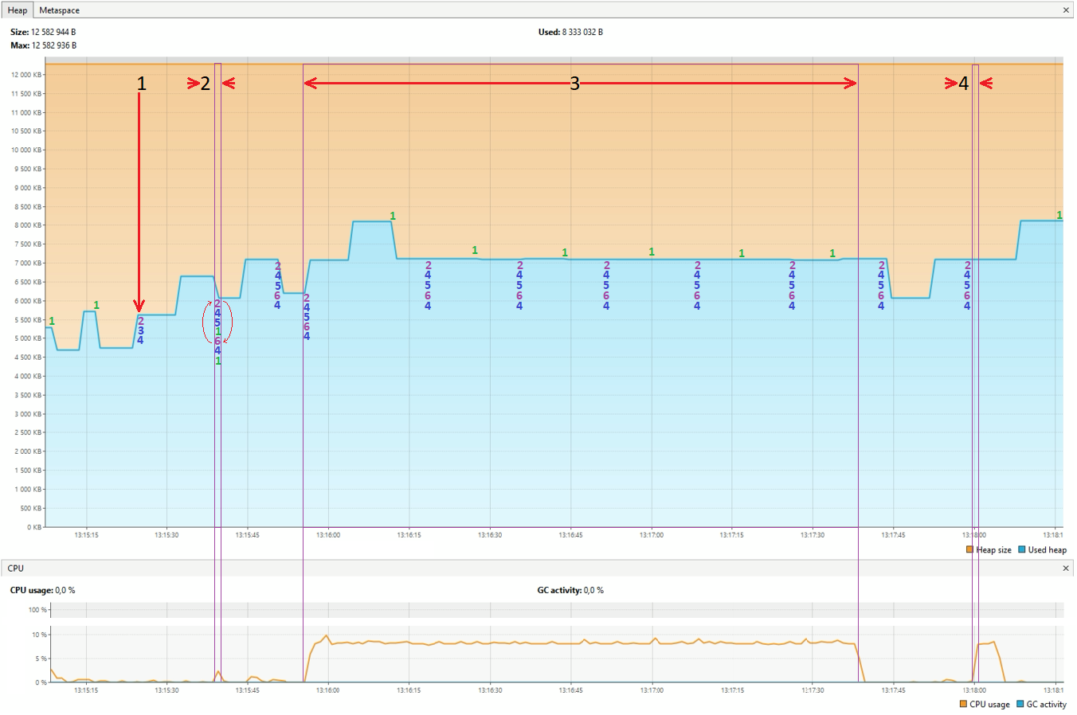

|  |  |  |
| --- | --- | --- |
| 1 — вставка 250000 элементов массива  2 — сортировка слиянием  3 — сортировка пузырьком  4 — сортировка вставкой | | **1** Pause Young(Normal)  **2** Pause Young(Concurrent Start)  **3** Concurrent Undo Cycle  **4** Concurrent Mark Cycle  **5** Pause Remark  **6** Pause Cleanup |
| Рисунок 1 | В G1 цикл сортировки (рис. 1) может работать в двух режимах - если при обращении к Old Generation он будет заполнен на определённый рассчитанный процент, то происходит большая сборка мусора с использованием всех шагов очистки, но если при обращении он заполнен меньше, то произойдет пропуск части цикла (синяя стрелка). | |

До момента 2 произошло несколько малых сборок мусора и один ускоренный цикл сборки G1.

Сортировка слиянием заняла полторы миллисекунды, при этом за время работы произошло несколько больших циклов сборки мусора и несколько малых сборок.

|  |  |
| --- | --- |
| До сортировки |  |
| После сортировки |  |

После завершения сортировки слиянием произошел большой цикл сборки мусора.

Сортировка пузырьком заняла 1 минуту 43 секунды, при этом сборки Young и Old Generation происходили поочередно (всего по 6 раз). Если сравнить график с Parallel GC, то можно заметить, что G1 GC старается поддерживать заполненность памяти на одном уровне, причем уровни дискретны, что скажется на более стабильной работе программы, но количество сборок было больше, чем у Parallel GC.

|  |  |
| --- | --- |
| До сортировки |  |
| После сортировки |  |

Сортировка вставкой заняла 4 с половиной секунды, при этом за время работы произошел один полный цикл сборки мусора.

|  |  |
| --- | --- |
| До сортировки |  |
| После сортировки |  |

|  |  |
| --- | --- |
| **1**  **1**  **1**  **1**  **2**  **2**  **2**  **2**  **2**  **2**  **2**  **2**  **2**  **2**  **2**  **2**  **2**  **2**  **2**  **2**  **2**  **2**  **2**  **2**  **2**  **2**  **2**  **2**  **2**  **2**  **2**  **2**  **2**  **2**  **2**  **2**  **2**  **2**  **2**  **2**  **2**  **2**  **2**  **2**  **2**  **2**  **2**  **2**  **2**  **2**  **2**  **2**  **2**  **2**  **2**  **2**  **2**  **2**  **2**  **2**  **2**  **2**  **2**  **2**  **2**  **3**  **3**  **3**  **3**  **3**  **3**  **3**  **3**  **3**  **3**  **3**  **3**  **3**  **3**  **3**  **3**  **3**  **3**  **3**  **3**  **3**  **3**  **3**  **3**  **3**  **3**  **3**  **3**  **3**  **3**  **3**  **3**  **3**  **3**  **3**  **3**  **3**  **3**  **3**  **3**  **3**  **3**  **4**  **4**  **4**  **4**  **4**  **4** | **[2024-03-01T13:15:03.506+0300][info][gc] Using G1**  **[2024-03-01T13:15:06.946+0300][info][gc] GC(0) Pause Young (Normal) (G1 Evacuation Pause) 4M->2M(12M) 2.871ms**  **[2024-03-01T13:15:06.986+0300][info][gc] GC(1) Pause Young (Normal) (G1 Evacuation Pause) 3M->2M(12M) 2.223ms**  **[2024-03-01T13:15:07.008+0300][info][gc] GC(2) Pause Young (Normal) (G1 Evacuation Pause) 3M->2M(12M) 1.103ms**  **[2024-03-01T13:15:07.051+0300][info][gc] GC(3) Pause Young (Normal) (G1 Evacuation Pause) 4M->3M(12M) 1.450ms**  **[2024-03-01T13:15:07.104+0300][info][gc] GC(4) Pause Young (Normal) (G1 Evacuation Pause) 5M->3M(12M) 1.592ms**  **[2024-03-01T13:15:07.145+0300][info][gc] GC(5) Pause Young (Normal) (G1 Evacuation Pause) 6M->3M(12M) 1.454ms**  **[2024-03-01T13:15:07.250+0300][info][gc] GC(6) Pause Young (Normal) (G1 Evacuation Pause) 6M->3M(12M) 1.383ms**  **[2024-03-01T13:15:07.478+0300][info][gc] GC(7) Pause Young (Normal) (G1 Evacuation Pause) 6M->4M(12M) 3.303ms**  **[2024-03-01T13:15:08.571+0300][info][gc] GC(8) Pause Young (Normal) (G1 Evacuation Pause) 6M->4M(12M) 3.013ms**  **[2024-03-01T13:15:16.642+0300][info][gc] GC(9) Pause Young (Normal) (G1 Evacuation Pause) 6M->4M(12M) 1.271ms**  **[2024-03-01T13:15:24.296+0300][info][gc] GC(10) Pause Young (Concurrent Start) (G1 Humongous Allocation) 5M->4M(12M) 1.168ms**  **[2024-03-01T13:15:24.296+0300][info][gc] GC(11) Concurrent Undo Cycle**  **[2024-03-01T13:15:24.296+0300][info][gc] GC(11) Concurrent Undo Cycle 0.151ms**  **[2024-03-01T13:15:39.471+0300][info][gc] GC(12) Pause Young (Concurrent Start) (G1 Humongous Allocation) 7M->5M(12M) 1.190ms**  **[2024-03-01T13:15:39.471+0300][info][gc] GC(13) Concurrent Mark Cycle**  **[2024-03-01T13:15:39.478+0300][info][gc] GC(13) Pause Remark 8M->8M(12M) 3.967ms**  **[2024-03-01T13:15:39.480+0300][info][gc] GC(14) Pause Young (Normal) (G1 Evacuation Pause) 8M->6M(12M) 1.191ms**  **[2024-03-01T13:15:39.481+0300][info][gc] GC(13) Pause Cleanup 6M->6M(12M) 0.016ms**  **[2024-03-01T13:15:39.481+0300][info][gc] GC(13) Concurrent Mark Cycle 10.284ms**  **[2024-03-01T13:15:39.488+0300][info][gc] GC(15) Pause Young (Normal) (G1 Evacuation Pause) 7M->6M(12M) 1.002ms**  **[2024-03-01T13:15:39.501+0300][info][gc] GC(16) Pause Young (Concurrent Start) (G1 Evacuation Pause) 7M->6M(12M) 1.541ms**  **[2024-03-01T13:15:39.501+0300][info][gc] GC(17) Concurrent Mark Cycle**  **[2024-03-01T13:15:39.506+0300][info][gc] GC(17) Pause Remark 6M->6M(12M) 1.793ms**  **[2024-03-01T13:15:39.507+0300][info][gc] GC(17) Pause Cleanup 7M->7M(12M) 0.017ms**  **[2024-03-01T13:15:39.507+0300][info][gc] GC(17) Concurrent Mark Cycle 6.203ms**  **[2024-03-01T13:15:39.510+0300][info][gc] GC(18) Pause Young (Normal) (G1 Evacuation Pause) 7M->6M(12M) 1.147ms**  **[2024-03-01T13:15:39.512+0300][info][gc] GC(19) Pause Young (Concurrent Start) (G1 Evacuation Pause) 7M->6M(12M) 1.031ms**  **[2024-03-01T13:15:39.512+0300][info][gc] GC(20) Concurrent Mark Cycle**  **[2024-03-01T13:15:39.517+0300][info][gc] GC(21) Pause Young (Normal) (G1 Evacuation Pause) 7M->6M(12M) 1.349ms**  **[2024-03-01T13:15:39.520+0300][info][gc] GC(20) Pause Remark 7M->7M(12M) 1.934ms**  **[2024-03-01T13:15:39.522+0300][info][gc] GC(22) Pause Young (Normal) (G1 Evacuation Pause) 7M->6M(12M) 0.869ms**  **[2024-03-01T13:15:39.522+0300][info][gc] GC(20) Pause Cleanup 6M->6M(12M) 0.016ms**  **[2024-03-01T13:15:39.522+0300][info][gc] GC(20) Concurrent Mark Cycle 9.957ms**  **[2024-03-01T13:15:39.524+0300][info][gc] GC(23) Pause Young (Normal) (G1 Evacuation Pause) 7M->6M(12M) 0.797ms**  **[2024-03-01T13:15:39.526+0300][info][gc] GC(24) Pause Young (Concurrent Start) (G1 Evacuation Pause) 7M->6M(12M) 0.894ms**  **[2024-03-01T13:15:39.526+0300][info][gc] GC(25) Concurrent Mark Cycle**  **[2024-03-01T13:15:39.528+0300][info][gc] GC(26) Pause Young (Normal) (G1 Evacuation Pause) 7M->6M(12M) 0.540ms**  **[2024-03-01T13:15:39.529+0300][info][gc] GC(27) Pause Young (Normal) (G1 Evacuation Pause) 7M->6M(12M) 0.447ms**  **[2024-03-01T13:15:39.533+0300][info][gc] GC(25) Pause Remark 7M->7M(12M) 2.736ms**  **[2024-03-01T13:15:39.535+0300][info][gc] GC(28) Pause Young (Normal) (G1 Evacuation Pause) 7M->6M(12M) 0.650ms**  **[2024-03-01T13:15:39.535+0300][info][gc] GC(25) Pause Cleanup 7M->7M(12M) 0.018ms**  **[2024-03-01T13:15:39.535+0300][info][gc] GC(25) Concurrent Mark Cycle 9.488ms**  **[2024-03-01T13:15:39.536+0300][info][gc] GC(29) Pause Young (Normal) (G1 Evacuation Pause) 7M->6M(12M) 0.363ms**  **[2024-03-01T13:15:39.538+0300][info][gc] GC(30) Pause Young (Concurrent Start) (G1 Evacuation Pause) 7M->6M(12M) 0.454ms**  **[2024-03-01T13:15:39.538+0300][info][gc] GC(31) Concurrent Mark Cycle**  **[2024-03-01T13:15:39.539+0300][info][gc] GC(32) Pause Young (Normal) (G1 Evacuation Pause) 7M->6M(12M) 0.239ms**  **[2024-03-01T13:15:39.542+0300][info][gc] GC(33) Pause Young (Normal) (G1 Evacuation Pause) 7M->7M(12M) 0.480ms**  **[2024-03-01T13:15:39.546+0300][info][gc] GC(31) Pause Remark 7M->7M(12M) 2.762ms**  **[2024-03-01T13:15:39.547+0300][info][gc] GC(34) Pause Young (Normal) (G1 Evacuation Pause) 8M->7M(12M) 0.279ms**  **[2024-03-01T13:15:39.548+0300][info][gc] GC(31) Pause Cleanup 7M->7M(12M) 0.022ms**  **[2024-03-01T13:15:39.548+0300][info][gc] GC(31) Concurrent Mark Cycle 9.174ms**  **[2024-03-01T13:15:39.548+0300][info][gc] GC(35) Pause Young (Normal) (G1 Evacuation Pause) 8M->7M(12M) 0.185ms**  **[2024-03-01T13:15:39.550+0300][info][gc] GC(36) Pause Young (Concurrent Start) (G1 Evacuation Pause) 8M->7M(12M) 0.416ms**  **[2024-03-01T13:15:39.550+0300][info][gc] GC(37) Concurrent Mark Cycle**  **[2024-03-01T13:15:39.552+0300][info][gc] GC(38) Pause Young (Normal) (G1 Evacuation Pause) 8M->7M(12M) 0.276ms**  **[2024-03-01T13:15:39.553+0300][info][gc] GC(39) Pause Young (Normal) (G1 Evacuation Pause) 8M->7M(12M) 0.280ms**  **[2024-03-01T13:15:39.557+0300][info][gc] GC(37) Pause Remark 7M->7M(12M) 2.979ms**  **[2024-03-01T13:15:39.559+0300][info][gc] GC(40) Pause Young (Normal) (G1 Evacuation Pause) 8M->7M(12M) 0.583ms**  **[2024-03-01T13:15:39.560+0300][info][gc] GC(37) Pause Cleanup 7M->7M(12M) 0.028ms**  **[2024-03-01T13:15:39.560+0300][info][gc] GC(37) Concurrent Mark Cycle 9.293ms**  **[2024-03-01T13:15:39.561+0300][info][gc] GC(41) Pause Young (Normal) (G1 Evacuation Pause) 8M->7M(12M) 0.368ms**  **[2024-03-01T13:15:39.562+0300][info][gc] GC(42) Pause Young (Concurrent Start) (G1 Evacuation Pause) 8M->7M(12M) 0.362ms**  **[2024-03-01T13:15:39.562+0300][info][gc] GC(43) Concurrent Mark Cycle**  **[2024-03-01T13:15:39.564+0300][info][gc] GC(44) Pause Young (Normal) (G1 Evacuation Pause) 8M->7M(12M) 0.235ms**  **[2024-03-01T13:15:39.568+0300][info][gc] GC(43) Pause Remark 9M->9M(12M) 2.218ms**  **[2024-03-01T13:15:39.570+0300][info][gc] GC(43) Pause Cleanup 9M->9M(12M) 0.024ms**  **[2024-03-01T13:15:39.570+0300][info][gc] GC(43) Concurrent Mark Cycle 7.618ms**  **[2024-03-01T13:15:39.571+0300][info][gc] GC(45) Pause Young (Normal) (G1 Evacuation Pause) 9M->5M(12M) 0.451ms**  **[2024-03-01T13:15:50.578+0300][info][gc] GC(46) Pause Young (Concurrent Start) (G1 Evacuation Pause) 7M->6M(12M) 0.525ms**  **[2024-03-01T13:15:50.578+0300][info][gc] GC(47) Concurrent Mark Cycle**  **[2024-03-01T13:15:50.584+0300][info][gc] GC(47) Pause Remark 6M->6M(12M) 2.215ms**  **[2024-03-01T13:15:50.585+0300][info][gc] GC(47) Pause Cleanup 6M->6M(12M) 0.023ms**  **[2024-03-01T13:15:50.585+0300][info][gc] GC(47) Concurrent Mark Cycle 6.680ms**  **[2024-03-01T13:15:55.896+0300][info][gc] GC(48) Pause Young (Concurrent Start) (G1 Humongous Allocation) 6M->5M(12M) 0.792ms**  **[2024-03-01T13:15:55.896+0300][info][gc] GC(49) Concurrent Mark Cycle**  **[2024-03-01T13:15:55.901+0300][info][gc] GC(49) Pause Remark 6M->6M(12M) 2.424ms**  **[2024-03-01T13:15:55.903+0300][info][gc] GC(49) Pause Cleanup 6M->6M(12M) 0.026ms**  **[2024-03-01T13:15:55.903+0300][info][gc] GC(49) Concurrent Mark Cycle 7.175ms**  **[2024-03-01T13:16:11.594+0300][info][gc] GC(50) Pause Young (Normal) (G1 Evacuation Pause) 8M->6M(12M) 0.671ms**  **[2024-03-01T13:16:19.603+0300][info][gc] GC(51) Pause Young (Concurrent Start) (G1 Evacuation Pause) 7M->6M(12M) 0.723ms**  **[2024-03-01T13:16:19.603+0300][info][gc] GC(52) Concurrent Mark Cycle**  **[2024-03-01T13:16:19.608+0300][info][gc] GC(52) Pause Remark 6M->6M(12M) 2.445ms**  **[2024-03-01T13:16:19.610+0300][info][gc] GC(52) Pause Cleanup 6M->6M(12M) 0.024ms**  **[2024-03-01T13:16:19.610+0300][info][gc] GC(52) Concurrent Mark Cycle 8.083ms**  **[2024-03-01T13:16:27.609+0300][info][gc] GC(53) Pause Young (Normal) (G1 Evacuation Pause) 7M->6M(12M) 0.588ms**  **[2024-03-01T13:16:35.615+0300][info][gc] GC(54) Pause Young (Concurrent Start) (G1 Evacuation Pause) 7M->6M(12M) 0.568ms**  **[2024-03-01T13:16:35.615+0300][info][gc] GC(55) Concurrent Mark Cycle**  **[2024-03-01T13:16:35.619+0300][info][gc] GC(55) Pause Remark 6M->6M(12M) 1.770ms**  **[2024-03-01T13:16:35.620+0300][info][gc] GC(55) Pause Cleanup 6M->6M(12M) 0.022ms**  **[2024-03-01T13:16:35.621+0300][info][gc] GC(55) Concurrent Mark Cycle 6.052ms**  **[2024-03-01T13:16:44.596+0300][info][gc] GC(56) Pause Young (Normal) (G1 Evacuation Pause) 7M->6M(12M) 0.544ms**  **[2024-03-01T13:16:52.627+0300][info][gc] GC(57) Pause Young (Concurrent Start) (G1 Evacuation Pause) 7M->6M(12M) 0.561ms**  **[2024-03-01T13:16:52.627+0300][info][gc] GC(58) Concurrent Mark Cycle**  **[2024-03-01T13:16:52.633+0300][info][gc] GC(58) Pause Remark 7M->7M(12M) 2.087ms**  **[2024-03-01T13:16:52.634+0300][info][gc] GC(58) Pause Cleanup 7M->7M(12M) 0.017ms**  **[2024-03-01T13:16:52.634+0300][info][gc] GC(58) Concurrent Mark Cycle 6.745ms**  **[2024-03-01T13:17:00.635+0300][info][gc] GC(59) Pause Young (Normal) (G1 Evacuation Pause) 7M->6M(12M) 0.717ms**  **[2024-03-01T13:17:09.610+0300][info][gc] GC(60) Pause Young (Concurrent Start) (G1 Evacuation Pause) 7M->6M(12M) 0.508ms**  **[2024-03-01T13:17:09.610+0300][info][gc] GC(61) Concurrent Mark Cycle**  **[2024-03-01T13:17:09.615+0300][info][gc] GC(61) Pause Remark 6M->6M(12M) 1.860ms**  **[2024-03-01T13:17:09.617+0300][info][gc] GC(61) Pause Cleanup 6M->6M(12M) 0.022ms**  **[2024-03-01T13:17:09.617+0300][info][gc] GC(61) Concurrent Mark Cycle 6.396ms**  **[2024-03-01T13:17:17.650+0300][info][gc] GC(62) Pause Young (Normal) (G1 Evacuation Pause) 7M->6M(12M) 0.581ms**  **[2024-03-01T13:17:26.616+0300][info][gc] GC(63) Pause Young (Concurrent Start) (G1 Evacuation Pause) 7M->6M(12M) 0.507ms**  **[2024-03-01T13:17:26.617+0300][info][gc] GC(64) Concurrent Mark Cycle**  **[2024-03-01T13:17:26.622+0300][info][gc] GC(64) Pause Remark 6M->6M(12M) 1.825ms**  **[2024-03-01T13:17:26.623+0300][info][gc] GC(64) Pause Cleanup 6M->6M(12M) 0.019ms**  **[2024-03-01T13:17:26.623+0300][info][gc] GC(64) Concurrent Mark Cycle 6.639ms**  **[2024-03-01T13:17:34.661+0300][info][gc] GC(65) Pause Young (Normal) (G1 Evacuation Pause) 7M->6M(12M) 0.602ms**  **[2024-03-01T13:17:43.666+0300][info][gc] GC(66) Pause Young (Concurrent Start) (G1 Evacuation Pause) 7M->5M(12M) 0.554ms**  **[2024-03-01T13:17:43.666+0300][info][gc] GC(67) Concurrent Mark Cycle**  **[2024-03-01T13:17:43.671+0300][info][gc] GC(67) Pause Remark 6M->6M(12M) 1.873ms**  **[2024-03-01T13:17:43.672+0300][info][gc] GC(67) Pause Cleanup 6M->6M(12M) 0.022ms**  **[2024-03-01T13:17:43.672+0300][info][gc] GC(67) Concurrent Mark Cycle 6.434ms**  **[2024-03-01T13:17:59.601+0300][info][gc] GC(68) Pause Young (Concurrent Start) (G1 Humongous Allocation) 7M->5M(12M) 0.850ms**  **[2024-03-01T13:17:59.601+0300][info][gc] GC(69) Concurrent Mark Cycle**  **[2024-03-01T13:17:59.608+0300][info][gc] GC(69) Pause Remark 6M->6M(12M) 2.481ms**  **[2024-03-01T13:17:59.609+0300][info][gc] GC(69) Pause Cleanup 6M->6M(12M) 0.025ms**  **[2024-03-01T13:17:59.609+0300][info][gc] GC(69) Concurrent Mark Cycle 7.560ms**  **[2024-03-01T13:18:16.688+0300][info][gc] GC(70) Pause Young (Normal) (G1 Evacuation Pause) 8M->5M(12M) 0.562ms** |

**Z GC**

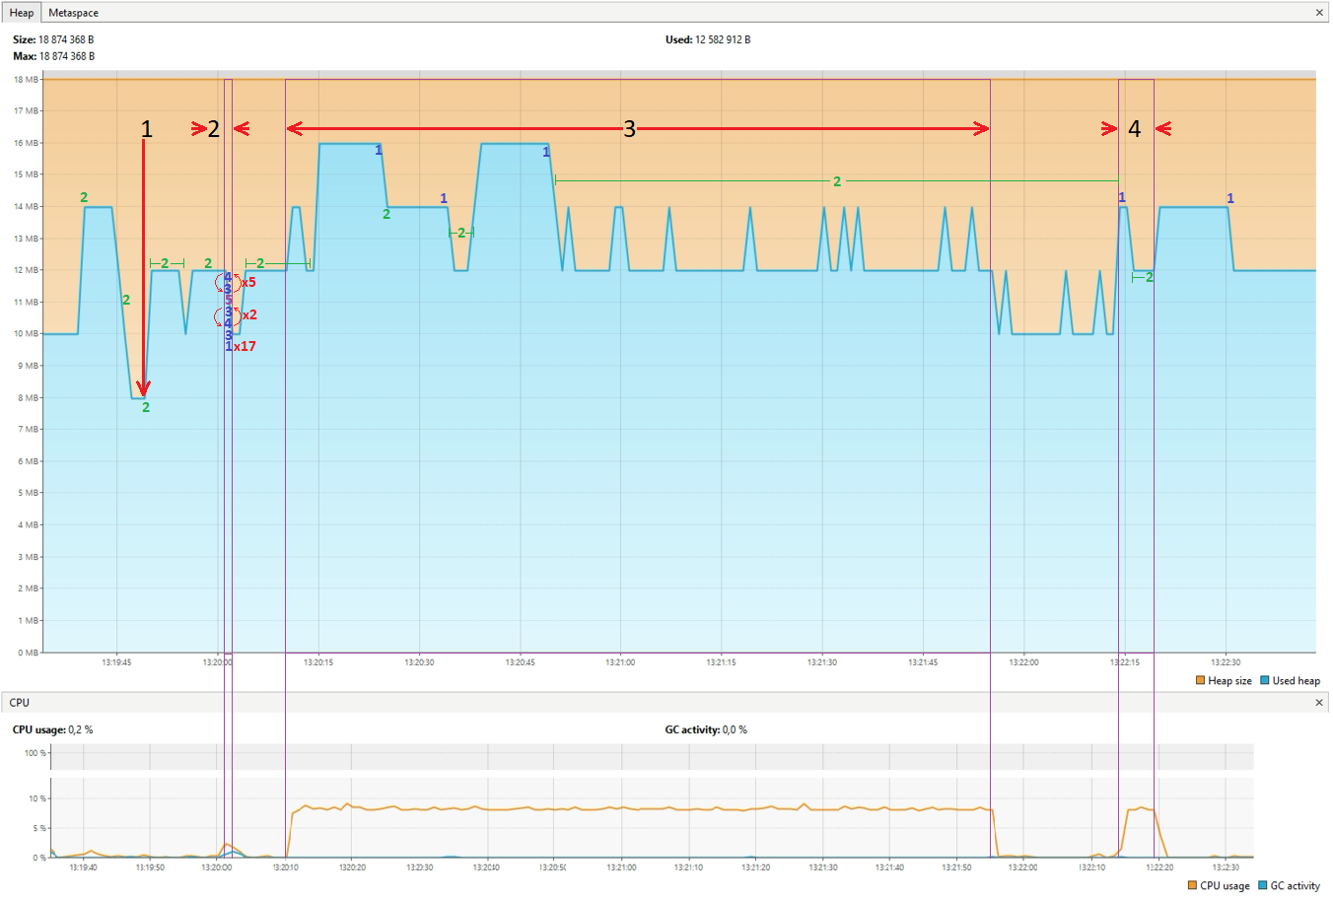

|  |  |
| --- | --- |
| 1 — вставка 250000 элементов массива  2 — сортировка слиянием  3 — сортировка пузырьком  4 — сортировка вставкой | **1** Garbage Collection (Allocation Rate)  **2** Garbage Collection (Proactive)  **3** Garbage Collection (Allocation Stall)  **4** Allocation Stall (main)  **5** Relocation Stall (main) |

Практически все время работы программы происходит **2** - фактически означает активную фазу работы GC.

Сортировка слиянием заняла 0.32 миллисекунды, при этом во время сортировки GC активно заполнял и распределял потоки (**345**).

|  |  |
| --- | --- |
| До сортировки |  |
| После сортировки |  |

Сортировка пузырьком заняла 1 минуту 45 секунд, при этом в начале работы потребовалось закрыть потоки **1**, что освободило новые объемы памяти, а далее GC работал в обычном режиме **2**. Загрузка памяти в начала работы взялась из-за создания копии массива, но GC почему-то долго держала память заполненной.

|  |  |
| --- | --- |
| До сортировки |  |
| После сортировки |  |

Сортировка вставкой заняла 5 с половиной секунд, при этом во время работы не запускались более глубокие механизмы по перераспределению потоков, была выполнена только **1** Garbage Collection (Allocation Rate).

|  |  |
| --- | --- |
| До сортировки |  |
| После сортировки |  |

|  |  |
| --- | --- |
| **1**  **2**  **2**  **2**  **2**  **2**  **2**  **2**  **2**  **2**  **2**  **2**  **2**  **2**  **2**  **2**  **3**  **3**  **3**  **3**  **3**  **3**  **3**  **3**  **3**  **3**  **3**  **3**  **3**  **3**  **3**  **3**  **3**  **3**  **3**  **3**  **3**  **3**  **3**  **3**  **3**  **3**  **3**  **3**  **3**  **3**  **3**  **3**  **3**  **3**  **3**  **3**  **3**  **3**  **3**  **3**  **3**  **3**  **3**  **3**  **3**  **3**  **3**  **3**  **3**  **3**  **3**  **3**  **3**  **3**  **3**  **3**  **3**  **3**  **3**  **3**  **3**  **3**  **3**  **3**  **3**  **3**  **3**  **3**  **3**  **3**  **3**  **3**  **3**  **3**  **3**  **3**  **3**  **3**  **3**  **3**  **3**  **3**  **3**  **3**  **4**  **4**  **4**  **4**  **4**  **4**  **4** | **[2024-03-01T13:19:30.498+0300][info][gc] Using The Z Garbage Collector**  **[2024-03-01T13:19:30.726+0300][info][gc] GC(0) Garbage Collection (Warmup) 4M(22%)->4M(22%)**  **[2024-03-01T13:19:30.820+0300][info][gc] GC(1) Garbage Collection (Warmup) 4M(22%)->4M(22%)**  **[2024-03-01T13:19:31.622+0300][info][gc] GC(2) Garbage Collection (Warmup) 6M(33%)->4M(22%)**  **[2024-03-01T13:19:33.330+0300][info][gc] GC(3) Garbage Collection (Proactive) 8M(44%)->6M(33%)**  **[2024-03-01T13:19:33.437+0300][info][gc] GC(4) Garbage Collection (Allocation Rate) 12M(67%)->10M(56%)**  **[2024-03-01T13:19:33.528+0300][info][gc] GC(5) Garbage Collection (Allocation Rate) 14M(78%)->8M(44%)**  **[2024-03-01T13:19:33.623+0300][info][gc] GC(6) Garbage Collection (Allocation Rate) 8M(44%)->6M(33%)**  **[2024-03-01T13:19:33.723+0300][info][gc] GC(7) Garbage Collection (Allocation Rate) 8M(44%)->6M(33%)**  **[2024-03-01T13:19:33.822+0300][info][gc] GC(8) Garbage Collection (Allocation Rate) 8M(44%)->8M(44%)**  **[2024-03-01T13:19:33.924+0300][info][gc] GC(9) Garbage Collection (Allocation Rate) 8M(44%)->8M(44%)**  **[2024-03-01T13:19:34.030+0300][info][gc] GC(10) Garbage Collection (Allocation Rate) 10M(56%)->8M(44%)**  **[2024-03-01T13:19:34.130+0300][info][gc] GC(11) Garbage Collection (Allocation Rate) 8M(44%)->8M(44%)**  **[2024-03-01T13:19:34.231+0300][info][gc] GC(12) Garbage Collection (Allocation Rate) 10M(56%)->10M(56%)**  **[2024-03-01T13:19:34.327+0300][info][gc] GC(13) Garbage Collection (Allocation Rate) 10M(56%)->10M(56%)**  **[2024-03-01T13:19:34.426+0300][info][gc] GC(14) Garbage Collection (Allocation Rate) 10M(56%)->10M(56%)**  **[2024-03-01T13:19:34.527+0300][info][gc] GC(15) Garbage Collection (Allocation Rate) 10M(56%)->10M(56%)**  **[2024-03-01T13:19:34.627+0300][info][gc] GC(16) Garbage Collection (Allocation Rate) 10M(56%)->10M(56%)**  **[2024-03-01T13:19:34.727+0300][info][gc] GC(17) Garbage Collection (Allocation Rate) 10M(56%)->10M(56%)**  **[2024-03-01T13:19:34.826+0300][info][gc] GC(18) Garbage Collection (Allocation Rate) 10M(56%)->10M(56%)**  **[2024-03-01T13:19:34.927+0300][info][gc] GC(19) Garbage Collection (Allocation Rate) 10M(56%)->10M(56%)**  **[2024-03-01T13:19:35.027+0300][info][gc] GC(20) Garbage Collection (Allocation Rate) 10M(56%)->10M(56%)**  **[2024-03-01T13:19:35.127+0300][info][gc] GC(21) Garbage Collection (Allocation Rate) 10M(56%)->10M(56%)**  **[2024-03-01T13:19:39.229+0300][info][gc] GC(22) Garbage Collection (Proactive) 12M(67%)->10M(56%)**  **[2024-03-01T13:19:45.027+0300][info][gc] GC(23) Garbage Collection (Proactive) 12M(67%)->8M(44%)**  **[2024-03-01T13:19:45.829+0300][info][gc] GC(24) Garbage Collection (Proactive) 10M(56%)->6M(33%)**  **[2024-03-01T13:19:46.748+0300][info][gc] GC(25) Garbage Collection (Proactive) 8M(44%)->8M(44%)**  **[2024-03-01T13:19:49.627+0300][info][gc] GC(26) Garbage Collection (Proactive) 12M(67%)->10M(56%)**  **[2024-03-01T13:19:52.027+0300][info][gc] GC(27) Garbage Collection (Proactive) 12M(67%)->10M(56%)**  **[2024-03-01T13:19:53.626+0300][info][gc] GC(28) Garbage Collection (Proactive) 12M(67%)->10M(56%)**  **[2024-03-01T13:19:54.826+0300][info][gc] GC(29) Garbage Collection (Proactive) 12M(67%)->10M(56%)**  **[2024-03-01T13:19:55.746+0300][info][gc] GC(30) Garbage Collection (Proactive) 12M(67%)->10M(56%)**  **[2024-03-01T13:19:58.726+0300][info][gc] GC(31) Garbage Collection (Proactive) 12M(67%)->10M(56%)**  **[2024-03-01T13:20:01.021+0300][info][gc] Allocation Stall (main) 13.606ms**  **[2024-03-01T13:20:01.021+0300][info][gc] GC(32) Garbage Collection (Allocation Stall) 18M(100%)->14M(78%)**  **[2024-03-01T13:20:01.041+0300][info][gc] Allocation Stall (main) 12.307ms**  **[2024-03-01T13:20:01.041+0300][info][gc] GC(33) Garbage Collection (Allocation Stall) 18M(100%)->16M(89%)**  **[2024-03-01T13:20:01.058+0300][info][gc] Allocation Stall (main) 11.683ms**  **[2024-03-01T13:20:01.058+0300][info][gc] GC(34) Garbage Collection (Allocation Stall) 18M(100%)->16M(89%)**  **[2024-03-01T13:20:01.074+0300][info][gc] Allocation Stall (main) 11.519ms**  **[2024-03-01T13:20:01.075+0300][info][gc] GC(35) Garbage Collection (Allocation Stall) 18M(100%)->16M(89%)**  **[2024-03-01T13:20:01.092+0300][info][gc] Allocation Stall (main) 13.334ms**  **[2024-03-01T13:20:01.093+0300][info][gc] Relocation Stall (main) 0.026ms**  **[2024-03-01T13:20:01.093+0300][info][gc] GC(36) Garbage Collection (Allocation Stall) 18M(100%)->16M(89%)**  **[2024-03-01T13:20:01.114+0300][info][gc] Allocation Stall (main) 16.122ms**  **[2024-03-01T13:20:01.115+0300][info][gc] GC(37) Garbage Collection (Allocation Stall) 18M(100%)->18M(100%)**  **[2024-03-01T13:20:01.132+0300][info][gc] Allocation Stall (main) 14.521ms**  **[2024-03-01T13:20:01.132+0300][info][gc] GC(38) Garbage Collection (Allocation Stall) 18M(100%)->12M(67%)**  **[2024-03-01T13:20:01.228+0300][info][gc] GC(39) Garbage Collection (Allocation Rate) 12M(67%)->10M(56%)**  **[2024-03-01T13:20:01.329+0300][info][gc] GC(40) Garbage Collection (Allocation Rate) 10M(56%)->10M(56%)**  **[2024-03-01T13:20:01.428+0300][info][gc] GC(41) Garbage Collection (Allocation Rate) 10M(56%)->10M(56%)**  **[2024-03-01T13:20:01.527+0300][info][gc] GC(42) Garbage Collection (Allocation Rate) 10M(56%)->10M(56%)**  **[2024-03-01T13:20:01.628+0300][info][gc] GC(43) Garbage Collection (Allocation Rate) 10M(56%)->10M(56%)**  **[2024-03-01T13:20:01.729+0300][info][gc] GC(44) Garbage Collection (Allocation Rate) 10M(56%)->10M(56%)**  **[2024-03-01T13:20:01.833+0300][info][gc] GC(45) Garbage Collection (Allocation Rate) 10M(56%)->10M(56%)**  **[2024-03-01T13:20:01.930+0300][info][gc] GC(46) Garbage Collection (Allocation Rate) 10M(56%)->10M(56%)**  **[2024-03-01T13:20:02.127+0300][info][gc] GC(47) Garbage Collection (Allocation Rate) 10M(56%)->10M(56%)**  **[2024-03-01T13:20:02.226+0300][info][gc] GC(48) Garbage Collection (Allocation Rate) 12M(67%)->10M(56%)**  **[2024-03-01T13:20:02.326+0300][info][gc] GC(49) Garbage Collection (Allocation Rate) 10M(56%)->10M(56%)**  **[2024-03-01T13:20:02.426+0300][info][gc] GC(50) Garbage Collection (Allocation Rate) 10M(56%)->10M(56%)**  **[2024-03-01T13:20:02.526+0300][info][gc] GC(51) Garbage Collection (Allocation Rate) 10M(56%)->10M(56%)**  **[2024-03-01T13:20:02.626+0300][info][gc] GC(52) Garbage Collection (Allocation Rate) 10M(56%)->10M(56%)**  **[2024-03-01T13:20:02.727+0300][info][gc] GC(53) Garbage Collection (Allocation Rate) 10M(56%)->10M(56%)**  **[2024-03-01T13:20:02.825+0300][info][gc] GC(54) Garbage Collection (Allocation Rate) 10M(56%)->10M(56%)**  **[2024-03-01T13:20:02.926+0300][info][gc] GC(55) Garbage Collection (Allocation Rate) 10M(56%)->10M(56%)**  **[2024-03-01T13:20:03.626+0300][info][gc] GC(56) Garbage Collection (Proactive) 12M(67%)->10M(56%)**  **[2024-03-01T13:20:04.327+0300][info][gc] GC(57) Garbage Collection (Proactive) 12M(67%)->10M(56%)**  **[2024-03-01T13:20:05.227+0300][info][gc] GC(58) Garbage Collection (Proactive) 12M(67%)->12M(67%)**  **[2024-03-01T13:20:10.327+0300][info][gc] GC(59) Garbage Collection (Proactive) 14M(78%)->12M(67%)**  **[2024-03-01T13:20:11.227+0300][info][gc] GC(60) Garbage Collection (Proactive) 14M(78%)->12M(67%)**  **[2024-03-01T13:20:12.226+0300][info][gc] GC(61) Garbage Collection (Proactive) 14M(78%)->12M(67%)**  **[2024-03-01T13:20:13.231+0300][info][gc] GC(62) Garbage Collection (Proactive) 14M(78%)->12M(67%)**  **[2024-03-01T13:20:14.227+0300][info][gc] GC(63) Garbage Collection (Proactive) 14M(78%)->14M(78%)**  **[2024-03-01T13:20:24.328+0300][info][gc] GC(64) Garbage Collection (Allocation Rate) 16M(89%)->12M(67%)**  **[2024-03-01T13:20:25.228+0300][info][gc] GC(65) Garbage Collection (Proactive) 14M(78%)->14M(78%)**  **[2024-03-01T13:20:33.226+0300][info][gc] GC(66) Garbage Collection (Allocation Rate) 16M(89%)->12M(67%)**  **[2024-03-01T13:20:33.328+0300][info][gc] GC(67) Garbage Collection (Allocation Rate) 14M(78%)->12M(67%)**  **[2024-03-01T13:20:34.228+0300][info][gc] GC(68) Garbage Collection (Proactive) 14M(78%)->12M(67%)**  **[2024-03-01T13:20:35.027+0300][info][gc] GC(69) Garbage Collection (Proactive) 14M(78%)->12M(67%)**  **[2024-03-01T13:20:35.828+0300][info][gc] GC(70) Garbage Collection (Proactive) 14M(78%)->12M(67%)**  **[2024-03-01T13:20:36.627+0300][info][gc] GC(71) Garbage Collection (Proactive) 14M(78%)->12M(67%)**  **[2024-03-01T13:20:37.427+0300][info][gc] GC(72) Garbage Collection (Proactive) 14M(78%)->12M(67%)**  **[2024-03-01T13:20:38.227+0300][info][gc] GC(73) Garbage Collection (Proactive) 14M(78%)->14M(78%)**  **[2024-03-01T13:20:49.326+0300][info][gc] GC(74) Garbage Collection (Allocation Rate) 16M(89%)->12M(67%)**  **[2024-03-01T13:20:50.327+0300][info][gc] GC(75) Garbage Collection (Proactive) 14M(78%)->12M(67%)**  **[2024-03-01T13:20:51.328+0300][info][gc] GC(76) Garbage Collection (Proactive) 14M(78%)->12M(67%)**  **[2024-03-01T13:20:52.328+0300][info][gc] GC(77) Garbage Collection (Proactive) 14M(78%)->12M(67%)**  **[2024-03-01T13:20:53.328+0300][info][gc] GC(78) Garbage Collection (Proactive) 14M(78%)->12M(67%)**  **[2024-03-01T13:20:54.326+0300][info][gc] GC(79) Garbage Collection (Proactive) 14M(78%)->12M(67%)**  **[2024-03-01T13:20:55.326+0300][info][gc] GC(80) Garbage Collection (Proactive) 14M(78%)->12M(67%)**  **[2024-03-01T13:20:56.328+0300][info][gc] GC(81) Garbage Collection (Proactive) 14M(78%)->12M(67%)**  **[2024-03-01T13:20:57.326+0300][info][gc] GC(82) Garbage Collection (Proactive) 14M(78%)->12M(67%)**  **[2024-03-01T13:20:58.328+0300][info][gc] GC(83) Garbage Collection (Proactive) 14M(78%)->12M(67%)**  **[2024-03-01T13:20:59.327+0300][info][gc] GC(84) Garbage Collection (Proactive) 14M(78%)->12M(67%)**  **[2024-03-01T13:21:00.326+0300][info][gc] GC(85) Garbage Collection (Proactive) 14M(78%)->12M(67%)**  **[2024-03-01T13:21:01.326+0300][info][gc] GC(86) Garbage Collection (Proactive) 14M(78%)->12M(67%)**  **[2024-03-01T13:21:02.327+0300][info][gc] GC(87) Garbage Collection (Proactive) 14M(78%)->12M(67%)**  **[2024-03-01T13:21:03.326+0300][info][gc] GC(88) Garbage Collection (Proactive) 14M(78%)->12M(67%)**  **[2024-03-01T13:21:04.327+0300][info][gc] GC(89) Garbage Collection (Proactive) 14M(78%)->12M(67%)**  **[2024-03-01T13:21:05.327+0300][info][gc] GC(90) Garbage Collection (Proactive) 14M(78%)->12M(67%)**  **[2024-03-01T13:21:06.327+0300][info][gc] GC(91) Garbage Collection (Proactive) 14M(78%)->12M(67%)**  **[2024-03-01T13:21:07.326+0300][info][gc] GC(92) Garbage Collection (Proactive) 14M(78%)->12M(67%)**  **[2024-03-01T13:21:08.327+0300][info][gc] GC(93) Garbage Collection (Proactive) 14M(78%)->12M(67%)**  **[2024-03-01T13:21:09.327+0300][info][gc] GC(94) Garbage Collection (Proactive) 14M(78%)->12M(67%)**  **[2024-03-01T13:21:10.327+0300][info][gc] GC(95) Garbage Collection (Proactive) 14M(78%)->12M(67%)**  **[2024-03-01T13:21:11.327+0300][info][gc] GC(96) Garbage Collection (Proactive) 14M(78%)->12M(67%)**  **[2024-03-01T13:21:12.326+0300][info][gc] GC(97) Garbage Collection (Proactive) 14M(78%)->12M(67%)**  **[2024-03-01T13:21:13.327+0300][info][gc] GC(98) Garbage Collection (Proactive) 14M(78%)->12M(67%)**  **[2024-03-01T13:21:14.326+0300][info][gc] GC(99) Garbage Collection (Proactive) 14M(78%)->12M(67%)**  **[2024-03-01T13:21:15.326+0300][info][gc] GC(100) Garbage Collection (Proactive) 14M(78%)->12M(67%)**  **[2024-03-01T13:21:16.327+0300][info][gc] GC(101) Garbage Collection (Proactive) 14M(78%)->12M(67%)**  **[2024-03-01T13:21:17.328+0300][info][gc] GC(102) Garbage Collection (Proactive) 14M(78%)->12M(67%)**  **[2024-03-01T13:21:18.326+0300][info][gc] GC(103) Garbage Collection (Proactive) 14M(78%)->12M(67%)**  **[2024-03-01T13:21:19.227+0300][info][gc] GC(104) Garbage Collection (Proactive) 14M(78%)->12M(67%)**  **[2024-03-01T13:21:20.027+0300][info][gc] GC(105) Garbage Collection (Proactive) 14M(78%)->12M(67%)**  **[2024-03-01T13:21:20.726+0300][info][gc] GC(106) Garbage Collection (Proactive) 14M(78%)->12M(67%)**  **[2024-03-01T13:21:21.428+0300][info][gc] GC(107) Garbage Collection (Proactive) 14M(78%)->12M(67%)**  **[2024-03-01T13:21:22.326+0300][info][gc] GC(108) Garbage Collection (Proactive) 14M(78%)->12M(67%)**  **[2024-03-01T13:21:23.325+0300][info][gc] GC(109) Garbage Collection (Proactive) 14M(78%)->12M(67%)**  **[2024-03-01T13:21:24.328+0300][info][gc] GC(110) Garbage Collection (Proactive) 14M(78%)->12M(67%)**  **[2024-03-01T13:21:25.327+0300][info][gc] GC(111) Garbage Collection (Proactive) 14M(78%)->12M(67%)**  **[2024-03-01T13:21:26.326+0300][info][gc] GC(112) Garbage Collection (Proactive) 14M(78%)->12M(67%)**  **[2024-03-01T13:21:27.327+0300][info][gc] GC(113) Garbage Collection (Proactive) 14M(78%)->12M(67%)**  **[2024-03-01T13:21:28.327+0300][info][gc] GC(114) Garbage Collection (Proactive) 14M(78%)->12M(67%)**  **[2024-03-01T13:21:29.326+0300][info][gc] GC(115) Garbage Collection (Proactive) 14M(78%)->12M(67%)**  **[2024-03-01T13:21:30.327+0300][info][gc] GC(116) Garbage Collection (Proactive) 14M(78%)->12M(67%)**  **[2024-03-01T13:21:31.326+0300][info][gc] GC(117) Garbage Collection (Proactive) 14M(78%)->12M(67%)**  **[2024-03-01T13:21:32.326+0300][info][gc] GC(118) Garbage Collection (Proactive) 14M(78%)->12M(67%)**  **[2024-03-01T13:21:33.327+0300][info][gc] GC(119) Garbage Collection (Proactive) 14M(78%)->12M(67%)**  **[2024-03-01T13:21:34.227+0300][info][gc] GC(120) Garbage Collection (Proactive) 14M(78%)->12M(67%)**  **[2024-03-01T13:21:34.927+0300][info][gc] GC(121) Garbage Collection (Proactive) 14M(78%)->12M(67%)**  **[2024-03-01T13:21:35.627+0300][info][gc] GC(122) Garbage Collection (Proactive) 14M(78%)->12M(67%)**  **[2024-03-01T13:21:36.327+0300][info][gc] GC(123) Garbage Collection (Proactive) 14M(78%)->12M(67%)**  **[2024-03-01T13:21:37.326+0300][info][gc] GC(124) Garbage Collection (Proactive) 14M(78%)->12M(67%)**  **[2024-03-01T13:21:38.327+0300][info][gc] GC(125) Garbage Collection (Proactive) 14M(78%)->12M(67%)**  **[2024-03-01T13:21:39.328+0300][info][gc] GC(126) Garbage Collection (Proactive) 14M(78%)->12M(67%)**  **[2024-03-01T13:21:40.328+0300][info][gc] GC(127) Garbage Collection (Proactive) 14M(78%)->12M(67%)**  **[2024-03-01T13:21:41.326+0300][info][gc] GC(128) Garbage Collection (Proactive) 14M(78%)->12M(67%)**  **[2024-03-01T13:21:42.327+0300][info][gc] GC(129) Garbage Collection (Proactive) 14M(78%)->12M(67%)**  **[2024-03-01T13:21:43.326+0300][info][gc] GC(130) Garbage Collection (Proactive) 14M(78%)->12M(67%)**  **[2024-03-01T13:21:44.327+0300][info][gc] GC(131) Garbage Collection (Proactive) 14M(78%)->12M(67%)**  **[2024-03-01T13:21:45.327+0300][info][gc] GC(132) Garbage Collection (Proactive) 14M(78%)->12M(67%)**  **[2024-03-01T13:21:46.326+0300][info][gc] GC(133) Garbage Collection (Proactive) 14M(78%)->12M(67%)**  **[2024-03-01T13:21:47.326+0300][info][gc] GC(134) Garbage Collection (Proactive) 14M(78%)->12M(67%)**  **[2024-03-01T13:21:48.326+0300][info][gc] GC(135) Garbage Collection (Proactive) 14M(78%)->12M(67%)**  **[2024-03-01T13:21:49.326+0300][info][gc] GC(136) Garbage Collection (Proactive) 14M(78%)->12M(67%)**  **[2024-03-01T13:21:50.327+0300][info][gc] GC(137) Garbage Collection (Proactive) 14M(78%)->12M(67%)**  **[2024-03-01T13:21:51.328+0300][info][gc] GC(138) Garbage Collection (Proactive) 14M(78%)->12M(67%)**  **[2024-03-01T13:21:52.326+0300][info][gc] GC(139) Garbage Collection (Proactive) 14M(78%)->12M(67%)**  **[2024-03-01T13:21:53.327+0300][info][gc] GC(140) Garbage Collection (Proactive) 14M(78%)->12M(67%)**  **[2024-03-01T13:21:54.325+0300][info][gc] GC(141) Garbage Collection (Proactive) 14M(78%)->12M(67%)**  **[2024-03-01T13:21:55.228+0300][info][gc] GC(142) Garbage Collection (Proactive) 14M(78%)->10M(56%)**  **[2024-03-01T13:21:56.027+0300][info][gc] GC(143) Garbage Collection (Proactive) 12M(67%)->10M(56%)**  **[2024-03-01T13:21:56.726+0300][info][gc] GC(144) Garbage Collection (Proactive) 12M(67%)->10M(56%)**  **[2024-03-01T13:21:57.426+0300][info][gc] GC(145) Garbage Collection (Proactive) 12M(67%)->10M(56%)**  **[2024-03-01T13:21:58.328+0300][info][gc] GC(146) Garbage Collection (Proactive) 12M(67%)->10M(56%)**  **[2024-03-01T13:21:59.326+0300][info][gc] GC(147) Garbage Collection (Proactive) 12M(67%)->10M(56%)**  **[2024-03-01T13:22:00.326+0300][info][gc] GC(148) Garbage Collection (Proactive) 12M(67%)->10M(56%)**  **[2024-03-01T13:22:01.326+0300][info][gc] GC(149) Garbage Collection (Proactive) 12M(67%)->10M(56%)**  **[2024-03-01T13:22:02.326+0300][info][gc] GC(150) Garbage Collection (Proactive) 12M(67%)->10M(56%)**  **[2024-03-01T13:22:03.326+0300][info][gc] GC(151) Garbage Collection (Proactive) 12M(67%)->10M(56%)**  **[2024-03-01T13:22:04.325+0300][info][gc] GC(152) Garbage Collection (Proactive) 12M(67%)->10M(56%)**  **[2024-03-01T13:22:05.327+0300][info][gc] GC(153) Garbage Collection (Proactive) 12M(67%)->10M(56%)**  **[2024-03-01T13:22:06.326+0300][info][gc] GC(154) Garbage Collection (Proactive) 12M(67%)->10M(56%)**  **[2024-03-01T13:22:07.327+0300][info][gc] GC(155) Garbage Collection (Proactive) 12M(67%)->10M(56%)**  **[2024-03-01T13:22:08.327+0300][info][gc] GC(156) Garbage Collection (Proactive) 12M(67%)->10M(56%)**  **[2024-03-01T13:22:09.326+0300][info][gc] GC(157) Garbage Collection (Proactive) 12M(67%)->10M(56%)**  **[2024-03-01T13:22:10.327+0300][info][gc] GC(158) Garbage Collection (Proactive) 12M(67%)->10M(56%)**  **[2024-03-01T13:22:11.327+0300][info][gc] GC(159) Garbage Collection (Proactive) 12M(67%)->10M(56%)**  **[2024-03-01T13:22:12.328+0300][info][gc] GC(160) Garbage Collection (Proactive) 12M(67%)->10M(56%)**  **[2024-03-01T13:22:13.326+0300][info][gc] GC(161) Garbage Collection (Proactive) 12M(67%)->10M(56%)**  **[2024-03-01T13:22:14.128+0300][info][gc] GC(162) Garbage Collection (Proactive) 14M(78%)->12M(67%)**  **[2024-03-01T13:22:14.326+0300][info][gc] GC(163) Garbage Collection (Allocation Rate) 14M(78%)->12M(67%)**  **[2024-03-01T13:22:15.327+0300][info][gc] GC(164) Garbage Collection (Proactive) 14M(78%)->12M(67%)**  **[2024-03-01T13:22:16.327+0300][info][gc] GC(165) Garbage Collection (Proactive) 14M(78%)->12M(67%)**  **[2024-03-01T13:22:17.327+0300][info][gc] GC(166) Garbage Collection (Proactive) 14M(78%)->12M(67%)**  **[2024-03-01T13:22:18.327+0300][info][gc] GC(167) Garbage Collection (Proactive) 14M(78%)->12M(67%)**  **[2024-03-01T13:22:19.326+0300][info][gc] GC(168) Garbage Collection (Proactive) 14M(78%)->14M(78%)**  **[2024-03-01T13:22:30.426+0300][info][gc] GC(169) Garbage Collection (Allocation Rate) 16M(89%)->10M(56%)**  **[2024-03-01T13:22:31.327+0300][info][gc] GC(170) Garbage Collection (Proactive) 12M(67%)->12M(67%)** |