- Создание проекта авалония

ПАКЕТЫ
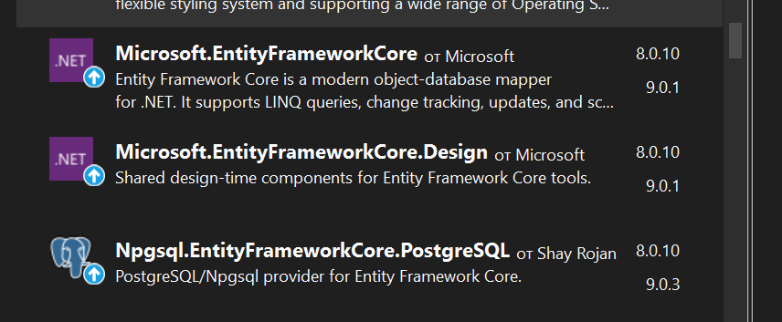
- Перенести бд в вижуал студио
Cd desktop
Cd Agents
dotnet ef dbcontext scaffold "Host=45.67.56.214;Port=5421;Database=user7;Username=user7;Password=a8yLONBC" Npgsql.EntityFrameworkCore.PostgreSQL -o Models --project blagodattt.csproj --schema blagodat

dotnet ef dbcontext scaffold "Host=localhost;Port=5438;Database=Elbrus_region;Username=nastya;Password=123" Npgsql.EntityFrameworkCore.PostgreSQL -o Models --project ElbrusRegion

dotnet ef dbcontext scaffold "Host=79.174.88.58;Port=16639;Database=Vakhitova;Username=Vakhitova;Password=Vakhitova123." Npgsql.EntityFrameworkCore.PostgreSQL -o Models --project OrderTaxi

Создать локальную бд(это курсовая!!)
СНАЧАЛА: docker ps
docker run --name var7 -p 5438:5432 -e POSTGRES_USER=nastya -e POSTGRES_PASSWORD=123 -e POSTGRES_DB=var7 -d postgres

ПОДСТАВИТЬ:
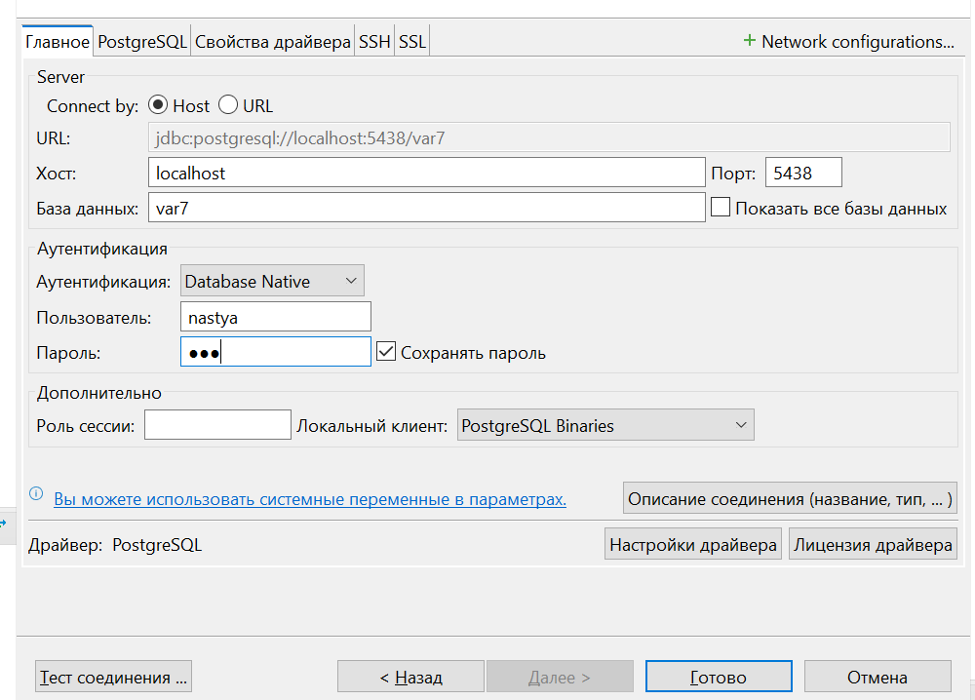

БД
My.sql
CREATE TABLE IF NOT EXISTS MaterialSupplier (
MaterialID INT NOT NULL,
SupplierID INT NOT NULL,
PRIMARY KEY (MaterialID, SupplierID),
CONSTRAINT FK_MaterialSupplier_Supplier
FOREIGN KEY (SupplierID)
REFERENCES Supplier (ID)
ON DELETE NO ACTION
ON UPDATE NO ACTION,
CONSTRAINT FK_MaterialSupplier_Material
FOREIGN KEY (MaterialID)
REFERENCES Material (ID)
ON DELETE NO ACTION
ON UPDATE NO ACTION);

Postgres
CREATE TABLE IF NOT EXISTS MaterialSupplier (
MaterialID INT NOT NULL,
SupplierID INT NOT NULL,
PRIMARY KEY (MaterialID, SupplierID),
CONSTRAINT FK_MaterialSupplier_Supplier
FOREIGN KEY (SupplierID)
REFERENCES Supplier (ID)
ON DELETE NO ACTION
ON UPDATE NO ACTION,
CONSTRAINT FK_MaterialSupplier_Material
FOREIGN KEY (MaterialID)
REFERENCES Material (ID)
ON DELETE NO ACTION
ON UPDATE NO ACTION
);

mysql
CREATE TABLE IF NOT EXISTS Shop (
ID INT NOT NULL AUTO_INCREMENT,
Title VARCHAR(150) CHARACTER SET 'utf8mb4' NOT NULL,
Address VARCHAR(300) CHARACTER SET 'utf8mb4' NULL,
AgentID INT NOT NULL,
PRIMARY KEY (ID),
CONSTRAINT FK_Shop_Agent
FOREIGN KEY (AgentID)
REFERENCES Agent (ID)
ON DELETE NO ACTION
ON UPDATE NO ACTION);

Postgres
CREATE TABLE IF NOT EXISTS Shop (
ID SERIAL PRIMARY KEY,
Title VARCHAR(150) NOT NULL,
Address VARCHAR(300),
AgentID INT NOT NULL,
CONSTRAINT FK_Shop_Agent
FOREIGN KEY (AgentID)
REFERENCES Agent (ID)
ON DELETE NO ACTION
ON UPDATE NO ACTION
);

