Exercise 1.1

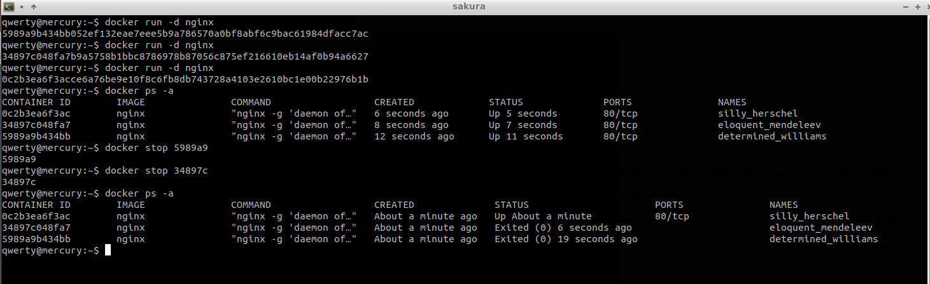
Exercise 1.2
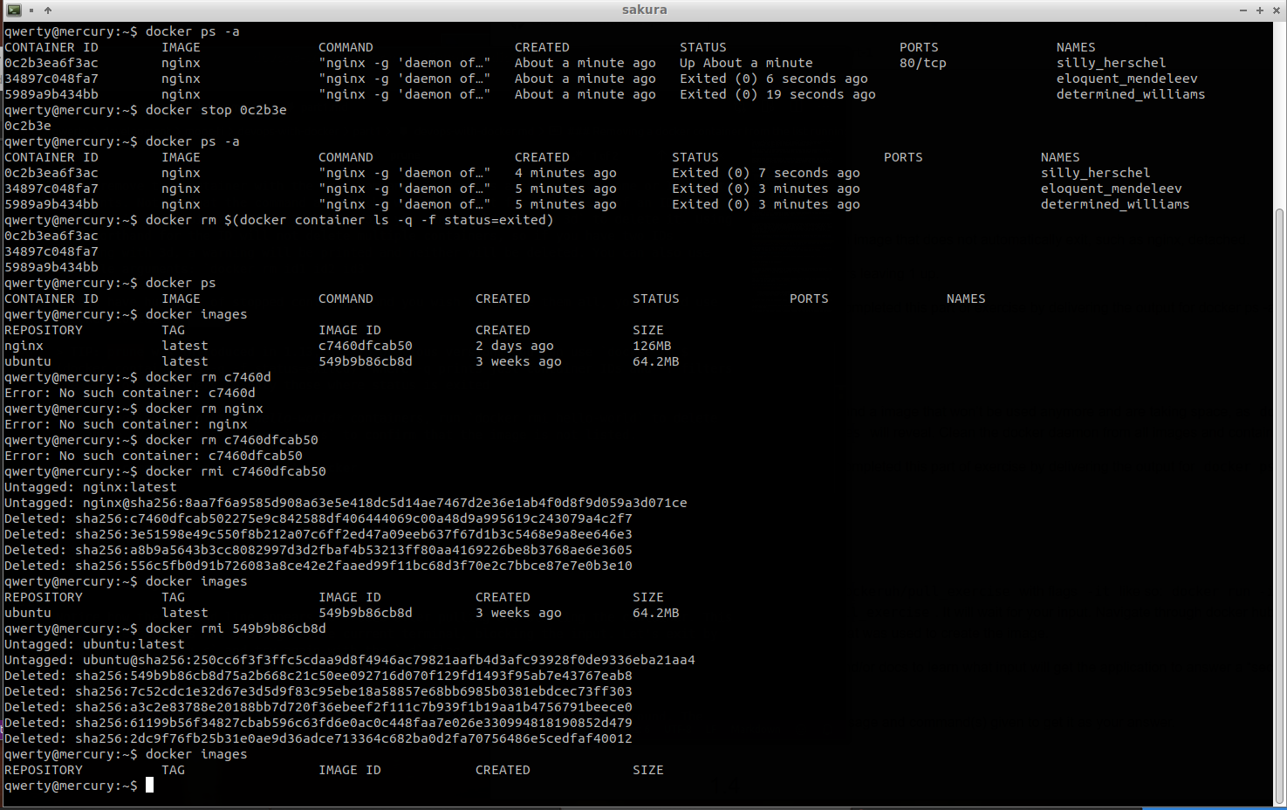
Exercise 1.3

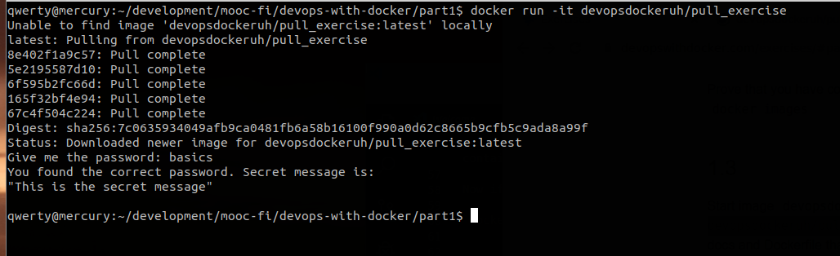
Exercise 1.4
