Exercise 1.1

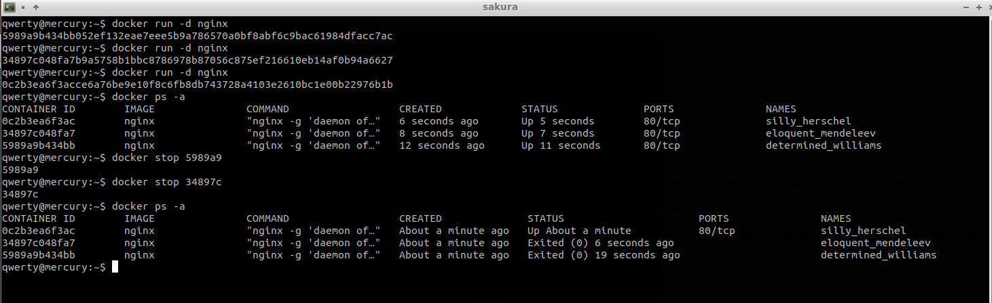
Exercise 1.2
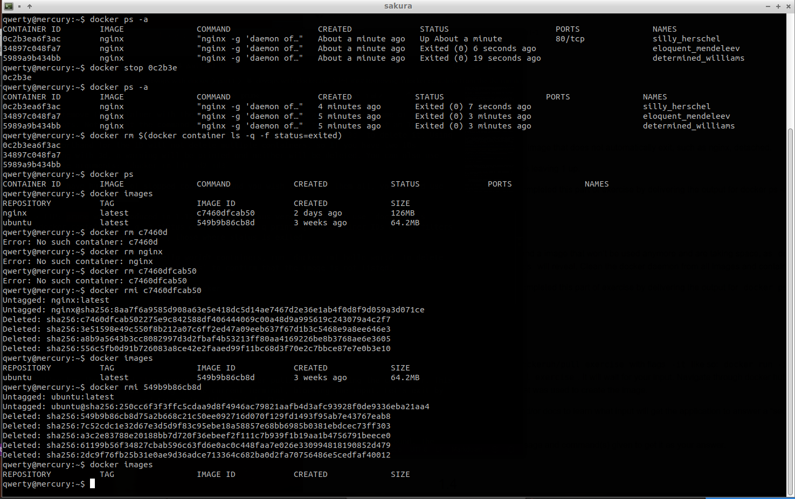
Exercise 1.3

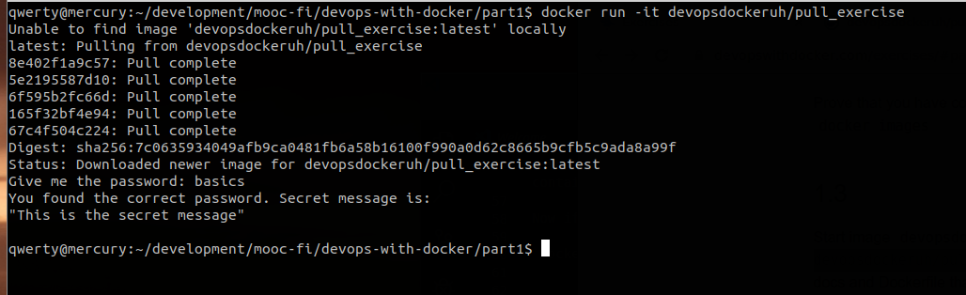
Exercise 1.4
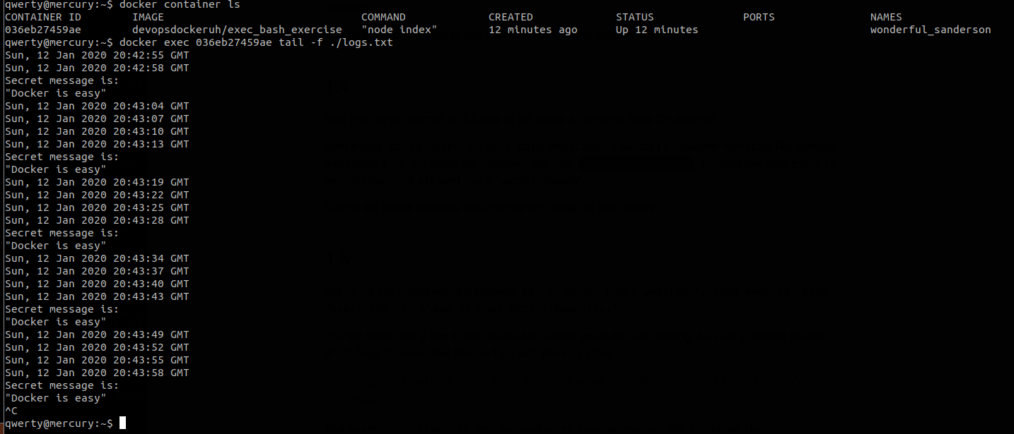
Exercise 1.5
This was a several step process with the following commands to install curl from inside the container:
step1: docker run ubuntu sh -c 'apt-get -y update; apt-get -y install curl'
step2: docker ps -a
Step2 showed the id of the container. This id was then used instep 3 where step 3 was used to commit the changes made to the image as shown below.
step3: docker commit 9234f2a600c4 ubuntu-curl
Remove all containers and use step 4 to run the needed command:
step 4: docker run -d -it --name looper-reader ubuntu-curl sh -c 'while true; do echo "Input website:"; read website; echo "Searching.."; sleep 1; curl http://$website; done'
Attach to the container ass shown in step 5:
step 5: docker attach --sig-proxy=false looper-reader
Enter the web site: helsinki.fi at the prompt while attached to the container; this gave the result shown in below:
Result:
helsinki.fi
Searching..
<!DOCTYPE HTML PUBLIC "-//IETF//DTD HTML 2.0//EN">
<html><head>
<title>301 Moved Permanently</title>
</head><body>
<h1>Moved Permanently</h1>
<p>The document has moved <a href="http://www.helsinki.fi/">here</a>.</p>
</body></html>
Input website:
