COMS20006-MVP-specifications

1. Landing Page
Static page

2. Login Page
- Login form with email & password
- Forget password triggers a dialog where user enters email and auto-sends reset-password email

3. Home Page
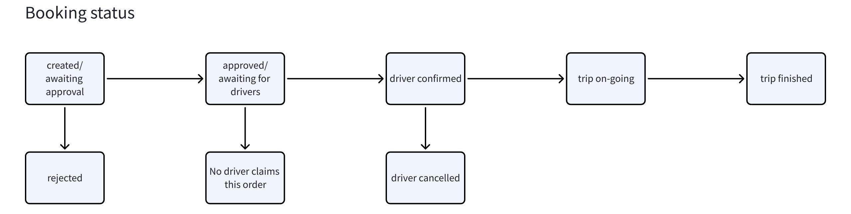
- Shows booking list with pagination.
- User can view each booking detail via dialog
- User can cancel bookings where the driver has not confirmed
- User can edit bookings before it is approved

4. Booking Form Page
- Form fileds
- Pick-up location
- Drop-off location
- Booking time
- Additional info
- The right hand side shows the route in the map

5. Booking Detail Page
- Booking detail
- Pick-up location
- Drop-off location
- Booking time
- Additional info
- The right hand side shows the route in the map

6. User Management Page
- Only show this page when the current user is manager of some department
- User list with pagination under certain department
- Manager can view each user's information
- Manager can add new users under his department(s)
- Manager can delete user
- Manager can freeze users (they can login but cannot booking)

7. Department Management Page
- Only show this page to super admin
- Super admin can add new department and assign manager
- Super admin can update, delete departments
- Super admin can view department detail

8. User Saved Addresses Page
- Show saved address list with pagination
- Users can add, view, update, delete addresses.

9. Booking Approval Page
- Only show this page when the current user is manager of some department
- Manager can approve/reject the bookings

10. User Profile Page
- Users can update their profile info
- Users can reset their password

11. About Page
Static page

12. Help Page
Static page

