|  |  |  |
| --- | --- | --- |
| Team 7: |  | |
| • | Fairuz Anindya Kurnia | (20230140013) |
| • | Gagat Padi Y | (20230140030) |
| • | Octaviani Putri Anggraeni | (20230140032) |

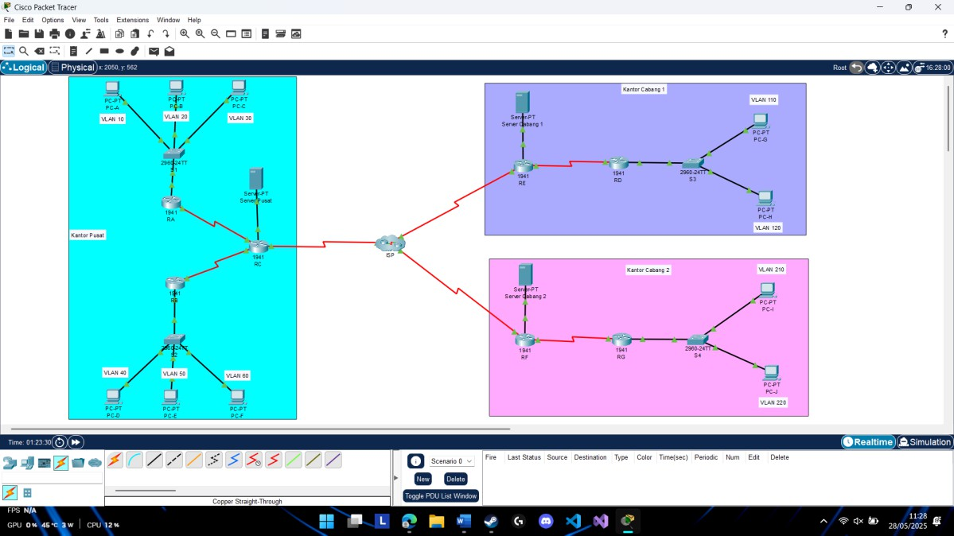TOPOLOGY

Adressing Table

Kantor Pusat

|  |  |  |  |
| --- | --- | --- | --- |
| VLAN / Jaringan | IP Subnet | Router | Deskripsi |
| VLAN 10 (User1) | 10.10.10.0/24 | Router A | Pengguna Divisi A |
| VLAN 20 (User2) | 10.10.20.0/24 | Router A | Pengguna Divisi B |
| VLAN 30 (User3) | 10.10.30.0/24 | Router A | Pengguna Divisi C |
| VLAN 40 (User4) | 10.10.40.0/24 | Router B | Pengguna Divisi D |
| VLAN 50 (User5) | 10.10.50.0/24 | Router B | Pengguna Divisi E |
| VLAN 60 (User6) | 10.10.60.0/24 | Router B | Pengguna Divisi F |
| Internal Server | 10.10.100.0/24 | Router C | Server internal |
| Link A-C | 10.10.201.0/30 | Router A-C | Link antar Router A dan C |
| Link B-C | 10.10.202.0/30 | Router B-C | Link antar Router B dan C |
| IP Publik NAT | 203.0.113.2/30 | - | IP NAT akses internet |

Kantor Cabang 1

|  |  |  |  |
| --- | --- | --- | --- |
| VLAN / Jaringan | IP Subnet | Router | Deskripsi |
| VLAN 10 (User1) | 10.20.10.0/24 | Router D | Pengguna Cabang Div A |
| VLAN 20 (User2) | 10.20.20.0/24 | Router D | Pengguna Cabang  Div B |
| Internal Server | 10.20.100.0/24 | Router E | Server lokal cabang |
| Link D-E | 10.20.200.0/30 | Router D-E | Link antar Router D dan E |
| IP Publik NAT | 203.0.113.5/30 | - | IP NAT akses internet |

Kantor Cabang 2

|  |  |  |  |
| --- | --- | --- | --- |
| VLAN / Jaringan | IP Subnet | Router | Deskripsi |
| VLAN 10 (User1) | 10.30.10.0/24 | Router D | Pengguna Cabang Div A |
| VLAN 20 (User2) | 10.30.20.0/24 | Router D | Pengguna Cabang Div B |
| Internal Server | 10.30.100.0/24 | Router E | Server lokal cabang |
| Link D-E | 10.30.200.0/30 | Router D-E | Link antar Router D dan E |
| IP Publik NAT | 203.0.113.9/30 | - | IP NAT akses internet |