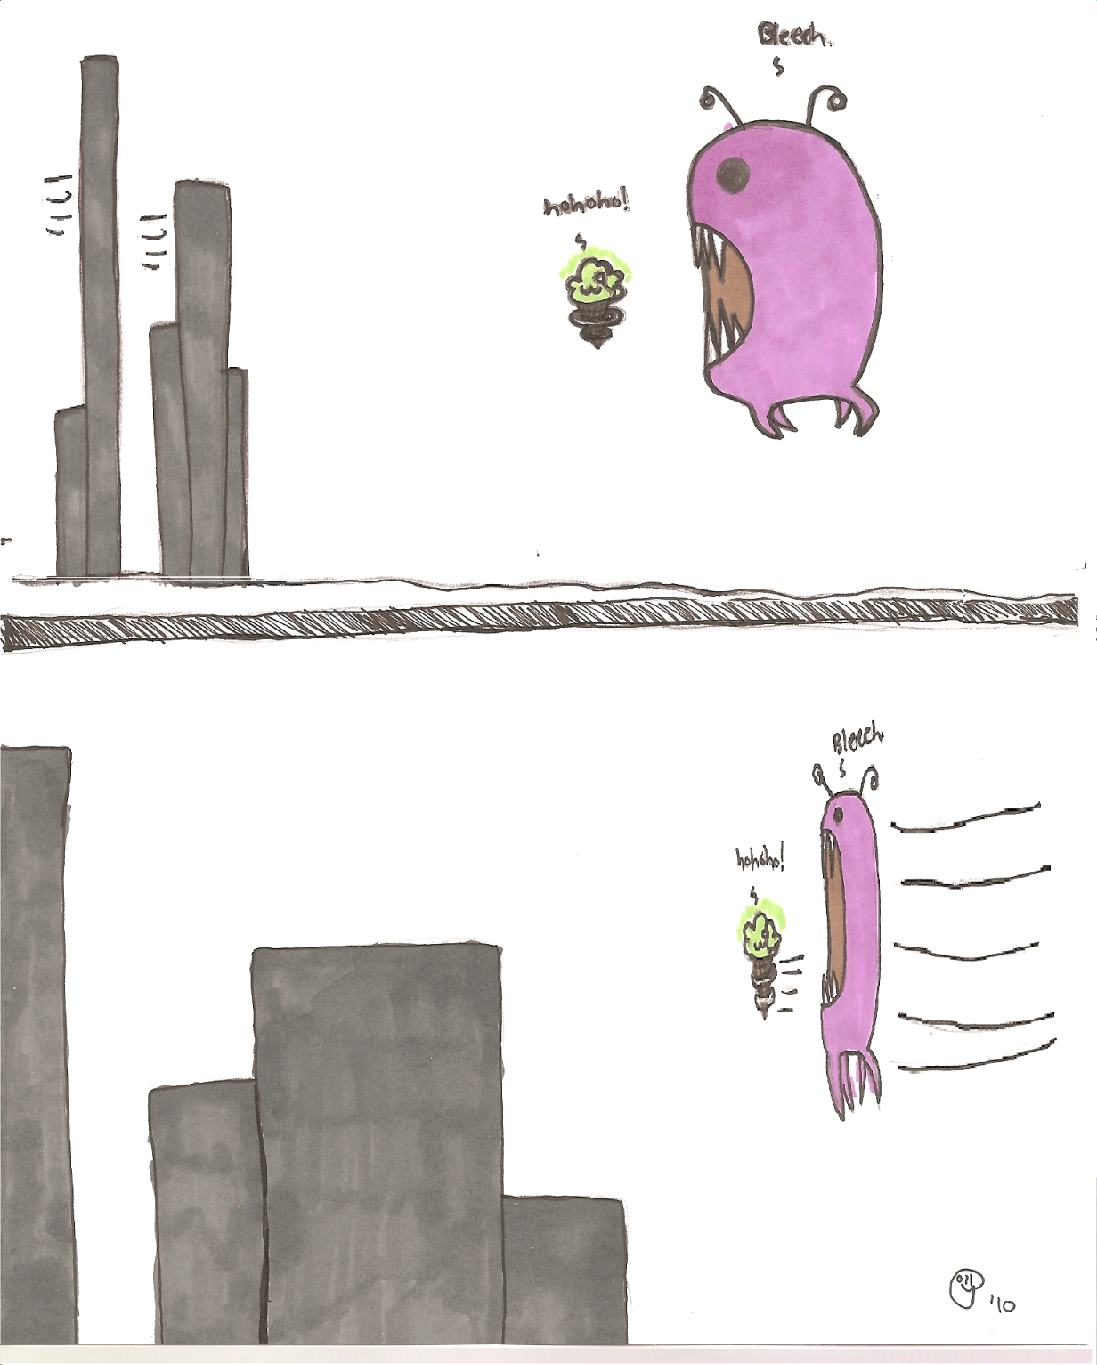

Copyright © 2016 by the Bucknell University Department of Physics & Astronomy.

All rights reserved.

Cover art by Polly Solomon