atharv desai

atharvdesai2002Gmail.com

Abstract

To manage Vaccines

Drug Lord v1.10

Vaccine Management System

Contents

Project Synopsis 2

Title. 2

Problem Statement 2

Why this Topic? 2

Objective and Scope. 2

Methodology for developing project. 2

Proposed Architecture 3

Requirements 3

Software Requirements 3

Hardware Requirements 3

Platform 4

Contribution 4

Conclusion 4

Introduction 5

Background 5

Objective 5

Purpose 5

Application 5

Scope 5

Achievements 5

Survey of Technology 7

# Project Synopsis

## Title.

Vaccine Management System Codename: DrugLordv1.10

## Problem Statement

The main objective of this System is to maintain records of vaccinations for the purpose of monitoring the quality of vaccine and timely assurance in rural area where health centres are not easily accessible.

## Why this Topic?

To reduce the paperwork required for maintaining records instead digitizing it for data visualization to minimize reading of records and providing easy access to third party bodies to get, deliver, administer vaccines.

## Objective and Scope.

* To reduce the paperwork required
* To maintain a detail record of each individual with ease
* To analyse data easily for the person/body using this system
* To create a system which manages both deliveries along with facility for vaccine administration

## Methodology for developing project.

In this system, I am going to use Extreme Programming for developing appropriate system as a solution for rapidly changing requirements

Advantages: Communication, Simple, Easy, Agile.

## Proposed Architecture

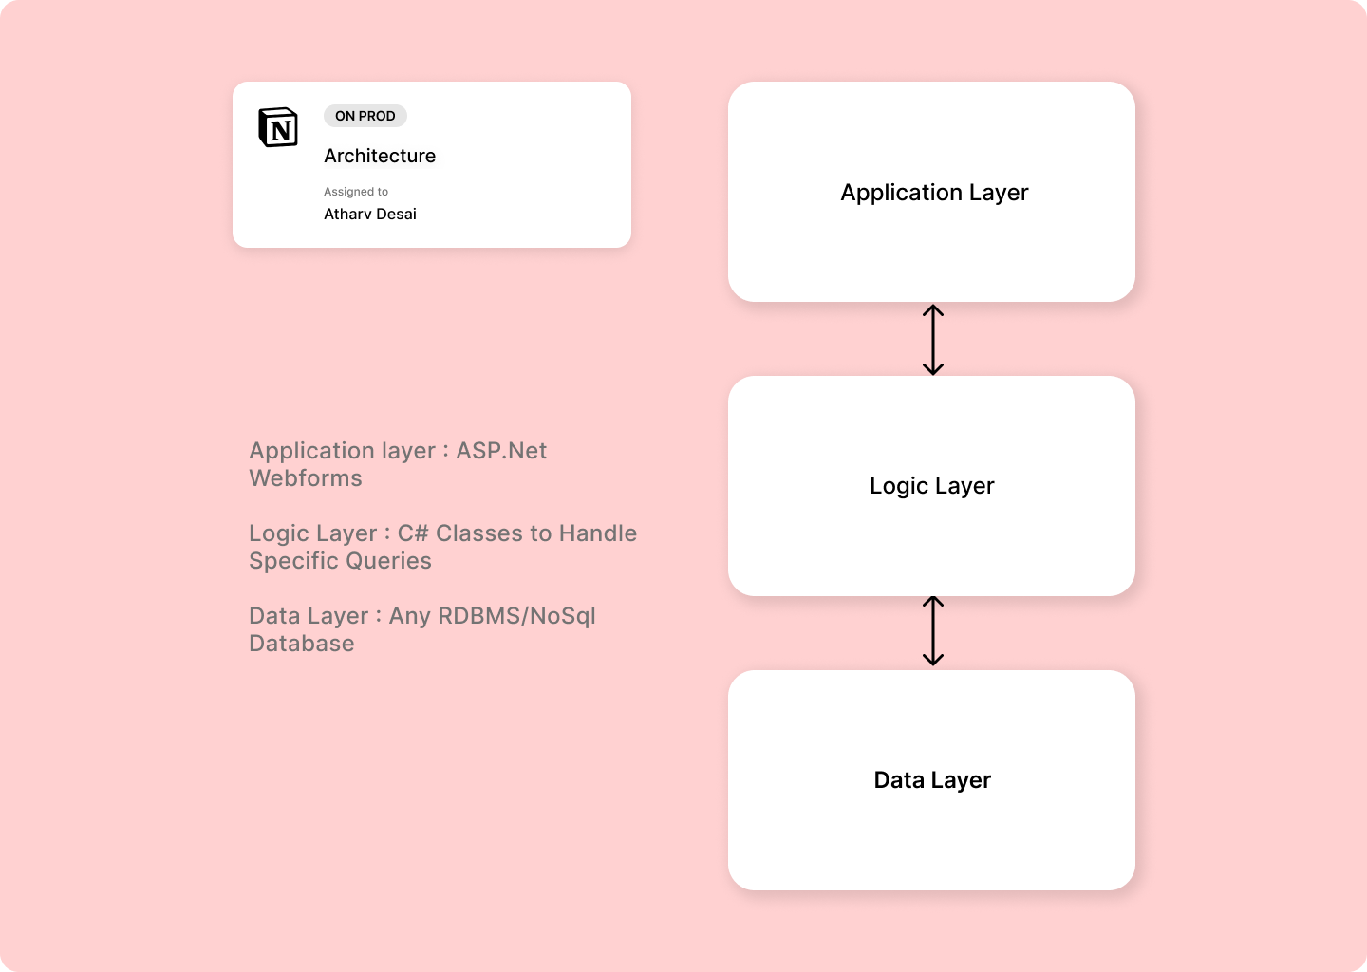

## Requirements

### Software Requirements

* Front-end : HTML5, CSS , JS,Tailwindcss
* Back-end :,ExpressJs, NodeJS, MongoDb.
* Operating System : Windows 7.0 +.

### Hardware Requirements

* Processor : Intel Core Duo 2.0 GHz or more.
* RAM : 2 GB or more.
* Monitor : 17 CRT or LCD.
* Hard disk : 500 GB or more.
* Keyboard: Normal or multimedia.

## Platform

Visual Studio Code

## Contribution

This system will help people in rural areas get access to vaccines along with reduced paperwork and record generation an keep of each individual till date.

## Conclusion

This system will help to reduce paper work and provide access to people in rural areas.

# Introduction

## Background

The current Vaccination Systems which are use are not centralized i.e., the data generated is confined to a organization or a company except due to recent pandemic newer methods are cultivated

References

* <https://www.servicenow.com/solutions/vaccine-management.htm>
* <https://www2.deloitte.com/us/en/pages/public-sector/solutions/vaccine-management-system.htm>
* [https://www.intelex.com/products/applications/vaccine-management}{Intelex Vaccine Solution](https://www.intelex.com/products/applications/vaccine-management%7d%7bIntelex%20Vaccine%20Solution)

## Objective

The main purpose of this project is to help benefit NGO's in providing vaccine access to rural area people without using musch resources, by providing a verified personal of NGO or any indiviual to request access to medical vaccine under the guidance of a medicine practitioner.

## Purpose

* Provide rural areas to the exposure of vaccine
* Create a platform where people can register for appointment, delivery as well as monitor the records.

## Application

The idea can be fundamentally used in any management system of products in any medical fields.

## Scope

Creating a platorm for all domestic producers to sell thier vaccines local consumers, NGO's etc and to simplify the delivery process, regulations and management.

## Achievements

By this project I will get to learn various technologies used to develop asystem. This system will give a digital platform to the all Domestic producers of vaccines which will increase the vaccine prdction rate and simplify the delivery process as well as help them to manage their data. Once they get satisfactory results from the system, users will start trusting the system and eventually most of the tasks will get digital.

# Survey of Technology