

**Fall Semester 2023**

Course Name: Software Testing

CSC 4399 - 02

**Assessment Type and number**

Milestone 4

Student’s Name: Bouchentouf Othman

Supervised by: Dr. Bouchaib Falah

Submission Date: 10 December 2023

1. **INTRODUCTION:**
   1. **SCOPE OF THE PROJECT :**

The project, named "**MyHomeLibrary**”, constitutes a comprehensive library management system poised to provide users with a multitude of functions and options. This system will empower librarians and library patrons alike by facilitating tasks such as catalog management, user registration, and resource access. Specifically, it will enable librarians to create, update, and maintain a digital catalog encompassing books, study rooms, events, user profiles, and guest data. Furthermore, it will allow users to register, log in, borrow books, attend events, and reserve study rooms. Importantly, it does not involve content creation, digitalization, or sales; instead, it emphasizes efficient resource management and user services.

The primary objective of "**MyHomeLibrary**" is to enhance productivity by simplifying tasks for both librarians and users. Users will have the capability to locate books, borrow them, and reserve study rooms and events. Simultaneously, the system will assist librarians in managing borrowed books, reserved rooms, and events efficiently. The application will consist of two key user roles: the Admin/Librarian and the User. The Admin/Librarian will have access to features such as user management, book and resource management, and event coordination. On the other hand, the User will be able to browse available books, reserve or borrow them, manage their borrowed items, reserve study rooms, and attend scheduled events, thus enriching their library experience.

* 1. **Feasibility Study of the Project:**
     1. **TECHNICAL FEASIBILITY:**

We believe that our team have the expertise to develop and maintain the application, and the necessary software and hardware support for it.

* + 1. **ECONOMIC FEASIBILITY:**

The project business is estimated to be at $100,000 which include software development, hardware acquisition and staff training.

* + 1. **FINANCIAL FEASIBILITY:**

The annual revenues are estimated to be $60,000 generated through app purchase and potential partnerships with e-book publishers.

* + 1. **LEGAL FEASIBILITY:**

The system will comply with the data privacy laws, intellectual property for software code and library content, content licensing and accessibility standards.

* + 1. **ENVIREMENTAL FEASIBILITY:**

This mobile library system is expected to reduce paper usage and energy consumption by promoting digital content and online services while also using sustainable hosting options and energy-efficient servers.

* 1. **OVERVIEW OF THE DOCUMENT OF THE WHOLE PROJECT:**

In the subsequent chapters of this project documentation, we will systematically delve into various facets of the application's development. Chapter 2 will encompass a comprehensive exploration of software requirements, encompassing both functional and non-functional aspects, along with an in-depth requirement analysis facilitated by the implementation of use-case diagrams. Moving forward to Chapter 3, we will focus on the architectural diagram that vividly portrays the structural underpinning of the application, alongside a class diagram that elucidates the intricate interactions among its constituent entities. Chapter 4 will pivot towards the heart of the project, providing a detailed examination of the entire project code, replete with accompanying screenshots that visually demonstrate the app's user interface and its multifaceted functionality. Finally, in Chapter 5, we will culminate the documentation with a presentation of the executable application, subjecting it to rigorous testing procedures to ascertain its alignment with the meticulously defined requirements.

1. **Requirements:**





**2.2.2.2 Operational requirement:** The application should be operational 24/7, with a dedicated support team available during business hours to handle user inquiries and technical issues promptly.

**2.2.2.3 Development requirement:** Comprehensive documentation, including code comments and user guides, must be maintained throughout the development process to facilitate future maintenance and enhancements.

**2.2.3 External requirement:**

**2.2.3.1 Regulatory requirement:** The application should comply with all relevant data protection and privacy regulations

**2.2.3.2 Ethical requirement:** The application should promote ethical practices, ensuring that user data is handled with utmost respect for privacy.

**2.2.3.3 Legislative requirement:**

**2.2.3.3.1 Accounting requirement:** The application should facilitate the generation of financial statements, budgeting, and auditing to ensure transparency and compliance with financial regulations.

**2.2.3.3.2 Safety/Security requirement:** The application must have mechanisms to protect users' personal information and ensure the safety of user data. It should have measures in place to prevent data breaches, unauthorized access, and secure authentication.

**2.3 Requirement Analysis:**

**2.3.1 Use case diagram:**

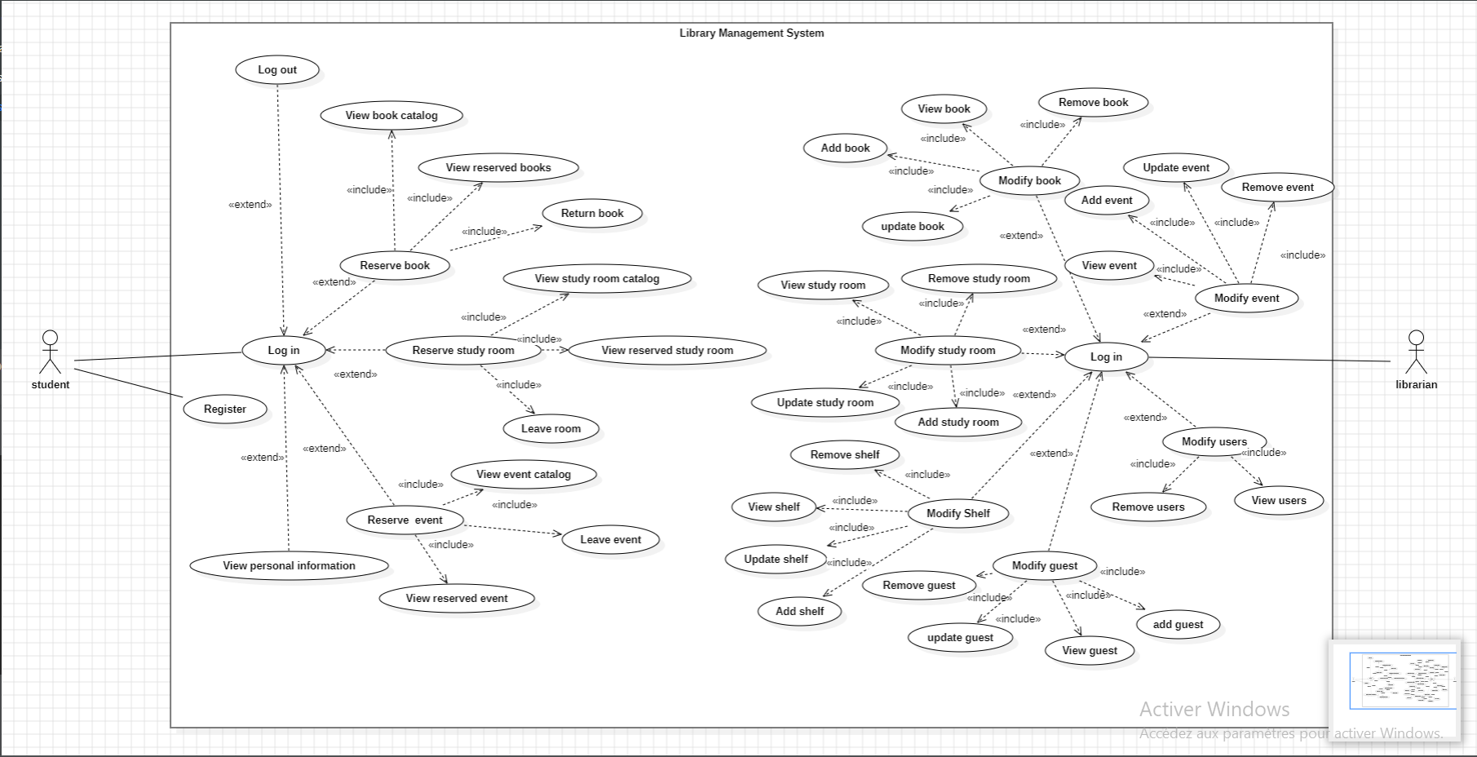

**2.3.2 Use Case Specification:**

**2.3.2.1 Log in**

|  |  |
| --- | --- |
| **Log in** | |
| **Use case ID** | **001** |
| **Actors:** | **Student, Admin** |
| **Description:** | **The user gets access to his account** |
| **Data:** | **User name, Password** |
| **Pre-condition** | **The user is in the login page** |
| **Main flow** | **The user selects the log in/sign in option.** |
| **Response:** | **A confirmation message and is redirected to the user-main page if it is a user or to admin-main page if it is the admin.** |

**2.3.2.2 Log out**

|  |  |
| --- | --- |
| **Log out** | |
| **Use case ID** | **002** |
| **Actors:** | **Student, Admin** |
| **Description:** | **The user leaves his account.** |
| **Data:** | **None** |
| **Pre-condition** | **The user is in any user page** |
| **Main flow** | **The user selects the log out option in menu bar.** |
| **Response:** | **The user is redirected to the main page.** |

**2.3.2.3 Register**

|  |  |
| --- | --- |
| **Register** | |
| **Use case ID** | **003** |
| **Actors:** | **Student** |
| **Description:** | **The user creates his account** |
| **Data:** | **User name, email, password** |
| **Pre-condition** | **The user is in main page** |
| **Main flow** | **The user select the register option and enters the username, email, password and confirms the password.** |
| **Response:** | **A confirmation message and is redirected to the user-main page if the inputs are correct or an error message if the passwords do not match or if the input types are incorrect.** |

**2.3.2.4 View book catalog**

|  |  |
| --- | --- |
| **View book catalog** | |
| **Use case ID** | **004** |
| **Actors:** | **Student, Admin** |
| **Description:** | **The user have access to a list of book available** |
| **Data:** | **None** |
| **Pre-condition** | **The user is in any user page** |
| **Main flow** | **The user select the view book button in menu bar options.** |
| **Response:** | **The system provides the list of all books available with their respective ID, title, author, field, status and shelf number.** |

**2.3.2.5 Reserve book**

|  |  |
| --- | --- |
| **Reserve book** | |
| **Use case ID** | **005** |
| **Actors:** | **Student** |
| **Description:** | **The user reserves a book** |
| **Data:** | **None** |
| **Pre-condition** | **The student is in the book catalog page** |
| **Main flow** | **The user select a book that he wants to reserve and click on it, and a small notification page will appear displaying the reserve book button.** |
| **Response:** | **A confirmation message is displayed or an error message. The system will then search for this book in the database and change the status from “available” to “not available” and associate the user ID to the book.** |

**2.3.2.6 View reserved book**

|  |  |
| --- | --- |
| **View reserved book** | |
| **Use case ID** | **006** |
| **Actors:** | **Student** |
| **Description:** | **The student gets a list of his reserved books** |
| **Data:** | **None** |
| **Pre-condition** | **The student is in the book catalog page** |
| **Main flow** | **The student selects the view reserved book option in the menu bar.** |
| **Response:** | **The system provides the list of all books he reserved with their respective ID, title, shelf number and user id.** |

**2.3.2.7 Return book**

|  |  |
| --- | --- |
| **Return book** | |
| **Use case ID** | **007** |
| **Actors:** | **Student** |
| **Description:** | **The student returns the reserved book** |
| **Data:** | **None** |
| **Pre-condition** | **The student is in the reserved book page** |
| **Main flow** | **The student selects one of his reserved books and clicks on remove from reservation.** |
| **Response:** | **A confirmation message that the book is removed.** |

**2.3.2.8 View study room catalog**

|  |  |
| --- | --- |
| **View study room catalog** | |
| **Use case ID** | **008** |
| **Actors:** | **Student, Admin** |
| **Description:** | **The student have a list of study rooms** |
| **Data:** | **None** |
| **Pre-condition** | **To be in the user page** |
| **Main flow** | **The student selects the study room option in the menu bar.** |
| **Response:** | **A List of study room will be displayed with their respective room ID and room label.** |

**2.3.2.9 Reserve study room**

|  |  |
| --- | --- |
| **Reserve study room** | |
| **Use case ID** | **009** |
| **Actors:** | **Student** |
| **Description:** | **The student reserve a study room** |
| **Data:** | **None** |
| **Pre-condition** | **The student is in the study room page** |
| **Main flow** | **The student selects one of the available study rooms and click on reserve study room.** |
| **Response:** | **A confirmation message that the study room has been reserved. Then the system will associate the study room ID to the user.** |

**2.3.2.10 View reserved study room**

|  |  |
| --- | --- |
| **View reserved study room** | |
| **Use case ID** | **010** |
| **Actors:** | **Student** |
| **Description:** | **The student have view of the study room he reserved** |
| **Data:** | **None** |
| **Pre-condition** | **The student is in the reserved study room page** |
| **Main flow** | **The student selects the study room reserved option in menu bar.** |
| **Response:** | **A List of reserved rooms will be displayed with their respective room ID and room label.** |

**2.3.2.11 Leave room**

|  |  |
| --- | --- |
| **Leave room** | |
| **Use case ID** | **011** |
| **Actors:** | **Student** |
| **Description:** | **The student leaves the room** |
| **Data:** | **None** |
| **Pre-condition** | **The student is in the reserved study room page** |
| **Main flow** | **The student selects one of his reserved rooms and clicks on remove from reservation.** |
| **Response:** | **A confirmation message that the book is removed.** |

**2.3.2.12 View event catalog**

|  |  |
| --- | --- |
| **View event catalog** | |
| **Use case ID** | **012** |
| **Actors:** | **Student, Admin** |
| **Description:** | **The user get a list of event** |
| **Data:** | **None** |
| **Pre-condition** | **The user is in the event page** |
| **Main flow** | **The student or admin selects event option on menu bar.** |
| **Response:** | **The system will show a list of events with their respective event ID, Name and guest.** |

**2.3.2.13 Reserve event**

|  |  |
| --- | --- |
| **Reserve event** | |
| **Use case ID** | **013** |
| **Actors:** | **Student** |
| **Description:** | **The student reserves an event** |
| **Data:** | **None** |
| **Pre-condition** | **The student is in the event page** |
| **Main flow** | **The student selects one of the available events and click on reserve event.** |
| **Response:** | **A confirmation message that the event has been reserved. Then the system will associate the event ID to the user.** |

**2.3.2.14 View reserved event**

|  |  |
| --- | --- |
| **View reserved event** | |
| **Use case ID** | **014** |
| **Actors:** | **Student** |
| **Description:** | **The student view his reserved event** |
| **Data:** | **None** |
| **Pre-condition** | **The student is in his reserved event page** |
| **Main flow** | **The student select reserved event option in menu bar.** |
| **Response:** | **A List of events reserved by that student with their respective event ID, Name and guest.** |

**2.3.2.15 Leave event**

|  |  |
| --- | --- |
| **Leave event** | |
| **Use case ID** | **015** |
| **Actors:** | **Student** |
| **Description:** | **The student leaves the event** |
| **Data:** | **None** |
| **Pre-condition** | **The student is in his reserved event page** |
| **Main flow** | **The student selects one of his reserved events and clicks on remove from reservation.** |
| **Response:** | **A confirmation message that the event is removed.** |

**2.3.2.16 View personal information**

|  |  |
| --- | --- |
| **View personal information** | |
| **Use case ID** | **016** |
| **Actors:** | **Student** |
| **Description:** | **The student view a list of his personal information** |
| **Data:** | **None** |
| **Pre-condition** | **The student is in his main user page** |
| **Main flow** | **The student selects settings option on the menu bar.** |
| **Response:** | **The user information will be displayed.** |

**2.3.2.17 Add book**

|  |  |
| --- | --- |
| **Add book** | |
| **Use case ID** | **017** |
| **Actors:** | **Admin** |
| **Description:** | **The librarian adds book to the catalog.** |
| **Data:** | **Title, author, field, shelf.** |
| **Pre-condition** | **The admin is in the librarian main page** |
| **Main flow** | **The admin selects Add book option on the menu bar and inputs the Title, author and field, and shelf of the book.** |
| **Response:** | **A confirmation message that the book has been added.** |

**2.3.2.18 Remove book**

|  |  |
| --- | --- |
| **Remove book** | |
| **Use case ID** | **018** |
| **Actors:** | **Admin** |
| **Description:** | **The admin removes a book from the catalog** |
| **Data:** | **None** |
| **Pre-condition** | **The admin is in the book view page** |
| **Main flow** |  |
| **Response:** | **A confirmation message that the book is removed.** |

**2.3.2.19 Update book**

|  |  |
| --- | --- |
| **Update book** | |
| **Use case ID** | **019** |
| **Actors:** | **Admin** |
| **Description:** | **The admin update a book’s information** |
| **Data:** | **Title, author, field and shelf.** |
| **Pre-condition** | **The admin is in his book view page** |
| **Main flow** | **The admin selects one of the book and clicks on update book.** |
| **Response:** | **The system will redirect the user to a page where he can change the information.** |

**2.3.2.20 Add study room**

|  |  |
| --- | --- |
| **Add study room** | |
| **Use case ID** | **020** |
| **Actors:** | **Admin** |
| **Description:** | **The admin adds a study room to catalog** |
| **Data:** | **room label** |
| **Pre-condition** | **The admin is in his study room view page** |
| **Main flow** | **The admin selects add room option on the menu bar and inputs the label of the room.** |
| **Response:** | **A confirmation message that the study room is created.** |

**2.3.2.21 Remove study room**

|  |  |
| --- | --- |
| **Remove study room** | |
| **Use case ID** | **021** |
| **Actors:** | **Admin** |
| **Description:** | **The admin removes a study room from catalog** |
| **Data:** | **None** |
| **Pre-condition** | **The admin is in his study room view page** |
| **Main flow** | **The admin selects one of the study rooms and clicks on delete.** |
| **Response:** | **A confirmation message that the study room is removed.** |

**2.3.2.22 Update study room**

|  |  |
| --- | --- |
| **Update study room** | |
| **Use case ID** | **022** |
| **Actors:** | **Admin** |
| **Description:** | **The admin updates a study room information** |
| **Data:** | **Room label** |
| **Pre-condition** | **The librarian is in the study room view page** |
| **Main flow** | **The admin selects one of the study rooms and clicks on update study room and change the information.** |
| **Response:** | **The system will redirect the user to a page where he can change the information.** |

**2.3.2.23 Add shelf**

|  |  |
| --- | --- |
| **Add shelf** | |
| **Use case ID** | **023** |
| **Actors:** | **Admin** |
| **Description:** | **The admin adds a shelf to the catalog.** |
| **Data:** | **Shelf label and room number** |
| **Pre-condition** | **The librarian is in the shelf view page** |
| **Main flow** | **The admin selects add shelf option on the menu bar and inputs shelf label and shelf number.** |
| **Response:** | **A confirmation message that the shelf is added.** |

**2.3.2.24 Remove shelf**

|  |  |
| --- | --- |
| **Remove shelf** | |
| **Use case ID** | **024** |
| **Actors:** | **Admin** |
| **Description:** | **The admin removes a shelf from catalog** |
| **Data:** | **None** |
| **Pre-condition** | **The librarian is in the shelf view page** |
| **Main flow** | **The admin selects one of the shelves and clicks on delete shelf.** |
| **Response:** | **A confirmation message that the shelf is removed.** |

**2.3.2.25 Update shelf**

|  |  |
| --- | --- |
| **Update shelf** | |
| **Use case ID** | **025** |
| **Actors:** | **Admin** |
| **Description:** | **The admin update a shelf information** |
| **Data:** | **shelf label and room number** |
| **Pre-condition** | **The librarian is in the view shelf page** |
| **Main flow** | **The admin selects one of the shelves and clicks on update shelf.** |
| **Response:** | **The system will redirect the user to a page where he can change the information of the shelf.** |

**2.3.2.26 Add guest**

|  |  |
| --- | --- |
| **Add guest** | |
| **Use case ID** | **026** |
| **Actors:** | **Admin** |
| **Description:** | **The admin adds a guest to the catalog** |
| **Data:** | **Guest name and guest profession** |
| **Pre-condition** | **The librarian is in the guest view page** |
| **Main flow** | **The admin selects add guest option on the menu bar and inputs guest name and guest profession.** |
| **Response:** | **A confirmation message that the guest is added.** |

**2.3.2.27 Remove guest**

|  |  |
| --- | --- |
| **Remove guest** | |
| **Use case ID** | **027** |
| **Actors:** | **Admin** |
| **Description:** | **The admin deletes a guest from catalog** |
| **Data:** | **None** |
| **Pre-condition** | **The librarian is in the guest view page** |
| **Main flow** | **The admin selects one of the guests and clicks on delete guest.** |
| **Response:** | **A confirmation message that the guest is removed.** |

**2.3.2.28 Update guest**

|  |  |
| --- | --- |
| **Update guest** | |
| **Use case ID** | **028** |
| **Actors:** | **Admin** |
| **Description:** | **The admin updates a guest information** |
| **Data:** | **Guest name and guest profession** |
| **Pre-condition** | **The librarian is in the guest view page** |
| **Main page** | **The admin selects one of the guests and clicks on update guest.** |
| **Response:** | **The system will redirect the user to a page where he can change the information of the guest.** |

**2.3.2.29 Add event**

|  |  |
| --- | --- |
| **Add event** | |
| **Use case ID** | **029** |
| **Actors:** | **Admin** |
| **Description:** | **The admin adds an event to catalog.** |
| **Data:** | **Event name and guest ID** |
| **Pre-condition** | **The librarian is in the event view page** |
| **Main flow** | **The admin selects add event option on the menu bar and inputs guest name and guest profession.** |
| **Response:** | **A confirmation message that the event is added.** |

**2.3.2.30 Remove event**

|  |  |
| --- | --- |
| **Remove event** | |
| **Use case ID** | **030** |
| **Actors:** | **Admin** |
| **Description:** | **The admin remove an event from catalog** |
| **Data:** | **None** |
| **Pre-condition** | **The librarian is in the event view catalog** |
| **Main flow** | **The admin selects one of the events and clicks on delete event.** |
| **Response:** | **A confirmation message that the event is removed.** |

**2.3.2.31 Update event**

|  |  |
| --- | --- |
| **Update event** | |
| **Use case ID** | **031** |
| **Actors:** | **Admin** |
| **Description:** | **The admin update an event** |
| **Data:** | **Event name and guest ID** |
| **Pre-condition** | **The librarian is in the event view catalog** |
| **Main flow** | **The admin selects one of the events and clicks on update event.** |
| **Response:** | **The system will redirect the user to a page where he can change the information of the event.** |

**2.3.2.32 View users**

|  |  |
| --- | --- |
| **View users** | |
| **Use case ID** | **032** |
| **Actors:** | **Admin** |
| **Description:** | **The admin have a list of users registered** |
| **Data:** | **None** |
| **Pre-condition** | **The librarian Is in the user view page** |
| **Main flow** | **The admin selects View users option on the menu bar** |
| **Response:** | **A list of Users with their respective ID, name, email, room_num and event_num will be displayed.** |

**2.3.2.33 Delete users**

|  |  |
| --- | --- |
| **Delete users** | |
| **Use case ID** | **033** |
| **Actors:** | **Admin** |
| **Description:** | **The admin deletes a user from catalog** |
| **Data:** | **None** |
| **Pre-condition** | **The librarian is in the user view page** |
| **Main flow** | **The admin selects a user and clicks on delete** |
| **Response:** | **A confirmation message that the user is deleted.** |

**2.3.2.34 View shelves**

|  |  |
| --- | --- |
| **View shelves** | |
| **Use case ID** | **034** |
| **Actors:** | **Admin** |
| **Description:** | **The admin have a list of shelves** |
| **Data:** | **None** |
| **Pre-condition** | **The librarian is in the view shelf page** |
| **Main flow** | **The admin selects View shelves option on the menu bar** |
| **Response:** | **A list of shelves with their respective ID, label and room ID will be displayed.** |

**2.3.2.35 View guests**

|  |  |
| --- | --- |
| **View guests** | |
| **Use case ID** | **035** |
| **Actors:** | **Admin** |
| **Description:** | **The admin has a list of guests** |
| **Data:** | **None** |
| **Pre-condition** | **The librarian is in the view guest page** |
| **Main flow** | **The admin selects View guests option on the menu bar** |
| **Response:** | **A list of guests with their respective ID, name and job will be displayed.**  **.** |

1. **Software Design :**

**3.1. Package diagram:**

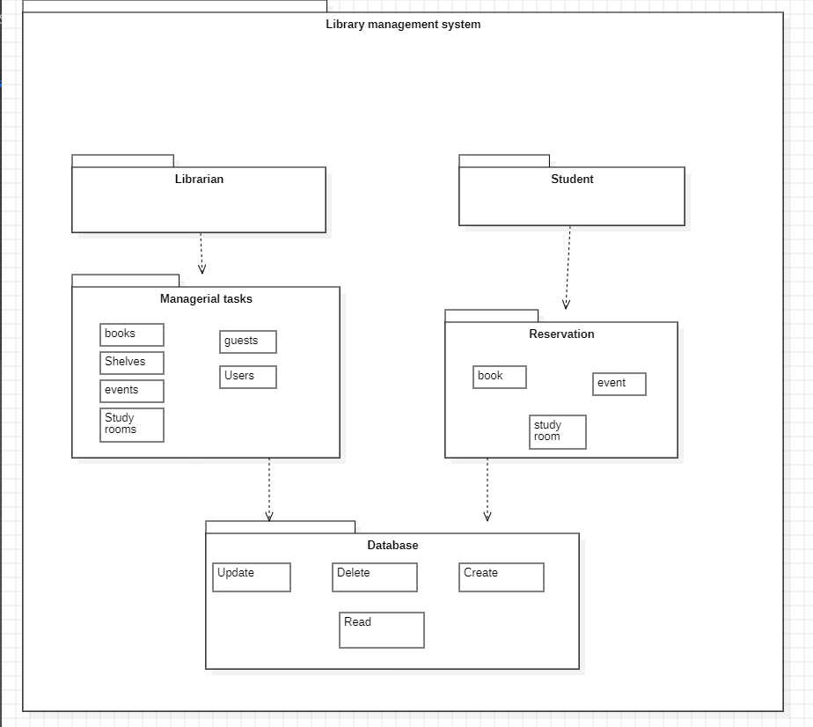

**3.2. Class diagram:**

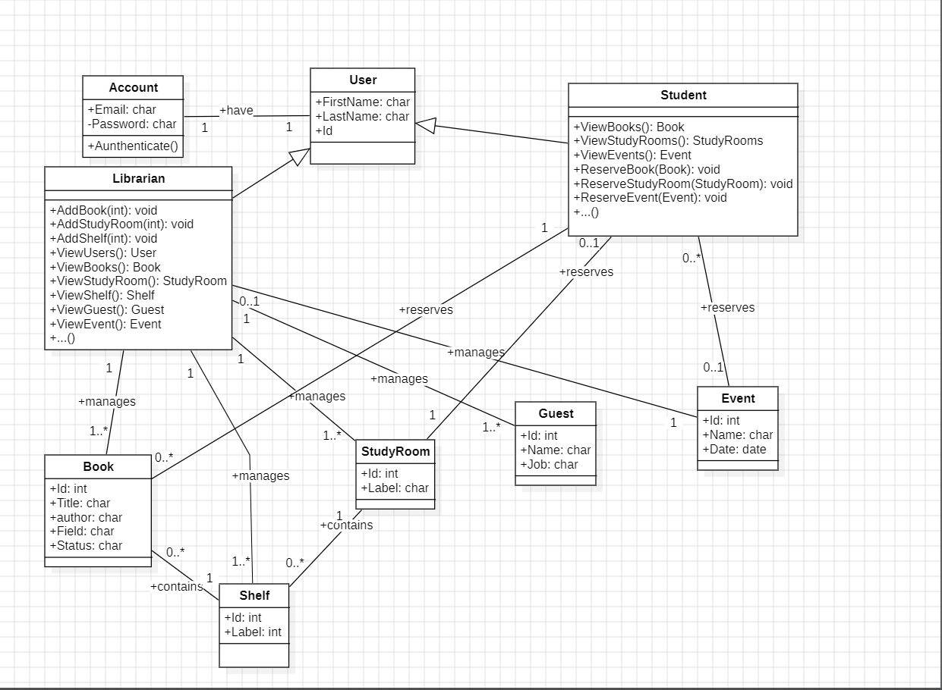

1. **Software Implementation :**

**4.1. Source Code and tools used:**

Please view the content of the ZIP file for the source code.

The development of our smartphone application was executed using Kotlin as the primary programming language, in conjunction with XML for defining the user interface components. Android Studio served as the integrated development environment (IDE), offering a robust platform for Android app creation. The choice of Kotlin, a modern and expressive language designed for the Java Virtual Machine (JVM), facilitated concise and readable code, enhancing our productivity. XML, on the other hand, played a pivotal role in crafting the user interface, allowing for the structured definition of layouts and views. To manage the application's data, we implemented SQLite as the database management system. SQLite's lightweight and embedded nature provided an efficient and reliable solution for storing and retrieving data within the mobile application. This combination of Kotlin, XML, and SQLite in Android Studio empowered us to create a responsive and feature-rich application, delivering a seamless user experience.

**4.2. Some Screenshots of the app:**

*Main page:*

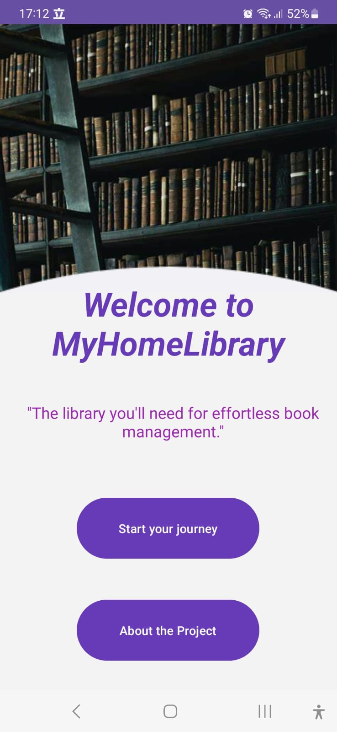

*Log in/ sign in page:*

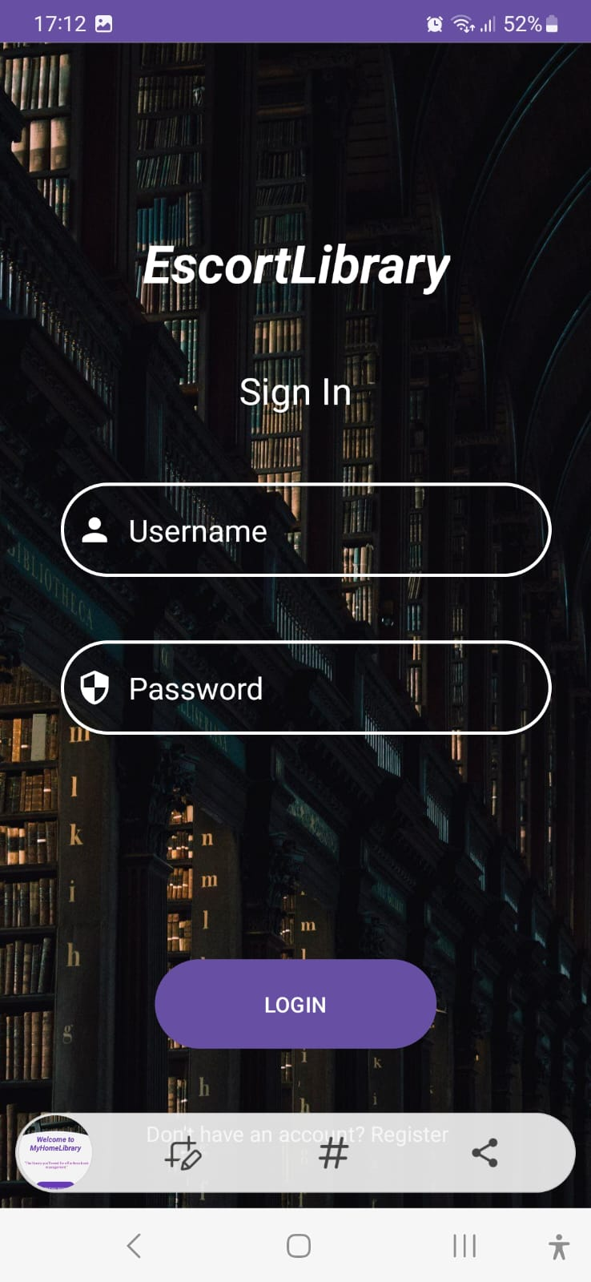

*Register / create account page:*

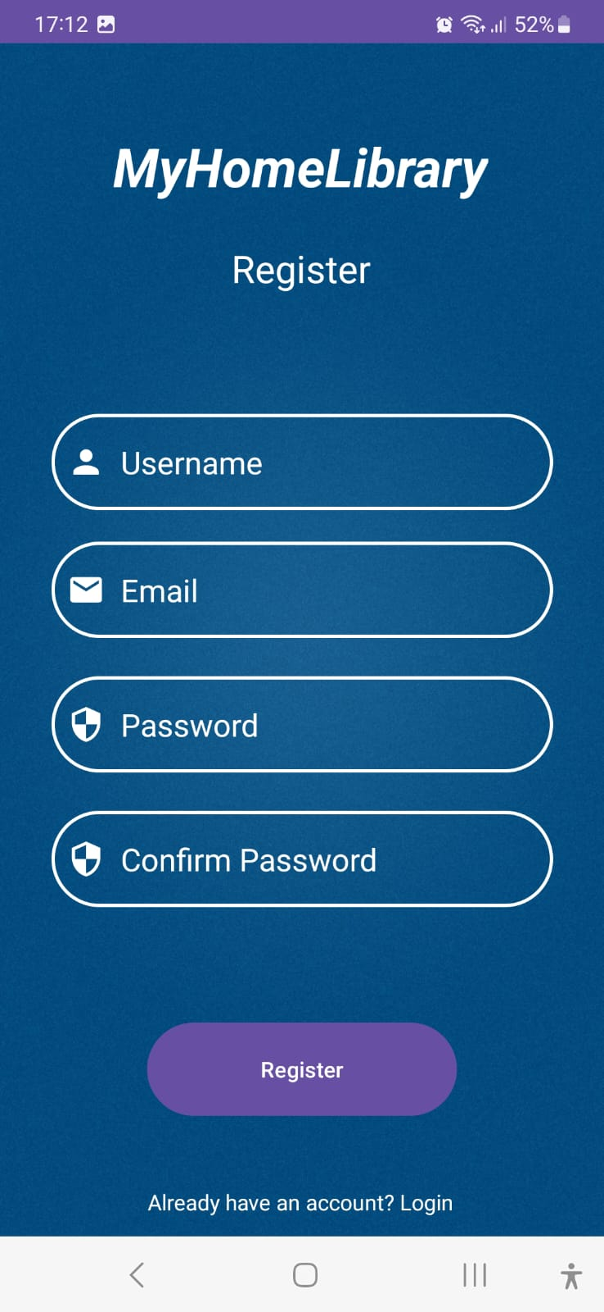

*User list from admin page:*

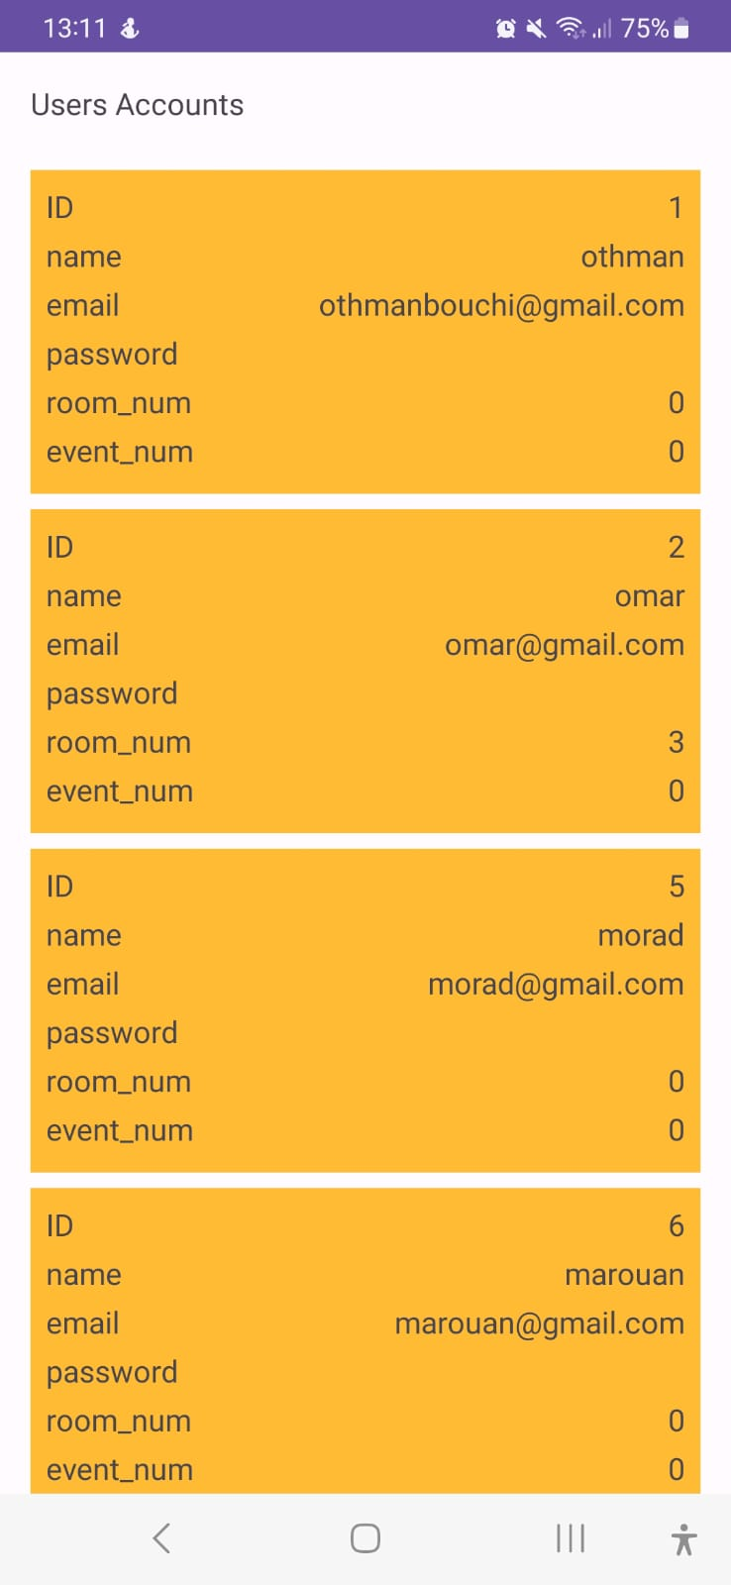

*Book list from admin page:*

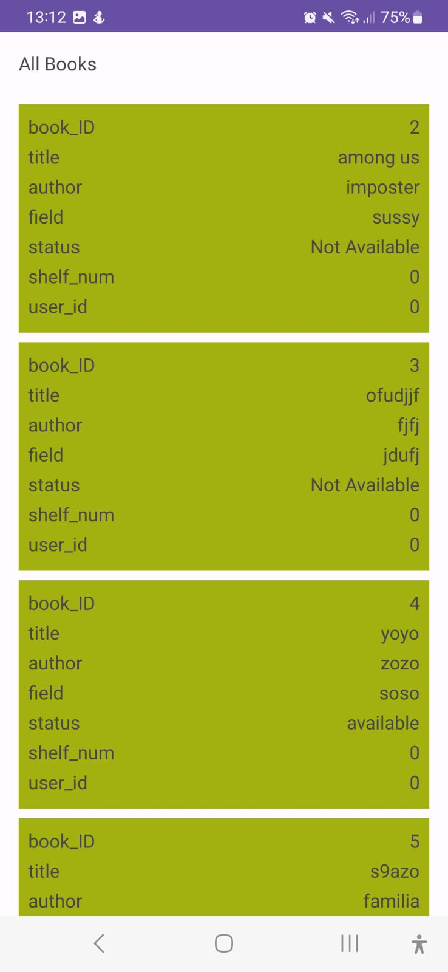

*Book functions:*

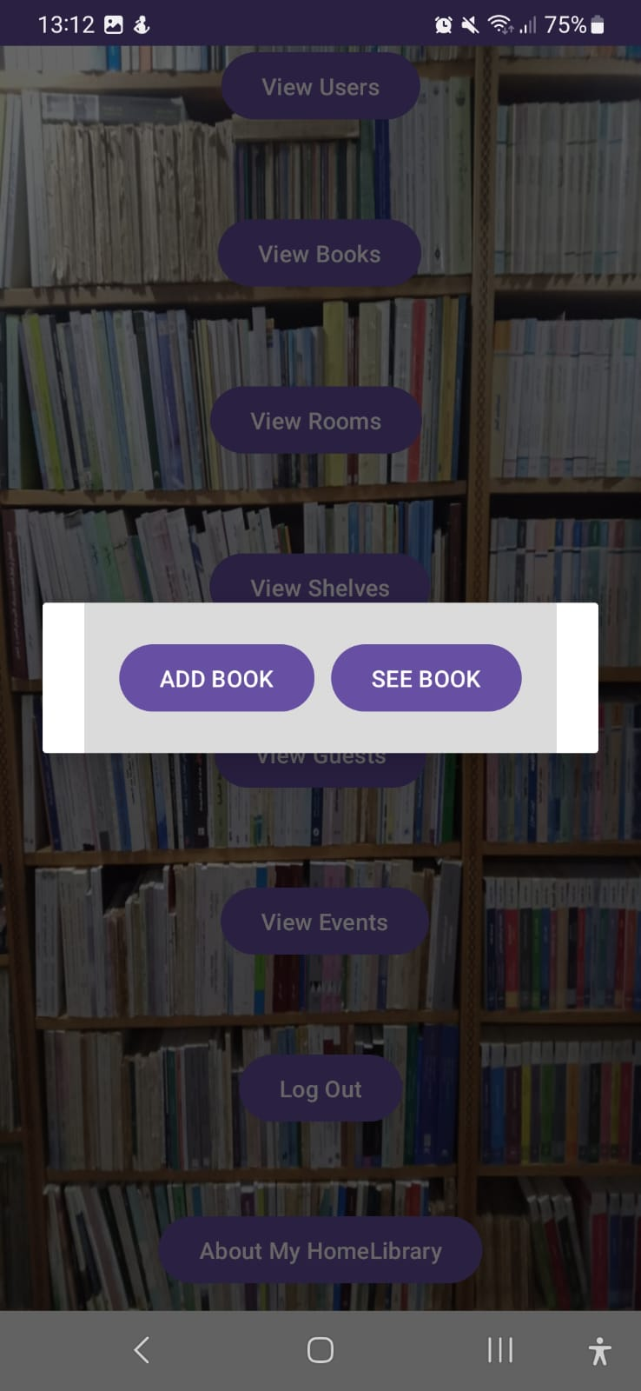

*Add book:*

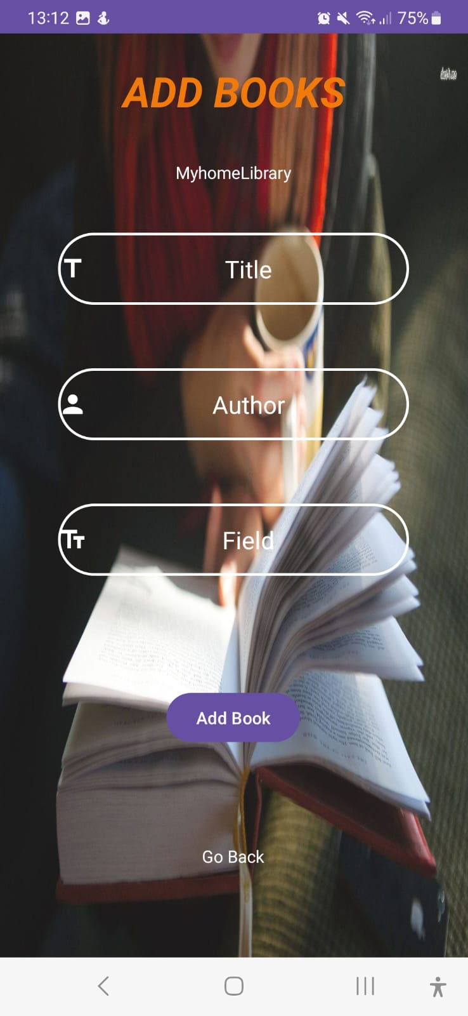

*Same functionality goes for rooms, guests, events and shelves (for adding, listing, and deleting)*

*User view of books:*

*(here, it list the books that have the status == ‘available’, which means books that did not get reserved by other students)*

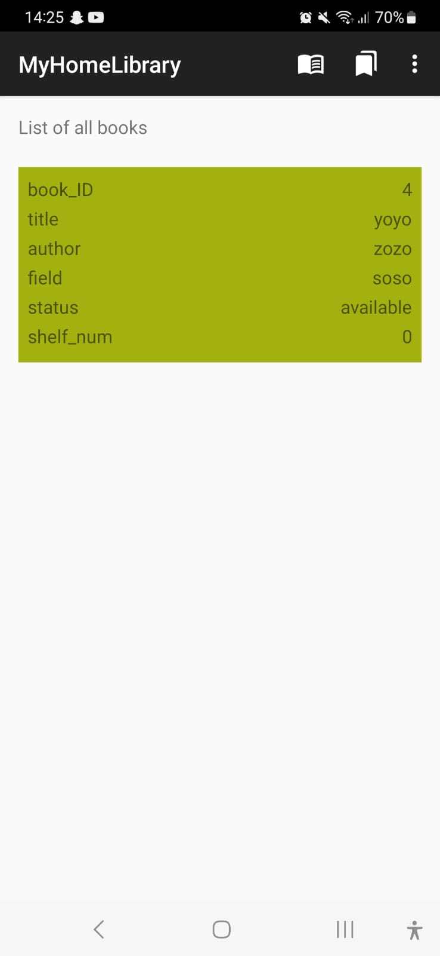

*Reserve book procedure:*

*We click on the book and then click on reserve*

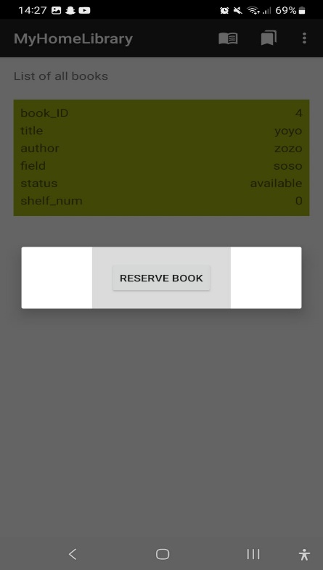

*We then go then to the reserved book area to see the book reserved by this student.*

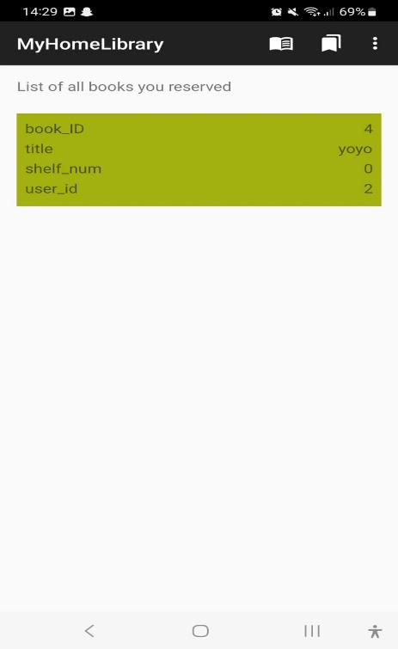

*We can see that the book reserved is stored in this page.*

*The same procedure goes for the reservation of events and study rooms.*