
Supervised Learning and neural networks
COMP3611: Coursework 1

november 03, 2016
Othman Alikhan
sc14omsa@leeds.ac.uk
University of Leeds

1) the dataset

Class 1
x-range = [2,5]
y-range = [1,4]
rotation = 75 degrees
colour = red

Class 2
x-range = [1, 3]
y-range = [-5, -1]
rotation = 75 degrees
colour = blue

Class 3
mean = (-2, -3)
covariance = [[0.5, 0], [0, 3]]
colour = green

Class 4
mean = (-4, -1)
covariance = [[3, 0.5], [0.5, 0.5]]
colour = cyan
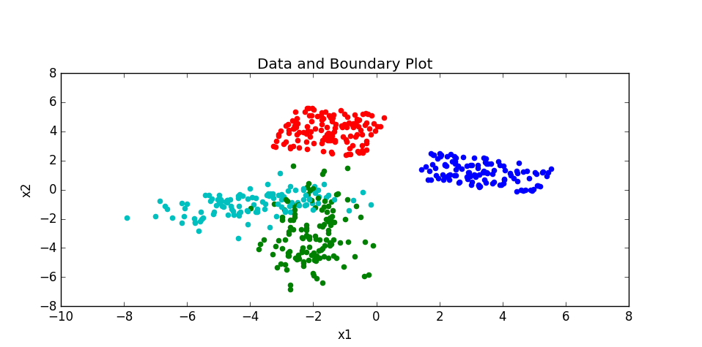
Figure 1. Plot of the data instances.

2) the Single-layer Perceptron

Classes Chosen: Class 2 (blue) and all other classes treated as a single class (red, green, cyan).
Reason: The two classes as shown above are linearly separable hence the single perceptron will be able to linearly distinguish them.
On the other hand, if classes, say, Class 3 (cyan) and Class 4 (green) were chosen, then the single-layer perceptron would perform poorly as they are not linearly separable.

Training Parameters
epoch = 10
batch = 10
eta (optimal) = 0.2 (since it reaches near 0 error the first and has the least errors after the epoch=1)
accuracy = 1.0 = 100% (see the hyperplane below separator below correctly classifying all instances)
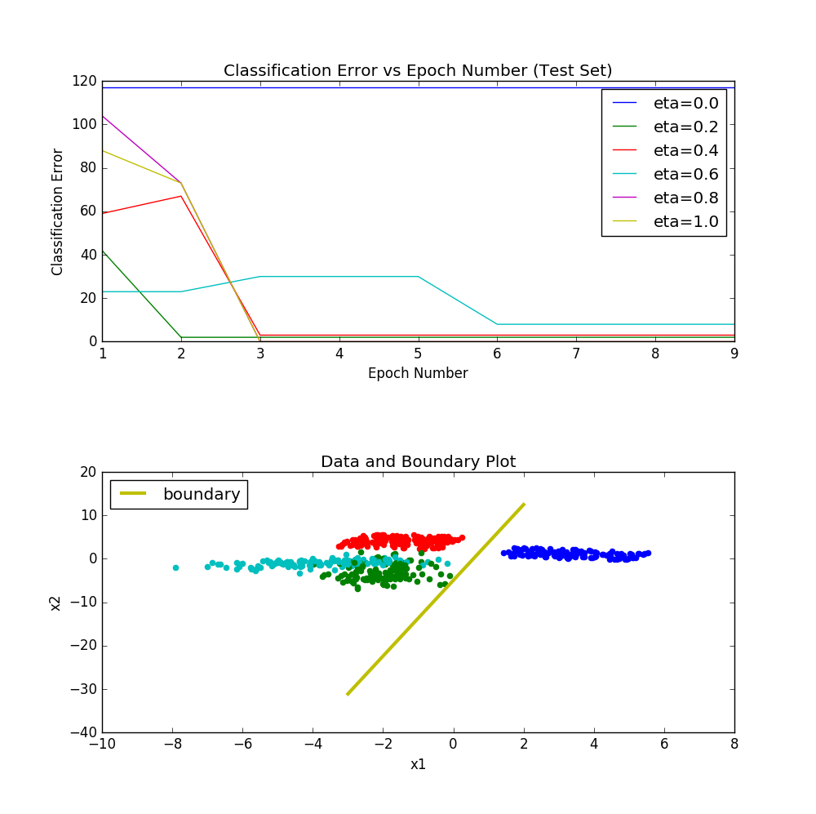

2) the Multi-layer Perceptron

Training Parameters
epoch = 200
batch = 5
eta = 0.1

hidden nodes = 2
confusion matrix:
[[132 0 0 0]
[ 0 116 0 0]
[ 4 0 0 129]
[ 10 0 0 109]]
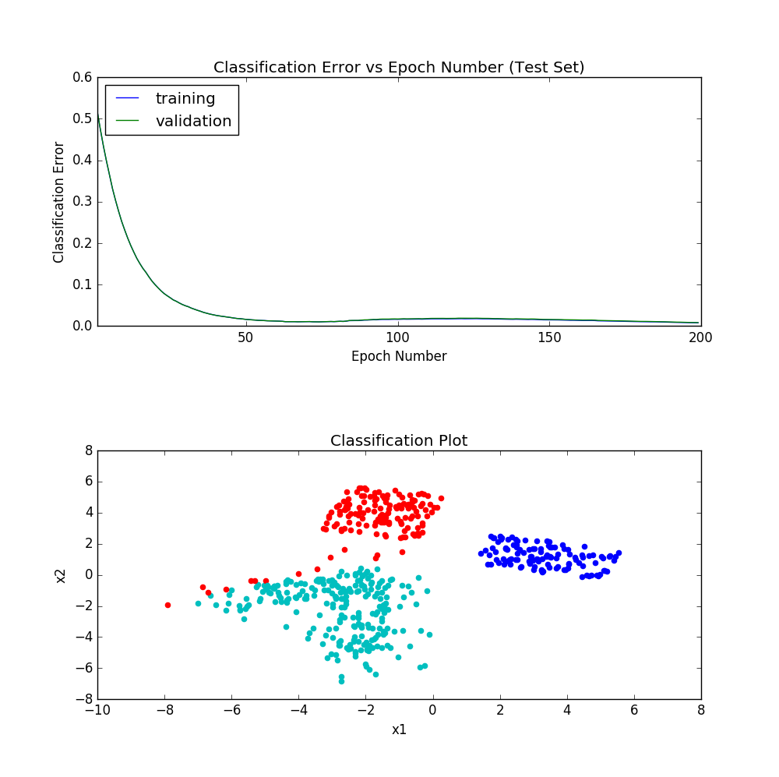

hidden nodes = 5 (BEST PERFORMANCE (see matrix and plot below))
confusion matrix:
[[132 0 0 0]
[ 0 116 0 0]
[ 3 0 120 10]
[ 0 0 26 93]]

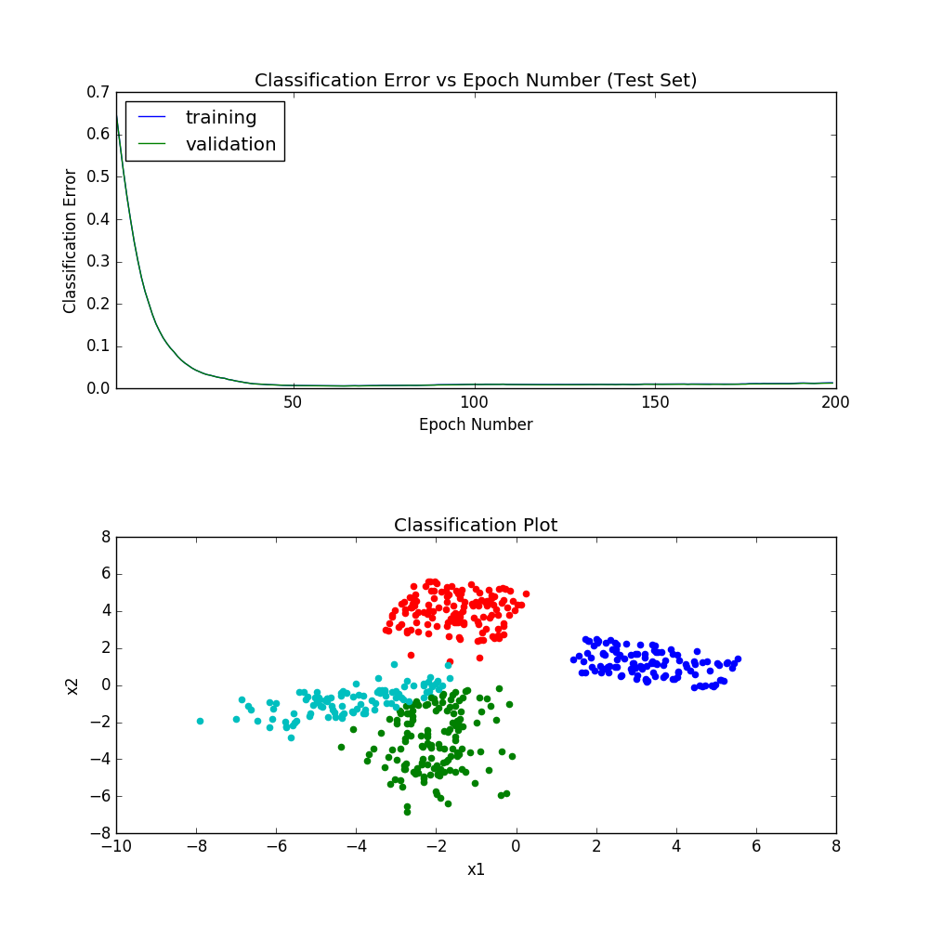

hidden nodes = 20
confusion matrix:
[[132 0 0 0]
[ 0 116 0 0]
[ 4 0 119 10]
[ 2 0 24 93]]

