Visual Assets Showcase
Images, logos, signatures, and SVG charts rendered by RusDox

Context
This example exercises the new visual block support with both raster and SVG assets.
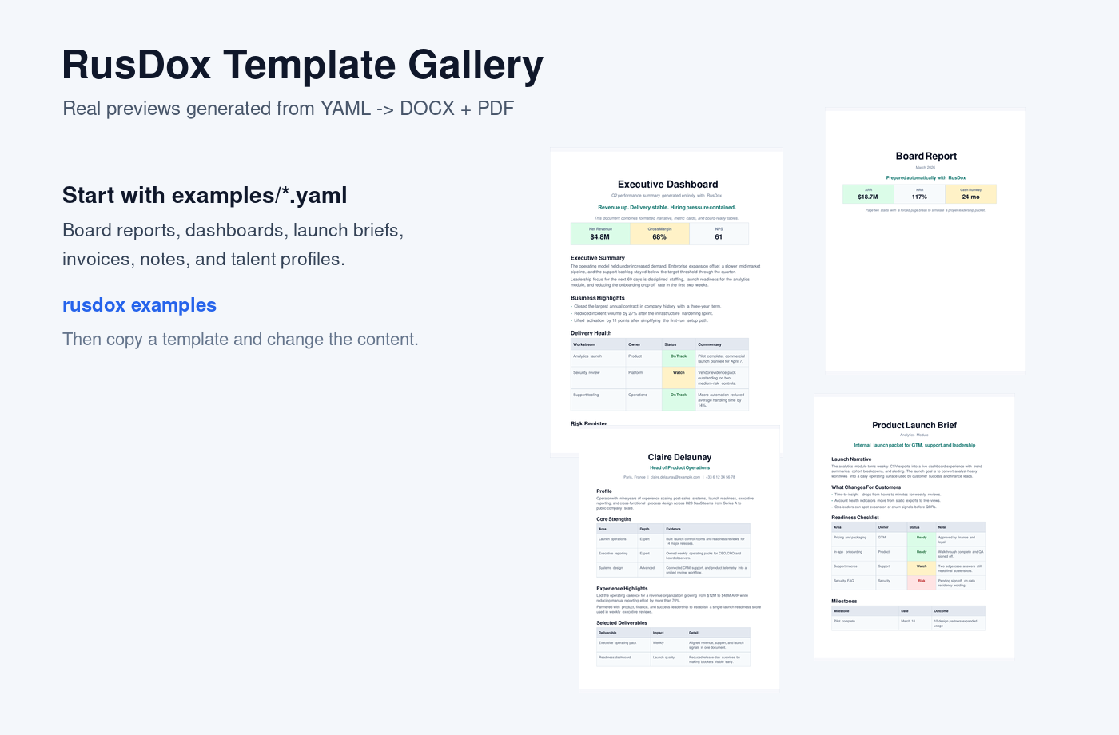
Benchmark Chart
SVG chart files now flow through the same document pipeline and render into both DOCX and PDF outputs.
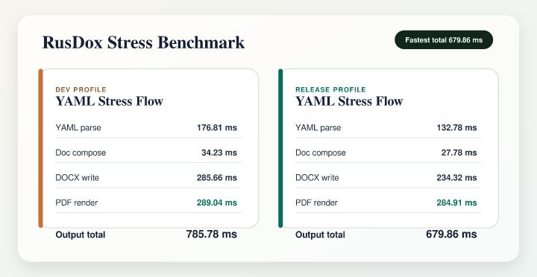
Sign-Off
Signatures and approval marks can be embedded directly as SVG assets.


