Pizza Sales SQL Queries

- KPI’s
- Total Revenue
Select sum(total_price) as Total_Revenue
From pizza_sales

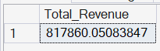

- Average Order Value

Select sum(total_price)/COUNT(distinct order_id) as Average_Order_Value
From pizza_sales

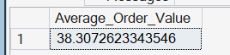

- Total Sold Pizzas

select sum(quantity) as total_pizza_sold from pizza_sales

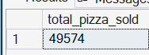
- Total Orders
select count(distinct order_id) as total_orders from pizza_sales

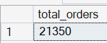
- Average Pizzas Per Order
select cast (cast (sum(quantity) AS decimal(10, 2)) / cast( count(distinct order_id) as decimal(10,2)) as decimal (10,2))as Average_Pizza_Per_Order
from pizza_sales

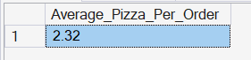
- Daily Trends for Total Orders
Select DATENAME(DW, order_date) as Order_Days, COUNT(Distinct order_id) As Total_Order
from pizza_sales
group by DATENAME(DW, order_date)

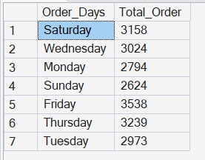
- Monthly Trends for Total Orders
Select DATENAME(month, order_date) as Order_Months, COUNT(Distinct order_id) As Total_Order
from pizza_sales
group by DATENAME(month, order_date)

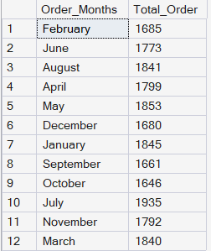

- Percentage of sales by pizza category
Select pizza_category, CAST(SUM(total_price) AS decimal (10,2)) as total_reveune, CAST(sum(total_price) * 100 / (Select sum(total_price) from pizza_sales) AS Decimal (10,2)) AS Percentage_Of_Pizza_Sales
from pizza_sales
group by pizza_category
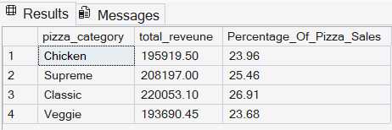

- Percentage of Sales by Pizza size

Select pizza_size, CAST(SUM(total_price) AS decimal (10,2)) as total_reveune, CAST(sum(total_price) * 100 / (Select sum(total_price) from pizza_sales) AS Decimal (10,2)) AS Percentage_Of_Pizza_Sales
from pizza_sales
group by pizza_size

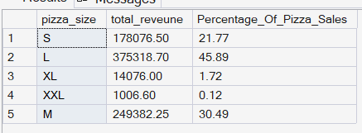
- Total Pizza Sold By Pizza Category

Select pizza_category, sum (quantity) as total_quantity_sold
from pizza_sales
group by pizza_category
order by total_quantity_sold DESC

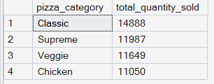

- Top 5 Pizzas by Revenue

Select top 5 pizza_name, sum (total_price) as total_revenue
from pizza_sales
group by pizza_name
order by total_revenue DESC
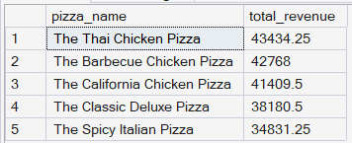

- Bottom 5 Pizzas By Revenue
Select top 5 pizza_name, sum (total_price) as total_revenue
from pizza_sales
group by pizza_name
order by total_revenue ASC

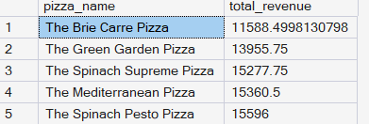

- Top 5 pizzas By Quantity
Select top 5 pizza_name, sum (quantity) as total_revenue
from pizza_sales
group by pizza_name
order by total_revenue Desc

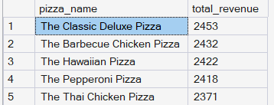

- Bottom 5 Pizzas by Quantity
Select top 5 pizza_name, sum (quantity) as total_revenue
from pizza_sales
group by pizza_name
order by total_revenue ASC
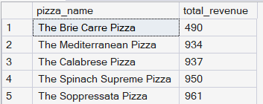

- Top 5 pizzas by total orders
Select top 5 pizza_name, count (order_id) as total_revenue
from pizza_sales
group by pizza_name
order by total_revenue Desc

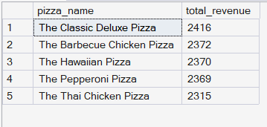

- Bottom 5 Pizzas by total orders
Select top 5 pizza_name, count (order_id) as total_revenue
from pizza_sales
group by pizza_name
order by total_revenue ASC

