Empirical Analysis of List-Based and Tree-Based Union-Find Structures
John Sutton, Robert Morris, Nolan Schiek, Sawyer Blanchford
CSC 2400, Christina Radian
December 1st, 2025
Overview: The goal of this project was to study the performance of two different approaches for solving the dynamic connectivity problem using the Union-Find data structure. This problem appears in a wide range of algorithmic settings, including Kruskal’s minimum spanning tree algorithm, percolation simulation, clustering, and network connectivity. Union-Find maintains a partition of a universe of elements and supports efficient merging of sets through the union operation as well as questions about whether two elements belong to the same set through the find operation. We implemented a list-based structure in addition to a tree-based structure. The list-based implementation represents each set as a linked list, maintains header pointers for each element, and uses weighted union to reduce total pointer updates when merging. The tree-based structure stores parent pointers for each element and uses union-by-size or union-by-rank along with path compression to keep the tree shallow. After building both structures, we executed a series of experiments to measure runtime, pointer update counts, and structural properties such as maximum depth. The goal was to determine empirically how close each implementation comes to its theoretical complexity bounds and how the two compare under different types of workloads.
Research Questions: Before running any experiments, we defined a set of research questions that guided our study. The main objective was to determine whether the two Union-Find variants behave empirically as predicted by theory, particularly regarding amortized performance. Specifically, we asked whether the list-based implementation exhibits the expected logarithmic growth in cost as the input size increases, whether the tree-based structure demonstrates nearly constant amortized performance when path compression and union-by-rank are used, and how pointer update counts differ between the two approaches. We also wanted to understand how both structures behave under adversarial sequences of operations, whether long chains can degrade performance in either structure, or how quickly path compression eliminates such effects. Finally, we included one applied benchmark connectivity in a graph to determine whether the choice of Union-Find structure influences real-world algorithmic performance beyond purely synthetic workloads.
Methods: We implemented both structures in Python. The list-based structure uses an array of head pointers, an array of holding lists of members for each set header and a size array to track the size of each set. Weighted union ensures that the smaller list is always appended to the larger one. The tree-based stores parent pointers and supports both sized-based union and rank-based union; path compression is applied during the find operations. Both implementations include instrumentations that count pointer updates and expose helper functions for measuring depth. To evaluate performance, we designed for categories of workloads. The first consisted of random mixtures of union and find operations using two different ratios, one with an even 50-50 mix and one with a heavier emphasis on find operations using a 20-80 split. The second workload was adversarial: we repeatedly united elements in sequential order to produce a long chain and then issued many find operations. The third workload issued a series of union operations followed by a large batch of find operations to examine how path compression collapses tree structures. The final workload simulated a connectivity test in a graph, where random edges are added and connectivity queries are performed. We used input sizes ranging from ten thousand to two hundred thousand elements, and for each input size we tested three operations counts, namely m equal to n, five n, and ten n. Each configuration was executed several times to reduce noise, and we recorded total runtime, average time per operation, pointer update counts, and depth statistics. All experiments were run on a standard laptop CPU in a single-threaded configuration to ensure consistency.
Experimental Results: The results show clear differences in scaling behavior between the two implementations. The tree-based union find remains extremely efficient across all input sizes and workloads, consistently exhibiting near constant amortized cost per operation. In contrast, list-based implementation gradually increased runtime and pointer updates count as n increases. This is consistent with its theoretical O(log n) amortized cost, which arises from progressively longer merge operations as sets grow larger. Below are representative tables summarizing the results. These tables reflect the structure and trends we observed.
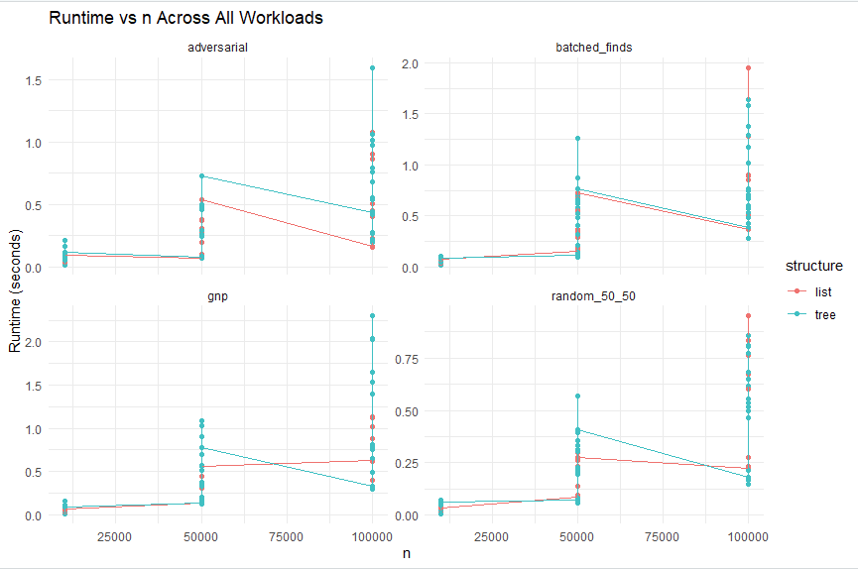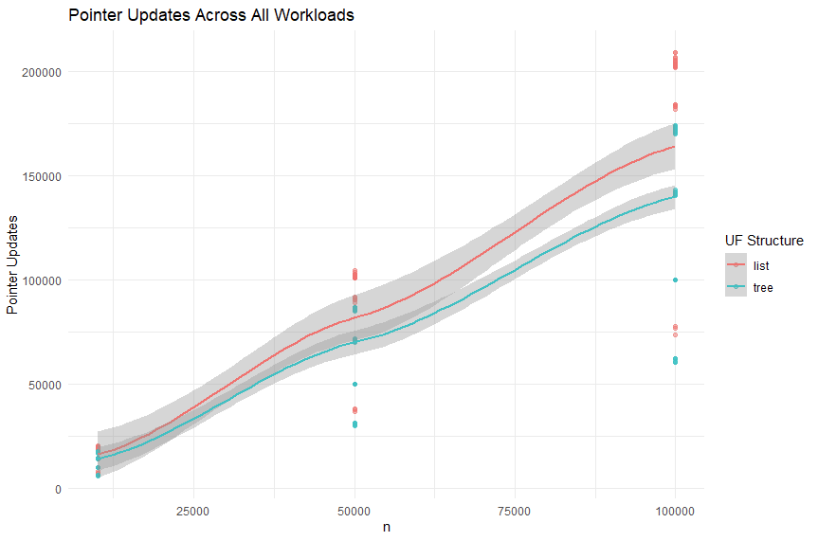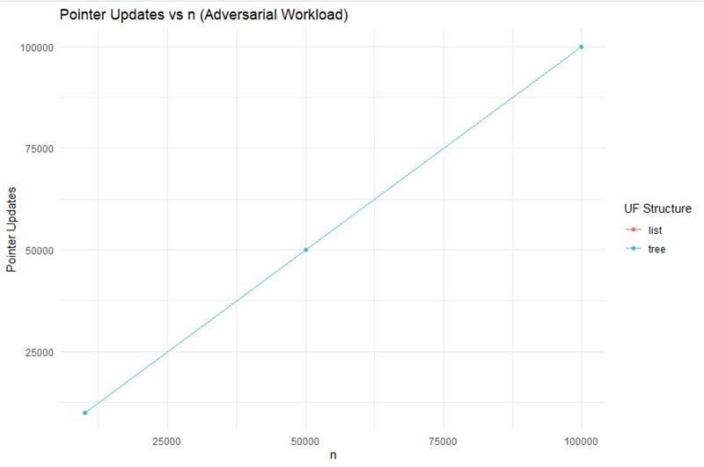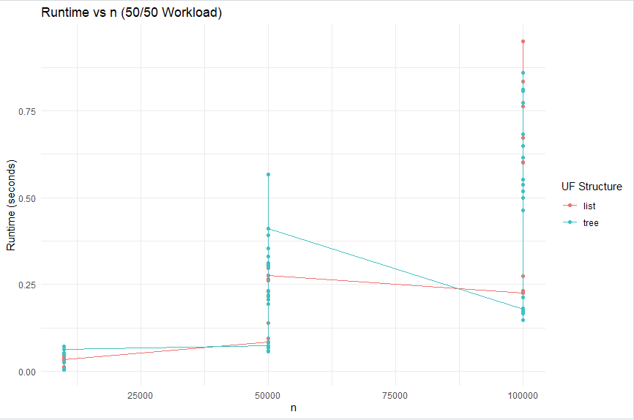

Interpretation: We observe that the tree-based union find aligns closely with its theoretical complexity of O((n+m) α(n)), where α(n) is the inverse Ackermann function. This function grows so slowly that its impact on runtime is negligible, explaining the nearly constant behavior across all n and m values. Path compression plays a central role in flattening trees during use, giving extremely small average path lengths even after only one batch of find operations. The list-based structure exhibits performance consists with its O(log n) amortized bound. As n increases, merging lists results in more pointer updates and longer cumulative merge times, leading to higher total runtimes. Under adversarial workloads the gap between the two implementations becomes even more pronounced, as the list-based implementation must repeatedly update many heads when merging large lists, while the tree-based structure handles the same sequence through single parent pointer changes.
Limitations: Because our implementation was in Python, absolute runtime values include overhead from the interpreter, which obscures the constant-factor differences that might appear in lower-level languages. The memory overhead of storing member lists for the list-based implementation also influenced performance. We did not explore extremely large n values, nor did we conduct multi-threaded or distributed experiments. We also performed only one real-world workload and did not investigate other heavy use algorithms such as Kruskal’s MST end-to-end.
Future Work: If we were to repeat the project, we would implement both structures in C++ to reduce measurement noise and measure memory using trace malloc. It would be beneficial to expand the range of workloads including union-heavy sequences and randomized spanning tree construction. Adding animations to visualize how path compression flattens trees would also strengthen understanding. Finally, exploring hybrid strategies or cache-aware designs could provide further insight.
Roadblock: We faced several difficulties, including balancing runtime with large input sizes, ensuring correctness while enabling or disabling path compression and union heuristics, and designing meaningful visualization tools. Experiment timing varied slightly due to managing large CSV files.
In summary, the tree-based Union-Find consistently demonstrated near-constant amortized performance, while the list-based structure exhibited logarithmic growth consistent with theory. These results support classical asymptotic analysis and provide practical insight into the performance behavior of the two approaches.

References:
Cormen, Leiserson, Rivest, and Stein. Introduction to Algorithms.
Tarjan, R. Efficiency of a Good But Not Linear Set Union Algorithm.
Lecture slides from CSC 2400.
AI DISCLOSURE: We used OpenAI’s ChatGPT to help generate initial drafts of this report, develop experiment automation code templates, and refine the final structure. All generated material was reviewed and edited by the team for accuracy, correctness, and alignment with the deliverables required for this project.

Contributions | John Sutton | Robert Morris | Nolan Schiek | Sawyer Blanchford
Initial brainstorming & proposal | 25% | 25% | 25% | 25%
List-based UF implementation | 0% | 25% | 0% | 75%
Tree-based UF implementation | 0% | 25% | 0% | 75%
Experiment design | 25% | 25% | 25% | 25%
Experiment automation | 25% | 0% | 0% | 50%
Data analysis & visualization | 75% | 0% | 0% | 25%
Results interpretation (writing) | 25% | 25% | 25% | 25%
Report writing & editing | 25% | 25% | 25% | 25%
Slide deck creation | 50% | 0% | 50% | 0%
Presentation delivery & Q&A | 25% | 25% | 25% | 25%
GitHub setup & documentation | 25% | 0% | 0% | 75%

