# Tripod

# 

**Key Features**

* Load Capacity: 8.8 lb
* Max Height: 52"
* Min Height: 15.4"
* Reverse Folded Length: 12.6"
* Leg Sections: 5
* Weight: 3.7 lb
* Two-Angle Locking Leg Positions
* Arca-Type Q0 Ball Head with QR Plate
* Separate Ball and Pan Locks
* Carrying Case Included

Description

*The****MeFOTO BackPacker Classic Aluminum Travel Tripod Kit****from****Benro****offers a sturdy, compact aluminum alloy tripod that extends to 52", supports up to 8.8 lb, and has reverse-folding legs that allow it to fold down to a comapact and portable 12.6". It features a titanium color accent extends to the included, matching Q-Series ball head.*

The tripod's legs can be spread independently, with two-position leg angle stops. A ballast hook is located in a recess at the bottom of the center column, allowing heavy objects to be hung for additional stability.

The Q0 ball head offers separate head and pan locks, a 360° pan index, and an integral bubble level. An Arca-type quick release plate with a 1/4"-20 camera screw is included in the kit, along with a durable carrying case with a shoulder strap for storage and transport.

* Arca-type compatible Q0 ball head with quick release plate, 360° panoramic scale, and bubble level
* 180° Reverse folding legs for compact storage and travel
* Travel friendly tripod can fit inside a backpack or suitcase
* Anti-rotation legs
* Independent leg spread
* Two locking leg positions
* Weather- and dust-resistant twist-lock joints
* Rapid center column with twist-lock joint
* Recessed ballast hook
* Carrying case with shoulder strap

# Drones

# 

**Youtube link: https://www.youtube.com/watch?v=T5IgH__lL7I**

**Key Features**

X9-8K Air Full-Frame 3-Axis Gimbal

8K25 CinemaDNG or 8K75 Apple ProRES

CineCore 3.0 Image Processing

Centimeter-Level RTK Positioning

1/1.8" FVP Camera with 161° DFOV

Spotlight Pro Subject Tracking

Omnidirectional Obstacle Avoidance

Up to 9.3-Mile Control via O3 Pro

Up to 58.4 mph Flight Speed

RC Plus Remote with 7" 1200-nit Display

Show Less

Description

*Improving upon many aspects of the Inspire 2, the****DJI Inspire 3 Drone****keeps up with the advancements and needs of film and television producers, allowing filmmakers to capture creative and stunning results. It begins with the X9-8K Air, an 8K, full-frame, 3-axis, gimbal camera custom-built for the Inspire 3. It joins a new 1/1.8" FPV camera with double the DFOV of the Inspire 2. Together, they help capture professional footage and complex shots thanks to a customizable obstacle avoidance system, built-in centimeter-level RTK accuracy, and tracking solutions that allow accurate and repeatable shots.*

8K X9-8K Air Gimbal

The heart of the Inspire 3 is the custom-built X9-8K Air gimbal that uses CineCore 3.0, DJI's latest image processing system to internally record up to 8K25 CinemaDNG video or 8K75 Apple ProRes RAW video, both meeting the needs of professional film and television productions. The footage retains a lifelike texture that's close to what the human eye can see, allowing for enough space for adding visual effects and color grading. Complex lighting sources are supported with 14+ stops of dynamic range and the use of the DJI cinema Color System authenticity in recording everything from urban landscapes to a variety of skin tones. Additional features include:

* 8K75 Apple ProRes RAW video
* S&Q Mode: Up to full-frame 4K120 ProRes RAW without cropping
* Dual Native ISO at full-frame 30 fps and below
* EI 800/4000 at 24 fps for film production
* EI 320/1600 above 30 fps for commercial and TV production
* 14+ stops of dynamic range for capturing rich highlights and shadow in complex lighting scenarios and allowing for more possibilities during editing
* DJI Cinema Color System (DCCS): An improved DCCS retains authentic colors across natural and urban settings and skin tones in various lighting, and it helps make color matching the X9-8K Air with ground-based cameras easier to achieve.

FPV Camera

Doubling the DFOV of the Inspire 2 to 161°, the new 1/1.8" FPV camera lets pilots take in an ultra-wide first-person view of what the drone sees in flight. The camera supports the transmission of live feeds at 1080p60 and provides a large 3 μm pixel size. The larger pixels offer better light-sensing for improved night vision and safer low-light FPV flying.

Centimeter-Level RTK Positioning

With RTK antennas built into the Inspire 3's airframe, pilots can take advantage of centimeter-level accuracy normally utilized in architecture and surveying to use DJI Waypoint Pro to confidently fly complex routes over and over. The RTK antennas work in conjunction with three types of GNSS (GPS, BeiDou, and Galileo) and dual-frequency positioning. Pilots can choose to activate an RTK Network, using the internet connection of the RC Plus to connect to an NTRIP server or set up an optional D-RTK 2 Mobile Station without needing to install additional modules.

Waypoint Pro

This feature encompasses a wide range of settings, including Repeatable Routes and 3D Dolly, allowing filmmakers to take advantage of RTK positioning to more easily replicate and capture highly-complex scenes.

* Repeatable Routes: Have the Inspire 2 automatically fly the same route over and over while keeping all preset parameters, such as altitude, speed, gimbal angle, and camera settings. This helps perform difficult one-take shots and fly identical routes at different times of the day for transition shots.
* 3D Dolly: Simulate a crane, cable cam, or dolly shot with the added flexibility that aerial cinematography can provide. You can plan the dolly route and then move the Inspire 3 drone back and forth along it while adjusting speed, gimbal angle, and other parameters as needed.

Spotlight Pro

With improved machine-learning algorithms, the Inspire 3 can use Spotlight Pro to automate subject recognition and locking for both people and vehicles with increased accuracy. Choose from Follow or Free modes to capture the scene.

* Follow Mode: In this mode, the drone and gimbal lock onto a subject and orient toward it in the same direction, allowing for easier circling shots
* Free Mode: Taking advantage of the gimbal's 360° pan ability, the gimbal can stay locked onto a subject while the pilot uses the FPV camera to check the surroundings and control the flight route.

Omnidirectional Obstacle Avoidance

To help keep the Inspire 3 and bystanders safe during filming, DJI incorporates nine visual sensors to detect obstacles in all directions. This includes 360° horizontal, upward, and downward coverage, in addition to a depth-sensing downward ToF sensor. A fisheye camera is attached to each of the four landing arms. When they are raised, obstruction from the airframe can be avoided, and when lowered, you gain horizontal obstacle sensing.

A new feature offered by the Inspire 3 is the ability to customize obstacle avoidance. So, filmmakers can enable or disable horizontal, upward, or downward sensing independently. This allows pilots to fly closer to objects, performing complex and creative maneuvers without automated avoidance ruining the shot. You still get the ability to manually set a range, where the Inspire 3 will give you an audible alert sound if you get too close, and you'll always be able to see an object's distances on the controller's display.

O3 Pro

O3 Pro is a generational leap in distance, video latency, and stability compared to the Inspire 2. Using the DJI O3 Pro video transmission and control system, pilots of the Inspire 3 can enjoy a maximum control distance of 9.3 miles in single-control mode or up to 7.5 miles in dual-control mode. Both the 8K gimbal and FPV can provide live feeds of 1080p90 at a low 90 ms latency, and for the first time, filmmakers can have live feeds at 4K30 or 1080p60 at up to 3.1 miles.

DJI RC Plus

In addition to classic piloting controls with integrated buttons and dials, the RC Plus's 7" display works with the DJI Pilot 2 app to add a live video feed and telemetry, such as camera exposure, video specs, focal length, and gimbal angle. The display provides 1200 nits of brightness, making it suitable for outdoor viewing.

To share the live video feed with others on set, you can use the built-in HDMI output to connect the controller to an optional monitor. It can run for up to 3.3 hours per battery charge and supports hot swapping to extend battery life. If you do fly for long periods, the included strap and waist support help to make piloting more comfortable.

Dual Control with Independent Links

Unlike Inspire 2, primary and secondary control links are not bound. This means that two remotes can operate independently, giving each operator live feeds and the ability to be at different physical positions. Also, if the pilot loses the signal, the gimbal operator can take over to land the drone safely. Please note that a second remote is optional and not included.

Expandable DJI PRO Ecosystem

Even with the DJI Inspire 3's impressive cinematic capabilities, pilots and gimbal operators can expand the drone's performance even more with optional DL Mount lenses and DJI PRO Ecosystem accessories and features.

* DJI High-Bright Remote Monitor can be used as a second controller to receive live feeds or control the gimbal and focus
* DJI Three-Channel Follow Focus uses the O3 Pro system with the High-Bright Remote Monitor to transmit control signals to the Inspire 3. This allows the focus puller to accurately achieve remote focus and stepless aperture adjustments
* DJI Master Wheels works with a High-Bright Remote Monitor to allow for gimbal control
* DJI Transmission supports unlimited remote monitors with the connection of the RC Plus to a DJI Video Transmitter with Broadcast mode

TB51 Dual-Battery System

Six TB51 batteries are included with a charging hub to maximize flight time. Each pair of the small and lightweight TB51 batteries delivers 28 minutes of flight time and supports hot swapping to get fresh batteries into the Inspire 3, reducing downtime. The intelligent flight batteries also offer an automatic heating function to maintain flight performance under 64°F. Use the included folding charging hub to make sure all batteries are ready to go. It can accommodate up to eight batteries, charging two to 90% in just 35 minutes in Fast Mode, and all eight to 100% in just 160 minutes.

1TB PROSSD

Capture footage on the included 1TB PROSSD drive and easily offload it to a PC with just the included USB-C data cable. Preview your footage fast, thanks to a maximum read speed of 900 Mb/s.

Trolly Case

Get the Inspire 3 and accessories safely to the set with the included trolly case. An extendable handle, two side handles, and four 360° wheels make transportation easy. Two numbered locks are included to safely secure the case's contents. The case is designed to hold the following:

* Inspire 3
* X9-8K gimbal camera
* Two RC Plus remotes (one included)
* Four (optional) lenses
* 12 flight batteries (six included)
* Two battery charging hubs (one included)
* Three sets of propellers and more

Multicamera Timecode Sync

Through the 3.5mm port, you can sync timecodes between equipment in the air and on the ground. Helping filmmakers simplify the editing process.

Dual-Antenna Orientation

Front and rear built-in stacked ceramic antennas have an anti-magnetic-interference capability to improve flight accuracy and safety.

# DJI RC Plus for Inspire 3

# 

**Key Features**

For DJI Inspire 3

7" Built-In 1200-nit Display

Up to 3.3 Hours of Battery Life

Wi-Fi 6 (802.11ac) & Bluetooth 5.1

Hot-Swappable Battery

HDMI Output

## **DJI CP.IN.00000046.01 Overview**

Designed to control the DJI Inspire 3, the **DJI RC Plus** remote controller gives pilots classic controls, a selection of integrated buttons and dials, and a built-in 7" display. The display is made to show the live feed from the Inspire 3, along with essential telemetry, such as camera exposure, video specs, focal length, and gimbal angle. When it comes to film and TV production, time is money, which is why DJI used a bright 1200-nit display so it can be used easily outdoors in the daylight.

Hot-Swappable Battery

The battery of the RC Plus supports hot swapping, which means you can replace the battery as needed to extend operation beyond the 3.3 hours of a single battery charge.

HDMI Output

Creating a film, show, or commercial is often a collaborative process. The built-in HDMI port on the DJI RC Plus helps to assist in that process by outputting the live feed from the Inspire 3 to an optional external monitor.

Wireless Transmission

* Wi-Fi 6 (802.11ac) dual-band transmission
* Bluetooth 5.1 support

# DJI Mic 2-Person Compact Digital Wireless Microphone System/Recorder for Camera & Smartphone (2.4 GHz)

# 

Link: https://www.bhphotovideo.com/c/product/1664904-REG/dji_cp_rn_00000197_01_action_2_wireless_microphone.html

**Key Features**

2-Person Interviews, Videos, Streaming

Connects to Cameras, iOS/Android Devices

2 x Clip-On Transmitter/Recorder Mics

Compact 2-Channel Receiver

Records 14 Hours of Audio

Bright OLED Display, Headphone Out

USB Audio Interface Functionality

Internal 5-Hour Batteries, Charging Case

Up to 820' Wireless Range

Description

Content creators of all experience levels can raise the production values of their videos, interviews, and streaming with the **DJI Mic**, an easy-to-use, truly wireless digital microphone/recorder system that offers vivid audio quality while supplying all the elements needed to simultaneously capture two subjects to a DSLR/mirrorless cameras or iOS/Android smartphone. The system records clear and reliable audio at up to 820' via two miniature clip-on omnidirectional mics/transmitters, which double as backup recorders for worry-free wireless. The tiny receiver can either be mounted on a DSLR camera or DJI Action 2 camera or plugged directly into the Lightning/USB port of a smartphone or laptop. With Fast Pairing, the transmitters and the receiver automatically charge and pair as soon as you place them in the charging case. Simply complete the initial setup and you can be ready to record quality audio in seconds.

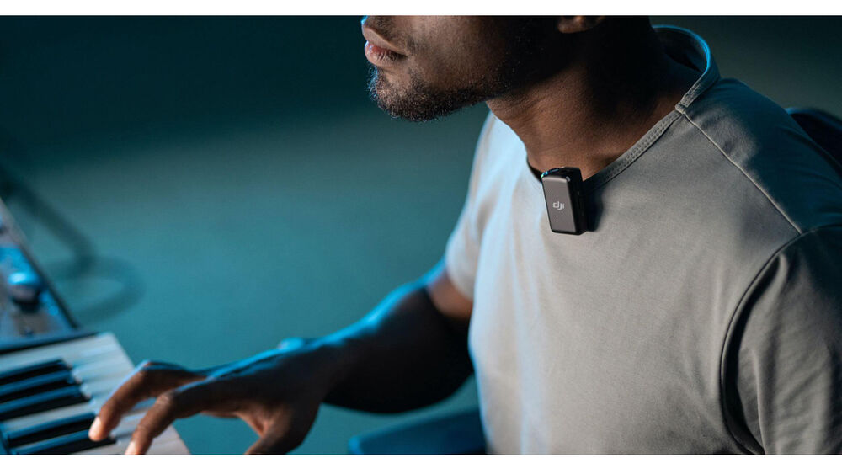

Wearable and Portable Microphones

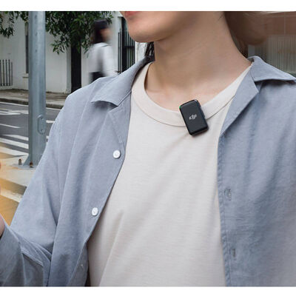

* For a truly wireless experience, conveniently attach a transmitter to whatever you're wearing via the integrated back clip (or by using the clip magnets) without having to wire yourself or your talent.
* You can also hold the transmitter in your hand and use it as a handheld microphone. Use the transmitter as a lavalier mic (no need for a separate mic), or operate it as a traditional bodypack transmitter by plugging an external lav mic (available separately).
* The internal mic features an omnidirectional pickup pattern that ensures reliable speech capture, even if mic placement is less than ideal; your subject's voice is captured with clarity, intelligibility, and consistency.
* Weighing approximately 1 oz, the miniature transmitter is comfortable to wear, easy to position, and easy to conceal on camera.
* Two furry windscreens are provided to effectively suppress wind noise while still recording clear sound.

High-Quality Audio with Flexibility for Post-Production

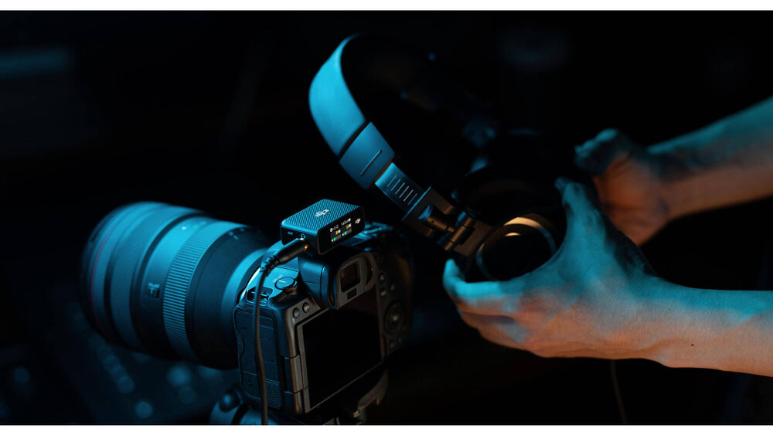

* DJI Mic allows you to record high-fidelity, professional audio by accurately reproducing tone across a wide frequency range.
* The microphones can be combined and recorded in mono or recorded separately with one person on the left and the other person on the right, allowing you to isolate each person's dialog and adjust each level individually later in post.
* To ensure that you are capturing a clean signal you can monitor your sound via the receiver’s 3.5mm headphone output while recording
* The Safety Track mode enables you to record a secondary audio track (in mono) as a backup with a lower volume of -6 dB (different from the main audio track), helping to safeguard your audio in case of unforeseen level spikes.

Built-In Recorders and Safety Track

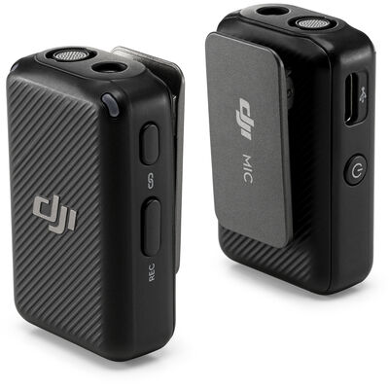

* Both transmitters have onboard recording capability with 8GB of storage for up to 14 hours of backup recording. This allows you to record audio directly to each transmitter as a backup in case of wireless interference and dropouts. You can also use the transmitters as standalone recorders.
* Files are in 48 kHz/24-bit mono WAV format and can be transferred to your computer via the USB Type-C cable.

Reliable and Secure Wireless with Encryption

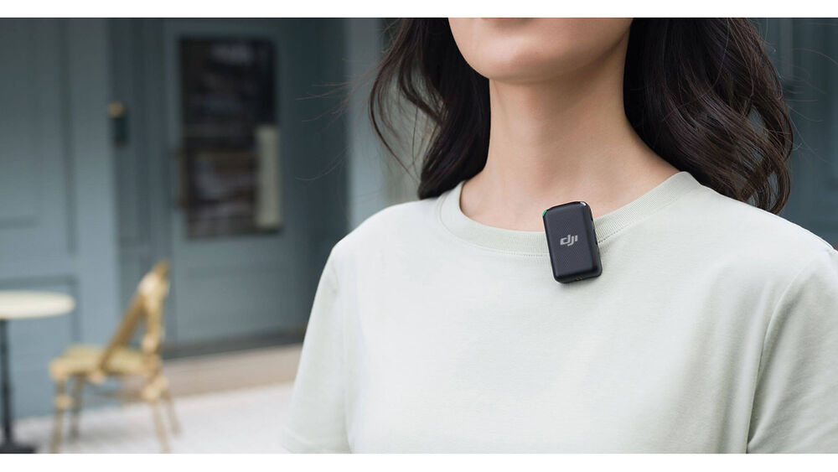

* The DJI Mic is capable of recording crisp audio at distances of up to 820' using DJI's encryption technology for secure communications.
* The optimized wireless transmission system ensures a stable and reliable stream of audio, even in busy areas such as train stations, shopping malls, and offices.
* The system avoids interference from TV and radio waves by operating in the 2.4 GHz frequency band, which occupies frequencies beyond those of television, radio transmissions, and UHF wireless microphone systems.

Easy to Operate with Built-In Touchscreen

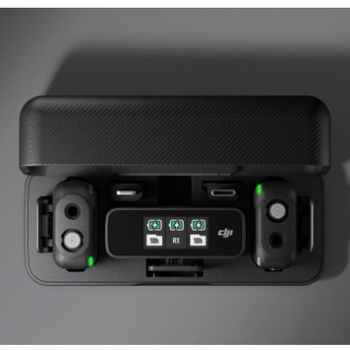

* The receiver's touchscreen interface makes it easy to configure the system.
* You can view and adjust gain levels between -12 and +12 dB to find the perfect setting for your surroundings. Battery life, recording status, and wireless signal strength are also displayed.
* The touchscreen can be used to remotely mute a transmitter’s microphone, start or stop recording, adjust headphone volume, and switch between stereo, mono, or -6db safety track.

Get a Full Day of Audio Recording

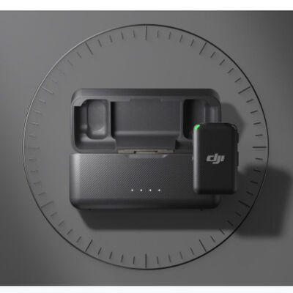

* The ultra-portable charging case is the perfect home for DJI Mic. With it, you can charge the transmitters and receiver, conveniently store components, and fast-pair the system right out of the case.
* Enjoy 5.5 hours of battery life from the transmitters, 5 hours from the receiver, and up to 15 hours with the charging case.

Vastly Compatible

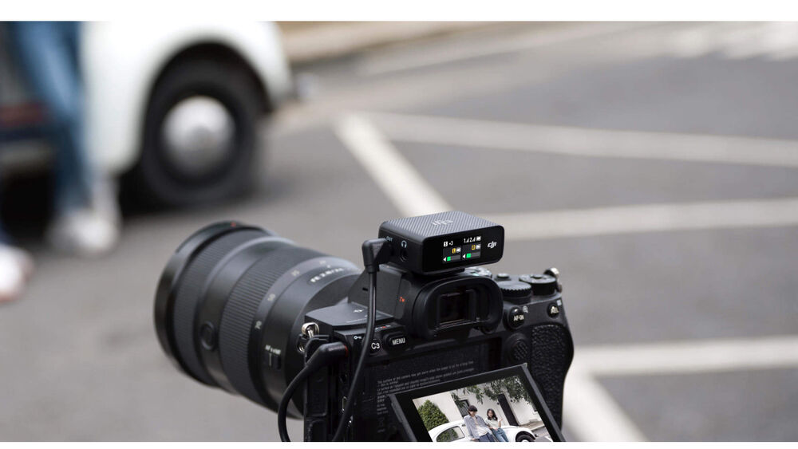

* Different devices mean different input adapters, and DJI Mic covers them all.
* If you want to use the DJI Mic with a smartphone, just insert either the Lightning or USB Type-C adapter into the expansion port at the bottom of the receiver and connect it to your phone and start shooting.
* The receiver can be mounted on the hot shoe of a DSLR/mirrorless camera via the included hot-shoe adapter. Use the 3.5mm TRS cable to connect the camera's 3.5mm mic connector to the receiver's 3.5mm audio-output connector and start filming on your camera.