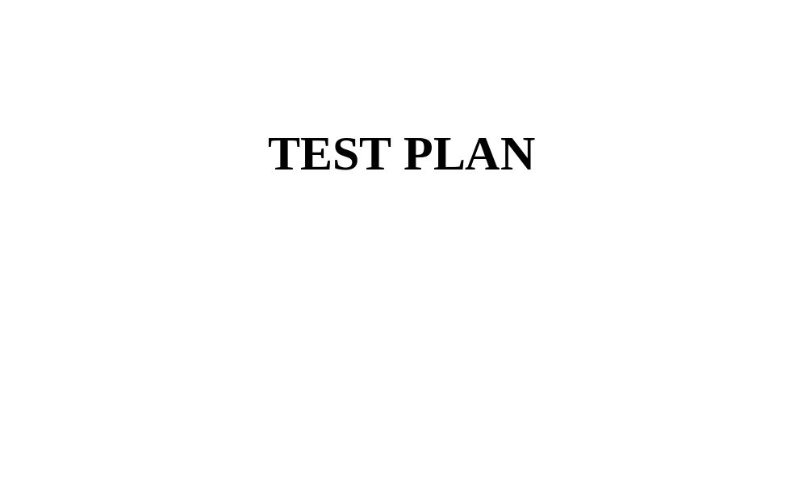

Table of Contents

INTRODUCTION:
1. OBJECTIVES

  - SOFTWARE PRODUCT

  - SCOPE

  - ASSUMPTIONS / RISK

- TEST APPROACH

  - TEST AUTOMATION

2.2 TEST ENVIRONMENT

  - MILESTONES/ DELIVERABLES

  - TEST SCHEDULE

  - TEST DELIVERABLES

Introduction
This test plan is documented to communicate the procedural test to approach to team members. Which includes the objectives, scope, work plan, risks and approach. This document will show clearly what the test deliverables are and what will be and what is discovered to be in and out of scope.

Objectives
The QA Engineer and as well as the Test team is responsible for testing the product and ensuring it meets required specifications. In this instance the QA Engineer is the direct tester
And project team (CV Medik) as supervisor

Phase 1 of the project will deliver Billable hours (Test Case Billable hours) with functionality to create and store manual tests. This will allow the QA Engineer and test team to document proper test cycle to the Team Members.

Resource Name | Role
Supervisor | Project Manager
Otomba T-Omotayo | QA Engineer
Otomba T-Omotayo | Software Tester

Scope
The initial phase will include all ‘must have’ requirements. These and any other requirements that get included must all be tested. At the end of Phase 1, a tester must be able to:
- Create a manual test with the necessary steps
- Save it
- Retrieve it and have the ability to view it when running the test
- Enter results and appropriate comments
- View results

Load testing will not be considered part of this project since the user base is known and not an issue.
Rewriting, moving or porting existing test cases from the existing Word documents is not considered part of this project.

Assumptions / Risks

Assumptions
This section lists assumptions that are made specific to this project.
- Delivery of the product is in format that the test team can check it into CSV

Risks
The following risks have been identified and the appropriate action identified to mitigate their impact on the project. The impact (or severity) of the risk is based on how the project would be affected if the risk was triggered. The trigger is what milestone or event would cause the risk to become an issue to be dealt with.

# | Risk | Impact | Trigger | Mitigation Plan
1 | Continuous changes – as testers become more familiar with the tool, they will want more functionality | High | Implementation delays | Functionality will be closely monitored on each increment iteration. Stakeholders will discuss and prioritize set TASK. Since the driver is functionality and not time, it may be necessary to push the date out.
2 | Functionality changes will impact test cases already written | High | Loss of all test cases | Data export and re-import prior to upgrade is necessary
3 | Weekly delivery is feasible possible because the developer works off site | Medium | Product did not get delivered on schedule | Discuss/ finalize product deliverables timelines with all team members and Stakeholders
4 | No Error message was displayed for the application that was unresponsive | High | Product was unresponsive | Display error message for better user experience and app improvements

Test Approach
The project is using an agile approach, with weekly iterations. At the end of each week the requirements identified for that iteration will be delivered to the team and will be tested.

Exploratory testing will play a large part of the testing as the team has never used this type of tool and will be learning as they go. Tests for planned functionality will be created and added to TCT as we get iterations of the product.

Test Automation
The Automation unit testing are part of the development process, managing testing data and utilizing results to improve the quality of the software product.

Test Environment
A new server is required for the web server, the application and the database.

Milestones / Deliverables

Test Schedule
The initial test schedule follows……….

Task Name | Start | Finish | Effort | Comments
Test Planning | 11am | 2pm | 1d
Review Requirements documents | 2pm | 4pm | 1d
Create initial test estimates | 4pm | 5pm | 1d
Regression testing | 5pm | 6pm | 1d
UAT
Resolution of final defects and final build testing
Deploy to Staging environment
Performance testing
Release to Production

Note Below: The application was unresponsive and as such could not return Parse Elements, thereby halting the test procedures.

S/N | Test Case | Test Element | No of Scripts | Test Result | Duration | Environment/Libraries used
1 | Enter the file Path | https://github.com/BundleOssCode/billable-hours-app-test | 0 | Fail | 20m | Appium,Java client,Seleniumhq,intellij IDEA,lang3 libraries
2 | Call the Parse Content |  | 0 | Fail
3 | Display details of the Parse Element
4 | On click of a company

Deliverables
Deliverable | For | Date / Milestone
Test Plan | QA Engineer | 2021-05-10
Test Results | QA Engineer | 2021-05-10
Test Status report | QA Engineer | 2021-05-10

