**Mini Automated Web Testing Project**

**Summary**

For this project, the site that you will be testing is <https://www.saucedemo.com/>. This has been created specifically for practicing automation coding. Your TASK is to look at the functionality for the website, derive user stories from this and create some test cases for said user stories. You can have as many Sprints as you require.

**Planning**

You will need to create a sprint back log of all user stories on your project board (use Trello or GitHub). An example project board is shown below:

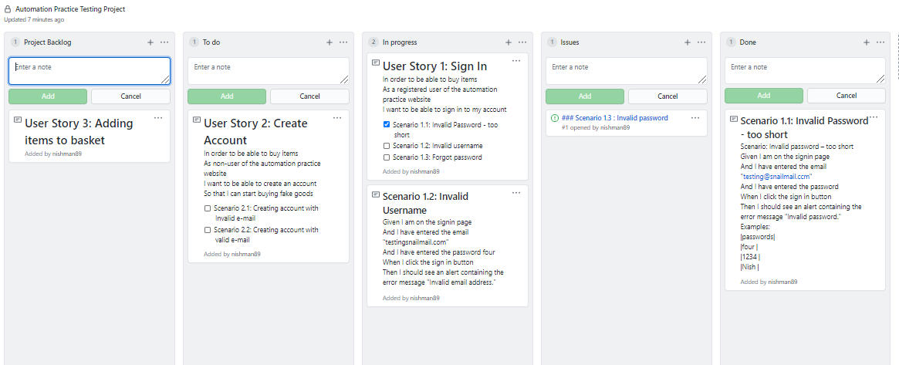

If you do find any defects, convert the ticket into an issues and place into the issue column. Add a description about that the issue:

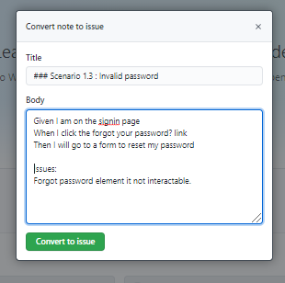

**Deliverables**

1. Up to date project board
2. High quality user stories and test cases
3. Fully functional test framework using POM pattern
4. Very clear Gherkin scenarios that represent the user journeys
5. A README.md that includes all your documentation of what you have tested and how to run your test framework.
6. Use GitHub collaboratively
7. Present your work on Friday 9th Feb (Time TBC)