Lesion Synthesis Toolbox

By Hanif Gabrani-Juma, B.Eng, MASc (2019)

# Purpose

Follow these instructions to generate synthetic lesions in raw PET data. This tutorial will walk you through getting data from the console, generating synthetic lesion in raw PET data and then reconstruct the resulting data using the GE Image Reconstruction Toolbox, also known as DUETTO. This work is supported using DUETTO v2.18 and generates lesions using time-of-flight reconstruction algorithms only. For image reconstruction questions contact GE Healthcare.

The **Lesion Synthesis Toolbox** directory is distributed with all support functions needed.

# STEP 1 – Get the RAW patient data

Raw PET data must be archived offline from the scanner onto the local machine where the lesion simulation toolbox is being used. To simulate a lesion in a specific you must have the following directory structure, with supporting files. Each patient requires the following files:

* Reconstructed CTAC Scan - for attenuation correction of the PET data during reconstruction, to define lesion location and to simulate photon interactions. Stored as Dicom images.
* PET Histogram Files - the raw emission data measured by the PET system and used to reconstruct patient activity, 1 per bed position.
* PET Geometric Correction File - used to maintain uniform pixel size across transverse planes and to correct for detector efficiency (geo3d)
* PET Normalization File - used to correct data considering detector efficiency (norm3d)
* 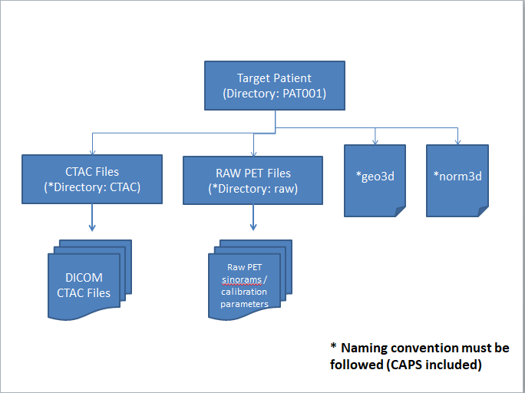

Figure : Directory Structure of the Target Patient Data Stored Offline

This can be done using the DiscoveryDR (Client or source code) for Data Retrieval from GE Discovery 600/690/710 systems (Developed Division of Nuclear Medicine, The Ottawa Hospital) or other methods described in the GE Recon Toolbox Manual. For the purposes of this work, we will describe methods using the DiscoveryDR Client/source code.

## Discovery DR Source Code

For a more customizable approach you can use the Discovery DR Source Code to retrieve and populate directories from the scanner console. Using the source code, you will need to prepare a XLS document with MRNs of the patient data you would like to import. A template XLS file is provided in the **DiscoveryDR Client and Source** folder.

Using MATLAB command line type the following:

updateDRclients = 1;

MRN2SearchDir = 'C:\Users\hjuma\Documents\MATLAB\Lesion Synthesis Toolbox\FTP Tool\MRN2Search.xlsx';

DiscoveryDR_SC(updateDRclients,MRN2SearchDir)

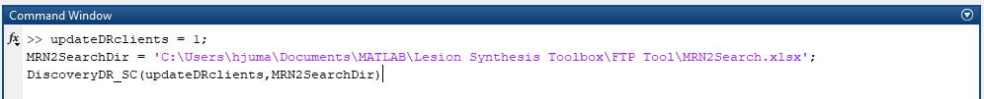

Figure : Command Prompts to Initiate Discovery DR Source Code

**UpdateDRclients** is typically set to 1 – searches the console and populates an updated list of available scans. If this was previously done before new scans were acquired on the console you can set this to 0.

**MRN2SearchDir** is a filepath to location where a XLS file with MRNs to import from the console is stored. A template file is provided and illustrated below.

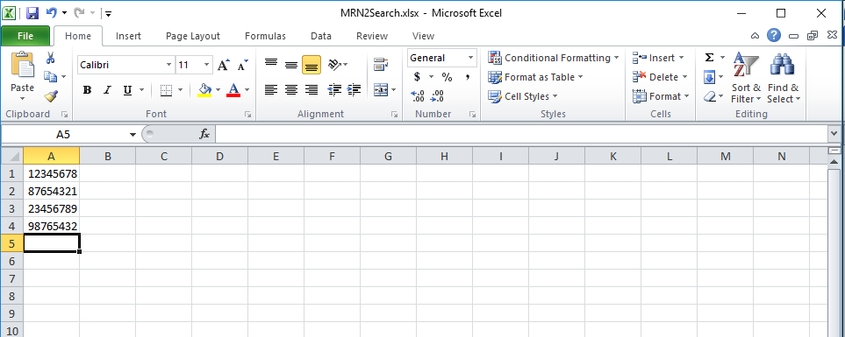

Figure : Sample MRN2Search XLS file

To configure the local directory to import the data/modify the scanner credentials edit the MATLAB script/file **DiscoveryDR_SC.mat** in the **DiscoveryDR Client and Source** directory

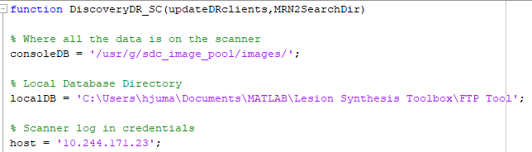

Figure : DiscoveryDR_SC Source Code

## DiscoveryDR Client

Using the DiscoveryDR Client, specify the Host IP, Username, and Password of the target scanner on which the patient data is stored. The DiscoveryDR Client must be used on the same network as the scanner.

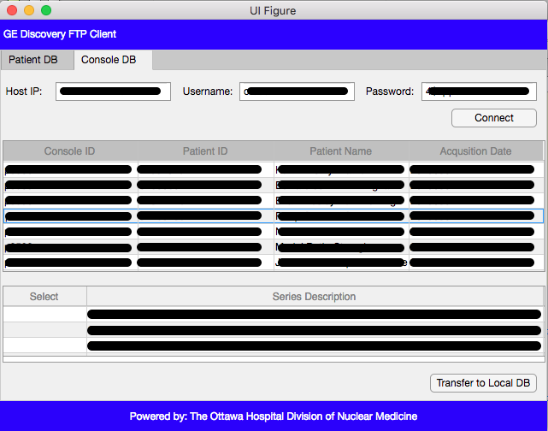

Figure : DiscoveryDR Client

Select the target patient data, and click transfer to local DB. The DiscoveryDR client will save the data in the appropriate file structure on the local drive for further processing with the lesion synthesis toolbox.

***Once you have imported your data, initiate a reconstruction to generate a baseline reconstruction. This baseline reconstruction is necessary to sample the initial image when defining lesion characteristics.***

# Lesion Synthesis in RAW Patient PET Data

To simulate and embed a synthetic lesion in RAW patient PET data, first a preliminary reconstruction of the target patient data is required. The preliminary reconstruction will be used to sample the activity distribution around the target lesion location. Using the GE Reconstruction Toolbox (DUETTO v2.18) initiate a preliminary reconstruction. It is recommended to specify the same reconstruction parameters as the final target patient + lesion image will have.

You can now begin the lesion synthesis process. Simply specify the directory where the preliminary reconstruction is archived and the location to store generated files using the MATLAB command prompt.

datastoredir = 'C:\Users\hjuma\Documents\MATLAB\Lesion Synthesis Toolbox\Test Lesion Synthesis\';

patdir = 'C:\Users\hjuma\Documents\MATLAB\Lesion Synthesis Toolbox\Test Lesion Synthesis\12345678;

MakeLesionInsertionStudy(patdir,datastoredir,reconName)

runLesionInsertionPlusRecon(patdir,datastoredir,reconName)

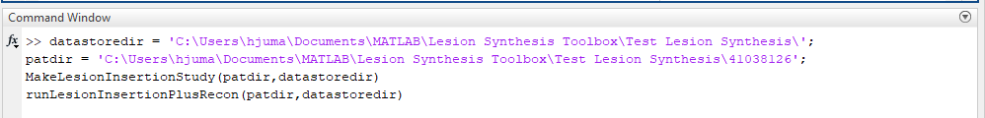

**datastoredir** – a string specifying the path where generated lesion synthesis files are stored

**patdir** – a string specifying the path where the target patient data is archived (preliminary reconstruction + files needed for recon)

**reconName –** the user defined unique recon name. This is used later downstream and should be unique name with no spaces or special characters.

**MakeLesionInsertionStudy**- Function that drives the characterization of the synthetic lesion and populates some simulation directories

**runLesionInsertionPlusRecon** – Function that finalizes simulation directories, generates baseline reconstruction, generates lesion projections, combines simulation and patient data, generates final reconstruction