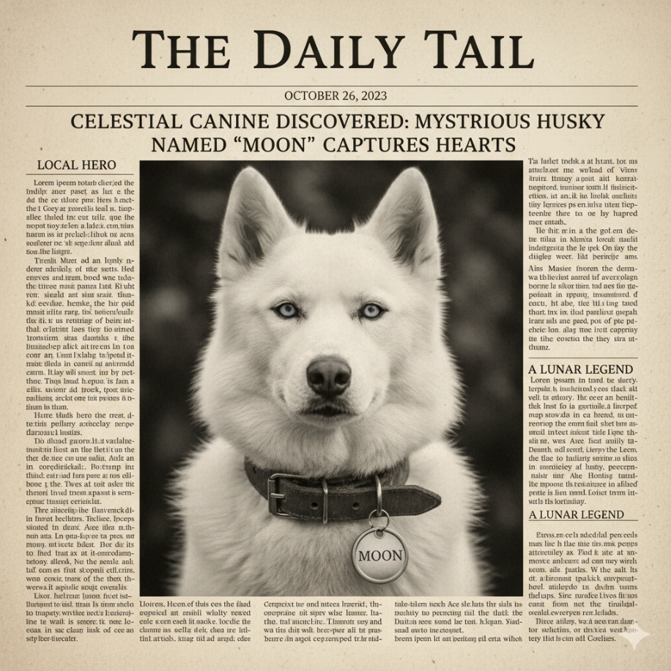

Good Boy Given Award for Helping Geese

A white Siberian Husky has been given an award by the mayor for helping a group of Canada Geese cross the local main road.
The nine-year old Husky was observed herding a group of Geese at a crosswalk so they could reach the local river safely.

