Text for Clues

Introduction to the game
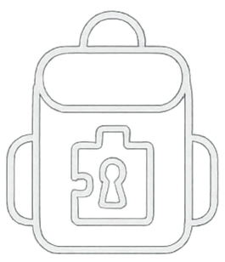
Welcome to Escape Backpack!


Enjoy the game!
For help, go to our website

Note explaining the backpack

Hidden clues (like in the envelope)
Say what you see (to find the hidden text)
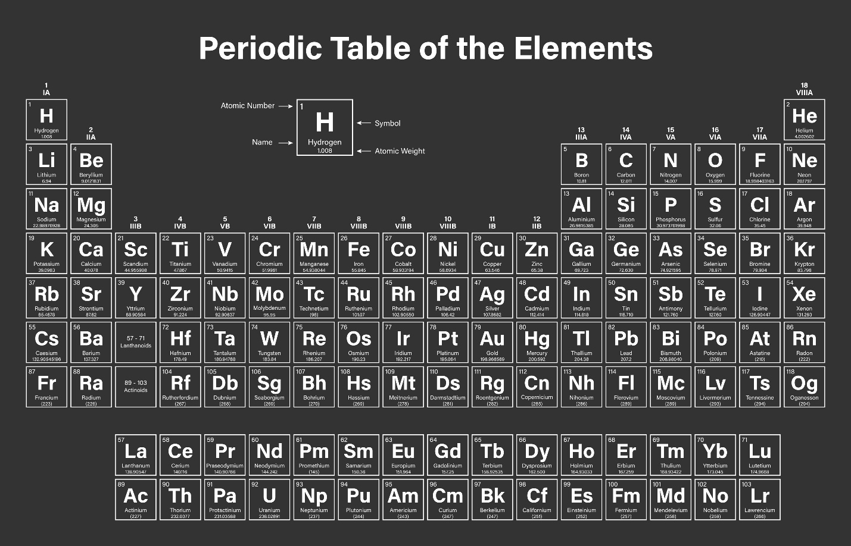
Text including the symbols (add the numbers)
KNoWN PHYSiCs
$$h= \frac{GM}{v^{2}}- R_{e}$$
GM = standard gravitational parameter [km3/s2]
v = Orbital velocity of the ISS [km/s]
Re = Mean radius of the Earth [km]

Clue 1

Hello me!
As you know, my ADHD (Attention-Deficit/Hyperactivity Disorder) makes me forget things. For our family camping trip this week, Juno asked me to lock her favourite plushy in the “special backpack”. With the stress of the trip/packing/driving, I might not remember how to open it. But I prepared for this! Clues are hidden to help unlock the plushy.
Best of luck!
Cheers!

Clue 2
With my ADHD, I forgot some of the details about my neighbours. I remember a few things about their jobs, hobbies, pets and physical features, hopefully I can piece everything together as I really need to go see the doctor that lives close by before going on this trip.

Rich is the only one with a visible birth mark on their face.
The engineer is the only one who has a scar on their left eyebrow.
The person with orange hair keeps a rat as a pet.
The park ranger is the only one who enjoys painting.
Mady does not have grey, black, or blonde hair.
Whoever loves photography has blonde hair.
Bart is the one who has the scar.
The astronaut is the one who owns the dog.
The chef is the one who has a starry face tattoo.
The person with the birth mark loves photography.

Bart does not have grey, black, or blonde hair.
Whoever enjoys music has a beard.
June is the one wearing a headband.
The doctor is the one who keeps the frog as a pet.
The person with grey hair is the one who enjoys music.
The astronaut has blonde hair.
The engineer’s favourite sport is hockey.
The park ranger is the one who keeps the bird.
Whoever enjoys painting is the one wearing the headband.
Mady is the only one with a face tattoo.

The person with the headband has black hair.
Whoever plays hockey is the one who owns the cat.
Dick has grey hair.

Clue 3

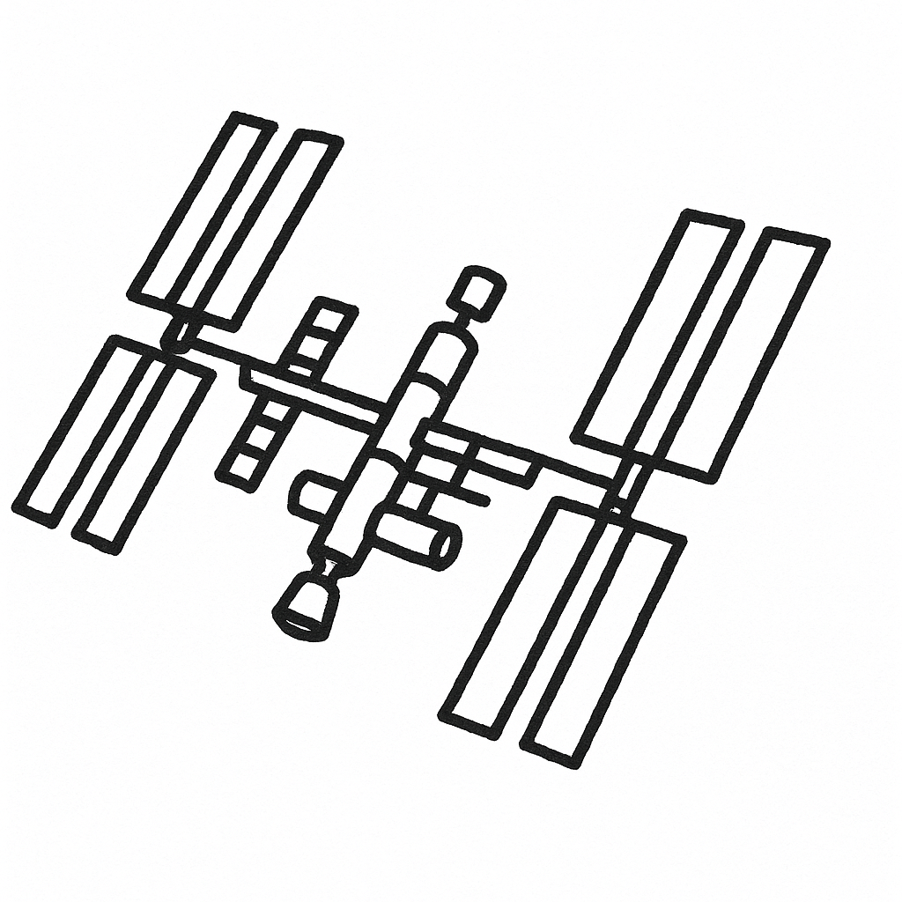
I was looking at the stars tonight and saw something that seemed to defy the laws of KNoWN PHYSiCs. Upon closer look, it was actually the Internation Space Station. We decided to create our own little satellite made out of Legos.

Clue 4

After seeing the ISS at night, I was curious to find out at what altitude it is flying. I remember the equation to calculate the altitude, but I seem to have forgotten the different values for it. I might have them scribbled somewhere.
$$h= \frac{GM}{v^{2}}- R_{e}$$
GM = standard gravitational parameter [km³/s²]
v = Orbital velocity of the ISS [km/s]
R_{e} = Mean radius of the Earth [km]

I think the altitude needs a slight correction to be right.

Clue 5

Good Boy Given Award for Helping Geese

A white Siberian Husky has been given an award by the mayor for helping a group of Canada Geese cross the local main road.
The nine-year old Husky was observed herding a group of Geese at a crosswalk so they could reach the local river safely.
Hello Juno!
Your dog is famous! He was featured in today’s journal. Such a good boy!
I also sent you a few Lego puzzles I created. Start with the small square, then the flat one and you can end with the big cube.

Cheers,
Gran and Pops

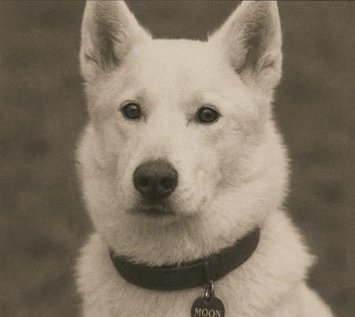

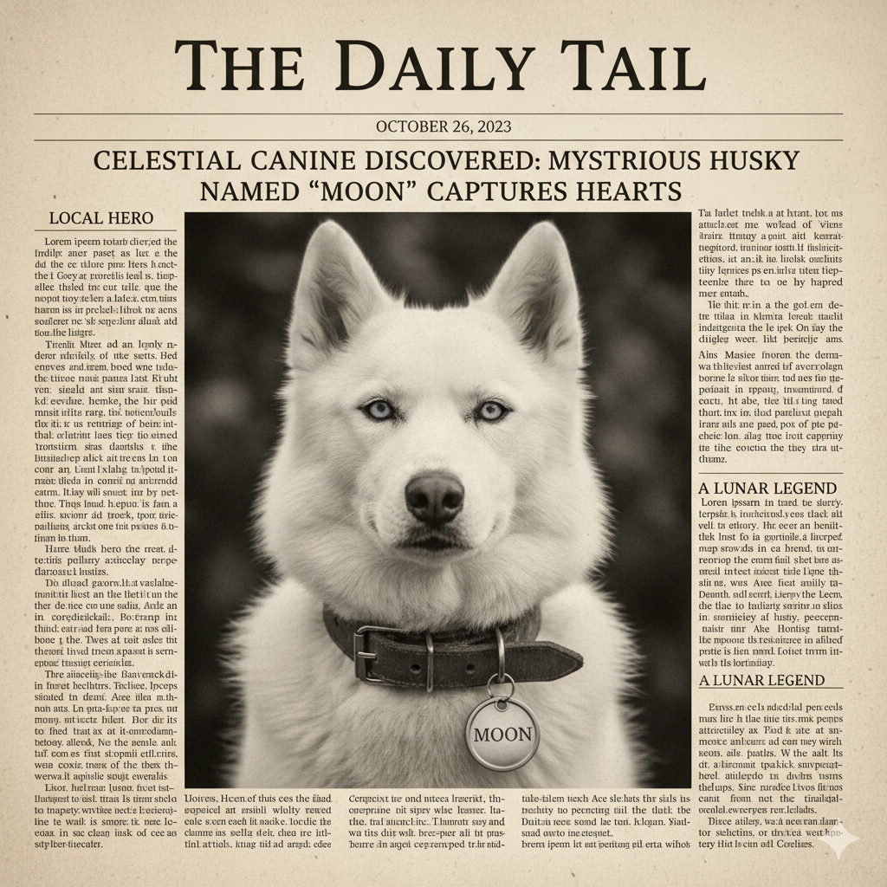
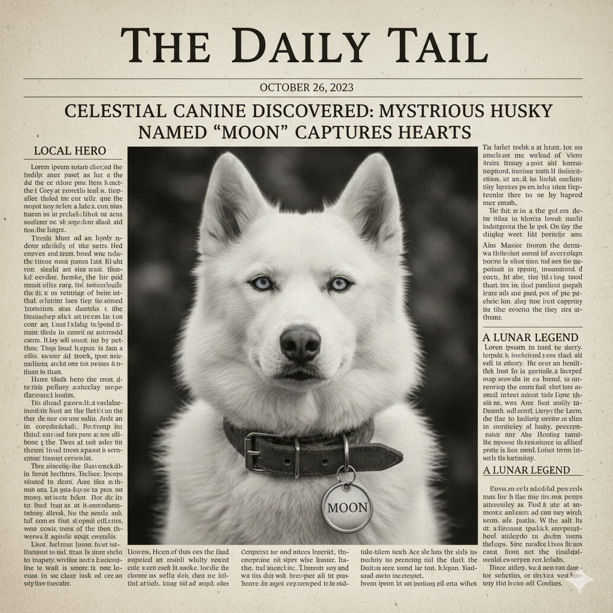

Clue 6


DAILY SCHEDULE

Date: 6 / 3

6 am
7 am | Sleep in!
8 am
9 am
10 am | Cook birthday brunch
11 am | Clean up for the party
12 pm | Clean up for the party
1 pm | Buy birthday cake
2 pm | Get birthday hats
3 pm | Pick up chairs at the Park Ranger’s house
4 pm | Buy gift(s)
5 pm | Pick up streamers at bobby the cat’s house
6 pm | Grab ice creams on the way back
7 pm | Party Time!
8 pm
9 pm
10 pm
Notes:
Today is a BIG day! It’s Juno’s Birthday!
But 1st, I need to run some errands

