LEGO Backpack

Introduction to the game
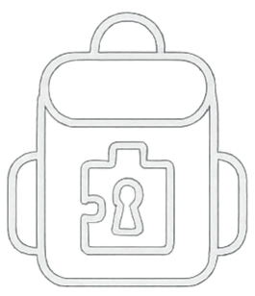

Welcome to Escape Backpack!


Enjoy the game!
For help, go to our website

Note explaining the game

Hello Friend!
We need your help to find our friend that has been lost in this backpack.

