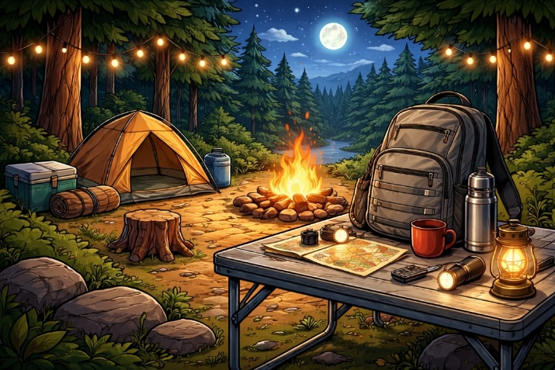
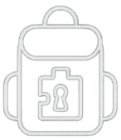







You completed the game!
Feel free to keep the plushy!
Let us know what you thought of the game by completing our survey
Hiking Backpack
Congratulations!
Enjoy the game!

For hints, a timer and more, go to:
https://ottawavisuals.github.io/escape-backpack-games/hiking-hints.html
Hiking Backpack
Welcome to
Escape Backpack!

